|  |  |
| --- | --- |
| **Course Name : CE 363** | **Date of Testing: 03.05.2010** |
| **No. and Title of Test : SML 23 LABORATORY VANE TEST** | |
| **Year and Section: 3/1** | **Lab. Group : 04** |
| **SURNAME, Other names of student:** | |

# OBJECT

To obtain the values of the peak and residual undrained shear strength of the soil.

# APPARATUS

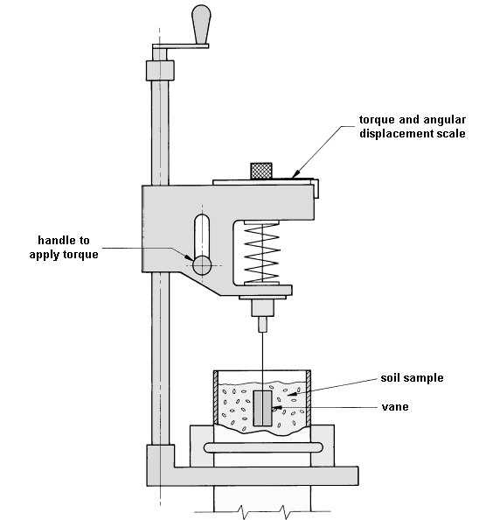

# THEORY



then, by integrating dM



# TEST PROCEDURE

1. Calibration
   1. Apply a known torque to the vertical shaft carrying the vane and read off the angular deflection of the spring. The required torque can be applied by means of a thread wound round the 9.5 mm diameter section of the vane shaft, and pulled horizontally axis, and placing weights on a hanger attached to its end.
   2. Readings should be taken for loading and unloading stages and the mean spring deflection determined in order to eliminate the effect of friction at the pulley.
2. Testing Procedure
   1. If an undisturbed sample is available, transfer this into a Proctor or other suitable mould. Otherwise, remould about 1 kg of Ankara Clay with distilled water to a consistency corresponding to a water content of about 35%. Fill a C.B.R. mould with this clay, taking care not to trap any air in the sample. Place the sample so prepared on the base plate of the vane apparatus, centrally below the vane.
   2. Rotation of the handle, having a horizontal axis, rotates a graduated disc which is coupled with the top of a helical spring. The lower end of this spring is coupled with the vane shaft and also with two pointers. The shorter of these pointers reads against the graduated disc and hence registers the relative angular motion between the top and bottom of the spring, that is, the “spring deflection”. The longer pointer reads against a stationary graduated dial and hence gives the angular rotation of the vane.
   3. Set the two pointers in contact with each other, with the longer pointer reading a value close to zero. Take the initial readings of both pointers.
   4. By turning the handle at the top of the screw spindle anticlockwise, lower the vane until it is just contact with the top of the sample. Then give it 12 more turns so that the vane penetrates the sample by about 3 times its own height, H, in order to avoid the surface irregularities of the sample. Take the pointer readings once more to check whether any twist of the vane has taken place as it entered the soil.
   5. Then apply a torque to the vane by a steady clockwise rotation of the appropriate handle at a speed of one-quarter of a revolution every 10 seconds. During this process, take the readings of the spring deflection and of the angular rotation of the vane at intervals of 10 seconds. Continue until the sample fails, this being indicated by a reduction in the spring deflection. If the spring deflection reaches 1000, stop the test and repeat with stiffer spring.
   6. Rotate the vane rapidly through two complete revolutions; then reduce the speed of rotation of the handle to the value used in (5), and take a final reading of the spring deflection and the angular rotation.
   7. Raise the vane out of the sample by rotating the vertical spindle clockwise. Wipe the blades clear of adhering soil. Shift the sample so that the vane can be lowered to a point at least 30 mm from the point of the previous test and repeat steps (4) to (6).

# CALCULATIONS and GRAPHS



|  |  |  |
| --- | --- | --- |
| **Applied mass** | **Applied torque** | **Total spring deflection (deg)** |
|
| 200 | 0.93195 | 2.2 |
| 400 | 1.8639 | 5.4 |
| 600 | 2.79585 | 8.2 |
| 800 | 3.7278 | 10.5 |
| 1000 | 4.65975 | 13.1 |
| 1200 | 5.5917 | 16.9 |
| 1400 | 6.52365 | 20 |
| 1600 | 7.4556 | 22.5 |
| 1800 | 8.38755 | 25.4 |
| 2000 | 9.3195 | 28.2 |
| 2200 | 10.25145 | 30.1 |



|  |  |  |  |  |  |  |
| --- | --- | --- | --- | --- | --- | --- |
| **Time** | **Spring deflection** | | **Torque from graph (N.cm)** | **c** | **Vane Rotation** | |
| **Reading** | **Deflection** | **Reading** | **Deflection** |
| 0 | 60 | 0 | 0 | 0 | 12 | 0 |
| 10 | 64 | 4 | 1.5 | 3.666929889 | 12 | 0 |
| 20 | 66 | 6 | 2 | 4.889239852 | 13.5 | 1.5 |
| 30 | 67.5 | 7.5 | 2.9 | 7.089397785 | 15 | 3 |
| 40 | 69 | 9 | 4 | 9.778479704 | 16 | 4 |
| 50 | 70 | 10 | 4.7 | 11.48971365 | 18.5 | 6.5 |
| 60 | 70.5 | 10.5 | 5.4 | 13.2009476 | 20 | 8 |
| 70 | 71 | 11 | 5.6 | 13.68987158 | 23.5 | 11.5 |
| 80 | 71 | 11 | 5.7 | 13.93433358 | 26 | 14 |
| 90 | 71 | 11 | 5.9 | 14.42325756 | 29 | 17 |



# DISCUSSION

This experiment was carried out to determine the peak and residual undrained shear strength of the specimen. We might have some errors during experiment such as rounding off. Additionally, because of not reaching perfectly constant velocity while we turn the handle, we may also get some errors. Then, there may also be errors due to the readings of the deflections. Moreover, this experiment is only applicable to soft soil although it is easy to manage.

**CONCLUSION**

We have obtained the spring deflection and vane rotation readings during the experiment in order to calculate peak and residual undrained shear strength. Spring deflection shows the resistance and vane rotation shows deflection of the specimen. We have obtained the stress-strain graph by using these values.

# REFERENCES

Mirata, Türker (2001). Laboratory Instructions for Soil Mechanics Students. Middle East Technical University.