|  |  |
| --- | --- |
| Course No. : CE363 | Date of Testing : 2.12.2011 |
| No. And Title of Test : (19) Unconfined Compression Test | |
| Year and Section : 2011/5 | Lab Group : 3 |
| SURNAME and Other names : | |

**UNCONFINED COMPRESSION TEST**

**Theory**

For soils, the undrained shear strength is necessary for the determination of the bearing capacity of foundations, dams, etc. The undrained shear strength of clays is commonly determined from an unconfined compression test. The undrained shear strength of a cohesive soil is equal to one-half the unconfined compressive strength when the soil is under the f = 0 condition (f = the angle of internal friction). The most critical condition for the soil usually occurs immediately after construction, which represents undrained conditions, when the undrained shear strength is basically equal to the cohesion

**Object**

The object of this experiment is to determine the unconfined compressive strength and hence the undrained shear strength of a saturated clay.

**Apparatus**

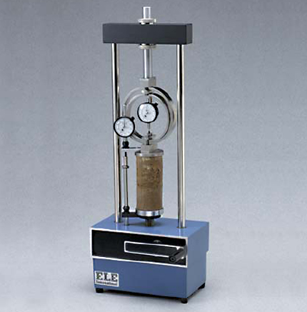

**Procedure**

1. Prepare a specimen by jacking a thin-walled, lubricated core cutter into the soil sample. Then push the specimen out of the core cutter by means of a loose-fitting wooden dolly, and trim it to the required height by placing it inside a trimming tube which is of the right height and has a diameter slightly larger than that of the specimen.
2. Take water content and specific gravity samples.
3. Weigh the sample and determine its mean diameter and height.
4. Place the sample between the loading platens of the testing machine. Adjust the vertical deflection and proving ring dial gauges to zero.
5. Apply an axial load at a constant rate of strain, sufficiently slow to permit recording of the strain and the proving ring dial readings at 10-division intervals of the strain dial. Continue until failure occurs.
6. Prepare a sketch showing the mode of failure of the specimen, measuring the angle of inclination of the failure plane, if any, to the axis of the specimen.

**Calculations**

|  |  |
| --- | --- |
| mass of sample (g) | 125,5 |
| initial height of sample (mm) | 72 |
| initial diameter of sample (mm) | 36 |
| initial area of sample (mm^2) | 1017,87602 |
| initial water content (%) | 15 |

Strain=strain dial/initial height of the sample

Corrected area = initial area of sample/(1-strain)

Axial load = proving ring constant*proving ring dial

Compressive stress = Axial load/Corrected area

|  |  |  |  |  |  |
| --- | --- | --- | --- | --- | --- |
| Strain Dial | Strain | Corrected Area | Proving Ring Dial | Axial Load | Compressive Stress |
| 0 | 0 | 1017,87602 | 0 | 0 | 0 |
| 10 | 0,001388889 | 1019,291703 | 2,5 | 0,0168 | 16,48203351 |
| 20 | 0,002777778 | 1020,711329 | 6 | 0,04032 | 39,5018639 |
| 30 | 0,004166667 | 1022,134915 | 10,5 | 0,07056 | 69,03198291 |
| 40 | 0,005555556 | 1023,562478 | 12,5 | 0,084 | 82,06631428 |
| 50 | 0,006944444 | 1024,994034 | 15 | 0,1008 | 98,34203582 |
| 60 | 0,008333333 | 1026,4296 | 18 | 0,12096 | 117,8453934 |
| 70 | 0,009722222 | 1027,869192 | 18,5 | 0,12432 | 120,9492423 |
| 80 | 0,011111111 | 1029,312829 | 19 | 0,12768 | 124,0439217 |
| 90 | 0,0125 | 1030,760526 | 19 | 0,12768 | 123,8697027 |
| 100 | 0,013888889 | 1032,212302 | 19 | 0,12768 | 123,6954838 |
| 110 | 0,015277778 | 1033,668172 | 19 | 0,12768 | 123,5212648 |

Unconfined compressive strength, $q_{u}$ = 124,0439217

Undrained shear strength, $c_{u}$ = $q_{u}/2$ = 62,02196

Maximum stress is reached before 20% strain.

**Discussion of Results**

The main error source for his test is the error done while taking readings. There might be some errors that is stemmed from the machine used. As for the specimen, it should not be exposed to any force before doing the test.

**Conclusion**

In this test, compressive stress values were calculated using load and strain values which are obtained by calculating from some properties of the machine used and dimensional properties of the sample tested. Lastly, compressive stress-strain graph was drawn, and then unconfined compressive strength and undrained shear strength was obtained from the graph. Maximum stress was reached before 20% strain.

**Reference**

Mirata, T. (2009) *Laboratory instructions for soil mechanics students.* Ankara: METU Press.