MIDDLE EAST TECHNICAL UNIVERSITY

CIVIL ENGINEERING DEPARTMENT

# Soil Mechanics Lab Report

|  |  |
| --- | --- |
| Course No: CE363 | DATE OF TESTING: 25.11.2011 |
| NO. AND TITLE OF THE TEST: SML 22 | |
| Consolidation Test on an Undisturbed Clay | |
| Year & Section : 3, 04 | Lab Group: 03 |
| Surname, Name: | |

# SML 22- Consolidation Test on an Undisturbed Clay

## Object of the Experiment

In this experiment, the object is to determine for an undisturbed clay, which is a cohesive soil;

* The relationship between void ratio and the effective stress
* The time-settlement characteristics.

## Apparatus

* Consolidometer

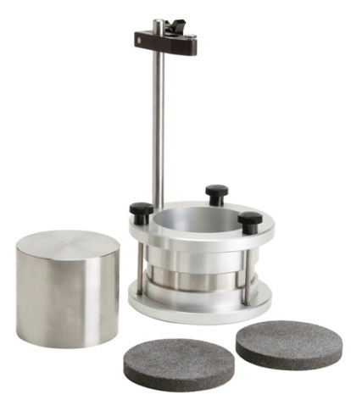

<http://www.humboldtmfg.com/c-2-p-99-id-2.html>

## Theory

Consolidation is the decrease in volume of soil. If the soil is saturated, the consolidation will occur with decreasing in water content of soil without any replacement of water by air. Consolidation occurs when any stress is applied to the soil specimen. We can predict the time for consolidation which can take years. The coeffient of consolidation is as follows:

http://environment.uwe.ac.uk/geocal/SoilMech/consol/pics/qconsmo3.gif

## Procedure (Method of Test)

1. Weigh the consolidometer ring and measure its depth and internal diameter, entering these values in Data Sheet 1. Then exract a specimen by driving a special, thin-walled ring( with the over-drive piece attached) into the undisturbed soil sample, and trim the ends as follows:
2. For the consolidometer of Soiltest, the thickness of the specimen should be slightly less than the depth of the ring in order to accommodate the porous stone. While the specimen is still in the thin-walled ring, trim one end; then, using the extruder, push the specimen through the ring for a few millimeters and cut the other end flush with the edge of the ring. Measure the height of the specimen, and transfer it into the consolidometer ring.
3. For the consolidometer of the Karol-Warner Inc., there is no need for such a clearance. The specimen is therefore transferred into the consolidometer ring and the ends trimmed flush with the ends of this ring. Measure the height of specimen.
4. Take samples for the determination of the specific gravity of the soil.
5. Place the specimen with its ring in an evaropating dish and weigh.
6. With filter paper discs placed on top and bottom of the specimen, assemble the ring in the consolidation cell and mount this on the loading device.
7. Adjust the deflection dial to give sufficient travel under the proposed increment of the load, and to record a small amount of swelling.
8. Loading sequence
9. Select the sequence of loading to be followed from the following range of pressures (kPa):

10, 25, 50, 100, 200, 400, 800, 1600, 3200. The initial pressure to be applied should be large enough to prevent swelling of the specimen; this should be around the effective overburden pressure at the depth from which the sample was taken for stiff clays, and as low as 10kPa for very soft clays.

1. Having recorded the initial dial reading, apply the initial pressure selected above, and instantaneously start the stopwatch.
2. Use an adequate number of stages of loading( not less than 4), ensuring that the maximum pressure on the specimen is greater than the effective pressure expected in situ due to the overburden and the proposed structure.
3. Unloading
4. After completing the readings under the maximum applied pressure, decrease the pressure to a quarter of the maximum pressure, and then to 10kPa, leaving each pressure on for at least 4 hours.
5. After taking the final reading under the 10kPa pressure, quickly dismantle the apparatus. Remove the filter papers, dry the excess water on the surface of the specimen, and weigh the specimen while still inside the ring.
6. Place the specimen and ring in an evaporating dish and dry in the oven to constant weight.

## Calculations

The dial gage readings against the square root of time:

### Data sheet1;

Equivalent height of solids;

2H0=MS/(GS*A)=1.445 cm= 14.45 mm

### Data sheet 3;

**For 50kpa** ;

Change in height of specimen;

(4.92-4.4)*10^-2mm=0.52*10^-2 mm

Height of specimen 2H;

20mm-0.52*10^-2 mm=19.9948mm

Equivalent height of voids;

2H-2H0=5.55 mm

Void ratio,e;

e=(2H-2H0)/ 2H0=0.384

## Results

Results are given on the data sheet.

## Discussion of Results

There may some errors such as human error or we use a computer to take the data from the experiment so there may be some engineering problem due to the machines that were used. In real, the consolidation is very important issue for civil engineers, so this test must be done very carefully.

## Conclusion

In this experiment, the relationship between time and the effective pressure is determined. We plotted three diagrams dial vs. square root of time, so that we obtained how the settlement occurs. This is very important to have some idea about the soil.

## References

1. Mirata ,T. (2009*). Laboratory Instructions for Soil Mechanics Students*