|  |  |
| --- | --- |
| Course No. : CE363 | Date of Testing : 2.12.2011 |
| No. And Title of Test : (23) Laboratory Vane Test | |
| Year and Section : 2011/5 | Lab Group : 3 |
| SURNAME and Other names : | |

**LABORATORY VANE TEST**

**Theory**







 Then, by integrating dM



**Object**

The object of this experiment is to determine the peak and residual undrained shear strength of soft, undisturbed or remoulded clay, assumed as saturated, using the laboratory vane apparatus.

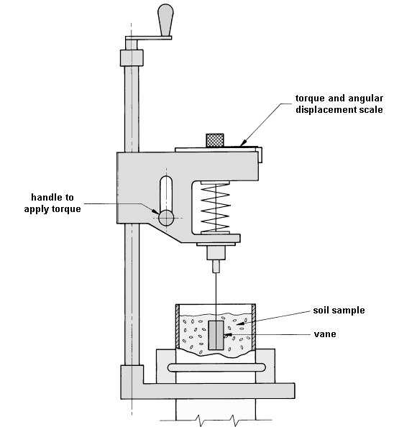**Apparatus**

**Procedure**

*(a)Calibration*

1. Apply a known torque to the vertical shaft carrying the vane and read off the angular deflection of the spring. The required torque can be applied by means of a thread wound round the 9.5 mm diameter section of the vane shaft, and pulled horizontally axis, and placing weights on a hanger attached to its end.

2. Readings should be taken for loading and unloading stages and the mean spring deflection determined in order to eliminate the effect of friction at the pulley.

*(b)Testing Procedure*

1. If an undisturbed sample is available, transfer this into a Proctor or other suitable mould. Otherwise, remould about 1 kg of Ankara Clay with distilled water to a consistency corresponding to a water content of about 35%. Fill a C.B.R. mould with this clay, taking care not to trap any air in the sample. Place the sample so prepared on the base plate of the vane apparatus, centrally below the vane.

2. Rotation of the handle, having a horizontal axis, rotates a graduated disc which is coupled with the top of a helical spring. The lower end of this spring is coupled with the vane shaft and also with two pointers. The shorter of these pointers reads against the graduated disc and hence registers the relative angular motion between the top and bottom of the spring, that is, the “spring deflection”. The longer pointer reads against a stationary graduated dial and hence gives the angular rotation of the vane.

3. Set the two pointers in contact with each other, with the longer pointer reading a value close to zero. Take the initial readings of both pointers.

4. By turning the handle at the top of the screw spindle anticlockwise, lower the vane until it is just contact with the top of the sample. Then give it 12 more turns so that the vane penetrates the sample by about 3 times its own height, H, in order to avoid the surface irregularities of the sample. Take the pointer readings once more to check whether any twist of the vane has taken place as it entered the soil.

5. Then apply a torque to the vane by a steady clockwise rotation of the appropriate handle at a speed of one-quarter of a revolution every 10 seconds. During this process, take the readings of the spring deflection and of the angular rotation of the vane at intervals of 10 seconds. Continue until the sample fails, this being indicated by a reduction in the spring deflection. If the spring deflection reaches 1000, stop the test and repeat with stiffer spring.

6. Rotate the vane rapidly through two complete revolutions; then reduce the speed of rotation of the handle to the value used in (5), and take a final reading of the spring deflection and the angular rotation.

7. Raise the vane out of the sample by rotating the vertical spindle clockwise. Wipe the blades clear of adhering soil. Shift the sample so that the vane can be lowered to a point at least 30 mm from the point of the previous test and repeat steps (4) to (6).

**Calculations**



|  |  |  |
| --- | --- | --- |
| Applied mass (g) | Applied torque (N-cm) | Total spring deflection (deg) |
|
| 200 | 0,93195 | 2,2 |
| 400 | 1,8639 | 5,4 |
| 600 | 2,79585 | 8,2 |
| 800 | 3,7278 | 10,5 |
| 1000 | 4,65975 | 13,1 |
| 1200 | 5,5917 | 16,9 |
| 1400 | 6,52365 | 20 |
| 1600 | 7,4556 | 22,5 |
| 1800 | 8,38755 | 25,4 |
| 2000 | 9,3195 | 28,2 |
| 2200 | 10,25145 | 30,1 |



|  |  |  |  |  |  |  |
| --- | --- | --- | --- | --- | --- | --- |
| **Time(second)** | **Spring deflection** | | **Torque from calibration curve (N.cm)** | **c** | **Vane Rotation** | |
| **Reading** | **Deflection** | **Reading** | **Deflection** |
| 0 | 240 | 0 | 0 | 0 | 5 | 0 |
| 10 | 243 | 3 | 1,2 | 2,934 | 6 | 1 |
| 20 | 245 | 5 | 1,8 | 4,400 | 6,5 | 1,5 |
| 30 | 247 | 7 | 2,5 | 6,112 | 7 | 2 |
| 40 | 250 | 10 | 3,5 | 8,556 | 7,5 | 2,5 |
| 50 | 253 | 13 | 4,4 | 10,756 | 8 | 3 |
| 60 | 254 | 14 | 4,8 | 11,734 | 9 | 4 |
| 70 | 256 | 16 | 5,4 | 13,201 | 10 | 5 |
| 80 | 258 | 18 | 6 | 14,668 | 11 | 6 |
| 90 | 260 | 20 | 6,7 | 16,379 | 12 | 7 |
| 100 | 261 | 21 | 7 | 17,112 | 15 | 10 |
| 110 | 261 | 21 | 7 | 17,112 | 17 | 12 |
| 120 | 262 | 22 | 7,3 | 17,846 | 19 | 14 |
| 130 | 262 | 22 | 7,3 | 17,846 | 22 | 17 |
| 140 | 262 | 22 | 7,3 | 17,846 | 25 | 20 |

**Discussion of Results**

The experiment might be erroneous due to some mistakes done during the experiment. Calibrating speed of the handle is hard to do; therefore this might be a source of error. The readings from the apparatus might be erroneous as well. While doing this test, it should be remembered that this test is valid for soft soils.

**Conclusion**

During the test, readings of spring deflection and vane rotation were taken. Using the data obtained from the test and the calibration curve of the spring, mobilized shear stress values were calculated, and then utilizing these values, stress-strain curve was obtained.

**Reference**

Mirata, T. (2009) *Laboratory instructions for soil mechanics students.* Ankara: METU Press.