|  |  |
| --- | --- |
| Course No. : CE363 | Date of Testing : 14.10.2011 |
| No. And Title of Test : (3) Atterberg Limit Tests | |
| Year and Section : 2011/5 | Lab Group : 3 |
| Surname, Name : | |

**ATTERBERG LIMIT TESTS**

**Theory**

Atterberg limits, also known as consistency limits, are a measure for fine-grained soils(silt and clay). Soil has four states depending on water content of it: solid, semi-solid, plastic, viscous liquid. Consistency and behaviour of soils in each state differs, consequently its engineering properties vary. Clays and silts act in different ways with different moisture content. Shear strength and size of the soil changes with water content. Due to these varieties, Atterberg limit test are widely utilized before any construction to predict how soil will react.

**Object of Experiment**

Object of the experiment is to determine liquid limit of dry soil, which is the water content at which the soil turns into liquid state from plastic state with the help of Casagrande limit device.

**Apparatus**

1. **Liquid limit device:** a mechanical device consisting of a brass cup suspended from a carriage designed to control its drop onto a hard rubber base. The device may be operated by either a hand crank or electric motor.
2. **Grooving tool:** a metal tool with specific dimensions.
3. **A glass plate**
4. **Two palette knives:** used to mix soil and water, to place wet soil on the liquid limit device properly.
5. **Moisture content test apparatus**
6. 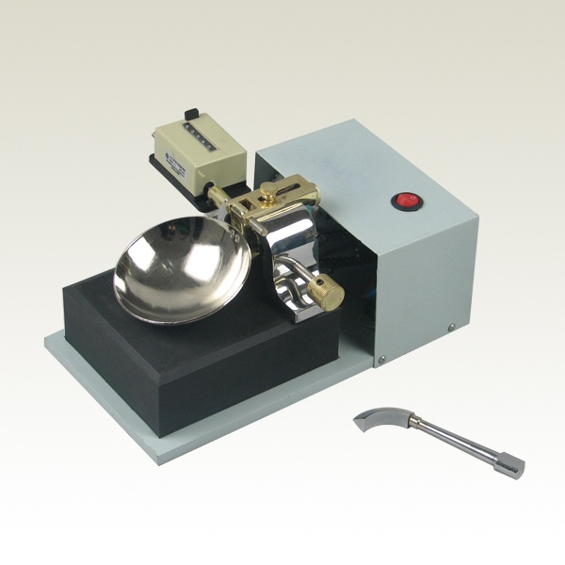**400 micron sieve**

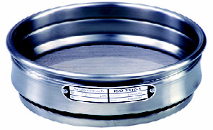

**(6) 400 micron sieve**

**(1) liquid limit device, (2) grooving tool**

**Procedure**

1. Adjust the height to which the cup of liquid limit device is lifted, so that, when the cup is raised to its maximum height, the 10mm gauge will just pass between it and the base.
2. Take 200 g of the dry soil passing through the 400 micron sieve, place it on the glass plate. Add distilled water to the soil and mix by palette knife until water homogeneously diffused into the soil.
3. Allow the soil to wait for 24 hours to let the water permeate through the soil mass.
4. Place some of the wet soil into the cup by a palette knife, make the surface that soil smooth and parallel to the base.
5. Open a groove by the grooving tool along the diameter of the cup through the centre to the hinge, holding it normal to the surface of the cup with the chamfered edge facing the direction of movement.
6. Turn the crank of the device at speed 2 revolutions/second until the two separated parts of the soil come into contact at the bottom of the groove along a distance of 13mm. If the number of drops remains between 40 and 60 when you have the situation explained, take 10 g of the soil that is experimented and place it in a container to determine moisture content later.
7. Repeat steps 2-6 at least for 4 more times using the same sample that water has been added previously. The test must always proceed from the drier to wetter condition of the soil. Each time remember to clean the cup and the grooving tool before testing the soil with new water content.

**Calculations**

Water content (w) = $(mass of water)/(mass of soils)$

For container no. 1;

w=6.21/11.82=52.5%

**Discussion of Results**

According to the flow curve obtained by water content values calculated with the help of data of the experiment, liquid limit ( $w_{L})$ is 55.2%. The soil sample passes from liquid state to plastic state at 51% water content.

As it is mentioned in theory section, liquid limit is an identifier for fine-grained soils like silt and clay. In addition to liquid limit test done in the laboratory session, fall cone test can be done to determine liquid limit. It is based on measurement of penetration of a cone shaped mass into the soil. Although Casagrande method is common universally, it is claimed that fall cone test is more accurate since it decreases the chance of error caused by humans.

As it is the case in many experiments, human factor can affect the results of this experiment too. The wet soil sample is used in the experiment obtained by adding distilled water to dry soil. The water added should be mixed homogenously, so how carefully the person mixes the sample may be effective on the results. Besides, human factor is active again when placing the wet soil into the cup of Casagrande device. The soil has to be smoothly placed and groove has to be opened properly.

On the other hand, errors may not only caused by human factor. The device may generate an error while implementing the test.

To improve the accuracy of the test, firstly, repeating the test for many times and taking the average of the results can be done. Also sample should be taken carefully to avoid different grains size between portions of the same sample taken.

**B. Plastic Limit Test**

**Object**

Object of this experiment is to determine the plastic limit of soil which means the minimum water content when the soil can be rolled into a thread 3 mm in diameter without breaking apart.

**Apparatus**

1. A glass plate
2. A palette knife
3. Moisture content apparatus
4. 400 micron sieve
5. A non-corrodible airtight container

**Procedure**

1. Take 20 g of the dry soil which can pass the 400 micron sieve. Mix it with distilled water, then form two balls from it. Place one of them and ¾ of the other one in the airtight container. Apply the following steps to the remaining quarter.
2. Form a thread with about 6 mm diameter, with the remaining soil. Put it on the glass plate and roll it until its diameter is reduced to 3mm. Try to keep the rolling pressure constant.
3. Reshape the thread and do step 2 again until the thread shears when it reaches 3mm diameter. Place the pieces of soil into a suitable container to determine moisture content of it.
4. Repeat steps 2 and 3 for each quarter of the ball you already used a quarter of it. Place the soil into the same container, determine the moisture content as a whole.
5. Do the steps 2-4 for the other ball.

**Calculations**

$w_{P}=\frac{25.41\%+25.62\%}{2}=25.51\%$ (Plastic limit)

$$I_{P}= w_{L}-w_{P}$$

$I_{P}$ = 55.2% - 25.51 = 29.69%

**Discussion of Results**

When the required calculations done with the data obtained from previous test and the data obtained from this test, plastic limit and plasticity index are calculated. Plasticity index of the specimen is 29.69%, where the plastic limit is 25.51%.

**Conclusion**

In these two experiments, liquid and plastic limits of a specimen are calculated. In addition to them, plasticity index is found. In the light of the observations and results, the specimen is classified as CH according to the plasticity chart.

**References**

Mirata, T. (2009). *Laboratory instructions for soil mechanics students.* Ankara: METU Press.