|  |  |
| --- | --- |
| **COURSE NO:** CE 363 | **DATE OF TESTING:** 14.10.2011 |
| **NO. AND TITLE OF TEST:** SML 3(a) - Atterberg Limit Tests | |
| **YEAR AND SECTION:** 3 - 5 | **LAB GROUP:** 3 |
| **SURNAME, OTHER NAMES OF STUDENT:** | |

**1. OBJECT OF THE EXPERIMENT**

**a) Liquid Limit Test:** To determine the liquid limit of a soil sample. This procedure is determined by observing the closure of the groove over 13 mm in the Casagrande device.

**b) Plastic Limit Test:** To determine the plastic limit by rolling the sample. At 3 mm in diameter soil breaks.

**c) Determination of the Plasticity Index:** To determine the plasticity index of a soil.

NOTE: Shrinkage Limit Determination Test was not done in the lab.

**2. APPARATUS**

**a) Liquid Limit Test:**

1. Casagrande Device
2. Grooving tool
3. A glass plate
4. Two palette knives
5. Moisture content test apparatus
6. 400 micron sieve

**b) Plastic Limit Test:**

1. A glass plate
2. A palette knife
3. Moisture content apparatus
4. 400 micron sieve
5. A non-corrodible airtight container

**3. THEORY**

Casagrande Device can measure the liquid limit with its design and when water content is at liquid limit, device is bumped for 25 times. In fact it is a very simple device, because by the shaking and hitting, soil moves and it moves faster if its water content is high. Just the opposite, if the water content is low, then the groove closes more than 25 hits. In the second test, also the plasticity limit was determined before by experiments and when it is in the true water content it can be shaped and rolled until it comes 3 mm diameter. At this point if sample breaks, then it is just at the plasticity limit. But in the real world it is nearly impossible to determine the best results.

**4. METHOD OF TEST**

In the first part, Casagrande device is used to determine the liquid limit of the soil sample. It was like a small show of the experiment but not the experiment itself. But as we told, dried soil which is passing 400 micron sieve was used for the test. The sample was mixed with water and placed on the Casagrande device. After smoothing the sample, the paste was cut with grooving tool. Then the bumps were counted. In the real test the specimen is weighed in each step but as long as it is impossible to wait 24 hours for drying, it was not done in the test day. Necessary measurements were made before the test and they were taken after the test.

In the second part how to do a plastic limit test was shown. Some wet sample was taken and rolled to ball shape. Then it was broken into different pieces. Each of the pieces were taken and rolled until its diameter becomes 3 mm. Again the pre-measured values were given because of the impossibility of doing test in 24 hours. Because, the dry weight is needed again.

**5. RESULTS**

Results of the test are given in the test table.

**6. CALCULATIONS**

Mass of moisture is found by subtracting mass of cont. + dry soil from mass of cont. + wet soil. Mass of dry soil is found by again subtracting mass of cont. from mass of cont. + dry soil. Water content is mass of moisture over mass of dry soil.

Liquid Limit (LL) is found on the flow curve the corresponding water content where 25 drops occur.

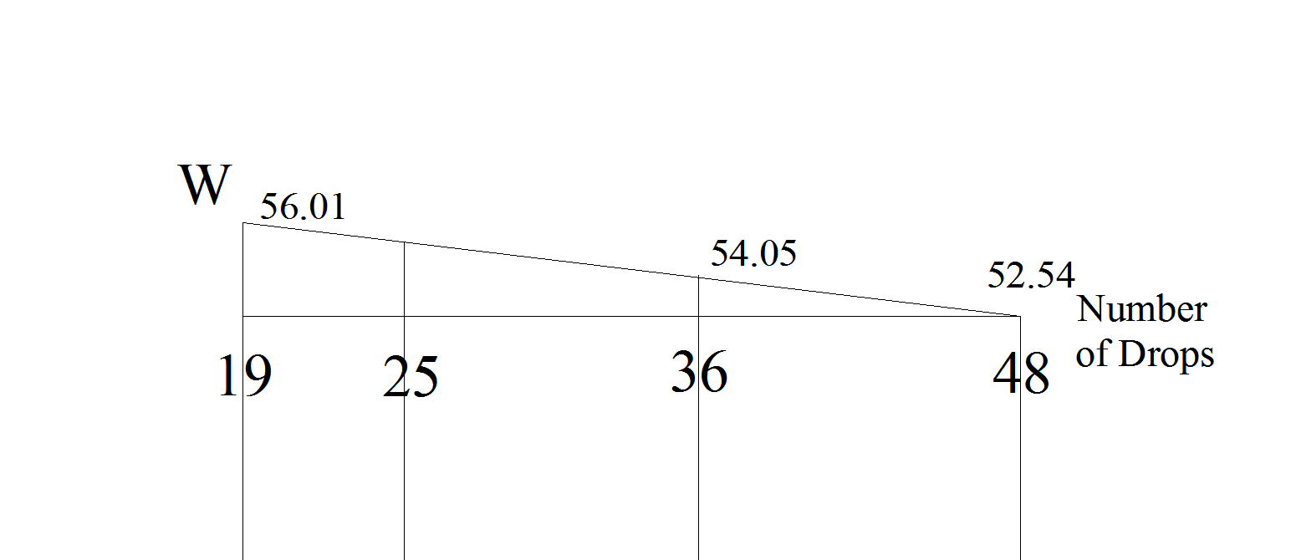

Flow chart of the soil sample

From the similarity of triangles, LL=> (48-19)/(48-25)=(56.01-52.54)/x then; x = 2.75 and LL = 55.29 % is found.

PL = (25.41 + 25.62)/2 = 25.52 %

PI = LL - PL = 55.29 - 25.52 = 29.77 %

So, soil is defined as CH in Casagrande's Plasticity Chart.

**7. DISCUSSION OF RESULTS**

Calculations and the results are found as stated before. But there are a lot of mistakes and errors in the test that can affect every value. First of all, the test was not done by myself. The values were ready and taken after the explaining session. There was a mistake in those values and it is corrected after the test day. Therefore the values are wrong but it can still be calculated. Also as seen in the graph above, similarity of triangles is used to determine water content at 25. There may be an error to find that value, so LL, PI values may be completely wrong. And that affects the definition of soil, which is very close to the CH-CL limit in Casagrande Chart. But in this shape the values are still reasonable.

In the test Atterberg limits are found. It was not so well learnt but if it is necessary I believe I can complete all the test by myself.

**8. CONCLUSION**

In the test, LL, PL and PI values are determined. The usage of Casagrande device is also learnt.

**9. REFERENCES**

Mirata, T. (2009). *Laboratory instructions for soil mechanics students.* Ankara: METU Press.