**CE 363 – SOIL MECHANICS**

***Laboratory Session 5 – Atterberg (Consistency) Limits***

Relevant standards: ASTM D4318; TS 1900

**1. Purpose of the Test**

Classify a fine-grained soil by determining its liquid limit and plastic limit.

**2. Equipment**

- Casagrande cup (liquid limit device)

- spatula - glass plate

- grooving tool - example rod (3.2 mm diameter)

- water content tares

- dish for mixing soil - linear shrinkage and shrinkage limit demo

**3. General Rules**

- Always work from moist to dry for a given soil sample, as it is not possible to hydrate soil grains equally by mechanical mixing.

- Hydrating new soil grains requires tempering time, so you can’t add dry soil to your specimen to reduce its water content. (However, the time constraints of the lab session might necessitate doing this, as it is a much faster way of decreasing water content compared to evaporation.)

- An easy way of evaporating water from the specimen is by spreading it on a glass plate and applying paper towel.

- Tempering is required only once, at the specimen preparation stage. It is not necessary at every water content change in this test.

**4. Specimen**

- Soil fraction finer than #40 sieves (fine sand and smaller) is used.

- About 500 grams of soil at toothpaste consistency is left to temper overnight in the humid room.

**5. Calibration**

- On the base of the liquid limit device, the worn area where the cup impacts should be smaller than 10 mm in diameter.

- The drop height of the cup should be 100.2 mm. This can be checked by inserting the end of the handle of the grooving tool.

- Fill the cup with water in its lowest position. The geometry of this water is the required initial geometry of the specimen.

- For plastic limit, the only calibration is to keep the example rod on the table

**6. Procedure**

*6.1. Liquid Limit with Casagrande Cup*

1- Place soil in the Casagrande cup such that it forms a flat, horizontal surface at the elevation of the lowermost point along the rim of the cup. This geometry is the same as that of water filling the cup. All points under this surface must be filled with soil, no air can be entrapped.

2- Make a groove perpendicular to the cup’s axis of rotation, through the entire length of soil, using the grooving tool.

3- Turn the handle at the rate of 2 hits per second while counting the number of hits, until the bottom of the groove closes along a length of 13 mm. Record the blow count.

4- Take water content measurement specimen as an entire section perpendicular to the groove, at its center.

5- Dry the soil a bit.

6- Repeat steps 1 to 5 at least twice more, until tou have at least one blowcount on either side of 25.

*6.2. Plastic Limit*

1- Dry about 50 g of soil to a stiff, dough-like consistency.

2- Roll a constant diameter string of soil, and keep rolling it thinner and thinner until it breaks/crumbles.

3- If it was possible to roll a string thiner than the example rod, remix the soil dry it a bit, and repeat step 2 until the string breaks exactly when it has the same diameter as the example rod (3.2 mm).

4- Put all pieces of the broken string into a tare and close its lid.

5- Repeat steps 2 and 3; put the new pieces into the same tare until at least 6g soil is accumulated.

6- Measure water content of the pieces accumulated in the tare.

*6.3. Shrinkage Limit Discussion*

Shrinkage limit determination and Linear shrinkage are the tests related to the shrinkage limit of the soil. However, these tests are almost never used in practice, as their results are rarely relevant to engineering calculations. Nevertheless, these tests will be briefly discussed if there is time remaining in the lab session.

**7. Calculations of Liquid Limit Test**

**Container Number=1**

Mass of wet soil= (mass of container+wet soil)-mass of container

=16.28-3.9=12.38

Mass of dry soil= (mass of container+drysoil)-mass of container

=11.44-3.9=7.54

Mass of moisture (water) = (mass of wet soil)-(mass of dry soil)

= 12.38-7.54=4.84

Moisture Content= (mass of water/mass of dry soil)x100= (4.84/7.54)x100=**64.2%**

**Container Number=2**

Mass of wet soil=(mass of container+wet soil)-mass of container=19.39-4.17=15.22

Mass of dry soil=(mass of container+drysoil)-mass of container=13.27-4.17=9.10

Mass of moisture(water)=(mass of wet soil)- (mass of dry soil)

= 15.22-9.10=6.12

Moisture Content=(mass of water/mass of dry soil)x100= (6.12/9.10)x100=**67.2%**

**Container Number=3**

Mass of wet soil=(mass of container+wet soil)-mass of container=20.11-4.07=16.04

Mass of dry soil=(mass of container+dry soil)-mass of container=13.59-4.07=9.52

Mass of moisture(water)=(mass of wet soil)-(mass of dry soil)

=16.04-9.52=6.52

Moisture Content=(mass of water/mass of dry soil)x100= (6.52/9.52)x100=**68.5%**

**According to the best straight line,**

**Number of drops 25**

**Moisture Content 68% which is liquid limit of soil (wL).**

**8. Calculations of Plastic Limit Test**

**Container No:4**

Mass of wet soil=(mass of container+wet soil)-mass of container

=10.22-3.93=6.29

Mass of dry soil=(mass of container+dry soil)-mass of container

=8.87-3.93=4.94

Mass of moisture(water)= mass of wet soil-mass of dry soil

=6.29-4.94=1.35

Moisture Content=(mass of water/mass of dry soil)x100

= (1.35/4.94)x100=27.3%

**Container No:5**

Mass of wet soil=(mass of container+wet soil)-mass of container

=10.21-4.17=6.04

Mass of dry soil=(mass of container+dry soil)-mass of container

=8.9-4.17=4.73

Mass of moisture(water)= mass of wet soil-mass of dry soil

=6.04-4.73=1.31

Moisture Content=(mass of water/mass of dry soil)x100

= (1.31/4.73)x100=27.7%

**Average Moisture Content=(27.3+27.7)/2=27.5% which is plastic limit of the soil(wp).**

**9. Reporting Results**

Results are given below;

**wL= 68%**

**wP=28%**

**Determination of Plastic Index**

**Ip=wL-wP=68-28=40%**

**IP= 40%**

According to Casagrande’s Plasticity Chart, Soil is classified as: CH

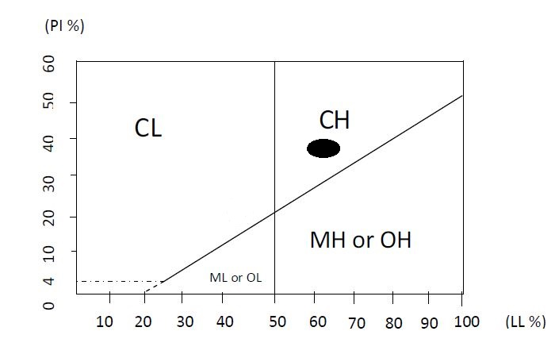

Figure: According to PI% and LL% results, material is classified as CH

**10. Conclusion**

In the light of this experiment liquid limit, plastic limit, and plastic index are learned. Classification of soil is done with respect to calculated results which are LL=68%, PL=28%, PI=LL-PL=40%. However, we have to take into account the experimental errors caused by measurements and rotation of liquid limit device.