Table of Contents

Purpose of the Test 2

Equipment 2

General Rules 3

Sample Preparation 3

Calibration 3

Test Procedure 4

Calculations 4

Reporting Results 5

**Grain Size Distribution by Sieve Analysis**

# Purpose of the Test

Purpose of the test is to decide the grain size distribution (GSD) of the coarse fraction (larger than 0.75 μm) of a soil sample. GSD is particle size vs. % of soil finer than that size.

# Equipment

* Set of standard sieves. There are many different standard sieve sizes. Form a stack of 6-8 sieves (as the sieve shaker permits); such that the particle size range is covered (for example there is no point in having many sieves finer than #10 for a gravel sample). Selecting sieves at the boundaries of grain sizes (coarse/medium/fine sand/gravel etc.) is a good idea. Last sieve must be #200.
* brush
* sieve shaker
* digital scale
* evaporating dishes

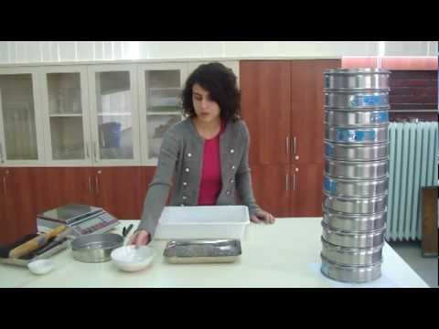

Figure-1: A Sample for Sieve Analyisis (taken from Google Images)

# General Rules

* Particles might be unable to pass a coarser sieve if there is too much soil on the sieve (i.e. the sieve is overloaded), preventing the particle from reaching the sieve. Consult appendix table for overloading limits of sieves.
* If a particle is stuck in a sieve, do not push it through; invert it and brush.
* If brushing is not enough, stuck particles may be dislodged by impact. This can be done by hitting the sieve’s upper rim on a table/bench surface. Do not deliver impact on the sides of the sieve.
* If any particles remain stuck, for coarse sieves, use a pin that is thinner than the sieve size from the underside of the sieve. For fine sieves, apply ultrasonic vibrations in water.
* Do not rub fingers or a hard brush on a fine sieve.
* Do not wash fine sieves with pressurized water.

# Sample Preparation

* Soil sample is washed in No.200 until the water flows cleanly.
* It should be waited for 24 hours so that it perfectly dries. However, because of the time limitations, ready-made soil is used in this experiment.
* Before starting the test, assure that all sieves are clean. If not, make clean properly
* If the soil sticks together, it is ground or broken into small pieces. (done before the lab session)

# Calibration

* Check sieves before use: Don’t use sieves that have sagged, are torn or rusty. Sometimes wires of coarse sieves are dislocated due to improper use – don’t use those either.
* Check if the selected set of sieves easily fit and separate from each other.
* Calibrated sands are available to check if sieves work properly.

# Test Procedure

* Sample of soil is measured in order to obtain total mass of dry sample.
* Soil is washed in No.200 until water seems clear.
* Then this soil sample is changed by another one which is prepared before the lab. (Because of time limitations).
* Weight of the new sample is measured as the total dry mass of granular fraction (>#200 sieve).
* If fine particles are less than 12 %, no need hydrometer test. In this experiment, 4.5% is fine which means it is not necessary to do hydrometer test.
* After that soil was put the sieves and shaken by each person. Moreover, each person took the sample above the sieve. This process was repeated 8th times.
* Each time soil sample remaining above the sieve was jotted down.
* The mass of soil retained on any sieve is in the acceptable interval.

# Calculations

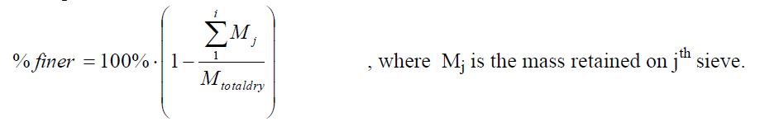

Figure-2: Formulation for finding the percentage finer of soil particles

# Reporting Results

Figure 3: Openining Size (mm) & Cumulative Passing (%)

* According to graph shown in the Figure-3, the soil which is used in this laboratory is mainly sand, but it also covers some part of the gravel. Some errors may exist in this laboratory session, which are the result of the following reasons;
* Measurement mistakes
* Observer mistakes (one may not read the actual readings)
* Sample may not be washed properly, and the new sample may not be perfectly clean (it may include fine particles)
* Sieves may not be shaken properly
* Because of the reasons listed above, the experiment may have some errors. However, in the light of this experiment, purpose of the sieve analysis and classification of soil according to sieve analysis is learned. Soils larger than 0.75 μm can be classify by means of sieve analysis.