Table of Contents

Purpose of the Test 2

Equipment 2

General Rules 3

Sample Preparation 3

Calibration 4

Procedure 4

Calculations 6

Reporting Results 7

Standard Proctor Compaction Test

# Purpose of the Test

To be able to determine the optimum water content at which a well-graded soil can be compacted efficiently.

# Equipment

* Proctor compaction equipment (mold, base, collar, standard proctor hammer)
* caliper
* digital scales (10 kg capacity, and another with 500 g capacity)
* spatula, scoop or trowel
* straight edge
* water content tares, oven

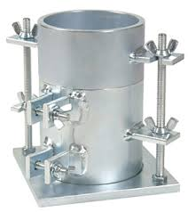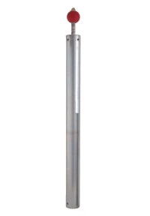

Figure 1: Sample of the Mold&Hammer

# General Rules

* Do not use oven-dried soils with fine content in the experiment
* In real experiment, it is not convenient to reuse samples. However, in this laboratory class samples can be reused for instruction purposes
* Attachment of collars&bases of the of the molds should be done during the compaction
* The mold should rigidly be hold during the test, to do so, a rigid foundation of at least 90 kg can be used or apply your own weight by stepping on two corners of the mold.
* Be careful while using proctor compaction equipment, especially the hammer of the proctor. Keep your hands away from at which rods go into cylinder, and also from the ventilation holes.

# Sample Preparation

* Compaction test is done in 3 days in normal conditions. Because of time constraints it takes only 30 minutes in this lab session.
* In this test, diameter of the soil particles should not exceed 9.5 mm (3/8” sieve).
* If needed, remove the particles those are larger than 9.5 mm by sieve or spread the soil in a tray.
* If more than 5 % of the soil is removed in this application, oversize correction must be performed.
* Find out the initial water content&GS values of the coarse particles alone
* If more than 20% of the soil is larger than 9.5 mm, instead of 3x25 blows in a 4” mold, this material should be compacted by 5x56 blows in a 6” mold, which allows particles upto 19mm.
* In this lab session, soil is already air-dried. It is assumed that 5%-20% of the particles left above the sieve.
* Because of the time limitation, obtaining 1 data should physically be done, and the remaining 4 data should be given by assistant.
* Water should be added to each portions with different amounts, and mixed well. After that, portions should be sealed and tempered overnight (it should be waited in an oven at the temperature of 105o-110o for 1 day). However, because of the time limitation, this step is neglected and portion is waited 2-3 minutes in microwave oven.

# Calibration

* Measurement of the inside dimensions of the compaction mold, and weight of the compaction mold and base, without collar. The data about the mold that is used in this lab session is given in Table-1.

Table 1: Dimensions&Volume of the Mold

|  |  |
| --- | --- |
| Height of the Mold | 11.65 cm |
| Diameter of the Mold | 10.16 cm |
| Volume of the Mold | 944.503 cm3 |

# Procedure

* Fill slightly more than half of the mold with moist sample.
* Fix the base of the mold by your own weight.
* 25 hammer blows should be delivered to the soil which is shown in Figure-1.

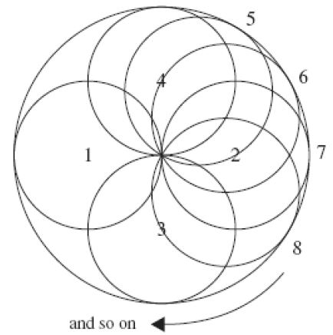

Figure 1: Illustration of the sequence, which the hammer blows, should be applied.

* There are three steps for this test.
* **At first, 25 blows should be performed**
* **After that draw a line on the surface of the compacted soil by screw driver. There are two main reasons for that application. The first one is that when the second layer is placed on the first layer, this application enables testers to separate two layers of the soil. The second one is that the upper and lower surface densities of the first layer can be equated by means of this application.**
* **Do not apply hammer blows to the middle part of the soil because if the blows are done according to the sequence illustrated in the Figure-1, each time hammer blows touch the middle as it can be seen again, in the Figure-1.**
* Previous step should be repeated once more, to do so, fill the mold close to the top.
* When the collar is removed, if the mold is not completely filled with soil, if the top level of the soil is below the top level of the mold, it is not an acceptable test. Repeat all steps from the beginning and do again.
* If the soil level is above the mold (not too much), then excess soil should be removed by a straight-edge.
* Measure the weight of the mold, base and the soil.
* Detach the mold from the base.
* Determine the water content of the soil by taking a sample representative of the whole soil. In this lab session, assistant take sample both the upper and lower surface of the compacted soil and from the middle part of the soil volume.

# Calculations

* Calculation of water content and dry density of the each of the five data points are done and attached to the end of the report.
* Calculation of water content&dry density of 1st sample is shown below

Table 2: Sample Data Obtained in the Laboratory for the 1st portion

|  |  |  |
| --- | --- | --- |
|  | Unit | 1st Portion |
| Mass of mold+base+compacted soil (M2) | g | 5784 |
| Mass of mold+base  (M1) | g | 4206 |
| Mass of compacted Soil (M2-M1) | g | 1578 |
| Bulk Density  (p=( M2- M1)/V) | g/cm3 | 1.67072 |
| Dry Density  pd=100p/ (100+w(%)) | g/cm3 | 1.396 |
| Corrected Dry Density  (pd, corrected) | g/cm3 | 1.522471 |

Table 3: Sample Data Obtained in the Laboratory for the 1st portion

|  |  |  |
| --- | --- | --- |
|  | Unit | 1st Portion |
| Container No |  |  |
| Contianer+Wet Soil | g | 33.8 |
| Container+Dry Soil | g | 31.4 |
| Mass of Container | g | 19.2 |
| Mass of Moisture | g | 2.4 |
| Dry Mass | g | 12.2 |
| Moisture Content (w) | % | 19.67 |
| Corrected Moisture Content (wcorrected) | % | 18.8761 |

* In the calculation of the corrected dry densities and corrected moisture content, formulations given in the Figure-2 are used.



Figure 2: Oversize Correction Formulas for Density&Water Content

# Reporting Results

Figure 3: Dry Density/Water Content Graph

Maximum dry density, (pd)max=1.52 g/cm3

Optimum moisture content, wopt=18.8761 %

* Because of the time limitations, some part of the experiment was skipped, and it results in errors. For example, it is an experiment which lasts for 3 days, but it was done in 30 minutes in this lab session. It was assumed that 17% of the particles are coarser than 9.5 mm, but in reality it may not.
* According to data taken from assistant İlyas Özkan, the isosaturation curves (Sr100%-Sr90%-Sr80%) are drawn, and it can be seen in Figure-3. Moreover, five data points are joint each other by means of Microsoft Excel and graph shown in Figure-3 is obtained.