Table of Contents

Purpose of the Test 2

Equipment 2

General Rules 3

Specimen 3

Theory 3

Calculation 3

Discussion of Results 5

References 7

Unconfined Compression Test

# Purpose of the Test

This test is applicable to understand and determine the unconfined compressive strength and deformation characteristics of a soil specimen. The unconfined compression test is by far the most popular method of soil shear testing because it is one of the fastest and cheapest methods of measuring shear strength. The method is used primarily for saturated, cohesive soils recovered from thin-walled sampling tubes. The unconfined compression test is inappropriate for dry sands or crumbly clays because the materials would fall apart without some land of lateral confinement.

# Equipment

* Glass plate
* Grease
* Water content equipment
* Vernier frame
* Loading frame
* Load measurement, which is proving ring in this lab
* Displacement measurement, which is dial gage in this lab

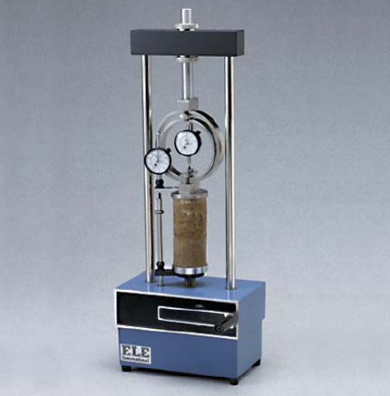

Figure 1: Device for unconfined compression test

# General Rules

General rules are about to minimize the specimen disturbance.

* While transporting the specimen to the scale, or the load frame, always support it
* İf the soil is in contact with a surface other than the platens of the load frame (such as a glass plate); put wax paper in between, to prevent sticking.

# Specimen

The specimen is ready to use, and it is reconstituted by static compaction. The measurements of the height and the diameter are done and written in the data sheet. Weight of the specimen is done. As usual, the assistant is prepared the specimen before the laboratory session in order to save time during the laboratory session.

Theory

While under no confining pressure, a cylindrical sample is subjected to an axial load until failure. This test is only performed on fully saturated clays. Total stress parameters are obtained. The cohesion is taken as one-half the unconfined compressive strength, qu

# Calculation

Initial height of sample, h0 = 101mm

Initial diameter of sample, d0 = 50mm

A0 = = 198313.0363 mm2

Proving ring constant Cp = 0.097 kN/div  
Initial water content= 15%

**Sample calculation for strain dial=10**

ε = (Strain Dial Reading in mm) / h0 = 10x10-2 /101 = 0.0010

Corrected Area, A = A0 / (1 - ε) = (198313.0363)/(1-0.0010) = 198509.5804 mm2

Deviator Load, P = Cp*(Proving Ring Deflection) = 0.097*15 = 14.274 N   
Compressive Stress = P / A = 14.274/198509.5804= 0.0001 MPa

|  |  |  |  |  |  |
| --- | --- | --- | --- | --- | --- |
| Axial Deformation Unit: ( 10-2 ) | Proving Ring Deformation Unit: ( ) | Axial Strain | Corrected Area Unit: ( mm2 ) | Axial Load Unit: ( N ) | Compressive Stress Unit: ( MPa ) |
| 0 | 0 | 0.0000 | 198313.0363 | 0.000 | 0.0000 |
| 10 | 15 | 0.0010 | 198509.5804 | 14.274 | 0.0001 |
| 20 | 35 | 0.0020 | 198706.5145 | 33.305 | 0.0002 |
| 30 | 61 | 0.0030 | 198903.8397 | 58.046 | 0.0003 |
| 40 | 87 | 0.0040 | 199101.5573 | 82.787 | 0.0004 |
| 50 | 117 | 0.0050 | 199299.6683 | 111.334 | 0.0006 |
| 70 | 172 | 0.0069 | 199697.0754 | 163.670 | 0.0008 |
| 90 | 216 | 0.0089 | 200096.0705 | 205.539 | 0.0010 |
| 110 | 253 | 0.0109 | 200496.6633 | 240.747 | 0.0012 |
| 130 | 278 | 0.0129 | 200898.8632 | 264.536 | 0.0013 |
| 150 | 300 | 0.0149 | 201302.6800 | 285.471 | 0.0014 |
| 200 | 336 | 0.0198 | 202319.3602 | 319.728 | 0.0016 |
| 250 | 351 | 0.0248 | 203346.3621 | 334.001 | 0.0016 |
| 300 | 349 | 0.0297 | 204383.8435 | 332.098 | 0.0016 |
| 350 | 339 | 0.0347 | 205431.9658 | 322.582 | 0.0016 |
| 400 | 327 | 0.0396 | 206490.8934 | 311.163 | 0.0015 |
| 500 | 281 | 0.0495 | 208641.8402 | 267.391 | 0.0013 |

* Determination of E0&E50 values, by taking the data from the axial stress and axial strain graph.

E0=stress/stain, where the stress value is equal to 0.0006 MPa, and the strain value is equal to 0.005.

Thus, E0 = 0.12 MPa.

E50=qu/2/strain, where qu/2 is equal to 0.0008 and the corresponding strain value is equal to 0.0069. Therefore, E50= 0.1183 MPa.

# Discussion of Results

In this laboratory session, it is endeavoured to investigate the unconfined compressive strength of a soil sample by the guidance of assistant Yılmaz Emre Sarıçiçek. First of all, it is feasible to mention about information that are given during the lab session.

* In order to minimize the friction between apparatus and the soil sample, Vaseline is used.
* Undrained conditions are considered in this test, so **φ = 0o**
* Confining pressure is zero; therefore, when the Mohr circle is drawn, one should start drawing at zero value.
* The most important thing in this laboratory is that H0/D0 =2 or 3. If it is not, then it can result in end effects. If the sample is too short there will be significant end effects. End effects are caused by the top and bottom loading plates that grip the sample. They can increase the strength of a soil sample by preventing the formation of the weakest failure plane. If the sample is too long, we find that it tends to buckle. A length-to-width ratio of two to three is recommended to avoid this problem.

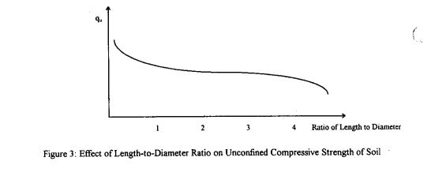

Figure 2: Effect of Length-to-Diameter Ratio on Unconfined Compressive Strength of Soil

* As additional information, the soil is not confined during shear but will be confined in the field if the soil is located at a depth of a few feet or more. The problem is most severe with fissured soils (soils that contain cracks). In the ground, the cracks are held closed by the confining pressure due to the weight of soil above it. The soil is much stronger in this state than it is with no confining pressure in an unconfined compression test.
* The soil may be unrepresentative because it is not the same as, or perhaps even similar to. The bulk of the soil found in the ground the sample can also be unrepresentative if it has been disturbed or changed from its original slate. A common cause for disturbance is the soil sampling process. Disturbance usually has the effect of lowering the strength of the soil and reducing the slope of the stress-strain curve

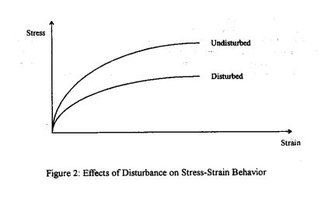

Figure 3: The effects of disturbance on Stress-Strain Behaviour

According to the data obtained during the lab session the graph of axial stress and axial strain is obtained.

Figure 4: The graph of the axial stress and axial strain

From the graph the peak value of compressive strength is 0.0016 MPa

Half of this value is the undrained shear strength: **Cu = 0.0016/ 2 = 0.0008 MPa, since φ = 0o**

* In order to find E0 value of the soil sample (modulus of the elasticity), take the slope of the initial part of the axial stress and axial strain graph. Then, necessary stress and strain values are taken and divided. (shown in calculation part)
* In order to find the E50, a line is drawn between zero and qu/2 values. Then, necessary stress and strain values are taken and divided. (shown in calculation part)
* Effect of deformed area plays a prominent role in this experiment because after some point it reduces the stress on the sample and enables soil to strength much more. In this test, the fractures are formed on diagonal axis and the shape swelled on diagonal direction which is drawn below.
* Effect of the water content also plays a prominent role because if the water content is large it reduces the shear strength of the soil sample, and the relationship between water content and the shear strength of the soil is drawn below.
* Because of the observer mistakes, there may exist some errors. As it is mentioned earlier that soil sample may not be represent actual behaviour of this type of soils. Moreover, there may be some calibration errors in the apparatus. Because of the friction that cannot be reduced by using Vaseline, surface area of the soil sample may be disturbed. Most importantly, soil may not be an undisturbed sample and contain much more water content. The effect of these two parameters is discussed before. All in all, behaviour of soil is observed under these conditions.

# Conclusion

In the light of this experiment, determination of unconfined compressive strength of a soil sample is done. Effect of water content and deformed area is discussed. Test equipment, and how to do this test is comprehended.

# References

http://www.cyut.edu.tw/~jrlai/CE7334/Unconfined.pdf