**Bonus Question:**  **a)**

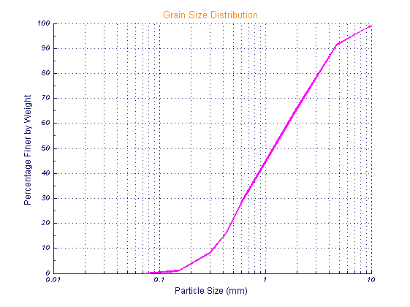

**Graph. 1-** The graph which I used Mathlab with my laboratory datas.

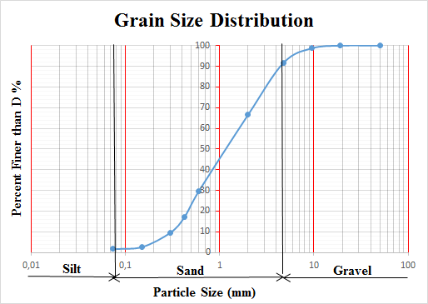  
 **Graph. 2-** The graph which I drawn in Sieve analysis report with my laboratory datas.

**b)** My graph which I drawn in Excel is curvilinear also the other graph that I drawn in Mathlab is curvilinear (a little bit linear rather than first one). Approximately, both of graphs have same grain size distribution curve and same D10, D30, D60,CU,CZ values.

**c)** I didn’t find any error or bug, the code works correctly and soil type is found.