**Table of Contents**

**1)****Purpose of the Test................................................2**

**2)****Equipment..............................................................2**

**3)****General Rules.........................................................2**

**4) Calibration..............................................................2**

**5) Specimen.................................................................2**

**6)** **Procedure................................................................****3**

**7)****Calculations.............................................................3**

**8)** **Discussion of Results..............................................5**

**9)****Conclusion...............................................................****9**

**CE 363 / 364 – SOIL MECHANICS**

***Laboratory Session 10 –– Unconfined Compression Test***

# Purpose of the test

Determine unconfined compressive strength and deformation characteristics.

# Equipment

* Glass plate
* Grease
* Water content equipment
* Vernier calipers
* Loading frame
* Load measurement instrument (proving ring in this lab session)
* Displacement measurement instrument (dial gage in this lab session)

# General Rules

These are for softer specimens. In this session, you have a stiff specimen, but these are given to give you a general idea of additional precautions to minimize specimen disturbance.

* When transporting the specimen to the scale, or the load frame, never leave it unsupported. This means support the base with a glass plate. Protect it from toppling with your other hand.
* Whenever you’ll put the specimen in contact with a surface other than the platens of the load frame (such as a glass plate), put wax paper in between, to prevent sticking.
* If the specimen will wait, have a wax paper and metal retaining sleeve around it. It should be allowed to wait only in a humid room/container.

# Calibration

Remember the discussion on measurement devices from Lab Session 1. Familiarize yourself with their usage. Record the calibration factor of the proving ring.

# Specimen

The specimen in this lab session is reconstituted by static compaction, and is ready for your use. Undisturbed specimens are either cut with a cutting ring (for stiff specimens, use like a mini Shelby tube), or trimmed in a vertical lathe with a wiresaw (for soft specimens, similar to trimming döner kebab).

* Measure the height (at 2-3 locations) and diameter (at mid-level in two orientations) of the specimen with calipers.
* Weigh the glass plate and wax paper.
* Weigh the specimen (with the glass plate and wax paper).

# Procedure

1- Apply grease to the end platens of the load frame.

2- Place and center the specimen on the load frame.

1. Set/Record zero value of load measurement device.
2. Bring the top cap to contact with the specimen. You can ensure contact by watching the load measurement.
3. Set/record the displacement measurement device zero.
4. Set the load frame’s displacement rate to a rate that corresponds to between 0.5 and 2 % strain per minute. Stiffer soils should be sheared slower than softer soils. In this session, 1%/min is reasonable.
5. Start shearing. Take axial load measurements at 0.1% strain intervals upto 0.5%, then 0.2% intervals upto 1.5%, then 0.5% intervals upto 5%, and 1% intervals thereafter. Take an additional load and displacement reading when the load starts to decrease (i.e. peak load). Beware that the early readings will be quick; I recommend one person watching the displacement dial and calling out at the specified values, to another person who reads load dial at that moment.
6. Stop when a failure plane develops, or axial load drops by 25%, or at 15% axial strain.
7. Remove the load.
8. Measure the diameter (2 measurements at each of top, mid- and bottom levels) of the specimen with calipers. If visible, measure the angle of failure plane from the horizontal.
9. Draw a sketch or take a photograph of the failed specimen.
10. Weigh the specimen.

13- Ovendry and obtain the total dry mass of specimen.

# Calculations

Initial height of sample, h0 = 100 mm

Initial diameter of sample, d0 = 50 mm

Volume of sample, V = (pi*502 *100)/4 = 196250 mm3

A0 = = 196349.5408 mm2

Proving ring constant Cp = 0.075 kN/div Dial gage →1 div= 0.01 mm  
 Providing ring →1 div= 0.075 kg

Initial water content= Mass of water/ dry mass → w= mw/ ms

Weight of sample = 341.9 g

Dry mass of sample with container = 217.2 g

Wet mass of sample with container = 242.5 g

Mass of container = 139.77 g

Mass of water, mw = 242.5-217.2= 25.33 g Dry mass, ms= 217.2-139.77 =77.43 g

w=mw/ms=25.33/77.43= 0.327= 32.7%

ρ = Mass of specimen /Volume of specimen= 341.9 g /196250 mm3

ρ = 0.0017421 g/mm3

**Sample calculation for strain dial = 90**

ε = (Strain Dial Reading in mm) / h0 = 90x10-2 /100 = 0.0090

Corrected Area→ A = A0 / (1 - ε) = (196349.5408)/(1-0.0090) = 198132.7355 mm2

Deviator Load→ P = Cp*(Proving Ring Deflection) = 0.075*67*9.81= 49.295 N   
Compressive Stress = Axial Load /Corrected Area= 49,295/198132.7355= 0,0002 MPa

|  |  |  |  |  |  |
| --- | --- | --- | --- | --- | --- |
| **TO BE RECORDED** | | **TO BE CALCULATED** | | | |
| Axial Deformation Unit:  (div) | Proving Ring Deformation Unit:  (div) | Axial Strain | Corrected Area Unit:  (mm2) | Axial Load Unit:  (N ) | Compressive Stress Unit:  (MPa) |
| 0 | 0 | 0,0000 | 196349,5408 | 0,000 | 0,0000 |
| 10 | 6 | 0,0010 | 196544,1390 | 4,415 | 0,0000 |
| 20 | 11 | 0,0020 | 196743,0269 | 8,093 | 0,0000 |
| 30 | 16 | 0,0030 | 196934,4948 | 11,772 | 0,0001 |
| 40 | 22 | 0,0040 | 197138,0932 | 16,187 | 0,0001 |
| 50 | 28 | 0,0050 | 197326,4042 | 20,601 | 0,0001 |
| 70 | 45 | 0,0070 | 197733,6766 | 33,109 | 0,0002 |
| 90 | 67 | 0,0090 | 198132,7355 | 49,295 | 0,0002 |
| 110 | 94 | 0,0110 | 198533,4083 | 69,161 | 0,0003 |
| 130 | 117 | 0,0130 | 198935,7050 | 86,083 | 0,0004 |
| 150 | 135 | 0,0150 | 199339,6354 | 99,326 | 0,0005 |
| 200 | 170 | 0,0200 | 200356,6743 | 125,078 | 0,0006 |
| 250 | 201 | 0,0250 | 201384,1445 | 147,886 | 0,0007 |
| 300 | 226 | 0,0300 | 202422,2071 | 166,280 | 0,0008 |
| 350 | 241 | 0,0350 | 203471,0268 | 177,316 | 0,0009 |
| 400 | 249 | 0,0400 | 204530,7717 | 183,202 | 0,0009 |
| 450 | 250 | 0,0450 | 205601,6135 | 183,938 | 0,0009 |
| 500 | 244 | 0,0500 | 206683,7272 | 179,523 | 0,0009 |
| 600 | 210 | 0,0600 | 208882,4903 | 154,508 | 0,0007 |
| 700 | 173 | 0,0700 | 211128,5385 | 127,285 | 0,0006 |

# Table.1- All recorded and measured datas of the experiment

According to the data obtained during the lab session the graph of axial stress and axial strain is obtained:

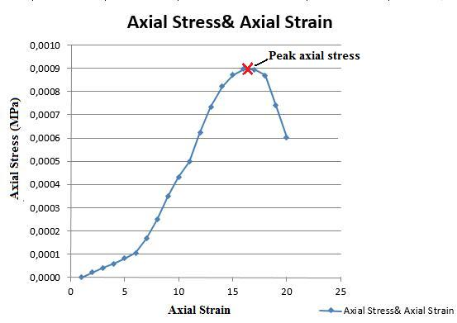

Figure.1- The graph of the axial stress and axial strain

Maximum point on stress vs. strain graph is the peak axial stress value,

Peak axial stress, qu = 0,0009 MPa (found by the help of graph)

Undrained shear strength, cu= qu/2= 0.00045 MPa

Tangent modulus is E0 = (0.0000225-0) / (0.0010-0.0000) = 0.0225 MPa

Secant modulus is E50 = (0,00045 -0) / (0.0140-0,0000) = 0.03214 MPa

# 8. Discussion of Results

In this laboratory session, it is endeavoured to investigate the unconfined compressive strength of a soil sample by the guidance of assistant Yağızer Yalçın. First of all, it is feasible to mention about information that are given during the lab session.

* In order to minimize the friction between apparatus and the soil sample, vaseline is used.
* Undrained conditions are considered in this test, so **φ = 0o**
* Confining pressure is zero; therefore, when the Mohr circle is drawn, one should start drawing at zero value.
* The most important thing in this laboratory is that H0/D0 =2 or 3. If it is not, then it can result in end effects. If the sample is too short there will be significant end effects. End effects are caused by the top and bottom loading plates that grip the sample. They can increase the strength of a soil sample by preventing the formation of the weakest failure plane. If the sample is too long, we find that it tends to buckle. A length-to-width ratio of two to three is recommended to avoid this problem.

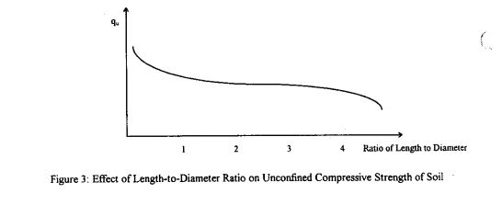

Figure.2- Effect of Length-to-Diameter Ratio on Unconfined Compressive Strength of Soil

* As additional information, the soil is not confined during shear but will be confined in the field if the soil is located at a depth of a few feet or more. The problem is most severe with fissured soils (soils that contain cracks). In the ground, the cracks are held closed by the confining pressure due to the weight of soil above it. The soil is much stronger in this state than it is with no confining pressure in an unconfined compression test.
* The soil may be unrepresentative because it is not the same as, or perhaps even similar to. The bulk of the soil found in the ground the sample can also be unrepresentative if it has been disturbed or changed from its original slate. A common cause for disturbance is the soil sampling process. Disturbance usually has the effect of lowering the strength of the soil and reducing the slope of the stress-strain curve

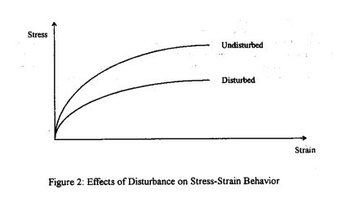

Figure.3- The effects of disturbance on Stress-Strain Behaviour

From the graph the peak value of compressive strength is 0.0009 MPa

Half of this value is the undrained shear strength: **Cu = 0.0009/ 2 = 0.00045 MPa, since φ = 0o**

* In order to find E0 value of the soil sample (modulus of the elasticity), take the slope of the initial part of the axial stress and axial strain graph. Then, necessary stress and strain values are taken and divided. (shown in calculation part)
* In order to find the E50, a line is drawn between zero and qu/2 values. Then, necessary stress and strain values are taken and divided. (shown in calculation part)
* Effect of deformed area plays a prominent role in this experiment because after some point it reduces the stress on the sample and enables soil to strength much more. In this test, the fractures are formed on diagonal axis and the shape swelled on diagonal direction which is drawn below.
* Effect of the water content also plays a prominent role because if the water content is large it reduces the shear strength of the soil sample, and the relationship between water content and the shear strength of the soil is drawn below.
* Because of the observer mistakes, there may exist some errors. As it is mentioned earlier that soil sample may not be represent actual behaviour of this type of soils. Moreover, there may be some calibration errors in the apparatus. Because of the friction that cannot be reduced by using vaseline, surface area of the soil sample may be disturbed. Most importantly, soil may not be an undisturbed sample and contain much more water content. The effect of these two parameters is discussed before. All in all, behaviour of soil is observed under these conditions.

# Conclusion

In the light of this experiment, determination of unconfined compressive strength of a soil sample is done. Effect of water content and deformed area is discussed. Test equipment, and how to do this test is comprehended.