**Table of Contents**

**1)****Purpose of the Test ..............................................2**

**2)****Equipment ............................................................2**

**3)****General Rules.............................................****..........2**

**4) Calibration** **and Preparation...............................2**

**5) Specimen Preparation** **.........................................2**

**6)****Setup Assembly.....................................................3**

**7) Shearing.................................................................3**

**8) Calculations...........................................................3**

**9) Reporting of Results..............................................6**

**CE 363 / 364 – SOIL MECHANICS**

***Laboratory Session 11 – Unconsolidated Undrained Triaxial Test***

# Purpose of the test

* Obtain undrained stress-strain-strength behavior of a cohesive soil.
* Familiarize with a triaxial setup. UU is the simplest triaxial test, therefore many components of the setup are not used/connected. In order for the students to understand which parts of the setup are active in this test, all students are required to draw a schematic diagram of the setup showing only the active components.

# Equipment

* These items must match the specimen diameter: 4 o-rings, o-ring stretcher, o-ring grease, 2 impermeable end plates, one thick triaxial membrane, membrane stretcher.
* Triaxial cell.
* Measurement devices: Axial load, axial displacement, cell pressure.
* Control devices: cell pressure controller, loading frame.
* Water reservoir.
* Plumbing with junctions and valves, to connect all components associated to cell water to each other.

# General Rules

* Note that there are many unused components in this setup. Pay attention not to get confused.
* DO NOT pay attention to the software operation, as it can vary from setup to setup.
* The procedures here will be given in terms of “which components to connect” rather than “which valve to turn”, as the latter varies a lot between different setups.
* This test has o-ring seals. The solid surfaces contacting o-rings must be clean, flat; free of particles, hair, dents, scratches. The o-rings must be flexible and without cracks. Rings must be greased before placement. If o-rings are placed on a membrane, the membrane must be free of wrinkles under the o-ring seal.

# Calibration and Preparation

1. Piston friction and weight will be ignored in this lab session. (In a more precise test, they must be determined by taking force measurements while the piston is going into and out of the cell. This can be done on a lab scale.)
2. Membrane stiffness will be ignored. (In a more precise test, the membrane takes a portion of axial and radial stress, as a function of axial strain, based on the thickness, perimeter and Young’s Modulus of rubber membrane.)
3. The membrane must be about 6 cm longer than the specimen. If it is not, cut it to desired length.
4. Visually inspect o-rings for cracks.
5. In a UU test, the pores of the specimen will be sealed. Therefore all valves on the base shall remain closed, except one that connects to the cell. Connect this valve to the pipe junction on the wall, so that you can connect it to either the water reservoir or the cell pressure controller as necessary.

# Specimen Preparation

The specimen in this lab session is reconstituted by static compaction, and is ready for your use. Undisturbed specimens are either cut with a cutting ring (for stiff specimens, use like a mini Shelby tube), or trimmed in a vertical lathe with a wiresaw (for soft specimens, similar to trimming döner kebab).

* Measure the height (at 2-3 locations) and diameter (at mid-level in two orientations) of the specimen with calipers.
* Weigh the specimen.

# Setup Assembly

1. Place an end plate on the pedestal.
2. Place the specimen on the end plate.
3. Place top end plate on the specimen, in the side drain.
4. Grease the lateral surfaces of the pedestal and top cap.
5. Place the membrane in the membrane stretcher, fold out its ends.
6. While sucking the membrane stretcher’s tube, place it around the specimen.
7. Unfold both ends of the membrane from the stretcher. Remove the membrane stretcher.
8. Place 4 greased o-rings on the o-ring stretcher. Place the stretcher around the specimen.
9. Fold the top of the membrane onto itself.
10. Place the top cap on the top plate.
11. Unfold the membrane onto the top cap.
12. Place two o-rings on the membrane around the pedestal and two on the top cap.
13. Move the o-ring stretcher up along the top drainage pipe and remove it.
14. Make sure the o-ring on the base and its sealing surfaces are clean. Grease the o-ring.
15. Place the top parts of the triaxial cell (jar, piston, etc.), with care not to impact the specimen or the top drainage line.
16. Bring the piston to the verge of contact with the top cap.
17. Attach assemblies of load and displacement measurement.
18. Fill the cell with water by connecting it to the water reservoir. The air vent at the top of the cell must be open. When full, close the air vent.
19. Use the load frame control to bring the piston in contact with the top cap by watching for changes in measured load.
20. Take/set zero readings from load and displacement measurement devices.
21. Disconnect the water reservoir and connect the pressure controller to the cell.

**7. Shearing**

1. Apply cell pressure.
2. Set axial strain rate to 0.5% to 2% per minute.
3. Start load frame motor; let the computer record deviator load and axial displacement.
4. Continue shearing until passing the peak axial stress by a few % axial strain.

5- After failure, disassemble the cell and retrieve the specimen (all of it).

6- Ovendry the specimen to measure its dry mass.

**8. Calculations**

Initial height → H0 = 100 mm

Initial diameter → D0 = 50 mm

Original Area → A0 = (π *D02/4) =( π *50²/4) =1963.5 mm2

The shape and the volume of the specimen will be conserved, in other words we expect a cylinder as deformed shape.

Corrected Area → Af = A0 / (1- ϵ)

Axial Strain → ϵ **=** Axial displacement / Initial height of specimen

Cell pressure (All around pressure) → σ3 = 100 kPa

Deviator Stress (Principal stress difference) → σ1 – σ3 = Load **/** Corrected Area

|  |  |  |  |  |  |  |  |
| --- | --- | --- | --- | --- | --- | --- | --- |
| **Recorded Data** | | | | | **Calculated Data** | | |
| **No** | **Deflection (mm)** | **Load (N)** | **Calibrated defl.(mm)** | **Calibrated Load (N)** | **Strain ϵ** | **Corrected Area (mm)** | **Deviator Stress (kPa)** |
| 1 | 2,27 | -8 | 0 | 0 | 0 | 1963,5 | 0 |
| 2 | 2,57 | 15 | 0,3 | 23 | 0,003 | 1969,408225 | 11,67863509 |
| 3 | 2,87 | 112 | 0,6 | 120 | 0,006 | 1975,352113 | 60,7486631 |
| 4 | 3,18 | 170 | 0,91 | 178 | 0,0091 | 1981,531941 | 89,82948816 |
| 5 | 3,48 | 212 | 1,21 | 220 | 0,0121 | 1987,549347 | 110,6890756 |
| 6 | 3,79 | 251 | 1,52 | 259 | 0,0152 | 1993,805849 | 129,9023173 |
| 7 | 4,09 | 278 | 1,82 | 286 | 0,0182 | 1999,898146 | 143,0072829 |
| 8 | 4,39 | 301 | 2,12 | 309 | 0,0212 | 2006,027789 | 154,0357525 |
| 9 | 4,69 | 317 | 2,42 | 325 | 0,0242 | 2012,195122 | 161,5151515 |
| 10 | 5 | 332 | 2,73 | 340 | 0,0273 | 2018,607998 | 168,4329004 |
| 11 | 5,3 | 344 | 3,03 | 352 | 0,0303 | 2024,853047 | 173,8397759 |
| 12 | 5,6 | 351 | 3,33 | 359 | 0,0333 | 2031,136857 | 176,7483066 |
| 13 | 5,91 | 363 | 3,64 | 371 | 0,0364 | 2037,671233 | 182,0705882 |
| 14 | 6,21 | 371 | 3,94 | 379 | 0,0394 | 2044,034978 | 185,4175707 |
| 15 | 6,51 | 382 | 4,24 | 390 | 0,0424 | 2050,438596 | 190,2032086 |
| 16 | 6,81 | 390 | 4,54 | 398 | 0,0454 | 2056,882464 | 193,496715 |
| 17 | 7,11 | 398 | 4,84 | 406 | 0,0484 | 2063,366961 | 196,7657754 |
| 18 | 7,42 | 409 | 5,15 | 417 | 0,0515 | 2070,110701 | 201,4385027 |
| 19 | 7,72 | 417 | 5,45 | 425 | 0,0545 | 2076,679006 | 204,6536797 |
| 20 | 8,02 | 421 | 5,75 | 429 | 0,0575 | 2083,289125 | 205,9243697 |
| 21 | 8,33 | 433 | 6,06 | 441 | 0,0606 | 2090,163934 | 210,9882353 |
| 22 | 8,63 | 436 | 6,36 | 444 | 0,0636 | 2096,860316 | 211,745149 |
| 23 | 8,93 | 440 | 6,66 | 448 | 0,0666 | 2103,599743 | 212,9682709 |
| 24 | 9,23 | 448 | 6,96 | 456 | 0,0696 | 2110,382631 | 216,0745607 |
| 25 | 9,53 | 452 | 7,26 | 460 | 0,0726 | 2117,209403 | 217,267125 |
| 26 | 9,84 | 460 | 7,57 | 468 | 0,0757 | 2124,310289 | 220,3067991 |
| 27 | 10,14 | 463 | 7,87 | 471 | 0,0787 | 2131,227613 | 220,9993888 |
| 28 | 10,44 | 471 | 8,17 | 479 | 0,0817 | 2138,190134 | 224,0212376 |
| 29 | 10,75 | 471 | 8,48 | 479 | 0,0848 | 2145,432692 | 223,264986 |
| 30 | 11,05 | 471 | 8,78 | 479 | 0,0878 | 2152,488489 | 222,5331296 |
| 31 | 11,35 | 479 | 9,08 | 487 | 0,0908 | 2159,590849 | 225,5056786 |
| 32 | 11,65 | 483 | 9,38 | 491 | 0,0938 | 2166,740234 | 226,6076903 |
| 33 | 11,95 | 483 | 9,68 | 491 | 0,0968 | 2173,937112 | 225,8574994 |
| 34 | 12,26 | 487 | 9,99 | 495 | 0,0999 | 2181,424286 | 226,9159664 |
| 35 | 12,56 | 491 | 10,29 | 499 | 0,1029 | 2188,719206 | 227,9872167 |
| 36 | 12,86 | 491 | 10,59 | 499 | 0,1059 | 2196,06308 | 227,2248026 |
| 37 | 12,89 | 483 | 10,62 | 491 | 0,1062 | 2196,800179 | 223,5069009 |

# Table.1- All recorded and measured datas of the experiment

To calibrate deflection datas, I subtract 2.27 mm from all deflection values. To calibrate load datas, I add 8 N to all load values.(The reason of making this calibrations, we want to these datas start exactly from zero.)

Max. deviator stress = (σ1 – σ3)max = 227.9872 kPa. This value can be read from the this graph.

(σ1 – σ3) + σ3 = σ1 = 327.9872 kPa.

*The calculation of No.3:*

Strain, 𝜀 = ΔH/H0= 0.6/100= 0.006

Corrected Area = 𝐴0/(1−𝜀) = p/4*502/(1−0.006)= 1975.352113 mm2

Deviator Stress =Calibrated Load/Corrected Area=120 N /1975.352113 mm² = 0.060749MPa

= 60.748663 kPa

Peak axial stress, qu = 327.9872 kPa (found by the help of graph)

Undrained shear strength, cu= qu/2= 163.9936 kPa

Tangent modulus is E0 = (11.67863509-0) / (0.003-0.0000) = 3892.878363 kPa

Secant modulus is E50 = (163.9936 - 0) / (0.0253-0.0000) = 6481.960474 kPa

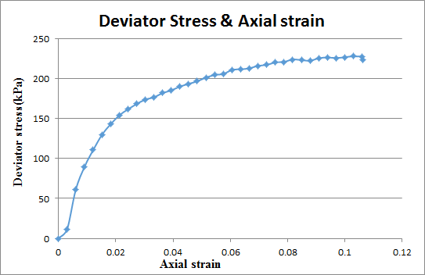

**Graph.1-**Deviator Stress-Axial Strain graph

If the test is performed under the cell pressure, σ3 = 200 kPa, the deviator stress will be same but σ1 will be larger than the previous one.

Max. deviator stress = (σ1 – σ3)max = 227.9872 kPa , σ3 = 200 kPa

(σ1 – σ3) + σ3 = σ1 = 227.9872 +200 = 427.9872 kPa

→ And also the curve on Mohr circle will move towards right by increasing of σ3.

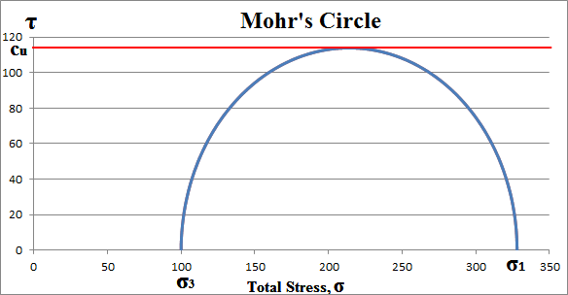

**Graph.2-**The Mohr's Circle of Ankara clay

**9. Discussion of results**

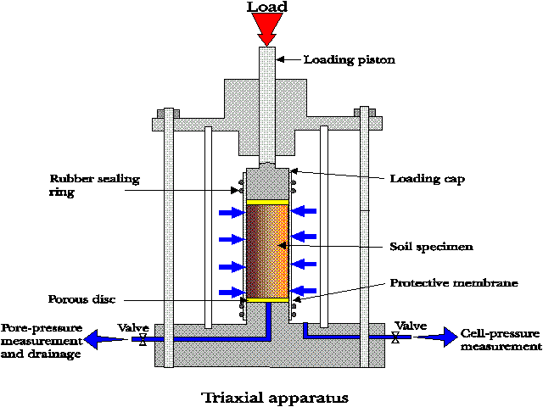

**Figure.1-** The sketch of unconsolitated undrained triaxial test

* + - * Consolidation is the gradual reduction in volume of voids of a fully saturated soil of low permeability due to drainage of pore water.
      * Triaxial test is the shear strength test that can be done in the laboratory. Depending on drainage conditions in stage I and II (concolidation and shearing stages), it has three types of it:

-Consolidated Drained Triaxial Test

-Consolidated Undrained Triaxial Test

-Unconsolidated Undrained Triaxial Test

* + - * In our lab, we did Unconsolidated Undrained Triaxial Test because it take less time compared to others.
      * Triaxial tests can be done on all types of soils.Cohesive soils (clay) take undisturbed sample from field but for cohesionless soils,undisturbed sample is not possible,prepare same density in the field.
      * Our specimen that tested in the lab is Ankara clay. So we can show clay’s behaviour.
      * At the Mohr’s Circle of Ankara clay, the deviator stress will remain same. The reason of that the drainage line is close in consolidation stage. Then, internal friction angle equal zero (Ø=0). The

C value is Cu(clay)= 327.9872 /2=163.9936 kPa