**Table of Contents**

**1)****Purpose of the Test.................................................2**

**2)****Equipment...............................................................2**

**3)****General Rules..........................................................2**

**4) Calibration...............................................................2**

**5) Specimen..................................................................2**

**6) Test** **Procedure........................................................**.**3**

**7)****Calculations..............................................................3**

**8)** **Discussion of Results&Conclusion.........................5**

**9) What We Did During Experiment..****.......................****.7**

**CE 363 / 364 – SOIL MECHANICS**

***Laboratory Session 12 –– Direct Shear Test***

# Purpose of the test

Obtain strength-deformation characteristics of a dry sand at a specified density.

# Equipment

* Direct shear box with two separator bolts and two restraining bolts.
* Top cap (a steel ball is placed on top of the cap in many setups, but here we do not need it)
* Porous stones and ribbed plates
* Direct shear load frame with lever arm and weights
* Shear load measurement device (proving ring)
* Horizontal and vertical displacement measurement devices (dial gages)
* Vernier calipers
* Gauging disc (or block for square specimens).
* Dish, spoon, spatula.

# General Rules

* The specimen in this test is cohesionless. Cohesionless soils change density, and therefore mechanical properties, when subject to vibrations. Therefore, avoid bumping the table during preparation, shaking the shear box during assembly, or bumping the setup during the test.
* It is important that your preparation procedure is repeatable, and you do not vibrate the specimen in any of the steps after specimen constitution.

# Calibration

1. Note the mechanical advantage of the loading arm. This is usually 10, and is given by the manufacturer. But if necessary, it can be calculated by determining the dimensions of the loading arm and taking the ratio of the moment arms of applied load and normal stress on the specimen.
2. Notice the load transmitted by the lever arm to the specimen is not zero when there is no load. Weigh the individual components that will rest on the specimen (i.e. top cap, porous stone, top half of the shear box) to figure out the zero load. (If the loading arm itself is not balanced, a balancing load can be figured out by applying external weights on one side.) For our equipment, the arm is balanced, so zero load on the lever arm corresponds to the total weight of components on the specimen (about 1.5 kg).
3. Note which bolts restrain relative movement of the two halves of the shear box, and which bolts separate the two halves from each other.
4. Determine how many turns of the separator bolts make a gap equal to the maximum grain diameter. This can be done by measuring the thread width on the bolts. The bolts of our setup have 0.8 mm threads.
5. Adjust the separator bolts such that they barely touch the bottom half. Fix the two halves to each other by the restraining bolts.
6. Measure inner diameter or width of the box. 7- Place the lower porous stone into the box.

8- Place the ribbed plate into the box, with ribs facing up and perpendicular to shearing. 9- Measure the depth of the shear box from its top to the ribbed plate.

10- Measure the height of the small diameter (or width) portion of the gauging disc (or block). 11- Calculate specimen volume from the measurements in steps 6, 9 and 10 above.

# Specimen

1. Constitute the specimen in the shear box. This process may vary depending on soil type and desired density.
   1. Calculate the mass of sample material to be placed in the shear box, from volume of the shear box and the desired density.
   2. Weigh a batch of soil such that it has exactly the required mass.
   3. Place the required mass of soil into the box (without spilling any soil outside the box).
   4. Smoothen the soil surface by fingers or a spatula.
   5. Compact the soil to desired density by pressing and rotating the gauging disc on it. 2- Place the ribbed plate with ribs facing down and perpendicular to shearing
2. Place the top porous stone.
3. Place the top cap (and the steel ball for many other setups).
4. Place and connect the shear box into the frame with minimal vibration. 6- Remove the restraining bolts.

7- Create a gap between two halves of the shear box, equal to the maximum grain size, by rotating the separator bolts by the amount determined in calibration step 4.

# Test Procedure

1. Affix the measurement devices to the shear box.
2. Take zero readings of the displacement measurement devices.
3. Calculate the normal force you must add (based on calibration step 2) to achieve desired normal stress.
4. Apply the vertical load. The loading lever must remain horizontal – if it does not, adjust by rotating the loading screw.
5. Record vertical settlement. 6- Loosen the separator bolts.
6. Adjust the motor to shear the specimen at about 0.7 mm/min.
7. Start shearing, read the shear force at every 0.1 mm displacement at the beginning. You can widen the interval once the test passes the point of peak shear force. Also record the elapsed time every 5-10 readings, in order to verify the rate of shear displacement.
8. Stop beyond the observation of peak shear force, or at 3mm shear displacement.
9. Repeat steps 2 to 9 at twice the vertical load. (In a real test, a new specimen is prepared and the test is restarted at each normal load. But in this lab session, due to time constraints, the same specimen will be used, and shearing will continue from the final shear deformation reading of the first loading.)

# Calculations

|  |  |  |  |
| --- | --- | --- | --- |
| Normal Loads | P1,P2 | 11.5 22.5 | kg |
| Internal Diameter | D | 63.5 | mm |
| Initial Area of Specimen | A0 | 3166.922 | mm2 |
| Depth to the top of the lower porous stone | d | 33.08 | mm |
| Thickness of gauging disc | t | 14.30 | mm |
| Initial Thickness of specimen | T=d-t | 18.78 | mm |
| Mass of specimen | M | 101.4 | gr |
| Density of specimen | p | 1.705 | gr/cm3 |
| Proving ring constant | Cp | 0.107 | kg/div |

Table.1- Data obtained in the laboratory and the calculated values are bolted in the table.

* The initial area of the specimen is

A0 = pi*(63.5)^2/4 =3166.922 mm2

* In order to calculate the density

ρ = M/V = 101.4*1000 / (3166.922 *18.78) =1.705 g/cm3

*For the third row:*

u*=20

u=0.01*(u*) =0.01*20=0.2 mm

v=0.01*(v*) =0.01*(-11)= -0.11 mm

Applied Load=0.107*(δ*)*g =0.107*39*9.81=40.93713 N



Figure.1-Shear area for circular box, D is specimen diameter and u is the shear displacement

-The corrected area is calculated from the formulation given in Figure.1.

A=(63.5^2/2)*(ACOS(0.2/63.5)-(0.2*SQRT(63.5^2-0.2^2))/(63.5^2))= 3154.221765 mm2

All corrected areas are calculated and they are tabulated in Table.1 and Table.2.

-In order to find shear stress

τ = ( Cp*δ ) / A

τ3=(0.107 * 39*9.81)/ 3154.221765 = 12.97851992 *10^-3 MPa= 12.97851992 kPa

The maximum normal stress is that cause failure on specimen. When the failure is happened, the shear stress will be maximum at the peak point of the failure plane. Then by the corrected area of that shear stress we can calculate the normal stress for each loading:

- For the 1st loading= 11.5*9.81=112.815 N

τmax=32.32253893 kPa and Ϭmax= 112.815 / 3071.681= 0.03672745*10^-3MPa=36.72745 kPa

- For the 2nd loading= 22.5*9.81=220.725 N

τmax=61.20650989 kPa and Ϭmax = 220.725 / 3033.596= 0.07276018*10^-3MPa=72.76018 kPa



|  |  |  |  |  |  |  |  |
| --- | --- | --- | --- | --- | --- | --- | --- |
| **First Loading** | | | | | | | |
| Shear Displacement u* | u mm | Vertical Deflection v* | v mm | Proving ring deflection δ* | Applied Load (N) | Corrected Area, A (mm²) | Shear Stress (kPa) |
|
| 0 | 0 | -10 | -0,1 | 0 | 0 | 3166,922 | 0 |
| 10 | 0,1 | -11 | -0,11 | 29 | 30,44043 | 3160,572 | 9,631304851 |
| 20 | 0,2 | -11 | -0,11 | 39 | 40,93713 | 3154,222 | 12,97851992 |
| 30 | 0,3 | -11 | -0,11 | 44,5 | 46,71032 | 3147,872 | 14,83869666 |
| 40 | 0,4 | -11 | -0,11 | 50 | 52,4835 | 3141,522 | 16,7063931 |
| 50 | 0,5 | -10 | -0,1 | 59 | 61,93053 | 3135,172 | 19,7534708 |
| 70 | 0,7 | -9 | -0,09 | 73 | 76,62591 | 3122,473 | 24,54013813 |
| 90 | 0,9 | -6 | -0,06 | 82 | 86,07294 | 3109,774 | 27,67820088 |
| 110 | 1,1 | -2 | -0,02 | 87 | 91,32129 | 3097,075 | 29,48630013 |
| 130 | 1,3 | 1 | 0,01 | 91,5 | 96,04481 | 3084,378 | 31,13912115 |
| 150 | 1,5 | 4 | 0,04 | 93,5 | 98,14415 | 3071,681 | 31,95128585 |
| 180 | 1,8 | 8 | 0,08 | 94 | 98,66898 | 3052,637 | 32,32253893 |
| 210 | 2,1 | 13 | 0,13 | 92 | 96,56964 | 3033,596 | 31,83338791 |
| 240 | 2,4 | 20 | 0,2 | 90 | 94,4703 | 3014,558 | 31,33802663 |
| 270 | 2,7 | 24 | 0,24 | 86 | 90,27162 | 2995,523 | 30,13550801 |
| 300 | 3 | 29 | 0,29 | 85,5 | 89,74679 | 2976,493 | 30,15185859 |

**Table.1-**Measured and calculated values of the first loading

|  |  |  |  |  |  |  |  |
| --- | --- | --- | --- | --- | --- | --- | --- |
| **Second Loading** | | | | | | | |
| Shear Displacement u* | u mm | Vertical Deflection v* | v mm | Proving ring deflection δ* | Applied Load (N) | Corrected Area, A (mm²) | Shear Stress (kPa) |
|
| 0 | 0 | -16 | -0,16 | 0 | 0 | 3166,922 | 0 |
| 10 | 0,1 | -18 | -0,18 | 52 | 54,58284 | 3160,572 | 17,26992594 |
| 20 | 0,2 | -19 | -0,19 | 85 | 89,22195 | 3154,222 | 28,28651776 |
| 30 | 0,3 | -20 | -0,2 | 102 | 107,0663 | 3147,872 | 34,01229347 |
| 40 | 0,4 | -20 | -0,2 | 115 | 120,7121 | 3141,522 | 38,42470413 |
| 50 | 0,5 | -20 | -0,2 | 127 | 133,3081 | 3135,172 | 42,52018292 |
| 70 | 0,7 | -19 | -0,19 | 143 | 150,1028 | 3122,473 | 48,07177743 |
| 90 | 0,9 | -18 | -0,18 | 156 | 163,7485 | 3109,774 | 52,65608948 |
| 110 | 1,1 | -16 | -0,16 | 165 | 173,1956 | 3097,075 | 55,92229336 |
| 130 | 1,3 | -14 | -0,14 | 171 | 179,4936 | 3084,378 | 58,19442314 |
| 150 | 1,5 | -10 | -0,1 | 175 | 183,6923 | 3071,681 | 59,80187191 |
| 180 | 1,8 | -6 | -0,06 | 178 | 186,8413 | 3052,637 | 61,20650989 |
| 210 | 2,1 | -2 | -0,02 | 172 | 180,5432 | 3033,596 | 59,51459479 |
| 240 | 2,4 | 2 | 0,02 | 167 | 175,2949 | 3014,558 | 58,14944942 |
| 270 | 2,7 | 5 | 0,05 | 163 | 171,0962 | 2995,523 | 57,11730006 |
| 300 | 3 | 9 | 0,09 | 161 | 168,9969 | 2976,493 | 56,77718401 |

**Table.2-**Measured and calculated values of the second loading

# Discussion of Results &Conclusion

The graphs are shown below. All sample calculations are shown in the calculation part. Because of the calibration of the equipment, some errors exist in this experiment. Moreover, sand may not be as clean as it is mentioned. While reading the datas, observer may make some mistakes. If one touch the machine or the table on which the machine stand, it could vibrate the machine and disturb its calibration.

This test is normally should be done at least three times, but owing to time constraints it is done once just to investigate the process.

It is observed and plotted that if the horizontal load is constant, it can be comprehended that the material is failed.

During the test, the surface area of the specimen is changed; therefore, in each step, corrected area is calculated.

With the guidance of Berkan Söylemez, the purpose of the direct shear test is comprehended. At least, all students are now familiar with this device and test. Shear strength of the cohesionless soils are understood.

The students are supposed to find the shear displacement & shear stress graph, normal stress & shear stress graph, shear displacement & vertical displacement graphs. All of them are given below:

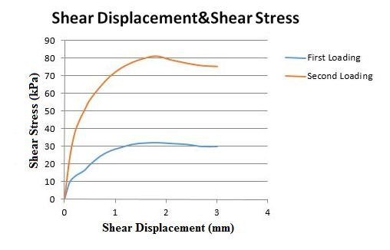

Graph.1- Shear displacement & Shear stress graph

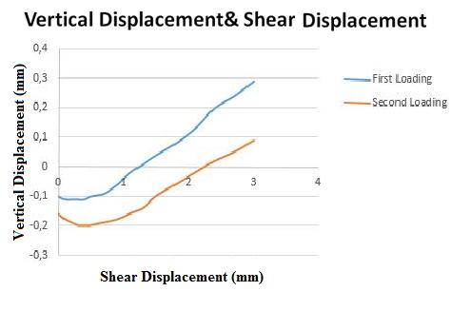

**Graph.2-** Vertical displacement vs. Shear displacement graph

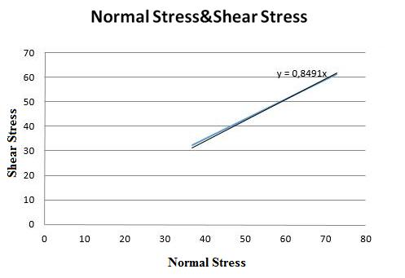

**Graph.3-** Normal Stress vs. Shear Stress

According to the graph,the trend line that intercepts at the origin (since c’=0 for sands) has a tangent of 0.8491.

y=0.8491x

τ= tanΦ’ Ϭ+ c’ (c’=0)

So Φ’= arctan(0.8491)=40.335 **°**

1. **What We Did During Experiment**

In this experiment it was tried to obtain the strength-deformation characteristics of dry sand at a specified density. The setup of the experiment like this: First, porous stone and a filter paper is placed on the bottom of the shear box. Then the sample can be drained easily. Henceforth, dry sand is put on the shear box and it is balanced by the help of two bolts. After balance, a ribbed plate is put on the sample to measure shear stress.

After putting the shear box in direct shear load frame we can measure the data. By using datas, we can calculate the vertical deformation and shear deformation. Next with the corrected area, we can calculate shear stresses of the sample for related loading. At the peak point, the sample will be failed and its shear stress values gradually decrease. When it is reached maximum shear stress, it will also reach the maximum normal stress. Again by corrected area and load, we can calculate the maximum normal stress. Drawing the graph of maximum shear stressvs. normal stress, we can obtain information about the Mohr’ Coulomb strength failure envelope. Because of the sample is dry sand, the cohesion coefficient must be zero on this envelope equation (τ= c’ + tanΦ’ Ϭ).Then, we can easily find the angle of failure, Φ, by this equation.