**Table of Contents**

**1)** **Purpose of the Test................................................2**

**2)** **Equipment..............................................................2**

**3)** **General Rules.........................................................2**

* **Thermal Equilibrium**
* **Vacuum Operation**
* **Procedure Modification**

**4)** **Specimen..................................................................3**

**5)** **Procedure................................................................3**

**6)** **Calculations.............................................................4**

**7)** **Reporting Results....................................................5**

**8)** **Conclusion................................................................5**

**CE 363 – SOIL MECHANICS**

***Laboratory Session 2 – Determination of Specific Gravity of Solids***

# **1) Purpose of the Test**

To determine the specific gravity of the soil particles of medium-and coarse-grained soils at 20oC.

# **2) Equipment**

* Pycnometer (or iodine flask) (in this test, “bottle” refers to this piece of equipment)
* digital scale (0.001g resolution)
* distilled deaired water
* Vacuum pump and setup to apply vacuum to pycnometer (vacuum jar, tubing, water trap etc.) squirt bottle
* thermometer (preferably digital, 0.1oC resolution)
* thermally insulated container large enough to contain pycnometer, thermometer, squirt bottle (this will be omitted in the lab session, as it is necessary only for the thermal equilibration, which will be skipped)

# **3) General Rules**

## **Thermal Equilibrium**

Because of the time limitation, steps of equilibration are skipped in this experiment. However, methods of achieving thermal equilibrium are given below;

* If the objects which are equilibrated are at different temperature, they should be waited in a thermally insulated container overnight.
* If the objects are already in the thermal container, 3 hours will be sufficient to achieve equilibration
* The surface should be a good insulator such as Styrofoam, wood if one wishes to do easier operation outside of the insulated container.
* Water should be distilled
* Oven mitts and tongs should be used to hold the bottle by hand.

## **Vacuum Operation**

· Connection of the vacuum pump should be firstly opened to the atmosphere before turning the pump off.

· In order to avoid imploding bottle or sucking water into the vacuum pump, do not attempt to connect the pump to the mouth of the bottle. Instead, place the bottles into a vacuum jar that will enable to prevent direct connection of the pump and the bottle.

## **Procedure Modification**

It would be more efficient if this test was done with one bottle, and the test procedure and the calibration steps are repeated three times, with different time durations. However, because of the time constraints, this test is done by using two bottles simultaneously in this lab session.

## **4) Specimen**

About 60 grams of coarse grained soil which is oven-dry specimen is used per bottle, and the dry masses of soils are measured.

## **5) Procedure**

· Transfer soil into the bottles

· Fill the 2/3 of the bottles by distilled water

· Vacuum the bottles for 1 hour; however it is feasible to vacuum the bottles in this lab session a few minutes owing to time limitation.

· In order to avoid mixing air with the slurry, add water to the bottles extremely slowly

· As mentioned in thermal equilibrium part, equilibrate the bottles. Nevertheless, skip this part due to time constraints.

· Dry the excess water outside the bottle properly

· Measure the temperature in the bottle

· Calculate the volume of the bottle for each measurement

· By using Figure-1, density of water which is changing with temperature can be shown.

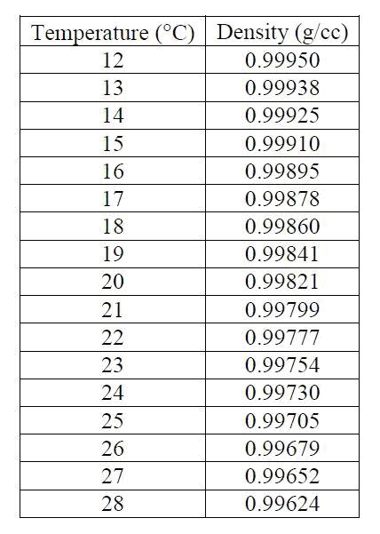

**Figure.1:** Density of pure water with respect to different temperatures

* In this lab session, only one temperature value is measured and all datas are obtained at 21o C. After that, specific gravity of soil at 20o C is calculated by using the formulation shown in Figure-2.

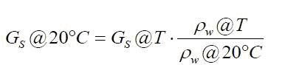

**Figure.2:** Formulation to convert the GS  value of the soil at 21o C to 20o C.

# **6) Calculations**

GS@T= MS / (Mb+w + Ms-Mb+w+s)

Specific gravity of solids at 21o C is calculated according the above formula, and all results are given in the data sheet at my last page:

**For the bottle which its number is 2:**

While T= 21o C,

Mb= 72.75 MS= Mb+s -Mb=132.75-72.75= 60.00

Mb+s= 132.75 Mb+w + Ms- Mb+w+s  = 322.43+60.00-359.95= 22.48

Mb+w= 322.43 GS@T= MS / (Mb+w + Ms-Mb+w+s)= 60.00/22.48= 2.669

Mb+w+s= 359.95 GS1= 2.669 at T= 21o C

Specific gravity of soil (GS1) is equal to **2.669.**

**For the bottle which its number is 5:**

While T= 21o C,

Mb= 70.52 MS= Mb+s -Mb=131.91-70.52= 61.39

Mb+s= 131.91 Mb+w + Ms- Mb+w+s  = 319.97+61.39-357.92= 23.44

Mb+w= 319.97 GS@T= MS / (Mb+w + Ms-Mb+w+s)= 61.39 /23.44= 2.619

Mb+w+s= 357.92 GS2= 2.619 at T= 21o C

Specific gravity of soil (GS2) is equal to **2.619.**

Error limit part is omitted in this lab session because of the skipped parts.

# **7) Reporting Results**

By using formula which given Figure.2 , we calculate the specific gravity of solids at 20o C:

GS@20o C= 2.669*(0.99799/0.99821)=2.668

GS1=2.668 (at 20o C)

GS@20o C= 2.619*(0.99799/0.99821)=2.618

GS2=2.618 (at 20o C)

The purpose of the experiment is to calculate the specific gravity of soil at 20o C. Thus, it is convenient to use the GS values at 20o C. That is; GS1=2.668 (at 20o C) and GS2=2.618 (at 20o C).

Mean value of GS= (GS1 (at 20o C) + GS2 (at 20o C) ) / 2

= (2.668+2.618) /2 = 2.643

And by using Excel , I found standard deviation of these values:

**Standard Deviation= + 0.025**

**8) Conclusion**

In the test of determination of specific gravity, measurement of GS value of a soil sample was done. However, because of the skipped parts such as equilibration and short time application of vacuum (a few minutes) affected considerably results of the experiment. For example, while drying the bottles, one may not be able to dry the bottles properly and it could result in weightier bottles. Additionally, one may not pour water slowly which causes air bubbles in the prepared sample. Due to the given reasons, there is a standard deviation which is 5 %. All in all, how to calculate the specific gravity of a coarse-grained and medium size soil was comprehended in the light of this experiment.

# 