**Table of Contents**

**1)** **Purpose of the Test..................................2**

**2)** **Equipment................................................2**

**3)** **Sample Preparation.................................2**

**4)** **Procedure.................................................3**

**5)** **Calculations..............................................4**

**6)** **Reporting Results....................................5**

**7)** **Conclusion................................................****5**

**CE 363 – SOIL MECHANICS**

***Laboratory Session 6– Standard Proctor CompactionTest***

# **1) Purpose of the Test**

To be able to determine the optimum water content at which a well-graded soil can be compacted efficiently.

**2) Equipment**

* Proctor compaction equipment (mold, base, collar, standard proctor hammer)
* caliper
* digital scales (10 kg capacity, and another with 500 g capacity)
* spatula, scoop or trowel
* straight edge
* water content tares, oven

**3) Sample Preparation**

· Compaction test is done in 3 days in normal conditions. Because of time constraints it takes only 30 minutes in this lab session.

· In this test, diameter of the soil particles should not exceed 9.5 mm (3/8” sieve).

- If needed, remove the particles those are larger than 9.5 mm by sieve or spread the soil in a tray.

- If more than 5 % of the soil is removed in this application, oversize correction must be performed.

- Find out the initial water content & GS values of the coarse particles alone

- If more than 20% of the soil is larger than 9.5 mm, instead of 3x25 blows in a 4” mold, this material should be compacted by 5x56 blows in a 6” mold, which allows particles up to 19mm.

· In this lab session, soil is already air-dried. It is assumed that 5%-20% of the particles left above the sieve.

· Because of the time limitation, obtaining 1 data should physically be done, and the remaining 4 data should be given by assistant.

· Water should be added to each portions with different amounts, and mixed well. After that, portions should be sealed and tempered overnight (it should be waited in an oven at the temperature of 105o-110o for 1 day). However, because of the time limitation, this step is neglected and portion is waited 2-3 minutes in microwave oven.

# **4) Procedure**

· Fill slightly more than half of the mold with moist sample.

· Fix the base of the mold by your own weight.

· 25 hammer blows should be delivered to the soil.

· There are three steps for this test.

- At first, 25 blows should be performed

- After that draw a line on the surface of the compacted soil by screw driver. There are two main reasons for that application. The first one is that when the second layer is placed on the first layer, this application enables testers to separate two layers of the soil. The second one is that the upper and lower surface densities of the first layer can be equated by means of this application.

- Do not apply hammer blows to the middle part of the soil because each time hammer blows touch the middle.

- Previous step should be repeated once more, to do so, fill the mold close to the top.

· When the collar is removed, if the mold is not completely filled with soil, if the top level of the soil is below the top level of the mold, it is not an acceptable test. Repeat all steps from the beginning and do again.

· If the soil level is above the mold (not too much), then excess soil should be removed by a straight-edge.(1 cm above from top is acceptable)

· Measure the weight of the mold, base and the soil.

· Detach the mold from the base.

· Determine the water content of the soil by taking a sample representative of the whole soil. In this lab session, assistant take sample both the upper and lower surface of the compacted soil and from the middle part of the soil volume.

# **5) Calculations**

· Calculation of water content and dry density of the each of the five data points are done and wrote at below:

· Calculation of water content & dry density of five samples is also shown below:

|  |  |  |  |  |  |  |
| --- | --- | --- | --- | --- | --- | --- |
| Mass of mold+base+ soil(M2) | g | 5679.0 | 5700 | 5820 | 5720 | 5660 |
| Mass of mold + base (M1) | g | 4205.5 | 4205.5 | 4205.5 | 4205.5 | 4205.5 |
| Mass of Compacted Soil (M2-M1) | g | 1473.5 | 1494.5 | 1614.5 | 1514.5 | 1454.5 |
| Bulk Density ρ =(M2-M1)/V | g/cm3 | 1.5578 | 1.5800 | 1.7069 | 1.6012 | 1.5377 |
| Dry Density pd=100ρ/(100+W(%)) | g/cm3 | 1.3590 | 1.3636 | 1.4044 | 1.2817 | 1.2175 |
| Corrected Dry Density (pd, corrected) | g/cm3 | 1.4563 | 1.4609 | 1.5010 | 1.3797 | 1.3154 |

**Table 1:** All density datas which are calculated

|  |  |  |  |  |  |  |
| --- | --- | --- | --- | --- | --- | --- |
| Container + wet sample | g | 35.60 | 37.0 | 38.5 | 40.3 | 41.8 |
| Container + dry sample | g | 33.45 | 34.5 | 35.0 | 36.0 | 37.0 |
| Mass of Container | g | 18.75 | 18.75 | 18.75 | 18.75 | 18.75 |
| Mass of Moisture | g | 2.15 | 2.5 | 3.5 | 4.3 | 4.8 |
| Dry Mass | g | 14.7 | 15.75 | 16.25 | 17.25 | 18.25 |
| Moisture Content (w) | % | 14.63 | 15.87 | 21.54 | 24.93 | 26.30 |
| Corrected Moisture Content (wcorrected) | % | 14.54 | 15.61 | 20.48 | 23.40 | 24.58 |

**Table 2:** All moisture content datas which are calculated

**For unit 1;**

Gs= 2.73 Height of the Mold= 11.65 cm

% coarser than 9.5 mm(C)=14 Diameter of the Mold= 10.17 cm

w(coarse)=14 Volume of the Mold=(pi*10.172 *11.65)/4

Gs (coarse)=2.65 = 945.88 cm3

M₂=5679.0 g

M₁=4205.5 g

M₂-M₁=5679.0-4205.5= 1473.5 g

ρ =(M2-M1)/V= 1473.5/945.88= 1.5578 g/cm3

pd=100ρ/(100+W(%))= (100*1.5578)/(100+14.63)= 1.3590 g/cm3

pd, corrected = (1.3590*2.65*0.981)/(1.3590*0.14+2.65*0.981*(1-0.14))

=1.4563 g/cm3

Container + wet sample= 35.60 g

Container + dry sample= 33.45 g

Mass of Container= 18.75 g

Mass of Moisture= 35.60-33.45 =2.15 g

Dry Mass= 33.45-18.75= 14.70 g

Moisture Content (w)= 2.15/14.70=0.1463= 14.63%

Corrected Moisture Content (wcorrected)= 0.14*14+(1-0.14)*14.63

= 0.1454= 14.54%

In the calculation of the corrected dry densities and corrected moisture content, formulations given in the Figure-1 are used.

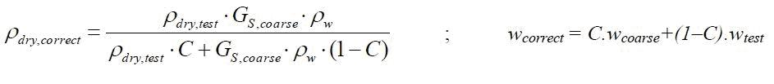

**Figure 1:** Oversize Correction Formulas for Density & Water Content

# **6) Reporting Results**

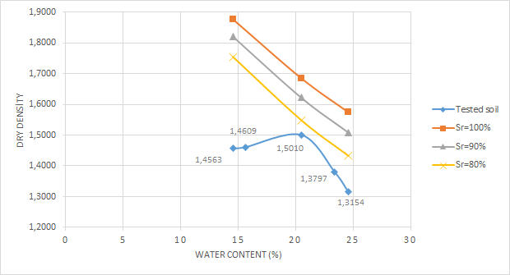

**Figure 2:** Dry Density/Water Content Graph

**Maximum dry density, (pd)max**= 1.5010 g/cm3

**Optimum moisture content, wopt**= 20.48 %

· Because of the time limitations, some part of the experiment was skipped, and it results in errors. For example, it is an experiment which lasts for 3 days, but it was done in 40 minutes in this lab session. It was assumed that 14% of the particles are coarser than 9.5 mm.

· According to data taken from assistant Gizem Can, the isosaturation curves (Sr100%-Sr90%-Sr80%) are drawn, and it can be seen in Figure-2. And I used the following formula to find dry density for the different degree of saturation:

pd= (Gs* ρw)/1+(W*Gs)/Sr

# **7) Conclusion**

Compaction curve of well-graded soiled with isosaturation curves was drawn and optimum water content was determined roughly with errors due to drying phase, equipment defects and personal mistakes during the compaction process of soil.This process is used to prohibit structural damages which will be show up by time because of air volume. Insufficient and weak soils may have this problem. It is used for support some structures like building foundations, roadways, walkways. In the lab session, experiment is not performed by only assistant, we also get involved it. This makes more understandable for experiment.