**Table of Contents**

**1)****Purpose of the Test ..............................................2**

**2)****Equipment ............................................................2**

**3) Preparation ...........................................................2**

**4) Procedure...............................................................2**

**5) Calculations...........................................................3**

**6) Discussion of Results.............................................6**

**CE 363 – SOIL MECHANICS**

***Laboratory Session 8 –– Consolidation Test (with Incremental Loading)***

# Purpose of the test

In the light of this experiment, compressive stress-volumetric strain-time relation characteristics of soil are obtained under 1-D loading conditions. This experiment enables students to analyse an undisturbed saturated, cohesive soil, the relationship between the effective pressure and void ratio and the time-settlement characteristics.

# Equipment

* cutting ring
* oedometer cell (retaining ring, top cap, pedestal, drainage lines)
* porous stones
* filter papers
* oedometer load frame
* displacement measurement device (LVDT & data acquisition system).

# Preparation

* GS should be determined
* The inner surface of retaining ring and cutting ring should be greased.
* A specimen should be obtained by using the cutting ring, but since it is a long and complicated procedure it is skipped in this lab session for simplicity, and the assistant brings as pre-made reconstituted specimen already in the cutting ring.)
* Weight of the cutting ring and the soil specimen should be measured.
* Filter papers should be placed on the surface of the specimen.
* Align the retaining and cutting ring and transfer the specimen to the retaining ring by pushing it with the top cap ad porous stones.
* Bring the screw-knob under the loading lever in contact with the lever, to prevent any unintentional load application.
* Water should be filled the base.
* Placement of soil with ring and bottom stone should be done.
* Place top porous stone and top cap on top of the specimen, under the loading crossbar.
* Application of a tiny seating load should be done.
* The LVDT on top should be attached. Moreover, ensure that it is on the correct side of its range. Record zero reading.

# Procedure

# There are two possible starts for this test:

# a) Swelling pressure start

# b) Free swell start

# Generally, the using load increments are ranged 50-100-200-400-(200-100-200-400)-800-1600-400-100-0 kPa .Because of the time constrains, in this lab session only three loading is applied. (These are 50-100-50 kPa in our lab test.)

# For each increment, record the displacement reading versus time.

# Indeed at 2, 4, 8, 24 hour readings are made, again because of time constraints, we make readings only a few minutes for each increment.

# Repeat steps 2 & 4 for each increment.

# At the end of the test, the specimen is taken out from ring and remove filter papers.

# Collect soil remnants and add to the specimen.

# Oven drying the specimen and determine the dry mass of it.

# Calculations

# (1)

# Area of Ring=π*D²/4→ π*6.35²/4=31.67 cm2

|  |  |
| --- | --- |
| *Diameter of Ring (cm)* | 6.35 |
| *Area of Ring (cm2)* | **31.67** |
| *Initial Height of Specimen (i.e. Height of ring), 2H1 (cm)* | 1.88 |

Initial Moisture Content, m1**→ [** (Mass of Ring+Wet Soil)-(Mass of Ring+Dry Soil)**]/[** (Mass of Ring+Dry Soil)-Mass of Ring**]=**[(167.650-130.575)/(130.575-68.810)]=60.0 %

|  |  |
| --- | --- |
| *Mass of Ring (gram)* | 68.810 |
| *Mass of Ring + Wet Soil (gram)* | 167.650 |
| *Mass of Ring + Dry Soil (gram)* | 130.575 |
| *Initial Moisture Content, m1 (%)* | **60.0** |
| *Final Water Content (after unloading), m2 (%)* | 30.00 |
| *Specific Gravity, GS* | 2.76 |

|  |  |
| --- | --- |
| *Volume of Sample (volume of ring), V (cm3)* | **59.5396** |
| *Volume of Solids, VS= mass of solids/(GS*ɣw) (cm3) (where ɣw=1gram/cm3)* | **22.379** |
| *Volume of Voids, Vv=V-Vs (cm3)* | **37.1606** |
| *Void Ratio, e=Vv/Vs* | **1.6605** |
| *Degree of Saturation, Sr=Vwater/Vvoids = (mwater/ɣwater)/Vv (%)* | **99.7696** |
| *Equivalent Height of Solids, 2H0=Vs/Area of Specimen (cm)* | **0.7066** |

# Did we reach %100 Sr?

# →No, the degree of saturation is 99.7696%. It should be 100 % but it is also very close to the Sr= 100 % . So it is feasible for the experiment.

# (2)

For pressure increment from 320 kPa to 480 kPa deformation (d) and time (t) data is given below.

|  |  |
| --- | --- |
| *Pressure on the sample=480 kPa* | |
| *Elapsed time (minute)* | *Total deformation (mm)* |
| 0 | 2.250 |
| 0.1 | 2.286 |
| 0.25 | 2.296 |
| 0.5 | 2.309 |
| 1 | 2.324 |
| 2 | 2.344 |
| 4 | 2.375 |
| 8 | 2.423 |
| 15 | 2.479 |
| 30 | 2.578 |
| 60 | 2.713 |
| 120 | 2.880 |
| 240 | 3.043 |
| 456 | 3.157 |
| 863 | 3.241 |
| 1649 | 3.307 |

**-Taylor’s method:**

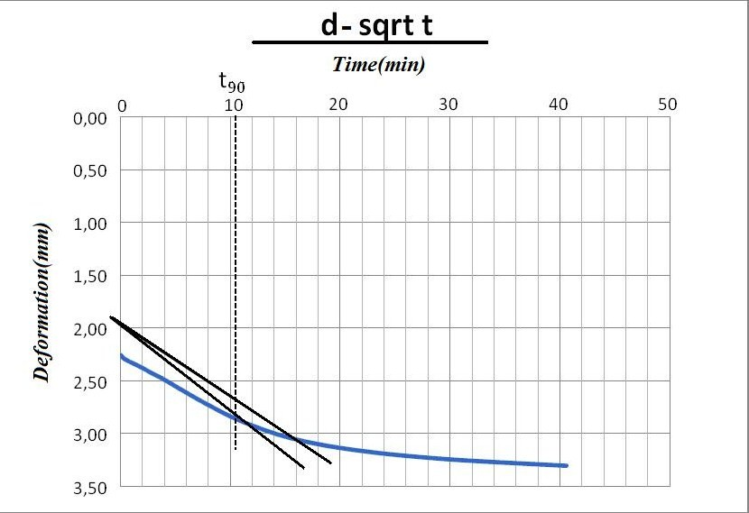

**Graph.1-** d vs.sqrt t

cv = 0.848*H12 / t90 = 0.00354 mm2/sec

**-Casagrande’s Method:**

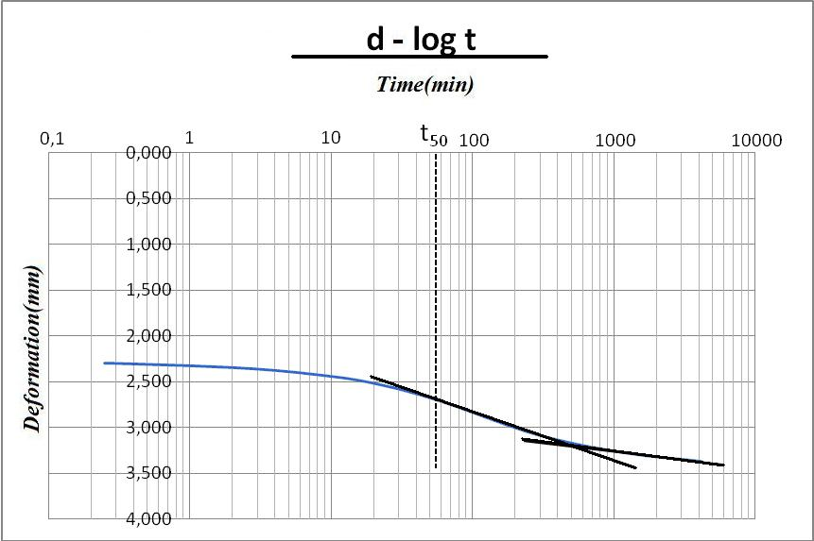**Graph2-** d vs.log t

cv= 0.196*H12 **/** t50 = 0.02099 mm2/sec

# d100=3.243 mm (from above Casagrande plot)

# (3)

|  |  |  |  |  |
| --- | --- | --- | --- | --- |
|  | *Decrease in height of void* |  |  |  |
| *Consolidation Pressure (kPa)* | *Change in Height of Specimen*, H (mm)* | *Height of Specimen, (2H=2H1-H) (mm)* | *Equivalent Height of Voids, (=2H-2H0) (mm)* | *Void Ratio, e=(2H-2H0)/2H0* |
|
| 0 | 0 | **18.8** | **11.734** | **1.660628361** |
| 20 | 0 | **18.8** | **11.734** | **1.660628361** |
| 40 | 0.172 | **18.628** | **11.562** | **1.636286442** |
| 80 | 0.384 | **18.416** | **11.350** | **1.606283612** |
| 160 | 0.749 | **18.051** | **10.985** | **1.554627795** |
| 320 | 2.002 | **16.798** | **9.732** | **1.377299745** |
| 480 | **3.243** | **15.557** | **8.491** | **1.201669969** |
| 640 | 4.343 | **14.457** | **7.391** | **1.045994905** |
| 1280 | 7.156 | **11.644** | **4.578** | **0.647891311** |

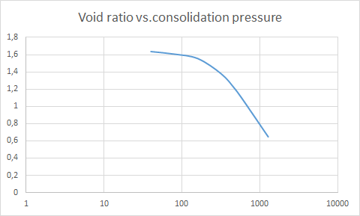

**Graph.3-**Void ratio vs.consolidation pressure

*σ′*p = 160 kPa.

The Compression index (Cc) & The Recompression index (Cr): Cc and Cr can be used for over-consolidated soils if the final effective stress is more than the preconsolidation stress. Otherwise, only Cr is used for that.

σ′o=120 kPa & σ′p= 160 kPa, recompression index, Cr = (e0-e1)**/** log(σ′1**/**σ′0) = 0.2065

σ′p=160 kPa & σ′v=2×σ′p=320 kPa, compression index, Cc = (e0-e1)/ log(σ′1/σ′0) = 0.5889

# (4)

The coefficient of volume compressibility, mv , for the pressure range of σ′o=120 kPa and σ′1=220 kPa:

mv = [(e0 – e1) **/** (1 + e0)]*[1 **/** (σ′1 - σ′o)] = [(1.5804-1.4881 ) **/** (1 +1.5804 )]*[1/220-120] = 3.57696*10^-4 m2/kN

# (5)

t50= 4200 sec. from part (2).

|  |  |  |  |  |
| --- | --- | --- | --- | --- |
| *Consolidation Pressure (kPa)* | *Average Pressure on the Sample (kPa)* | *t50 (seconds)* | *Height of specimen, 2H (mm)* | *Cv (mm2/sec)* |
|
| 40 | - | 3250 | **18.628** | **0.005232** |
| 80 | 60 | 3380 | **18.416** | **0.004917** |
| 160 | 120 | 3540 | **18.051** | **0.00451** |
| 320 | 240 | 3920 | **16.798** | **0.003527** |
| 480 | 400 | **4200** | **15.557** | **0.002824** |
| 640 | 560 | 4340 | **14.457** | **0.00236** |
| 1280 | 960 | 4410 | **11.644** | **0.001506** |

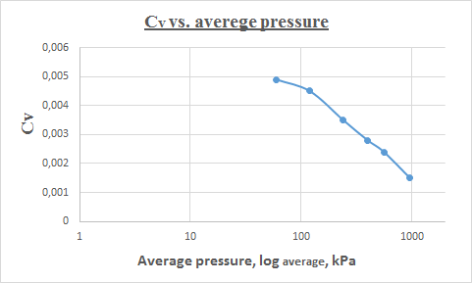

|  |  |  |  |
| --- | --- | --- | --- |
|  | *Total deformation (mm)* | | |
| *Elapsed time (minute)* | *50 kPa* | *100 kPa* | *50 kPa* |
| 0 | 1.148 | 1.402 | 2.038 |
| 1 | 1.392 | 2.000 | 2.038 |
| 2 | 1.398 | 2.020 | 2.038 |
| 3 | 1.402 | 2.038 | 2.038 |

# Discussion of results

The consolidation test is carried out on undisturbed clay. It is seen in the test that as the applied pressure increases, the void ratio decreases.

In this test, the characteristics of a soil during one dimensional consolidation or swelling can be determined by means of oedometer test. The personal factor in this test is very important since it affects directly the results obtained from the test. A misreading of the values, a carelessness or improper application of the test may yield totally wrong results. Also the equipment limit the accuracy of the test since the values are read from dials and the human eye can not determine exactly the values but rather approximate values are obtained. Instead of these equipment electronic, data processors with high accuracy (if available) could be used.

The results obtained from this test can be used when we are dealing with problems such as construction of structures when we are dealing with settlements and is useful since it provides us with such data.