**Table of Contents**

**1)****Purpose of the Test.................................................2**

**2)****Equipment...............................................................2**

**3) Preparation…****.........................................................2**

**4) Sample….................................................................2**

**5) Procedure................................................................2**

**6) Calculations.****...........................................................****.3**

# 7) Reporting of Results...............................................5

**8)** **Interpretation of Results........................................6**

**CE 363 / 364 – SOIL MECHANICS**

***Laboratory Session 9 – Laboratory Vane Test***

# Purpose of the test

Determine peak and residual values of undrained shear strength of a soft clay.

# Equipment

* straight edge spatula
* miniature laboratory vane
* water content determination equipment
* chronometer

# Preparation:

* The blades of the vane must be clean and undamaged.
* Measure and record dimensions (Height and Diameter) of the vane.
* The spring with the correct stiffness must be used, according to the strength of soil. Record spring number and calibration factor. If the calibration factor is not known, it can be determined by applying a known torque and measuring rotation of the spring.

-The standard rate of loading is rotating the spring by 1° per second. To match this rate easily by hand, figure out the corresponding rate of handle rotation.

* If there isn’t one already, place a mark on the vane shaft, 13mm above the top of the blades.
* Set needle indicators to zero.

# Sample

Normally this test is done on undisturbed samples. However, in this lab session, it will be done on a reconstituted sample in a Proctor mold. The rest of this section explains how the test is done on undisturbed samples.

* If you are cutting shelby tubes, then cut a section with a height that is compatible with the height of the vane from the table. Clean the upper end with spatula if necessary.
* If you are not cutting shelby tubes, then extrude a section with a height that is compatible with the height of the vane from the table. Affix it into a container that is slightly shorter in height. Trim the top with the wire saw.
* If you are testing a block sample, you can raise the vane apparatus and reverse the direction it faces, to accomodate for the sample’s size.

# Procedure

1. Insert the vane into the sample until the mark touches the soil surface.
2. Start rotating the vane at a rate that turns the spring by about 1 degree per second. Record measurements of spring and vane rotation indicators at equal intervals of time.
3. At failure, the soil in the vane is sheared off from the rest. Take a set of measurements at that point.
4. One of the needles on the indicator records the peak value. This corresponds to the peak shear strength.
5. Rotate the vane several times. 6- Set needle indicators to zero.
6. Rotate at the testing rate until the spring measurement reaches a constant value. Record this constant value. This corresponds to the residual shear strength.
7. In a real test you would repeat steps 1 to 6 twice more at undisturbed locations of the soil surface, then take their average. Here, once is enough for instruction purposes.
8. Excavate the test location and take that soil for water content determination.

# Calculations

First of all, D and H values in the formula are both given as 1.25 cm. That is, radius is 0.6 cm.

|  |  |  |
| --- | --- | --- |
| *Mass (g)* | *Spring Deflection* | *T (N.cm)* |
| 200 | 2,2 | 1,22625 |
| 400 | 5,4 | 2,4525 |
| 600 | 8,2 | 3,67875 |
| 800 | 10,5 | 4,905 |
| 1000 | 13,1 | 6,13125 |
| 1200 | 16,9 | 7,3575 |
| 1400 | 20 | 8,58375 |
| 1600 | 22,5 | 9,81 |
| 1800 | 25,4 | 11,03625 |
| 2000 | 28,2 | 12,2625 |
| 2200 | 30,1 | 13,48875 |

Table .1- The calculation of the applied torque is tabulated above.

* T= (200/1000)*9.81*0.625=1,22625. This is the calculation of the first row, and the same procedure is applied to the other rows.
* The peak and residual shear strength values are obtained from the graph and the data obtained during the lab session.

cresidual =4.306442 kPa cpeak=21.532212 kPa

**Sensitivity= cpeak / cresidual = 5.00** . Since sensitivity is in between 4&8. It is said to be a sensitive sample.

* By using the trend line equation that is obtained from the spring deflection&applied torque graph, the torques are calculated shown in Table 2.
* To do so, **y = 0.4404x** equation is used. The x value represents the spring deflection.
* For the second and third values, y=0.4404*3=1.3212 **T2=**1.3212

y=0.4404*8=3.5232 **T3=**3.5232

Other torque values are tabulated in Table-2.



Figure.1- The torque formulation

By using the torque formulation shown in Figure.2, the average shear strengths are calculated and they are tabulated in Table.2, in the last column.

As an example, τ= Torque/(π*D^2*((H/2)+(D/6))). At t= 50, τ= 20,455602 kPa by means of this formulation. Where D=1.25 cm, H= 1.25 cm. This calculation is done for other values.

|  |  |  |  |  |  |  |  |
| --- | --- | --- | --- | --- | --- | --- | --- |
| **Time(sec)** | **Spring Deflection** | | **Torque(N.cm)** | **Vane Rotation** | | | **τ(kPa)** |
| **Reading** | **Deflection** | **Reading** | | **Deflection** |
| 0 | 10.00 | 0.00 | 0 | 5.00 | | 0.00 | 0 |
| 10 | 13.00 | 3.00 | 1,3212 | 7.00 | | 2.00 | 3,2298318 |
| 20 | 18.00 | 8.00 | 3,5232 | 9.00 | | 4.00 | 8,6128849 |
| 30 | 23.00 | 13.00 | 5,7252 | 11.00 | | 6.00 | 13,995938 |
| 40 | 26.00 | 16.00 | 7,0464 | 14.00 | | 9.00 | 17,22577 |
| 50 | 29.00 | 19.00 | 8,3676 | 16.00 | | 11.00 | 20,455602 |
| 60 | 30.00 | 20.00 | 8,808 | 21.00 | | 16.00 | 21,532212 |
| 70 | 30.00 | 20.00 | 8,808 | 28.00 | | 23.00 | 21,532212 |
| 80 | 30.00 | 20.00 | 8,808 | 35.00 | | 30.00 | 21,532212 |
| **Residual** | | | | | | | |
| t=0 | 11.00 | 0.00 | 0 | 4.00 | 0.00 | | 0 |
|  | 14.50 | 3.50 | 1,5414 | 5.00 | 1.00 | | 3,768137 |
|  | 15.00 | 4.00 | 1,7616 | 13.00 | 9.00 | | 4,306442 |
|  | 15.00 | 4.00 | 1,7616 | 19.00 | 15.00 | | 4,306442 |
|  | 15.00 | 4.00 | 1,7616 | 25.00 | 21.00 | | 4,306442 |

Table.2- Data sheet that is arranged by using Microsoft Excel and calculated torque is written in the middle column.

To find water content Table.3 is prepared:

|  |  |  |  |  |  |
| --- | --- | --- | --- | --- | --- |
| Mass of Container Mc (g) | Mc + wet mass (g) | Mc + dry mass (g) | Mass of water (g) | Mass of dry soil (g) | Water content |
|
|
| 18.33 | 33.32 | 30.04 | 4,08 | 10,35 | 0,394203 |

**Table.3-**Recorded and calculated values about water content

Mass of water= (Mc + wet mass) –(Mc + dry mass) = 33.32-30.04=3.28 g

Mass of dry soil= (Mc+dry mass) – Mc= 30.04-18.33=11.71 g

Water content =Mass of water /Mass of dry soil =3.28/11.71= 28 %

# 7. Discussion of Results

The graphs that are obtained are as followings. By using Spring Deflection &Applied Torque Graph, the torque is calculated, shown in calculation part. In this laboratory, the undrained shear strengths of a soil sample are determined, and the peak value is 21.532212 kPa. The residual shear strength value is found as 4.306442 kPa. According to these values, the sensitivity of the soil is determined that it is a sensitive soil.

There are definitely some errors in this experiment because of the human factors during the experiment. To exemplify, when applying torque to the specimen, it is difficult to adjust time and rotation of the vane. Owing to some calibration errors, the results that are obtained are affected. In the laboratory session, the torque applied to the vane is not measured and the tabulated form of the applied mass (g) & deflection (deg) is given by the assistant. Then, the graph of the spring deflection and applied torque is plotted (see Figure.1) by means of the data given by the assistant. Moreover, the trend line of the graph is obtained and by using the equation of the trend line, the corresponding torque values are calculated, which is shown in calculation part. Because of the small round off error in this trend line, the results are of course affected. The most prominent thing is that the used soil sample actually used before in the other experiments which means this sample is disturbed, and results in errors.

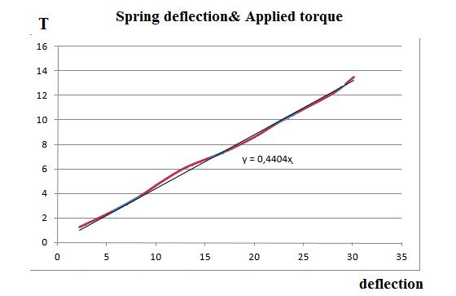

**Graph.1-** Spring deflection & Applied torque

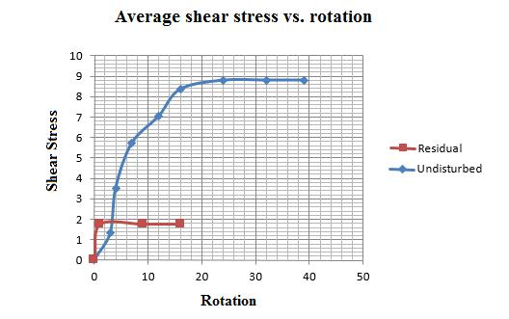

**Graph.2-** Average shear stress vs. rotation

**8)** **Interpretation of Results**

For many naturally deposited clay soils, the unconfined compression strength is much less when the soils are tested after remolding without any change in the moisture content. This property of clay soil is called sensitivity. The degree of sensitivity is the ratio of the unconfined compression strength in an undisturbed state to that in a remolded state, or

St = qu(undisturbed )/qu(remolded )

* If the sensitivity is1 to 4, insensitive
* If the sensitivity is 4 to 8, sensitive
* If the sensitivity is 8 to 16, extra sensitive

The sensitivity ratio of most clays ranges from about 1 to 8; however, highly flocculent marine clay deposits may have sensitivity ratios ranging from about 10 to 80. Some clay turn to viscous liquids upon remolding, and these clays are referred to as “quick” clays. The loss of strength of clay soils from remolding is caused primarily by the destruction of the clay particle structure that was developed during the original process of sedimentation.