Due 27/04, Monday, 17:00

**Soil Mechanics Homework-4**

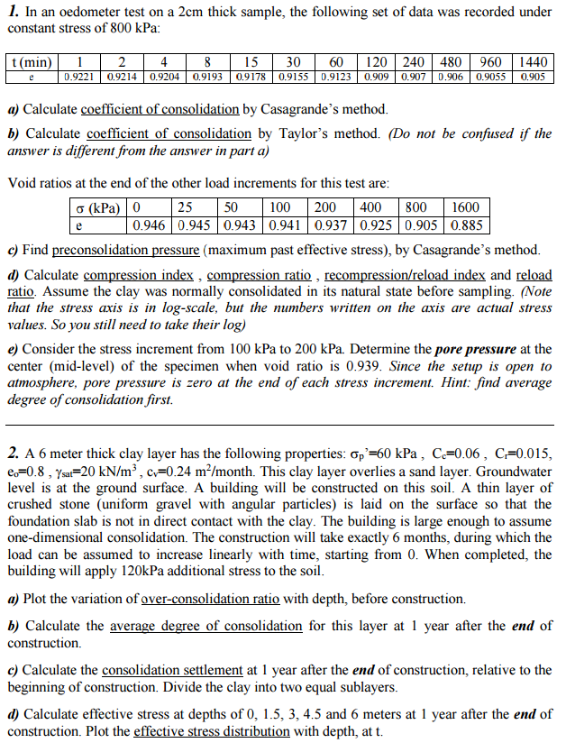

***CE 363-364 Homework-4 Solution***

1. The specimen is 2 cm thick, drained on both sides. Therefore Hd = 1 cm.

Casagrande’s Method uses a deformation-time graph with logarithmic time scale. Given data is plotted in e-logt scale.

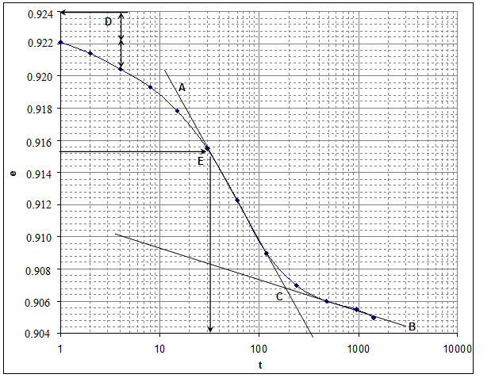

A: The steep portion of the curve is extended linearly.

B: The linear portion on the right is extended.

C: These two lines intersect at the end of consolidation.

D: t = 1 min. and 4t = 4 min. are selected on the upper portion of the curve. From these,

eo = et + (et – e4t) = 0.9221 + (0.9221 – 0.9204) = 0.9238

E: The arithmetic average of the void ratio at the start of the consolidation (eo = 0.9238) and the void ratio at the end of consolidation (at point C, e100 = 0.9068) is ;

e50 = (0.9238+0.9068)/2 = 0.9153. Time necessary for 50% consolidation (t50) is the time that corresponds to this e. From the plot, t50 = 32 min.

cv = 0.196 Hd2 / t50 = 0.196 x 12 / 32 = ***0.006125 cm2/min*** = 0.0265 m2/month

***b)*** Taylor’s Method uses a deformation-time graph with square-root of time scale. Given data is plotted in e-√t scale.

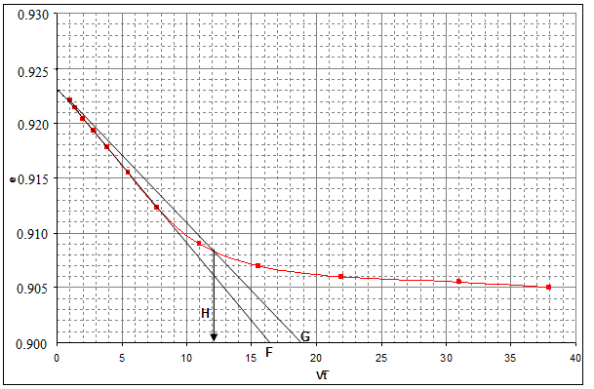

F: When the steep portion of the curve is extended, it intersects the time axis at 

G: The slope of that line is to be flattened by 1.15 times. Both lines starting from the same point at t=0, the second line should intersect the time axis at 16.4 x 1.15 = 18.86

H: The second line intersects the curve at t90, which is at  ⇒ t90 = 12.22 = 149 min.

cv = 0.848 Hd2 / t90 = 0.848 x 12 / 149 = ***0.00569 cm2/min*** = 0.0246 m2/month

***c)*** The given data is plotted in e-log’ on the next page. Casagrande’s Method follows the steps below, letters indicated on the graph:

I: The point of maximum curvature is located on the compression curve.

J: From that point, a horizontal line is drawn.

K: The line that is tangent to the compression curve at the point of max. curvature is drawn.

L: The angle bisector of the two lines from the preceding steps is drawn.

M: Virgin Compression Line is drawn by extending the steep portion of the curve.

N: The maximum past pressure is at the intersection of the lines from steps L and M. It is read from the graph as p′ = ***270 kPa***.



***d)*** The compression curve is given above as e – log′ graph. The slopes of the steep and flat ends of the curve are compression (Cc) and reload (Cr) indices, respectively. These indices divided by 1+eo gives the compression (CR) and reload (RR) ratios. The initial void ratio is the void ratio under zero stress (eo = 0.946).

 

 

***e)*** In the stress increment from 100 kPa to 200 kPa, e changes from 0.941 to 0.937. Until the moment when e=0.939, half of the consolidation deformation (and strain) during this stress increment has happened. This means Uav=50%. From consolidation handout given in the class, Tv =0.196 ~ 0.2.

Using total height of specimen as 2Hd (due to drainage on both sides), middle of the specimen corresponds to z/Hd = 1. From consolidation handout given in the class , using Tv =0.2 and z/Hd = 1 , U can be read as 0.23.

U = ’/  ⇒ 1 – U = u /  ⇒ u = (1-U)  = (1-0.23) x 100 = 77 kPa

(the remaining 23 kPa is transferred to effective stress)

The oedometer specimen is connected to the atmosphere, so uo=0 ⇒ u = u = ***77 kPa***

***2. a)*** p’=60 kPa is given.

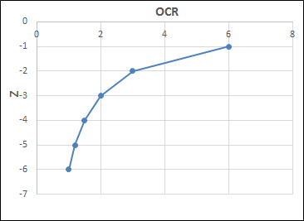

$$σ_{v }^{'}=σ_{v}-u$$

For this soil layer

( uniform, saturated, G.W.T. at surface, no surcharge load)



$$σ_{v }^{'}=γ_{s}*z-u*z=20z-10z=10z$$

$OCR=\frac{60}{10z}=\frac{6}{z}$

$\frac{6}{2}+12=15 months$

Double side drainage: $H_{d}=\frac{6}{2}=3 m$

$T_{V}=\frac{C_{V}*t}{{Hd}^{2}}=\frac{0.24*15}{3^{2}}=0.4$ Uav= 70 %(From consolidation handout

given in the class)

1. First layer 3 m ( z=1.5 m)

$σ_{vo }^{'}=10z=15 kPa σ_{vf }^{'}=15+120=135 kPa$

${ ε}_{1}=\frac{C_{r}}{1+e_{0}}*log\frac{σ_{p}^{'}}{σ_{o}^{'}}+\frac{C_{c}}{1+e_{0}}*log\frac{σ_{f}^{'}}{σ_{p}^{'}}=\frac{0.015}{1+0.8}*log\frac{60}{15}+\frac{0.06}{1+0.8}*log\frac{135}{60}$ = 0.0167

$${∆H}_{1}=ε_{T}*H=0.0167*3=0.0501m=5.01cm$$

Second layer 3 m ( z=4.5 m)

$σ_{vo }^{'}=10z=45 kPa σ_{vf }^{'}=45+120=165 kPa$

${ ε}_{2}=\frac{C_{r}}{1+e_{0}}*log\frac{σ_{p}^{'}}{σ_{o}^{'}}+\frac{C_{c}}{1+e_{0}}*log\frac{σ_{f}^{'}}{σ_{p}^{'}}=\frac{0.015}{1+0.8}*log\frac{60}{45}+\frac{0.06}{1+0.8}*log\frac{165}{60}$ = 0.0157

$${∆H}_{2}=ε_{T}*H=0.0157*3=0.0471m=4.71cm$$

$${∆H}_{T}={{∆H}_{1}+∆H}_{2}=5.01+4.71=9.72cm$$

$${∆H}_{1}={∆H}_{T}*U=9.72*0.7=6.8 cm$$

1. U , which is degree of consolidation, is read from consolidation handout given in the class with respect to Tv= 0.4 and depth ratio ( Z=z/Hd ).

|  |  |  |  |  |
| --- | --- | --- | --- | --- |
| **z** | $$σ_{v }^{'}=γ^{'}*z$$ | **Z=z/Hd** | **U** | $$σ_{v }^{'}=σ_{vo }^{'}+U*∆σ$$ |
| 0 | 0 | 0 | 1 | 0+120=120 |
| 1.5 | 15 | 0.5 | 0.66 | 15+0.66*120=95 |
| 3 | 30 | 1 | 0.52 | 30+0.52*120=92.4 |
| 4.5 | 45 | 1.5 | 0.66 | 45+0.66*120=125 |
| 6 | 60 | 2 | 1 | 60+120=180 |

