**1. INTRODUCTION**

Civil Engineering has a very wide definition. In addition to this, applications of a civil engineering can be seen everywhere. Roads, bridges, airports, pipeline systems are some examples of civil engineering. Every structure must be pass some processes. Some of them are on field processes, some of them are office works.

Every civil engineering student Middle East Technical University learn both construction site works and office works roughly. In addition to these theoretical courses, some of them have laboratory sessions and these give us practical perspective. This practical perspective is very important because theoretical information and applications of civil engineering are very different in our country.

Moreover, while laboratory sessions were showing practical side of civil engineering during an academic year, summer practices are showing them with long term. CE300 and CE400 are two must courses of METU, Civil Engineering Department.

Mostly, field processes happens on construction sites. A civil engineer that works on construction site resolves the problems and delays on site, fixes missing parts of structure plan, informs the technical office engineers about progress etc. CE300 Summer Practice course is a very great chance to face these works on site.

On the other hand, CE400 Summer Practice course can be done either construction site or technical office. Technical office is my first choice because I wanted to see also daily office works.

Technical office engineers have different responsibilities than the site engineers. Estimations, preparing quantity takeoffs, drawing projects, preparing budgets, making contracts, preparing proposals for tenders, purchase and sale works, progress payments etc. some of these responsibilities.

In Production Planning and Cost Control Office of Sinpaş REIT, managing budgets, checking contracts, unit price analysis, quantity takeoffs and progress payments are main duties. Because they have many on-going constructions, they have specific technical offices.

**2. PREFACE**

**2.1. Name and Contact Addresses:**



Sinpaş Plaza Barbaros Bulvarı

Yenidoğan Sok. No: 36 34349

Darphane – Beşiktaş,

İstanbul / Türkiye

**2.2 Brief History**

Sinpaş Group was founded in 1974 by Avni ÇELİK. During Its 44 year journey, 28 companies has pioneered to Industrial, Service& Finance, Energy and Real Estate sectors. Sinpaş Group was in the real estate sector with Sinpaş Yapı, was founded in 1974 and Sinpaş REIT, was founded in 2007 separately until 2018.

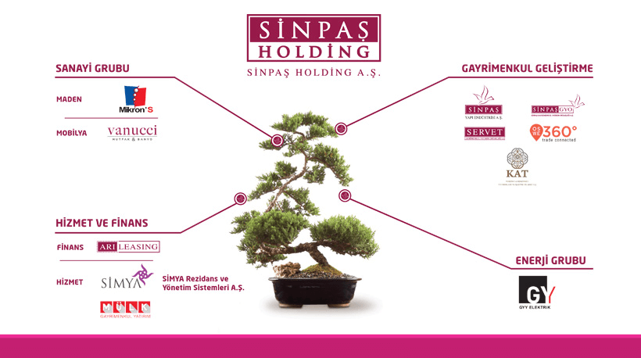

**Figure 1 : Sinpaş Holding's Business Lines**

**2.3. Organizational Scheme of Sinpaş Group**

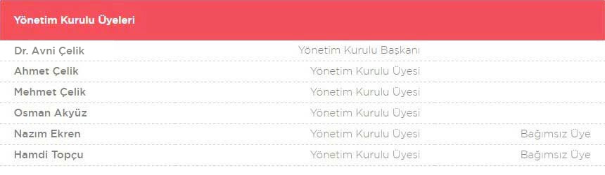

**Figure 2 : Sinpaş Holding's Board Members**

**2.4. Organizational Scheme of Production Planning and Cost Control Office**

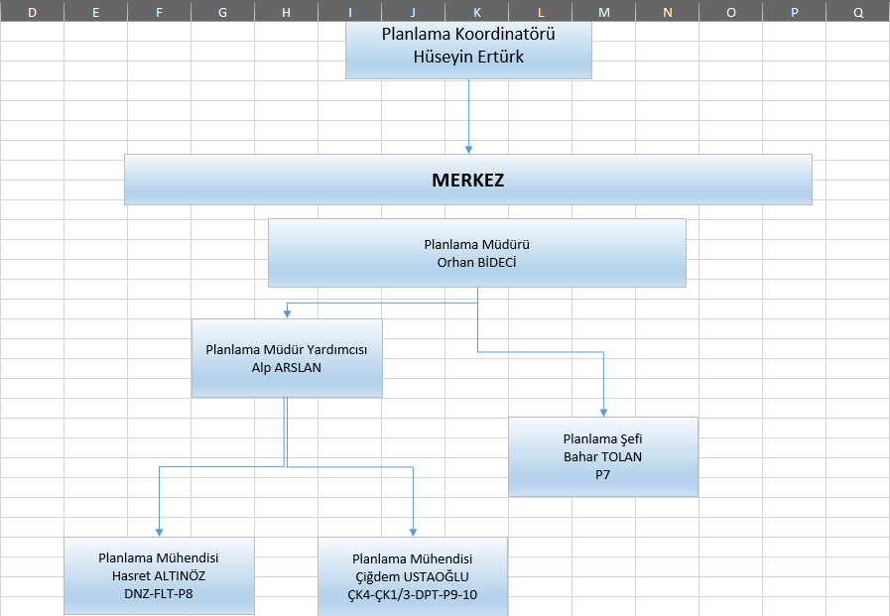

**Figure 3 : Organizational Scheme of the office**

**2.5. Main Sphere of Activity**

Sinpaş Group is one of the largest companies in the Türkiye In addition to this, Sinpaş REIT is one of the pioneers in the real estate sector. During the years, many projects were completed and will be completed. Some examples of them;

* Finansşehir, Ümraniye - İstanbul
* Altınoran , Çankaya - Ankara
* İş Modern , Ambarlı - İstanbul
* Gökorman, Ümraniye - İstanbul
* Metrolife, Sancaktepe - Istanbul
* Aqua City , Demirtaş - Bursa
* Ege Vadisi, Çankaya - Ankara
* Aqua City , Merkezefendi - Denizli

Because of the current market in Türkiye, like many other companies, Sinpaş REIT also has some difficulties. I am very grateful to whole Production Planning and Cost Control Office, in these difficult days, they tried to show things as much as possible.

Special thanks to Orhan Bideci, Çiğdem Ustaoğlu and Hasret Altınöz.

**3. MAIN TEXT**

**Week 1**

SUMMARY FORM

|  |  |
| --- | --- |
| Date :13.08.2018 | .............1............. working date |
| Summary of the Work Done:  Firstly, I came to Sinpaş Corporate Office. I delivered my entrance documents to Neslihan Maden from Human Resources. She informed me about some general rules. Then, she introduced me to Production Planning and Cost Control Office. Planning Manager Orhan Bideci mentioned some procedures of planning part of a construction. He asked me to draw a template of these procedures. I.T. gave me a username and a password for entrance to IFS system. This IFS system is used to do work on digital by all departments of Sinpaş. Planning Manager gave me Project Planning and Control Procedure to read it. I took notes from some important parts.E:\Rapora koyulanlar\Yeni klasör\chart.png  **Figure 4 : Procedures of Planning and Control Processes** | |

Stamp

Name, Surname, Signature of the Supervisor:

SUMMARY FORM

|  |  |
| --- | --- |
| Date :14.08.2018 | ............2.............. working date |
| Summary of the Work Done:  I examined that Obligations of Contractor During the Preparation Period of Progress. I compared softcopies and hardcopies of different steel price tables, I rearranged and checked. I examined The Corrective and Preventive Action Procedure.  Hasret Altınöz told me about BFPT (Birim Fiyat Poz Tanımlama) system on IFS ERP. Sinpaş has been using this system for 10 years. Mrs. Altınöz introduced IFS interface. She told how I can found past documents, how I can examine documents and she showed archiving procedure. She showed ‘Satın Alma Talebi’ module. In addition to this, she introduced topics of progress payment report’s cover page.  E:\Rapora koyulanlar\Yeni klasör\ifsmainpage.png **Figure 5: IFS ERP Interface** | |

Stamp

Name, Surname, Signature of the Supervisor:

SUMMARY FORM

|  |  |
| --- | --- |
| Date :15.08.2018 | .............3............. working date |
| Summary of the Work Done:  Paper Work database is shown by Mr. Bideci . Operation and necessity of this database is told. Five contracts are uploaded to Paper Work Database with Contract ID taken from IFS. Two of these contracts are made between Contractor (Sinpaş) and Subcontractor (NRC Metal), three are made between Contractor (Sinpaş) and Prime Contractor(Ülke)  …………………………………………………………………………………………………  ………………………………………………………………………………………………… | |

Stamp

Name, Surname, Signature of the Supervisor:

SUMMARY FORM

|  |  |
| --- | --- |
| Date :16.08.2018 | ............4.............. working date |
| Summary of the Work Done:  Mrs. Altınöz gave me preliminary project of Sancaktül. She introduced me what is Sancaktül project. When was it start and when will it finish. After that, I took quantity takeoff that prepared by project owner and I started to preparation for the preliminary estimate. Mrs. Altınöz wanted from me quantity takeoff of joineries of every floor.  B4,B3,B2,B1,ZK,1K,2K,3K are completed by myself.  .....................................................................................................................................................  ..................................................................................................................................................... | |

Stamp

Name, Surname, Signature of the Supervisor:

SUMMARY FORM

|  |  |
| --- | --- |
| Date :17.08.2018 | .............5............. working date |
| Summary of the Work Done:  I finished joineries quantity takeoff after completing 4K,5K,6K and ÇK, then I prepared an Excel Table for the railing quantity takeoff.    **Figure 6 : Quantity takeoff of Sancaktül Project**  ................................................................................................................................................... | |

Stamp

Name, Surname, Signature of the Supervisor:

SUMMARY FORM

|  |  |
| --- | --- |
| Date :18.08.2018 | ............6.............. working date |
| Summary of the Work Done:  Çiğdem Ustaoğlu is one of the civil engineers in the planning and production department. She told preparation process of Process Control Forms. Furthermore, she showed preparation of contracts on IFS roughly.  ................................................................................................................................................... | |

Stamp

Name, Surname, Signature of the Supervisor:

**Discussion of First Week**

* Describing Unit Price for Poses (Birim Fiyat Poz Tanımlama) module on IFS is very important because Sinpaş REIT has lots of projects and they should not repeat themselves in every project. This module provides that every single production's information. Price, be used projects, be paid progress payments, subcontractors , contracts etc. Because every poses have this detailed information, lots of poses are using. This module is like a pos library. Pos numbers tell us its information. First two letter are main group code, second two letter are sub-group code, third two letter are secondary group code, then a numerator that has 4 number starting from 0, finally last two letter are special group code

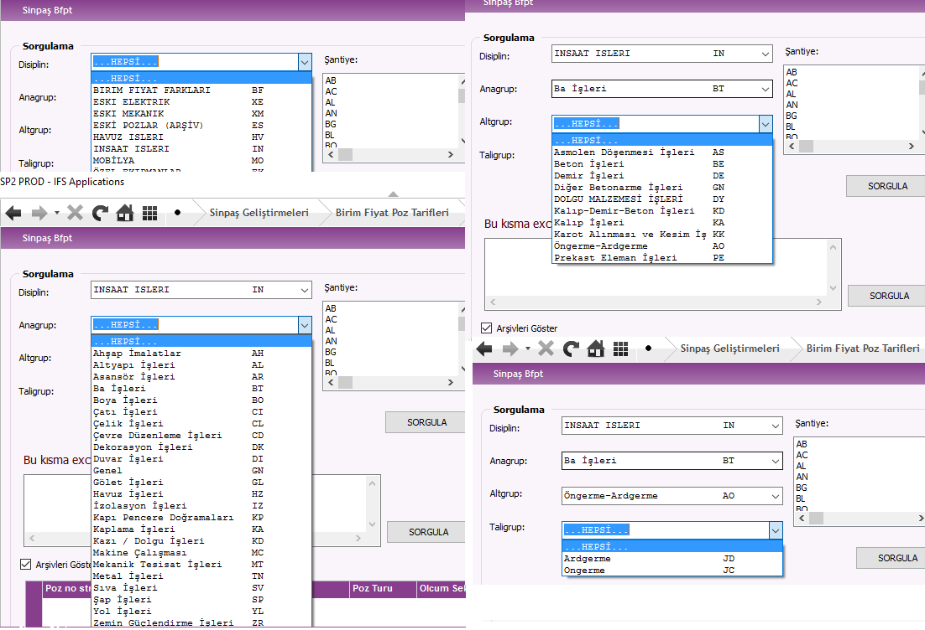

**Figure 7 : ''Birim Fiyat Poz Tanımlama'' Module on IFS**

* Procedure of Project Planning and control consists of these steps :

-> Construction projects of Static, Electric, Mechanic and Landscape are prepared by related designers(İlgili proje müellifleri)

->Statical and architectural projects will be planned

-> Designers(Müellifler) will take their quantity takeoffs

-> Main work flow(Temel İş Akışı) are determined

-> Construction Site Planning Office transfer this flow to PC.

-> Production Planning and Cost Control Office checks this flow. If it is risky to main plan, Main Work Flow will be updated.

-> Cost and project dates are sent to Assistant General Manager of Production and Assistant General Manager of Planning.

* Sancaktül is an old factory in Küçükçekmece, İstanbul. Sinpaş REIT will construct residence and mall on this area. Sinpaş REIT is at very beginning of these project. I took quantity takeoffs from designer's concept project.

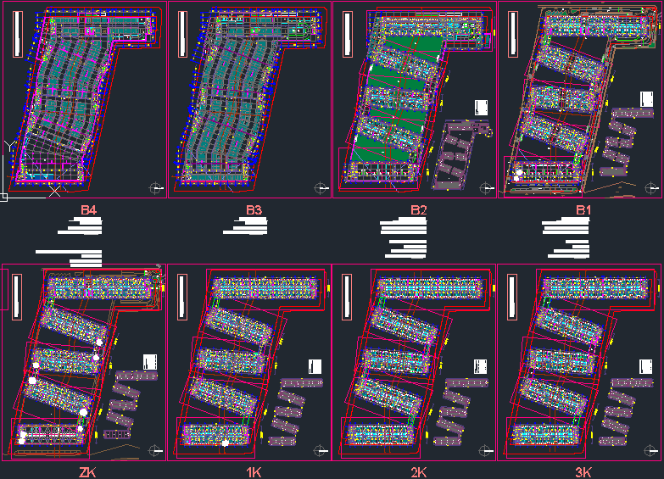

**Figure 8 : AutoCAD of Sancaktül Project's Plan**

**WEEK 2**

SUMMARY FORM

|  |  |
| --- | --- |
| Date :27.08.2018 | .............7............. working date |
| Summary of the Work Done:  ...................................................................................................................................................  I compared digital compendiums of Ülke Proje’s payments of May and June with bills. I identified that unsigned ones, unapproved ones by corporate and I noted them. I checked also VAT amounts to write correct number on progress payment. Sinpaş pays total money with %18 VAT. So , I checked the bills have VAT percent %8 and %0.  ................................................................................................................................................... | |

Stamp

Name, Surname, Signature of the Supervisor:

SUMMARY FORM

|  |  |
| --- | --- |
| Date : 28.08.2018 | ..............8............ working date |
| Summary of the Work Done:  ..................................................................................................................................................  I scanned a contract of the Sinpaş REIT Altınoran Project. This contract is about landscape plan of the 4. Parcel and after scanning, I upload to Paper Work system. I checked again bills because assistant general manager will sign documents which have no signature. According to this revision, I rearranged the Excel table.  ...................................................................................................................................................  ................................................................................................................................................... | |

Stamp

Name, Surname, Signature of the Supervisor:

SUMMARY FORM

|  |  |
| --- | --- |
| Date : 29.08.2018 | .............9............. working date |
| Summary of the Work Done:  I started to railing quantity takeoff of Sancaktül project. I asked some inexplicable points to Osman Çelik who is one of the civil engineers in planning office. I completed sixth floor.  ................................................................................................................................................. | |

Stamp

Name, Surname, Signature of the Supervisor:

SUMMARY FORM

|  |  |
| --- | --- |
| Date : 31.08.2018 | ............10.............. working date |
| Summary of the Work Done:  ...................................................................................................................................................  Today, I continued with Sancaktül Project’s railing quantity takeoff. I Completed fourth and fifth floor. However, I realize some differences between plan drawings and frontal view. I took notes about these mismatches.    ...................................................................................................................................................  ................................................................................................................................................... | |

Stamp

Name, Surname, Signature of the Supervisor:

SUMMARY FORM

|  |  |
| --- | --- |
| Date : 01.09.2018 | .............11............. working date |
| Summary of the Work Done:  ...................................................................................................................................................  Today, I completed B2,B1,ZK,1K,2K and 3K of railing quantity takeoff. I revised my notes about mismatches. However, I have to wait Mrs. Altınöz because she is in annual leave.  ...................................................................................................................................................  .................................................................................................................................................. | |

Stamp

Name, Surname, Signature of the Supervisor:

SUMMARY FORM

|  |  |
| --- | --- |
| Date : 03.09.2018 | .............12............ working date |
| Summary of the Work Done:  ...................................................................................................................................................  I examined cross-sections of Sancaktül Project, with the guidance of Mr. Çelik, we tried to solve mismatches. For the non-posed joineries, I identified proper poses.  ...................................................................................................................................................  ................................................................................................................................................... | |

Stamp

Name, Surname, Signature of the Supervisor:

**Discussion of Second Week**

* Sancaktül's project is a preliminary design. So, there is no certain values or drawings. They wanted from me only joinery, railing and bridges external quantity takeoffs. They need these quantity takeoffs because preliminary estimate needs some rough numbers. With these quantity takeoffs, they will make budget.
* However, this preliminary design has some contradictions. When I look to general view, I can see that at 2nd floor between 37 I-H axis, there is a large window. On the other side, in plan, at same axis there are a straight balcony and two windows. This is reported to Mrs. Altınöz and she said that when I faced contradictions like this, I must base on plans.

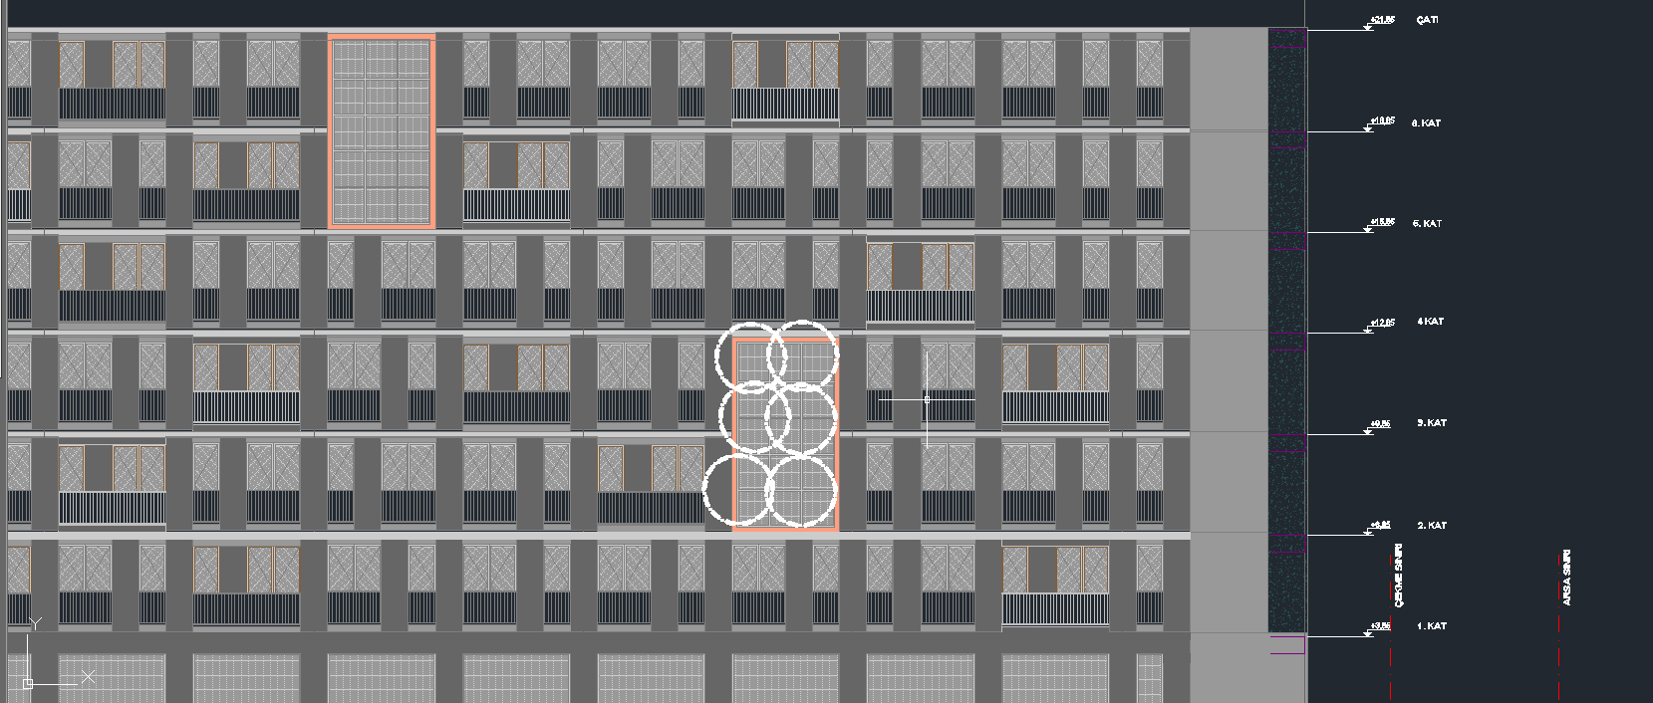

**Figure 9 : Frontal View of 2nd Floor**

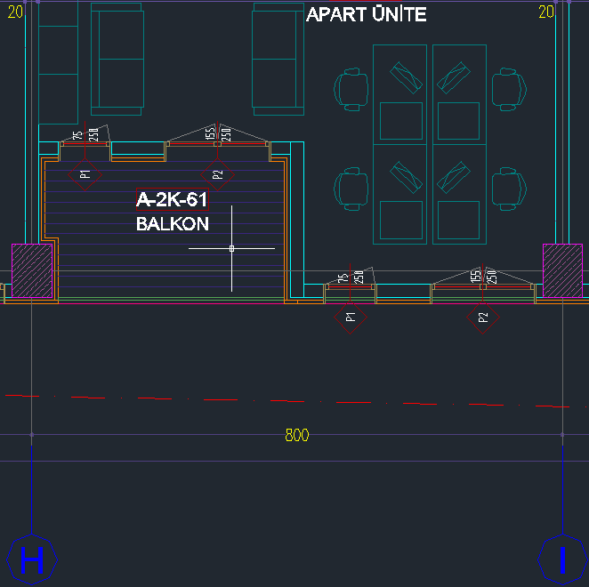

**Figure 10 : Plan View of 2nd Floor**

**WEEK 3**

SUMMARY FORM

|  |  |
| --- | --- |
| Date :04.09.2018 | .............13............. working date |
| Summary of the Work Done:  Today, I analyzed some Progress Payments of August. These came from some subcontractors named as Asek, Kafa, Miras, Okro, Özşahin and Triya. Parts of cover page and its details are examined with Mr. Çelik. I learned that why deduction was done on Asek’s progress payment.  Asek hakediş  **Figure 11 : Cover Page of Progress Payment of ASEK Cons.** | |

Stamp

Name, Surname, Signature of the Supervisor:

SUMMARY FORM

|  |  |
| --- | --- |
| Date : 05.09.2018 | .............14............ working date |
| Summary of the Work Done:  ...................................................................................................................................................  Today, Mrs. Altınöz returned to Office. We checked my joinery and railing quantity takeoff tables. In addition to that, we discussed mismatches of Sancaktül Project. She gave me some instructions to correct these points. I’ve done joinery quantity takeoff of B1’s common site and the bridges that located between blocks. I added these to excel.  ................................................................................................................................................. | |

Stamp

Name, Surname, Signature of the Supervisor:

SUMMARY FORM

|  |  |
| --- | --- |
| Date : 06.09.2018 | .............15............. working date |
| Summary of the Work Done:  Mrs. Altınöz gave me 2nd,3rd,4th,6th,7th,8th blocks’ ‘Front-Roof and “Duvar Topuk”’ quantity takeoff tables of Ümraniye,Çakmak-Finansşehir Project. I checked them. These quantity takeoffs are prepared by Project owners, so I edited them according to Sinpaş’s Poses. Missing and non-defined parts are marked , therefore Mrs. Altınöz can check them. I arranged their Activity Codes and cost centers.  **Figure 12: Changing Designer's Pos to Sinpaş Pos** | |

Stamp

Name, Surname, Signature of the Supervisor

SUMMARY FORM

|  |  |
| --- | --- |
| Date : 07.09.2018 | ............16.............. working date |
| Summary of the Work Done:  ..................................................................................................................................................  I followed Mrs. Altınöz while she was analyzing the Mamaco’s August progress payments. She showed what must be done by planning engineer when a progress payment has come to department. She has checked all numbers of a Mamaco’s progress payment, revised them and signed lastly. After her procedure, the progress payment was given to Mr. Bideci ‘’ Manager of Production Planning and Cost Control Department”. Before it signed by assistant general manager, Mr. Bideci checked numbers on cover page, and signed them. After it came back to office, Mrs. Altınöz closed that progress payment on IFS and IFS system gave a SAS code. After she noted that code on hardcopy, this progress payment was sent to the accounting office to pay money.    ..................................................................................................................................................  ................................................................................................................................................... | |

Stamp

Name, Surname, Signature of the Supervisor:

SUMMARY FORM

|  |  |
| --- | --- |
| Date : 08.09.2018 | .............17............. working date |
| Summary of the Work Done:  ...................................................................................................................................................  We discussed May and June’s payments and bills of our prime contractor Ülke Group, with Mr. Bideci. Finally, we had to take out some spending from progress payments because one of them has no detailed information and one of them has no sign of project manager.  .................................................................................................................................................. | |

Stamp

Name, Surname, Signature of the Supervisor:

SUMMARY FORM

|  |  |
| --- | --- |
| Date : 10.09.2018 | .............18............ working date |
| Summary of the Work Done:  ...................................................................................................................................................  Another Planning Engineer Alp Arslan gave me Ülke Group’s May, June and July spending and bills of Finansşehir Project to check with digital table. These bills analyzed. Few of them have no sign of supervisor and some of them have big amount of money. If any bill’s amount passes 7000 TL with no VAT, they must be checked and signed by Assistant General Manager Mehmet Yavaş. After checking every bill, some notes took on them.    ...................................................................................................................................................  ................................................................................................................................................... | |

Stamp

Name, Surname, Signature of the Supervisor:

**Discussion of Third Week**

* Ülke Group is one of the main contractors of Sinpaş REIT. They are working on Altınoran-Çankaya and Finansşehir-Ümraniye projects. Ülke Group is responsible firm for these constructions. They manage the site, they pay for every payment either government or sub-contractors.
* Every 15th of month, progress payments come from contractors. Because Ülke Group is different from sub-contractors according to responsibilities, their progress payments are larger than other contractors. Their progress payments include every single payment.
* As the Production Planning and Cost Control office, we will check every bill and their request on IFS system. Cost Centers, confirmations, including poses numbers etc. check one by one.
* If any missing signature, missing request or wrong cost center is noticed, their bills will removed from progress payment. If the missing part is corrected, it will be paid in the next progress payment.
* Cost Centers, Fields , Expense Group are main subtitles of bills. All bills that must be paid in related progress payments has be listed in Excel. After that, power chart will be used to check.

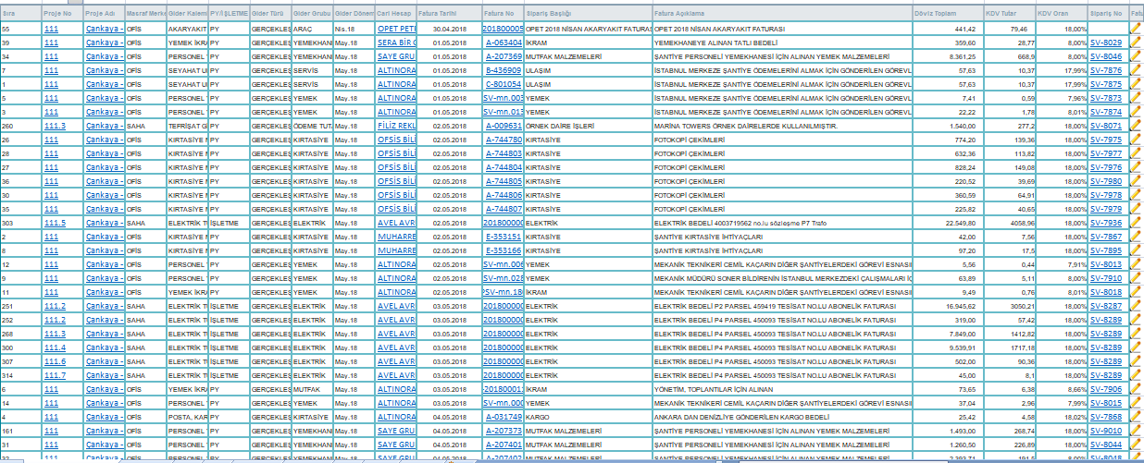

**Figure 13 : Ülke Proje's Expenses Excel List**

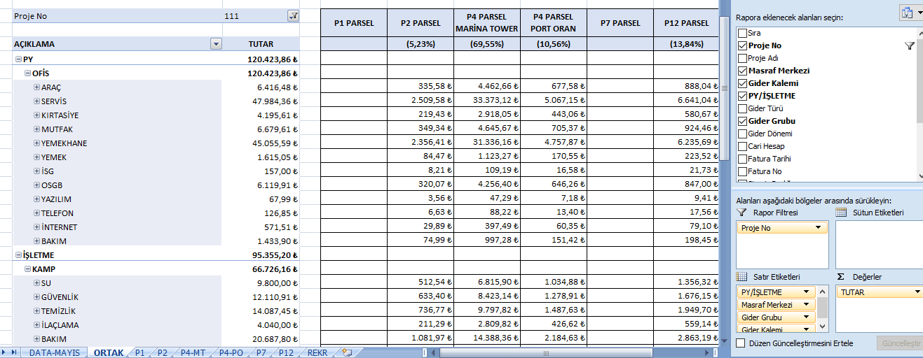

**Figure 14 : Ülke Proje's Expenses' Pivot on Excel**

**WEEK 4**

SUMMARY FORM

|  |  |
| --- | --- |
| Date :11.09.2018 | .............19............. working date |
| Summary of the Work Done:  ...................................................................................................................................................  Mrs. Ustaoğlu gave twenty different scanned contracts. She wanted from me to check them on IFS. Then, I took their contract ID’s from IFS system and I uploaded to Paperwork Domain. The numbers of these contracts are listed below    ................................................................................................................................................... | |

Stamp

Name, Surname, Signature of the Supervisor:

SUMMARY FORM

|  |  |
| --- | --- |
| Date : 12.09.2018 | ..............20............ working date |
| Summary of the Work Done:  ...................................................................................................................................................  I closed August progress Payment of Nefa Construction. I took SAS number from IFS. Then, I sent it to Accounting Office.  Mrs. Altınöz has quitted and her duties have been given to other engineers. For my part, I checked progressive payments on IFS with cover pages. After ordering them by project to project, Excel table was prepared by myself. Pivot chart was used and after they were checked by Mr. Bideci, they were sent to archive.    **Figure 15 : List of Archived Progress Payments**  ................................................................................................................................................... | |

Stamp

Name, Surname, Signature of the Supervisor:

SUMMARY FORM

|  |  |
| --- | --- |
| Date : 13.09.2018 | ..............21............ working date |
| Summary of the Work Done:  ...................................................................................................................................................  In June, there was a bill has total amount of 140,000 TL. Mr. Bideci wanted to see that bill because it’s cost center was not clear. It’s cost center was ‘steel construction’ but Mr. Bideci said that, that construction may have specific subtopic. We searched on IFS and we saw that a cost center named as “Pond rough construction”. Then he changed its cost center. True cost centers and their activity codes are necessary for the next projects. Their information can guide more clearly when a new project is started.  ................................................................................................................................................... | |

Stamp

Name, Surname, Signature of the Supervisor:

SUMMARY FORM

|  |  |
| --- | --- |
| Date : 14.09.2018 | ..............22............ working date |
| Summary of the Work Done:  ...................................................................................................................................................  Bahar Tolan, she is also one of the civil engineers in the planning office, gave me some contracts which are related with Ankara Altınoran Project and Marina Ankara Project. Some of these contracts are Main contract and the rest of them are sub-contract. She showed how a contract is controlled by a supervisor. She checked one of them as an example for me, then I started to control the other contracts. Four of them were checked by myself.  ................................................................................................................................................... | |

Stamp

Name, Surname, Signature of the Supervisor:

SUMMARY FORM

|  |  |
| --- | --- |
| Date : 15.09.2018 | ..............23............ working date |
| Summary of the Work Done:  ...................................................................................................................................................  I continued to control procedure and I finished all of them. For the final step, I gave all of them to Mrs. Tolan. She will check my notes and then she will sign. Then, contracts will be scanned and be transferred to PaperWork system.  ................................................................................................................................................... | |

Stamp

Name, Surname, Signature of the Supervisor:

**Discussion of Fourth Week**

* In Production Planning and Cost Control Office, all work are done on papers such as contracts, progress payments, confirmation letters etc. Usage of this amount paper has negative sides. First of all, usage of paper is the worst thing for the Earth. Secondly, if any problem will occur with contractors, it is hard to find related progress payments or contracts. Because it is very hard to archive all of them correctly.
* Paperwork domain is very advantageous system. It is simple to use, very easy to learn. If there is any question mark in any head, very simple to find related document.
* If a contract will upload to Paperwork, first of all, contract Id must be taken from IFS with contract number. With this ID, paperwork can take all information of contract from IFS, only remaining thing to do is uploading document from PC to Paperwork. Then, paperwork module can create folder in own library and archive it.

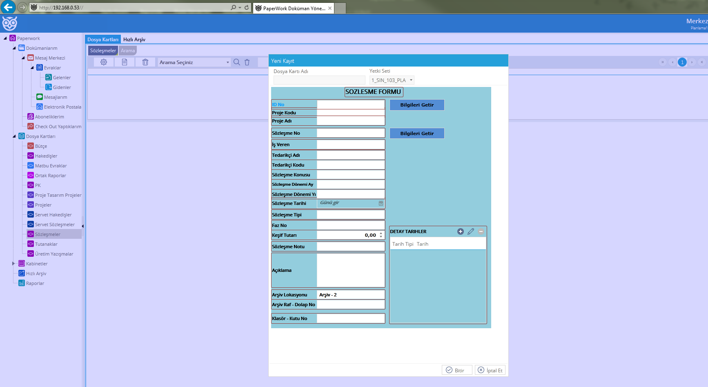

**Figure 16 : Paperwork's Interface**

**Week 5**

SUMMARY FORM

|  |  |
| --- | --- |
| Date : 17.09.2018 | ..............24............ working date |
| Summary of the Work Done:  ...................................................................................................................................................  Today, Mr. Bideci gave me five ‘Altınoran P2 Parsel’ contracts. First, I look their contract ID’s from IFS. Then I scanned to PC. With contract ID’s I took from IFS, I uploaded to PaperWork system. Finally, Mr. Bideci signed contract list and signed them and I took them to archive.  After lunch, I did a short interview with Mrs.Ustaoğlu.  ................................................................................................................................................... | |

Stamp

Name, Surname, Signature of the Supervisor:

SUMMARY FORM

|  |  |
| --- | --- |
| Date : 18.09.2018 | ..............25............ working date |
| Summary of the Work Done:  ...................................................................................................................................................  Today, the Cleaning and Transportation of Rubble in the Ankara-Altınoran Construction Site Sub-Contract was analyzed and scanned to PC. With its Contract number, contract ID’ has given from IFS. Then, it was uploaded to Paperwork system by myself. Lastly, it was sent to Archive.  ................................................................................................................................................... | |

Stamp

Name, Surname, Signature of the Supervisor:

SUMMARY FORM

|  |  |
| --- | --- |
| Date : 19.09.2018 | ..............26............ working date |
| Summary of the Work Done:  ...................................................................................................................................................  Mr. Arslan gave me a progress payment on Nefa Construction. This is related with rough construction of İş Modern Ambarlı Project. Mr. Arslan showed procedure of control a progress payment. According to these directions, I started to check progress payment.  Firstly, I checked Steel Unit Prices with relevant dates’ confirmation letters. The amounts in the progress payment were checked from IFS. Purchase forms compared with bills according to dates, amounts, unit prices.  The bills of Concrete and steel purchases checked. Payments were checked according to field progress report. Some little differences were found.  ................................................................................................................................................... | |

Stamp

Name, Surname, Signature of the Supervisor:

SUMMARY FORM

|  |  |
| --- | --- |
| Date : 20.09.2018 | ..............27............ working date |
| Summary of the Work Done:  ...................................................................................................................................................  ...................................................................................................................................................  Today, I read some old contracts from paperwork. Some of these are main contracts and rest of them are subcontract. The reason why I read old contracts is comparison of steel pricing. I have prepared an Excel table for steel prices by years.  ...................................................................................................................................................  ................................................................................................................................................... | |

Stamp

Name, Surname, Signature of the Supervisor:

SUMMARY FORM

|  |  |
| --- | --- |
| Date : 21.09.2018 | ..............28............ working date |
| Summary of the Work Done:  ...................................................................................................................................................  ...................................................................................................................................................  I checked different contracts so far, today, I read Preparation of Contract Procedure. Some specific terms are asked to Mr.Bideci. Differences of Main and Subcontracts are determined. Their contents are compared .  ...................................................................................................................................................  ................................................................................................................................................... | |

Stamp

Name, Surname, Signature of the Supervisor:

SUMMARY FORM

|  |  |
| --- | --- |
| Date : 22.09.2018 | ..............29............ working date |
| Summary of the Work Done:  ................................................................................................................................................... ...................................................................................................................................................  Old projects of Sinpaş REIT are examined. Their types, including, prices, locations etc. are examined. Also, from database I found Aydos Country's cost. So, I can compare Aydos Country's cost and price. ...................................................................................................................................................  ................................................................................................................................................... | |

Stamp

Name, Surname, Signature of the Supervisor:

SUMMARY FORM

|  |  |
| --- | --- |
| Date : 24.09.2018 | ..............30............ working date |
| Summary of the Work Done:  ...................................................................................................................................................  I completed my summer practice report early Because last week engineers could not give enough work to me . Today I continued to write my report.  ...................................................................................................................................................  ................................................................................................................................................... | |

Stamp

Name, Surname, Signature of the Supervisor:

**Discussion of Fifth Week**

* 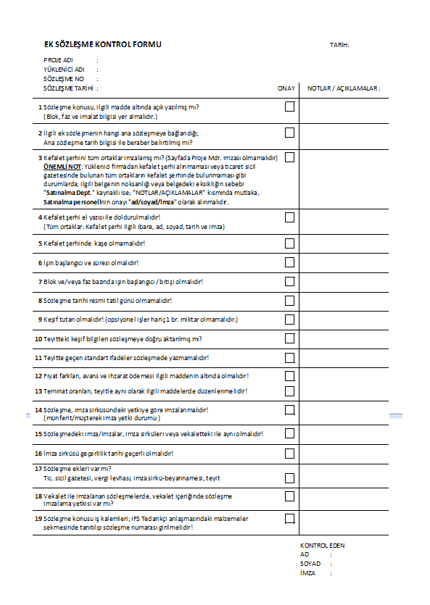This week, generally I worked with contracts. Contracts' control procedure is different than the progress payments.

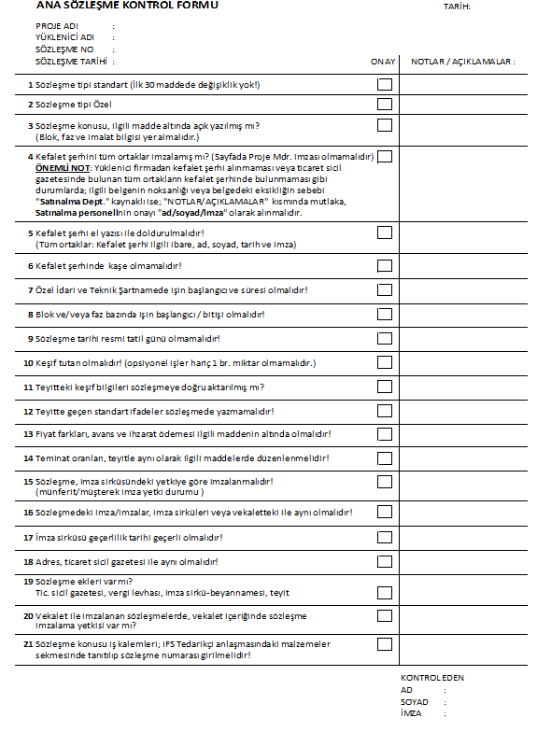

**Figure 17 : Control Forms of Main Contract and Sub Contract**

* Every contract should be controlled in the guidance of these control forms. Then, related person should take notes on these forms
* After missing or wrong parts of contracts are rearranged, signature of the that person must be put on these forms.

**4.INTERVİEW WITH SUPERVISOR**

Çiğdem Ustaoğlu is one of the civil engineers in the Production Planning and Cost Control Office. 28-year-old Mrs.Ustaoğlu has graduated from Yıldız Technical University's Civil Engineering department. She has started to work with Sinpaş for 5 years.

Firstly, I asked her experiences ,

" I finished my license program in 2012. In those days, I thought that working in foreign countries is the only way for a new-graduated engineer. I contacted with different companies; However. some of them did not return my applications, the others offered very poor conditions. So I changed my mind and I searched a job in Istanbul. When I was a student, I did an internship in Torunlar REIT. For the first time, I witnessed planning office work in there. After some job researches, I started to work in Doğa Kolejleri. Those days, Doğa Kolejleri had active constructions and I dealt with them from technical office. After 9 months, Doğa Kolejleri passed difficult days then I quitted from there. I contacted with IGA for Third Airport of Istanbul. I went to the interviews. Unfortunately, their offer was not enough to change my daily life. After that, I started to my Master Science in YTU in geotechnical researches. Right after I started to my MS, my application to Sinpaş REIT was accepted. I have worked here for 5 years."

Secondly, I asked her opinions about planning part of civil engineering.

" Because I did an internship in planning office, I had some positive thoughts about planning office works. However, now I can understand that if planning office gets bigger, the problems will be bigger. Big firms like Sinpaş REIT have lots of contractors. The large numbers of subcontractors create difficulty to communicate with people. If you cannot deal with people in this office, your work will not be done correctly. I can advise that if working hours, dusty-dirty construction sites are not problem for any civil engineer, site engineering is better than planning office. However, If an engineer really wants to be in planning office, firstly he-or-she should work in construction site's planning office."

**5.CONCLUSION**

Summer practice is a chance to start to be real engineer. During a year, students are learning theoretical topics. Theoretical basis of course essential but without practice, students will not be learn something's' workableness. First steps of the engineering is Internships.

When I contacted with Sinpaş for application to summer internship, HR people said that your place is ready in the planning office. However, I do not know what is going on in the planning offices. The only thing is that I know about planning offices is they pay the money to contractors.

Beginning of the practice days, I had difficulties meeting and speaking with the engineers in the office because they had lots of the work to do and they could not spare time to me.

Day by day, thanks to Mr.Bideci , everyone tried to show me something. Then, they started to give work to me. While I were working on them, I asked questions continuously because there were lots of things that I did not know.

Generally, I worked with preparing, controlling and archiving contracts, checking of progress payments, taking quantity takeoffs. If I will face with them in future, I can overcome their difficulties.

In conclusion, summer practice is the important step for being an engineer. Two obligatory internship is a good chance; However, 30 work days are not enough to learn basis of works. Duration must be stretched out. Both site and office practices must be extended to 40 work days.