## C:\Users\mc\Desktop\ODTU.png

## MIDDLE EAST TECHNICAL UNIVERSITY

## DEPARTMANT OF CIVIL ENGINEERING

## CE 4002

## BIM and Its Applications in Construction

## 

**Advantages of BIM Usage for Site Management**

## 

Submitted by:

ID:

Section: 01

Due Date: 11.01.2016

Table of Contents:

1. Introduction: 1

2. BIM for Site Management: 2

2.1. Improved Site Planning and Coordination: 2

2.2. Improved Site Monitoring 4

2.3. Safer Construction Sites 7

2.4. Prefabrication 9

2.5. Cost Estimation 10

3. Discussion: 12

4. Conclusion: 13

5. References: 14

# 1. Introduction:

When we look to construction sector, it is rapidly growing and managing all phases of the construction project becoming very hard by using traditional methods. Instead of constructing regular apartment building we are construction building complex, instead of constructing only one office building, perhaps we need to construct huge home-office skyscrapers and obviously these are results of increased people needs. However using traditional methods are not helping us to meet those requirement easily, since they have not any practical improvement.

Needs for both construction and non-farming products are increasing. Since construction can be fabricated like non-farming productions, expecting same productivity from both might be unrealistic. However there is slight decrease in construction productivity between 1964 and 2012 according to US Census Bureau’s statistics. There must be innovations to meet customer needs and accelerate construction productivity.

Collaboration and support of technology might be the two of the most important key factors to compensate 50 years long decrease and go further. Creating common interface for all parties involved in same job have not practically adopted in construction business and people are accustomed to their own job in closed environment. However, with there is huge interest to relatively new process which is building information modelling (BIM). Staring with US, England and Australia not only governments but also owners are looking for BIM based projects.

Building information modelling (BIM), is continuously spreading in construction business. It is a process which all stakeholders get benefit from during the designing, planning, construction, managing phases of infrastructures. BIM creates more than just CAD files. With the developed power of computing technology, now it is possible to create intelligent models to use them for many different purposes. BIM allows all participants such as civil engineers, architects, mechanical engineers and owner work on the same platform. Unlike old fashion technologies, it is dynamic model which always provides consistent and coordinated information throughout the lifecycle of the project.

# 2. BIM for Site Management:

After completing the design part of the project, site is the real place that all planned elements will be constructed. The relation between designing and constructing is similar to the relation between recipe and kitchen. In that situation the more chef is experienced the more our meal will be delicious. When the customer is be satisfied with his/her meal, result would be a happy ending for both owner of the restaurant and chef.

Same linkage exists in construction business and that is why all of the construction companies seek of experienced site engineers. As the time passes by, complexity of the construction projects are increasing rapidly. Considering uniqueness of the every construction project, even for the well experienced engineers it might be very challenging to deal with highly interconnecting factors that affects overall convenience planning of the site. In this report, advantages of BIM applications for site management will be discuss for different subjects.

## 2.1. Improved Site Planning and Coordination:

Planning and coordination at the site are two key factor for effective time management. Beside the construction of drawn project there are many issued to reach ideal site coordination such as arranging suitable material flow, use of huge field equipments, different transportation paths, and communicate with people working at the site. This complexity result in a lot of assumption which are hoped to be correct. Any simplification or ignorance cause significant time and money lost or more tragically they might cause serious casualties.

Usage of traditional solutions which are relatively dependent on personal abilities cannot be systemized or developed. However building information modeling can be considered as optimal approach to overcome problems mentioned above. It provides several advantages for many different phases of site planning and coordination.

First of all, engineers will able to see 3D view of the site during the construction. This decreases required detailing drawings for specific production such as connection details. When project is sent to the site engineers go ever the project and request for information for missing parts of the project and getting new information from the office takes a lot of time depending on the project delivery method. In figure 2.1.1, currently used CAD drawing and one connection detail can be seen and it can be understood easily that it is not easy to view all connections without making any mistakes.

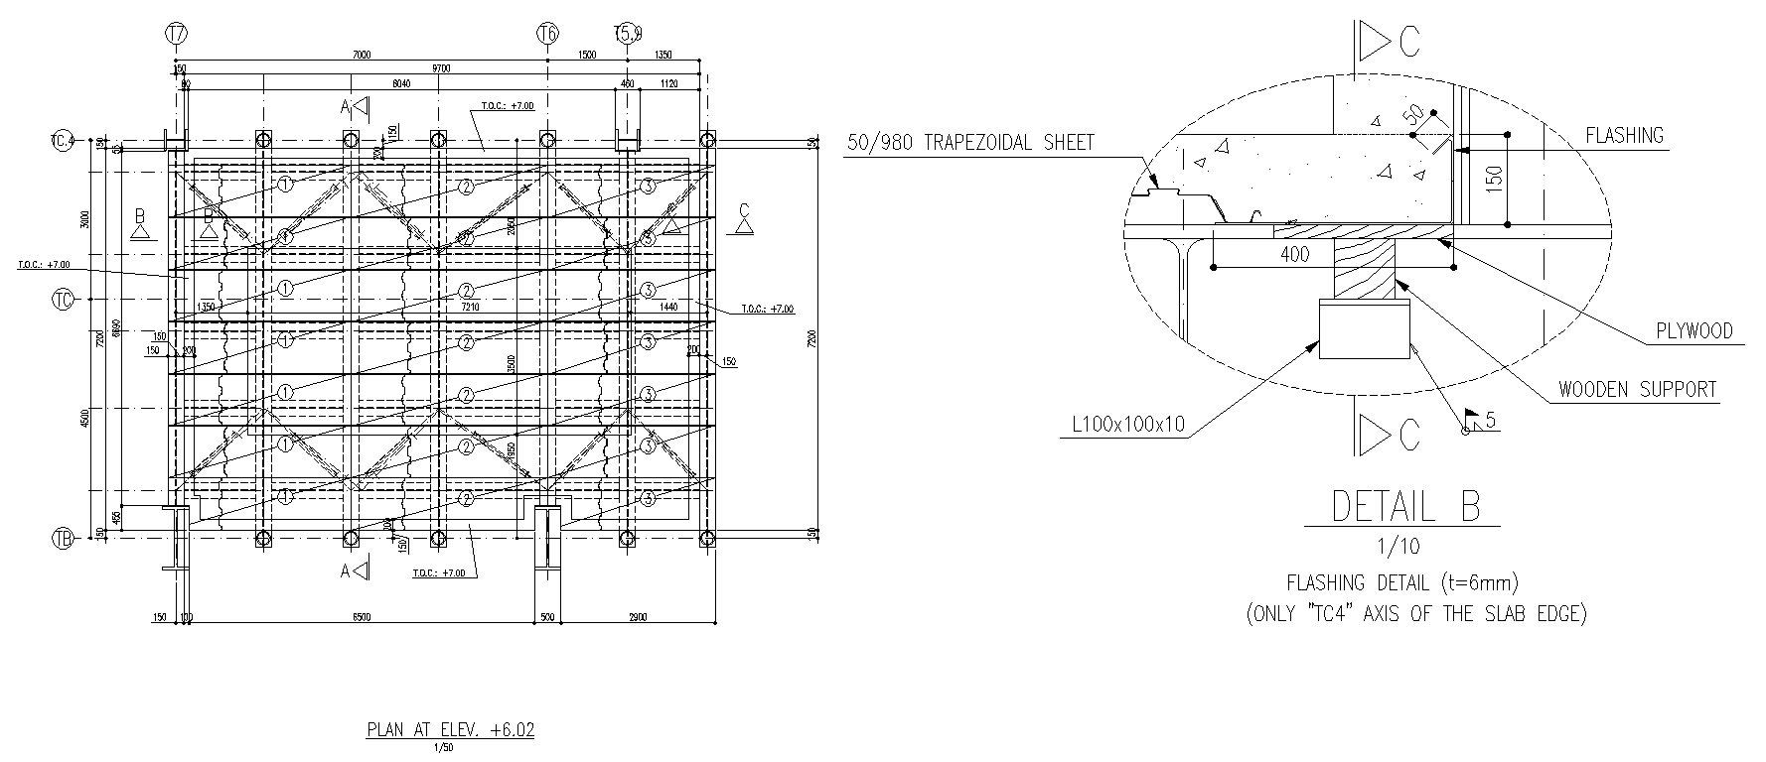

Figure 2.1.1: CAD drawing for deck plan and connection detailing.

On the other hand, if our BIM model is detailed enough, at the site we do not need any RFI and it will not cause any delay in the schedule. Unlike the example above, missing information might be more significant for our schedule or it might mislead us to give a wrong order. Since the purpose behind the CAD drawing is visualization, I believe that real 3D model would be more helpful for that purpose which can be seen in figure 2.1.2.

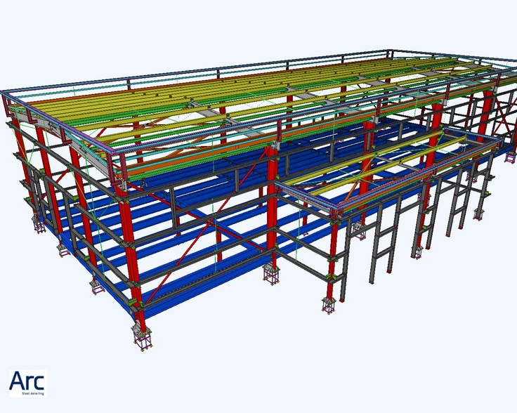

Figure 2.1.2: BIM model of steel construction, [Norman Alcaraz](https://www.pinterest.com/normanalcaraz/), La Africana Central Termosolar, Córdoba, España

*Retrieved from:* [*https://www.pinterest.com/pin/498703358714325859/*](https://www.pinterest.com/pin/498703358714325859/) *on 03.01.2016*

Visualization will also help site planning in terms of real dimensions and shapes of site equipments. We can model cranes, pumps, stocking areas, trucks, oven real facilities near the construction site. For instance there might be conflict about arrival times of concrete truck and steel delivery truck and at that time there might not be enough space for all of them to fit in since site locates in very narrow part of the neighborhood. It is possible to make hundreds of hypothetical examples. Another example might be related to planned location of the pump. The rented or owned pump might not reach all parts of the building from one position and it have to be repositioned another side of the building. In that case ıf the only one side is suitable for pump location, it will stop everything until engineers find an optimal solution. Those kinds of problems are very likely to occur in real practice and BIM helps engineers to make more sensitive analyses at the site in terms of most of the significant unpredicted issues. Moreover BIM provide developed communication all participants at the site. People working at site simply use cellphones to communicate and solve identified problems. Problem might be related to schedule, design or material delivery. When two people solve a problem on the phone it will be solved for only these two people not for the all project crew and it is the sign of huge coordination problem.

Usage of BIM provides common interface for all participants working at the site to communicate in qualified environment. Problem will be solved before it occur at the real construction site without causing any delay. More coordinated site and more realistically planned working details are right in front of us thanks to BIM.

## 2.2. Improved Site Monitoring

Site monitoring is very important for collection date from ongoing operation at the site. Likewise accuracy and correctness of the tracked data have significant effect on decision making and progress record. Current methods for monitoring is manually taking pictures and trying to match actual process with planned process. Even engineers take picture and give reports, these might not be enough to understand real progress. Consider figure 2.2.1 and sentence “50% of the dam body is completed.” in the received report. Is it 50% of the planned height of the dam? Or is it 50% of the planned labor hours? Or is it the 50% of the actual works to be done? Those questions must be answered to come consistent result about actual progress.

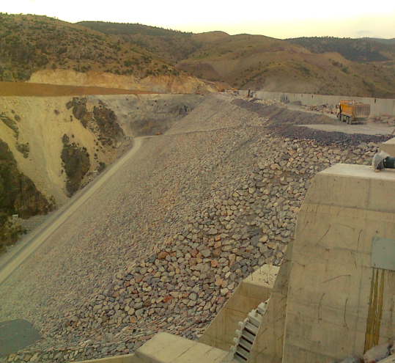

Figure 2.2.1: Picture taken from dam body progress report.

I completed my one of summer practice at AHİ Channel project in Konya. The cannel was about 126 km long and one of the site engineer responsible for progress recording. He travelled to some parts of the cannel which was under construction at that time generally twice a week. Since site was spread 126 km long area and there were no side road, it took one complete day to visit and take pictures of going construction operations. On the top of all, these pictures does not mean anything by their own. When the responsible engineer arrange them according to his preference, it would be very difficult to reach desired data for another person and he will the only one how can report photos’ real meaning for actual process. Figure 2.2.2 might give an idea how those photos can be complex regarding with file names. Data is completely subjective.

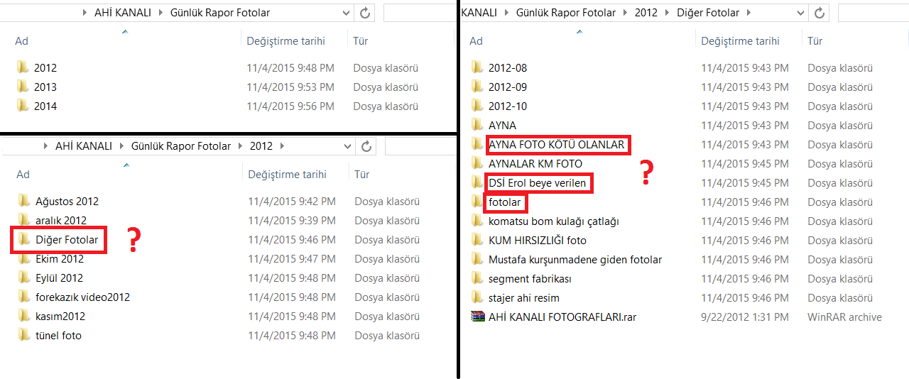

Figure 2.2.2: Some monitored data files from site engineer at AHI Channel

As manual monitoring can be disorders, it is time consuming and labor intensive. If we consider site engineers work 28 days in one month, the responsible engineer will take only photos during the 30% of those days without connect them to real schedule progress data or daily construction reports.

Another problem about manual monitoring is incorrect information about progressing operations. In huge construction projects a lot of subcontractors are working together. In the case of BOT delivery method government give the project to subcontractor and it is the one that responsible party from all operations. Considering AHI channel project DSI was responsible for checking subcontractor. Since there were no continuous monitoring, subcontractor did not send photos of problematic issues to DSI. Like mentioned the previous example, tracking the workers is not easy job.

Fortunately, BIM gives us a change to convert this unrealistic and labor intensive situation to opposite. It is possible to do automated monitoring by placing cameras at the construction site. By doing so, reliability of monitoring is increasing obviously. There are available software products that can link our 3D model to time. Not only the planned time, but also actual progress exists in the program which can be seen in figure 2.2.3. When people look at such a 4D model, all of them will understand same thing without of a doubt and any possible misunderstanding about planned and as-built progress will be vanished. BIM has considerable contribution to get dynamic site monitoring. Including BIM in to practical applications, we will end up with more realistic data during the construction phase and structures that we are sure about their real quality. Engineers can use their times to work on real engineering subject instead of wasting their time on repeating jobs which do not require any engineering knowledge.

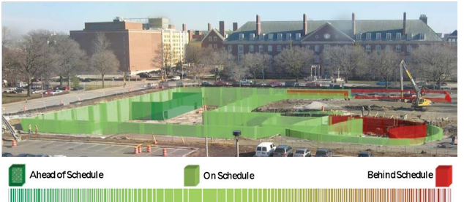

Figure 2.2.3: Data from real camera record and integrated into 4D model.

*Retrieved from:* [*https://thebimhub.com/2015/12/10/the-integration-between-4d-simulation-mobile-tec-2/#.Vo7eo_mLRD8*](https://thebimhub.com/2015/12/10/the-integration-between-4d-simulation-mobile-tec-2/#.Vo7eo_mLRD8)*, on 03.01.2016*

## 2.3. Safer Construction Sites

Managing the safety at the site is very crucial since construction site is one of the most dangerous working sites in the world and site manager is the one responsible every single accident. Traditional safety planning relies on manual based applications. We combine 2D drawings with previous observations to create safe working site. Also ‘safety’ means different than its old meaning. For instance, in past years number allowable of deadly accidents can be defined according to total cost of the project but today ‘zero accident’ rule is been applying in Turkey. As projects get bigger and bigger, the rules get stricter. Handling all possible safety issues automatically addressing to new approach to deal with safety at the site.

First of all, 4D modeling provide developed visualization of the site. With effective use of BIM based software programs, we can even simulate people and make him to walk in the model like in real site. When we complete our model to be sure about some critical locations that we cannot forecast workers safety easily, we can check it from the model as in figure 2.3.1.

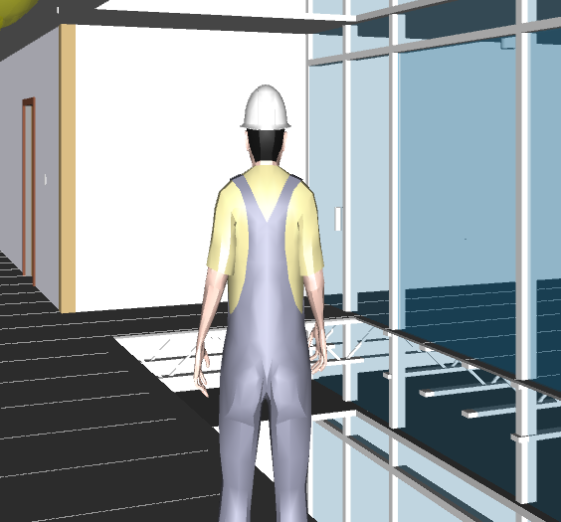

Figure 2.3.1: Third person in the Navisworks in realism view.

Moreover, it is also possible to create manuals for workers with more visual details. They can learn from those manuals more easily and with better understanding accident probability will be decreased. Furthermore, there are written standards, guidelines and checks list to meet safety requirements. Going over legal safety procedure manually does not match dynamic construction environment such as schedule changes, extensive storage of materials because of prior delay or possible hazard. BIM allows engineers to do rule checking automatically during both planning and constructing phases. Model will fail or pass under the current conditions. However making the model effective, interface requires understanding of safety and experience to set the rules. One example of rule based checking simulation can be seen in figure 2.3.2.

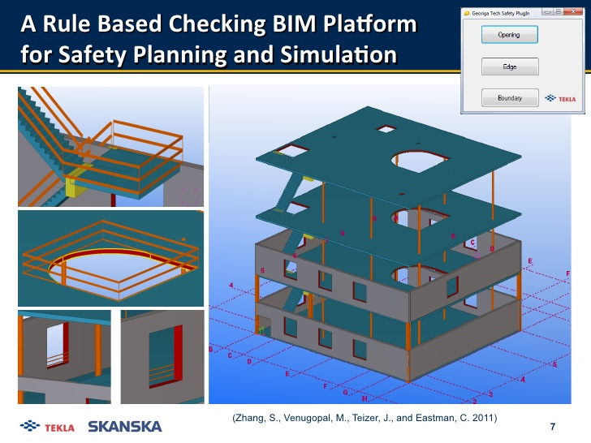

Figure 2.3.2: Tekla rule based checking BIM Platform for safety planning and simulation.

*From Zhang, S., VEnugopal, M., Teirzer, J., and Eastman, C. 2011*

## 2.4. Prefabrication

Prefabrication is relatively new subject in construction sector. It is fabricating some parts of the project at some other place than the construction site. Construction projects includes both mechanical and electrical mechanism to make structure metaphorically living. All of the structures need both mechanical and electrical connections for transmission in the building. In the traditional planning phase with 2D drawings of mechanical electrical and structural project are separate. By following old approach, prefabrication of any element is not possible but with support of the BIM prefabrication might be discussed since we have an intelligent model and we can get benefit from clash detection.

Traditionally mechanical equipments are produced at the site when their turns come. Therefore mechanical crew works at the construction site and it creates extra one team to be taken care of by site engineer for safety manner. Production of these equipments takes places after completing the construction of the related parts. Air ventilating system is usually hanged to the ceiling which create inefficient working conditions for workers. It can be seen in figure 2.4.1, it not the best position to get maximum efficiency but it is how it is with the traditional methods. Unfortunately he have to work at that position for every floor and for similar connection.



Figure 2.41: Mechanical worker connecting air ventilating system.

*Retrieved from:* [*http://www.pinchiffmechanical.com/*](http://www.pinchiffmechanical.com/)

On the other hand well organized planning phase with BIM has a great impact on construction site. Unlike traditional approach, all components and their real dimensions are precisely known before the construction starts and it allows accurate preordering or prefabrication. Since a buildings consist of same repeating components such as mechanical, electrical and plumbing system elements, it is possible to produce them prior to construction and we do not have to waste construction time to produce them at the site.

When the prefabrication is adopted, it will improve the quality of the installed components which reduce the effort to check those equipments at the site. There will be less amount of people and safer working sites and more space for other construction operations. Number simultaneous activities will decrease and site coordination will be more manageable. Because all elements are already produced, amount of waste material will decrease. It would create more environmental and less crowded site considering huge waste mechanical pieces. Since site is more coordinated and activity number decreased, possibility of delay is decreased and it implicitly provides time saving.

## 2.5. Cost Estimation

Cost estimation is one of the important subjects in construction business. Owner is looking for the constructor which can satisfy owner’s needs with the minimum amount of money. On the other hand constructer must have some desirable amount of profit from this partnership but meeting at the logical bidding price is not easy job. With the in accurate bidding price, bankruptcy is not that far from the constructor.

Traditional, project delivery methods have significant effect on that kind of situations. In the DBB delivery method there is no direct connection between designer and the constructor. Even constructor go over designed project before take the job, they might need revision at the site and every revision changes the first bidding price. Forecasting every detail by just looking at the 2D drawings is very difficult. No one can claim that s/he is capable to estimate the actual cost 100% for the project which will take 5 years to construct with thousands of CAD drawings.

Considering progress payment, the cost estimation is also part of the site management. Without any dependence to any external factors such as project delivery method, 5D phase of BIM is the most accurate way of cost estimation for both site and the head office. BIM provides better understanding by combining cost to dynamic model and schedule. Figure 2.5.1 can illustrate easily understandable interface of BIM in cost estimation.

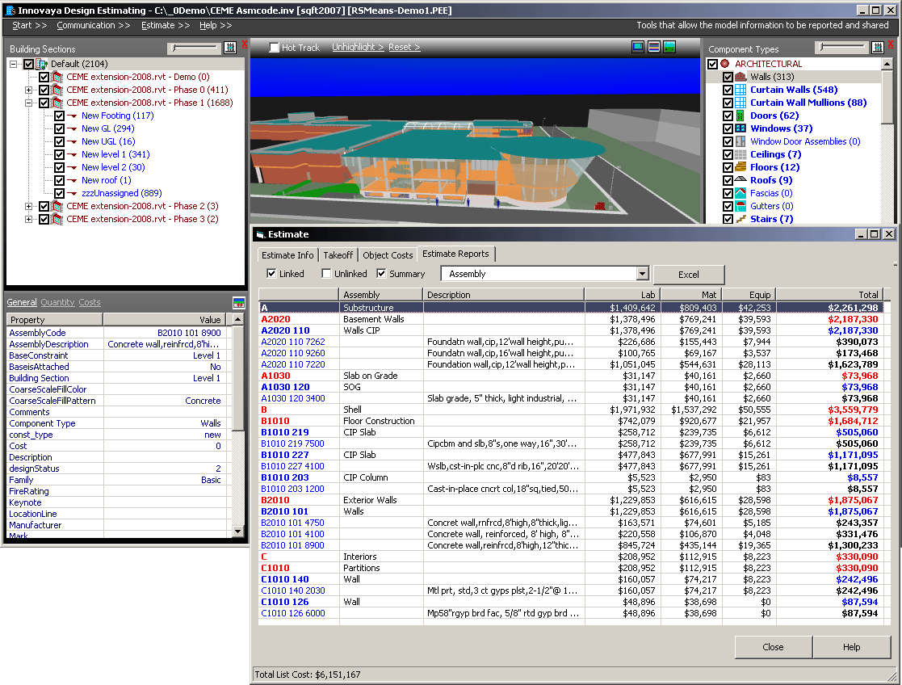

Figure 2.5.1: Cost estimation in ‘Innovaya’

*Retrieved from: http://www.pinchiffmechanical.com/*

BIM increases communication among the all parties involved in the project and it decreases inaccuracy in cost estimation also. With the minimum amount of omissions and less errors, both constructor and owner will be on the safe side. In addition, 5D cost estimation is beneficial in term of time-consuming and labor-intensive. Required time and effort for manual quantity takeoff for cost estimation is considerable more than BIM adopted cost estimation. At the site, engineers will spend less time on cost estimation and more time for real engineering problems. When the concern decreases about accurate cost estimation, engineers will become more comfortable about other issues and site will be more coordinated.

# 3. Discussion:

Building information modeling is continuously developing process. As itself, BIM gives people same dynamism. In my opinion, it might be one of the most effective triggering factors to emerge new ideas. With its high visualization, people can achieve their goals in short time. It has huge impact on practical applications and it can be adopted easily. The more people get benefit in a short time, the more they become willing to use BIM.

Besides the advantages that I discussed in the main body of this report, people more into this subject. There are a lot of new topics which are based on already accepted advantages of BIM. With the more interest of new generation to technology, BIM opens new limitless path for new researches. Most of the developed new ideas are suitable to try them at the site right after they are thought of. Improved collaboration, high visualization, parametric models, reduced labor intensive, increased quality of construction, faster delivery, easy and effective planning, quick and more realistic response to problems are some of the benefits of BIM adaptation. However, BIM have not completed its development and it is still under adaptation process.

When people see BIM’s capabilities and want more, meeting with imagined features requires high computing power and well developed coding to reach desired intelligence. Even it increases collaboration, there is still problems about interoperability. Software companies working to solve these issues. If one file can store all of the information it would be too loaded to operate, if it do not store some of the information it might lose its intelligence. Coding behind the BIM process might be improved. Moreover there is also standardization problem about BIM. It becoming commonly used tool but how we can codify some significant boundaries to be consistent? Starting from the early adopters of BIM, governments are working on that subject too.

Lastly, adaptation is one of the most significant problems. Not all of the people are willing to charge their working system that easy. Since collaboration is very significant, BIM should reach from low skilled to highly skilled jobs in the construction environment. Since BIM is not only a designing tool, people should understand the principles of BIM and it might require huge time.

# 4. Conclusion:

In this report, advantages of BIM for site management is discussed under different subtitles which are namely improved site planning and management, improved site monitoring, safer construction sites, prefabrication and finally cost estimation. In the future of BIM, creating not only structures, but also creating whole cites with BIM might be some development that we will face. It provides limitless spec to be come with new ideas. Both being aware of its boundaries and advantages, we can make things easier but BIM is not a tool to replace with humans and it is not perfect and complete. As a senior civil engineering student, I was able to see BIM’s advantages by linking published researchers to my observations from real life. I had also change to apply BIM process to Designing Together computation and master my skills. Personally I am very satisfied with BIM concept and its advantages. It gave me a lot of new thought to apply in my professional life. Site management might have complete new identity with BIM adoption.

# 5. References:

* Astour, H., & Franz, V. (2014). BIM-and Simulation-Based Site Layout Planning. *Computing in Civil and Building Engineering (2014)*.
* Golparvar-Fard, M., Savarese, S., & Peña-Mora, F. (2010). Automated Model-Based Recognition of Progress Using Daily Construction Photographs and IFC-Based 4D Models. *Construction Research Congress 2010*.
* Korman, T., & Lu, N. (2011). Innovation and Improvements of Mechanical, Electrical, and Plumbing Systems for Modular Construction Using Building Information Modeling. *AEI 2011*.
* Mitchell, J. (2015, April 23). BIM and Prefabrication: The new revolution. Retrieved January 3, 2016, from http://buildingsmart.org.au/bim-and-prefabrication-the-new-revolution/#.VolV2vmLRD9
* Plebankiewicz, E., Zima, K., & Skibniewski, M. (2015). Apparent labour productivity levels, information industries vs. total economy, 2012. *Creative Construction Conference 2015*.
* Teicholz, P. (2013, March 14). Labor-Productivity Declines in the Construction Industry: Causes and Remedies (Another Look). Retrieved January 4, 2016, from http://www.aecbytes.com/viewpoint/2013/issue_67.html
* Zhang, S., Teizer, J., Lee, J., Eastman, C., & Venugopal, M. (2013). Building Information Modeling (BIM) and Safety: Automatic Safety Checking of Construction Models and Schedules. *Automation in Construction,* 183-195.