

**CE 4002**

**BUILDING INFORMATION MODELLING**

**BIM for Site Management**

**Name:**

**Surname:**

**Student Id:**

**Section:** 01

**Table of Contents**

**1)** **INTRODUCTION** 1

**2)** **MAIN TEXT** 3

**2.1 4D-Planning, Monitoring and Coordination with BIM in Site** 3

**2.2 Cost Estimation with BIM-5D in Site** 6

**2.3 Prefabrication** 8

**2.4 Safety on Site** 9

**3)** **DISCUSSION** 10

**4)** **CONCLUSION** 11

**5)** **REFERENCES** 12

# **INTRODUCTION**

Site management is one of key element in construction as well as design process, so site manager should have significant skills and experiences to be able to coordinate different stakeholders simultaneously because as we all know, construction is complex and challenging progress which contains a lot of participant in itself. Because of being responsible for all works in construction field, being site manager is really stressful job. During the construction, time is considered as a money by contractor or subcontractor because they earn money in return what they have done. Thus, any delay on work means loss for contractors. Site managers aim to finish construction without any loss as soon as possible.

In order to minimize errors and conflict in site, new approach has been considered called building information modelling which ensure collaboration of all participants and enhance the quality of work. In other words, BIM modelling can be described as digital platform which enables stakeholders to become aware of their stages of works, and provide environment them for communication to exhibit seamless and smooth work with more efficiency and economy since the main reason for consuming time and money is directly related with lack of communication between stakeholders.

What are the features of BIM, and what using BIM brings with? These are main questions have to be answered to understand it more clearly. According Bureao of Labor Statistics Department for, all industries labor productivity, non-farm, except for construction show significant increase with developing technology; however, construction labor productivity could not grow with same acceleration as it is seen in figure 1 because adaptation of technology is becoming hard in construction sector. The first reason is that collaboration in traditional approach could not be enough to increase productivity. 2D drawings and CADs do not have capability of promoting the collaboration. The other reason is quality of works and labor productivity depend on many things such as properties of material, location, team members etc., so same procedure could not applied for new structures because they vary from each other even all design features and participants remain same. That mean, each project is unique. In order to increase labor productivity, new approach conducted for construction sector like BIM which provide owner pre-construction benefits, design benefits for designer, construction and fabrication benefits and post construction benefits.

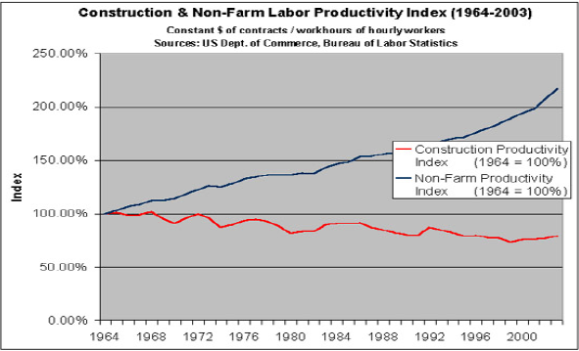

Figure 1. Construction and Non-farm Labor Productivity Index

*Retrieved from: Benefits of Building Information Modelling For Construction Manager*

In traditional approach which is being used, now, 2D drawings and CADs are main element for construction. Engineers and architects execute their job independently and without collaboration. For example, using with these drawings, it is not possible to make detailed clash detection in prior to construction, so when there will be conflicts between mechanical electronics plunging system (MEP) and structural elements, additional cost and extra time are needed to overcome it.

Moreover, BIM provide visual demonstration of construction phase with respect to scheduling in prior the construction physically. That mean, it gives opportunity to design virtually buildings on programs, simulate and analyze the buildings in order to overcome possible encountered problem during construction time, and see steps of work.

# **MAIN TEXT**

The main advantage of using BIM in site management is ability to obtain virtual design before starting the construction so that it provide site manager and other parties better understanding and knowledge to perform site works effectively. On the other hand, architect, engineers, managers and other members attend the BIM meetings for site management, and by this meetings, experienced participants can share their knowledge on their job, and with this, collaborative environment in jobsite might be established.

## **2.1 4D-Planning, Monitoring and Coordination with BIM in Site**

The process of synchronization of design and scheduling is coming from the integration of 3D model and schedule. This gives us great ideas about site logistics and building site operations. All monitoring and coordination is handled with scheduling and planning.

Monitoring of jobsite has great importance for both owner and site manager. All works have to be documented daily to identify the level of construction and other issues. In traditional way that we are using now, field engineers are responsible for reporting daily works besides managing site. However, when the construction size is becoming complex and larger, collecting data about site and works related site will become harder because at same time, it is not possible to access some area under extraordinary conditions. All these leads to problems between contractor and owner because owner always would like to see the stage of work.

Fortunately with BIM, site manager can compare easily the real work done in construction yard with simulation which is prepared with schedule of project. Cameras are being used to serve for monitoring purpose, now. Even in market, some programs that is able to interwork with recording and simulation exists. Schedule is prepared with critical path method where all activities are linked to each other. Therefore, duration, start and end date of activities are determined, and identified before construction. Simulation indicates the actual level of construction, so combining the records and simulation gives us great facilities. Help with this, site manager is able to follow activities and compare actual and anticipated works durations easily.

On the other hand, there are some consequences of monitoring on workers because all things that they exhibit in construction are followed, so they may be uncomfortable from this issue. Although, I believe that the safety of construction is also increasing in our country with monitoring, they are too disturbed. In order to overcome this problem, first the construction teams and crews must be educated with all construction manners especially safety manner.

Moreover, construction does not consist of only workers, but also vehicles which are used to serve for lifting, carrying or excavating the materials. Because of that reason, coordination is very important to provide traffic access for trucks, excavation or location of cranes, working efficiency of vehicle and area occupied in operating which have great importance to proceed to site works seamless. In other words, they should not disturb anything in construction yard or neighborhood during construction. In addition, at some time, cranes must be work in synchronization to lift large and heavy items like anchor box for large bridge like in following figure from my first summer practice, so simulation is important to detect these issues in order to place cranes wisely in prior to construction.

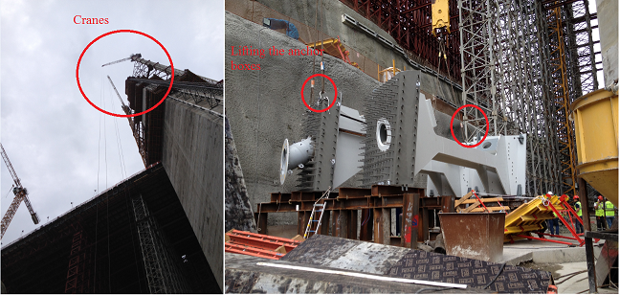

Figure 2. Lifting the Anchor Box with two cranes

Other concern might be determining the order of works in site. Let’s assume that we have construction yard which has one way to access. If construction starts from the access region, then the remaining part could not be completed due to inaccessibility of location. Simulation also gives ideas about order of works, or starting point. On the other hand, in plants and industrial construction like factories, the order of works is very important since heavy and large equipment is needed to be installed and carried in factory. For example, in prior to construct the interior wall, large equipment must be placed in room or chamber.

In addition, site crowdedness is other issue that site manager is responsible for. Crowded area make things more complicated because there is not much enough area to work freely. As well as vehicle crowdedness, labors number is too important for work efficiency. The higher number of workers decreases the workspace. Thus, the work efficiency and quality of work reduces. I show a graph which explain the relationship between crew size and labor productivity, and it is shown in following figure.

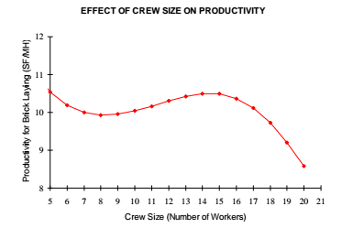

Figure 3. Relation between crew size and productivity

*Retrieved from: Ce 402 Lecture Notes*

Site manager has chance to see crowdedness help with BIM so that he plans to get rid of unnecessary or off-duty items, and is able to forecast for coordinating the site, workers or other equipment in prior to construction.

I have some experiences about these, and until now, I realize how BIM really helps to solve crowdedness and coordination problems. In North Marmara Motorway construction yard, I was assigned to work viaduct construction. Bored piles were placed at the bottom of foundation to reinforce the structure. However, some problems were confronted about lifting the reinforced bars placement because we did not have proper crane for lifting, and placing re-bars, and also, there was a distance between place of reinforcements fabrication and bored holes locations. At first, due to insufficient vehicles, digger known as JCB among construction business was used for carrying prepared re-bars. While carrying by dragging, re-bars was damaged because JSB could not lift at sufficient level. After that, due to not having crane, oger which is excavating machine for bored piles, was performed as a crane. This leads to a lot of time consuming in jobsite. If BIM approach was used in prior the project, we would not encounter with these issues.

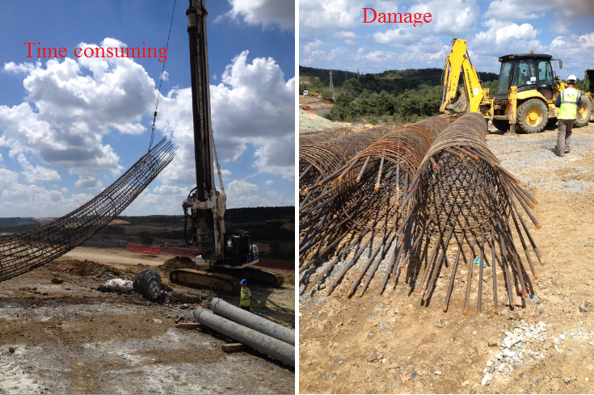

Figure 4. Placement of re-bars inside the bore hole for viaduct foundation

## **2.2 Cost Estimation with BIM-5D in Site**

There are two main steps for cost estimation those are quantity take off and cost estimating. The difference between traditional way and BIM approach is in quantity take off part because in traditional approach quantity take off is carrying out manually, whereas with BIM, all members of buildings properties in volume, area, types can be exported to Excel thanks to the intelligence of this system. It assigns identification for all members. In other words, programs realize the windows, doors or walls meanings. Help with these parametric information about buildings, quantities are captured from the 3D model more precisely. The error caused from calculation mistakes can be minimized with parametric approach. Briefly, ability of BIM approach for cost estimation is to understand the model as a building from computer software. Although BIM approach offers us these facilities, cost estimators should use their own engineering judgments because BIM does not determine costs automatically. For better understanding, quantity take off example is shown in following figure.

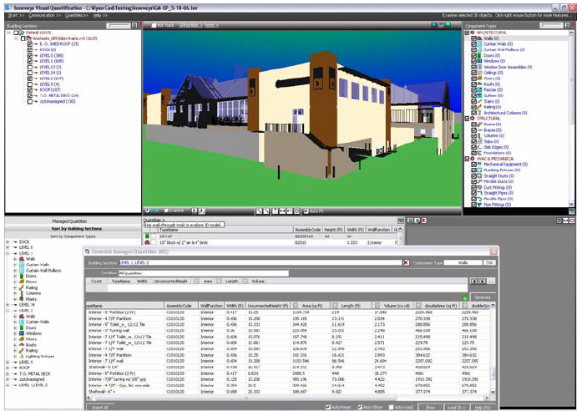

Figure 5. Example of calculating and counting material in Innovaya

*Retrieved from: Cost Estimation Document prepared by Autodesk*

What are the advantages of BIM cost estimation on site? The first one is absolutely time saving in adaptation of changing. Let’s assume that we have a complex construction. The geometry of buildings is also too complex and there are many different stakeholders to carry out site works. When something is changed in structure during construction, costs and all other parts depends on changing will change. With BIM’s intelligence which provide to update all structure documents regarding changes, it is easy to handle and deal with these cost and other dependent problems. Still, due to having complex construction, basic calculation may become difficult like determining the volume of concrete. If concrete is planned to be cast, concrete is ordered from the plant with certain amount, and with respect to this amount, progress payment and other costs are determined at the end of month. Unless the calculation of these things are performed without making any error, unnecessary money consumption will be observed, and these waste materials means money for contractor or owner. BIM approach minimize these minor error, and prevents the wasting money.

## **2.3 Prefabrication**

The importance of prefabrication is reducing the labor cost and preventing the time wasting, minimized the delays, improving the safety, and increasing the quality construction. Lack of prefabrication is the one of main reasons why labor productivity in construction could not increase like others. Before prefabrication, ventilating-air conditioning systems and mechanical electronic plunging (MEP) systems are established in site. It leads to time-sink, and also, at some time, some reworks due to clashes have to be performed in order to be placed these systems. However, prefabrication enables us to set up complex because it reduces the needs of experienced labors. Therefore, labor cost is decreased.

Safety is another issue in prefabrication because laborers work under dangerous circumstances. Unconfined electricity cables or height of working level could be reason for low safety. With prefabrication, possible dangers are prohibited, and safety is improved.

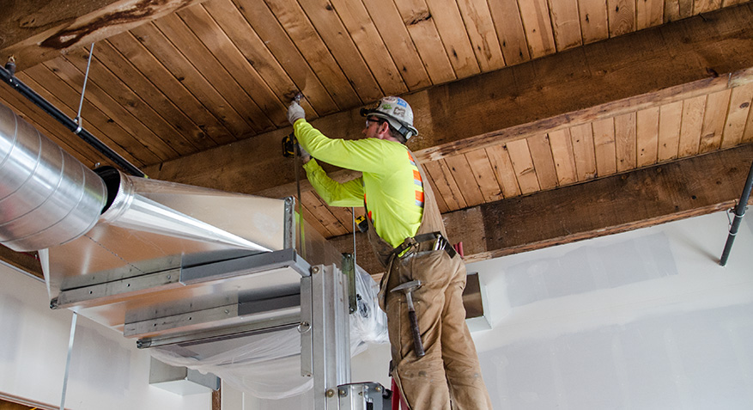

Figure 6. The example of working in unsafe position

*Retrieved from:* [*http://www.pinchiffmechanical.com/*](http://www.pinchiffmechanical.com/)

Other things are minimizing the delays and improving the quality of work. We can perform all these site works with saving time and qualified. However, in order to perform site works precisely, more than one tools and options are readily used. However, construction team should ensure that fabricator use the software congruent with BIM because there must be no differences between fabricated and designed items. If there is, items could not fit once on its place and leads to additional cost and time. Besides, fabricators remain loyal to the scheduling. Any delay on construction means time and money loss for contractor. On the other hand, when fabricated products are delivered to the jobsite before its time, protection of these should be provided well especially they are frangible like curtain wall.

## **2.4 Safety on Site**

Safety has great importance in construction industry due to the every tasks of construction which are generally hazardous. Actually, all I mentioned subtitles are connected each other because if the planning is performed precisely, hazardous placed will detected and precautions will be taken before construction starts. Especially, in our country, we are famous for accident in site yards due to lack of attention on safety manner. Almost every two weeks, we encountered with accident in construction or some other business.

Fortunately, BIM has great effects on improving the safety in site because with great visualization chance in all phase of construction, safety manner is also controlled before starting site works. BIM enables us to create avatar who looks like real worker, so this allow us to move around the buildings freely so that dangerous places can be detected, and precautions are taken for this areas.

In addition, specific risk assessment data exists in this system for different position in construction yard. When created avatar the dangerous position in site yard, safety management items are shown on the screen. Possible dangers are defined there, and explain whether the labor can work specified place, or not.

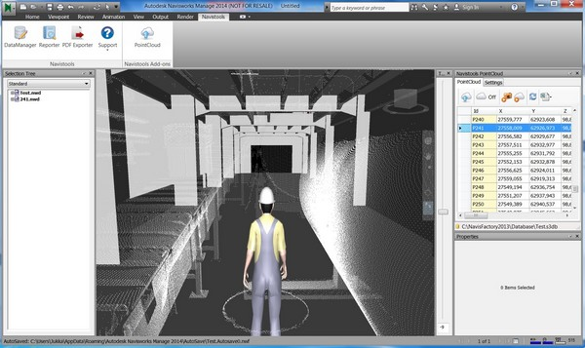

Figure 7. Safety Management System with Avatar in Naviswork

*Retrieved from:* [*http://www.codemill.fi/navistools/help/Using%20PointCloud.html*](http://www.codemill.fi/navistools/help/Using%20PointCloud.html)*, on 08.01.2016*

# **DISCUSSION**

Building Information Modelling is particular new approach that brings in countless facilities in construction industries. There a lot of benefits coming with BIM, but especially, it made significant contribution to site management, which were discussed at main body.

Although there are many advantages that BIM gives us with monitoring, coordinating, safety manner, prefabrication etc., more improvements are needed to be done in order to make this process easier and for better understanding. This approach is different than usual because ability to handle all indication of works together make construction process on software more complicated especially in our country.

By nature of our people, we have always problems in adopting new things. Our designer firms or contractor teams or workers get used the 2D drawings and CAD. For example, designers may not want to change their systems because they should train their crew with BIM approach. They have to pay attention if they want to use this, but this takes much time. Therefore, designers may resist to changing in order to escape first adaption troubles.

On the other hand, in part 2.1, I shared my thought and knowledge on monitoring process. I said that workers may be disturbed by monitoring because all things that exhibit on site are recorded. In our country, workers usually do not obey safety rules. For example, they generally refuse suiting helmet. With monitoring, these issues will appear. In order to overcome this problem, before adapting BIM process, first, workers and other crews must be trained with site safety manners.

On the other hand, if we talk about BIM more general, some other problems may appear. BIM approach consists of collaboration of more than one program, and for each program, different errors and difficulties exist. For example, making a mistake in 3D model is conveyed to 4D parts. Due to dealing with countless parameter and data, users may be in trouble in finding error in 3D model.

Finally, for BIM approach, there must be valid and current specification for all users in order to provide better collaboration between them.

# **CONCLUSION**

In this report, I try to explain and share my knowledge based on some academic articles published about facilities of BIM in site management. It is certainly understood that BIM approach enhances the process of before, during and after stages of construction.

Adapting the BIM seems inescapable. In USA, for large and complicated project, government request it, while in England, government give their construction firms few years for transition and adoption to BIM. On the other hand, major companies in our countries are using, now this approach in order to regulate works.

Finally, BIM improved my vision, and engineering judgment. I attended competition called Design Together organized by ITU. At some time, we have to make critical decision on scheduling or other part of construction. I realize how our judgment and vision improved with BIM approach while making these decisions.

# **REFERENCES**

* Autodesk. BIM and Cost Estimating
* Ce 402 Lecture Notes
* Cho, H. & Lee, K. H. & Lee, T., Jun Cho, H. & Hoon Kim, S. & Hyeok Nam, S (2013).Introduction of Construction Management Intagrated System Using BIM in the Honam High-Speed Railway. *Civil Engineering Technology Department, Ssangyong E&C, Seoul, Korea*
* Chowdhurt, G.K. Building Information Modelling in Site Management
* Collins, R. & Zhang, S. & Kim, K. & Dr. Teizer, J. (2014). Integration of Safety Risk Factors in BIM for Scaffolding Construction. *Conference 2015*
* Deke Smith. Introduction to Building Information Modelling. *Journal of Building Information Modelling.*
* Hergunsel, M.F. (2011). Benefits Of Buildings Information Modelling for Construction
* Manager and BIM Based Scheduling. *WORCESTER POLYTECHNIC INSTITUTE.*
* Maki, T. & Kerosuo, H. (2013). Site Managers’ Uses of Building Information
* Modelling on Construction Sites. *Institute of Behavioral Sciences, Center for Research on Activity, Development and Learning,University of Helsinki, Finland*
* Patrick Mays (March 06, 2015). The Advantage of Prefabrication for AEC.

[*https://thebimhub.com/2015/03/06/the-advantages-of-prefabrication-for-aec/#.Vo-OafmLTIV*](https://thebimhub.com/2015/03/06/the-advantages-of-prefabrication-for-aec/#.Vo-OafmLTIV)

* Plebankiewicz, E. & Zima, K. & Skibniewski, M. (2015). Analysis of the first Polish BIM-Based cost estimation application. *Creative Construction Conference (2015)*