**BIM FOR SUSTAINABLE CONSTRUCTION**

**Introduction**

In recent years, Building Information Modeling (BIM) is seen as a promising development in the construction industry. BIM enables improvements in project quality, accurate scheduling, quantity take-offs and cost estimation. Also, BIM provide good collaboration between the different disciplines. It means that in the preliminary design stage, all the members who are related with the project can involve in decision making process. With the help of animation features of BIM, visualization is easier than traditional methods so workers can understand their responsibilities more easily. Also, the visualizations can ensure for the engineers or designers to detect problems clearly. Therefore, with the help of BIM, the constructability of a project can be checked in the design stage so solutions can be generated if they are necessary. The purpose is to construct more efficient structure. Smart usage of resources and energy optimization are aimed with the efficient structures. Moreover, BIM provides shorter construction schedule, reliable cost estimations, better management and maintenance conditions, higher building values for the owners.

Global warming is a big issue for whole world so many industries try to find energy efficiency solutions for their industrial activities. Construction industry is the one of the biggest sectors that affects the environment with high usage of energy and creation of high amount of carbon footprint. According to “Center of Excellence for Sustainable Development” article of U.S. Department of Energy, Energy Efficiency and Renewable Energy Network (EREN) (2003), the energy consumption of commercial and residential buildings in US is approximately 40% of total energy in the country. Also, they consume 70% of total electricity, 40% of total raw materials and 12% of water resources in the country. The generation of greenhouse gas of these buildings is 30% of total and they generate 136 million tons of construction and demolition waste. As a result, energy efficient buildings are a requirement for the construction sector. For this purpose, “sustainable design” concept is rising in the sector. Sustainable design can be defined as minimizing environmental impacts of design, construction and operation stages of a project (Autodesk Revit White Paper).

In the rest of the paper, the sustainable design and sustainable construction will be described in detailed. Also, the relationship between the sustainable design and BIM is tried to be explained. At the end, some information about BIM applications in sustainability will be given.

**Sustainable Construction**

As it is mentioned before, the construction industry has to invest in the green buildings because of the global warming threat (Hertwich and Peters, 2009). The aim of the green buildings is defined as “environmentally responsible, profitable and healthy places to live and work.” according to U.S. Green Building Council (2004).

There were some attempts in sustainable design. Even these attempts have not reached the success, they have provides some improvements. For example, in 1993, the U.S. Green Building Council (USGBC) was come to light. They create a widely used sustainable design standard which is called LEED (Leadership in Energy and Environmental Design) Green Building Rating System. Site design, indoor environmental quality, efficient use of energy, water and materials are categories in this rating system (Autodesk Revit White Paper).

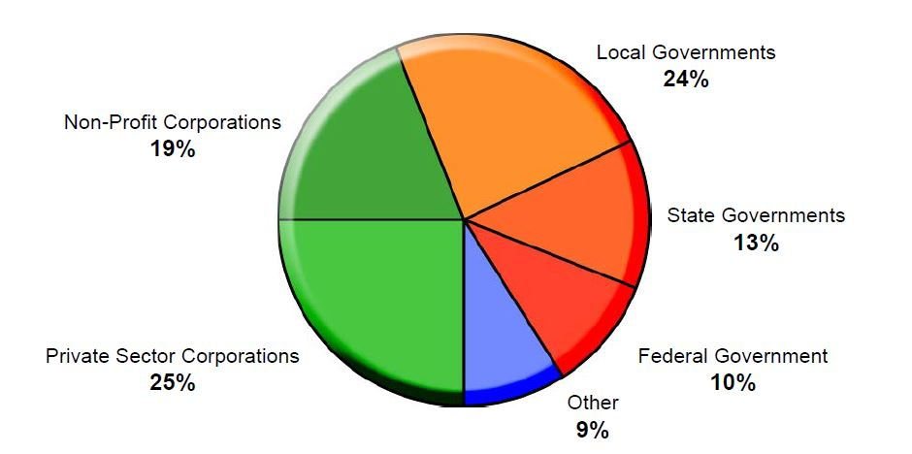

*Figure 1: LEED certification usage in sector (Autodesk Revit White Paper, p.2)*

Although LEED is mostly used in USA, some countries like Canada also accept LEED standards. There are other standard like BREEAM (Building Research Environment Assessment Method) which is used in UK, Eco-Quantum which is used in Holland and ecoinvent life cycle anaylsis methodology which is used in Swiss.

The expenditures of sustainable design depend on the project and green assessment standard which is used and can vary in a wide range. Sometimes, its cost may be very high. On the other hand, when life cycle assessment of a project is evaluated, sustainable design is seems as an economical solution.

To increase sustainable construction, these standards should be applied into design, construction and operation stages of a structure properly. In time, with the help of these standards and new construction methods, effects of construction sector on environment will decrease.

**BIM and Sustainability**

Building performance analyses and evaluations are costly and time-consuming with current traditional methods like 2D CAD because they are mostly dependent on human intervention. As a result, most of the buildings do not have building performance information. Because of the change of conditions in the world, building performance analyses gain more importance and the construction sector is in the search of a new practical method for these analyses. In this point, BIM gets into the picture.

Krygiel and Nies (2008) proposed that BIM can be used for analyses with the help of improvements in interoperability and interpolating of carbon tracker and weather data. Azhar (2011) suggested that building orientation, proper skin selection and also daylight analyses can be performed with the BIM in design stage. Moreover, during design stage, the evaluation of project about whether the construction and operation of the project is sustainable or not can be performed. According to Stadel et al. (2011), life cycle cost analysis can be carried out with the help of BIM software plug-ins.

When current situation of BIM is observed, these suggestions are not seems as utopias. In Revit, a structure is modeled with integrated information. It means that, the required data for sustainability analyses are defined in the design process. Also, Revit provides links the model to analyses software so the analyses’ result can be obtained simultaneously which enables to easily evaluate alternative designs to get an optimum solution. The amount of reused material, recycling and salvage can be determined with the scheduling features of BIM. Furthermore, visualization can help the client to make decisions about his/her project.

**The Interoperability between BIM and Sustainability**

Software companies develop environmental analysis software in order to be used with BIM to evaluate the performance of a structure. Between these software and BIM, a common file format, gbXML, is used for interoperability purposes. Also, some software can use IFC file format. In this part, some of the environmental analysis software are introduced.

*Autodesk Ecotect Analysis 2010*

It is published in summer 2008. The purpose of this software is to provide project information in design and preconstruction stages. It is a 3D platform with numerous sustainable design tools. The solar energy, daylighting, acoustical, thermal, etc. analyses can be performed for whole structure with Ecotect. It enables to determine the suitable location, shape and orientation of the building. It uses Green Building Studio web-based technology and the gbXML and IFC formats.

*IES <Virtual Environment>*

Integrated Environmental Solutions (IES) is published Virtual Environment (VE) software. The purpose of this software is to create design visuals for environmental purposes. Its models are similar to BIM’s. VE has some analytical tools for assessments:

* Mechanical
* Electrical
* Lightning
* Thermal
* Solar
* CFD
* Costs
* Value

It can work with SketchUp, Autodest Revit, Graphisoft ArchiCAD and other 3D modeling softwares. It uses gbXML/DXF file format.

*Graphisoft EcoDesigner*

It is a plug-in software which is used for Graphisoft ArchiCAD so its interoperability is quite flawless. It provides energy efficiency performance analysis in design stage of a project. It is not as detailed as other software.

*eQUEST*

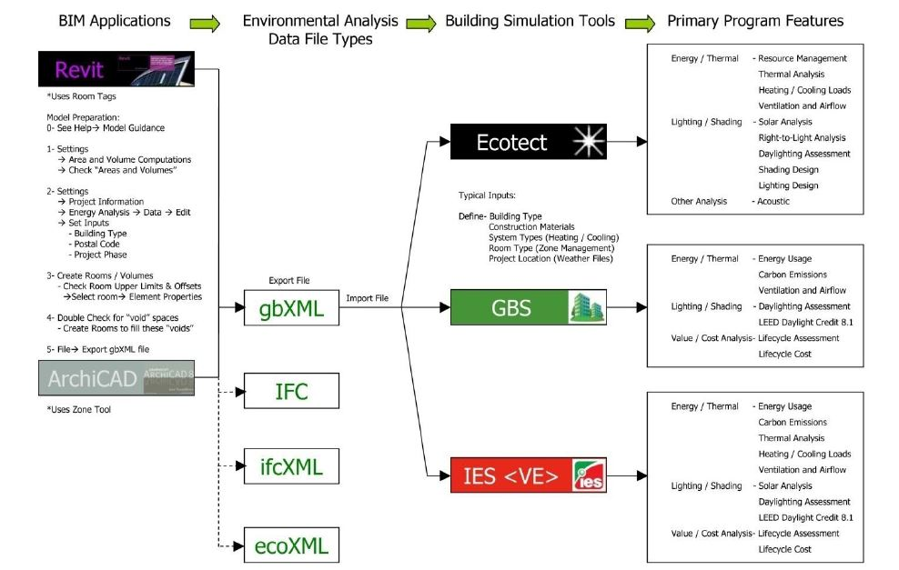Quick Energy Simulation Tool is published by US Department of Energy. It is designed for DOE-2 software. It provides online energy analysis for buildings. It uses the Energy-Efficiency Measures (EEM) Wizard to evaluate design alternatives. DWG files can be imported to software (Energy Design Resources, 2009)

*Figure 2: The Interoperability between BIM and Environmental Analysis Software (Azhar et. al.,2009)*

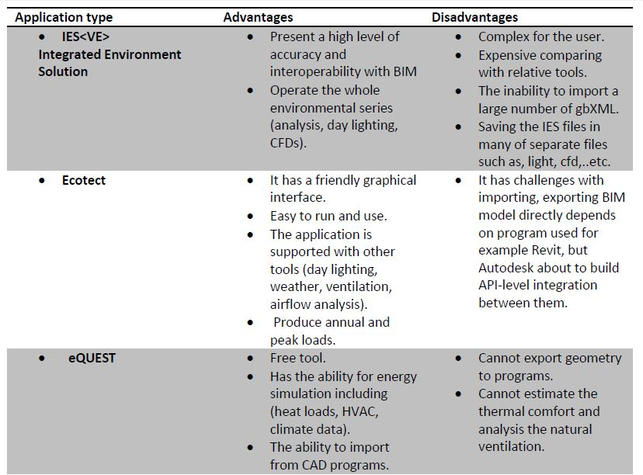

*Figure 3: The Comparision of Some Environmental Analysis Software (Alsaadi, 2014)*

**Conclusion**

Sustainability is one of the main requirements for industries, cities or communities. Especially, it should be a must in the construction sector. On the other hand, BIM is a promising platform for construction. It means that it should be continued to develop BIM in order to achieve sustainability standards. Also, the interoperability problems of BIM should be solved to perform more accurate structural and environmental analyses. The improvements in BIM technology and sustainability standards will enable to decrease the impacts of construction on environment in future. However, to achieve these goals, the contractors or the owners should agree to use BIM and follow sustainability standards.

**References**

Alsaadi, A., N. (2014). *Sustainability and BIM: the role of building information modeling to enhance energy efficiency analysis.* University of Salford-School of Built Environment. USA.

Autodesk, Inc. (2005). *Building information modeling for sustainable design.* Autodesk, Inc. White Paper. URL: [www.autodesk.com](http://www.autodesk.com).

Azhar, S.(2011). *Building information modeling (BIM): Trends, benefits, risks and challenges for the AEC industry.* Leadership Manage. Eng., 11(3),241-252.

Azhar, S., and Brown, J. (2009). *BIM for sustainability analysis.* International Journal of Construction Education and Research, 5:276-292.

Azhar, S., Brown, J. and Farooqui, R. (2009). *BIM-based sustainability analysis: evaluation of building performance anaylsis software.* ASC Journal. USA.

Bynum, W. P. (2010). *Building information modeling in support of sustainable design and construction* (Master's thesis, Univesity of Florida, 2010). Florida.

Bynum, P., Issa, R. R., & Olbina, S. (2013). *Building information modeling in support of sustainable design and construction.* American Society of Civil Engineering,139(1), 24-34. doi:10.1061/(asce)co.1943-7862.0000560.

Energy Design Resources (2009). eQUEST-The Quick Energy Simulation Tool. URL: <http://www.doe2.com/download/equest/eQUESTv3-Overview.pdf>.

Hertwich, E. G., and Peters, G. G. (2009). *“Carbon footprint of nations: A global trade-linked anaylsis.”* Environ. Sci. Technol., 43(16), 6414-6420.

Krygiel, E., and Nies, B. (2008). *Green BIM: Succesful sustainable design with building information modeling*, 1st Ed., Wiley, Newyork.

Stadel, A., Eboli, J., Ryberg, A., Mitchell, J., and Patari, S. (2011). “*Intelligent sustainable design: Integration of carbon accounting and building information modeling.”* J. Prof. Issues Eng. Educ. Pract., 137(2),51-54.

USA, Energy Efficiency and Renewable Energy Network (EREN), U.S. Department of Energy. (2003). *Center of Excellence for Sustainable Development*. Retrieved January, 2017.

USA, U.S. Green Building Council. (2004). *Mission Statement*. Retrieved January, 2017.