

MIDDLE EAST TECHNICAL UNIVERSITY

DEPARTMENT OF CIVIL ENGINEERING

CE4002- BUILDING INFORMATION MODELLING AND ITS APPLICATIONS IN CONSTRUCTION

BIM and Geospatial Data

Instructor

Assist. Prof. Dr. Aslı AKÇAMETE GÜNGÖR

Prepared by

08.01.2018

**TABLE OF CONTENT**

Introduction…………………………………………………………………………………...3

Geospatial Data in Parametric Modelling.…………………………………………………....4

* BIM – based approach for building…………………………………………..……....5
* BIM – based approach for infrastructure……………………………….………..…...6

Discussion…………………………………………………………………………………....10

Conclusion…………………………………………………………………………………...11

References…………………………………………………………………………………....12

**INTRODUCTION**

Building Information Modelling (BIM) is a technology involving the creation and management structure information along all stages of a project – from planning to operation-. BIM enables “improving the performance of our infrastructure – reducing waste, increasing resource efficiency, reducing risk, increasing resilience and increasing integration” (Kemp, 2011, p.1). In addition, it provides good interoperability of information between the different disciplines. In this way, civil engineers, electrical engineers, mechanical engineers, architects and owner can be involved in project. In spite of the outdated technology in construction, it creates more understandable and timesaving model throughout the whole lifecycle of the structure. BIM makes possible to present more efficient and effective structures for the owners. Kemp also mentioned that BIM enables analysing design and construction rapidly and early, managing cost reductions and increasing certainty.

In recent years, BIM gains popularity in United States and European countries, after them in whole world. It makes easier almost all complex and complicated projects by organizing workflow. It is a well-organized model that is influenced by any alteration of data automatically.

According to (Beal, n.d), geospatial data is information that describes geographic location of features and boundaries on Earth, plus it incorporates coordinates and topology that allow to use for mapping. On the other hand, it is highly important subject for many projects especially in connection with infrastructures and surveillance services. Various geospatial analysis software were developed up to the present to evaluate this data. Geographic Information System (GIS) is the one of the most common programs that used for this purpose. GIS is a powerful tool that is capable of capturing, storing, processing, analyzing, managing, transforming and displaying spatial and/or geographical data (Burrough et al., 1986).

Both BIM and GIS are programs that operationalize data, but BIM is interested with parametric objects and GIS does geographic ones. For this reason, collaboration of them is needed. To obtain mutually complementary solutions, they can be connected with each other (Figure 1).

As it is mentioned before, “geospatial data plays a more important role for infrastructure. Besides BIM software is essential along all infrastructure projects. This kind of projects necessitate expertise in engineering design and geospatial data” (Barazzetti et al., 2017, p.2). BIM will be in interaction with geospatial data, so it will automatically make real data 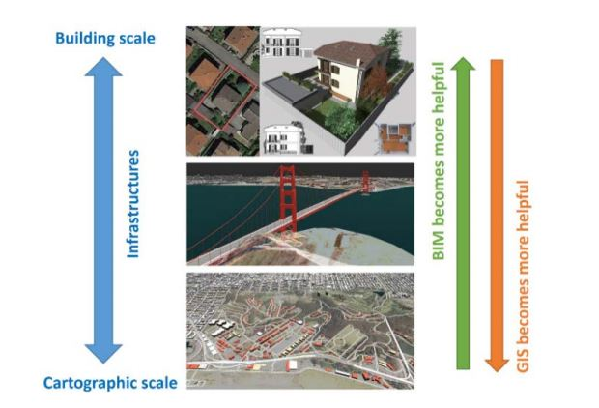acquisition from different databases.

Figure 1. BIM and GIS are like two interlocking puzzle pieces.

*Retrieved from “BIM and GIS: When Parametric Modeling Meets Geospatial Data. Remote Sensing and Spatial Information Sciences” (Barazzetti, L., Banfi, F., 2017)*

The paper will clarify that BIM and geospatial data in detailed and as well as try to explain the integration of BIM and GIS programs with varied utilizations.

**GEOSPATIAL DATA IN PARAMETRIC MODELLING**

In this part, how parametric modelling appeal to geospatial data is shown with the help of two basic examples.

(Eastman et al., 2008, p. 14) point out the definition of parametric objects in BIM as noted below:

* include geometric information and associated data and rules
* non-redundant integration is being for geometry, which allows for no inconsistencies
* parametric rules automatically modify associated geometries when inserted into building model or when changes are made to associated objects
* might be defined at different levels of aggregation
* its rules can identify when a particular change violates object feasibility regarding size, manufacturability, etc.
* have the ability to link to or receive, broadcast, or export sets of attributes such as structural materials, acoustic data, energy data, cost, etc., to other applications and models

In the first example, a building model which mainly indicate fundamental BIM objects is handled. In the other one, a road model is formed on BIM software.

1. **BIM – based approach for building**

BIM provides a platform for combining parametric objects which are classified into groups (beams, decks, skylights, railings, escalators, lintels, etc.). There are also horizontal planes in other words levels are situated as a reference like foundation, floor and roof.

According to (Barazzetti et al., 2017, p.2), complexity of structure, especially interiors or buildings, cannot be figured with GIS analysis. An external wall right after identifying its type, material, layers, width and thickness is a good example. Following wall placement, other objects like doors and windows can be inserted into walls and before that, same choosing part for their parameters is repeated.

Building design proceeds step by step in an architectural environment by taking into consideration structural aspects. Users work in 3D view and software reflects same processes to 2D view synchronically (Figure 2).

BIM project have mechanical, electrical, and plumbing (MEP) systems in its objects too. It is not just a 3D model where combines units. The software creates a dynamic rather than a static building model by including physical and functional characteristics (functions, dimensions, type etc.) of objects. Thus building design is converted to a new state that the clashes are detected automatically and automated manufacturing of drawings, reports and simulation analysis.

Figure 2. A building is designed with respect to parametric modelling in Autodesk Revit

*Retrieved from http://designagency.website/home-design-3d-architectural-rendering-civil-3d*

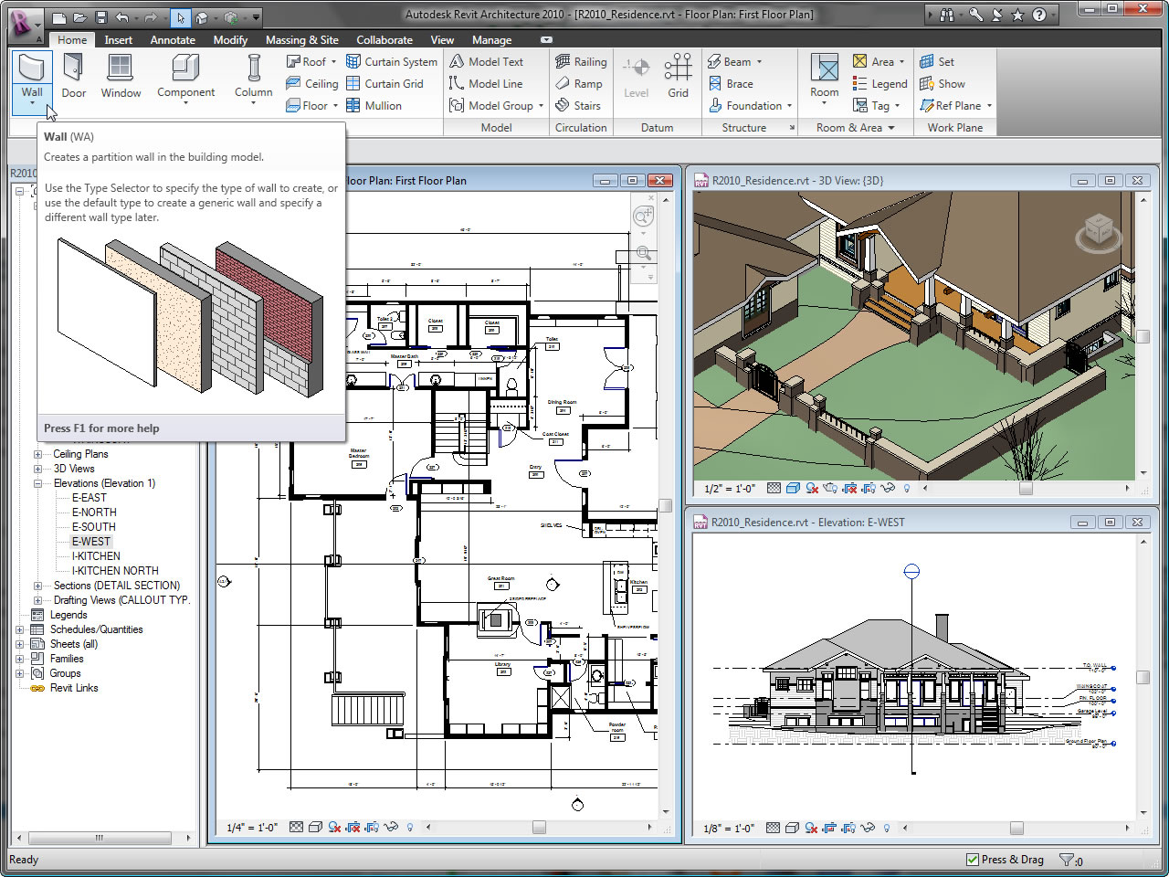

1. **BIM – based approach for infrastructure**

In this example, how geospatial data analysis is being crucial for infrastructures together with parametric modelling on BIM is evaluated.

Infrastructure is the major components that provide a service to a region, city or country and improve quality of life. (Sharma, 2014) categorise it in three groups:

* Facilities: premises that is for health-care, educational, socio cultural and recreational activities in urban planning
* Services: rail, road, air, waterways, telecommunication etc.
* Utilities: public services such as water supply, sewerage, drainage and electricity supply

In the first example, building design did not need any help of geographic reference system, but the opposite is true for infrastructure. Using the geographical coordinates is required. Although Universal Transverse Mercator (UTM) coordinate system is favourite way in that work, geographic coordinates can be an another one. Local reference system might be integrated in line with the requirements whether a lot of data sources is used. Auto-change in geographic reference system causes errors while making a transformation between national and international reference systems. To avoid getting into transformation difficulties, working in one reference system is preferable.

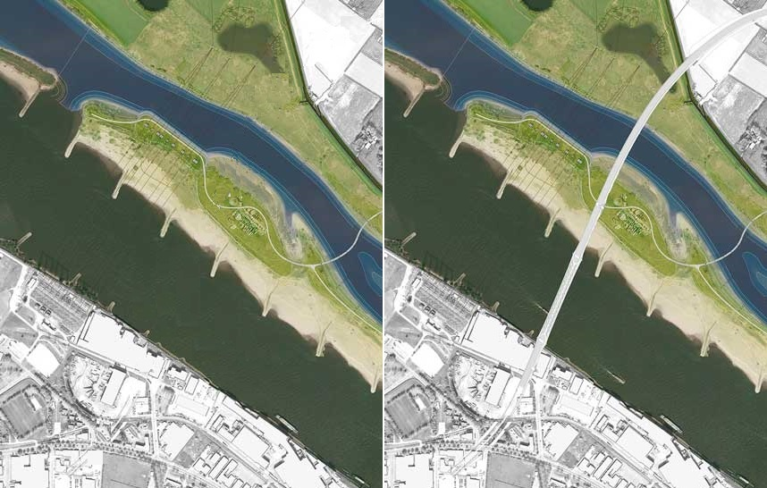During the pre-design phase of a new road project, geospatial data is collected. It involves digital terrain models and digital orthophotos for all landforms like mountains and streams and man-made structures like buildings and road networks. In the light of obtained datasets, type of new road is selected and its 3D profile on digital terrain model is formed automatically (Figure 3).

Figure 3. The zone before road construction (left) and after that (right).

*Retrieved and edited from http://www.landezine.com/index.php/2016/08/room-for-the-river-nijmegen-by-hns-landscape-architects/nijmegen-lent-12-hns_plan/*

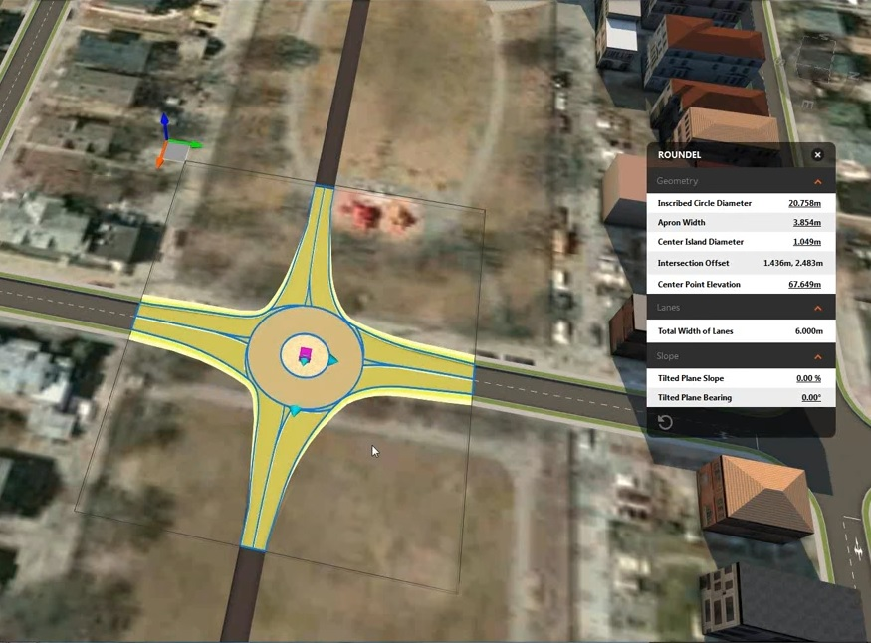Existing roads and the new one should bring together. While two, three or more roads show close proximity, this can be solved with an automated procedure. These generated solutions like crossroads and roundabouts can be changed (Figure 4).

Figure 4. According to parametric modelling, a roundabout is added and it can be modified considering geospatial data

*Retrieved from https://www.youtube.com/watch?v=FwsjWxyb_DA*

The road need to pass over the river. Then, a bridge is placed in compliance with available elevation data in DTM. And some changes such as adding columns/ removing and replacing existing ones, increasing/ decreasing length and modifying the vertical profile of this road might be made by designers. Parametric modelling instruments allow them to change graphics in 3D model.

As you can see final result of new road in Figure 5. Parametric modelling instruments will be extremely effective while working together with geospatial data if there will be any changes or amendments.

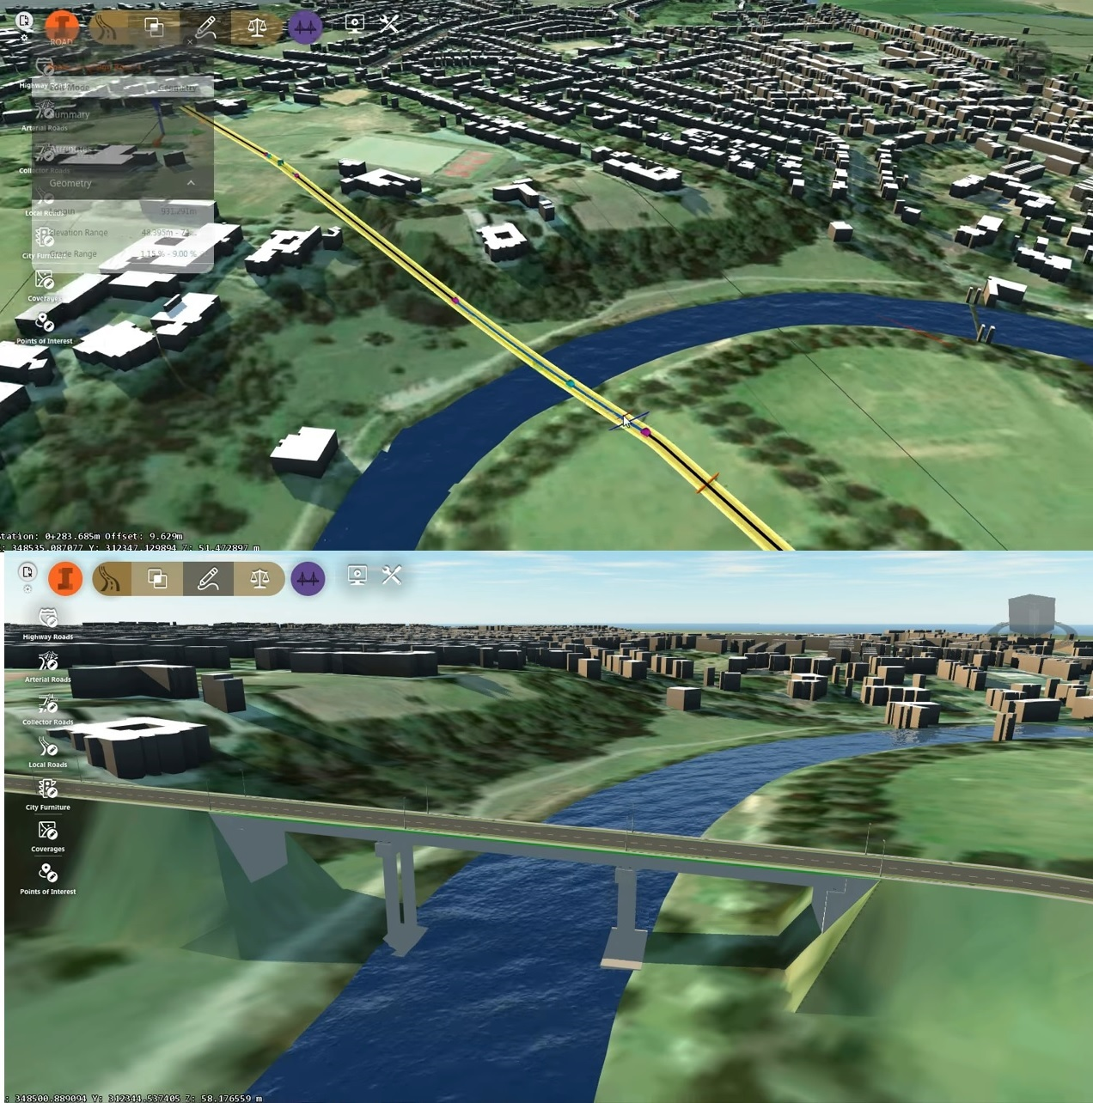

Figure 5. The bridge in Autodesk InfraWorks 360 without geoinformation (top) and final result after its integration (bottom).

*Retrieved from https://www.youtube.com/watch?v=_6kaGzovKqo*

**DISCUSSION**

After analysing and summarizing academic journals and resources, I learned a lot of new things during the research/writing stage about geospatial data and its application in Building Information Modelling (BIM). To write this paper, I took advantage of a course named as CE4007 Fundamentals of Geospatial Data Acquisition and Analysis in addition to our course. Also, I interviewed with Prof. Dr. Mahmut Onur Karslıoğlu about how to write a paper on my subject. He told what kind of examples are used in this manner. In the light of all these information, I was tried to give an idea about that.

Building Information Modelling is ever-developing approach. And using both BIM and GIS programs have benefits such as increasing quality of construction, easy and effective pre-design phase etc. Besides these advantages, using combination of them, as it can be seen, still needs time to obtain better results.

Afterwards, I inform applications of BIM for building and infrastructure in the main body of this paper. There are many examples in construction industry that BIM is used for design phase. But not all of them can be told. In conclusion, integrating geospatial data into BIM program is not must, but it becomes our ideas even more feasible.

**CONCLUSION**

The paper demonstrates that BIM and geospatial data are substantially interlocked to develop the performance of infrastructure. In the near future, BIM will not enable to generate only structures, also large-scale projects such as whole cities might be created. This might be make things easier only if the integration between other collaborative tools is constituted. Geospatial analysis, in a word, GIS is presider one at this stage. It is definitely that working both design and data acquisition and analysis on same platform will be a big chance at that. This paper just reviews an approach in line with this objective that smooth interoperability is already started. In consequence building information modelling has gained a new identity before and will gain again.

**REFERENCES**

1. Kemp, A., 2011. “BIM isn’t Geospatial” …. Or is it? , AGI GeoCommunity '11), pp. 1-12.
2. Beal, V. (n.d.). Spatial data. Retrieved from https://www.webopedia.com/TERM/S/spatial_data.html
3. Barazzetti, L., Banfi, F., 2017. BIM and GIS: When Parametric Modeling Meets Geospatial Data. Remote Sensing and Spatial Information Sciences, Volume IV-5/W1, 2017, Geospace 2017, 4–6 December 2017, Kyiv, Ukraine
4. Eastman, C., Teicholz, P., Sacks, R., Liston, K., 2008. BIM Handbook: A Guide to Building Information Modeling for Owners, Managers, Designers, Engineers and Contractors, 1st edition. John Wiley & Sons Inc, 490 pages.
5. Sharma, R. P., 2014. Fundamentals of Urban Development and Planning, An Academic Presentation to BdevS, Center for Development Studies, Kathmamndu University
6. Burrough P. A., McDonnell R. A., 1998. Principle of Geographic Information Systems. Oxford University Press, Oxford