HW-2 Group 1 REPORT

**Question 1**

There are several advantages of automated clash detection of BIM as compared to the traditional method of comparing paper or CAD documents. To show the benefits of automated clash detection tool an advantage & disadvantage table is prepared below.

Table 1: Advantages of Automated Clash Detection

|  |  |
| --- | --- |
| Advantages of Automated Clash Detection | Disadvantages of Traditional Workflow |
| * Find problems earlier | * Superposing the CAD drawings to find clash detection |
| * Fast clash detection | * Time consuming and error-prone |
| * Create opportunity to verify geometry (prefabrication) | * Human interpolation of 2D Drawings may lead to costly mistakes |
| * Avoid costly mistakes | * Increasingly complex |
| * Ability to interactively and graphically review the clashes | * Limited to effectively meet the needs of the todays multidisciplinary design teams |
| * Easy to prepare a systematic report fast | * Not reliable |
| * Enhances ability to filter through building elements quickly and run collision tests between isolated building elements | * two drawings can be compared at the same time in 2D CAD |

Despite the advantages of clash detection tool there are a few challenges about it. It is not particularly efficient to check every element category against every element category at one time. It can result in a lot of false positive, things that will pass through each other in a logical construction sequence, like pipe through stud framing and dry wall.

It is hard to represent some certain units of clashes to the relevant project team members since it does not group the clashes automatically.

**Question 2**

To get manageable results Navisworks provides us a smart tool to group clashes based on objects that will eventually change. With the help of grouping feature, we both reduce the total number of clashes and provide the consultants a better way of fixing all the clashes related to an item, before proceeding to the next item.

In our project, we proceeded through following steps;

* names have been assigned for each test
* selections have been done based on standards and search sets
* type and tolerance of clash test have been set
* clash test has been run
* click on results tab as shown in Figure 1
* In **Results** tab click the **Group Clashes Involving Items** button in the **Item 1** area, all the clashes that the selected structural wood is involved in are grouped together as shown in Figure 2
* Click on **Report** tab, select **Everything from the For-Clash Groups, include** list (see Figure 3)
* In output settings, for report type and report format All Tests(combined) and HTML(tabular) are selected respectively and then click Write Report button (see Figure 3)

Another feature of Navisworks Clash Detection Tool is that the tolerance and type of clash test can be adjusted. With proper adjustments clashes become more manageable. Finally, by ignoring different items in ‘Rules’ tab (see Figure 4) the number of clashes can be minimized.

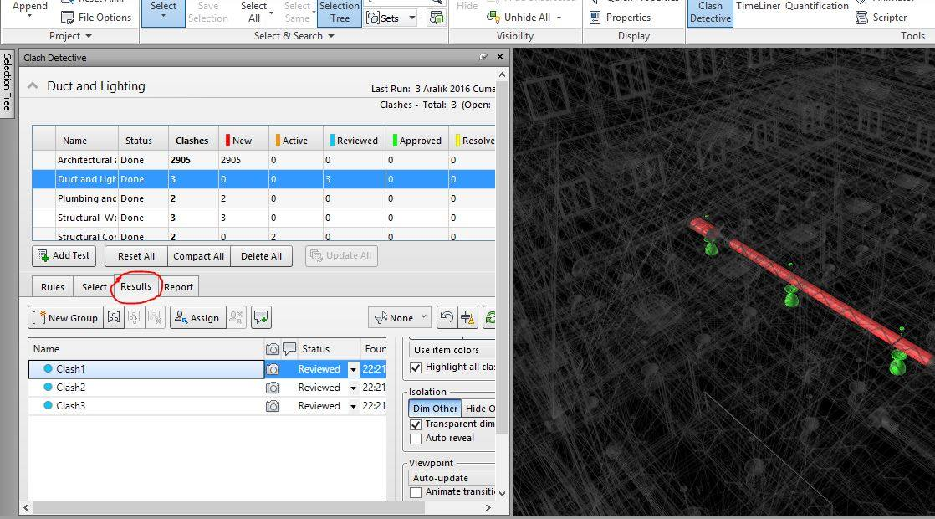

Figure 1: Results

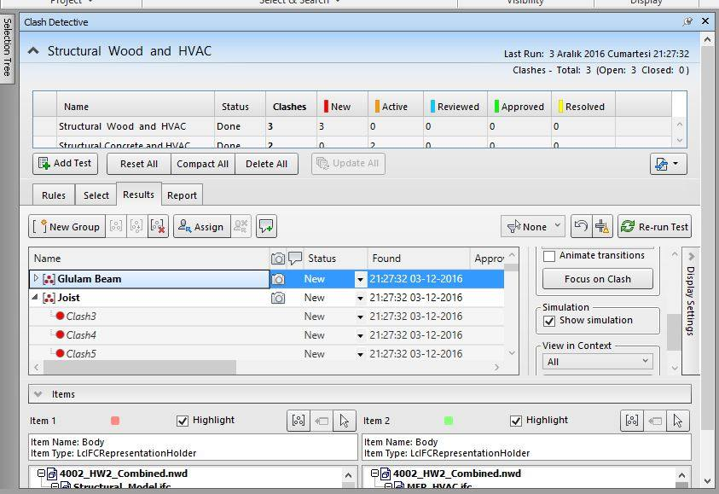

Figure 2: Grouping

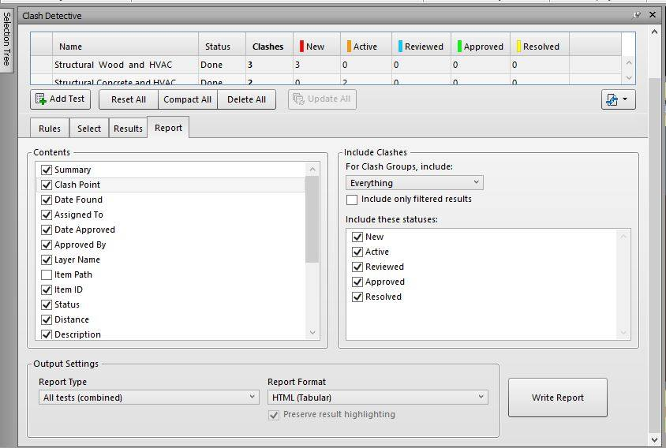

Figure 3: Writing Report

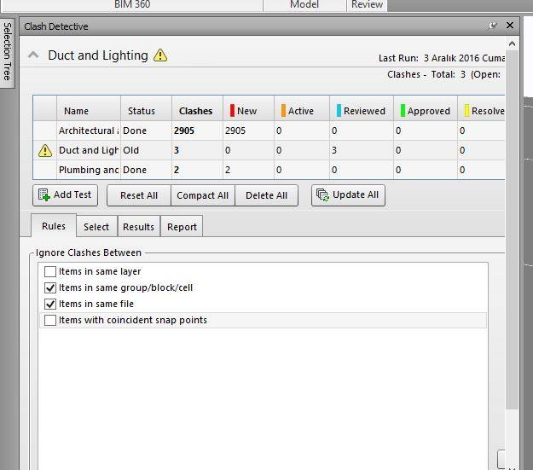

Figure 4: Rules Tab

**Question 3**

Yes, absolutely. Navisworks is a successful tool for identifying and reporting clashes throughout the whole design process even with multiple revisions of the model. However, for identifying and reporting clashes, Navisworks should be used in a way with minimum possible complexity. For that, Navisworks has the sufficient capability but the users who are involved in the project needs to be able to use the software for their specific purpose efficiently. Even though all users use the software for their specific purpose, this does not always mean perfect collaboration. For that different software, which can be embedded to Navisworks should be used. For example, BIM 360 Glue (see Figure 5) which allows the user to share the model for all participants simultaneously. Another example is BIM Track but this one is used in a more general sense. Also, these additions give the ability for the tracking of the resolved issues as they showed who access the program at what time and what they change.

**Question 4**

Navisworks should;

* Automatically group clashes according to their size, type, or material type by adding a sort by option. This will minimize the number of clashes
* Suggest possible automated solutions for clashes
* Understand the similarities in clashes and identify them to user like an option for sorting clashes. With the help of this grouping will be more effective.
* Have the option of priorities between the clashes which is assigned by the user. This may help to analyze and solve more important problems earlier and easier.
* Have the option for order of importance between the elements which is also should be assigned by the user. This will help different parties to understand clashes and model better.
* Simplify and improve the user interface for better coordination.

Note that;

**Better Coordination = Better Buildings**