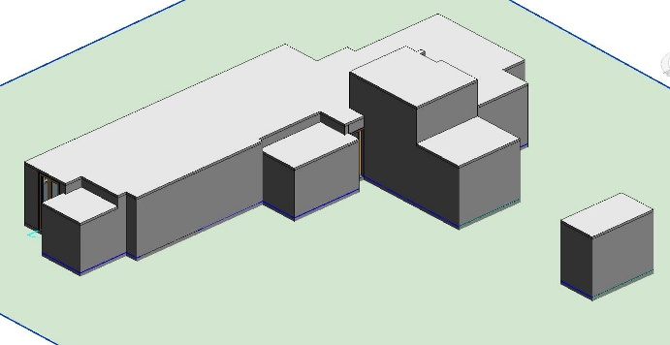

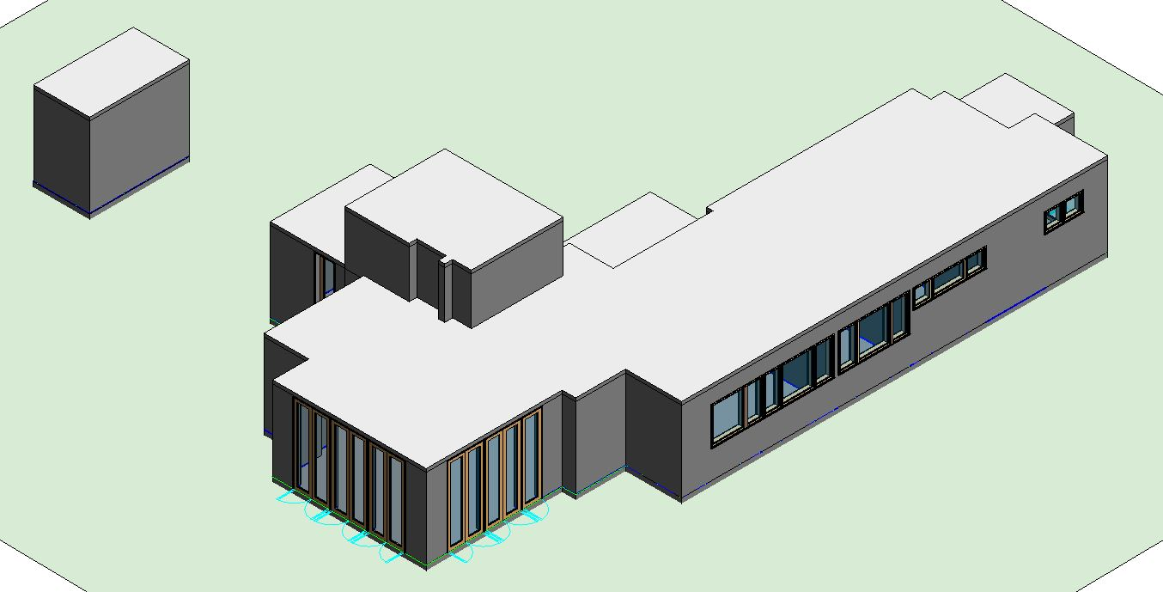

Figure 1: The front view Figure 2: The back view

1. a. While moving one of the exterior walls to the outer side by 1m., the walls, which are connected to the walls, and floor slide together.

b. All the walls are extended when the workspace roof’s elevation is changed to 6.27m. If changes cannot be seen, walls may not work together, or attachment command cannot be used properly.

1. Firstly, Generic 8” and Generic 3” walls were used for exterior and interior walls respectively. After completing the placing walls, the height of the walls were specified with their locations from east or west side elevation. For instance, if a wall belongs to the living room, the height of it was calibrated to 2.62m. For other existing walls which have different sizes are brought in the same line. In addition for this, top constraints of some walls are different than actual case. Also, these walls were arranged like other walls. Base constraint was selected as ground floor, and base offset was 0. These two should be chosen at the same time because these two parameters are related with each other. Although base constraint is ground floor, if base offset is not 0, walls cannot get in touch with the ground.
2. First of all, all walls related with the same room should be at the same level. After that, from structural roof element, roof was drawn manually. Base offset from level should be 0 for necessary base level. On the other hand, roofs are flat in this project. Therefore, attachment command was not used. All levels are set from East or West side. Then, roofs were added manually. Also, roofs are fitted better because in attachment command, roofs are always offset from the related height.

**Note:** The door which is in between Workspace and Bedroom was not fitted by Single Glass 24” x 102”, so Single Glass 30” x 84” was preferred to use.