**- PART 1:**

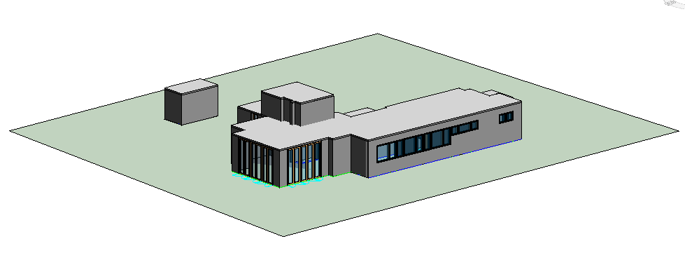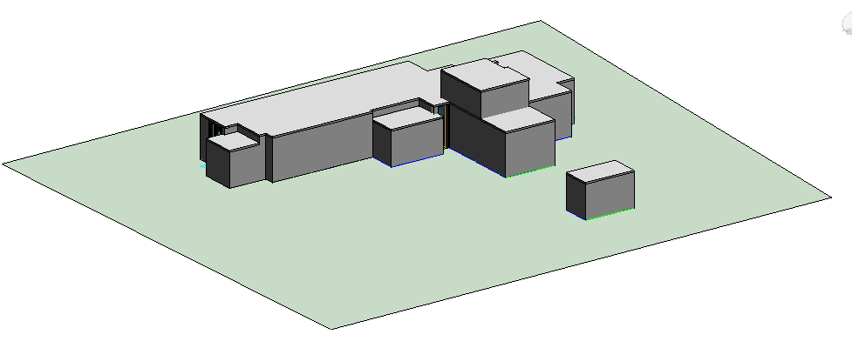

Figure 1. Frontside View Figure 2. Backside View

**DISCUSSIONS:**

**1.)** a. In Revit software, exterior walls define the border of the structure. While exterior walls are drawn, they are connected to other structural members for this reason. So, if one of the exterior walls is moved, connected members’ places also change and the floor plan slides. These changes are done automatically by the program.

**b.** If the roof is heightened to 6.27 m in the East elevation, all the walls are extended to that level, normally. But this cannot be happened due to lack of connection or some mistakes in attachment of the members. For example, walls may not be move together with the roof in such situation.

**2.)**  First of all, in the structural wall tab, desired wall type is selected. Wall types are predefined so that interior and exterior walls can be drawn according to user’s choice. Using the drawing tool in the software, wall is drawn. If there is another wall next to the drawn wall, these two are connected suitably. The software cannot allow any inconsistency and it does required modifications on these walls automatically.

**3.)** Wall heights are defined with height parameters and top constraints. Attachment properties enable that to fit ceiling to top of the wall. By the help of this, even if there are different wall heights in the structure, this does not affect the ceiling. Each ceiling is placed according to attached walls. This property provides that both elements are working together.

**- PART 2:**

**DISCUSSIONS:**

**1.)** First, all the tasks and the possible relations between them are searched in detail and roughly order of tasks is determined. Using the knowledge from CE332 course, job sequence in the construction site has known already. Pouring the columns concrete is only possible when the slab is ready. So, column tasks in each level are dependent to the floor slab or floor deck of that level. Also, the floor plans are divided in 3 equal parts virtually in each floor, as wanted in the assignment. For example, in the report it can be seen that there are 3 different tasks for level 1 columns named as A, B, and C. These 3 tasks represent the 3 virtual part of the floor 1. With assuming there is only one building worker group for each task it creates another dependency. Without the Level1 PartA’s column completion, it is not possible to start Level2 PartB task. Moreover, column and beam job has also linkage between them. To be able to construct the beams, there is need readily constructed columns.

Again assuming there is one available team for each task, this links interior wall task to exterior wall task. Furthermore, window& door task is affected by the same assumption. To be able to montage the windows and doors in Level 2, the team has to finish their job in Level1.

The last assumption is construction of the stairs. It is not divided in three level and it is constructed after the 3 level deck’s concrete is poured.

**2.)** Yes, if the more details of the project are taken part in schedule and model, better assessment of capabilities of 4D simulation [highly-likely](http://tureng.com/tr/turkce-ingilizce/highly-likely).

More detailing 4D simulation will permit:

* Fnding clashes in an easy way,
* Using all resources efficiently and continuously,
* Providing to save time and money of the project.

**3.)** If schedule or design is changed, first it is needed to change the original .csv file. After required changes are done (add new tasks, arrange the predecessors, or update durations etc.) Navisworks could understand the changes in the file with synchronize it. This synchronization is enough to create again 4D simulation when some updates are done. To check on this, making changes in Revit model and this revised model is opened into Navisworks to see what happened. Synchronization has been occurred instantly without defining objects same as before.So, the only change needed in the software is control and reorganize the predecessors.

**4.)** As group 9, we use AutoDesk Navisworks as 4D system. In this software the most helpful feature is simulation of the construction. It has opportunities to import files which consists job sequences and linkage between them and using the file creates a schedule. After that the construction stages (assigned tasks) can be simulated day by day. Here, it is very clear to see linkage between the tasks. So, mistakes that are done in the design stage, if there are any, can be easily distinguished and fixed before the construction.

The parts in Navisworks that need improvement are that, it has a complex structure and it is a little hard to use for a user who is not familiar with the software. Therefore, user interface of Navisworks could be developed. Also, for task sequence importing, it should be directly read a file from MS Excel (.xls) files because as a format .xls and .csv files are not very different and saving the created file in other version is only time consuming.

On the other hand, the creating sets for each Task ID is a time consuming part. A command can be developed for not to select the components one by one (i.e. columns were constructed in three phases). Also, national holidays are different from countries to countries. Every time, adding holidays by hand is too difficult. National holidays can be added to schedule, according to country.

Our wishlist for Navisworks:

* Weather and climate events can be shown under construction,
* Observation of the simulation can be better and more continuous,
* It may not need any software application like MS Project for scheduling.

**5.)** Creating a 4D model will bring many advantages. It enables to collaborate and to join different department to the project at the same time. Which means each department can design their own part at the same time and the inconsistencies could be signified easily. This will save plenty of time rather than each department works one by one. Also, 4D systems assist to detect the errors and clashes in the project before the construction. There always could be some points that escape the attention in design stage. Fortunately, creating a 4D model eliminates these errors. Lastly, a 4D model make it much easier to change the project according to revisions during the construction.

In construction area, process of project sometimes does not match with completed or done work in construction site. This delay or problem should be detected and

Converting operation can be expressed as a problem because creating 4D simulation from paperwork or 2D cad documents are really difficult and complicated. Therefore, this process can be identified as a problem or barrier.

Some tools of BIM can also use at the job site offline. Only, this cannot measure its value. If an example is needed, at the site, the work done by workers does not match with the project. When it detects, a report can be written immediately taking a photo. Then, this report comes to the system. Therefore, everybody sees the problem, and the qualified person pays attention this problem, and qualified person solves it. Also, digital platform provides not to use lots of paperwork. Deliveries can be done in software. It is also an environmentalist approach.