1. **Introduction and Description of the Project**
   1. **Main Definitions and Overview**

Bridge construction is one of the most ancient constructional achievements of mankind. From very early times of the history human being has needed individually or in group to gather foods on their trace they have needed to construct overpasses mostly medical use of dry tree trunk. In later periods stone, has started to be used especially in arch formed bridges in contemporary stage of bridge engineering, iron steel family materials have been used as well concrete family materials. Post-tensioned concrete which is the name of material also the type of construction method started to be used from late 19th century and was well developed during the last century. Our project group for the course CE410 has decided to concentrate on a contemporary Iraqi bridge with post-tensioned concrete material and processes. Both design and construction of facility has been led by Turkish companies, this fact constitutes an element of sympathy for this bridge and facilitates the process of getting information on this construction achievement.

**1.2 Bridge construction vs. New materials and techniques.**

It is well known that tensile strength of concrete is only about 10% of its compressive strength. As a result, plain concrete members are likely to crack when loaded. Reinforcing steel can be embedded in the concrete members to accept tensile stresses which plain concrete cannot resist. Reinforcing is selected assuming that the tensile zone of the concrete carries no load and that tensile stresses are resisted only by tensile forces in the reinforcing bars. Although the resulting reinforced concrete members may crack, still it can effectively carry the design loads. Starting from second half twentieth century there was a huge development and use of post tensioned concrete. Post-tensioned concrete bridges offer a broad range of engineering solutions and a variety of aesthetic opportunities. The function of prestressing is to place the concrete structure under compression in those regions where load causes tensile stress. Tension caused by applied loads will first have to cancel the compression induced by the prestressing before it can crack the concrete. Figure 1.1a shows a plainly reinforced concrete simple span beam and fixed cantilever beam cracked under applied load. Figure 1.1b shows the same unloaded beams with prestressing forces applied by stressing post-tensioning tendons. By placing the prestressing low in the simple-span beam and high in the cantilever beam, compression is induced in the tension zones; creating upward camber.

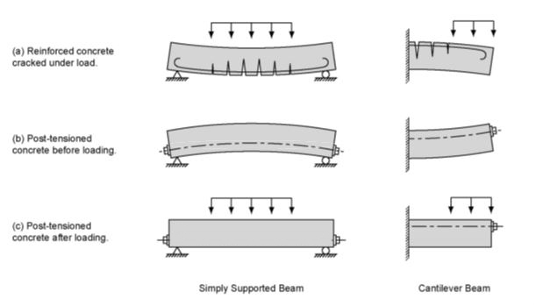

*Figure 1.1 - Comparison of Reinforced and Prestressed Concrete Beams*

Figure 1.1c shows the two prestressed beams under the action of post-tensioning and applied loads. The loads cause both the simple-span beam and cantilever beam to deflect down, creating tensile stresses in the bottom of the simple-span beam and top of the cantilever beam. The designer balances the effects of load and prestressing in such a way that tension from the loading is compensated by compression caused by the prestressing. Tension is eliminated under the combination of the two and tension cracks are prevented. As a result, durability is increased and more efficient, cost effective construction is realized.

Prestressing can be applied to concrete members in two ways, by pretensioning or post-tensioning. In pretension members, the prestressing strands are tensioned against restraining bulkheads before the concrete is cast. After concrete has been placed, allowed to harden and attain sufficient strength, the strands are released and their force is transferred to the concrete member. Prestressing by post-tensioning involves installing and stressing prestressing strand or bar tendons after the concrete has been placed, hardened and attained a minimum compressive strength for that transfer.

Compressive forces are induced in a concrete structure by tensioning steel tendons comprised of strands or bars placed in ducts embedded in the concrete. The tendons are installed after the concrete has been placed and sufficiently cured to a prescribed initial compressive strength. A hydraulic jack is attached to one or both ends of the tendon and pressurized to a predetermined value while bearing against the end of the concrete beam. This induces a predetermined force in the tendon and the tendon elongates elastically under this force. After jacking to the full required force, the force in the tendon is transferred from the jack to the end anchorage.

Tendons made up of strands are secured by steel wedges that grip each strand and seat firmly in a wedge plate. The wedge plate itself carries all the strands and bears on a steel anchorage. The anchorage may be a simple steel bearing plate or may be a special casting with two or three concentric bearing surfaces that transfer the tendon force to the concrete. Bar tendons are usually threaded and anchored by means of spherical nuts that bear against a square or rectangular bearing plate cast into the concrete.

The protruding “tails” of strands or bars of permanent tendons are cut off using an abrasive disc saw or plasma cutting after stressing. Flame cutting should not be used as it negatively affects the characteristics of the prestressing steel. Tendons are then grouted using a cementitious based grout. This grout is pumped through a grout inlet into the duct by means of a grout pump.

**1.3 Brief Description of the Structure Studied as Case of the Project Work**

The structure which is taken case study is located on the Great Zab River in Iraq. The total length of the bridge is 240m including connection roads. It is required to construct the bridge with 4 spans, each span length is 60, and 3 piers which average height is 10m. Bridge layout plan is shown in the figure 1.3.1

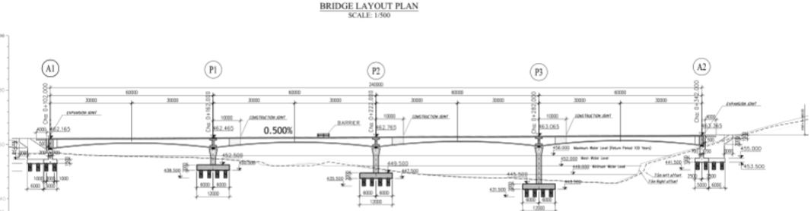

*figure 1.3.1*

The bridge has two lines (one line for each direction). The width of the bridge deck slab is 15 m. The width of the border is 6 m (3 meters for both sides of the bridge). Cross section dimensions of the span is changing from support to midspan (figure 1.3.2).

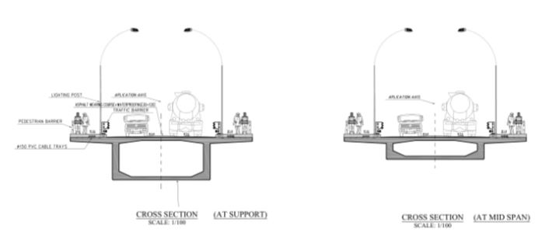

*figure 1.3.2*

The bridge was built by Scaffolding Method. The main reason of using this method is geography of the construction zone. The shallow valley having an average depth of 10 meters makes it reasonable in terms of economic goals. This will be widely explained in the next chapter.

1. **Structural and Mechanical Features of The Bridge**

**2.1 Zoregwan Bridge.**

Zoregwan Bridge which is situated on the great zap river that flows through turkey and Iraq, the Kurdish governorate of Iraq to be exact, was constructed due to various needs that will be mentioned in this chapter. The main reason behind its construction can be considered as its importance on logistics and transportation necessity at the region of Iraq. Geographically the Zab River starts its origin from the van region in Turkey. Then it continues through Hakkari region and through Iraq joins the great Tigris River which is more of a well-known river than Zab due to its historical importance. Everybody who took history classes must have heard Tigris rivers name at least once for sure. The Zab can be considered as biggest tributary that joins the Tigris. Also, the river is close to the Barzani’s village, who is the head of Kurdish state in Iraq, thus making it politically important too. Nonetheless, its geographical importance cannot be ignored. As it is well known humankind first started to settle near the river banks or sweet water shores as soon as he abandoned the nomad and hunter gatherer type of existence. Cultivation was the reason behind the humans settling and abandoning nomad life. Zab River was one of those where humans found shelter.

For our days, the river gained much importance because of high tension in the Iraqi region. Since previous bridge was destroyed during the clash between some of those minorities that occupy the region. Zab also serves as boundary between Erbil governorate and Ninawa governorate. Current bridge was constructed by Turkish design companies and contractor. As it is well known Turkish contractors and design companies carry out many important projects around the world especially in Middle Eastern region and post-soviet states. So, it is not a matter of surprise that the bridge was constructed by them. The exact geographical location of the bridge is somewhere near the Kandil Mountains and near the fore mentioned Barzani’s village. The channel of the bridge is not so wide and can be considered as narrow. The main characteristic of the bridge is that it was build using the post tensioning technique. This technique consists of casting the concrete by the use of scaffolding in-situ and then applying the post tensioning to the cables installed in the reinforced concrete mass. This operation was carried out by French “Freyssinet” and Turkish “Freysaş” venture. The company that carried out general construction works is a turkish contractor company called “HGG”. This particular operation required high Professional knowledge about the post tensioning and strict supervision of the Project, since these post tensioned cables will carry nearly all service load during the bridges lifetime. The idea of using this technology comes from its practicability in this kind of projects and since traditional prestressed and precast concrete technique is not suitable for use there because the bridges girder spans are 60 meters, it is not practical and somehow challenging to transport the precast concrete elements for installation. Preparing the formwork and scaffolding, then casting the concrete followed by its post-tensioning is more suitable. İt also preffered over the incremental launching method since the valley or the river bed is not so deep and wide.

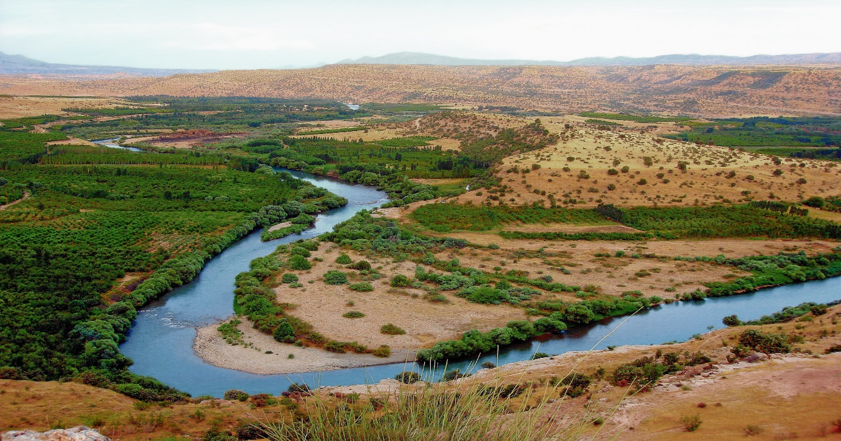

Figure 2.1: The Zab river valley

Coming to the companies which had a hand on the bridges construction. Freyssinet is one of the leading French design and construction companies which main activity is in bridge construction area. Founded over 70 years ago by Eugène Freyssinet, the inventor of prestressing, Freyssinet brings together an unrivalled range of skills in the specialist civil engineering sector, offering integrated technical solutions in the fields of construction and structural repair. Freyssinet is involved in numerous projects across five continents. The fields they have gotten expertised are: prestressing; construction methods; structural accessories; structural repair and reinforcement; structural maintenance.   
These activities are performed on a wide range of structures, including civil engineering structures, buildings, skyscrapers, industrial installations, power production plants, offshore platforms, transport and sporting infrastructure, and more.

Coming to the Turkish Freysas group. It was founded at 1988 by the Vinci Corporation that owns the Freyssinet and Yapi merkezi partnership and considered as one of the pioneer and qualified institutions in the field of modern structural practices and structural element production. Their area of operation consists of Middle Eastern and eastern European regions. The Zuregvan Bridge was constructed by the collaboration of the two companies Freyssinet and Freysas. As the posttensioning is crucial part of the bridge construction it can be stated that client knew to whom trust this job.

**2.2 Historical Reviews of Bridge Construction Techniques.**

Glimpsing back to the history of bridge construction one can see that in early days bridges were constructed by the means of masonry and stone crafting. Still most of them were durable and strong enough and preserved to our times. They were generally built as viaducts with relatively short spans as the strength of the stones allow. The most well-known of this bridges can be considered as Buyukcekmece bridge in Edirne which was constructed by Mimar Sinan by the order of Kanuni Sultan Suleyman, which is still under service. The bridges were constructed from materials like timber and later from mainly steel components. In our days starting from the early periods of the last century new materials and fitting techniques started to be used in bridge construction. Materials like reinforced concrete and tension cables were used and for relatively big spans, the girders of the bridge were hanged from the cables. Spans became wider and wider so the steel material used extensively as deck material and piers were made of reinforced concrete. Although the concrete is the most widely used material in construction the bridge deck was additionally reinforced by tension cables across the length to provide better tensile strength for the loads. However, for small spans still the reinforced concrete is used. One of the most beneficial innovation in bridge construction came with fabrication of prestressed concrete elements and its technology. From it the post tensioning technique derived for larger spans. Bridges and viaducts became able to carry heavier loads as machinery and railways thanks to this invention. The technique first started to be utilized across the Europe and USA. Nowadays nearly every bridge constructed it being traffic joints or over river, valley bridges benefit from posttensioning and pretensioning technology.

The origin of reinforced concrete bridge construction in the United States dates back to 1889 with the construction of the Alvord Lake Bridge in San Francisco, California. Though many advancements have been made, basic features of construction remain unchanged. The work requires construction of formwork to contain and provide shape to the wet concrete. Formwork is supported by falsework either resting on the ground or on prepared foundations, until the structure itself is self-supporting and formwork and/or falsework can be removed. Unfortunately, bridges constructed with reinforced concrete are only economical for relatively short spans. Superstructure types include flat slabs, beam with slabs, and box girders. At the time, longer spans were achieved by using arch construction.

Reinforced concrete box girder bridge construction flourished in the western part of the United States as a result of economy and local contractor experience. The California Department of Transportation (Caltrans) began constructing box girder bridges in the early 1950’s. With the popularization of prestressed concrete technology in the early 1960’s, Caltrans realized further economy through the construction of many post-tensioned concrete box girder bridges. Refinements to post-tensioned box girder bridge construction continued throughout the United States in the second half of the 20th century.

Turkish construction companies and contractors started to use this technology several years ago. French Freyssinet and Turkish Freysas venture carried out works on many important bridges in Turkey and can be considered as pioneers in this sector. The most recent examples in which they had a contribution can be considered as “Yavuz Sultan Selim” bridge in Istanbul, also known as 3rd bridge.

The post tensioning system Diwidak used in some projects in Turkey

**2.3 Different Procedures for Construction of Prestressed Decks.**

Here I want to mention the most commonly used techniques of bridge construction. In our days there mainly 3 different methods for post-tensioned decks and one for pre-tensioned precast decks construction.

**2.3.4 Scaffolding Method- Scaffoldings Resting on Land Method.**

Fourth and again widely used methods are the one where concrete is cast in-situ and tensioning is carried out on the place, it is referred to as scaffolding method. This method is generally preferred when the valley or the river bed is not so deep and wide. Scaffoldings and other similar equipment can be used here. Scaffolding is raised at the bed of the river or valley by draining that part of river via diversion weirs and artificial islands. On top of the scaffolding the formwork is placed and reinforcement installed. After concrete is cast and hardened the tensioning operation takes place. For the second span same method is used and after the first span acquired its necessary strength the scaffolding is removed together with formwork to use it for the third span. This way it continues until the bridge is finished. In the end the tensioning of internal cables is carried out once more so that the overall structure will acquire its final design or service strength. This is the method that was used in the construction of Zuregvan Bridge over Zab River. It should be mentioned that this technique was the preferred and adopted technique for our case study bridge

**2.3.3 Segmental Method.**

Here comes the segmental method of construction. In this particular technique, the scaffolding is installed for the first span and cables are installed along with reinforcement and concrete is cast. After the hardening of concrete element and its tensioning the scaffoldings are transferred to the other span by means of moving rails, that is, scaffolding under the bridge is mobile. So it continues until the end of construction. This method also called cast in place segmental method. It is generally preferred for large and relatively deep valleys.

**2.3.2 Incremental Launching Method.**

The second method is incremental launching method where one casts the concrete in the special area on site and the tensioning operation is carried out. The ready block, that is set and hardened and which developed enough stress is pushed by little amounts to its place by the use of special equipment and machinery. The other girders follow it by through the same procedure over each other. This method is preferred if the valley is big and deep thus making it hard or impractical to rise a scaffolding. When the bridge is too long the builders start to incrementally launch the blocks from each end until they meet somewhere in the middle. 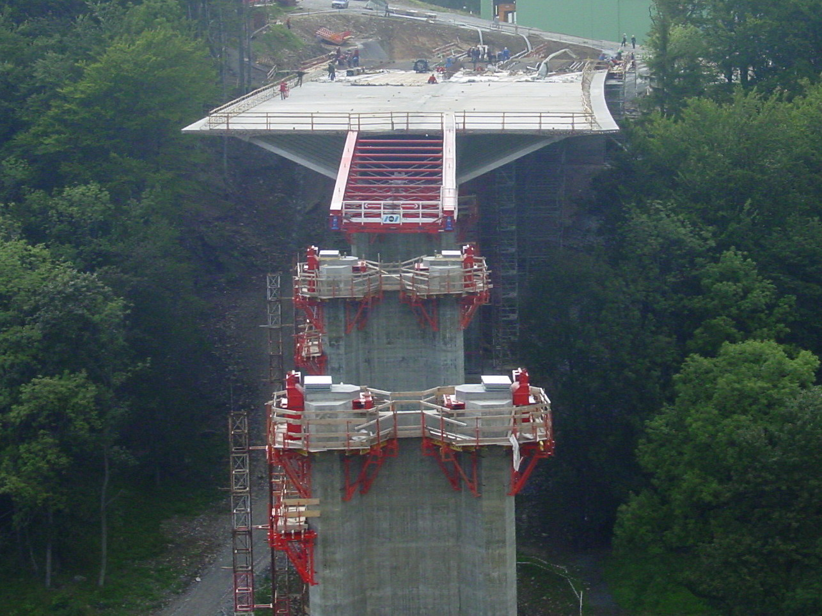

Figure 2.3: A good example of incremental launching method in deep and forested valley.

**2.3.1 Prestressed Concrete Elements Method.**

The first one will be the precast and presstressed concrete elements method, where one casts concrete on top of the already put together reinforcement and cables. Then settled and hardened concrete goes under tension which is applied by means of cable with special equipment. Thus internal compressive stresses are created in concrete because of tension in the cables. Here adherence between cables and concrete plays an important role in the development of these stresses. These operations are carried out in some other place and these blocks are carried to the site where they will be installed to their places according to design. So the other elements are installed until all the spans are ready.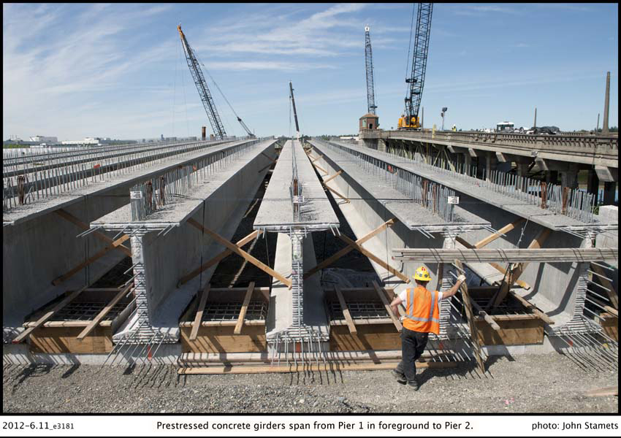

Figure 2.2: Prestressed concrete girders span from Pier 1 in foreground to Pier 2.(Photo by John Stamets, courtesy of King County DOT)

* 1. **Particularity of the adopted technique**

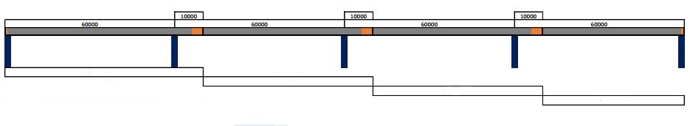

Structurural features of the application of these techniques in Zoregwan Bridge are going to be retaken in the following chapters consecrated on analysis and design.

Coming to the particular construction technique applied in “Zuregvan” bridge, we can say following things. The Zab River has a width exceeding 200 meters in the geography of construction region. This is a shallow valley having a depth of 10 meters in average varying from 5 meters to 15 meters. Very shallow parts of the valley used to be dried during 3-4 months of the summer season, this foot has constituted a big practical advantage for construction of footings and piers easily and rapidly almost 3 spanning length of the deck area had this advantage while the remaining 50-60 meters of valley was showing a deeper geometry where the water flow was continuous during the year.

Overall information on the construction operations

Construction of footings and piers staying in this part of river required special precautions. Formation of some artificial islands was necessary to facilitate the construction of footings and piers in this part of the river. Thanks to this land filling in the river to create artificial isles a dried surface is obtainable and construction of footings and piers for this last span would be possible. During this operation flow of water would be around the artificial island and whole flowing region of the river would not be disturbed too much. At the end of this operations the filled earth portions are taken from the filling area and moved to various parts of the river.

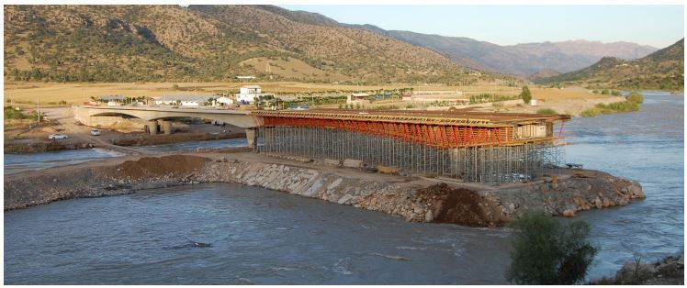

Figure 2.4: “Zoregwan” bridge constructed by scaffolding method

**2.5 Cross Sectional Properties of the Deck**

As previously mentioned the post tensioned bridge cross section is of a box girder with a hollow middle part. It can be multi cell or single cell depending on the architectural and structural needs. Indeed, these sectional differences are of general order. For each bridge case and situation some variations should be expected. In our case, the box given in the Figure 2.7 would have different thickness values ensuring the change of moment of inertia which would be needed to have different values at the mid span and the support. This is a necessity and unavoidable result of the longitudinal structural behavior of the bridge deck. As shown in Figure 2.5.

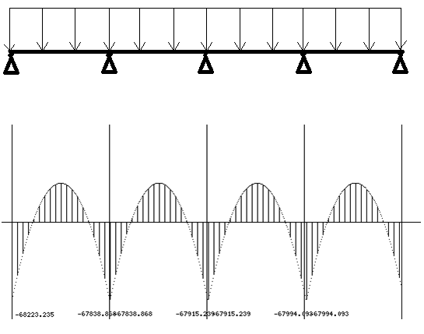

Figure 2.5: Moment diagram of the four span bridge

Support level longitudinal flexural moments are higher than mid-level flexural moments. This would lead to the requirement of stronger and more massive cross sectional values at the supports than of the mid-span. Practically speaking, there are two ways to ensure the change of structural system values and moments of inertia. One would be to change the value of depth of the cross section from the support to the mid-span. Second way is to ensure increase the moment of inertia at support level is to play with thicknesses at web and upper slab portion of cross section. In the second approach, it is easier from construction practice point of view and it is more often preferred for the discussed situation as in the case of “Zoregwan” bridge.



Figure 2.6: Multi cell box girder



Figure 2.7: Single cell box girder cross section

The basic components of the cross section are:

• Top slab—the entire width of concrete deck, including the portions between the webs and the overhangs outside of the webs.

• Overhangs (cantilever wings) —the overhanging portion of the top slab.

• Webs—vertical or inclined, exterior or interior.

• Bottom slab.

The cross section that was used in our bridge is the single cell one. One of the differences which our bridge possesses is that it has got blisters on the lower sides of the hollow section which provides additional tensional strength for the bridge. The post tension cables are also installed in blisters. 2 earthquake energy dissipating elements are installed in between the girder and the pier. These energy dissipaters are crucial part of the contemporary bridge construction techniques since designers started to get more and more aware of the possible damage that can be caused by even small scale earthquake, which can for sure affect the service life of the structure even if not immediately but in the long run. From the afore mentioned words it can be derived that the total deck span is continuous, however total structure is not due to this transition zone between the pier and the deck where energy dissipaters are installed. In the following chapters characteristics of the reinforced concrete and tension cables that were used in bridge will be discussed in more detail.

## 3. Work Procedures in Final Design

## 3.1 General Information on design criteria and material Zoregwan Bridge Work

Zoregwan Bridge is designed and by Mega Engineering Consulting Company. Construction related work carried out by HGG Construction Inc. Post-tensioning is carried out by Frassinet, Turkish Freysaş venture. We have visited Mega Engineering and Consulting Company and they have shared their knowledge and information which is related with the Zoregwan Bridge with our group. They sent some files which is related with Zoregwan Bridge design to us in order to guide us in our design process. These files contain following files;

-AASTO LRFD Design Specifications

-5 bore log data which classifies soil related properties up to 30 m.

-Post Tensioning Tendon Installation and Grouting Manual

-Post-Tensioned Box Girder Design Manual

-A Table which Represents Traditional Minimum Depths for Constant Depth Superstructures

-Some basic information states lane number in the road, bridge deck slab width, curb width, thickness of asphalt pavement, load of pedestrian guard rail, load of road railing, temperature changes regarding load and relative humidity.

-Top and side profiles of Zuregvan Bridge Area with contour lines in AutoCAD file.

-Agreed dimensions of the Zuregvan Bridge (only top look).

-Manual of Construction Stage Analysis for FSM (Full Staging Method) Using General Functions

-An example looks of bridge with Midas computer program with a .mcb extension.

-Geotechnical report of Zuregvan Bridge.

-Fressinet Prestressing, the system of prestressed concrete manual.

-An example of balanced cantilever report.

Although these files are given to our group, they will be only a guideline for us. Some of them are only guidelines for fundamentals of bridge design. So, our main goal is here to do preliminary design by ourselves and comparing these results with actual design report to see whether results are logical or not.

## 3.2 Design Process of a Bridge

From the beginning of mankind, humans tend to go from somewhere to somewhere else. Humans need transportation by their nature. Sometimes they have tried to transport some goods or they had to go someplace to another. For this reason, they started to move. With time, this needs evolved to more complicated needs. They did want to go faster and more safely, so they have constructed the roads. One final need was to cross wide openings; they did not want to move around the longer paths. Therefore, bridges have to be constructed for their needs. With time they started to construct more sophisticated and complex bridges. Then process is standardized with time, technology and knowledge.

In our time, everything is restricted with some codes or standards. There are a number of design codes which states many features of bridges. Design process of a bridge is complicated and has many variables; these variables should be taken into consideration in so many ways. Any mistake can cause to catastrophic effects. Many examples can be found in history. Nevertheless, if below design procedures taken to consideration, failure probability will be significantly decreased.

**3.2.1 Appointment Stage**

Designing group should be in regular communication with the administration authorities and also construction groups.

To design steps would comprise the following activities

**3.2.2 Preliminary Design Stage**

1. Obtain all Relevant Existing data.
2. Obtain Local Regulations on Design Codes, Loadings, Restrictions, Bylaws
3. Environmental Impact Studies (where required by authorities)
4. Traffic & Roading Studies (where traffic involved)
5. Prepare Concept Plans & Budgetary Costing
6. Land, Facilities, Contour, Hydraulic and Hydrological Survey
7. Geotechnical Investigations and Analysis
8. Hydrological & Hydraulic Analysis (where river involved)
9. Prepare Preliminary Design & Costing
10. Obtain Client Approval for Preliminary Design & Costing

**3.2.3 Detail Design Stage**

Super-Structure Design

1. Determine HA & HB Loadings
2. Determine Dead Loads
3. Determine Earthquake & Wind Loads
4. Design of Main Girders
5. Design of Transverse Girders
6. Design of Deck Slabs
7. Design of Cantilever Slabs
8. Design of Parapets
9. Design of Bearings

Sub-Structure Design

1. Design of Piers
2. Design of Abutments
3. Design of Wing Walls
4. Design of Approach Walls
5. Design of Piles

General Stability Analysis

1. Wind Tunnel Analysis
2. Hydraulic Stability
3. Form & Stability Analysis

**3.2.4 Pre-Tender Stage**

1. Prequalification of Contractors
2. Prepare General & Specialist Works Specifications
3. Prepare Quantities Take-Off
4. Prepare Costing
5. Prepare Work Methodology
6. Prepare Contract Specifications

**3.2.5 Tender Stage**

1. Prepare Tender Drawings & Tender Documents
2. Calling of Tender Biddings
3. Evaluation of Tender Biddings Received
4. Recommendations for Contractor
5. Award of Contract

**3.2.6 Construction Stage**

1. Appoint Site Supervisory Staff
2. Establish Contract & Communication protocol
3. Establish Works Evaluation & Inspection Criteria
4. Establish Payments Claims Procedure
5. Establish Variation Orders Criteria & Protocol
6. Enforced QA/QC standards
7. Enforced Safety Standards & protocol
8. Evaluate Contractor's Work Methodology
9. Implement Common Construction Management Practices
10. Implement Project Management Procedures

Above, there are listed all the steps of constructing a bridge. All are not related with design, yet they are all crucial for a safe building. Above list should be carefully examined and should be applied when constructing the bridge or some other structure. In our case only preliminary and detailed design is applicable.

For our case, Setra, Post-Tension Box Girder Bridge Manual and Bridge Design to Eurocodes (EUR 25193 EN – 2012) will be our guide while designing the deck.

The work carried out by our group consisted to redesign the bridge considering all of the above standards and manuals. Indeed, spans, the height of piers, the form of deck, have been chosen considering geographical features of Zap River. So these aspects will not be changed and they will be stick to the original design which is made by professional engineers. Therefore, geographical features are going to be kept while designing the bridge. However, deck design will be remade from the beginning. The information to be obtained from Mega engineering office is going to be limited to external sizes.

In order to design the deck, starting from the geometry of the deck, continuing with design specifications, materials, details of reinforcements, limit state design; loads etc. are taking into consideration. Design is made regarding every possible outcome.

Deck design will be followed by cable (tendon design), after that bridge foots will be designed according to deck’s geometry. Foundation related design will be made according to superstructure properties.

1. **Material Properties and Design codes used in our study case**

The bridge was constructed in 4 stages. First step we put scaffolding for 70m.Between two piers we have 60m empty space. From our structure knowledge, we know that around L/5 the moment is zero. There we can connect post-tension cables in moment zero zones. For sake of simplicity we extend our span 10m after piers. Maximum moments occur in piers and half of maximum moment occur in spans. The pedestrian load is calculated with 100 kg/m and the car load is calculated 400 kg/m. In total we have 500 kg/m live load. Design of bridges there is two sources we got help from; AASHTO LRFD Bridge design specification and Eurocode. Eurocode is simpler and units are same with our country. For designing deck height we used formula for must suitable and accepted formula which is length over 15 so we found that our deck height must not be less than 3.The following table derived from AASHTO and says our beam height and widening limits. The width is equal to 15m.The pedestrian area is 3 m both sides.2 lane roadway with 9m.6 cm of asphalt is taken for dead load calculation. The bridge is in 3rd zone of earthquake territory. The bridge can have vertical load. To lower earthquake forces the spans has earthquake supports at ends and isolators on columns where span touches.

Table 4.1.1- Traditional T Minimum Depths for Constant Depth Superstructures

|  |  |  |  |  |  |  |
| --- | --- | --- | --- | --- | --- | --- |
| Superstructure | | Minimum Depth (Including Deck)  When variable depth members are used, values may be adjusted to account for changes in relative stiffness of positive and negative moment sections | | | | |
| Material | Type |  | | Simple Spans | Continuous Spans | |
| Reinforced Concrete | Slabs with main reinforcement parallel to traffic | 1.2 (S +10)  30 | | | *S* + 10 0.54 ft.  30 | |
| T-Beams | 0.070L | | | *0.065L* | |
| Box Beams | *0.060L* | | |  | *0.055L* |
| Pedestrian Structure Beams |  | *0.035L* | | *0.033L* | |
|  | Slabs | *0.030L* > 6.5 in. | | *0.027L* > 6.5 in. | |
| CIP Box Beams | *0.045L* | | | *0.040L* | |
| Precast I-Beams | *0.045L* | | | *0.040L* | |
| Pedestrian Structure Beams | *0.033L* | | | *0.030L* | |
| Adjacent Box Beams | *0.030L* | | | *0.025L* | |
| Steel | Overall Depth of Composite I-Beam | *0.040L* | | | 0.012L | |
| Depth ofI-Beam Portion of Composite I-Beam | *0.033L* | | | 0.027L | |
| Trusses | O.lOOL | | | O. l OOL | |
|  |  |  | | |  | |

## 4.2 Concrete

## 4.2.1 Compressive Strength

Compressive strength (f’c) is the characteristic that best gives an overall picture of the quality of a concrete.

The basic components of concrete are Portland cement, aggregates (coarse and fine) of varied gradation, water, and admixtures. Concrete sets and gains strength as a consequence of a hardening of the cement/water gel through the chemical reaction of hydration. The ratio of water to cement (water/cement ratio) is an important factor of resulting concrete strength. If too little water is used, not all of the cement will undergo hydration and the desired strength will not be obtained. Excessive water leads to overly dispersed hardened cement particles, again leading to less than desired strength. Water/cement ratios often range from 0.35 to 0.40.

Freshly placed, unconsolidated concrete contains excessive and detrimental voids. Unconsolidated concrete, if allowed to harden, will be porous and will poorly bond to the reinforcement. The resulting hardened concrete will have low strength, high permeability, and poor resistance to deterioration. Freshly placed concrete should be consolidated if it is to have needed characteristics of structural concrete.

Curing of the concrete is also important to producing high quality concrete. The main purpose of curing is to prevent unnecessary moisture loss, especially in the first few days of the initial hydration and strength development. In addition to moisture loss, control of the concrete temperature during curing is important. Hydration is an exothermic reaction, building up heat within the concrete member. This heat must be gradually dissipated in a controlled manner to offset excessive thermal gradients within the concrete that can lead to micro-cracking and diminished strength.

**4.2.2 Development of Compressive Strength with Time**

Standardized testing classifies strength at an age of 28 days. However, concrete continues to increase in strength over time. The increase in concrete compressive strength acts to increase other material characteristics that are related to strength (tensile strength, modulus of elasticity, time-dependent effects, etc.). As a result, it is important to be able to consider the change in concrete strength with time. The AASHTO LRFD specifications do not specifically address this feature of concrete, but other codes do. The Comite Euro-Intermationale du Beton/Federation International de la Precontrainte (CEB-FIP) Model Code (1990) provides the following relationship for the change in concrete compressive strength over time:

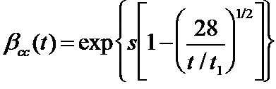(Eqn. 4.1) This equation reads that f subscript cm at time t equals the beta subscript cc at time t multiplied by f subscript cm.

(Eqn. 4.2)

Where, fcm = 28-day compressive strength

fcm(t) = concrete compressive strength at time t

cc = time-dependent coefficient dependent on age of concrete t = age of concrete at which fcm(t) is computed (days)

t1 = 1 day

s = cement rate of hardening coefficient

(0.20 for rapid hardening high strength concretes, 0.25 for normal and rapid hardening cement, 0.38 for slow hardening cements)

Note that the 28-day compressive strength predicted by testing in accordance with the AASHTO LRFD specifications is used without modification in equation 2.1. This is as opposed to using the 28-day strength plus 8 MPa as in other CEB-FIP equations.

Figure 4.1 shows a plot of the ratio of concrete compressive strength to 28-day compressive strength

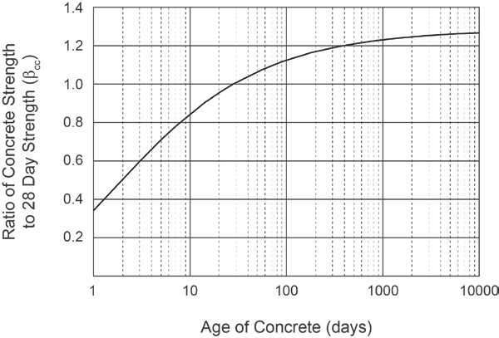

Figure 4.1 – Concrete strength gain with time

## 4.2.3 Tensile Strength

Concrete tensile strength greatly impacts prestressed concrete design as it forms the basis of the criteria for which post-tensioning force and layout is typically chosen. AASHTO LRFD specifies concrete tensile stress in two different ways: Modulus of Rupture and Direct Tensile Strength.

The Modulus of Rupture (fr) is defined as the tensile stress in concrete developed by concrete flexure. For concrete compressive strengths up to 15 ksi and for normal-weight concrete, AASHTO LRFD Article 5.4.2.6 specifies the modulus of rupture in ksi to be:

(Eqn. 4.3) 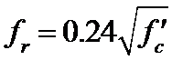

The Modulus of Rupture is determined by standardized test AASHTO T97 (ASTM C78).

The Direct Tensile Strength, also designated as fr, is specified in AASHTO LRFD Article 5.4.2.7. The commentary of this section specifies that for normal-weight concrete of compressive strengths up to 10 ksi, the direct tensile strength in ksi is:

(Eqn.4.3) This equation reads that f subscript our equals 0.23 multiplied by the square root of f prime subscript c.

Traditionally, testing for direct tensile strength is by the split cylinder tensile strength method performed in accordance with AASHTO T198 (ASTM C496). However, pull out methods specified in ASTM C900 may also be used.

## 4.3.1 Prestressing Strands

Strands for post-tensioning are made of high tensile strength steel wire conforming to ASTM A416. A strand is comprised of 7 individual wires, with six wires helically wound to a long pitch around a center “king” wire. Strand is most commonly available in two nominal sizes, 0.5 inch and 0.6 inch diameter, with nominal cross-sectional areas of 0.153 in2 and 0.217 in2, respectively. Though the majority of post-tensioning hardware and stressing equipment is based on these sizes, the use of 0.62 inch diameter strand has been increasing.

Strand size tolerances may result in strands being manufactured consistently smaller than, or larger than nominal values. Recognizing this, “Acceptance Standards for Post-Tensioning Systems” (Post-Tensioning Institute, 1998) refers to the “Minimum Ultimate Tensile Strength,” which is the minimum specified breaking force for a strand. Strand size tolerance may also affect strand-wedge action leading to possible wedge slip if the wedges and strands are at opposite ends of the size tolerance range.

Strand conforming to ASTM A416 is relatively resistant to stress corrosion and hydrogen embrittlement due to the cold drawing process. However, since susceptibility to corrosion increases with increasing tensile strength, caution is necessary if strand is exposed to corrosive conditions such as marine environments and solutions containing chloride or sulfate, phosphate, nitrate ions or similar. Consequently, ASTM A416 requires proper protection of strand throughout manufacture, shipping and handling. Protection during the project, before and after installation, should be specified in project drawings and specifications.

## 4.3.2 Tensile Strength

All strands should be Grade 270 ksi low relaxation, seven-wire strand conforming to the requirements of ASTM A416 “Standard Specification for Steel Strand, Uncoated Seven Wire Strand for Prestressed Concrete.” ASTM A416 provides minimum requirements for mechanical properties (yield, breaking strength, elongation) and maximum allowable dimensiontolerances. The AASHTO LRFD specifications do recognize the use of Grade 250 ksi prestressing steel, but this material is almost never used in major bridge construction, and is not addressed in this manual.

## 4.4 Reinforcing Steel

Reinforcing steel shall be in accordance with AASHTO LRFD Article 5.4.3. For this manual only reinforcing steel with a yield stress of 60 ksi is considered. AASHTO LRFD Article 5.4.3.1 permits the use of reinforcing steels with yield stresses greater than 60 ksi, up to 75 ksi, with the approval of the Owner. The modulus of elasticity of the reinforcing steel is 29,000 ksi as per AASHTO LRFD Article 5.4.3.2.

1. **Structural Analysis and Design of Deck Component**

**General approach to the analysis and design work**

**In the preliminary study and midterm report summarizing its finding had been based on the approximate hand computation. For evaluation of the self-weight of the structure estimation had been made for the cross sections. Thus the loads due to the own weight of the structure had been calculated. As for the moving vehicle loads a first approximation based on the overall engineering experience for such structures and certain percentage of the permanent load had been accepted as the part of moving loads on the system( 20% proportion which is maximum value overall for the moving of such structures had been used)**

**In the final stage of our work the analysis studies where advanced making use of the computer program “MIDAS Civil 2017”. In this application**

**Up to experience of the Turkish design groups operating in Iraq some approximate estimation are made in design process. The designing group Mega who was in charge of the design project for this operation made use of an approximation based of zonal coefficients equivalent of those which are applied in Turkish practice for the fourth zone of earthquake. This would lead to numerical values varying up to definitions of used codes or standards.**

**At the case of columns, it has been decided to make use of ASSHTo LRFD for the constructional arrangement with use of lead melanged elastic supporting plates between the bottom surface of the deck and upper surface of the columns.**

**Column system is formed by two columns circular form with diameter 2 meter these columns are placed with a distance of ….. meter. “Midas Civil 2017” program would provide**

**5.1 Definition of Components**

Various construction techniques for the erection of post-tensioned bridge decks exist as described in the Chapter 2. In all these systems, the decks are imagined and designed in the form of box structures for purpose of decreasing the structural weight.

The moment of inertia which is a function of the section sizes including the web and horizontal plate thicknesses are approximated as having a moment of inertia 12. Indeed, in the computer program based of the analysis of work 2 different values are going to be obtained; 1 at the mid-span and another one having larger value at the support value. In this stage the estimated value of moment is likely an approximation of these. Two values will be defined in finite computation. The sectional concrete stress values at the top and bottom fibers of the concrete box block could be easily computed.

The estimation of the area coefficient to obtain earthquake force coefficient could be made taking into considering Turkey’s earthquake map for this southern area. Since there is no engineering vise valid code coefficient for earthquake effect do not exist in Iraq. Discussing with the experienced engineers for earthquake activation in Iraq and especially, taking into consideration these subjections of the design project group Mega. The area of construction is coming to a place qualified between 2nd and 3rd zones of earthquake for Turkey equivalent. For a higher safety, the equivalent 2nd earthquake zone of Turkey will be taken into consideration. Therefore, geographical area coefficient will be taken as 0.3. Our value could be taken up to ASHTO definition between 3 and 5 for a higher safety situation. Our 3 equivalent is preferred in stage of design study.

The deck geometry which had been developed at the predesign stage by professional designers had also box section whose stability varies from mid-span to the pier supports.

According to U.S department of transportation federal highway administration post tension box girder design manual traditional minimum length to depth ratio is;

D=0.045L for simple span

D=0.040L for continuous span

The weight of the deck structure is not varying uniformly. As seen in the figure 5.1 the cross section of the deck has different values at the mid-span and at the level of pier supports.

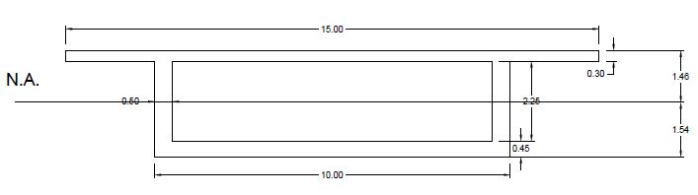

*Figure 5.1 Cross section of the deck at pier support and mid-span*

Overall deck values had been provided us by mega design office and confirmed by the post tensioning tension installing. Responsible engineers of the Freysaş company deck sizes with all details are going to be used at the design work of final report of the project. In this stage average approximate values are taken into consideration. As indicated in the figure total thickness of the deck is larger at the pier support than at the mid-span area.

Starting from the average geometrical size values structural properties are computed as

1. Concrete area = 11.25 m2

Concrete density = 25 kN/m3

11.25*25=280 kN/m

1. Asphalt area= 15*0.06=0.9m2

Asphalt density=21 kN/m3

0.9*21=18.9 kN/m

C. Pedestrian guardrail =1 kN/m

D. Guardrail = 4 kN/m

∑dead=280+18.9+1+4=305.3 kN/m

∑live=0.16*305.3=48.85 kN/m

The structural features are necessary and useful for evaluation and checking concrete stress values at the support and mid-span positions. It should be remembered that top fiber stress of a given section could be obtained by the relation σtop= M/I*u (upper level) In a similar way stress value created by the lower σbottom= M/I*u(lower level)

The remaining part of the design work is the evaluation of the longitudinal moment diagram of the deck system and the finding of moment values on the longitudinal direction

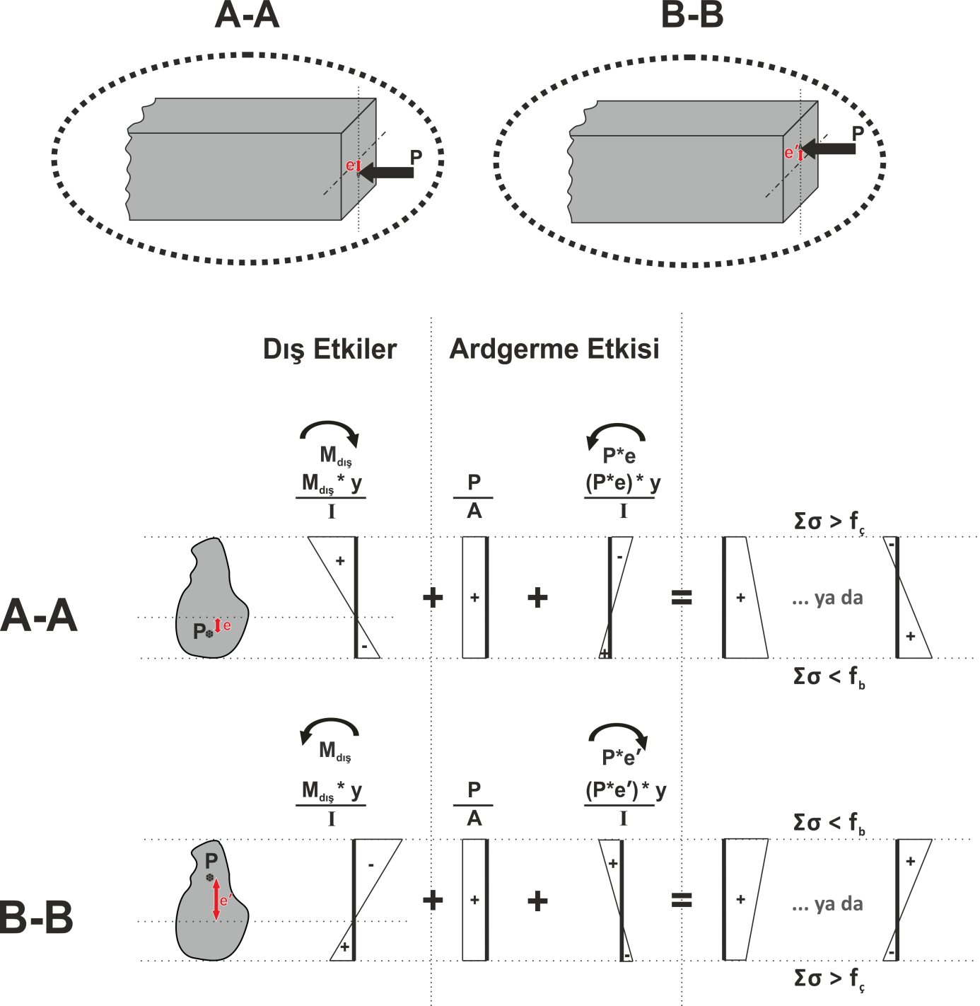

*Figure 5.2: The mechanism of post-tensioned technique - Creation of post-tensioning effect in structure elements and schematization of intra-sectional distribution of the critical points*

## 5.2 Longitudinal and Sectional Features of the Deck Structure

Figure 5.3 is showing the longitudinally the deck system. At the final stage of the project work the flexural moment diagram is to be obtained by means of computer programs. In this level an approximation is made based on the hand computation. The cable is going to have parabolic computation having the largest eccentricity at the mid-span and eccentricity at the support. This eccentricity values are approximately 1.36 m at the mid-span and 1.44 m at the support levels from neutral axis. But the construction technique is coming in this point to lead design process. As described in the Chapter2 figure. The structural system is going to be construction in 4 parts. The post tensioning cables tracing roughly recalling the geometric diagram would reach ‘0’ at approximately 10 m from the support section. First cabling operation would be realized that 70 m (60 m over the span and 10 m overpass)

4th stage

3rd stage

2nd stage

1st stage

*Figure 5.3 longitudinal deck systems*

The post tensioning cable starting from the abutment section of the system in the longitudinal direction would pass then by the lower part of the section as indicated in the figure. And at the top level of the section at the level of support and descending sharply and equal to zero section of the deck. In in this section level a junction is necessary to start the construction of the following neighboring part of deck therefore a new cable is taking place at second span would start from this junction and continue as in first span descending from span of box section with eccentricity 1.36 m at mid-span and 1.44 m at support.

The junction details are going to be provided at the final report. Here it should be briefly summarized that the junctions used to be achieved by the dead anchorage block installed in the mass of concrete continuing them. These dead anchors would be pressed in such a way that parts of going in one direction and other directions would be installed in neighboring position in the concrete mass in our days new devices have been developed allowing constructing junctions between neighboring cables without overlapping in the junction. Two edges coming from two parts of the deck and joining moments equals 0 sections longitudinally are linked one to other mechanically. Indeed the information which is related to use by designing and constructing teems of the Zuregvan Bridge the junctions are realized with the good old techniques of junctioning in the mass of concrete. This past of constructing details are going to be provided as mentioned above in the final report.

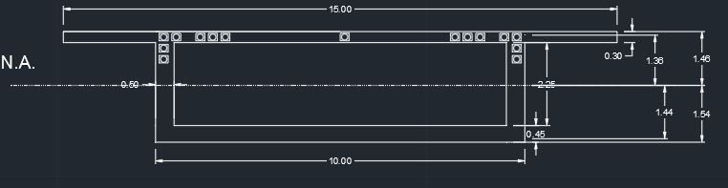

Figure 5.4 Cross-section and eccentricity

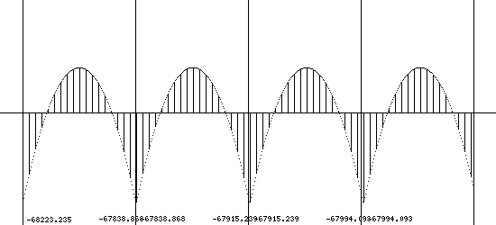

-54000 kNm

-54000 kNm

-54000 kNm

-54000 kNm

44000 kNm

44000 kNm

44000 kNm

44000 kNm

Figure 5.5 Moment Diagram of Span due to Dead Load

## 5.3 Flexural moments affecting the deck and cable post-tensioning installation

As mentioned in Chapter 2, two different procedures would be applied to ensure the change of moments and sectional thicknesses of the deck structure in the box form. In preliminary design approach the overall box thickness is kept as constant but the thicknesses of vertical load and horizontal slab plates would have larger size at the support levels that of the mid-span. Indeed, playing with the overall thickness of the box would be preferable and in the computer program based solutions to be collaborated in the final reports. These analyses could be used in this level for hand calculation based preliminary analysis and approximation is used to provide a preliminary idea in the preliminary idea in the cabling system. With the application of trial and error concept several numerical details are considered. Finally, overall thickness is 3 meters. (At the final stage, this value would likely vary from 2.5 to 4.5 making use of above mentioned second construction approach.)

-Ϭf = 13.52 kg/cm2

-Ϭb= 424.49 kg/cm2

-P= 2800 tons.

Above values are computed for support of the system.

- Ϭf = 390.93 kg/cm2

- Ϭb= 7.49 kg/cm2

- P= 2000 tons.

In this stage considering I=12 m4 and h=3m constant an approximation based trial and error approach and supports value is coming from this approximation.

-5400 t.m and +4300 t.m taking approximated cable forces as P=2800 tons at support and 2000 tons at mid-span. Sectional stress values are obtained as shown in the Figure 5.6 and 5.7.

## C:\Users\Can\Desktop\8.JPG

Figure 5.6

## C:\Users\Can\Desktop\9.JPG

Figure 5.7

Note that above stress distributions are showing after post-tensioning applications. With the post-tensioning stress helps us to develop compression in tension zones. Above figures has the unit kg/cm2.

**5.3.1 Transversal Cabling**

As described in the previous chapters describing cross sectional features of the deck system, the upper plate of the box was a thinner member with regard the webs and lower slab plate of the section. Vehicle loads especially heavy truck loads acting just at the middle or on the cantilever part of the upper plate would solicit this plate rather heavily and a classical reinforced web system would not be sufficient to carry stress created by a bad combination of loads. In that case, post tensioning would be also necessary in transversal direction of the section. Numerical details for this transversal cable are going to be provided in the final report.

**6. Installation of Post-Tensioning Cables**

**6.1 General Overview of Post-Tension Cabling**

As mentioned in the Chapter 5, post-tensioning is needed in order to across the relatively larger spans. In our case, the bridge has sixty-meter-long span. So, in order to pass this distance post-tensioning should be applied to the concrete. As it is determined in Chapter 5 with specified geometry post-tensioning must be applied to the elements of the structure.

As concrete cannot carry its own load due to huge amount of its geometry and mass, some cables must be placed in the concrete. With doing iterations, post-tensioning force may be estimated for to concrete to not expose to tension forces. The main idea was to in stress-strain relation (Figure 5.6 and 5.7) to eliminate tension forces and instead of tension, exposing concrete to compression loads and moments. After doing iterations, following forces are finding to apply to concrete.

-2800 tons for supports

Stress in concrete in the top fiber; Ϭt=13.52 tons/m2

Stress in concrete in the bottom fiber; Ϭb=424.49 tons/m2

-2000 tons for mid-spans

Stress in concrete in the top fiber; Ϭt= 390.93 tons/m2

Stress in concrete in the bottom fiber; Ϭb=390.93 tons/m2

With the above force magnitudes it is easy to overcome tension effect of deck’s own weight by using post-tensioned cables. After that, one may be calculate cable number required to be needed for applying this force.

Normally, cables have the strength varies between 1770 mPa to 1860 mPa. However, due to some effects this value is decreased significantly. Therefore, it is not advised to take catalog values while designing the system. These losses can be categorized as;

-Design and real value differences due to manufacturing and some other causes.

-Friction losses; friction caused by cover of the tendon and friction caused by anchorage.

-Losses due to anchorage settlements.

-Losses due to elastic shortening of concrete elements.

-Losses due to creep and shrinkage.

-After a while steel relaxes and do not carry such a load that it causes some losses.

These losses should be taken into consideration while selecting design strength value of the tendons. If we add all the losses, normally it will be around 10% to 15%. However, this value may go up to 20%. Since Turkey is not accustomed to pre-tensioning and tendon installation and there may be material related problems, we took this value as 20% of its ultimate strength. So, our design value for strength of tendons became 1110 mPa.

where, F= required post-tension force

Ϭ= strength of tendon

A= area

n= number of cable needed.

Ϭ is the strength of post-tension cable

Therefore n= for support

n= for mid-span

In placing tendons 170 cables are going to be needed for achieving the force in supports and 120 cables will be sufficing in mid-span. Catalog of Freyssinet can be found in Figure 6.1. From that catalog, we chose that 12C15 will be enough for our design.

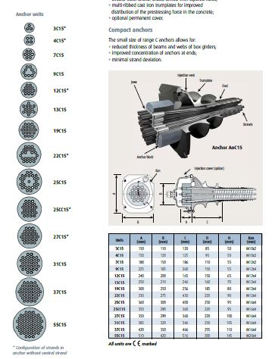

Figure 6.1

When we calculate it, 12*12=144 tendon in mid-span will be available and 3 additional tendons will be in support, 3*12=36. 144+36=180 tendons are total number of tendons which is going to be used in our deck. This number is greater than those of needed tendon number. So, we expect that with the number of tendons which we decided to use will be safely effective for our case.

**6.2 Cabling details along the deck component**

A detailed computer based analysis of the deck would be provided as previously explained in the final report. An approximation based on the hand computation is advanced in this stage and the post-tensioning forces are estimated at mid-spans at the column heads along the full length of the deck of the bridge.

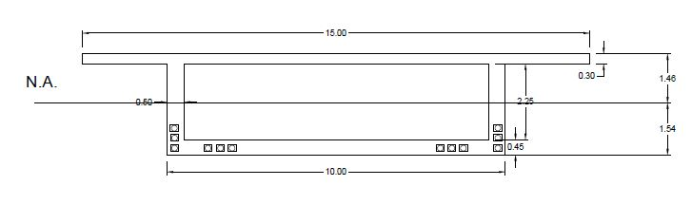With the number which we have obtained and calculated stresses a typical cross section of mid-span can be found in Figure 6.2.

Figure 6.2

In Figure 6.2 the boxes are anchorage plates of the tendons. In our design, we have tried to catch a clear cover that it would not be disturb the tendons itself and concrete also. In mid-span, as it is mentioned previously there are 12x12C15 tendons.

In cross-section of supports cross-sections are changing a little bit. From our calculations, it is advised to use 3x12C15 in order to reach designated force component. For that particular reason, mid-span tendons are transitioning from bottom web to the top slab concrete. Also, additional 3x12C15 is provided at the supports to help reinforcing greater moments than those of mid-span. Cross-section of support post-tension reinforcements can be found in Figure 6.3. Indeed, this transition has certain geometry. However, these calculations and geometry will be provided in computer based software. Therefore, these exact calculations will be given in the final report. On the other hand, an approximation of 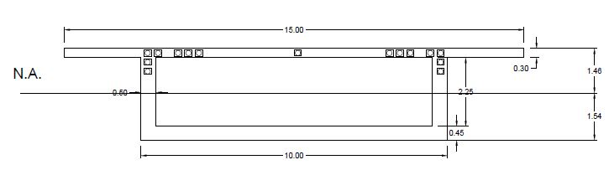this transition can be found in Figure 6.4.

Figure 6.3

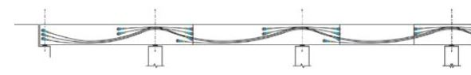

Figure 6.4

## 7. Design and construction of piers

As mentioned in the chapter 2, 3 piers of the bridge are constructed by application of different methods. For two of them land surface being naturally dried during summer times as sufficiently large construction area was formed. Footings and pier masses in concrete for these two piers well-constructed rather easily. No special precautions concerning their erection were needed. As for the 3rd pier area behind the pier floating was lying in all seasons in the water. An artificial island has been constituted in order to create a dry surface to advance the construction of footing and the piers. On the other hand, it should be added that two separate circular columns each having a diameter of 2 m and distanced 6.5 meters would be sufficient for the vertical bearing system (Figure 5.8).

At the case of earthquake, the columns are charged by horizontal loading effect. Columns are no inflected at the mid-height of their height because of the elastically moving supports braces at the head of each column. System would behave as a continuous beam simply supported at the head of each column. On the other hand, longitudinal effect of the deck under earthquake action would create geometry of deformation as approximated in Figure 5.10. Detailed analysis of the earthquake action is going to be taken into consideration in the final report. 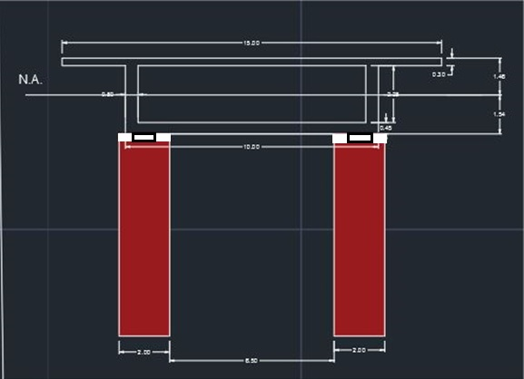

Figure 5.9 Bearing system

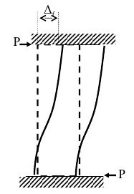

Figure 5.10-Horizontal deflection of column

**8. Geotechnical Design**

**8.1 Load Combinations**

In order to design the foundation system for the bridge, all types of forces that are transmitted to the soil have to be determined. The basic idea in order to determine the design loads for the foundation is to specify the most critical load combination, so that it ends up with the design of the largest piles and rafts or completion of safer ground improvement techniques. When the most critical loading case is determined, by designing a foundation system for that combination, safety is also satisfied for other cases.

Different load groups are used in order to find the most critical load combination. The post-tensioned highway bridge is a heavy structure, and this characteristic of it ends up with a high earthquake load. On the other hand, the bridge is in 1st earthquake zone. After calculating different load combinations, the most critical one is found to be:

Load Combination = (1.0) * D + (1.0) * L + (1.0) * E where;

D: Dead Load

L: Live Load

E: Earthquake Load

However, since in the preliminary design, we disregard the earthquake and live forces, it is appropriate to use

Load Combination = (1.5) * D

Note that, in the final calculations, earthquake forces and live forces will be used as well as dead loads and the foundation design will be finalized.

**8.2 Foundation System**

As a trial foundation system, a square single footing for each pier is considered. All calculations for a single footing are carried out. The widths B and L are estimated from the dimensions of the piers. Piers are selected to be in columns. The diameter of single column is estimated as 2m. Columns are constructed perpendicular to traffic flow as shown in the figure 8.1

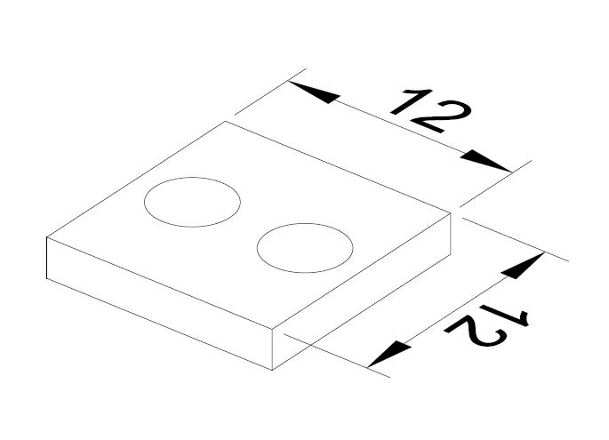

*Figure 8.1 Initial Foundation Design*

**8.3 Calculating Total and Net Foundation Pressures**

In order to determine Total Load = ΣQ, the weight of the footing has to be added to the structural loads that were determined before and it is calculated as 1500 tons.

Concrete unit weight has been taken as 2,5 t/m3,

Weight of the raft = 12 * 12 * 2 * 2.5 = 720 tons

The pier load calculations:

Total weight added to the load and axial design load that come from structural analysis is 1500 tons = 15000 kN

Total weight that is transmitted to the soil = 1500+720= 2220 tons

**8.4 Soil Profile**

The idealized soil profile is created by considering the tests carried out. Between 0-8.00m depth Alluvium layer exists. The alluvium layer is assumed to be clayey gravel and from the reference table given in the appendices f=30° and g=19kN/m3 is used for this layer. Beneath this layer between 8.00-20.0m depth, there exists weathered claystone-serpentine alternation. This layer is assumed to behave like Intermediate Geomaterial layer and: Assuming Claystone-Serpentine alternation is an Intermediate geomaterial, a cohesion value of Cu=400kPa is selected

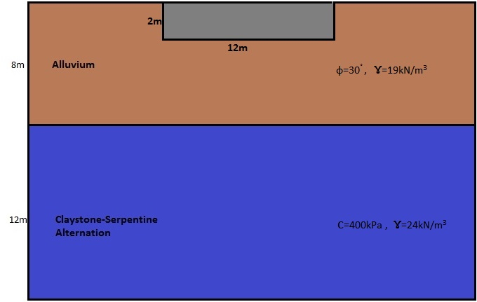

*Figure 8.2 Soil Profile*

**8.5 Net Foundation Pressure**

The weight of excavated soil = 12*12*2*19=5472 kN

qnet = (Total weight – excavated soil) / (B*L) = (22200-5472) / (12 * 12)

qnet = 116 kPa

**8.6 Settlements**

**8.6.1 Immediate Settlement**



Since there are different soil layers we take E as an average safe value which is 150Gpa

Where q is the net foundation pressure

B is the lesser dimension of the raft

E is the modulus of elasticity for clay.

Is the empirical factor and taken from chart by using dimensions

V poissons ratio

Q net is multiplied by 1.5 because there we don’t have any moment calculation exist at this stage



=116*1.5*12*(1-0,252)*1/150000=0,013m

Settlement that is calculated by this method is not very accurate because this formula is theoretically derived for endless soil layers that goes down to infinity. However, in this way more settlement calculated then the real case and we stayed on the safe side.

**8.7 Ultimate Capacity**

For the sand layer:

qf = (1 / 2) * sγ * γ * B * Nγ + sc * c * Nc + sq * γ * D *Nq

for sand layer, c = 0

Shape factors for vertical loading on rectangular footing:

sq = 1

sγ = 1 - 0,2 * (B / L) = 0,8

sc = 1+0,2*(B/L) = 1,2

Hatanaka and Uchida (1996);

Φ= 30

Nγ = 19 from the Terzaghi’s dimensionless bearing capacity factors vs Φ chart.

Nq = 19 from the Terzaghi’s dimensionless bearing capacity factors vs Φ chart.

Nc = 30 from the Terzaghi’s dimensionless bearing capacity factors vs Φ chart.

qf = ( 1 / 2 ) * 0,8 * (19) * 12 * 19 + 1 * (19) *2*19= 2454 kPa

Load is multiplied by 1.5 because moments are not calculated in our calculation at this level of design

2454/ (116x1.5) = 14> 3,0

**8.8 Pile Design**

Bored Piles are found to be the best solution for this structure because of economic reasons when compared other piling methods. There are two factors that affect the design of bore piles, one of them is Skin Friction and the other is end bearing capacity. These two and their contribution to the total strength of the pile will be discussed further below.

According to the soil profile, between 0-8.00m depth Alluvium layer exists. The alluvium layer is assumed to be clayey gravel and from the reference table given in the appendices Φ =30° and g=19kN/m3 is used for this layer. Beneath this layer between 8.00-20.0m depth, there exists weathered claystone-serpentine alternation. This layer is assumed to behave like Intermediate Geomaterial layer and: Assuming Claystone-Serpentine alternation is an Intermediate geomaterial, a cohesion value of Cu=400kPa is selected.

**8.8.1 Skin Friction**

Where;

*Ksi*: Coefficient of Lateral Pressure, for sands in bored pile: 0.5

Wall Friction for granular soil layer

Vertical effective stress at the middle of soil layer

For 0-8.0m Alluvium layer (Internal Friction angle, Φ=30°)

(2/3)*30o = 20o

(19-9.81)*8/2 = 36.7 kPa

Qsg = 3.14*6.7*8 = 168 kN=17tons

For 8.0-20.0m claystone-serpentine alternation layer (Cohesion, cu=400kPa)

Qf = 3.14*0.21*400*12=3165kN=317tons

Cumulative Skin Friction, Qs = 17+317=334 kN

**8.8.2 End Bearing**

The end bearing of a pile foundation structure could be found by;

For bearing capacity factor, at NAVFAC DM 7.2 Nc=9 is offered

For static conditions, factor of safety for side friction F.S.= 2 and for end bearing F.S.=3 is used.

Allowable pile capacity is calculated as:

Qall=(360/3)+(334/2)=287tons

Number of piles

Each pile diameter is estimated as 2m.

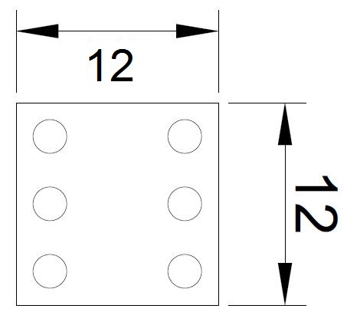

*Figure 7.3 Pile Placement*

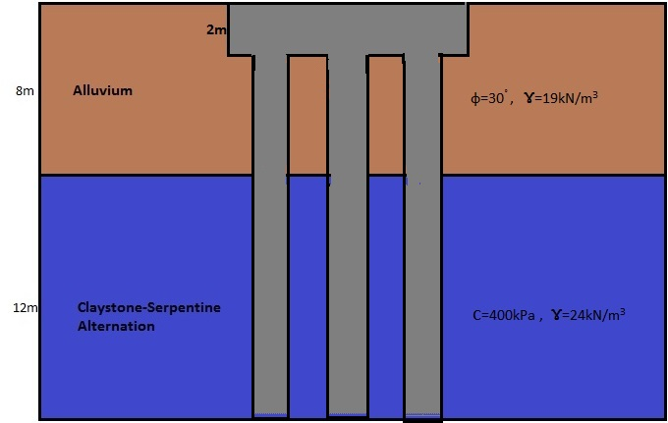

*Figure 8.4 Pile placement with soil profile*

**9. Aspect of Cost Estimation**

The studied bridge with the typical example of the continuous post tensioned deck bridges starting from engineering experience the cost of such bridge structures including their reinforced concrete piers is approximately known would also abbe to calculate approximate cost of the bridge. Based on the 1 m length of the bridge cost 52000 TL/m spent in the achievement our studied bridge for the full structure would arrive to 56000 TL/m. In the final report, this general approach is going to be compared with the material unit prices computation method. It is hopefully expected that more detailed and exact material qualities would be reached at the stage of final report. Therefore, the pricing and cost analysis could effectuated in a more realistic way 40000 $/m for Iraqi conditions. Indeed, a value of 25000 $/m could be considered as realistic value for conditions of the Turkish engineering reality.

It should be remembered that the structural system of the deck could be a continuous framing system and reinforcing bars coming from the piers could be placed in the mass of specially placed concrete over the column head. Then, fully concrete filled volumes could be necessary in a way also connecting column heads.