



**DEPARTMENT OF CIVIL ENGINEERING**

CE410 - CIVIL ENGINEERING DESIGN

PRELIMINARY DESIGN REPORT

MAR1 - Design of an Immersed Tube Tunnel Project in İzmir

VOLTRAN

**Advisor:** Prof. Dr. Ahmet Cevdet YALÇINER

- **Members:**

**Submission Date:** 10.04.2017

ANKARA

TABLE OF CONTENTS

1.INTRODUCTION1

1.1. ADVANTAGES OF TUBE TUNNEL PROJECT2

1.2. CROSSING ROUTE SELECTION2

1.2.1. WIND EFFECT4

1.2.2. WAVE AND CURRENT ANALYSIS5

2. GEOTECHNICAL DESIGN6

2.1. INTRODUCTION6

2.2. SITE INVESTIGATION AND IDEALIZED SOIL PROFILE6

2.3. SETTLEMENT11

2.3.1. IMMEDIATE SETTLEMENT11

2.3.2. CONSOLIDATION SETTLEMENT14

2.3.3. SECONDARY SETTLEMENT15

2.4. FOUNDATION SYSTEM16

2.5. BEARING CAPACITY16

3. BRIDGE DESIGN17

3.1. MATERIAL SELECTION18

3.2. SPAN LENGTH18

3.3. CABLES19

3.4. DECK DESIGN19

3.5. PIERS AND PYLONS.20

3.6. LOADING.21

4. HIGHWAY PROPERTIES24

4.1. SLOPE ANALYSIS24

4.2. PAVEMENT DESIGN25

5. ARTIFICIAL ISLAND26

5.1. GENERAL OVERVIEW27

5.2. TRANSPORTATION PHASE28

5.3. BREAKWATER DESIGN29

5.4. VOLUME AND MATERIAL SELECTION31

5.5. CONSTRUCTION PROCEDURE32

6. IMMERSED TUBE TUNNEL DESIGN34

6.1. DEFINITION35

6.2. PROPERTIES OF TUBE TUNNEL37

6.2.1. MATERIAL SELECTION37

6.2.2. DESIGN LOAD39

6.3. GROUND PROFILE39

6.4. CONSTRUCTION PROCEDURE41

7. COST ESTIMATION43

8. FUTURE PLANS AND CONCLUSION45

9. REFERENCES47

LIST OF TABLES

Table 1. Wind Speed Analysis5

Table 2. Wave Height Analysis 6

Table 3. Location and Depth of Each SPT Boreholes7

Table 4. Soil Parameters of the A-A Section of the Ground9

Table 5. Soil Parameters of the B-B Section of the Ground10

Table 6. μ0 of Immediate Settlement 12

Table 7. μ1 of Immediate Settlement 12

Table 8.Dead Loads of Bridge23

Table 9.Volume Calculation on Artificial IslandLoad Effects on Tunnel Base31

Table 10.Considering Tunnel Soil Parameters 38

Table 11.Volume Calculation on Artificial Island40

Table 12.Cost Estimation44

LIST OF FIGURES

Figure 1. Location of Project1

Figure 2. Fault Map of Izmir3

Figure 3. Existing Ports3

Figure 4. Bathymetry.4

Figure 5. SPT Boreholes7

Figure 6. Idealized Soil Profile and Element of Project8

Figure 7. Soil Profile of the A-A Section9

Figure 8. Soil Profile of the B-B Section10

Figure 9. A view of the foundation and excavated ground 11

Figure 10. The immediate settlement on Section A-A 13

Figure 11. The immediate settlement on Section B-B 13

Figure 12. Time - settlement curve 15

Figure 13. Skempton’s Nc Values 16

Figure 14. Bathymetry and the Route 17

Figure 15. Span Length 18

Figure 16. Concrete Deck 19

Figure 17. Design of the Deck 20

Figure 18. Drawing of Piers 21

Figure 19. Drawing of Pylons22

Figure 20. Isometric Drawing of the Road24

Figure 21. Preview of Road Gradient25

Figure 22. Pavement Design26

Figure 23. General Overview of Artificial Island27

Figure 24. Highway Junction Preview28

Figure 25. Cross-section of Breakwater Design31

Figure 26. Seawall Example from Kansai Internation Airport Construction32

Figure 27. Example of Rainbowing Process 33

Figure 28. View of Immersed Tube Tunnel 34

Figure 29. Dimensions of Tunnel 35

Figure 30. Tunnel Cross-section with respect to Soil Layers36

Figure 31. Integration of Tube Tunnel Segments by Bolts 37

Figure 32. Backfilling and Bedding Layer Preview 41

Figure 33. Immersion of Tube Tunnel 42

Figure 34. Beveled Excavation and Bedding Preview 43

**1. INTRODUCTION**

The aim of this project is that try to solve the traffic problem between Narlidere and Çigli. Izmir is a metropolitan city so there will be rising of the population because of university, tourism presence and industry. It is inevitable the traffic congestion. Normally, people who live in across side of Izmir Bay have to use ferry service or drive through the highway around the Bay. Because of the limited transportation capacity of ferry, most of the people have to use highways around the Izmir Bay. However, the highways are not enough for the daily traffic demand.

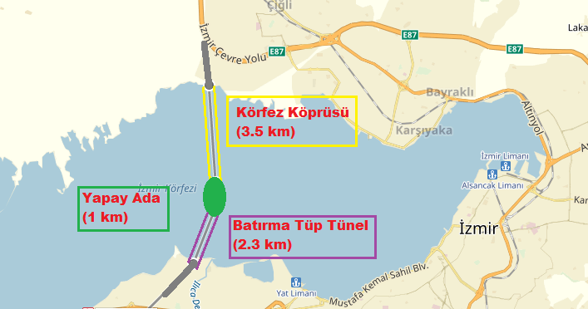By taking into account all of these problems, there is in need of a shortcut solution for two side of Bay. Therefore, bridge, artificial island and immersed tube tunnel project is considered for the Izmir Bay. The soil profile of Bay comprises of mostly very loose silty-sand layer. Because of this type of a soil profile, the ultimate bearing capacity of the soil is too low. Also, at immersed tube tunnel part, the existing maximum seawater depth is very shallow. (Approximately 17 m) Because of this reasons, the immersed tube tunnel is considered as a most suitable crossing structure for this type of soil. If the proposed Izmir Bay Immersed Tube Tunnel is constructed, it is expected from the surveys made by the Turkish State Directorate of Highways (KGM) that approximately 40,000 vehicles/day/direction will use the tunnel. This number may increase in the summer season because Izmir is a touristic place.

Figure 1. Location of Project

**1.1. Advantages**

The total distance between north and south coasts of Izmir Bay is approximately 40 kilometers and travel time is 60 minutes. After completed the project, this distance will be reduced 12 km, and maximum 10 minutes will be sufficient to pass cross side. This project consists of only 6800 meters part which is above the sea. This will be so beneficial for environment. For example, the time of vehicle usage will be reduced so petrol usage also is reduced. By this way, less air will be polluted causing from the exhaust gases. There will be a positive effect for the economy by saving the petrol.

Existing reserve supplies may not be capable of meeting the demand of the increasing and industrializing world population. If the usage rate of petroleum is remain constant, it may reasonably be expected that by 2050 most of the world’s known oil reserves will be consumed, and that the petrol unit price will increase. This destroys all economic balances all around the world.

In addition to environmental advantages, this project will increase the people’s life quality , by eliminating the traffic stress.

There will be also positive effect for regional contribution. The distance between Çigli and Adnan Menderes Airport will be decreased by 8 km. The traffic density will be dramatically diminished at the city center. Distance from Cesme Motorway to İzmir-Canakkale Road at the north side of the bay will be reduced by 40 km.

**1.2. Crossing Route Selection**

The active faults have been investigated, which have the potential to create a large earthquake in an area of about 50 kilometers radius, being the center of Izmir. There are thirteen active faults in Izmir and its surroundings. The active faults can be seen easily from Figure 2.

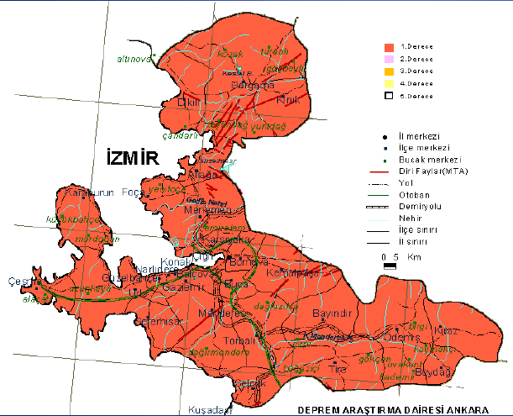

**Figure 2. Fault Map of Izmir**

In addition to faults, the feasibility and environmental factors such as water depth, soil profile, current and wind affects the crossing route. Because of these reasons, the past analyses belong to Izmir bay for current and wind has been collected and the feasibility of different types of bridges alternatives and underwater tunnel types should be examined.

Another important point is location of the navigation channel that a passage in a stretch of water where the sea or river bed has been deepened to allow access to large vessels. 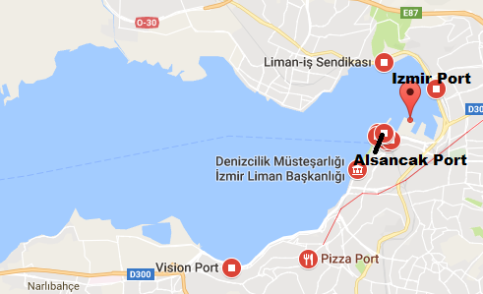

Figure 3. Existing Ports

There is Izmir port inside the bay which is used for commercial purposes. The ships with deeper draft will use the route also. Therefore, the sea traffic cannot be ignored. By considering this, the order of bridge, tunnel and artificial island should be well defined. If the entire road is designed as bridge, it has several disadvantages to project. For instance, the bridge should be constructed as higher clear deck height to ease the passage of commercial vessels. Besides, the deeper side of the bathymetry is wasted with bridge footings and decks which also increase the material cost of the height of piers disproportionally.

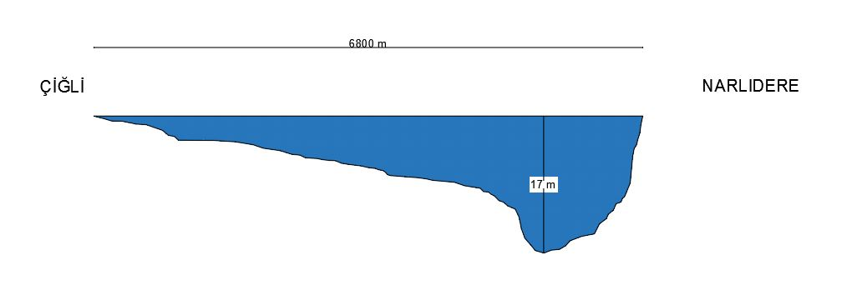On the other hand, the reason why the entire route is not designed as tube tunnel is economical. In Çigli side, the depth of water is shallow so immersed tube tunnel for all through the road will be costly compared to combined constructing bridge and tunnel. The detail of bathymetry can be seen in Figure 4 throughout the route.

Figure 4.Bathymetry

**1.2.1. Wind Effect**

The wind loads govern the design of the lateral force resisting system especially in bridge in this project. Wind direction, speed and frequency will influence the structure design including cable requirements, pier and abutment size selection, the distance between the piers, type of footing. The wind will cause some problems during the installation and placement of the tubes and cause an interruption in the project schedule.

The general wind direction must be considered in relation to the design of structure. Other aspects of wind to consider include is that the direction of the strongest wind, wind that comes off the sea (salt spray issues) and the wind direction that brings most of the rain.

After the analysis and researches, it is found that the effective wind blows as 10 m/s during the winter season which will used in design part. The necessary data which found from “Wind Climate for 38.500 N, 26.800 E” 2008 analysis in this project is shown as follows:

**Table 1: Wind Speed Analysis**

|  |  |  |  |  |  |  |  |  |  |  |
| --- | --- | --- | --- | --- | --- | --- | --- | --- | --- | --- |
| **Wind speed (m/s)** |  |  | **N** | **NW** | **W** | **SW** | **S** | **SE** | **E** | **NE** |
| **Winter** | **December** | 10,0 | 5,556 | 5,0 | 7,8125 | 7,8125 | 5,208 | 5,0 | 7,9375 |
| **January** | 10,0 | 5,556 | 5,0 | 7,8125 | 7,8125 | 5,208 | 5,0 | 7,9375 |
| **February** | 10,0 | 5,556 | 5,0 | 7,8125 | 7,8125 | 5,208 | 5,0 | 7,9375 |
| **Spring** | **March** | 10,0 | 6,4931 | 5,0 | 6,111 | 6,667 | 5,556 | 5,0 | 6,875 |
| **April** | 10,0 | 6,4931 | 5,0 | 6,111 | 6,667 | 5,556 | 5,0 | 6,875 |
| **May** | 10,0 | 6,4931 | 5,0 | 6,111 | 6,667 | 5,556 | 5,0 | 6,875 |
| **Summer** | **June** | 10,0 | 6,542 | 5,0 | 5,0 | 5,0 | 5,0 | 5,0 | 6,333 |
| **July** | 10,0 | 6,542 | 5,0 | 5,0 | 5,0 | 5,0 | 5,0 | 6,333 |
| **August** | 10,0 | 6,542 | 5,0 | 5,0 | 5,0 | 5,0 | 5,0 | 6,333 |
| **Autumn** | **September** | 9,0 | 5,9375 | 5,0 | 5,764 | 6,667 | 5,208 | 5,0 | 6,875 |
| **October** | 9,0 | 5,9375 | 5,0 | 5,764 | 6,667 | 5,208 | 5,0 | 6,875 |
| **November** | 9,0 | 5,9375 | 5,0 | 5,764 | 6,667 | 5,208 | 5,0 | 6,875 |

**1.2.2. Wave and Current**

It is difficult to build on the ground with strong waves and currents. Due to the strong effects of the waves, the sea-facing coasts of the islands are strengthened by using a special protective stone layer. Its aim is preventing the abrasion and protecting the existing strength. Therefore, flow and wave analysis are great importance in each part of the project. For instance, they make the installation difficult during the placement of the tubes and cause an interruption in the project schedule. The current rate is very slow and is found to be about 0.8 m / s.

After the analysis and researches, it is found that the maximum wave height as 2.06 m during the winter season from North direction. This will be the critical design parameter for wave. The necessary data in this project is shown as follows in Table 2.

|  |  |  |  |  |  |  |  |  |  |  |
| --- | --- | --- | --- | --- | --- | --- | --- | --- | --- | --- |
| **Wave height (m)** |  |  | **N** | **NW** | **W** | **SW** | **S** | **SE** | **E** | **NE** |
| **Winter** | **December** | 2,0625 | 0,75 | 0,5 | 1,125 | 1,125 | 0,5 | 0,5 | 1,03125 |
| **January** | 2,0625 | 0,75 | 0,5 | 1,125 | 1,125 | 0,5 | 0,5 | 1,03125 |
| **February** | 2,0625 | 0,75 | 0,5 | 1,125 | 1,125 | 0,5 | 0,5 | 1,03125 |
| **Spring** | **March** | 1,0 | 0,5625 | 0,5 | 1,125 | 1,125 | 0,5 | 0,5 | 0,7917 |
| **April** | 1,0 | 0,5625 | 0,5 | 1,125 | 1,125 | 0,5 | 0,5 | 0,7917 |
| **May** | 1,0 | 0,5625 | 0,5 | 1,125 | 1,125 | 0,5 | 0,5 | 0,7917 |
| **Summer** | **June** | 1,5833 | 0,8611 | 0,5 | 0,5 | 0,5 | 0,5 | 0,5 | 0,5 |
| **July** | 1,5833 | 0,8611 | 0,5 | 0,5 | 0,5 | 0,5 | 0,5 | 0,5 |
| **August** | 1,5833 | 0,8611 | 0,5 | 0,5 | 0,5 | 0,5 | 0,5 | 0,5 |
| **Autumn** | **September** | 1,5833 | 0,7083 | 0,5 | 0,5 | 0,5 | 0,5 | 0,5 | 0,7083 |
| **October** | 1,5833 | 0,7083 | 0,5 | 0,5 | 0,5 | 0,5 | 0,5 | 0,7083 |
| **November** | 1,5833 | 0,7083 | 0,5 | 0,5 | 0,5 | 0,5 | 0,5 | 0,7083 |

Table 2: Wave Height Analysis

**2. GEOTECHNICAL DESIGN**

**2.1. Introduction**

Izmır Bay has known as having very soft soil type at offshore. It is essential to investigate properly that kind of soil type; in order to prevent geotechnical failures. In that case, VOLTRAN’s aim is to collect data related with Izmır Bay, obtain parameters, analyze it and calculate related values which are part of geotechnical part.

**2.2. Site Investigation and Idealized Soil Profile**

There are 9 different Standard Penetration Tests (SPT) with vary depth. 5 of them are made at Navigation Channel near Narlidere, 4 of them are made at Circulation Channel near Cigli. Their location and depth of each SPT boreholes has shown as Table 3 and Figure 5.

**Table 3. The location and depth of each SPT boreholes**

|  |  |  |
| --- | --- | --- |
| Borehole No. | Location | Depth (m) |
| NTS - 02 | Navigation Channel | 29,75 |
| NTS - 03 | Navigation Channel | 20,75 |
| NTS - 15 | Navigation Channel | 29,75 |
| NTS - 24 | Navigation Channel | 29,75 |
| NTS - 25 | Navigation Channel | 23,75 |
| STS - 05 | Circulation Channel | 15,05 |
| STS - 06 | Circulation Channel | 15,05 |
| STS - 14 | Circulation Channel | 15,05 |
| STS - 22 | Circulation Channel | 15,05 |

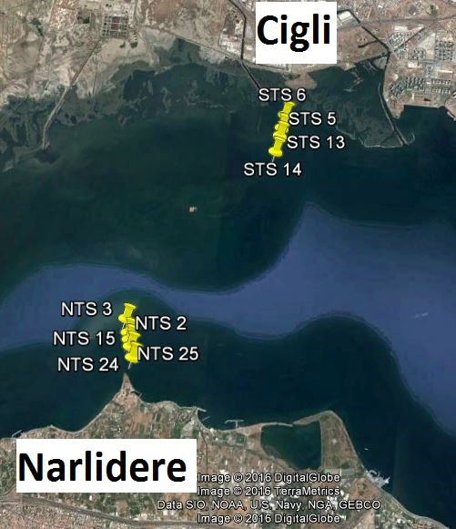

Figure 5. SPT boreholes

According SPT data and samples and laboratory tests, there is two major soil layers in Izmir Bay. And also in accordance those results, parameters of those layers are obtained. For general view of soil layers, upper layer is very soft – soft clay which has almost no contributes to bear constructions; on the other hand, second layer will majorly bear the constructions; in the light of those obtained data.

Parameters of soil layers are obtained as follows;

First of all, generally SPT data are used to obtain those parameters. In order to use those data, SPT data corrected to SPTN60 values. In addition, Atterberg Limits, consolidation test results are obtained from laboratory tests. With the help of those data, parameters are obtained with related correlations and general soil profile idealized (Figure 6). Since project area’s length is 7 kilometer, soil profile and parameters idealized in two different places which are located at the navigation channel and circulation channel (Figure 7 – 8, Table 4 – 5).

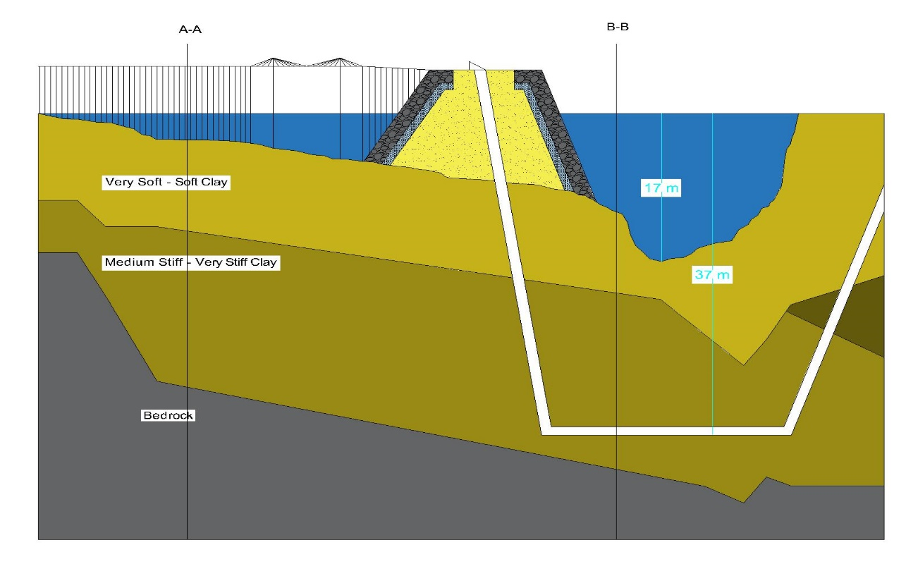 In order to find φ’, Schmertmann (1975) was chosen because it is both related with overburden pressure and SPT data. For unit weight of soil’s Çetin at all. (2016) correlation is used, since it correlation gave us direct unit weights with SPT value. Coduto (2000) correlation is used for estimating relative density of soils. To obtain cu, Stroud (1976) correlation which is directly related with plasticity index is used. On the other hand, Es parameter found by Kulhawy & Mayne (1990) correlation. For Eu parameter Paulos & Small (2000) correlation is used.

Figure 6. Idealized soil profile and elements of the project

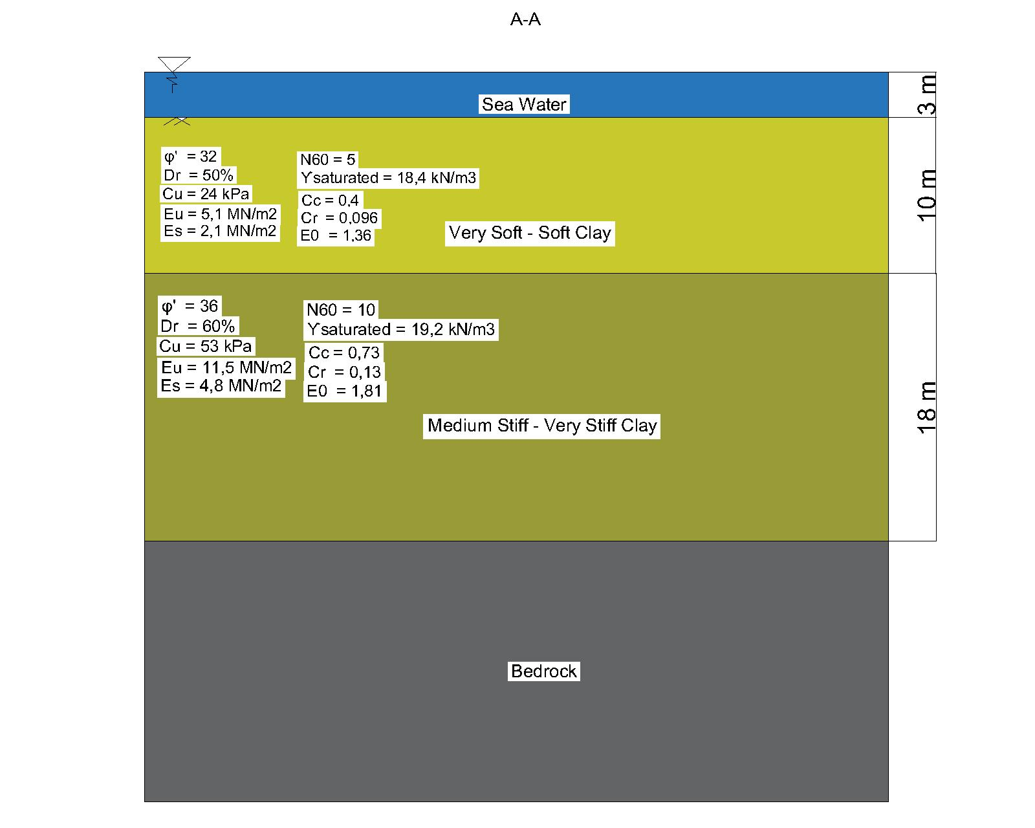

Figure 7. Soil profile of the A-A section of the ground

Table 4. Soil parameters of the A-A section of the ground

|  |  |  |
| --- | --- | --- |
|  | Very Soft - Soft Clay | Medium Stiff - Very Stiff Clay |
| Unit Weight (kN/m3) | 18,4 | 19,2 |
| Liquid Limit | 52,5 | 51,7 |
| Plastic Limit | 26,7 | 26 |
| Plasticity Index | 25,8 | 26 |
| Cu (kPa) | 25 | 53 |
| φ ( ͦ) | 0 | 36 |
| Es (MN/m2) | - | 4,8 |
| Eu (MN/m2) | - | 11,5 |
| Dr (%) | - | 60 |
| E0 | 1,36 | 1,81 |
| Cr | 0,096 | 0,13 |
| Cc | 0,4 | 0,73 |

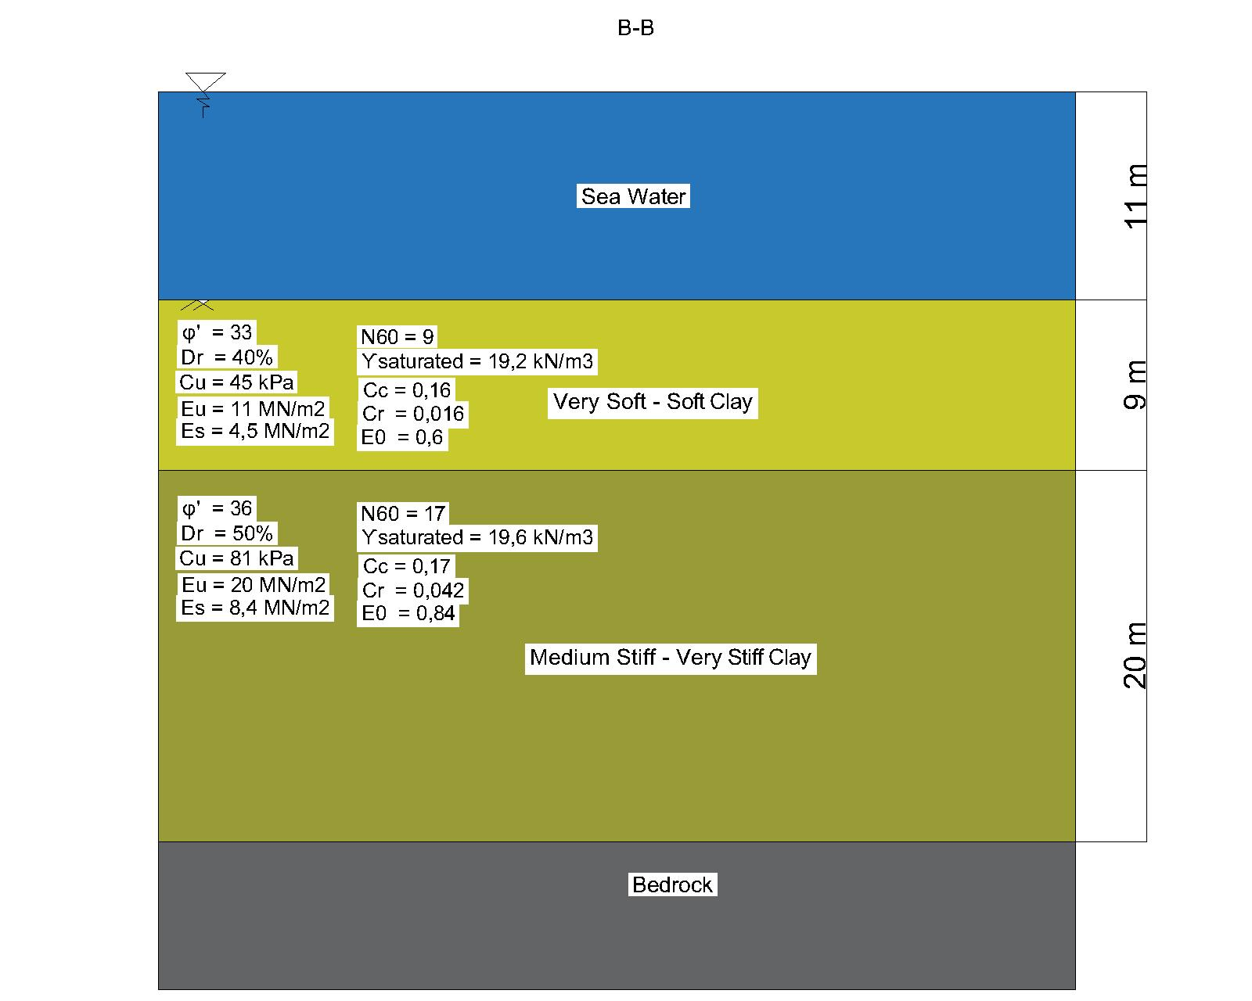

Figure 8. Soil profile of the B-B section of the ground

Table 5. Soil parameters of the B-B section of the ground

|  |  |  |
| --- | --- | --- |
|  | Very Soft - Soft Clay | Medium Stiff - Very Stiff Clay |
| Unit Weight (kN/m3) | 18,4 | 19,6 |
| Liquid Limit | 53,2 | 27,2 |
| Plastic Limit | 44,3 | 23,3 |
| Plasticity Index | 27,8 | 21,5 |
| Cu (kPa) | 25 | 81 |
| φ ( ͦ) | 0 | 36 |
| Es (MN/m2) | - | 8,4 |
| Eu (MN/m2) | - | 20 |
| Dr (%) | - | 50 |
| E0 | 0,6 | 0,84 |
| Cr | 0,016 | 0,042 |
| Cc | 0,16 | 0,17 |

As seen as Table 4 and Table 5, some parameters did not found. According SPT data, at first layer we have very soft clay which SPTN60 value is zero. Due to that very soft clay, those parameters did not obtain and also that layer did not count to bearing case.

**2.3. Settlement**

Settlement is a critical factor that should be taken into consideration in the design of foundations to make it safe, economical and serviceable. Immediate, consolidation and secondary settlements are calculated by using obtained parameters.

## 2.3.1. Immediate Settlement

## Immediate settlement will occur in a short time right after the constructing of a structure. According to Janbu, Bjerrum and Kjaernsli (1956), immediate settlement of foundations on clay is calculated by using formula and charts as below.

Si = μ0.μ1.q.

* Si : immediate settlement on clay (mm)
* q : average applied vertical pressure (kPa)
* B : width of the foundation (m)
* E : modulus of elasticity of the soil (MPa)

## 

## B is the smaller dimension.

## We obtain,

## μ0 from D / B

## μ1 from H / B and L / B

## Figure 9. A view of the foundation and excavated ground

## μ0 and μ1 are empirical factors dependent on foundation geometry and depth (dimensionless parameters).

## D: depth of the foundation (m)

## H: the vertical distance between hard stratum and the base of the foundation (m)

## L: length of the foundation (m)

**Table 6. μ0 of immediate settlement**

## 

## Table 7. μ1 of immediate settlement

To make calculations easily, all formulas and charts are integrated to a MATLAB code and more correct results are obtained as shown below.

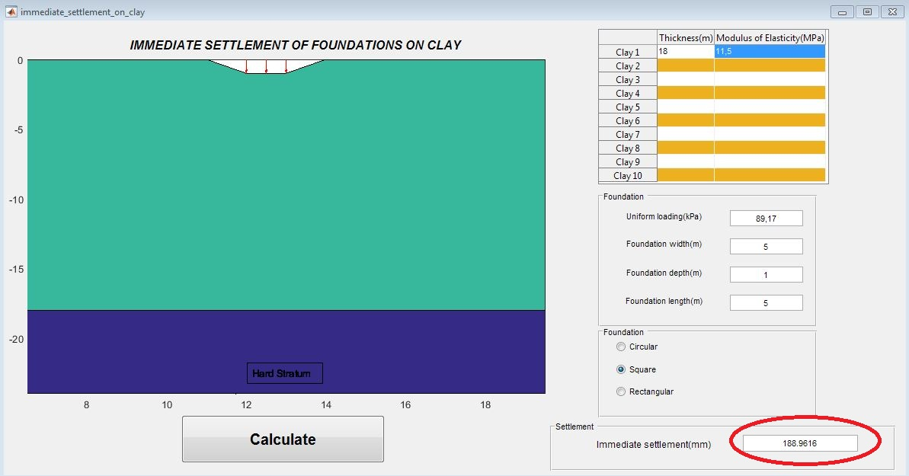

**Figure 10. The immediate settlement on Section A-A**

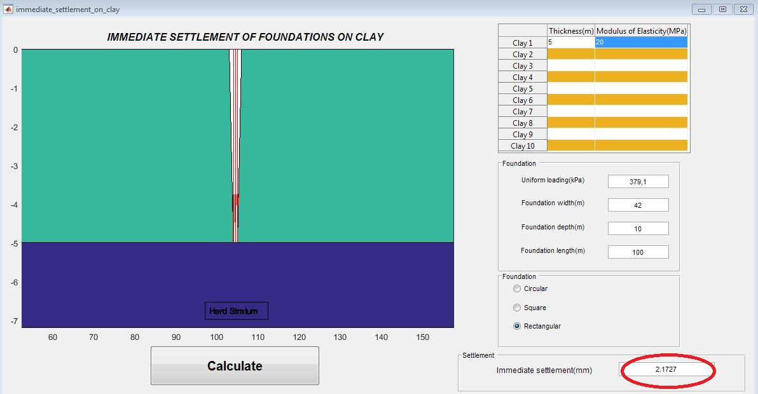

**Figure 11. The immediate settlement on Section B-B**

## 

## 2.3.2. Consolidation Settlement

## Consolidation settlement takes place in saturated clays exposed to an increased load after the application of the foundation. One-dimensional consolidation settlement (Soed) of clays is calculated.

## Soed =∑ [H. .log (

## Soed: consolidation settlement

## σ0΄: initial effective vertical stress (kPa)

## e0: initial void ratio

## Cc: compression index

## H: thicknesses of the clay layer (m)

## ∆σ΄: average increase in effective pressure on the clay layer caused by the construction of the foundation (kPa)

## Section B-B

## e0=0.84, 312 kPa

## = q1 == 246.3 kPa

## = 150 kPa ( with estimated additional live load)

## Soed = ∑ [5 xx log()] = 0.095m

## Section A-A

## e0=1.81, 114 kPa

## = q1 == 79.17 kPa

## =10 kPa (with estimated additional

## live load)

## Soed = ∑ [18 xx log ()] = 0.242m

## 

## Sc= Soed.μ

## Sc: consolidation settlement

## Soed: oedometric settlement

μ: Poisson ratio’ and μ = 1.1

Sc= 0.242x1.1= **0.266 m**  Sc= 0.101x1.1= **0.095 m**

## 2.3.3. Secondary Settlement

Some settlement occurs by the reason of plastic adjustment of soil fabric in cohesive soils after the preliminary consolidation is completed.

Ss = .H.log = 0.04±0.01, = 5

## Ss: secondary settlement

## Cα: coefficient of secondary compression

## Cc: compression index

## e0: initial void ratio

## H: thicknesses of the clay layer (m)

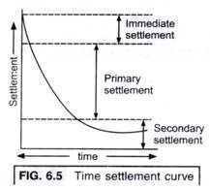

**Figure 12. Time - settlement curve**

SectionA-A SectionB-B

Cα = 0.73 x 0.05= 0.0365 Cα = 0.17 x 0.05= 0.0085

Ss = x 18 x log5= 0.163 m Ss = x 5 x log5= 0.016 m

Ss = 16.3 cm Ss = 1.6 cm

Considering immediate, consolidation and secondary settlement results, ground improvement is recommend for the sea bed.

**2.4. Foundation System**

The soil conditions under the piers of designed bridge are not suitable for heavy loads, therefore pile foundations should be used. Raft foundation is not desirable due to bridge piers are not far away from each other and pile foundations are more economical solution rather than it. The dimensions of pile foundation are 5x5x1 m. After that, bearing capacity and settlement values of the soil by using these dimensions.

**2.5. Bearing Capacity**

Bearing capacity of footings on clay is found by chart and formula of Skempton (1951).

qf = cu.Nc + γ.D

and

qall= F.S ≈ 2.5 - 3

SectionA-A SectionB-B

Nc = 6.52 Nc= 7.13

qf = 53 x 6.52 + 19.2 x 1 = 364.76 kPa qf = 81 x 7.13 + 19.6 x 10 = 773.53 kPa

qf = qult ≈ 365 kPa qf = qult ≈ 775 kPa

qall= = 121.67 kPa qall= = 258.33 kPa

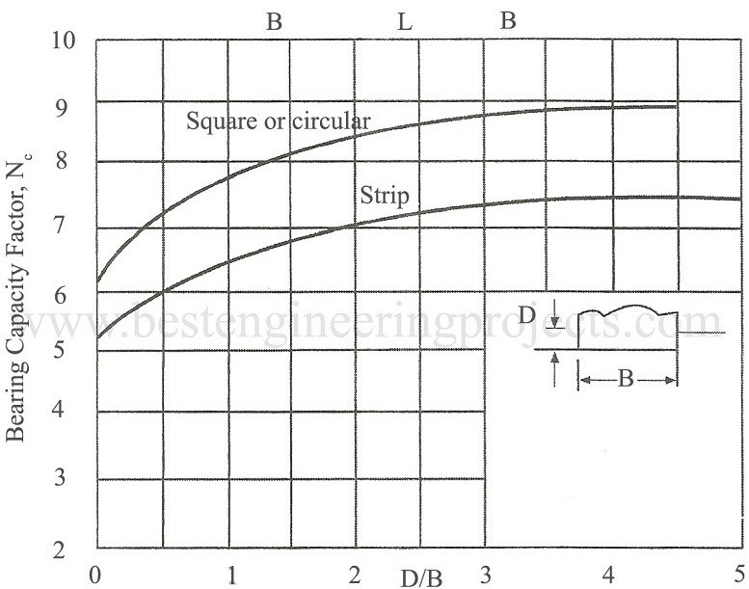

**Figure 13. Skempton’s Nc Values**

**3. BRIDGE DESIGN**

The bridge of our project is a complex bridge which consists of girder-bridge and cable-stayed bridge. It carries both rail and road traffic, and connects the 3500 m opening in total from Cigli coast to an artificial island that is also another part of this project. The reason why bridge starts from Cigli is bathymetry of Izmir Bay. Due to the shallowness of that coast constructing bridge will be more economical. The rough sketch of the project with bathymetry can be seen in Figure 11. This sketch is just for showing change in bathymetry throughout our route. So, different scales are used for horizontal and vertical axes.

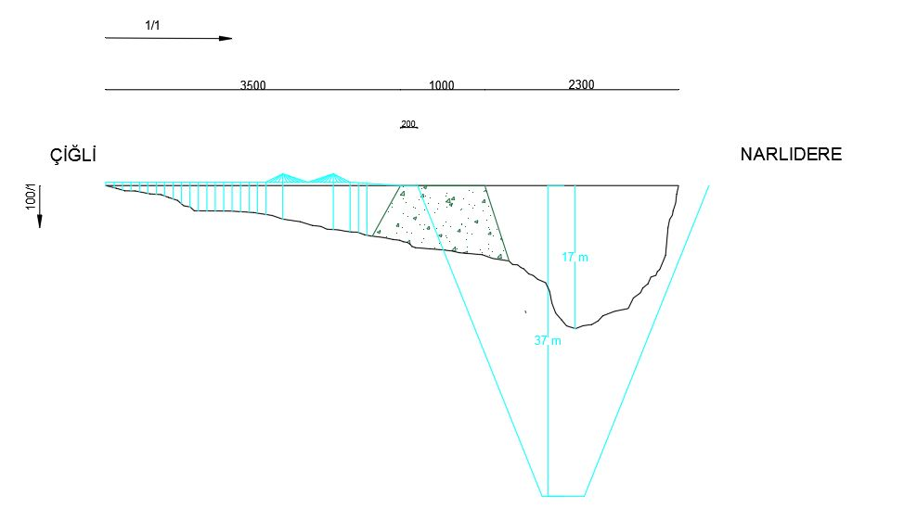

Figure 14. Bathymetry and the Route

In the design stage of bridge, it is first thought linking the coast and island with only girder-bridge which is economical and easy to design. But our analysis shows that there is a nearly 250 m circulation channel stated by Izmir Municipality on the route that the bridge has to pass. The physical properties of girder-bridge are not enough to pass that much span. So, at the circulation channel part it is designed to use a cable-stayed bridge. Besides the structural properties of cable-stayed bridge, it also brings an aesthetic appearance and it would be candidate to become a landmark for Izmir.

Girder bridge’s structure is simple; the only structural job of it is transferring the deck’s dead load and live load on it to piers and to the foundation then. However, the cable-stayed bridge is not that much simple. Inclined and symmetrical cables take the load first and transfer it to the pylons of cable-stayed bridge. Due to geometry, cables are in tension and it translated into compressive forces in the pylons.

**3.1 Material Selection**

Selection of which material is used where is a little bit important for the health of the structure and calculations. Foundations and piers are designed as concrete. It is mostly selected because of its economical efficient compare to steel and ease of construction at sea. Moreover, concrete is more durable against corrosion and it is influential under sea structures.

At first, the deck also designed as precast concrete box. But some calculations show that concrete causes extensive weight and extremely increment in dead loads. So, the deck box designed as steel. Besides decreasing the weight, it also helps the construction part.

The cables are covered with polyethylene to decrease wearing effects of wind and rain.

**3.2 Span Lengths**

The span lengths are designed according to other similar structures as preliminary design. The possible span length for a girder bridge is usually between 40 to 80 m. So, in our design we choose 50 m span length between two piers of girder-bridge. Cable-stayed bridge, on the other hand, has capacity to pass much longer distances. Depending design parameters, a cable-stayed bridge can pass even more than 1000 m spans. But in this project, it is not needed to pass that much spans with high level of spending. 250 m opening is designed between pylons of this bridge which is enough to pass circulation channel. Also, owing to bearer cables, longer span can be used between one before and one after pier with cable-stayed bridge’s pylons which is designed as 100 m in this project. Figure 15 shows span lengths between piers. The clear height of the lower most part of the deck is designed 20 m to enable accident free passing of vessels that will use circulation channel.

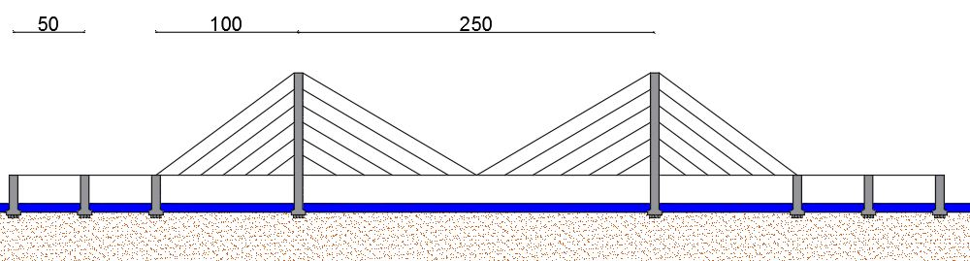

Figure 15. Span Length

**3.3 Cables**

Cable-stayed bridges work when the forces on both sides of the pylons are in equilibrium. This has the effect of reducing the moments in the pylon. To work efficiently, first the bonding angles of the cables should be designed and as in many similar cases, 30° inclined cables are used in this project. There are 6 cables supporting off each pylon in each side which makes 12 cables for one pylon. It means in that project there are 48 cables in total. Each cable consists of several wires that tie in bunches. The thickness of used wires and cables will be clarified after exact calculations.

**3.4 Deck Design**

The first design that was thought is using concrete box deck. The cross-section of concrete deck can be seen in Figure 16. But with this type of deck it is calculated an excessive amount of dead load and that much dead load will be result in thicker piers. As a result of researches conducted, the deck is changed into steel to decrease it weight and improve the decks cantilever beam capacity.

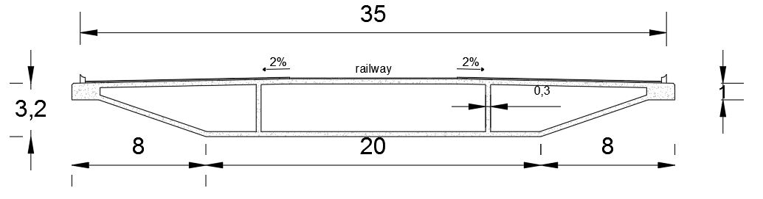

Figure 16 Concrete Deck

After deciding the material type of deck, it is started to defining design parameters. The width of the deck is designated according to the road design. Since the road is decided as 3 lanes of highway and 1 lane of railway in each direction, with empty spaces after the ending of lanes it makes totally 35 m width for the road. As a deck type, it is used I-beams as steel bearer elements. Since the allowable web distances are longer than the other types, HEB Sections are thought to be used. The exact section properties will be decided after final calculations. Above and below the beams there exist steel sheets to hold beams together and to form the deck. Section of the deck can be seen from Figure 17. Above the steel sheet on the top, it is needed a concrete layer to ease construction of the road. The deck is also planned by taking into consideration the highway and the railway standards. At the middle of the deck there is no slope as railway is horizontal, but after the railway 2% slope is performed as general directorate of highways standards.

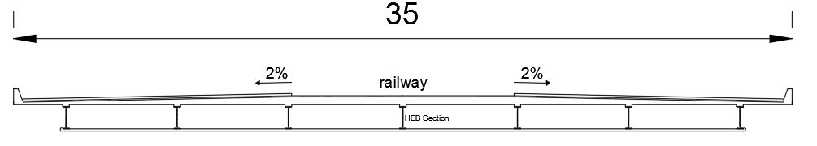

Figure 17. Design of the Deck

The bottom steel sheet is the part where piers will be connected with the deck. The type of connection would be probably pin support at one end, and roller support at the other hand to allow the deck to move. But since this report is just for preliminary design all dimensions could be change with detailed analysis.

**3.5 Piers and Pylons**

Girder bridge’s and cable-stayed bridge’s piers are designed differently. The first difference is on the foundation. It is thought that using single footing for piers of girder bridge; on the other hand there is continuous footing for cable-stayed bridge. This is result of the excessive compression forces on the cable-stayed bridge. The more concrete area is needed to meet that force. The common part of their foundation is uses of piles to hold the soil better. Throughout the bridge foots in the route there is shallow bathymetry. The maximum depth is nearly 6 m under the sea level for a footing. There will not be need of very deep excavation for bridge footings.

The piers thicknesses are also different between two types of bridges. Since span length is shorter for girder bridge, it also has less amount of load to bear. As a result, it needs less concrete area as column. As preliminary design it is decided to use 4 m thick piers for girder bridge and 5 m thick piers and pylons for cable-stayed bridge. In piers C 25/30 concrete will be used.

Another difference between the designs of two bridges type is cable-stayed bridge has extra girders. Those girders carry some of the loads. The girder at the bottom is mostly responsible for the carrying of the deck, while the girder on the top reduces excessive amount of forces on the pylons. The pylons are the parts that stand for hanging of cables. The height of pylons is designed in this project according to cables hanging angle.

To considering other similar cable-stayed project, it is decided to use 30° inclined cables and that criteria designated the height of pylons. It is calculated as 72 m height. The representative drawings of piers and pylons can be seen at Figure 18 and Figure 19.

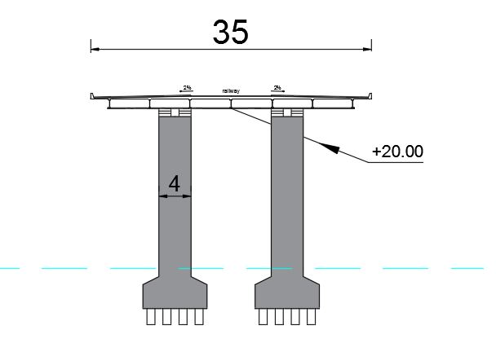

Figure 18 Drawing of Piers

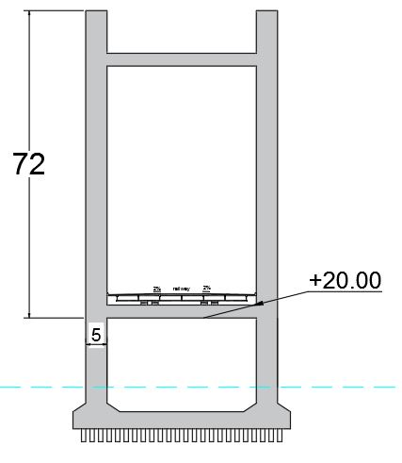

Figure 19. Drawing of Pylons

3.6 Loading

To analyze the bridge the loads acting on it must be identified which include dead, live, and wind load. After analyzing, the exact calculations of deck, piers, and pylons can be done. Dead loads can be calculating by the weight of deck. The calculation is easier than the one of live loads. The road’s thickness, the cross-sectional area of the deck and used materials determine our dead loads.

According to the cross-section that was showed in Figure 17 before, the area calculations are done. Table 1 shows our dead load calculations. The road thickness and its details are defined in Highway part. For more information that part should be checked. In exact calculations, lighting and services loads will also be added as dead loads.

Table 8. Dead Loads of Bridge

|  |  |  |  |  |
| --- | --- | --- | --- | --- |
| **Component** | **Material** | **Specific Weight (kN/m^3)** | **Area (m^2)** | **Load (kN/m)** |
| Girders | Steel | 77 | 0,28 | 21,56 |
| Box | Steel | 77 | 4 | 308 |
| Concrete Layer | Concrete | 24 | 1,75 | 42 |
| Roadway | Asphalt | 22 | 1 | 22 |
| Roadway Base | Asphalt | 22 | 1,5 | 33 |
| Railway Base | Gravel | 19 | 1 | 19 |
|  |  |  | **Total** | **426,56** |

For the calculation of live loads different standards will be used. Standards for Highways, BS 4500 (British Standards), and ‘AASHTO Standards’ are some standards to be helpful on those calculations. In that point loads of the cars and trains should be calculated separately. In bridge design those loads play an important role. Also, the wind load should be calculated for final design which affecting to the piers and pylons.

The primary wind direction and its magnitude are taking into consideration in calculations. The wind magnitudes are defined clearly in the introduction part. Since there are elements whose one dimension is considerably long than others, the temperature change also creates an extra force on the structure.

**4. HIGHWAY PROPERTIES**

This project is designed as enable to highway and railway traffic. The highway is thought to be as expressway which is for passenger cars. This means there will not be traffic of heavy vehicles like trucks or articulated lorries. The road is to be designed as 3 lanes for highway traffic and 1 lane for railway in each direction. The lane widths are designated according to general directorate of highways of Turkey, which is 3.75 m for one lane. The width of one railway lane is chosen as 5 m also. That makes 32.5 m in total. With free spaces nearby the first lanes, the width of the road is 35 m. The railway lanes are between the highways. Figure 20 shows a representative isometric drawing of the road.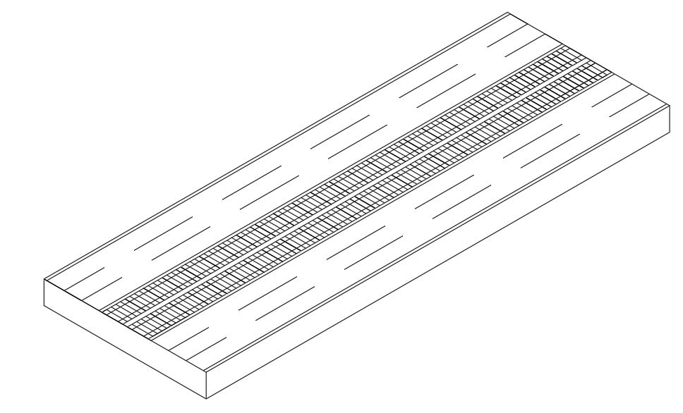

Figure 20. Isometric Drawing of the Road

**4.1 Slope Analysis**

Throughout the route general directorate of highways standards are applied to the road. In cross-sectional gradient for highway 2% slope is used, but the railway is kept horizontal. This gradient is needed for the interflow and to avoid the accumulation of water at the road.

According to standard the maximum possible slope for a highway is 8%. When the road turns into tube tunnel, first it is designed that using 7% slope. But when it is researched, it is seen that this railway is the one that designate the slope. Since highway and railway acts together at the road, the maximum slope is chosen 2.5% ( Figure 21 ).

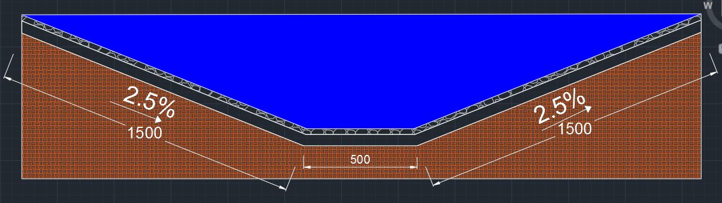

Figure 21. Preview of Roads Gradient

**4.2 Pavement Design**

Pavement is the upper part of a roadway which includes several layers. The original ground is called as subgrade and other layers rest on it. Those layers are the structural elements of pavement which are resisting against traffic loading.

There are 3 types of pavement mainly: Flexible pavement, rigid pavement, and composite pavement. The difference between them is material that is used. In flexible pavement asphalt concrete is used while Portland cement concrete is used in rigid pavement. As it can be understood from its name composite pavement is the pavement which both type are used as layer. Although Portland cement concrete’s structural performance and service life is better than asphalt concrete, due to economical purposes and construction easiness asphalt concrete is chosen in this project. Since there will not be excessive load in highway structural performance stays in the background in this situation.

In flexible pavement there are 3 main layers usually. The upper-most layer is wearing layer. Under that binder layer exists and base layer is reposes on the subgrade. If needed also a layer called subbase can also be used under the base layer. Those layers are aligned as better quality material being on the top. All parts are made up of asphalt concrete, bitumen (binder), and aggregate.

In this project the layers are designed as 4 cm thick wearing layer and 6 cm thick in total binder and base layers. The total pavement thickness will be 10 cm. Due to the existence of deck in bridge there will not be a subgrade layer as soil. Constructing the road on a concrete which comes with the deck clears away the need for subbase layer. Figure 22 shows a section of pavement design.

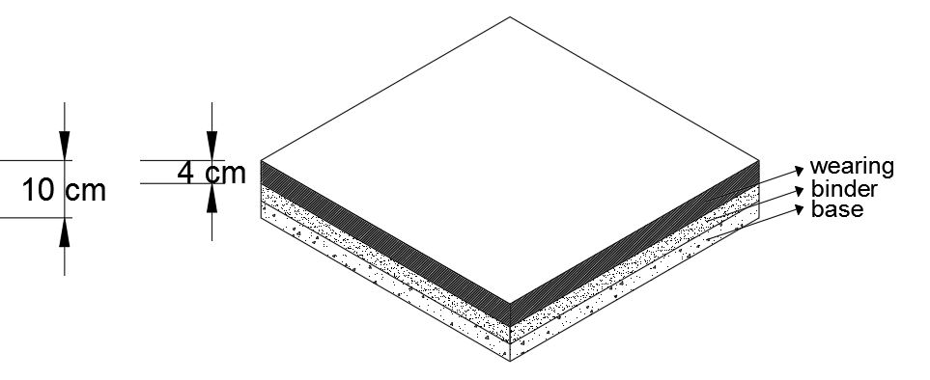

Figure 22. Pavement Design

# 5. ARTIFICIAL ISLAND

An artificial island is an island that built by humans in preference to using natural procedures. Their sizes are varying widely depending upon demand. They are used for much kind of purposes. In recent times, artificial islands are usually constructed by land reclamation.

The construction of an artificial island might show a change for all the islands according to parameters in which they are constructed. Those parameters are generally climate and sea conditions.

Building of artificial island has 3 main parts;

* Remediation of seabed,
* Placement of seawall,
* Fill.

Remediation of seabed process is kind of ground improvement process. In that process have various types according to conditions of soil. Aim of that process is that to prevent every type of geotechnical failures which are analyzed.

Aim of placing of seawall is to protect the perimeter of the reclaimed area. Those seawall are reflects the wave energy back into to sea which helps in reducing the energy available to cause erosion.

Fill is a material with which the body of the island is comprised. It normally consists of sand, gravel and rock.

Since sea water depth is vary in Izmir Bay, using only immersed tube tunnel or bridge is not efficient and economical way. Thereafter, immersed tube tunnel and girder bridge as chosen as structures to pass Izmır Bay. In Izmır Immersed Tube Tunnel project,

usage purpose of artificial island is create a connection hub for tube tunnel and girder bridge.

In design process of artificial island, wave and current analysis used as main parameters.

## 5.1. General Overview

In order to resist wave and current, artificial island designed as ellipsoid (Figure 23).

Main aim of using ellipsoid is to decrease destructive effect of wave and current. According to wave and current analysis, bridge side of artificial island will resist main wave direction. Since bridge side of island resist more energy than the other parts, calculations made for that critical part. Moreover, the height of the island is chosen according to wave height analysis. According to wave height analysis, maximum wave height in Izmir Bay at stormy day is 2,5 meters. In addition, considering of tsunami conditions and rising of sea level wave height assumed as 4,5 meters. In the light of those data and in order to stay at safety side, artificial island's height is chosen as 5 meters with respect to today's sea level.

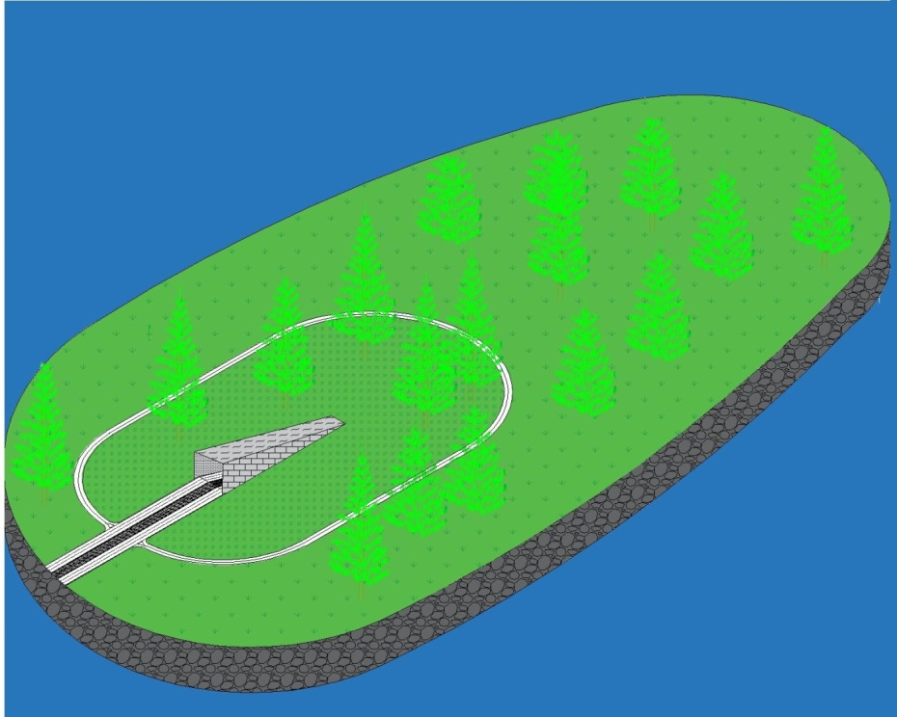

Figure 23. General Overview of Artificial Island

VOLTRAN's main purpose is tried to protect that structure from every kind of failure. Since artificial island located at the sea and rainy climate, one of the main problems VOLTRAN should deal with is float risk. Due to float risk of tunnel part, bridge and tunnel connection is located at the middle of the artificial island. With that approach, main objective is try to keep away water which is bring from wave until to reach to tunnel part of the bridge. In addition, raining condition is another parameter for float risk. In order to protect tunnel from rain water, roof has been placed at the start of the tunnel. On the other hand, water accumulation could bring some water related problems so that that water accumulation problem solved by gradient of artificial island. According to General Directorate Highways, gradient of artificial island is chosen as 2 percent. With that slope, water will move easily from island to sea. Also there will be drainage to support water transportation.

## 5.2. Transportation Phase

Since artificial island is part of transportation phase, there should be some transportation regulations. One of the most important regulations is made for accidentally users of that highway. In order to turn their way to correct way, additional returning way designed at artificial island. That way located at the near of tunnel and it is turning the island. In order to organize traffic of artificial island, crossroad will be designed. Aim of crossroad design is provide smooth and safe traffic for highway users (Figure 24).

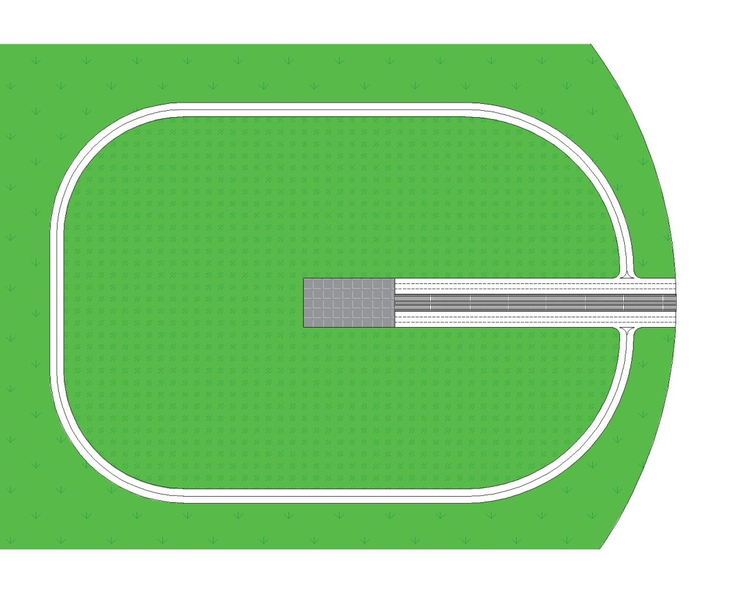

Figure 24. Highway Junction Preview

## 5.3. Breakwater Design

To design the artificial island, breakwater design formulas are used because edge of the island has to be act like a breakwater. With Hudson Formula the armor layer’s stone size can be calculated. In introduction part it can be seen that the primary wave direction is north and the maximum value of it is 2.0625 m. To be on the safe side in calculation, the wave height is taken as 2.5 m.

In general, specific weight of the stones are specified as 2.7 ton/m3, but in construction stage that much perfect stones may not be found and to make correction, specific weight of stone is assumed 2.45 ton/m3. Since it is sea water, specific weight of water is taken 2.45 ton/m3.

The slope of breakwaters is usually between from 1:1.5 to 1:2. Since the artificial island needs more amount of armor layer compared to a breakwater, the slope is designed as 1:2 to be on the safe side.

KD is stability coefficient which is prepared for different armor units and placements. Also for different part of the breakwater, there are different KD values. There are two parts in a normal breakwater named as head and trunk. Trunk is the body part of it and head is the edge part. There is more destructive effect of wave at the head and at that part heavier stones are needed. In this project the island is designed as head, although it is not totally. Another parameter that affects KD values is condition of the waves which can be breaking wave or non-breaking wave. Roughly it can be said that waves breaks at the depth nearly of their height. This means the design waves in this project is breaking around 2.5 m depth. The shallowest ground of the island is approximately 6 m. It can be definitely said the waves hit the armor units are non-breaking waves. KD value is chosen as 2.0.

As can be seen from the formula above, the stone size of armor layer is 3.6 tons. Inside the core layer, underlayer is needed. Stone weight of this layer is usually chosen as one tenth of armor layer. So, in design 360 kg stones should be used in underlayer.

Inside the underlayer, the core layer exists. There are no criteria for core layer and it is decided to use sand there. The only point that needs to be paid attention is it should be used rich soil at the top of the island due to landscape purposes.

Layers thicknesses are also calculated by formulas. The run up height of the structure is given by:

, where

Length of the wave in deep water (L0) can be approximately assumed as having 8 second period and L0=100 m.

&

The change in L0 directly affects the dimension of run up. 8 second period waves are very calm in influence. Tsunamis have much longer period so the need for the run up is increase. Since Izmir in the first-degree seismic zone, tsunami effect has to be considered also. With larger wave length it will be need for 4 m height for run up. When it is thought the service life of the island, rise of the sea level is taken into consideration as 1 m. This gives total 5 m run up height from the sea level for artificial island in the project.

Armor layer and underlayer thickness are related with the weight of the units. The formula can be seen below:

r: average thickness layer

n: number of units (typically n=2)

kΔ: the layer coefficient ( 1.00 in this project)

Since we know the weights of the units in each layer the thickness of armor layer is calculated approximately 2.3 m and thickness of underlayer is calculated 1.1 m.

The crest width also another parameter that can be calculated as:

n: number of units (typically n=3)

When it is calculated for armor layer, the crest width is calculated 3.5 m. But again to be on the safe side against tsunami conditions, the crest width is designed as 5 m. After 5 m of armor layer in width the artificial island’s sandy soil starts.

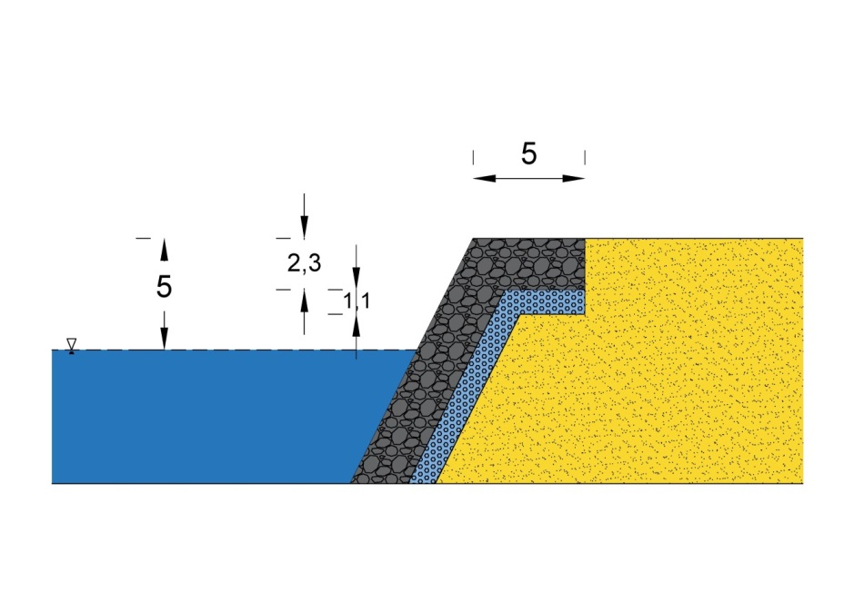

Figure 25. Cross-section of Breakwater Design

# 5.4. Volume and Materials Selection

In the light of those layer and geometric properties of artificial island, calculation related with volume is easily made.* At calculation part of volume of the artificial island, benefited from ellipsoid properties.* Since depth of sea is not uniform along artificial island. Since 2:1 gradient is used at design part of artificial island, base area is founded by geometry. Volume properties of artificial island obtained as follows;

Table 9. Volume Calculation on Artificial Island

|  |  |  |  |  |
| --- | --- | --- | --- | --- |
| Layer | Core | Armor | Under | Artificial Island |
| Volume (m3) | 11.443.000 | 133.750 | 44.600 | 11.621.350 |

According to those volume calculations, artificial island will be constructed from very huge amount of soil and stone combination. Those amount of soil and stone have many cost. VOLTRAN one of the first missions is known as construct economical structures. In order to build that artificial island economical, first attempt was try to use soil which excavated from at the base from the sea. According to Fill Legislation, at filling works such as filling with soil the core of artificial island, always sand or sand – cement mixture are used. Unfortunately, in the light of geotechnical analyzes, at the bottom of the sea which will be excavated, is very soft clay. Clay is not good material to fill somewhere. So that material cannot be used as filling material. In order to fill the core of artificial island, VOLTRAN strongly recommend bringing and using sand and sand – cement mixture from near markets. At the top layer of artificial island organic soil will be used almost 5 meters thickness, in order to create recreation area for island. On the other hand, stone layers are classified according to and armor layer stones are chosen as 2 – 4 tons scale and underlayer stones are chosen as 0 – 2 tons scale.

# 5.5. Construction Procedure

VOLTRAN calculated every part of island with full care but calculation is just a little part of the artificial island part. Construction process is one of the biggest challenges of the artificial island.

VOLTRAN aim is construct that artificial island with no error in three main as mentioned at introduction part of artificial island.

Since artificial island resist on the sea ground, soil – artificial island intersection is very important case. According to geotechnical analyzes, artificial island will be built on the very soft clay which Standard Penetration Test result is zero. In other words, that very soft clay does not contribute to bear any load such as artificial island. In order to keep stable, some ground improvement process will occur. Those processes will be decided at next steps. Only remediation of seabed process will be ground improvement process.

At construction process, every part of artificial island should demonstrate at the offshore where that island locates. Since that structure designed as breakwater it consist of three different layers. Every layer should be immersed to sea carefully. At that stage, properties of sea movement is very important. In order to eliminate current and wave effect of sea, seawall will be placed near the construction side (Figure 26). With the help of those walls, armor and underlayer will locate at the edge of artificial island with zero error. Than the geometric property of artificial island easily reflect.

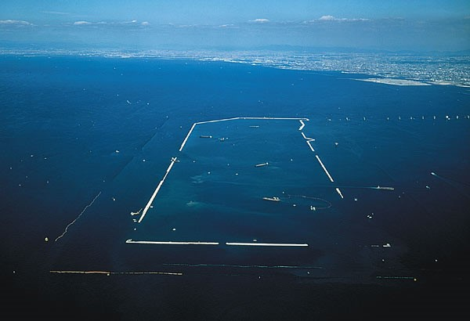

Figure 26. Seawall Example From Kansai International Airport Construction

After placing breakwater resist part of island, only final touch left. Final touch means that filling of artificial island. Since geometric properties of artificial island are extensive, filling core area of that structure is also high. In order to fill that area, there should be used some specialized techniques. One of the best and most used technique is rainbowing process (Figure 27). With that process specialized soil brings to artificial island and it pumps with some devices to core of artificial island. Then soil particles settle uniformly and artificial island will be formed. But since tube tunnel located in the artificial island, all amount of soil should not be filled at the core. That filling process should be coordinated with tube tunnel immersing project. According to tube tunnel slope, soil fill with gradient then tube tunnel will be immersed and montaged. Montaged part of tube tunnels’ will be filled with soil. After reaching ground level of artificial island, some compaction works are planning.

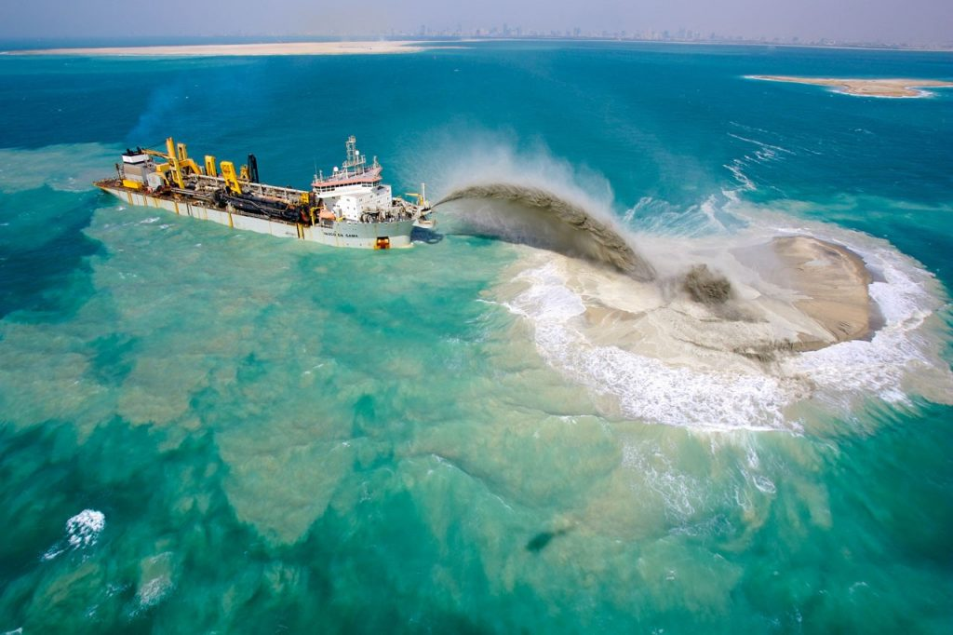

Figure 27. Example of Rainbowing Process

At the end of filling process highway connection of artificial island takes place. With transportation phase, pavement construction and railway construction start. According to crossroad design, secondary way will be constructed round of the tunnel roof. After finishing highway part, recreation area for artificial island will be created. At that recreation area, there will be located several kind of trees which are adopted Izmir climate and make advantage from their aspect in order to make that artificial island charming as Izmir.

**6. IMMERSED TUBE TUNNEL DESIGN**

**6.1. Definition**

The immersed tube tunnel, which is consisted of different elements and portions, is a technique of underwater tunneling used principally for underwater crossings relatively shallow water, also known as "sunken tube". The reason to suggest an immersed tube tunnel is due to the shallow water depth ( <25m). These elements are combination of segments. The first application was observed in the Detroit River in 1903 by the American engineer W.J. Wilgus. In addition, the tube tunnel is generally constructed for transportation as rail and road crossing, also infrastructure like water supply and electric cables ( Figure 28). In İzmir, immersed tube tunnel become connection between land surface and artificial island by using rail and road lanes. In addition, these tunnels are more compatible with cut and cover tunnel in order to solve level differences between land and water.

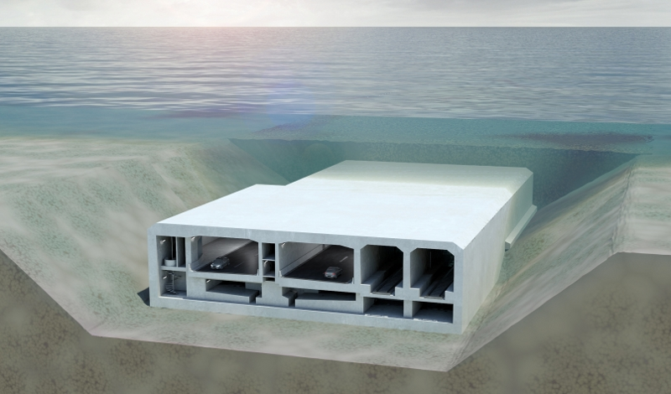

Figure 28. View of Immersed Tube Tunnel

**The main advantages of the Immersed Tube Tunnel in İzmir;**  
 - Environmental,

- Economical ( Cost-effective ),

- Contribution to located region ...

**6.2. Properties of Tube Tunnel**

The tube tunnel is designed as a rectangular shape including two curved corner sections. This shape is characterized for prelimary design. Each element has 42 m width, 10 m height and then approximately 100 m length. Highway width is determined 3.75 m and railway is also 5 m width by considering General Directorate of Highways parameters. Also, thickness of the each elements is 1.5 m each which makes totally 3 m . Total length of the tunnel is 3.500 m from artificial island to land surface ( Narlıdere region ). As a result, 35 tunnel elements will be used to complete 3500 m one by one.

Morever, a single span can not be used for tunnel cross-section, so it is designed three continuous support members in order not to deform and bend more (axial and lateral deformation or racking) in other words to keep the tunnel from collapsing. These members include two mechanic and ventilation rooms as 2 m span. Owing to this, connection between railway and highways is obtained in case of emergencies ( Figure 29). 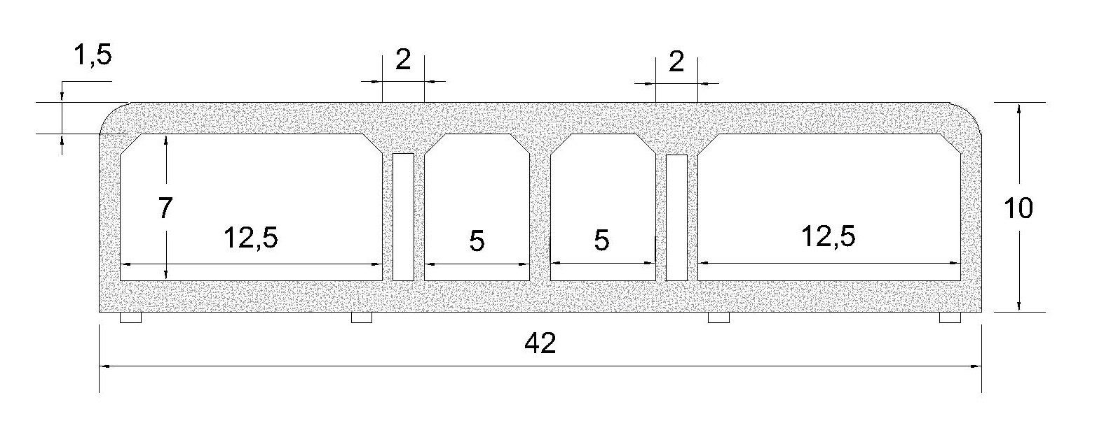 **Figure 29. Dimensions of Tunnel**

According to General Directorate of Highways, 2.5 % slope is selected for both declination and inclination. This slope value is acceptable and feasible for railway. For this reason, 3500 m length is composed from 500 m flat line and almost 1500 m two inclined portions like beginning and end point. In fact, inclined segments is placed between +5 m and -37 m elevation.

The State Ports and Airports Authority (DLH) report shows that the maximum water depth above the tunnel is about 17 m under current conditions. That is, the deepest point of tube tunnel is -37 m , included bedding as 5 m which is sufficient for foundation. Therefore, 20 m dredging operation is needed to fit sea level to 37 m. That is, our tunnel is located at the deepest point route in the dredge portion ( Figure 30).

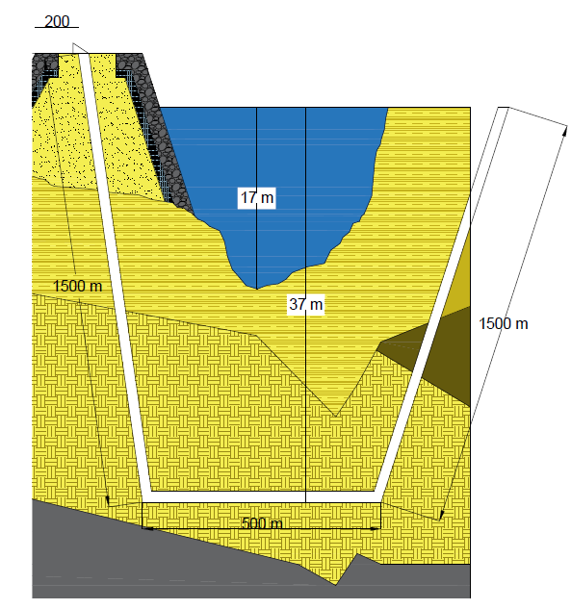

Figure 30. Tunnel Cross-Section with respect to Soil Layers

Finally, service life design of tunnel is expressed as 100 years but real life is almost 15 years. Maintenance and operation of reinforced concrete structures are more important due to reinforcement corrosion and carbonation so on. In fact, Operation and maintenance works in tunnels will most often have an adverse effect on the traffic in the tunnel. Hence, it is essential to plan operation and maintenance works rationally and effienciently.

**6.2.1. Material Selection**

For each tunnel element, reinforced concrete is used. Reinforced concrete blocks is integrated each other with anchorage ( springs or blots) to generate one 100 m tunnel element. Ductility of this block is the most important case, so steel sequence and quantity should be managed. Bolts connection is the most common method for element integration (Figure 31). The main reason of selection of reinforced concrete is property of factory precast unit.

Compared to steel, reinforced concrete tunnel elements is produced as precast by using formwork. Owing to this, time saving and rapid montage process are obtained. On the other hand, reinforced concrete has huge volume value, this brings about huge uplift force effect , so this effect can be eliminated thanks to excessive weight of reinforced concrete. Also, corrosion problem can not be occured on concrete blocks by considering underwater.

Abrasion problem can be tolerated by using some supplements which is added to concrete mixture. The other significant reason is economy, so reinforced concrete is reasonable materials compared to other ones like steel. That is why, reinforced concrete is more suitable and practical material for tunnel construction.

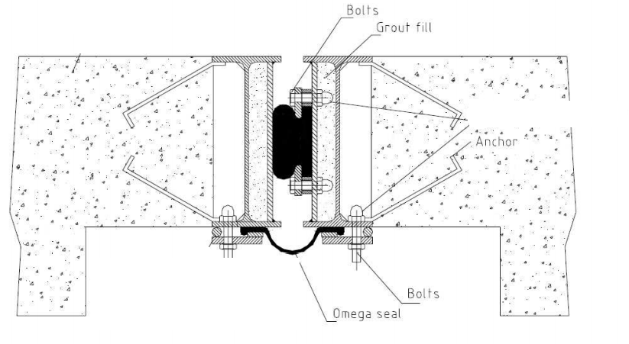

Figure 31. Integration of Tube Tunnel Segments by Bolts

Next, sandy gravel and cement-gravel type of soils are used as materials for backfilling and bedding application. Backfilling and bedding application prevent tube tunnel from earthquake vibration (seismic effects). In other words, when vibration level is decreased greatly, occurance of deformation due to earthquake decreases to reasonable values.

The sea-bed below the tunnel should be improved because of different thicknesses of loose and medium stiff clay. Therefore, gravel layer is prepared as bedding process.Sandy gravel soil is used for armour layer as known as protection layer. This layer mainly prevent tunnel from uplift effect also protects from ship's anchor and abrasion. Tablo 10. shows the components of the loads on the soil.

Tablo 10. Loads Effects on Tunnel Base

|  |  |  |  |  |  |  |
| --- | --- | --- | --- | --- | --- | --- |
| **Parts** | | **Materials** | **Specific Weight**  **( kN/m^3)** | | **Area ( m^2)** | **Load ( kN/m)** |
| Tunnel Elements | | Reinforced Concrete  ( C25 ) | 24 | | 164,45 | 3946,8 |
|
| Bedding | | Gravel - Cement Mixture | 22 | | 210 | 4620 |
|
| Backfilling | | Sandy Gravel Soil | 21 | | 410 | 8610 |
|
| Excavated | | Loose Stiff Clay | 19,6 | | 620 | -12152 |
|  |  |  |  |  |  | **5024,8** |
|  |  |  |  |  |  |

5024,8 kN/ m is distributed load on the 42 meters width section , so 119,64 kPa can be obtained after calculations. Consolidation settlement is calculated by considering 119,64 kPa value ( additional soil displacement ).

Detail of backfilling and bedding layers and settlement process are explained under " 2. Geotechnical Design " topic.

**6.2.2. Design Loads:**

- **Dead Load:**

Dead loads include the complete weight of the structure ( tube tunnel elements) and all the equipment that is used for jointing. Tube tunnel includes the base materials, 8 lanes road and rail also some mechanic equitments. Their weight is calculated roughly. According to Table 5.1, tunnel elements approximately are 3946,8 kN/m. Total length of tunnel along the route is 3500 meters. Therefore, calculations can be obtained below.

* 3946,8 kN/m ∗ 3500 meters = **13.813.800 kN**
* 13.813.800 / 9,81 = **1.408.134,56 tons**

Apart from tunnel element weight, some mechanical and lanes weight will be included in order to calculated total dead load.

Weight comes from ashpalt for highway.

* 55 kN/m * 3500 meters = **192.500 kN**
* 192.500 / 9,81 = **19.622,84 tons**

Weight comes from railway ground.

* 19 kN/m * 3500 meters = **66.500 kN**
* 66.500 / 9,81 = **6.778.80 tons**

Total dead load of tube tunnel is calculated roughly as **1.434.546,2 tons.**

**-Live Loads:**

AASHTO standart will be used for calculating live load which includes metro, automobiles, bus , trucks etc in the final design process. This part includes earthquake, buoyancy and live load.

**6.3. Ground Profile**

First of all, soil characterized should be checked for seismic analysis and improvement operation. The soil along the tunnel route is very loose and does not enough capacity tocarry the imposed loads due to the tunnel construction. In other words, soil may undergo large elastic settlements. As mentioned before, consolidation settlement value is approximately 9.55cantimeters without improvement by hand calculations, 9.55 cantimeters settlement value is not tolerable to construct and place tube tunnel to sea bed due to maximum allowable settlement is 2.5 cm. For this reason, ground improvement is strictly needed like bedding, compaction, grouting etc. In other words, construction of tunnel is feasible if significant soil improvement is conducted. Improvement process will be explained in the final design

Improvement detail will be showed and calculated in the final design. Now, only settlement value is calculated by considering " 2. 3. Settlement " Topic. Table is copied from this topic as showed next page ( Table 11 ). Using parameters are indicated as bolt and italic form.

Tablo 11. Settlement Soil Parameters

|  |  |
| --- | --- |
|  | Medium Stiff - Very Stiff Clay  -20 meters to -40 meters |
| Unit Weight (kN/m3) | **19,6** |
| Liquid Limit | 27,2 |
| Plastic Limit | 23,3 |
| Plasticity Index | 21,5 |
| Cu (kPa) | 81 |
| φ ( ͦ) | 36 |
| Es (MN/m2) | 8,4 |
| Eu (MN/m2) | 20 |
| Dr (%) | 50 |
| E0 | **0,84** |
| Cr | **0,042** |
| Cc | **0,17** |

Below the tube tunnel, bedding treatment is applied as ground improvement. Bedding treatment creates a smooth, suitable and stronger surface on the sea floor, so tube tunnel elements can be placed onto stronger bedding layer which also provides stability for tunnel. Generally, 1-10 cantimeters size gravel - cement mixture is prepared in order to be injected onto the existed weak soil layer. Underwater concrete pouring technique is implemented to conduct this bedding treatment. 5 meters gravel - cement mixture is filled to the sea-bed between -32 meters and -37 meters elevation. Tube tunnel elements are fixed to bedding layer through tunnel footings.

Excavation type should be bevelled not a straight. Our bevelled slope is approximately 15˚. After bevelled excavation, sandy gravel type of soil is backfilled and buried on two sides and over the tunnel as 5 meters height between -17 meters and -22 meters elevation. This soil layer protects tube tunnel either earthquake motion and vibration or uplift force ( buoyancy ).

Backfilling and bedding treatment provide high resistance for seismic actions. When seismic actions are analyzed, the seismic behaviour and design of tunnels differs from the behaviour and design of structures built above ground. As immersed tunnels are confined within surrounding soil inside the trench, they are not subjected to vibration amplifications. Although tube tunnel route is located first degree tectonic region, surrounding soil tube tunnel safer. At the end of this chapter, backfilling and bedding treatment around tunnel is showed below ( Figure 32).

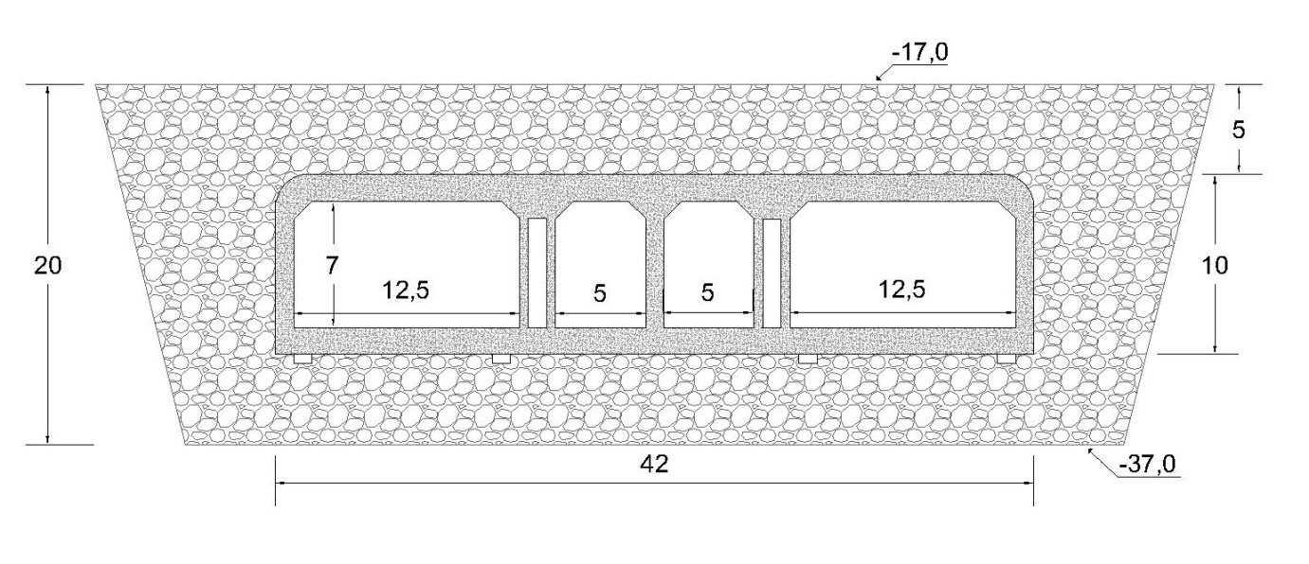

Figure 32. Backfilling and Bedding Layer Preview

**6.4. Construction Procedure**

VOLTRAN analyzed the construction procedure step by step. During the construction of tunnels and underground structures, each step of the process needs to be controlled carefully to obtain the required distribution of forces and geometry.

Procedure begins with casting basin and tube tunnels. Also tube tunnel can be obtained in a fabrication area. Tunnel elements that have been prefabricated in reinforced concrete. Outer shell is composed from steel as reinforcement and then is covered with concrete. Tunnel's shape exists in this way. Afterwards, the first batch of tube tunnel elements is constructed. Temporary Bulkhead is added in order to keep tunnel away from water that is both ends are closed before jointing operation. Floatation trial is made in order to control impermeability. Rubber seals are also a part of the ends of each element. One element has approximately 100 length.

Tunnel elements is transported to immersion site one by one. Elements should be integretad to be ready for immersion part. Next step is dredging a trench for tunnel base. As expressed in the "V.III. Foundation Properties" chapter, bedding layer is prepared by using gravel - cement basis bed at the bottom of the trench. While immersing process. It is controlled horizontally by anchorage and cable systems and the cranes on the immersion vanes control the vertical position until the element is lowered down and fully seated on the foundation ( Figure 33). The flow and wind waves make it difficult to place the tubes. For this, the wind and flow analyzes must be done correctly because depth of water is high. It is placed in coordinates with GPS. Tube tunnel footings should be fixed to gravel-cement mixture carefully in order to obtain full safety.

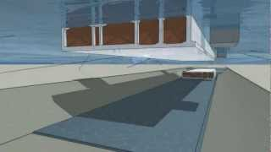

Figure 33. Immersion of Tube Tunnel

Thanks to beveled dredging, backfill materials, sandy gravel soil, is placed on the sides and over the tunnel in order to permanently bury ( Figure 34 ) . This materials can be called as protection or armour layer. In addition, water between the bulkheads of the previous and forward element is then removed which causes the rubber seals to press against each other and close the joint.

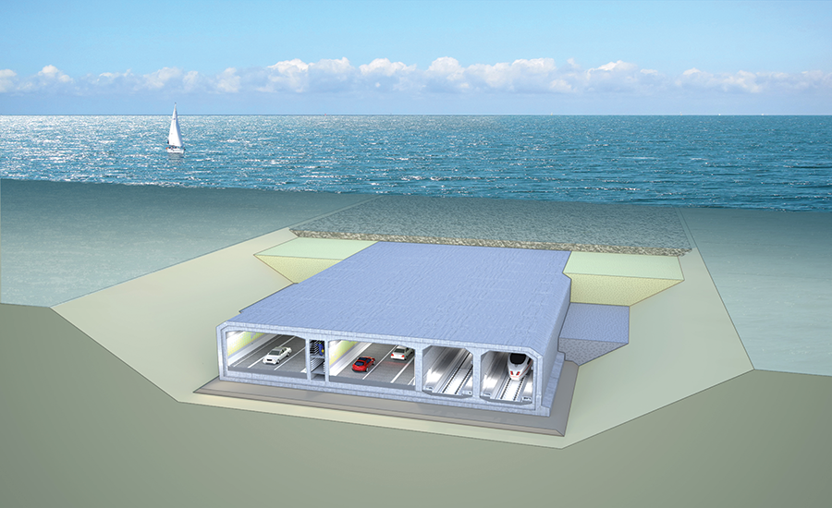

Figure 34. Beveled Excavation and Bedding Preview

The next and last step is starting asphalt and mechanical works like ventilation equipments. In other words, inside work operation continues by considering determined parameters.

1. **COST ESTIMATION**

Cost estimation is the part to find an approximately construction cost of the project. To have certain estimation, all items and job has to be designated clearly. As preliminary cost estimation, the used parameters are defined detail in other parts. After the determination of jobs and items, their pos. numbers are found using related websites which is provided by some institutions and ministries in Turkey like ministry of environment and urbanization or general directorate of highways. Using the pos. numbers the unit price of the job can be found. But the prices are for 2016, so the calculated cost is for 2016 actually. If wanted to have more successful estimation, the rate of inflation has to be applied to calculated cost.

As foundation works, it is considered that excavation and filling jobs. In the bridge part of the project, the only ground work is excavation for piers’ foundation. Since it is designed as pile foundation, roughly 2 m excavation is planned for a footing. The pos. number with definition of ‘bridge foundation excavation under water’ is used for unit price. Also, excavation of tunnel is considered and a pos. number defined as ‘wide excavations’ is used. The filling is an important part for this project. An artificial island is constructed as filling completely. To decrease cost of the project, it is thought to use some of the excavated soil in the filling of core of the island. Moreover, the tunnel has exceedingly backfilling and bedding jobs. For pos. numbers different materials with different sizes are defined as rock, stone, gravel, and sand. All those materials are used for the filling of the island and tunnel.

The structural elements of the bridge are defined as concrete piers, concrete pylons, steel deck girders and steel deck box. Their amounts are calculated using the length of the bridge which is 3500 m. With their founded unit prices and amount in the project the cost is calculated.

For highway and railway cost, the stated thicknesses in Highway section are used. All parts of the pavement are assumed as asphalt. On the other hand, the railway is assumed wood sleepers which lay on raised gravel layer. The length of the highway is calculated as the sum of length of bridge, tunnel, and the road on the island.

Cost of the tunnel is affected by the amount of its mold mostly. Since it is designed as concrete, concrete pos. number is used for unit price. The amount of the concrete box is calculated using the dimensions which are stated in Tube Tunnel section.

The calculated cost is just for materials and ground works. It does not consist of the labor prices, electrical and mechanical services, and transportation costs. The total cost of project is estimated as almost 750 million Turkish Liras. With the cost that will be included, it will be expected to have nearly 1 billion Turkish Liras project cost. The detailed table for cost estimation can be seen in the table below.

Table 12. Cost Estimation

|  |  |  |  |  |  |  |
| --- | --- | --- | --- | --- | --- | --- |
| **Name** | **Material** | **Pos. Number** | **Unit Price (TL)** | **Unit** | **Quantity** | **Total (TL)** |
| Piers | Concrete | Y.16.050/05 | 165,03 | m3 | 40320 | 6,654,009.6 |
| Pylons | Concrete | Y.16.050/05 | 165,03 | m3 | 5780 | 953,873.4 |
| Deck Girders | Steel | Y.23.101 | 3428,64 | ton | 7693 | 26,376,527.52 |
| Deck Box | Steel | Y.23.101 | 3428,64 | ton | 85000 | 291,434,400 |
| Highway | Asphalt | KGM/6306/S | 8,18 | m2 | 180000 | 1,472,400 |
| Railway Base | Gravel | 15.140/4 | 6,3 | m3 | 7200 | 45,360 |
| Railway | Wood Sleepers | 35.004 | 12,72 | m | 7200 | 91,584 |
| Bridge Found. Excavation | - | KGM/14.224 | 98,8 | m3 | 1920 | 189,696 |
| Wide Excavation (Tunnel) | - | 14.012/1 | 34,69 | m3 | 4000000 | 138,760,000 |
| Rubble Mound | Rock | 17.084 | 82,96 | m3 | 133750 | 11,095,900 |
| Underlayer of Island | Stone | 17.081 | 39,05 | m3 | 44600 | 1,741,630 |
| Filling for Island | Sand | 15.151/1 | 20,61 | m3 | 6000000 | 123,660,000 |
| Tunnel Mold | Concrete | Y.16.050/05 | 165,03 | m3 | 592700 | 97,813,281 |
| Backfilling & Bedding | Gravel | 15.151/1 | 20,61 | m3 | 1990000 | 41,013,900 |
|  |  |  |  |  | **TOTAL** | **741,302,561.5** |

1. **FUTURE PLANS AND CONCLUSION**

This report includes only preliminary design and parameters. This means with detailed analysis and designs, everything is open to change in this report. A design of a project starts with the needs and expectations form the government, companies, and user groups. First ideas and drafts are identified according to this approach. In this project needs are reducing traffic jam in the city center and spending less time in traffic. So, expectation from this project is meeting these needs with a safe way and long service life. This thought is the answer of “how the project is designed and how the route is decided” questions. The selection and basic designs of the bridge, artificial island, and tube tunnel is reported detail in related parts. This means as a first design stage of the project which is formed to meet expectations, the type of the project will not change. In the final design, the project will be consists of bridge, island and immersed tube tunnel again. Unless facing with an unexpected situation, the route will also not change. It is selected as being the safest one, considering bathymetry and tectonic faults. The things that may change in future designs are some dimensions and parameters only.

In foundation works, analyses are done and the results are reflected to the design. Bearing capacities and settlements are calculated according to soil properties. If the values stated in ‘Geotechnical Design’ part under the requirements, ground improvements will be done.

In bridge part, the main thing that will be added in future designs is load arrangements. In this report the only thing mentioned is the dead load of the deck. In addition to dead loads, actually there are live loads, wind loads, earthquake loads, and temperature change loads which should be calculated. With detailed loads calculations, also the deck properties may change. The sections of girders or the thickness of the steel sheet on the box can be arranged again to be able to carry the loads on it. After the deck’s dimensions become definite, piers, pylons, and footing calculations are done accordingly and change in the thicknesses seems possible.

Highway properties are decided according to project’s needs. Being 3 lanes for highway and 1 lane for railway will not change in oncoming calculations. This means the width of the road will be same in the future. The only thing that may change is pavement design. The thicknesses of layers are decided according to common use. But the speed limits were not considered. So, this could affect the asphalt thickness.

In design of artificial island the height and stone sizes of armor layer were calculated with guaranteed wave heights and tsunami conditions. So, those parameters do not seem to change in final design. Moreover, the addition live loads are considerably insignificant compared to the dead load of the island. This means the foundation calculations will not be affected from the change in loads.

Immersed tube tunnel’s shape and material selection is not thought to change in final design. The change may occur in the thicknesses of fillings when the weights and related loads will be calculated definitely. If there will change in the design of tube tunnel, this probably would connect to foundation.

To sum up, this report mentions about the preliminary design of Izmir tube tunnel, the location of the project, the geological properties of project area, soil properties, and detailed analyses of the parts of the project as bridge, artificial island and immersed tube tunnel. The preliminary design is done considering needs of the project and similar other design parameters. But as said, for all parameters any change is possible in final design.

1. **REFERENCES**

* A CRITICAL ANALYIS OF THE ØRESUND BRIDGE, CONNECTING COPENHAGEN TO MALMÖ. (2010), (n.d.) Retrieved April 2, 2017, from http://www.bath.ac.uk/ace/uploads/StudentProjects/Bridgeconference2011/papers/Saleema%20Hughes.pdf
* AMP Yazılım | www.ampyazilim.com.tr (n.d.). İnşaat, Tesisat ve Elektrik Birim Fiyat, Analiz ve Tarifleri - Birim Fiyat. Retrieved April 02, 2017, from http://www.birimfiyat.net/
* Birand, A., Ergun, U, & Erol, O. (n.d.). Foundation Engineering I Lecture Notes. Retrieved April, 2017
* DESIGN MANUAL FOR ROADS AND BRIDGES (n.d.) Retrieved April 02, 2017, from http://www.standardsforhighways.co.uk/ha/standards/dmrb/vol1/section3/bd3701.pdf
* Emre,Ö., &Dogan,A.,& Ozaksoy,V.,&Yıldırım,C.,&Goktas,F.,& Özalp, S. (2005). İZMİR YAKIN ÇEVRESİNİN DİRİ FAYLARI VE DEPREM POTANSİYELLERİ. Retrieved April 5, 2017, from <http://www.mta.gov.tr/v3.0/sayfalar/bilgi-merkezi/deprem/pdf/izmir_rapor.pdf>
* Ergin, A. (2009). Coastal engineering. Ankara: Metu Press.
* Ersoy, U., Özcebe, G., & Tankut, T. (2010). Reinforced concrete. Ankara: METU.
* Güzel,Ö.,&,Arıoğlu,E.(2012), El Mek Nimir ve Al Halfaia Köprülerinde Yenilikçi Yöntemler Retrieved April 02, 2017, from http://www.imo.org.tr/resimler/dosya_ekler/843ba6393d945ed_ek.pdf?dergi=269
* Immersed Tube Tunnel (n.d.). Retrieved April,2,2017, from http://www.railsystem.net/immersed-tube-tunnel/
* İZMİR METRO A.Ş. (n.d.). Retrieved April 02, 2017, from http://www.izmirmetro.com.tr/
* Kartaltepe, N., Egeli, İ. (2012). Preliminary design of an immersed tunnel in Izmir, GRAĐEVINAR, 64 (12)
* Mass, Weight, Density or Specific Gravity of Bulk Materials. (2016). Retrieved April 02, 2017, from https://www.simetric.co.uk/si_materials.htm
* Mei, G. X., Yinî, L., Zai, J., & Zim, G. (2005). Immediate settlement is an integral part of the final settlement of a foundation resting on a clay soil. p. 109-113. Retrieved April 4, 2017.
* N.KARTALTEPE,(2008).PRELIMINARY DESIGN AND ANALYSIS FOR AN IMMERSED TUBE TUNNEL ACROSS THE İZMİR BAY, Retrieved April 5, 2017, from http://library.iyte.edu.tr/tezler/master/insaatmuh/T000768.pdf
* Principles of Foundation Engineering, SI Seventh Edition BRAJA M. DAS
* Tanal,V.,&Pehlivan,S.,&Wang,J.,&Ozerkan,Z.,&Guler,I Retrieved April 2, 2017, http://www.yukselproje.com.tr/wp-content/uploads/2016/11/dredged-material-management-in-immersed-tube-tunnel-construction-pdf.pdf
* TÜBİTAK Desteğiyle Su Altı Taş Dökü Tesviye Sistemi Geliştirildi,(2013),(n.d) Retrieved April 2, 2017, from https://www.tubitak.gov.tr/tr/haber/tubitak-destegiyle-su-alti-tas-doku-tesviye-sistemi-gelistirildi
* Yataklama,(2015),(n.d) Retrieved April,2,2017, from http://polimertm.com/yataklama/