**CE410 PRELIMINARY DESIGN REPORT**

**“Design of a Commercial Port and Marina Complex at Antalya”**

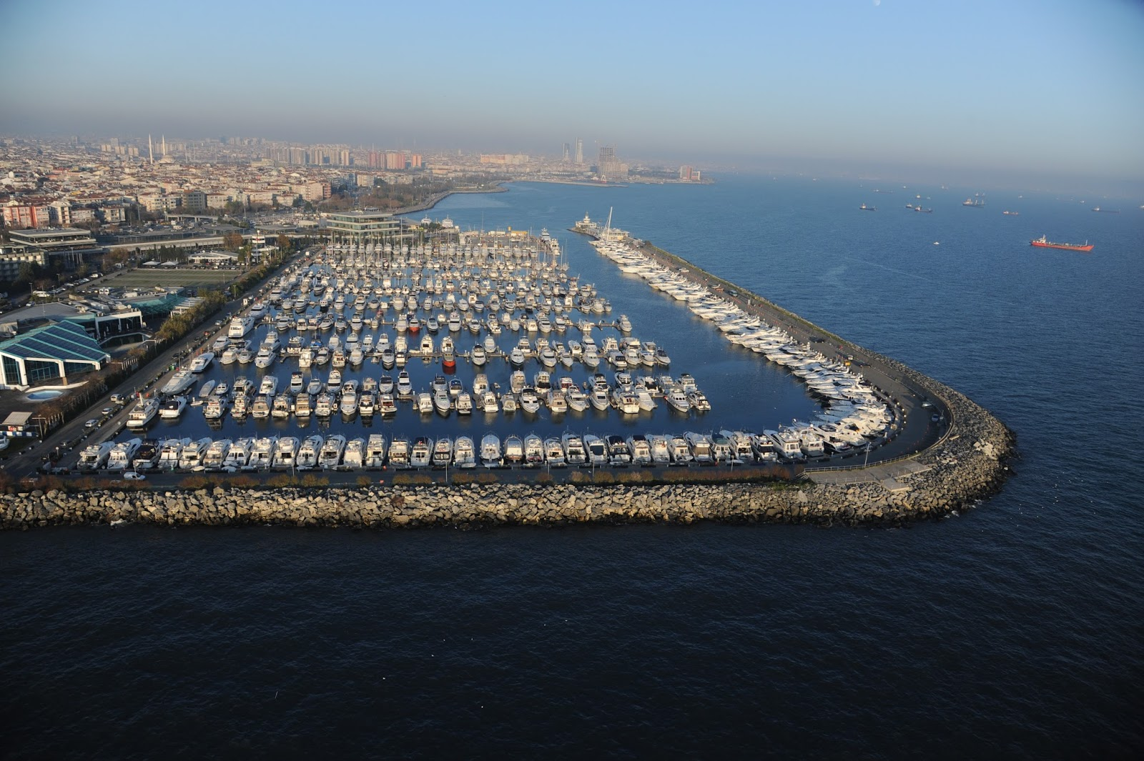

**Group Civilization Instructor**

*Prof. Dr.*

*Ahmet Cevdet YALCINER*

Table of Contents

Introduction 2

Site Selection 4

1. Service Life 5

Design Parameters 6

1.1. Wave Climate 6

1.1.1 Basic Definitions of Waves 6

1.1.2. Wave Height (H) and Wave Amplitude (a) 7

1.1.3. Wave Period (T) and Wave Frequency (f) 7

1.1.4. Finding the wave height (H) & wave period (T) 7

2.1. Wind Characteristics 9

2.1.1. Wind Data 9

2.1.2. Wind Rose (30.60E & 36.8N) 9

2.1.3.Design Parameters for Wind Climate 10

Topographic Conditions 11

Transportation Network 18

Preliminary Design 19

Marina Groups 19

1) Three anchor marinas: 19

2) Four anchor marinas: 20

3) Five anchor marinas 21

Design Features 22

Technical Details 22

Cost Estimation 25

Conclusion 25

References 26

# Introduction

Within the scope of CE410 lecture, the project is a design of commercial port and a marina complex at Antalya region. The requirements of the project are a design of the one structural building and the design of the marine structures in general. In the scope of the project to start with introducing the Antalya region by considering its climate, ship tourism and location.

Antalya is a region at which the dominant climate is a Mediterranean climate. The beauty of the Mediterranean climate is that the temperature change in between the summer and winter is not a significant value. Additionally, in this climate summers are generally in hot and arid but winters are relatively cold and rainy. Although Antalya region is generally good for yacht tourism, in winter time due to some extremities it would not be a best choice to be at that region. So it simply supports the need of the marina complex at Antalya region.

For the tourism point of view in Turkey yacht tourism movements started at late 80`s. The main reasons behind these movements were the rise of the national and especially the international demand toward yachting. According to the data taken from the ministry of culture and tourism the first acceleration on the yachting on Turkey is achieved because of the suitability of the Aegean and Mediterranean coasts for the yachting tourism. (See **Table 1**)

Table 1: Marina numbers of Turkey in years

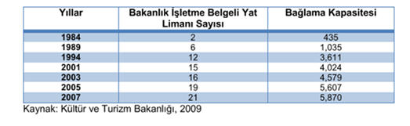

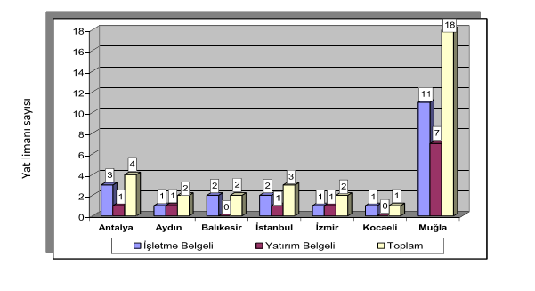As a policy nowadays Turkey is trying to increase the number of marinas at the Mediterranean Sea coasts since the marina complex volume is more or less reached its saturation point at the Aegean Sea coasts especially at the Muğla region. The distribution of the marinas of Turkey can be covered from the following graph. (See **Graph 1**)

Graph 1: Marina Distribution of Turkey

Antalya, the most important tourism center of Turkey, has a coastline of about 600 km. Sea Mountains and beaches do not show continuity due to mountains rising to the sea on the western coast of Antalya. However in the eastern part of the province, the mountains extending parallel to the sea provide plains formation between the mountains and the sea providing magnificent beaches which are formed from the thin fine sand. In addition to the fine sandy natural beaches and beautiful scenery in Antalya, the climate of Antalya and the sea water temperature are suitable for increasing the tourism potential of the seaside region. Beside these beauties of the Antalya Region if we talk about the exact location of our expected Marina Complex, it will be very strategically located since there existing Antalya port at the neighborhood. Since there is a port the efficiency of the marina is expected as high as possible.

* **Site Selection Criteria**

Although approximately 1/3 of Turkey`s tourism is actualizing at Antalya Region there are lack of marina complexes at the region. So in order to provide contribution to the Antalya region`s tourism, selection of the site is done as like this.

* **Design Parameters**

4 basic parameters are considered while designing the marina complex. They were Wave climate, Wind characteristics, Topographic conditions, and transportation network. The details related with individual topics will be given at the following pages.

* **Preliminary Design**

Basically the requirements are satisfied for the 5 Gold Anchor Marina. The capacities, dimensions of the components are forecasted and cost estimation is done by the light of these. Details of the preliminary design will be discussed at the related part of the report.

# Site Selection

Each marina in the world is specific in terms of location and offers a varied range of services to satisfy the necessities of the yachts. No two marinas are identical, but all share common site characteristics and business needs. There are two reasons of choosing the Antalya for the construction of marina. The two reasons are;

1. **Tourism**

According to the Ministry of Culture and Tourism, the number tourist who visit Antalya in 2015 is 10,5 million and the number of tourists who visit Turkey in 2015 is 36 million. As we can understand from the data, Antalya has a very high tourism potential. Since the tourism potential is very high, there will be also demand in terms of coastal structures such as marina complexes.

1. **Lack of Marina Complexes**

According to to **Deniz Turizminin Dünü, Bugünü ve Sürdürülebilirliği. (2015, April). *Deniz Turizmi*.**, there are 62 marinas in Turkey only 5 of them are located at Antalya.

In addition, According to the Chamber of Shipping, despite all the fact that Turkey has a longer coast in Mediterranean Sea, the number of marinas in Mediterranean Sea is very low. There are more than 700 000 yachts who travel around Mediterranean Sea and they contributes 60 billion $ each year to the countries in the region.

According to the Association of Turkish Travel Agencies, the yacht tying capacity of the countries that are in the Mediterranean region are;

France: 227000, Italy: 128000, Spain: 109000, Turkey: 15000, Croatia: 13000, Greece: 7000

In the light of this data, Turkey has only %3 yacht tying capacity between Mediterranean countries. However, since Turkey has very long coastline, the potential of Turkey for yacht tourism should be increased in Mediterranean Sea.

## 1. Service Life

In coastal engineering, determining the reliability of the coastal structures such as structural risk factors is necessary for the planning stage. The uncertainties encountered in the design of coastal structures are due to variables such as; experimental equations used during design, load and stiffness variables. Uncertainty factors affect the degree of reliability as well as the risk of damage that can occur during the design life of the structure. Statistical probabilistic methods are used to estimate the structural reliability by considering uncertainties. According to the specification of "[Ministry of Transport, Maritime Affairs and Communications](http://tureng.com/tr/turkce-ingilizce/ministry%20of%20transport%2c%20maritime%20affairs%20and%20communications) ", the table below shows the service life for different kind of structures.

Table 2: Risk levels of coastal structures

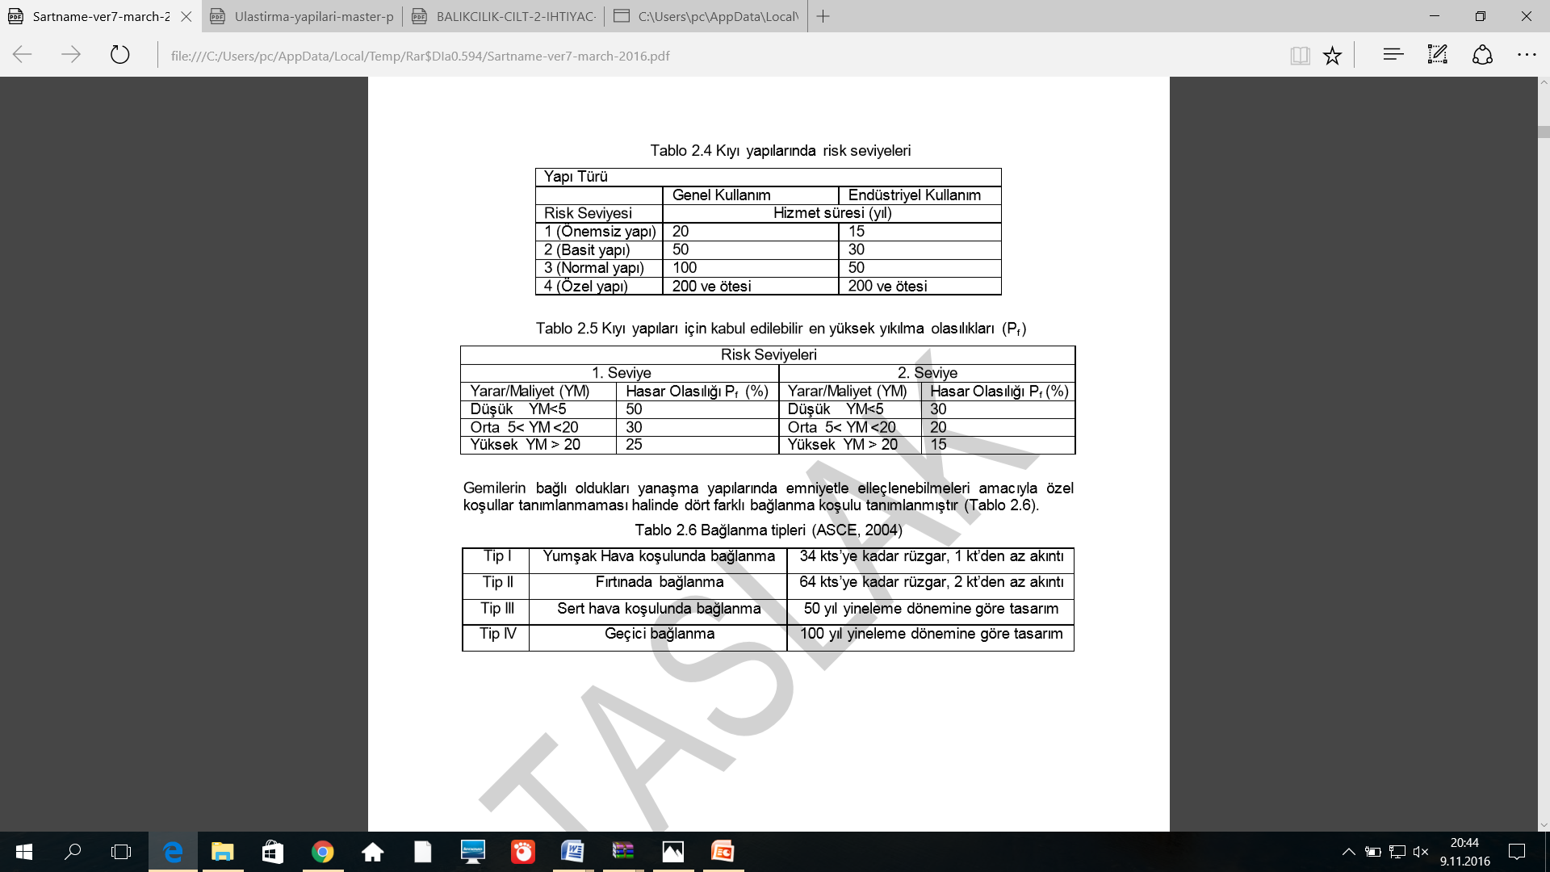

* **General Use:** Permanent structures without connection to any industrial facility.
* **Specific Industrial Use:** Coastal structures connected to private industrial installations or transit transportation. Levels of risk identified for these structures:

**Level 1 (Trivial structures):** The risk of human loss or damage to the environment is low. Example: local waste water offshore discharges industrial service facilities (maintenance, repair, etc.), temporary structures and the like. **Level 2 (Simple structures):** When damage occurs, the risk of human loss or damage to the environment is moderate. Example: shelters, coastal protection structures, municipal wastewater facilities, wooden sun decks, recreational arrangements, simple moorings and the like. **Level 3 (Normal structures):** When damage occurs, the risk of human loss or damage to the environment is high. For example: Urban protection structures, industrial facilities, ports, docking works, sea water receiving and protection of thermal power plants and similar structures. **Level 4 (Special structures):** Damage is a great effect on all living things. Example: Nuclear power plants.

* By examining the table with the given information, the marina structure is a level 3(normal structure). Since the marina will have no industrial facility; it will be constructed for general use. Therefore, we will design the marina for 100 year service life. After finding the service life for marina, then we have to find the design parameters.

# Design Parameters

In order to design the marina, there are some design parameters such as;

1. Wave Climate
2. Wind Characteristics
3. Topographic Condition
4. Transportation Network

By finding these parameters, we will do the preliminary design. Of course these parameters are not only important for preliminary design; they also will be used in the final design. Each design parameter will be explained one by one in the report.

## 1.1. Wave Climate

In order to examine the wave climate of Antalya, firstly we obtained the related data and graphs. We taught the data and graphs from the study which is "Türkiye Kıyıları için Rüzgar ve Derin Deniz Dalga Atlası, Özhan ve Abdalla, 1999”. From this study, we used the data of 36.75N & 30.70E. By using the graphs and data, we exactly found the characteristics of wave for that location.

### 1.1.1 Basic Definitions of Waves

Sea waves which are the most important environmental factor in the design of coastal structures are formed by the orbital movement of water particles. The simplest approach (linear waves) is given by the profile sine (or cosine) curve of the waves. The formation of these waves and hydrology of the waves are defined by basic physics rules.

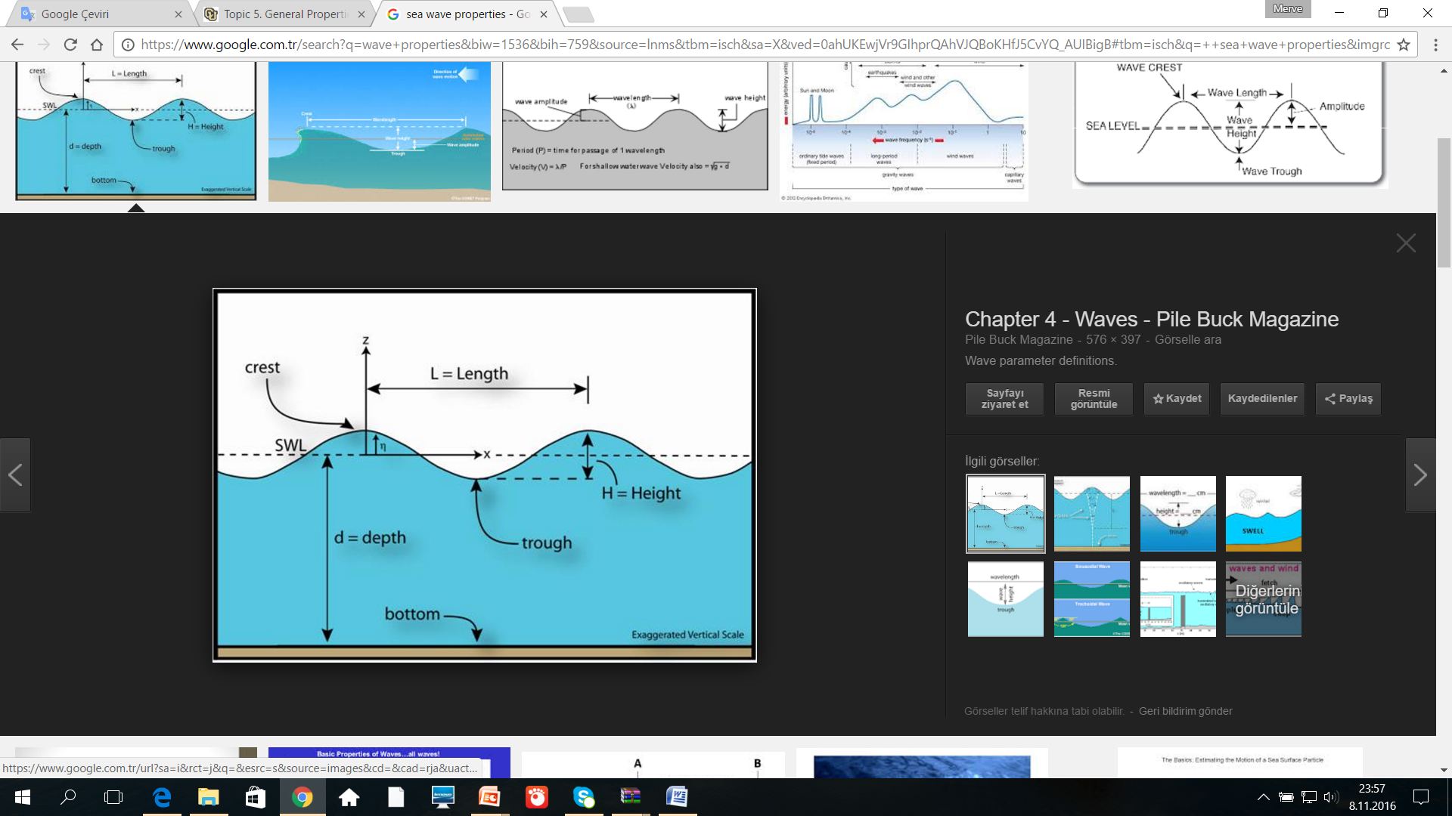

Figure 1: Wave parameters

### 1.1.2. Wave Height (H) and Wave Amplitude (a)

The wave height is the vertical distance between the successive crest and trough and it is indicated by "H". The wave amplitude (a) in linear waves is; a= H / 2.

### 1.1.3. Wave Period (T) and Wave Frequency (f)

Wave period is defined as the time required for two successive crests or trough to pass from the same point and it is indicated by "T". According to the small amplitude wave theory, it is assumed that the wave period is independent of the water depth. The wave frequency is inversely related with the wave period, f= .

### 1.1.4. Finding the wave height (H) & wave period (T)

In order to find the design parameters related to wave, wave climate of Antalya region is investigated.

* According to the graph which is taken from Ozhan E. and Abdalla S., (1999), "Turkiye Kıyıları Ruzgar ve Dalga Atlası", ODTU, Kıyı ve Deniz Mühendisliği Araştırma Merkezi Proje Raporu, we found the wave height as 8m for 100 year return period**. H =8m**

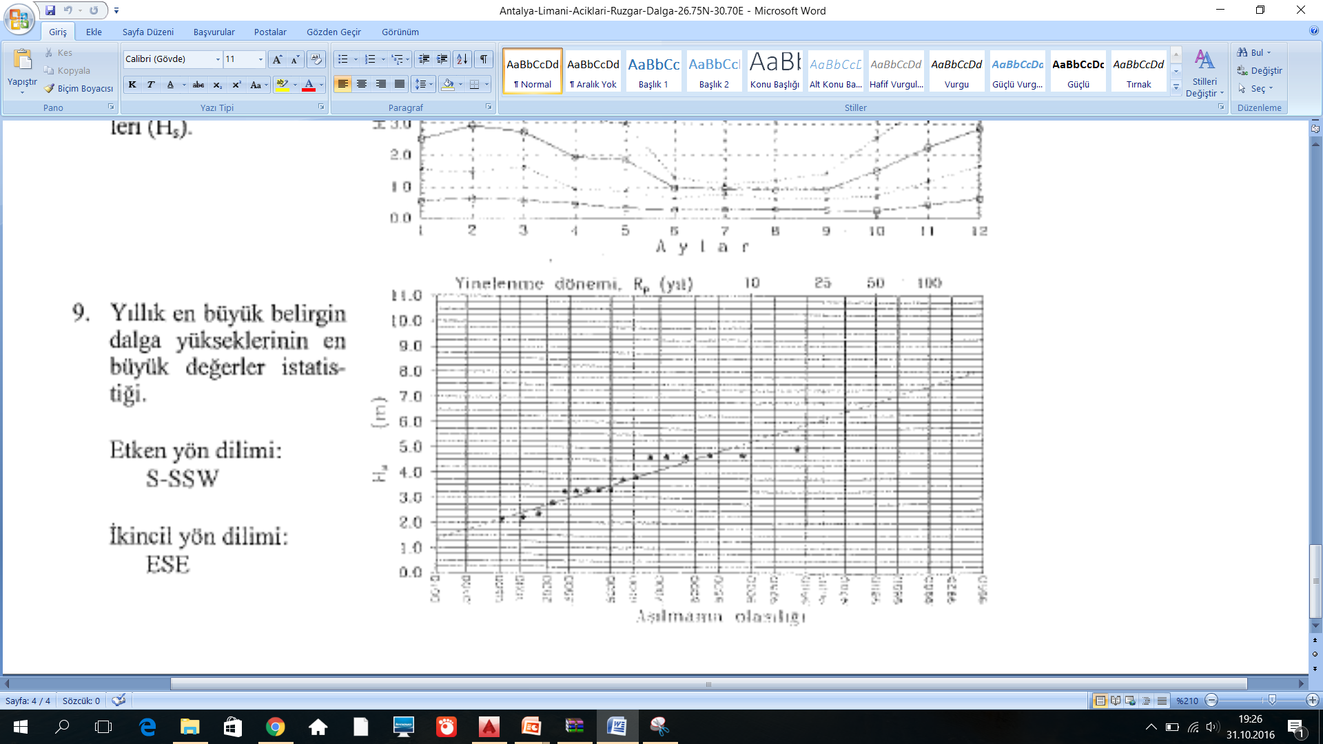

Graph 2: Wave Height vs Return period

* After finding the wave height, then also we have to find the wave period. Since we know that the wave height should be 8m. Then, we found from this graph the wave period as14 sec. **T=14sec.**

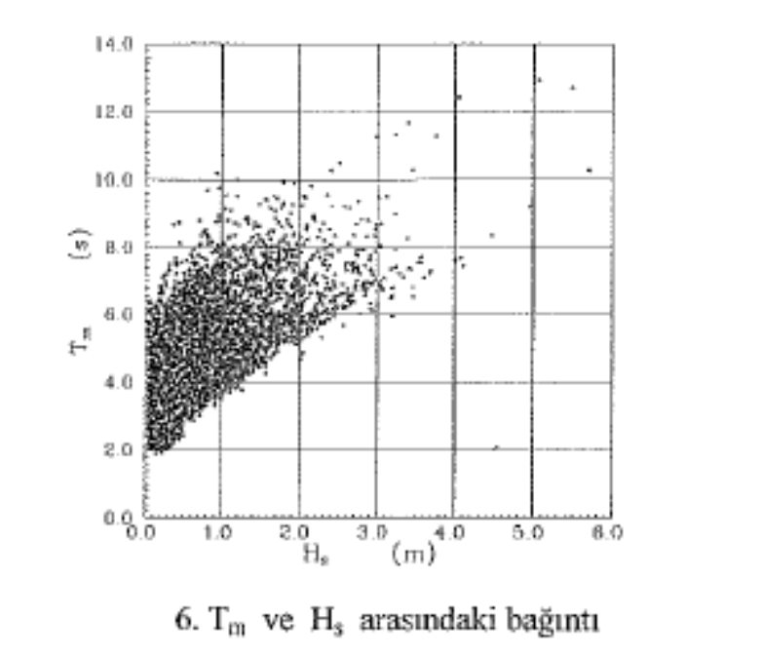

Graph 3: Wave Height vs Wave period

## 2.1. Wind Characteristics

### 2.1.1. Wind Data

Wind data are obtained from;

1) Long term measurement on the site,

2) Meteorological wind measurement stations in coastal areas

3) Synoptic maps

4) European weather forecasting institutions such as the European Center for Medium Range Weather Forecasts (ECMWF) or the National Oceanic and Atmospheric Administration (NOAA).

### 2.1.2. Wind Rose (30.60E & 36.8N)

Wind rose which is taken from the study of Ozhan E. and Abdalla S., (1999), "Turkiye Kıyıları Ruzgar ve Dalga Atlası", ODTU, Kıyı ve Deniz Mühendisliği Araştırma Merkezi Proje Raporu, shows the annual dominant wind directions for 30.60E &36.80N coordinates. By examining the wind rose,

* Dominant wind direction from sea to land is found as **South- South East.**
* Dominant wind direction from land to sea is found as **North- North West.**

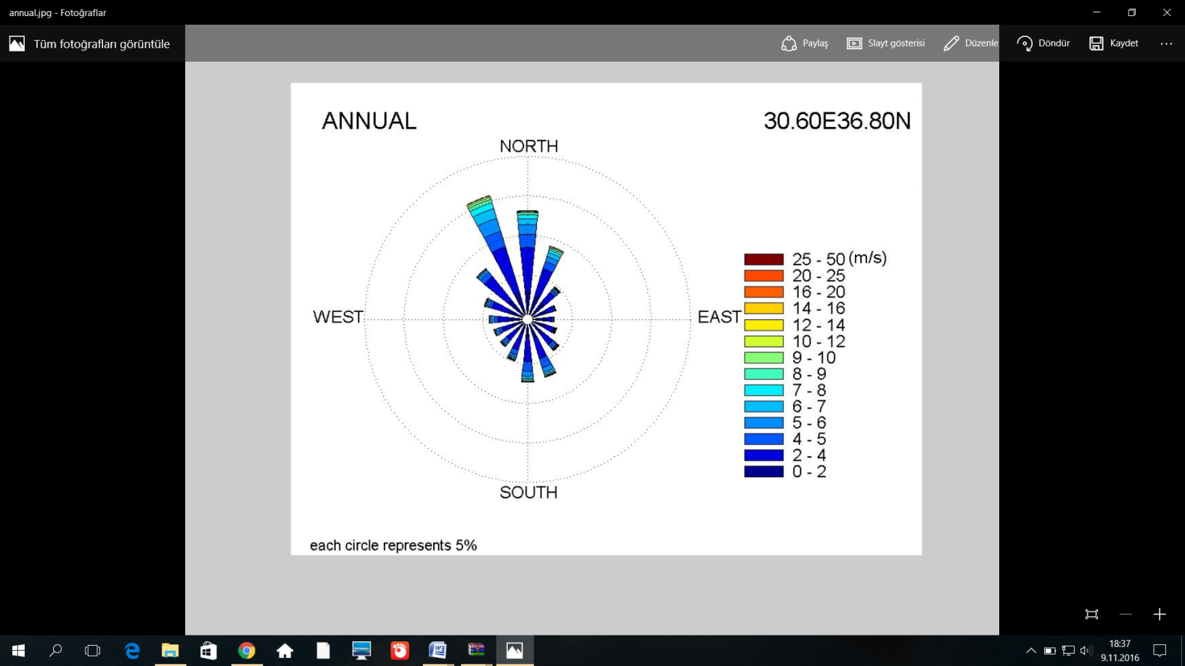

Figure 2: Wind Rose 30.60E 36.80N

As we understand from this wind rose, the proportion of the winds which blow from land to sea is more than the winds which blow from sea to land. In addition, the intensity of the winds which blow from land to sea is bigger than the winds which blow from sea to land. Also, nearly %40 wind blows from land to sea in North & Northwest directions.

### 2.1.3.Design Parameters for Wind Climate

According to the data which is taken from Ozhan E. and Abdalla S., (1999), "Turkiye Kıyıları Ruzgar ve Dalga Atlası", ODTU, Kıyı ve Deniz Mühendisliği Araştırma Merkezi Proje Raporu, the graph which is shown below is the graph of Return period vs. Maximum Wind Speed. From this graph, we determined the **maximum wind speed as 34m/sec.**

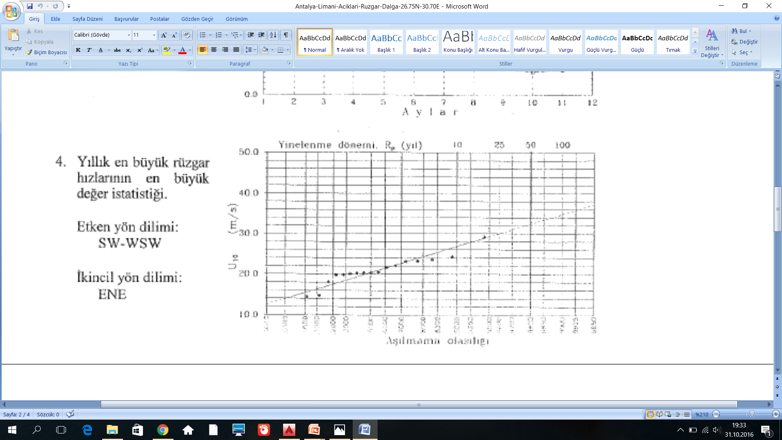

Graph 4: Max. wind speed vs. Return period

# Topographic Conditions

The marina is placed and designed according to several limitations. One of them is topographical conditions that include natural existing structures and soil properties.

Boğaçay River that is on the east side is the main limitation for the location. The Boğaçay basin consists of Karaman River, Doyran River, Çandır River and Çay River. Especially on winter and spring, the discharge increases up to 2300 m3/s in flood conditions. So, it is decided to left enough space from Boğaçay.

Antalya port is the other limitation and the marina will bound by it on the west. Although water quality maintaining is a concern for this situation, it is manageable. Also, mega yachts use the dry dock of the port to maintenance and service.

According to Tourism Coastal Structures Master Plan, the minimum water depth inside the marina must be at least the draft survey+0,5 m to be landed the pier safely. The draft surveys are shown on the table 3 below. The minimum depth according to this data is calculated as 3,5m. However it is decided as 5 m depth for both safety and gaining some land area. By using NAVIONICS software, the bathymetric map is obtained. By the help of this map, 5 m water depth is observed around 150 m away from the existing coast line. So, the filling work will performed for this area.

**Table 3: Draft Survey**

|  |  |
| --- | --- |
| Length (m) | Draft Survey (m) |
| 8 | 1,8 |
| 10 | 2,1 |
| 12 | 2,4 |
| 15 | 2,5 |
| 20 | 2,8 |
| 25 | 3,0 |

A soil evaluation report is given by Prof.Dr.Ufuk Ergun about our place. In this report 52 bore holes are used to obtain data about site conditions by in situ and laboratory experiments. Some main points following are determined according to it:

* The water depth varies between 5-20 meters.
* The slope of sea bottom does not change dramatically place to place.
* Sea bottom properties are simple and monotonous. By data obtained from bore holes shows that it consists of two main layers as sea bed overburden and bedrock.
* Sea bed overburden is made of sand, clayey silt- silty clay, sandy silt- silty fine sand and clayey gravel- gravelly clay, from top to the bottom respectively. All the related parameters for each layer are shown below, from **Table 4 to 8**.

**Table 4: Geotechnical parameters for sand layer**

|  |  |
| --- | --- |
| Classification | Unified: SP |
| Thickness | Hort : 4,00 m |
| SPT | N30 : 17 |
| Unit Weight | γn: 1,80 t/m3 |
| Internal Friction Angle | Φ : 35° |
| Cohesion | c : 0 |
| Deformation Modulus | M : 680 t/m2 |

**Table 5: Geotechnical parameters for clayey silt-silty clay layer**

|  |  |
| --- | --- |
| Classification | Unified: ML |
| Thickness | Hort : 8,00 m |
| SPT | N30 : 8 |
| Unit Weight | γn: 1,85 t/m3 |
| Internal Friction Angle | Φ : 30° |
| Cohesion | c : 2,0 t/m2 |
| Deformation Modulus | M : 320 t/m2 |
| Natural Moisture Content | Wn : 45 % |
| Liquid Limit | WL : 47 % |
| Plastic Limit | WP : 31 % |
| Plasticity Index | PI : 16 % |
| Void Ratio | e0 : 1,43 |
| Coefficient of Curvature | Cc : 0,46 |

**Table 6: Geotechnical parameters for sand layer**

|  |  |
| --- | --- |
| Classification | Unified: |
| Thickness | Hort : |
| SPT | N30 : |
| Unit Weight | γn: t/m3 |
| Internal Friction Angle | Φ : ° |
| Cohesion | c : |
| Deformation Modulus | M : t/m2 |

**Table 7: Geotechnical parameters for sandy silt- silty fine sand layer**

|  |  |
| --- | --- |
| Classification | Unified: ML-SM |
| Thickness | Hort : 6,00 m |
| SPT | N30 : 21 |
| Unit Weight | γ n: 1,90 t/m3 |
| Internal Friction Angle | Φ : 37° |
| Cohesion | c : 0 |
| Deformation Modulus | M : 840 t/m2 |

**Table 8: Geotechnical parameters for clayey gravel- gravelly clay layer**

|  |  |
| --- | --- |
| Classification | Unified: GP-GC-GM-CL |
| Thickness | Hort : 3,00 m |
| SPT | N30 : 48 |
| Unit Weight | γ n: 2,10 t/m3 |
| Internal Friction Angle | Φ : 40° |
| Cohesion | c : 40 t/m2 |
| Deformation Modulus | M : 5760 t/m2 |

* Bedrock is made of clay stone- sand stone (soft to medium hard) and lime stone (medium hard). All the related parameters is shown below on **Table 9**.

**Table 9: Geotechnical parameters for bedrock**

|  |  |
| --- | --- |
| Type of Rock | Fissured, soft to medium hard rock |
| Unit Weight | γ n: 2,50 t/m3 |
| Internal Friction Angle | Φ : 45° |
| Cohesion | c : 75 t/m2 |
| Deformation Modulus | M : 10000 t/m2 |

In the lights of this information an idealized soil profile is obtained as shown on **Figure 3**.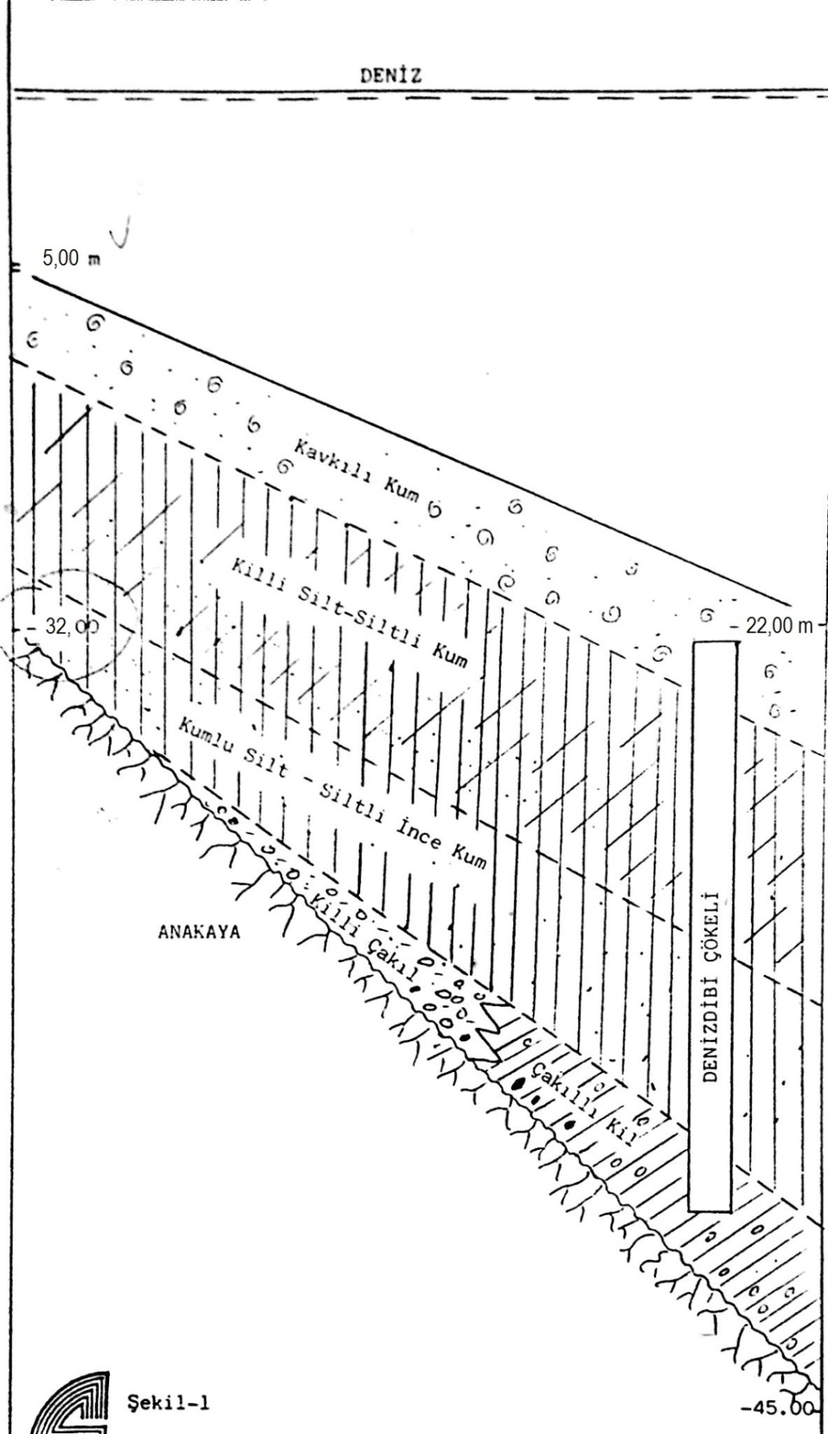

**Figure 3: Idealized soil profile (not scaled)**

For filling and breakwater, the loads acting on the bottom are estimated. The density of filling material (rock and/or concrete) is taken as 2,4 t/m3. The filling and the breakwater will set on top of the seabed overburden layer. The maximum load transferred from structures to the bottom is predicted as qmax = 26,5 t/m2 on **Figure 4**.

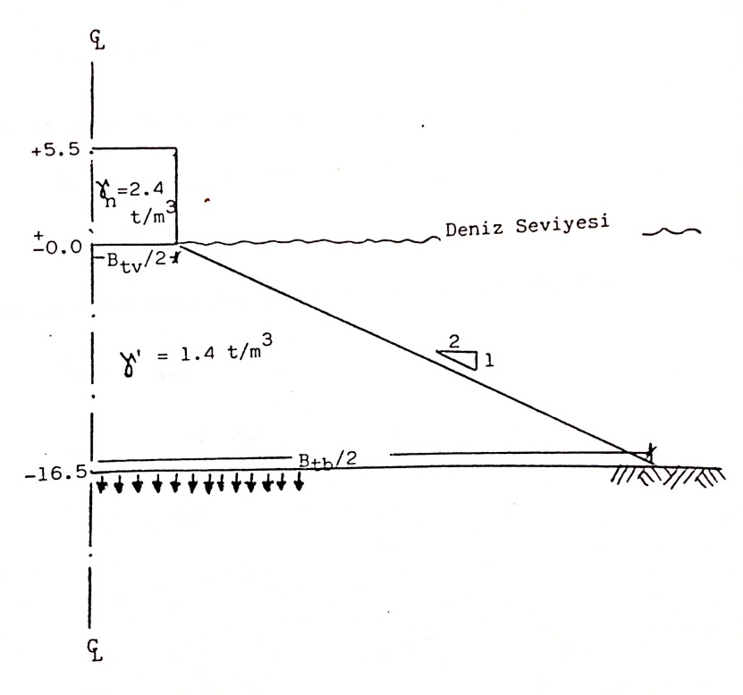

**Figure 4: Max. load transfer to the bottom (qmax)**

For the most unfavorable conditions, the ultimate bearing capacity is calculated as qult = 90 t/m2. With the factor of safety taken as 3, the allowable bearing capacity is found as qall = 30 t/m2. Since qall = 30 t/m2 > qmax = 26,5 t/m2 , any bearing capacity problem does not expected.

The sand and silty parts of the seabed overburden layer is compressible whereas hard and dense clay and gravel parts are not because of their high deformation modulus. So the settlement calculations are made for the former layers. As a result, settlement amount is calculated as 1,5 m. Completion of settlement is expected to end at the same time of completion of filling work. So, the settlement of structures above filling will be inside the acceptable limits.

For piers, if desired, steel bored piles or concrete driven piles are both possible and acceptable solutions. The required geotechnical parameters are given for the design stage of piles.

The slope stability is an important concept for the breakwater. Some analyses have conducted and the **Figure 5** is drawn for probable slip circle.

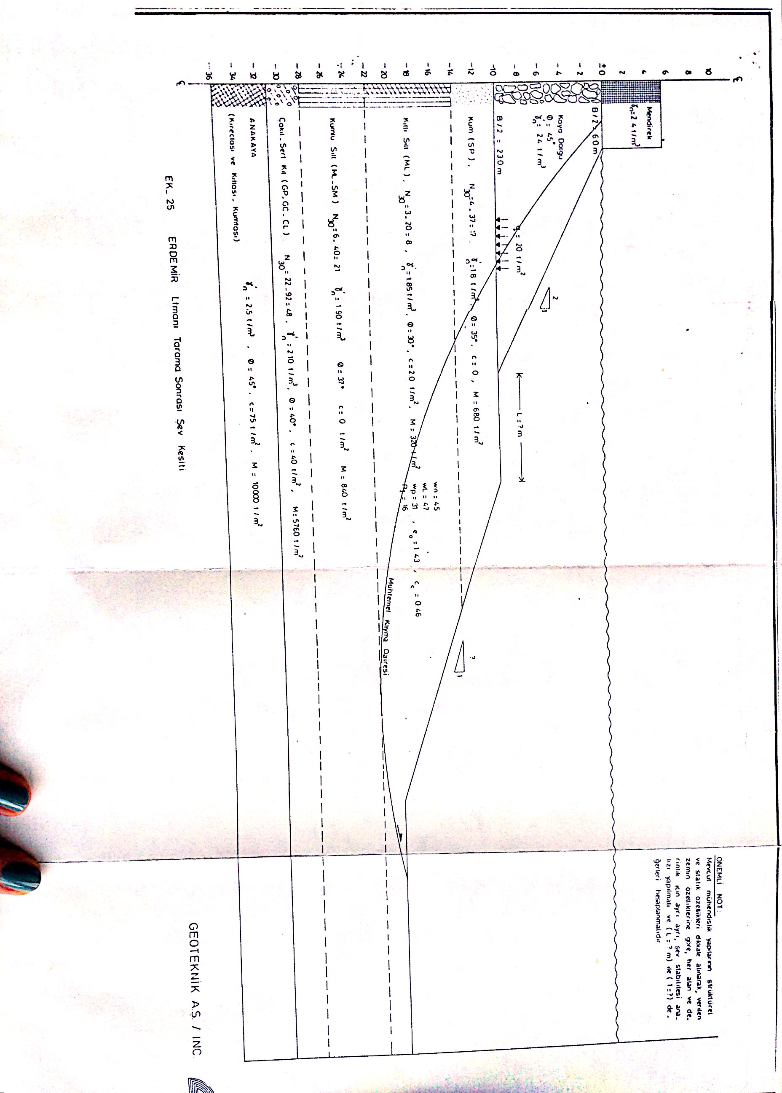

**Figure 5: Probable slip circle**

# Transportation Network

The entrance of marina is decided to connect to D400 Highway within 1 km distance. This highway follows the coast line from İzmir to Mersin. This highway will ease the access Antalya Airport and Gazipaşa Airport that locate in Antalya. All the other highways near Antalya region is given on **Figure 6** below.

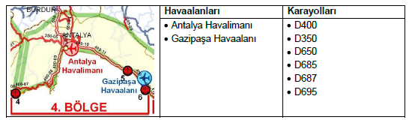

**Figure 6: Main highways and airports at Antalya**

A service road must be placed for ambulance, fire vehicles and garbage truck to pass including mooring places inside the marina. So 15 m wide 2-lanes service road is designed.

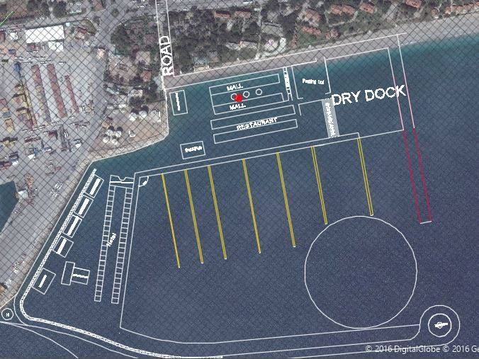

**Figure 7: The entrance of the marina and service road**

# Preliminary Design

## Marina Groups

Marinas can be divided into three groups, which are three anchor, four anchor and five anchor marinas.

### 1) Three anchor marinas:

Three anchor marinas should meet the following infrastructure and superstructure qualifications.

Infrastructure qualifications:

a) There must be docks and piers which the marina crafts can approach, and anchor neatly and safely,

b) For safely approaching and entrance, there must be lights and signs,

c) There must be lightning system and power generator in order to lighten all the facilities, piers and docks,

d) Enough clean water storage, and installation for hot/cold tap water,

e) Fire alarm, firefighting equipment in everywhere of the marina,

f) If the facility does not have the license of waste acceptance, the facility must have enough storage and treatment plant according to number 2872 environment law,

g) There must be boxes that meet the demand of tap water, TV, phone and electricity of yachts,

h) There must be parking lots, which have a 10% capacity of yacht capacity that can serve disabled people,

i) Internal, external phone, fax, internet, communication systems for cruising yachts that have multiple channels containing VHF bands,

j) There must be suitable roads for ambulance, fire vehicles, garbage truck to pass including mooring places.

k) Structures and systems in order to lower the rumble,

Superstructure qualifications:

a) Safe and controlled entrance for marine tourism

b) Pre-office and administration unit

c) Lounge

d) Food & beverage unit

e) Shower and toilet for women and men

f) Sale unit with and without custom

g) First aid closet

h) Marine tourism facilities and food, beverage, shower, toilet, lounge units for crew members

i) Oil plant

j) Deposit store for marine vehicles

k) Sport complexes

l) Warp boat for safe entrance and exit

m) Firefighting boat for first response from sea

n) Service building for civil servants that works for border crossing if the Council of Ministry have decided that the mentioned marine would be used for border crossing.

**Besides all above three anchor marinas must have the followings:**

1) Sale units

2) Shower and toilet for women and men that must have a capacity of at least 5% of mooring capacity.

3) Laundry and dish washing rooms

4) Lounge & social facilities

5) Toilet and special arrangements for disabled people

### 2) Four anchor marinas:

Besides all of the qualifications that three anchor marinas have, four anchor marinas must also have the followings:

a) Restaurant and cafe

b) Shower and toilet for women and men that must have a capacity of at least 10% of mooring capacity.

c) Dry cleaning

d) Dry dock & crane system

e) Maintenance & repair services

f) Warehouse for yacht owners

g) Parking lot for at least 20% of the mooring capacity

h) Tennis court

i) Swimming pool & beach

j) Gym, massage, sauna, Turkish bath

### 3) Five anchor marinas

Besides all of the qualifications that three anchor marinas have, five anchor marinas must also have the followings:

a) Heliport

b) Banking unit

c) Medical room

d) Exhibit, concert, entertainment places

e) Meeting Room

f) At least two tennis court

g) Parking lot for at least 30% of the mooring capacity

According to tourism structures master plan that is done by the authority of Ministry of Transportation, for the region whose boundaries are Kaş (on west) and Gazipaşa (on east) there is a recommendation that a total of 8 marinas should be constructed. Moreover, 6 of them should have 4-5 gold anchors. Given that fact, it is decided to construct 5 gold anchor marina.

## Design Features

For general layout see **Figure 8** below.

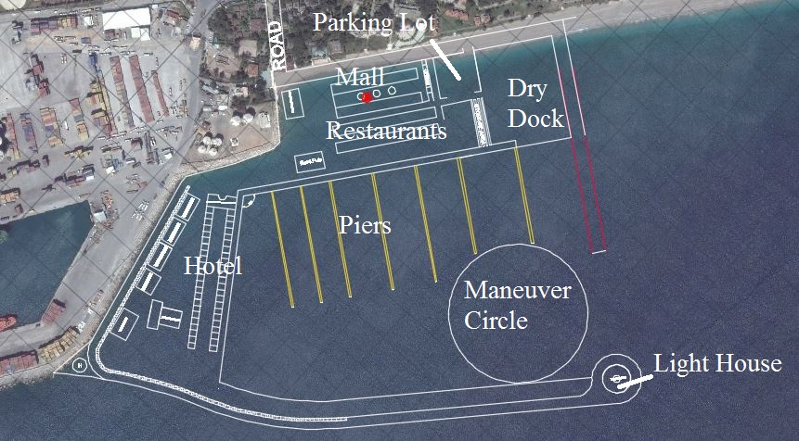

**Figure 8: General Layout**

### Technical Details

For technical details see **Figure 9** below.

|  |  |
| --- | --- |
| Land Area | 150000 m2 |
| Water Area | 175000 m2 |
| Yacht Capacity | 500 on water + 150 on land |

**Figure 9: Technical Details**

#### Yacht Capacity:

According to Tourism Coastal Structures Master Plan it is recommended to construct 500 yacht capacity marina for mentioned region. Thus, it is decided to construct 500 yacht capacity marina.

#### Land Area:

Since the draft survey is calculated as 5m, the minimum depth for the project must be at least 5m. By using Navionics software, bathymetric map of the project area formed. Having formed this map, it is decided to fill 150m from shoreline to sea. This fill area has been decided to be used as land area for marina facilities such as parking lot, dry dock, shopping mall etc. Also it is decided that to fill the area between planned marina and Antalya Harbour in order to have space for hotel, sport complex, swimming pool, yacht club and tennis courts.

The usage of land area is given in the below **Table 10**.

**Table 10: Land areas for facilities**

|  |  |
| --- | --- |
| Facility | Area |
| Dry dock | 17000 m2 |
| Hotel | 9500 m2 |
| Tennis Court | 2* 690 m2 |
| Sport Complex | 685 m2 |
| Heliport | 315 m2 |
| Yacht Club | 2000 m2 |
| Spa Center | 750 m2 |
| Bar & Pub | 1000 m2 |
| Restaurant | 6000 m2 |
| Mall | 6250 m2 |
| Park for service cars | 10000 m2 |
| Offices | 360 m2 |
| Parking Lot | 3600 m2 |
| Storage Area | 1210 m2 |

#### Pier Design:

In order to design pier structures the document that is prepared by the Ministry of Transportation, Marine and Communication is used.

It is decided to divide different size of yachts into three groups. Then, according to their groups 5 to 7 meter spacing is left between each yacht. (See **Table 11**)

**Table 11: Yacht sizes vs. Space left**

|  |  |
| --- | --- |
| Yacht sizes(m) | Space left(m) |
| 5-9 | 5 |
| 12-15 | 6 |
| 15-20 | 7 |

* For the distance between each pier 4*l where l is the longest yacht length that will use that pier is left (see **Table 12**).

**Table 12: Pier Spacing**

|  |  |  |  |
| --- | --- | --- | --- |
| Pier no (from right to left) | Multiplication Factor | Longest Yacht for related pier (m) | Space Left (m) |
| 1-2 | 4 | 20 | 80 |
| 2-3 | 4 | 15 | 60 |
| 3-4 | 4 | 15 | 60 |
| 4-5 | 4 | 15 | 60 |
| 5-6 | 4 | 10 | 40 |
| 6-7 | 4 | 10 | 40 |

* For harbour mouth it is decided to left 2.5*l where l is the longest yacht length for the whole design.

Harbour mouth spacing = 2.5*60 =150m

# Cost Estimation

For the preliminary design, the data which is taken from the Ministry of Environment and Urbanization is used. According to this data, average unit cost for marinas is . Therefore, total cost of the marina project is calculated as 80 million $. Besides, some of the components of the project is indicated as shown below in **Table 13**.The unit cost of piers is taken 2000 $/m for piled piers. Therefore, total cost of piers is 2,260,000 $. Unit Cost of the piers that has service station is taken 4,000 $/m. Total cost of this pier calculated as 680,000 $. The unit cost of breakwater is taken 10,000 $/m. Total length of breakwater is 650 m. Therefore, cost of breakwater is calculated as 6,500,000 $.

**Table 13: Cost Calculation for Priliminary Design**

|  |  |  |
| --- | --- | --- |
|  | Unit Cost | Total |
| Total | 250 $/m2 *320,000 m2 | 80,000,000 $ |
| Breakwater | 10,000 $/m *650 m | 6,500,000 $ |
| Pier for Service Station | 4,000 $/m *170 m | 680,000 $ |
| Other Piers | 2,000 $/m *1130 m | 2,260,000 $ |
|  |  |  |

# Conclusion

To summarize, the reasons of construction of marina project is explained. Also, it has explained why Antalya is chosen. Since Antalya Region has lack of marina complexes, 5 gold anchor marina with the capacity of 650 yachts will be constructed. The requirements are satisfied for 5 gold anchor marina. Marina components, their dimensions and their capacities are estimated. Then, general layout of the marina project was drawn in AutoCAD. Also, 4 basic design parameters that are wave climate, wind characteristics, topographic conditions and transportation network were calculated and shown. Lastly, cost estimation for preliminary design was done.

In the future, one of the marina facilities will be designed for structurally. The design of breakwater and piers will be done. It will be decided which type of piers will be designed. It will be considered 3 options: piled, floating, or combined. The best suitable one will be constructed. Finally, the detailed cost estimation will be calculated.

# References

Başbakanlık Mevzuatı Geliştirme ve Yayın Genel Müdürlüğü. (n.d.). Retrieved November 04, 2016, from http://www.resmigazete.gov.tr/eskiler/2016/04/20160409-22.htm.

Deniz Turizminin Dünü, Bugünü ve Sürdürülebilirliği. (2015, April). *Deniz Turizmi*.

Global Liman İşletmeleri. (n.d.). Retrieved November 12, 2016 from <http://globalports.com.tr/tr/liman-operasyonlari/dogu-akdeniz/port-akdeniz-antalya-limani/kruvaziyer-operasyonlari/deniz-hizmetleri/liman-ozellikleri/yonler.aspx>

Kıyı Yapıları Planlama ve Tasarım Teknik Esasları. (2016). Turkey.

Marina ve Yatçılık Raporu.(2012).Türkiye Turizm Yatırımcıları Derneği. Retrieved from <http://www.ttyd.org.tr/sayfa/Sektorel-TYD-Raporlari-16/28>.

Ozhan E. and Abdalla S., (1999), "Turkiye Kıyıları Ruzgar ve Dalga Atlası", ODTU, Kıyı ve Deniz Mühendisliği Araştırma Merkezi Proje Raporu.

Turizm Kıyı Yapıları Master Plan Çalışması Sonuç Raporu. 2010. Turkey: Yüksel Proje Uluslararası A.Ş.&Belde Proje ve Danışmanlık Tic. Ltd. Şti. Ortak Girişimi.

Türkiye'ye 2015'de 36 milyondan fazla turist geldi. (2016, January 28). Retrieved November 4, 2016, from <http://www.haberturk.com/ekonomi/turizm/haber/1187727-turkiyeye-2015de-36-milyondan-fazla-turist-geldi>

Ulaştırma Kıyı Yapıları Master Plan Çalışması Sonuç Raporu. 2010. Turkey: Yüksel Proje Uluslararası A.Ş.&Belde Proje ve Danışmanlık Tic. Ltd. Şti. Ortak Girişimi.