**Introduction**

Izmır Bay has known as having very soft soil type at offshore. It is essential to investigate properly that kind of soil type; in order to prevent geotechnical failures. In that case, VOLTRAN’s aim is to collect data related with Izmır Bay, obtain parameters, analyze it and calculate related values which are part of geotechnical part.

**Site Investigation and Idealized Soil Profile**

There are 9 different Standard Penetration Tests (SPT) with vary depth. 5 of them are made at Navigation Channel near Narlidere, 4 of them are made at Circulation Channel near Cigli. Their location and depth of each SPT boreholes has shown as T**able 3 and Figure 1.**

Table 3. The location and depth of each SPT boreholes

|  |  |  |
| --- | --- | --- |
| Borehole No. | Location | Depth (m) |
| NTS - 02 | Navigation Channel | 29,75 |
| NTS - 03 | Navigation Channel | 20,75 |
| NTS - 15 | Navigation Channel | 29,75 |
| NTS - 24 | Navigation Channel | 29,75 |
| NTS - 25 | Navigation Channel | 23,75 |
| STS - 05 | Circulation Channel | 15,05 |
| STS - 06 | Circulation Channel | 15,05 |
| STS - 14 | Circulation Channel | 15,05 |
| STS - 22 | Circulation Channel | 15,05 |

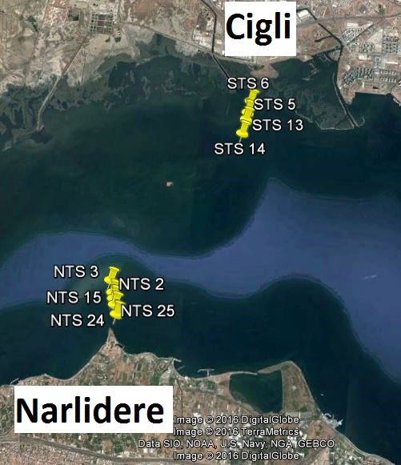

Figure 4. SPT boreholes

According SPT data and samples and laboratory tests, there is two major soil layers in Izmir Bay. And also in accordance those results, parameters of those layers are obtained. For general view of soil layers, upper layer is very soft – soft clay which has almost no contributes to bear constructions; on the other hand, second layer will majorly bear the constructions; in the light of those obtained data.

Parameters of soil layers are obtained as follows;

First of all, generally SPT data are used to obtain those parameters. In order to use those data, SPT data corrected to SPTN60 values. In addition, Atterberg Limits, consolidation test results are obtained from laboratory tests. With the help of those data, parameters are obtained with related correlations and general soil profile idealized (**Figure 2**). Since project area’s length is 7 kilometer, soil profile and parameters idealized in two different places which are located at the navigation channel and circulation channel (**Figure 3 – 4, Table 2 – 3**).

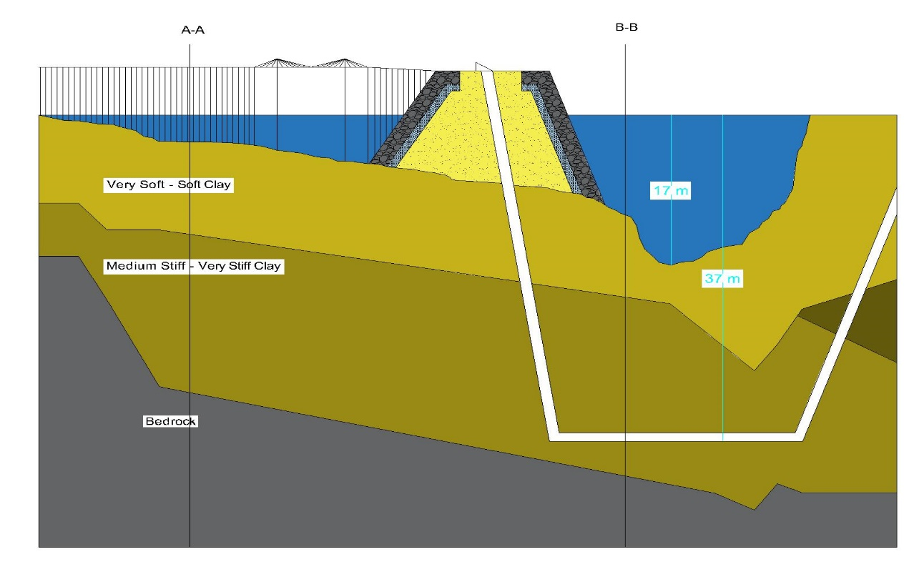 In order to find φ’, Schmertmann (1975) was chosen because it is both related with overburden pressure and SPT data. For unit weight of soil’s Çetin at all. (2016) correlation is used, since it correlation gave us direct unit weights with SPT value. Coduto (2000) correlation is used for estimating relative density of soils. To obtain cu, Stroud (1976) correlation which is directly related with plasticity index is used. On the other hand, Es parameter found by Kulhawy & Mayne (1990) correlation. For Eu parameter Paulos & Small (2000) correlation is used.

Figure 5. Idealized soil profile and elements of the project

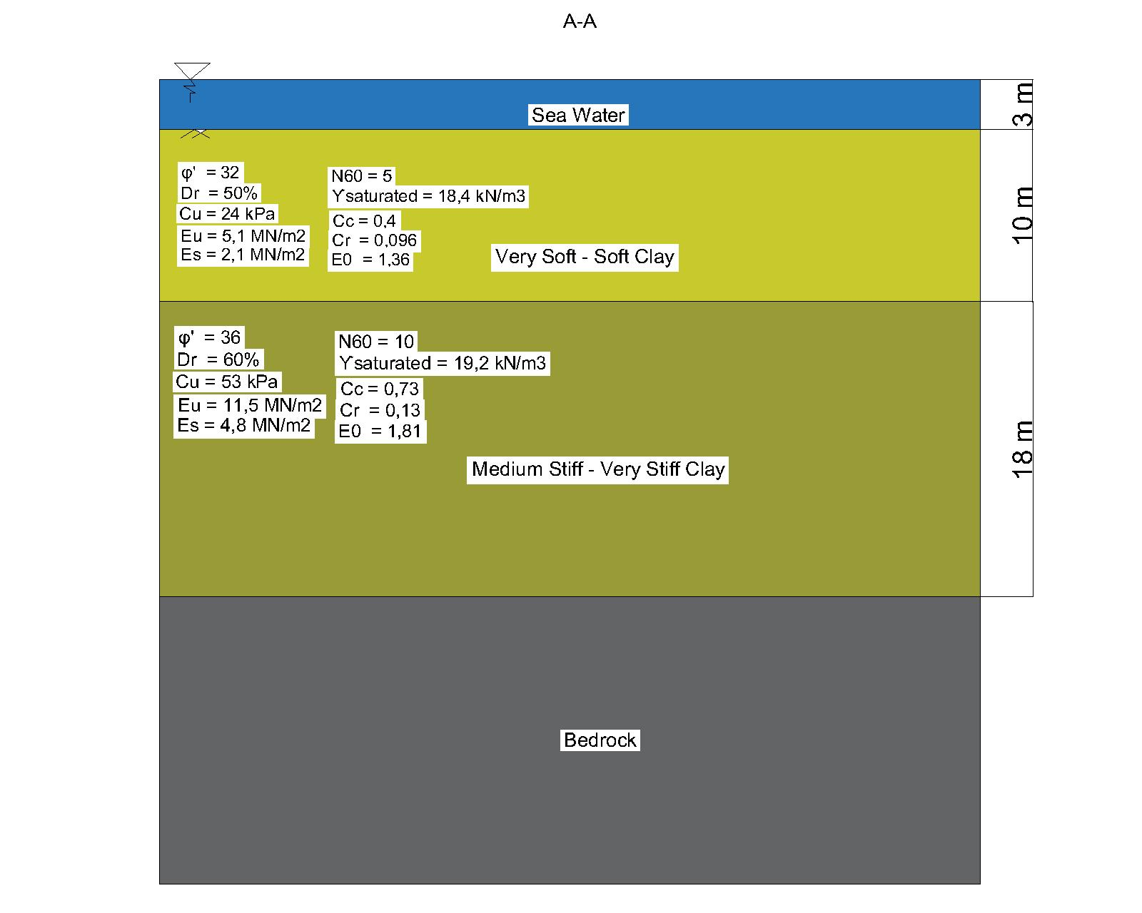

Figure 6. Soil profile of the A-A section of the ground

Table 4. Soil parameters of the A-A section of the ground

|  |  |  |
| --- | --- | --- |
|  | Very Soft - Soft Clay | Medium Stiff - Very Stiff Clay |
| Unit Weight (kN/m3) | 18,4 | 19,2 |
| Liquid Limit | 52,5 | 51,7 |
| Plastic Limit | 26,7 | 26 |
| Plasticity Index | 25,8 | 26 |
| Cu (kPa) | 25 | 53 |
| φ ( ͦ) | 0 | 36 |
| Es (MN/m2) | - | 4,8 |
| Eu (MN/m2) | - | 11,5 |
| Dr (%) | - | 60 |
| E0 | 1,36 | 1,81 |
| Cr | 0,096 | 0,13 |
| Cc | 0,4 | 0,73 |

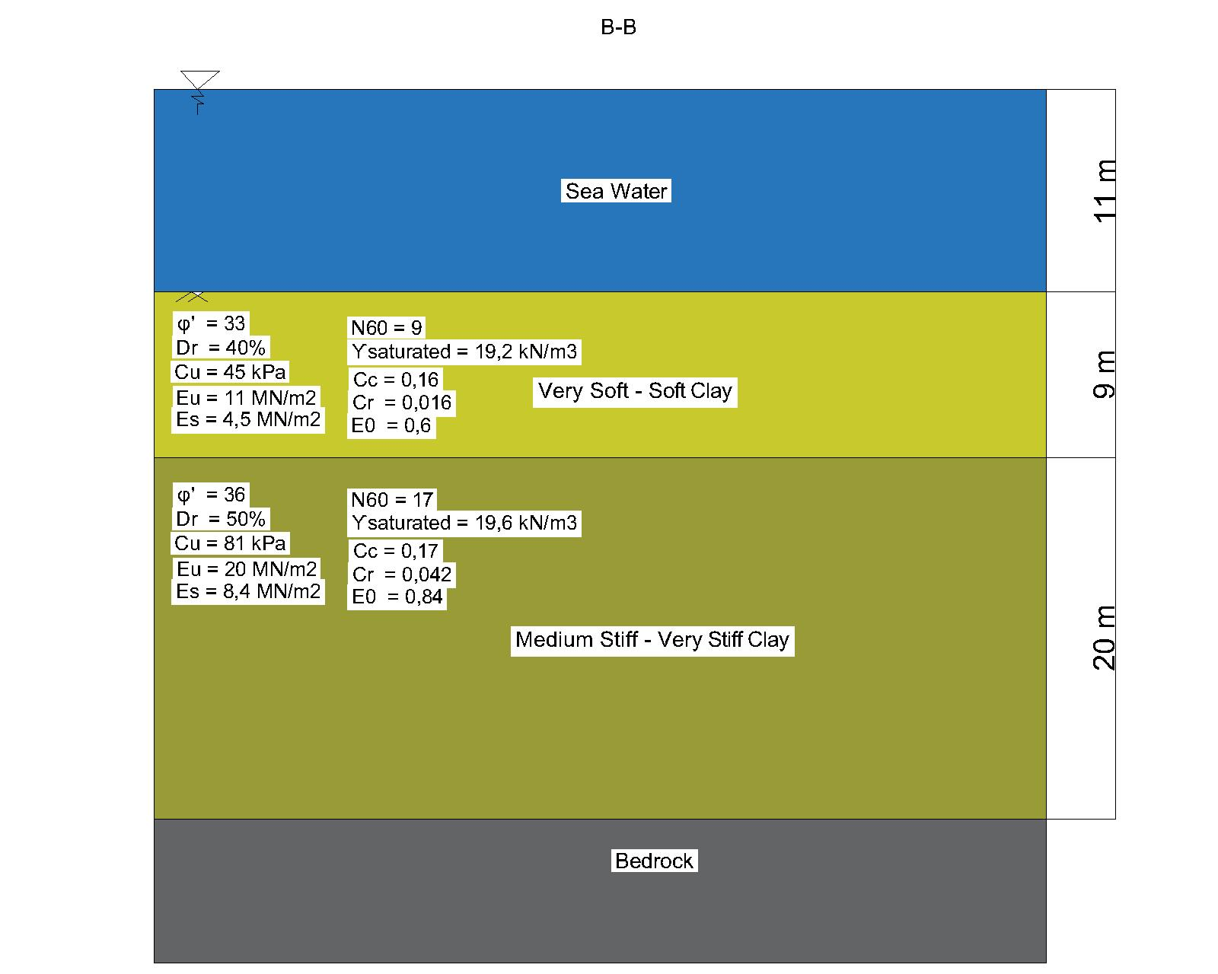

Figure 7. Soil profile of the B-B section of the ground

Table 5. Soil parameters of the B-B section of the ground

|  |  |  |
| --- | --- | --- |
|  | Very Soft - Soft Clay | Medium Stiff - Very Stiff Clay |
| Unit Weight (kN/m3) | 18,4 | 19,6 |
| Liquid Limit | 53,2 | 27,2 |
| Plastic Limit | 44,3 | 23,3 |
| Plasticity Index | 27,8 | 21,5 |
| Cu (kPa) | 25 | 81 |
| φ ( ͦ) | 0 | 36 |
| Es (MN/m2) | - | 8,4 |
| Eu (MN/m2) | - | 20 |
| Dr (%) | - | 50 |
| E0 | 0,6 | 0,84 |
| Cr | 0,016 | 0,042 |
| Cc | 0,16 | 0,17 |

As seen as **Table 2 and Table 3,** some parameters did not found. According SPT data, at first layer we have very soft clay which SPTN60 value is zero. Due to that very soft clay, those parameters did not obtain and also that layer did not count to bearing case.

**Settlement**

Settlement is a critical factor that should be taken into consideration in the design of foundations to make it safe, economical and serviceable. Immediate, consolidation and secondary settlements are calculated by using obtained parameters.

## Immediate Settlement

## Immediate settlement will occur in a short time right after the constructing of a structure. According to Janbu, Bjerrum and Kjaernsli (1956), immediate settlement of foundations on clay is calculated by using formula and charts as below.

Si = μ0.μ1.q.

* Si : immediate settlement on clay (mm)
* q : average applied vertical pressure (kPa)
* B : width of the foundation (m)
* E : modulus of elasticity of the soil (MPa)

## 

## B is the smaller dimension.

## We obtain,

## μ0 from D / B

## μ1 from H / B and L / B

## Figure 8. A view of the foundation and excavated ground

## μ0 and μ1 are empirical factors dependent on foundation geometry and depth (dimensionless parameters).

## D: depth of the foundation (m)

## H: the vertical distance between hard stratum and the base of the foundation (m)

## L: length of the foundation (m)

Table 6. μ0 of immediate settlement

## 

## Table 7. μ1 of immediate settlement

To make calculations easily, all formulas and charts are integrated to a MATLAB code and more correct results are obtained as shown below.

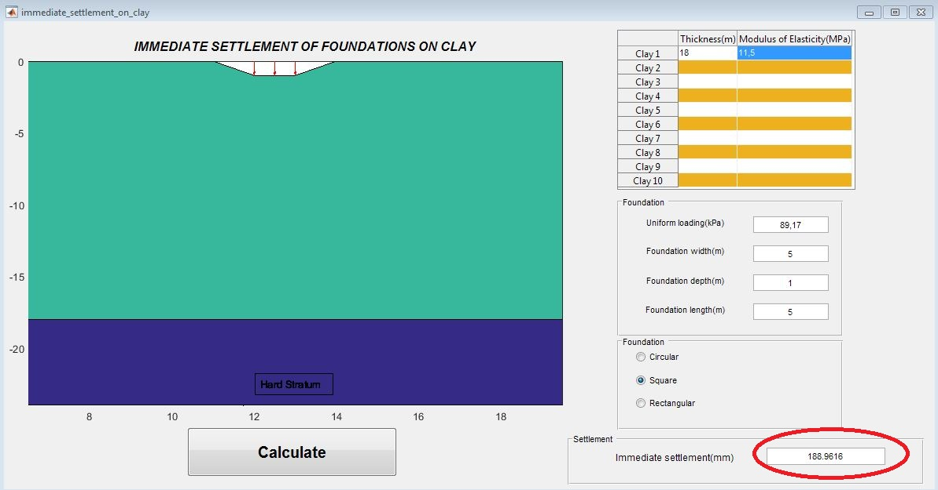

Figure 9. The immediate settlement on Section A-A

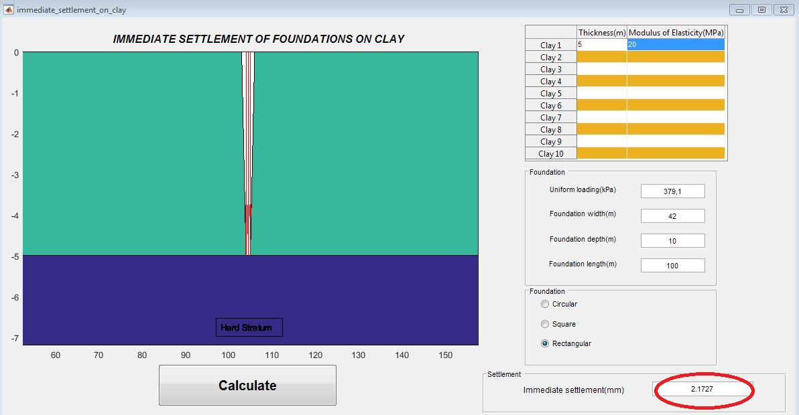

Figure 10. The immediate settlement on Section B-B

## Consolidation Settlement

## Consolidation settlement takes place in saturated clays exposed to an increased load after the application of the foundation. One-dimensional consolidation settlement (Soed) of clays is calculated.

## Soed =∑ [H. $\frac{Cc}{1+eo}$.log ($\frac{σ0΄+∆σ΄}{σ0΄})]$

## Soed: consolidation settlement

## σ0΄: initial effective vertical stress (kPa)

## e0: initial void ratio

## Cc: compression index

## H: thicknesses of the clay layer (m)

## ∆σ΄: average increase in effective pressure on the clay layer caused by the construction of the foundation (kPa)

## Section B-B

## e0=0.84, 312 kPa

## = q1 == 229.1 kPa

## $∆ σ'$ = 150 kPa ( with estimated additional live load)

## Soed = ∑ [5 x $\frac{0.17}{1+0.84}$ x log($\frac{229.1+150}{229.1}$)] = 0.101m

## Section A-A

## e0=1.81, 114 kPa

## = q1 == 79.17 kPa

## $∆σ'$ =10 kPa (with estimated additional

## live load)

## Soed = ∑ [18 x $\frac{0.73}{1+1.81}$ x log ($\frac{79.17+10}{79.17}$)] = 0.242m

## 

## Sc= Soed.μ

## Sc: consolidation settlement

## Soed: oedometric settlement

μ: Poisson ratio’ and μ = 1.1

Sc= 0.242x1.1= 0.266 m Sc= 0.101x1.1= 0.111 m

## Secondary Settlement

Some settlement occurs by the reason of plastic adjustment of soil fabric in cohesive soils after the preliminary consolidation is completed.

Ss = $\frac{Cα}{1+e0}$.H.log $\frac{t}{tp}$ $\frac{Cα}{Cc}$ = 0.04±0.01, $\frac{t}{tp}$ = 5

## Ss: secondary settlement

## Cα: coefficient of secondary compression

## Cc: compression index

## e0: initial void ratio

## H: thicknesses of the clay layer (m)

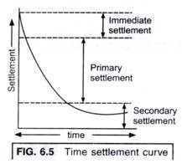

Figure 11. Time - settlement curve

SectionA-A SectionB-B

Cα = 0.73 x 0.05= 0.0365 Cα = 0.17 x 0.05= 0.0085

Ss = $\frac{0.0365}{1+1.81}$ x 18 x log5= 0.163 m Ss = $\frac{0.0085}{1+0.84}$ x 5 x log5= 0.016 m

Ss = 16.3 cm Ss = 1.6 cm

Considering immediate, consolidation and secondary settlement results, ground improvement is recommend for the sea bed.

**Foundation System**

The soil conditions under the piers of designed bridge are not suitable for heavy loads, therefore pile foundations should be used. Raft foundation is not desirable due to bridge piers are not far away from each other and pile foundations are more economical solution rather than it. The dimensions of pile foundation are 5x5x1 m. After that, bearing capacity and settlement values of the soil by using these dimensions.

**Bearing Capacity**

Bearing capacity of footings on clay is found by chart and formula of Skempton (1951).

qf = cu.Nc + γ.D

and

qall= F.S ≈ 2.5 - 3

SectionA-A SectionB-B

Nc = 6.52 Nc= 7.13

qf = 53 x 6.52 + 19.2 x 1 = 364.76 kPa qf = 81 x 7.13 + 19.6 x 10 = 773.53 kPa

qf = qult ≈ 365 kPa qf = qult ≈ 775 kPa

qall= = 121.67 kPa qall= = 258.33 kPa

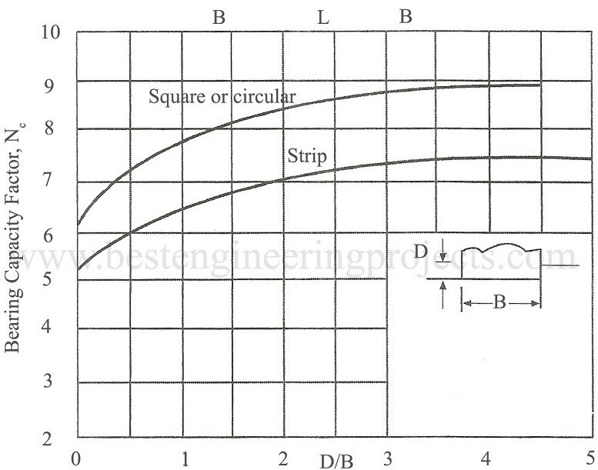

Figure 12. Skempton’s Nc Values

Birand, A., Ergun, U, & Erol, O. (n.d.). Foundation Engineering I Lecture Notes. Retrieved April, 2017

Mei, G. X., Yinî, L., Zai, J., & Zim, G. (2005). Immediate settlement is an integral part of the final settlement of a foundation resting on a clay soil. p. 109-113. Retrieved April 4, 2017.

Principles of Foundation Engineering, SI Seventh Edition BRAJA M. DAS