Table of Contents

Introduction 2

Question 1 2

Question 2 3

Question 3 4

Question 4 4

Question 5 4

Question 6 4

Question 7 5

# **Introduction**

This report is prepared for the solutions of the assigned problems in the Homework 1.

# **Question 1**

Table : Sieve Analysis

|  |  |  |  |  |  |
| --- | --- | --- | --- | --- | --- |
| Sieve Size (mm) | Mass Retained (gr) | Cumulative Mass Retained | Cumulative Retained % | Percent Mass |  |
| 2 | 0 | 0 | 0 | 0 | 16.7 (sand) |
| 1 | 0 | 0 | 0 | 0 |
| 0.5 | 5 | 5 | 4.90 | 4.9 |
| 0.25 | 4 | 9 | 8.82 | 3.9 |
| 0.1 | 8 | 17 | 16.67 | 7.8 |
| 0.05 | 15 | 32 | 31.37 | 14.7 | 44.1 (silt) |
| 0.002 | 30 | 62 | 60.78 | 29.4 |
|  | 40 | 102 | 100.00 | 39.2 | 39.2 (clay) |

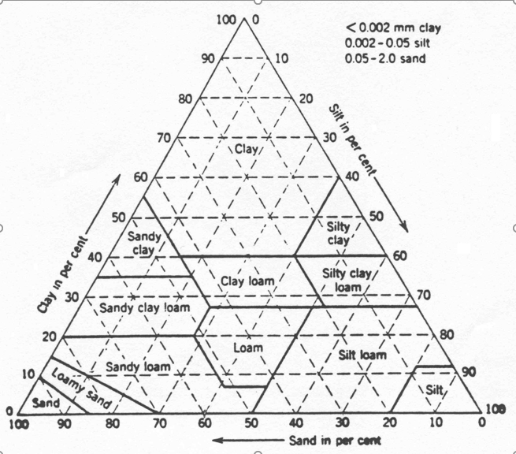

According to Figure 1, it is a ***Silty Clay Loam***.

Figure :Textural Chart

# **Question 2**

$$mass of wet soil{ m}_{w}=156.68 gr$$

$$mass of dry soil{, m_{dry}=m}_{w}-m_{lost}=156.68-31.33=125.35 gr$$

Moisture Content by mass basis

$$θ_{m}=\frac{{ m}_{w}-m_{dry}}{m_{dry}}=\frac{156.68-125.35}{125.35}=0.25$$

Bulk mass density

$$ρ_{b}=\frac{Weight of dry soil}{Volume of tube}$$

$$ρ_{b}=\frac{125.35}{\frac{π*5^{2}}{4}*5}=1.28 \frac{g}{{cm}^{3}}$$

Moisture Content by volume and bulk density

$$θ_{v}=θ_{m}*ρ_{b}$$

$$θ_{v}=0.25*1.28=0.32$$

Porosity

$$n=1-\left(\frac{ρ_{b}}{ρ_{s}}\right)=1-\frac{1.28}{2.67}=0.52 which is 52 \%$$

# **Question 3**

Matrix potential of a soil with equivalent diameter of 0.0002 mm pores is asked.

$$ψ_{m}=-\frac{2*γ}{ρ*g*r}$$

Where $γ$**=0.073 N/m, $ρ$** is the density of water 1000 kg/m2 and is radius of the capillary zone 0.0001 mm.

$$ψ_{m}=-\frac{2*0.073}{1000*9.8*0.0001}=-0.14 bar$$

# **Question 4**

$$ψ_{m}=-0.33=-\frac{2*0.073}{1000*9.8*r}$$

$$radius=4.47*{10}^{-5} mm$$

$$diameter=2*4.47*{10}^{-5}=8.94*{10}^{-5} mm=0.0000894 mm$$

# **Question 5**

*Osmotic Potential, $φ_{0}=-R*T*c_{s}$*

$$ψ_{0}=-\frac{1}{3}=-8.314*T*c_{s}$$

$$c_{s}=\frac{1}{3*8.314*T}=\frac{0.04}{T}, we dont know the temperature$$

$$if we consider the temperature as 290 K, then c_{s}=\frac{0.04}{290}=1.38*{10}^{-4}\frac{moles}{{cm}^{3}}$$

# **Question 6**

Water potential at -1/3 bar ;

$$ψ=ψ_{g}+ψ_{m}+ψ_{0}+ψ_{n}$$

$$ψ=-\frac{1}{3}-8.314*290*2*{10}^{-4}=-0.82 bar$$

# **Question 7**