

MIDDLE EAST TECHNICAL UNIVERSITY

DEPARTMENT OF CIVIL ENGINEERING

CE420- IRRIGATION AND DRAINAGE

Design Homework

Instructor

Assoc. Prof. Dr. Yakup DARAMA

Prepared by

08.05.2018

**TABLE OF CONTENT**

Introduction……………………………………………………………………………….…...3

Calculation………………………………………….………………………………….……...4

Discussion………………………………………………………………………………….....15

Conclusion……………………………………………………………………………….…...16

References……………………………………………………………………….…………....17

**INTRODUCTION**

In this design homework, designer should try to find consumptive water requirement by using Blaney-Criddle method and then find the capacity of irrigation canals at points A, B, C and D. After obtaining discharge values, optimum dimensions of main and secondary irrigation canals should be calculated and compared water depths with critical depths. Also maximum-minimum water velocities should be controlled. Lastly, irrigation frequency and duration of irrigation need to be determined. The capacity of the main canal after distributing the irrigation water requirements of secondary canals S1 and S2 is 1 m3/s. The area lies at a latitude 360 in the northern hemisphere. The aerial crop distribution in the project area is 50% tomatoes and 50% potatoes. The overall efficiency is 60% and the average root zone depth is 1.0 m with during June, July and August. In these months, effective precipitation are 15 mm, 10 mm and 5 mm and mean temperatures are 20oC, 25oC and 28oC, respectively. According to the given information, field capacity (FC) is 0.32, the permanent wilting point (PWP) is 0.12, deep percolation losses is 25% and infiltration capacity is equal to the 90% of the maximum daily average value of the consumptive use determined by Blaney-Criddle method.



Main Canal (S0=0.0004, n=0.016, z=1.5)

(S1=0.0006, n=0.016, z=1.5)

(S2=0.0006, n=0.016, z=1.5)

A

B

Q=1.0m3/s

Diversion

T1-2

T2-1

D

T2-2

50 ha

50 ha

50 ha

Boundary of

irrigation field

S2

T1-4

T2-3

T2-4

50 ha

50 ha

50 ha

Collector

T1-5

T1-6

T2-5

T2-6

River

50 ha

50 ha

50 ha

50 ha

Collector

T1-3

50 ha

S1

T1-1

50 ha

C

**Figure 1.** Preliminary layout of irrigation-drainage network

**CALCULATION**

1. **Capacities of Irrigation Canals**

**Table 1.** The values of k in the Blaney- Criddle formula

|  |  |  |  |  |  |  |  |  |  |  |
| --- | --- | --- | --- | --- | --- | --- | --- | --- | --- | --- |
| Crop | k1 | k2 values: Monthly consumptive use coefficient as % of seasonal coefficient k1 | | | | | | | | |
| March | April | May | June | July | Aug. | Sept. | Oct. | Nov. |
| Alfalfa | 0.85 | 70 | 120 | 108 | 114 | 125 | 113 | 108 | 68 | 70 |
| Corn | 0.8 |  |  |  | 46 | 146 | 162 | 100 | 38 |  |
| Cotton | 0.65 |  |  | 45 | 75 | 100 | 130 | 150 |  |  |
| Beans | 0.65 |  |  |  | 37 | 70 | 165 | 127 |  |  |
| Potatoes | 0.7 |  |  |  | 75 | 85 | 140 | 110 |  |  |
| Grass, Hay | 0.75 | 44 | 100 | 116 | 132 | 124 | 128 | 128 | 88 | 56 |
| Pasture | 0.6 | 93 | 182 | 100 | 98 | 100 | 93 | 93 | 145 | 93 |
| Citrus tree |  |  |  |  |  |  |  |  |  |  |
| Deciduous t. | 0.65 | 29 | 94 | 102 | 154 | 148 | 114 | 90 | 75 | 65 |
| Cereals | 0.8 | 102 | 153 | 118 | 24 |  |  |  |  |  |
| Small grain | 0.75 | 102 | 153 | 118 | 24 |  |  |  |  |  |
| Sugar beet | 0.7 | 53 | 75 | 153 | 242 | 192 | 100 | 42 | 38 | 8 |
| Rice | 1.1 |  | 30 | 125 | 133 | 131 | 135 | 48 |  |  |
| Tomatoes | 0.6 |  |  |  | 32 | 70 | 122 | 115 | 140 |  |

k: monthly consumptive use coefficient =f (crop type, temp)

k =k1* k2 where k1 is seasonal and k2 is monthly coefficient

**Table 2.** P values: % daytime hours in the Blaney- Criddle formula

|  |  |  |  |  |  |  |  |  |
| --- | --- | --- | --- | --- | --- | --- | --- | --- |
| Month | Latitudes (in northern hemisphere) | | | | | | | |
| 240 260 280 300 320 340 | | | | | | 360 | 380 |
| January | 7.58 | 7.49 | 7.4 | 7.3 | 7.2 | 7.1 | 6.99 | 6.87 |
| February | 7.17 | 7.12 | 7.07 | 7.03 | 6.06 | 6.91 | 6.86 | 6.76 |
| March | 8.4 | 8.4 | 8.39 | 8.38 | 8.37 | 8.36 | 8.35 | 8.34 |
| April | 8.6 | 8.64 | 9.68 | 8.72 | 8.75 | 8.8 | 8.85 | 8.9 |
| May | 9.3 | 9.38 | 9.46 | 9.53 | 9.63 | 9.72 | 9.81 | 9.92 |
| June | 9.2 | 9.3 | 9.38 | 9.49 | 9.6 | 9.7 | 9.83 | 9.95 |
| July | 9.41 | 9.49 | 9.58 | 9.67 | 9.77 | 9.88 | 9.99 | 10.1 |
| August | 9.05 | 9.1 | 9.16 | 9.22 | 9.28 | 9.33 | 9.4 | 9.47 |
| September | 8.31 | 8.31 | 8.32 | 8.34 | 8.34 | 8.36 | 8.36 | 8.38 |
| October | 8.09 | 8.06 | 8.02 | 7.99 | 7.93 | 7.9 | 7.85 | 7.8 |
| November | 7.43 | 7.36 | 7.27 | 7.19 | 7.11 | 7.02 | 6.92 | 6.82 |
| December | 7.46 | 7.35 | 7.27 | 7.14 | 7.05 | 6.92 | 6.79 | 6.66 |

P: monthly daytime hours / annual daytime hours

u = 25.4 * k * f 𝑓 = $\frac{(1.8t+32)}{100}*P$

u: monthly ET in mm

f: climatic factor

t: mean monthly temperature in 0C

**June**

* For Tomatoes,

*k = 0.60* 0.32= 0.19*

*f =* ***{****(1.8* 20 + 32) / 100}* 9.83= 6.684*

*u = 25.4 * 0.19 * 6.684= 32.3 mm/month*

*𝐶𝐼𝑅 = 0.5 ∗ (𝑈𝑡𝑜𝑚𝑎𝑡𝑜𝑒𝑠 − 𝑃𝑒𝑓𝑓)*

*= 0.5 ∗ ((32.3 − 15) = 8.7 𝑚𝑚/𝑚𝑜𝑛𝑡ℎ*

*𝑇𝐷𝑅 = 𝐶𝐼𝑅/𝑒 = 8.7/ 0.6 = 14.5 𝑚𝑚/𝑚𝑜𝑛𝑡ℎ*

* For Potatoes,

*k = 0.70* 0.75= 0.525*

*f =* ***{****(1.8* 20 + 32) / 100}* 9.83= 6.684*

*u = 25.4 * 0.525* 6.684= 89.1 mm/month*

*𝐶𝐼𝑅 = 0.5 ∗ (𝑈pot𝑎𝑡𝑜𝑒𝑠 − 𝑃𝑒𝑓𝑓)*

*= 0.5 ∗ ((89.1 − 15) = 37.1 𝑚𝑚/𝑚𝑜𝑛𝑡ℎ*

*𝑇𝐷𝑅 = 𝐶𝐼𝑅/𝑒 = 37.1/ 0.6 = 61.8 𝑚𝑚/𝑚𝑜𝑛𝑡ℎ*

*∑ 𝑇𝐷𝑅 = 76.3 𝑚𝑚/𝑚𝑜𝑛𝑡ℎ*

*𝑞𝑚𝑎𝑥 = (76.3* 10000)/ (30* 86400) = 0.29 𝑙𝑡/𝑠/ℎ𝑎*

**July**

* For Tomatoes,

*k = 0.60* 0.70= 0.42*

*f =* ***{****(1.8* 25 + 32) / 100}* 9.99= 7.692*

*u = 25.4 * 0.42 * 7.692= 82.1 mm/month*

*𝐶𝐼𝑅 = 0.5 ∗ (𝑈𝑡𝑜𝑚𝑎𝑡𝑜𝑒𝑠 − 𝑃𝑒𝑓𝑓)*

*= 0.5 ∗ ((82.1− 10) = 36.1 𝑚𝑚/𝑚𝑜𝑛𝑡ℎ*

*𝑇𝐷𝑅 = 𝐶𝐼𝑅/𝑒 = 36.1/ 0.6 = 60.2 𝑚𝑚/𝑚𝑜𝑛𝑡ℎ*

* For Potatoes,

*k = 0.70* 0.85= 0.595*

*f =* ***{****(1.8* 25 + 32) / 100}* 9.99= 7.692*

*u = 25.4 * 0.595* 7.692= 116.3 mm/month*

*𝐶𝐼𝑅 = 0.5 ∗ (𝑈pot𝑎𝑡𝑜𝑒𝑠 − 𝑃𝑒𝑓𝑓)*

*= 0.5 ∗ ((116.3 − 10) = 53.2 𝑚𝑚/𝑚𝑜𝑛𝑡ℎ*

*𝑇𝐷𝑅 = 𝐶𝐼𝑅/𝑒 = 53.2/ 0.6 = 88.7 𝑚𝑚/𝑚𝑜𝑛𝑡ℎ*

*∑ 𝑇𝐷𝑅 = 148.9 𝑚𝑚/𝑚𝑜𝑛𝑡ℎ*

*𝑞𝑚𝑎𝑥 = (148.9* 10000)/ (30* 86400) = 0.56 𝑙𝑡/𝑠/ℎ𝑎*

**August**

* For Tomatoes,

*k = 0.60* 1.22= 0.732*

*f =* ***{****(1.8* 28 + 32) / 100}* 9.40= 7.746*

*u = 25.4 * 0.732* 7.746=* ***144.0 mm/month***

*𝐶𝐼𝑅 = 0.5 ∗ (𝑈𝑡𝑜𝑚𝑎𝑡𝑜𝑒𝑠 − 𝑃𝑒𝑓𝑓)*

*= 0.5 ∗ ((144.0 − 5) = 69.5 𝑚𝑚/𝑚𝑜𝑛𝑡ℎ*

*𝑇𝐷𝑅 = 𝐶𝐼𝑅/𝑒 = 69.5/ 0.6 = 115.8 𝑚𝑚/𝑚𝑜𝑛𝑡ℎ*

* For Potatoes,

*k = 0.70* 1.40= 0.98*

*f =* ***{****(1.8* 28 + 32) / 100}* 9.40= 7.746*

*u = 25.4 * 0.98* 7.746=* ***192.8******mm/month***

*𝐶𝐼𝑅 = 0.5 ∗ (𝑈pot𝑎𝑡𝑜𝑒𝑠 − 𝑃𝑒𝑓𝑓)*

*= 0.5 ∗ ((192.8− 5) = 93.9 𝑚𝑚/𝑚𝑜𝑛𝑡ℎ*

*𝑇𝐷𝑅 = 𝐶𝐼𝑅/𝑒 = 93.9/ 0.6= 156.5 𝑚𝑚/𝑚𝑜𝑛𝑡ℎ*

*∑ 𝑇𝐷𝑅 = 272.3 𝑚𝑚/𝑚𝑜𝑛𝑡ℎ*

*𝑞𝑚𝑎𝑥 = (272.3* 10000)/ (30* 86400) =* ***1.02 𝑙𝑡/𝑠/ℎ𝑎***

**Table 3.** All values obtained while trying to find the irrigation modulus

|  |  |  |  |  |  |  |  |
| --- | --- | --- | --- | --- | --- | --- | --- |
|  | **JUNE** | | **JULY** | | **AUGUST** | | |
| **Tomatoes** | **Potatoes** | **Tomatoes** | **Potatoes** | **Tomatoes** | **Potatoes** | |
| **k1** | 0.60 | 0.70 | 0.60 | 0.70 | 0.60 | 0.70 | |
| **k2** | 0.32 | 0.75 | 0.70 | 0.85 | 1.22 | 1.40 | |
| **k** | 0.19 | 0.525 | 0.42 | 0.595 | 0.732 | 0.98 | |
| **t (0C)** | 20 | | 25 | | 28 | | |
| **P** | 9.83 | | 9.99 | | 9.40 | | |
| **f** | 6.684 | | 7.692 | | 7.746 | | |
| **uc (mm/mo)** | 32.3 | 89.1 | 82.1 | 116.3 | **144.0** | | **192.8** |
| **Peff (mm/mo)** | 15 | | 10 | | 5 | | |
| **% A** | 0.5 | | 0.5 | | 0.5 | | |
| **CIR** | 8.7 | 37.1 | 36.1 | 53.2 | 69.5 | | 93.9 |
| **TDR = CIR/e** | 14.5 | 61.8 | 60.2 | 88.7 | 115.8 | | 156.5 |
| **TDR (mm/mo)** | 76.3 | | 148.9 | | 272.3 | | |
| **qmax (l/s/ha)** | 0.29 | | 0.56 | | ***1.02*** | | |

Irrigation Modulus, qmax= 1.02 l/s/ha

𝑄= 𝐴 ∗ 𝐹 ∗ 𝑞𝑚𝑎𝑥

Q: canal capacity (lt/s)

A: area (ha)

F: flexibility coefficient >1

qmax: irrigation modulus (lt/s/ha)

*𝑄 = 𝐴 ∗ 𝐹 ∗ 𝑞𝑚𝑎𝑥 + 𝑄𝑟𝑒𝑚𝑎𝑖𝑛𝑖𝑛𝑔*

*𝑄𝐴 = (600 ∗ 1.35 ∗ 1.02)/1000 + 1.0= 1.83 𝑚3/𝑠*

*𝑄𝐵 = (300 ∗ 1.64 ∗ 1.02)/1000 + 1.0= 1.50 𝑚3/𝑠*

*𝑄C = (200 ∗ 1.89 ∗ 1.02)/1000= 0.386 𝑚3/s*

*𝑄𝐷 = (100 ∗ 2.15 ∗ 1.02)/1000= 0.219 𝑚3/s*

**Table 4.** Capacity of irrigation canals at points A, B, C and D

|  |  |  |  |  |  |  |
| --- | --- | --- | --- | --- | --- | --- |
| **POINT** | **AREA**  **(ha)** | **F** | **qmax** | **Q**  **(lt/s)** | **QSD**  **(m3/s)** | **QDesign (m3/s)** |
| **A** | 600 | 1.35 | 1.02 | 826.2 | 1.0 | ***1.83*** |
| **B** | 300 | 1.64 | 1.02 | 501.8 | 1.0 | ***1.50*** |
| **C** | 200 | 1.89 | 1.02 | 385.6 | - | ***0.386*** |
| **D** | 100 | 2.15 | 1.02 | 219.3 | - | ***0.219*** |

1. **Optimum** **Dimensions of Main and Secondary Irrigation Canals at Points A, B, C, and D**

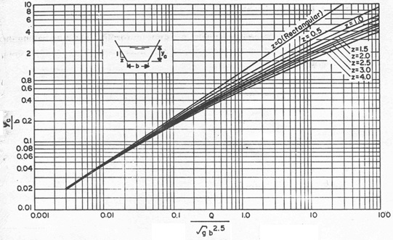

**Figure 2.** Critical depth in a trapezoidal canal

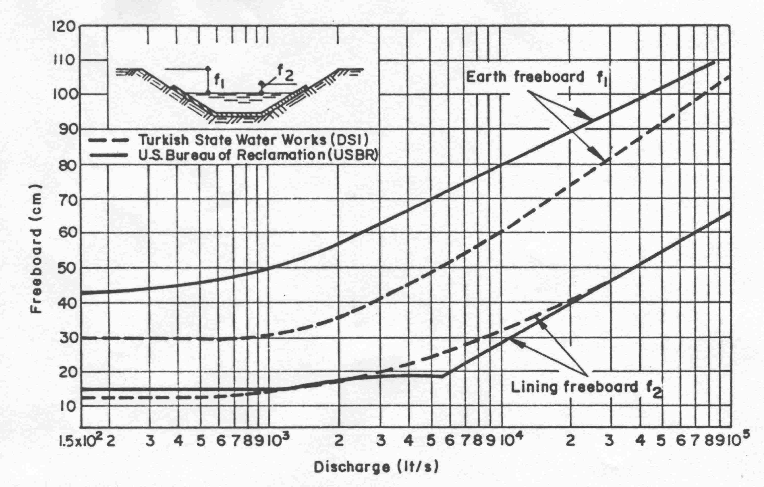

**Figure 3.** Recommended freeboards for canals

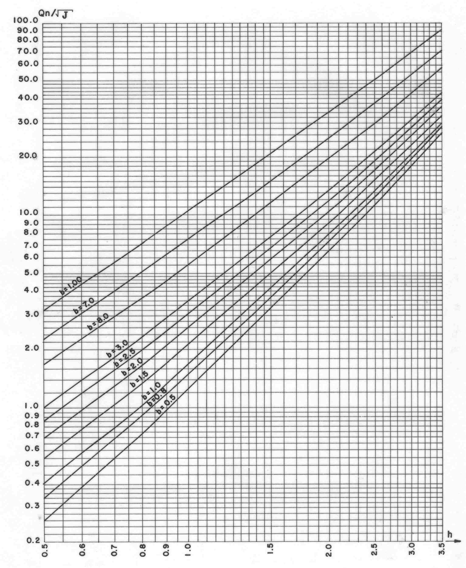

**Figure 4.** Manning Diagram for 1/1.5 Side Slope (y=0.1-0.6 m)

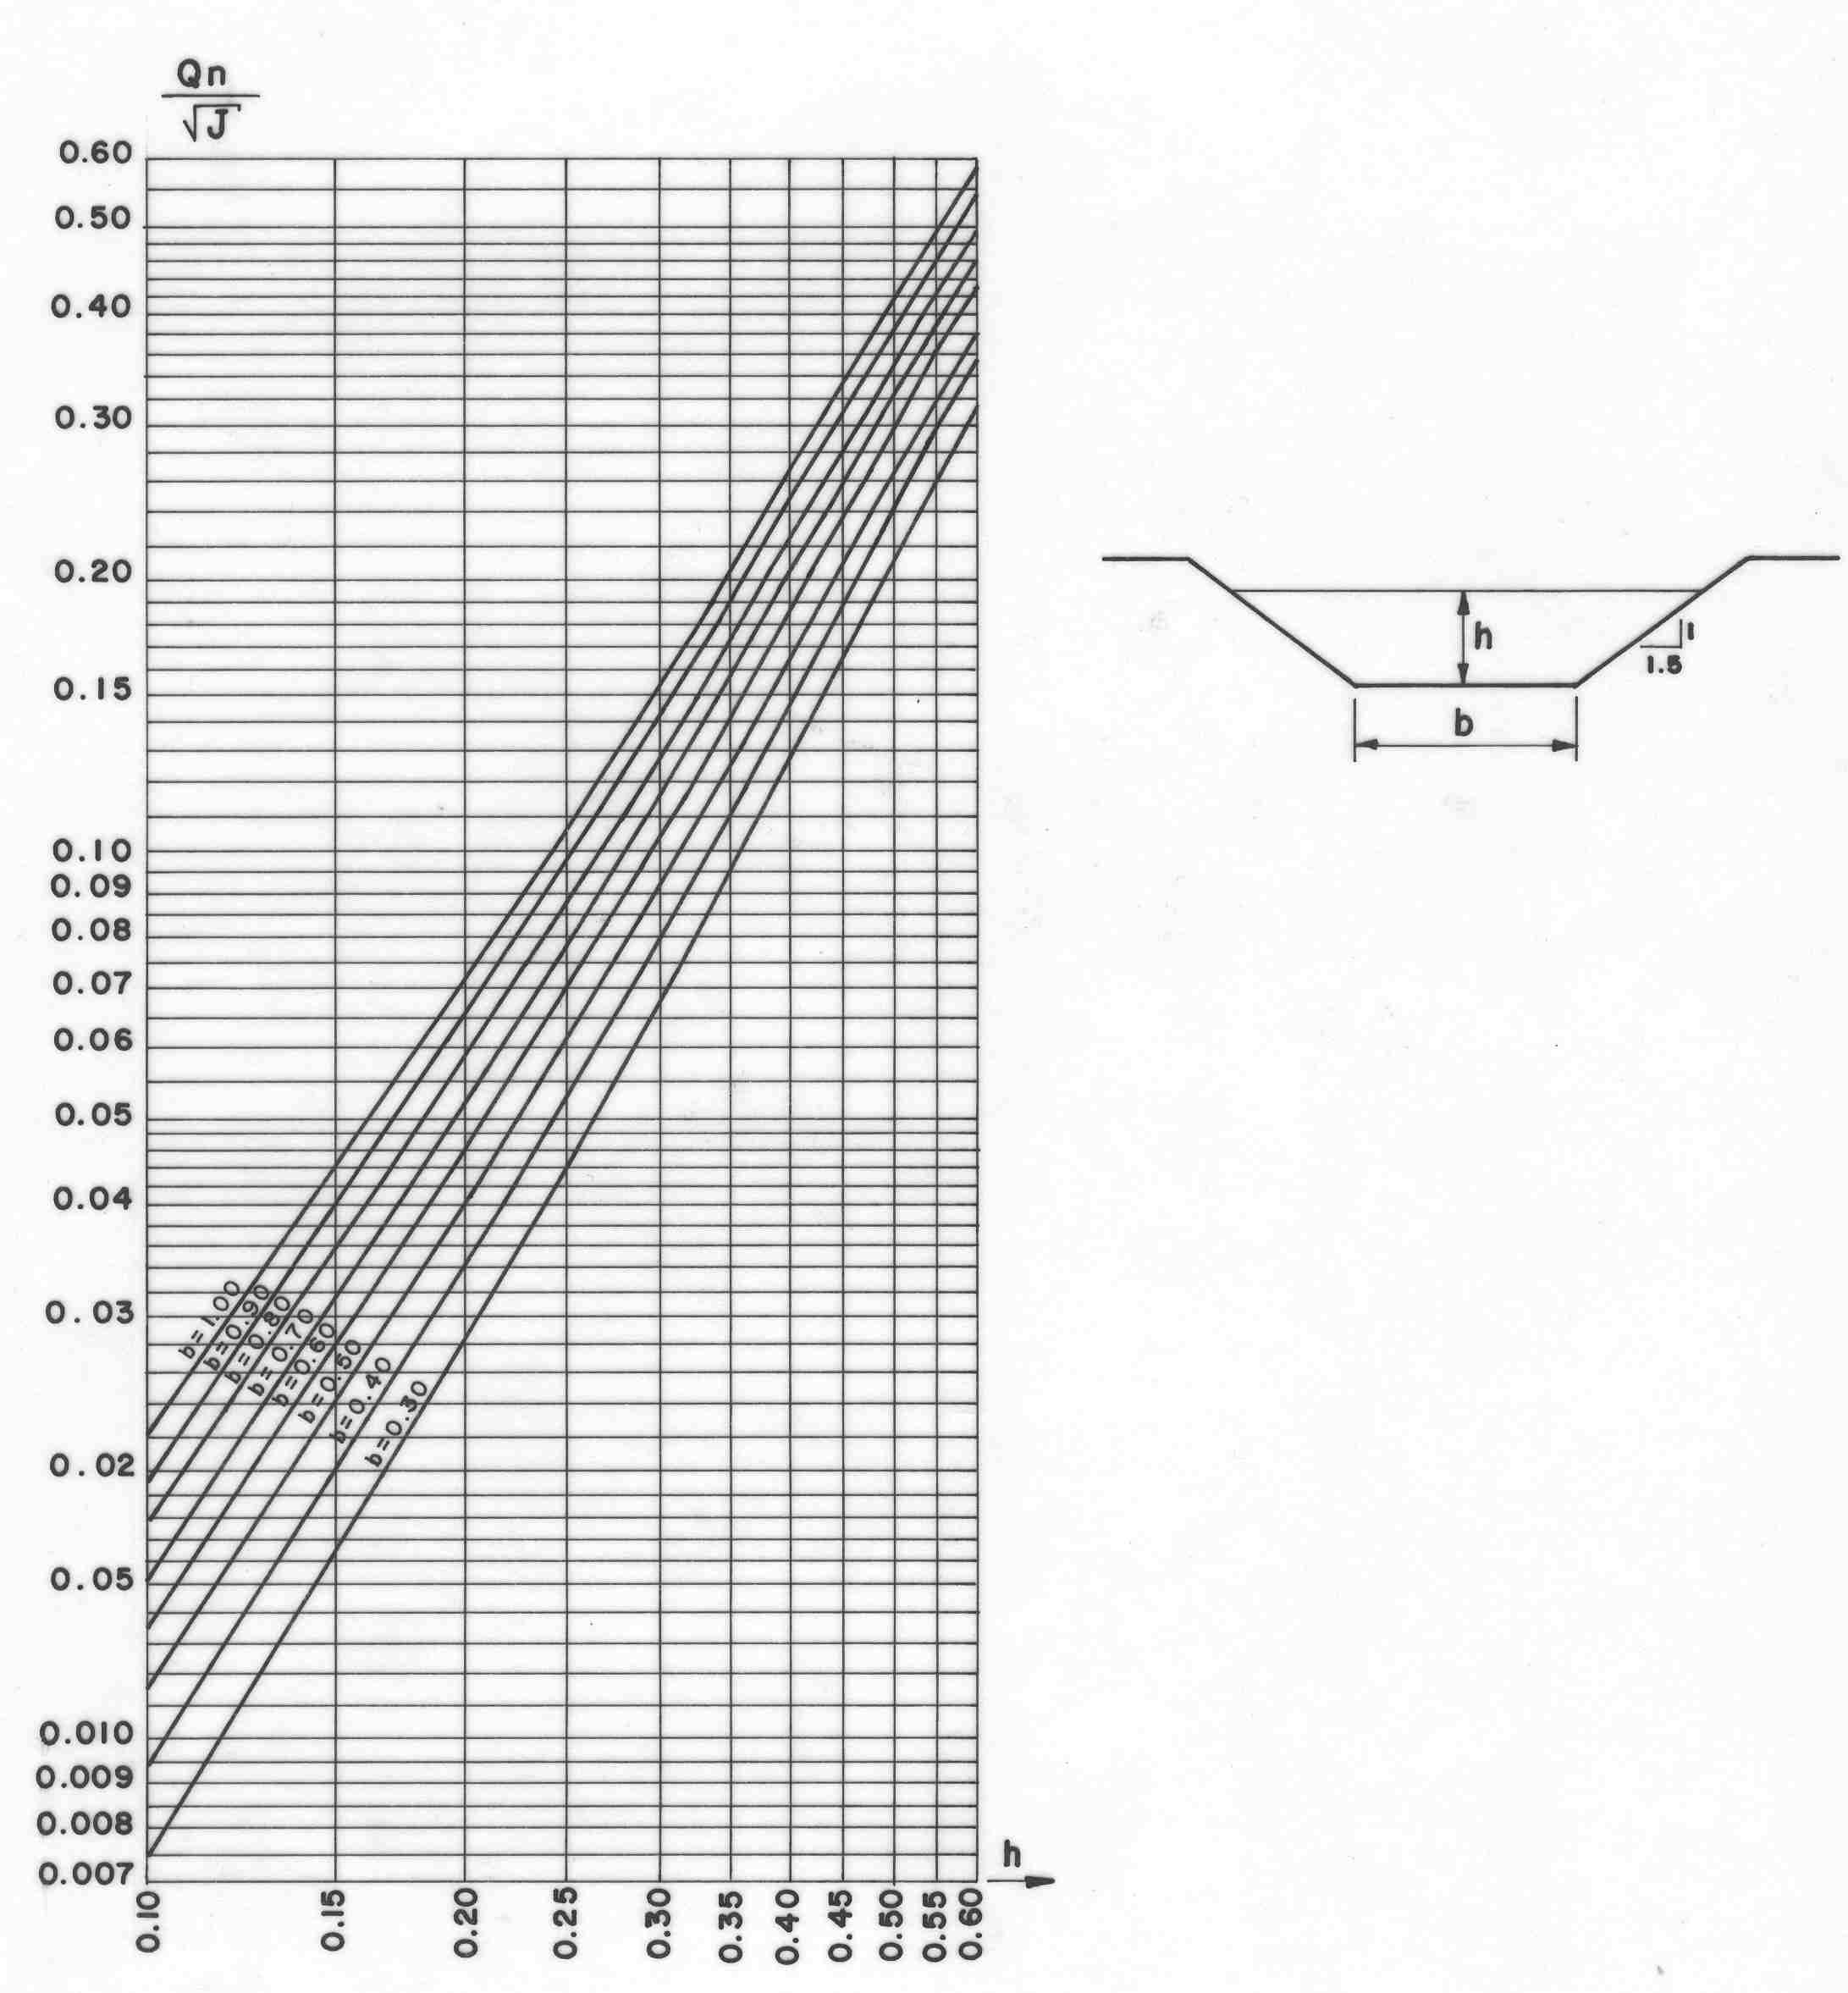

**Figure 5.** Manning Diagram for 1/1.5 Side Slope (y=0.1-0.6 m)

Manning Equation,

Q = (1/n)* A* R2/3* S01/2

AR2/3 = n* Q/ (S0)1/2 A = by + zy2 W = b + 2y*(1+z2)1/2 R = A / W

AR2/3: section factor

b: bottom width

y: water depth

z: side inclination

W: wetted perimeter

yc: critical depth

* Point A

*AR2/3= 0.016* 1.83/ $\sqrt{0.0004}$ = 1.464*

*Choose y= 0.94 m and b= 1.0 m from* ***Figure 4***

*A= 1.0* 0.94+1.5* 0.942= 2.27 m2*

*U= = = 0.81 m/s*

*0.5<0.81<2.5 (OK.)*

*yc= 0.53 m from* ***Figure 2***

*0.94> 1.1* 0.53= 0.58 (OK.)*

f1: earth freeboard

f2: lining freeboard

*f1= 55 cm & f2= 18 cm according to curved lines of USBR from* ***Figure 3***

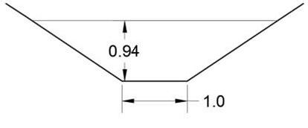

**Figure 6.** Cross section at point A

* Point B

*AR2/3= 0.016* 1.50/ $\sqrt{0.0004}$ = 1.200*

*Choose y= 0.86 m and b= 1.0 m from* ***Figure 4***

*A= 1.0* 0.86+1.5* 0.862= 1.97 m2*

*U= = = 0.76 m/s*

*0.5<0.76<2.5 (OK.)*

*yc= 0.50 m from* ***Figure 2***

*0.86> 1.1* 0.50= 0.55 (OK.)*

f1: earth freeboard

f2: lining freeboard

*f1= 53 cm & f2= 16 cm according to curved lines of USBR from* ***Figure 3***

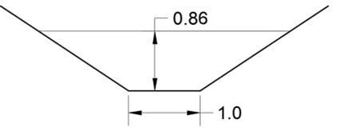

**Figure 7.** Cross section at point B

* Point C

*AR2/3= 0.016* 0.386/ $\sqrt{0.0006}$ = 0.252*

*Choose y= 0.49 m and b= 0.5 m from* ***Figure 4***

*A= 0.5* 0.49+1.5* 0.492= 0.61 m2*

*U= = = 0.64 m/s*

*0.5<0.64<2.5 (OK.)*

*yc= 0.30 m from* ***Figure 2***

*0.49> 1.1* 0.30= 0.33 (OK.)*

f1: earth freeboard

f2: lining freeboard

*f1= 44 cm & f2= 15 cm according to curved lines of USBR from* ***Figure 3***

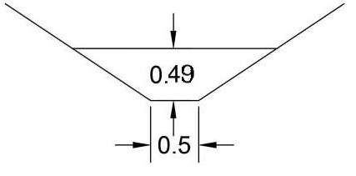

**Figure 8.** Cross section at point C

* Point D

*AR2/3= 0.016* 0.219/ $\sqrt{0.0006}$ = 0.143*

*Choose y= 0.38 m and b= 0.5 m from* ***Figure 4***

*A= 0.5* 0.38+1.5* 0.382= 0.41 m2*

*U= = = 0.54 m/s*

*0.5<0.54<2.5 (OK.)*

*yc= 0.21 m from* ***Figure 2***

*0.38> 1.1* 0.21= 0.23 (OK.)*

f1: earth freeboard

f2: lining freeboard

*f1= 43 cm & f2= 15 cm according to curved lines of USBR from* ***Figure 3***

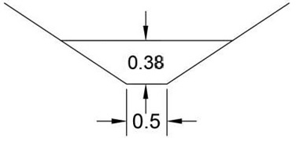

**Figure 9.** Cross section at point D

**Table 4.** All values obtained while trying to find dimensions of canals at points A, B, C, and D

|  |  |  |  |  |  |  |  |
| --- | --- | --- | --- | --- | --- | --- | --- |
| **POINT** | **S0** | **n** | **Q** | **AR2/3=nQ/(S0)1/2** | **Water Depth, y**  **(m)** | **Bottom Width, b**  **(m)** | **Velocity U (m/s)** |
| **A** | 0.0004 | 0.016 | 1.83 | 1.464 | 0.94 | 1.0 | 0.81 |
| **B** | 0.0004 | 0.016 | 1.50 | 1.200 | 0.86 | 1.0 | 0.76 |
| **C** | 0.0006 | 0.016 | 0.386 | 0.252 | 0.49 | 0.5 | 0.64 |
| **D** | 0.0006 | 0.016 | 0.219 | 0.143 | 0.38 | 0.5 | 0.54 |

1. **Irrigation Frequency and Duration of Water Application**

 ,  , 

RAW: Readily available water

FC: Field capacity

PWP: Permanent wilting point

T: Irrigation frequency

*RAWmin = 0.75 * ((0.32-0.12) * 250)/0.4= 93.75 mm*

*uc,daily= 336.8/31= 10.9 mm/day (August average)*

*T= 93.75/10.9= 8.6 days ≈* ***9 days***

*tıa= (10.9* 9)/((1-0.25)* (0.9* 10.9))= 13.33 hrs ≈* ***13 hrs***

**DISCUSSION**

After analysing and summarizing textbook and lecture notes, I learned a lot of new things during the research/solving stage about design of classical irrigation-drainage network. To make this homework, I took advantage of courses named as CE372 Hydromechanics and CE378 Water Resources Engineering in addition to our course.

Agriculture is the process of working the soil, growing crops and breeding livestock to produce food and other necessary products, or economic gain. And there are a lot of factors that affect this agricultural production. Irrigation system is one of these factors, and has a vital role. Because of this, design of irrigation and drainage system is becoming important automatically.

In short, I inform how to follow a path for designing a classical irrigation-drainage network in the main body of this homework. There are many examples in irrigation industry that classical method is used for design phase. But not all of them can be told. In conclusion, using classical method is not must, but it becomes many things even more feasible.

**CONCLUSION**

In the first part, after calculating irrigation modulus of each month, the maximum one was chosen to find discharges at points A, B, C and D by using Blaney-Criddle method.

In the second part, optimum dimensions of main and secondary irrigation canals were determined. In the light of related graphs, freeboards values and critical depth that was ready to check water depth is acceptable in canals were found. And of course, water velocities are checked in reference to minimum and maximum limit values.

And in the final part, irrigation frequency and duration of water application during the irrigation season were found.

**REFERENCES**

1. Darama, Y., *Introduction to Irrigation and Drainage Engineering*, 3rd revised edition, Ankara, September 2009.
2. National Geographic Society. (2012, October 09). Agriculture. Retrieved from https://www.nationalgeographic.org/encyclopedia/agriculture/