**Homework II**

**Q1)** It will not be any settlement because surcharge change occurs immediately after.

**Q2)** **a)**

The Boussinesq equation is;

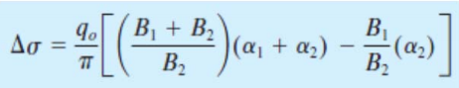 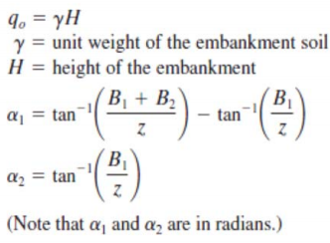

* In this equation, γ= 21 kN/m3 and H= 2 m→ q0= 21 kN/m3 x 2 m = 42 kPa
* The z value will be taken mid-depth of clay layer to use in Boussinesq equation.
* For given SPT-N values at the table, last two columns are added up for each line and its average are based on individually.
* 
* As can be seen in the formula of primary consolidation settlement, only having mv and Δδ is required for finding calculate in this question. But after applying this formula, we will get settlement according to oedometer test. To obtain real settlement, we need to multiply the result with the constant µ= 1.1
* So, the total settlement will be equal to 6.15 cm.
* After that, we assume a permeable layer under the bottom most clay layer, time factor for settlements can be easily calculated. The **Table.1.** shows the settlement of each three clay layer in different months. Then ,the degree of consolidation can be calculated for each month. In the **Table.1. ,** when we reach the 95% of settlement for each layer we should stop at that point.

At the below, there are tables which are used to solve problem on Excel.

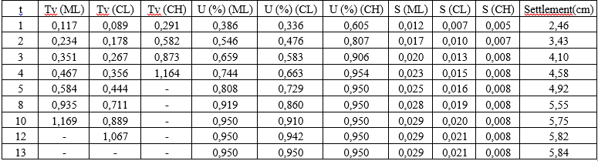

**Table.1.** Settlement of clay layer month by month.

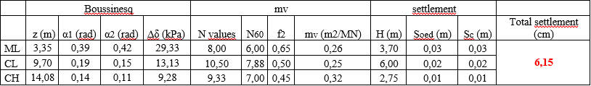

**Table.2.**Total settlement is calculated by the Boussinesq equation.

The graph of settlement vs. month is:

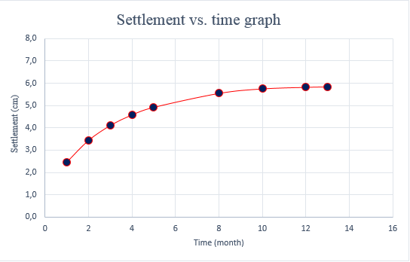

**Graph.1.**Settlement (cm) vs. Time (month) graph

**b)**