**CE464 GROUND IMPROVEMENT**

**HOMEWORK IV**

(My all input values can be shown at screenshots below.)

**Q.1)**

Step 1: Determine units to use.

Set the stress units = Metric, stress as kPa, and the settlement units = Meters.

Set the time units = Days and permeability units = meters / year.

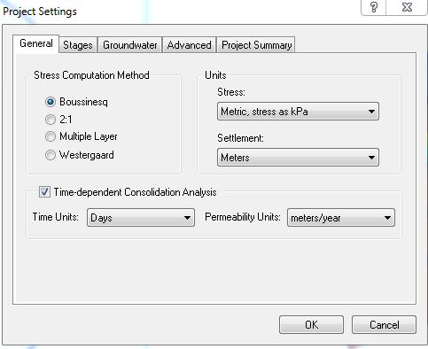

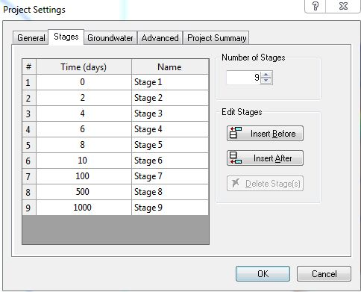Step 2: Set the stages.

Step 3: Define the load and load factors.

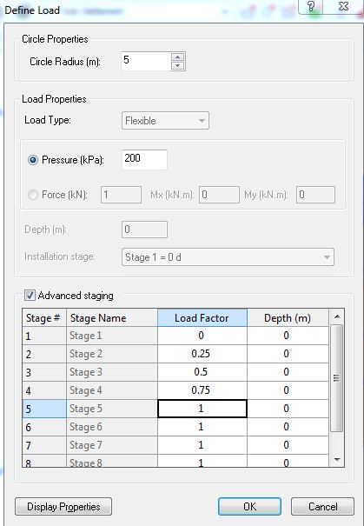

Step 4: Fill in the parameters of the Blue Clay.

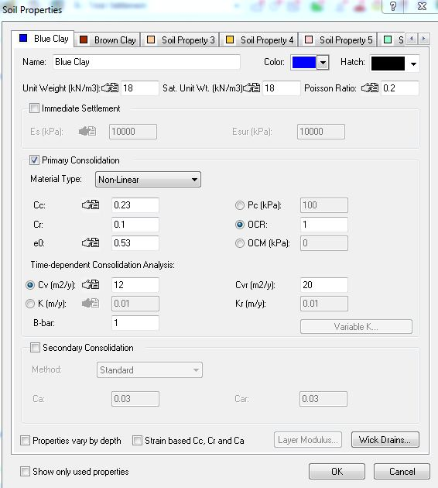

Step 5: Fill in the parameters of the Brown Clay.

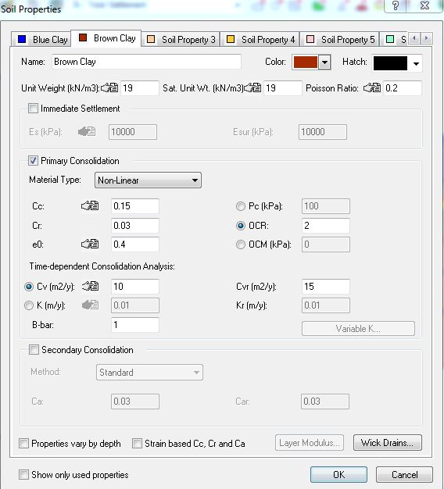

Step 6: Change the thickness and drainage conditions of the soil layers.

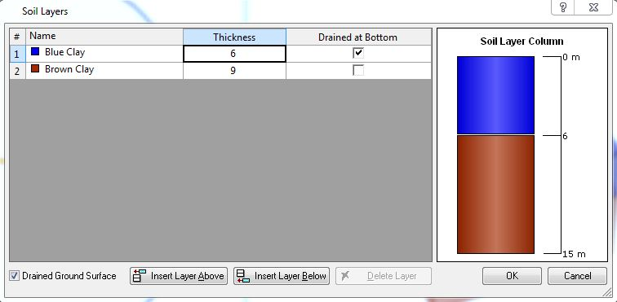

Part i - The plot of vertical stress increase under the center of the tank with depth, after the tank is constructed:

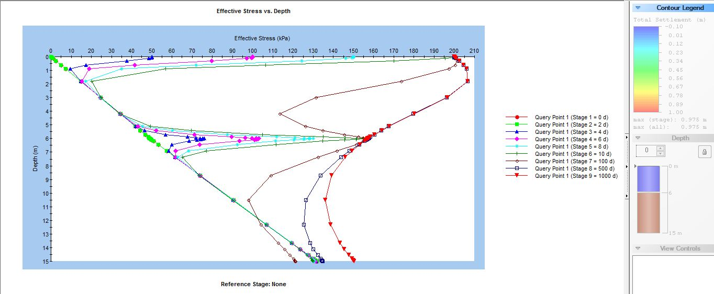

Part ii - The plot of settlement versus time at ground surface under the center of the tank:

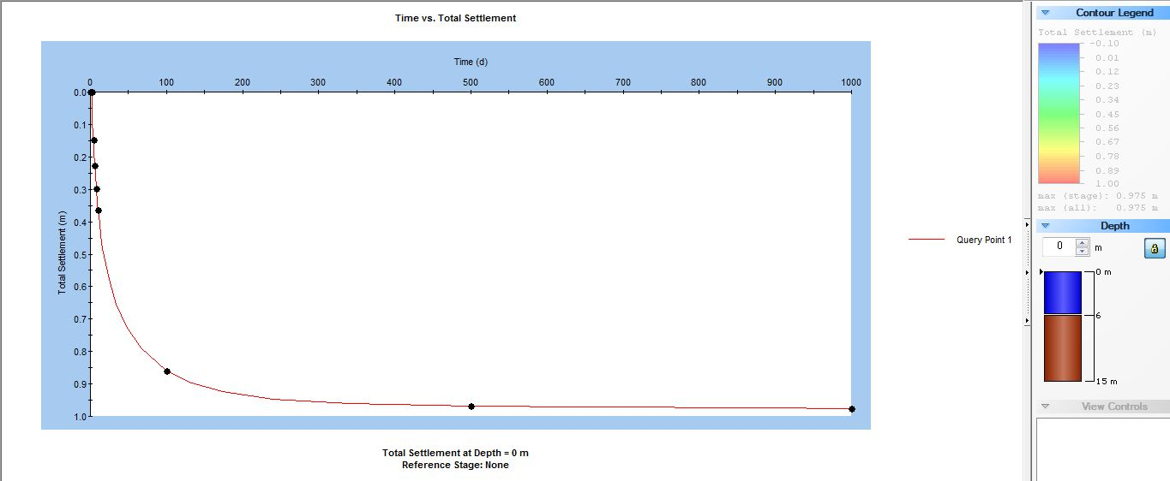

Part iii - The plot of degree of consolidation versus time:

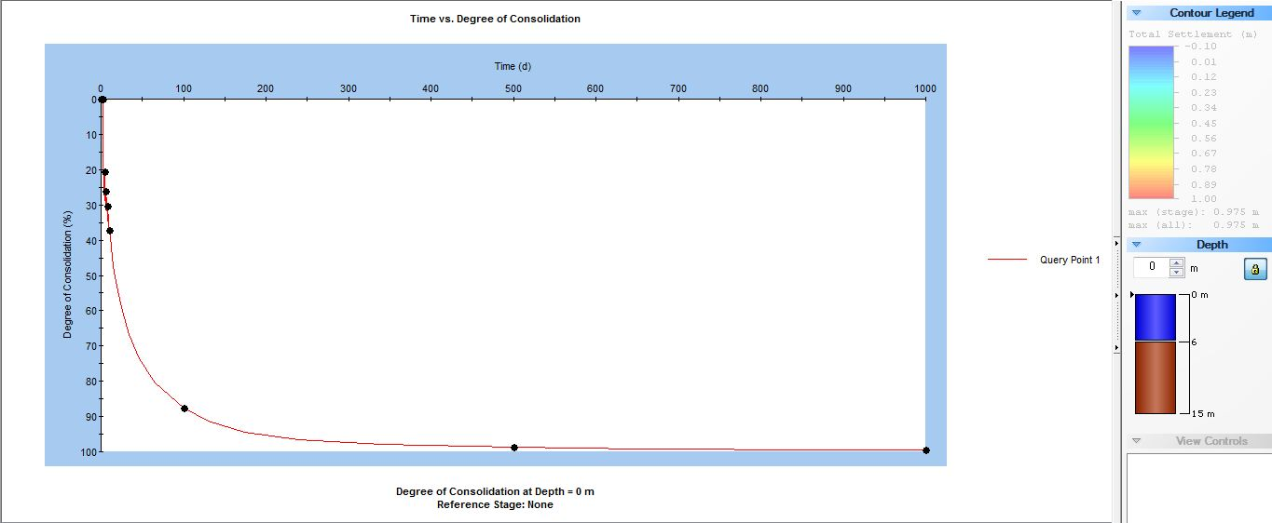

That plot is that when I imported data into excel:

The primary consolidation settlement expected under the tank → 0.975 meters

The time is needed for this settlement → 200 days

Part iv - The plot of excess pore water pressure with depth under the center of the tank at 4 different times:

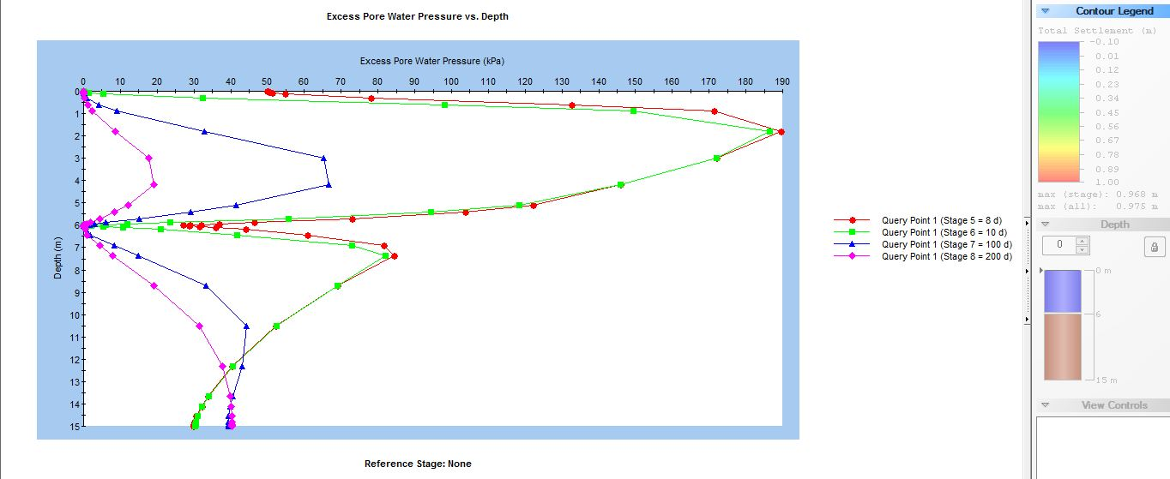

**Q.2)**

Part i – Design phase of prefabricated vertical drain system to be used with this fill:

* We cannot explicitly model an embankment of infinite length in Settle3D (e.g. if we wish to simulate a 2-dimensional plane strain analysis). To simulate an embankment of "infinite" length in Settle3D, simply define a length which is sufficient to avoid the 3-dimensional end effects of the embankment load, at the measurement point of interest.
* Set the number of layers to 7 and the base width to 120 m.
* For layer 0, change the stage to “Stage 1 = 0 d” and the height to 0 m. For layer 2, change the stage to “Stage 2 = 1 d” and the height to 0.5 m. For layer 3, set the stage to “Stage 3 = 2 d” and the height to 0.5 m again. In this manner, we complete that. From 1.5H:1V relationship, we obtain degree (tan-1 (⅔) = 33.7° ).

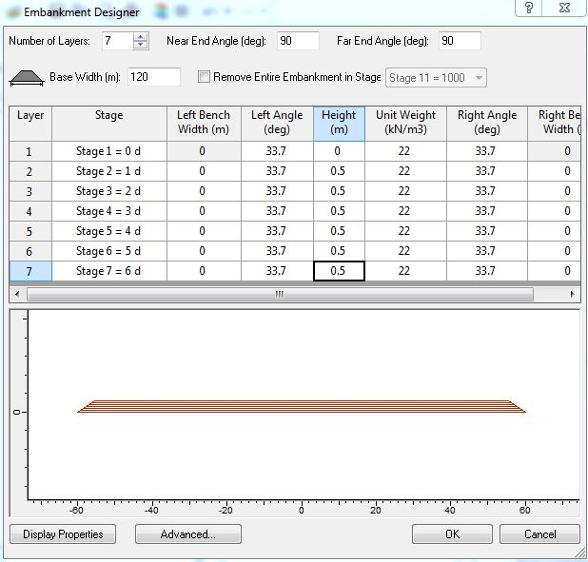

* Enter the following wick drain properties:

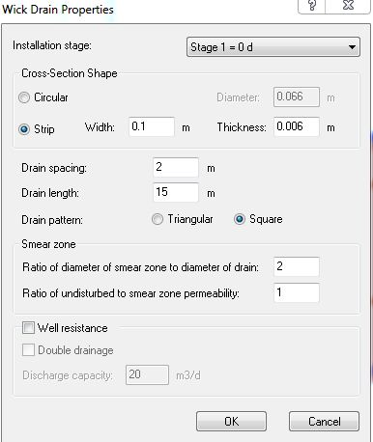

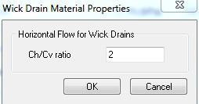

* As we can see below, it does not reach at least 70% of the settlement I calculated in part 1-iii in 4 months. (70% of total settlement = 0.70 * 0.975m = 0.6825m)

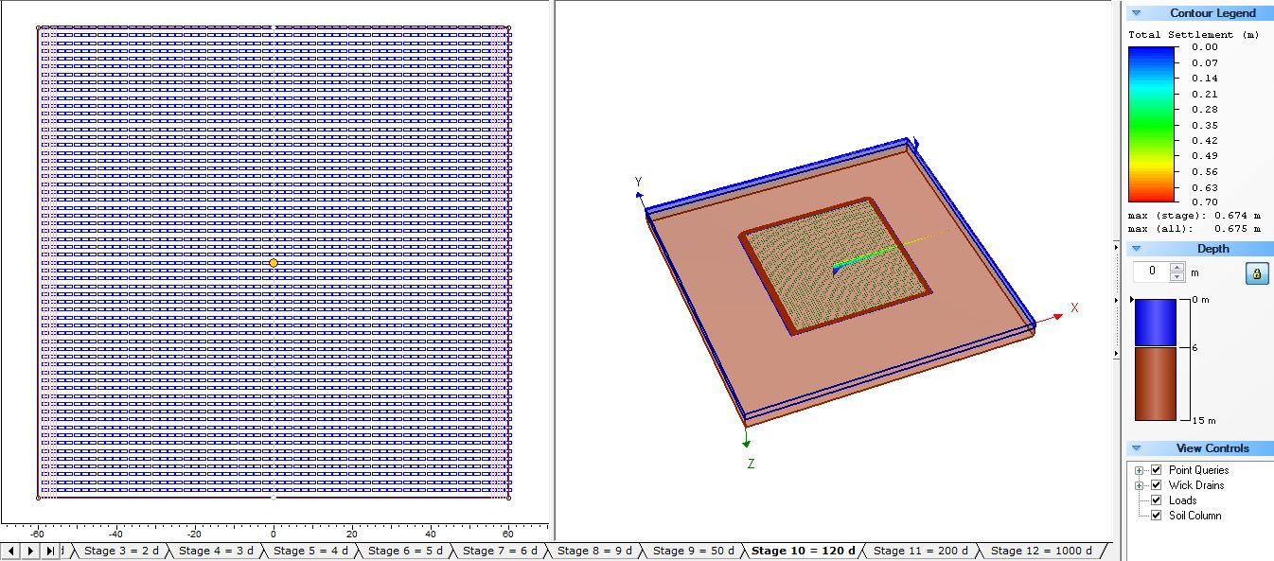

* To reach at least 70% of the settlement I calculated in part 1-iii in 4 months or less, I add new layer to embankment. Then I increase total settlement.

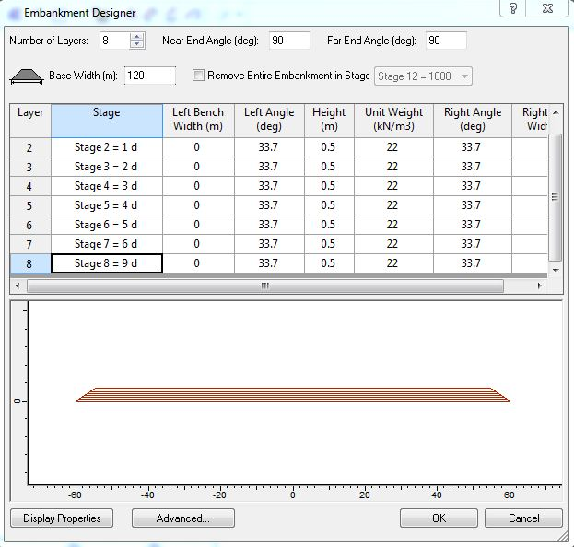

* It exceeds 70% of the settlement I calculated in part 1-iii in 4 months or less.

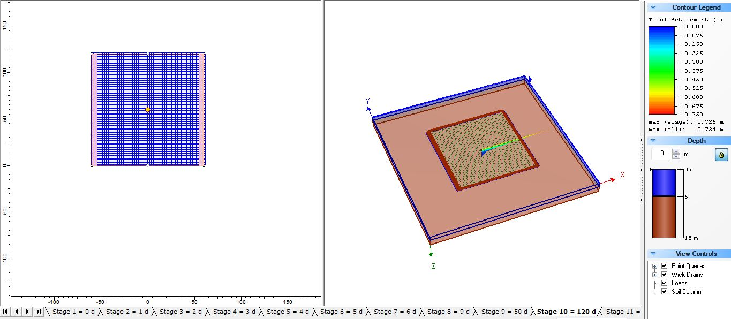

Part ii - The plot of time versus settlement at ground surface under the center of the wide embankment:

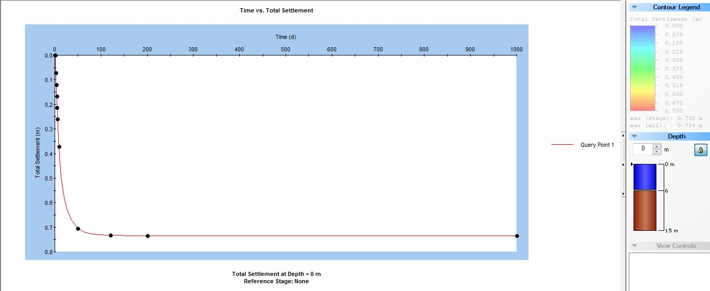

Part iii - The plot of excess pore water pressure with depth under the center of the wide embankment, at 4 different times:

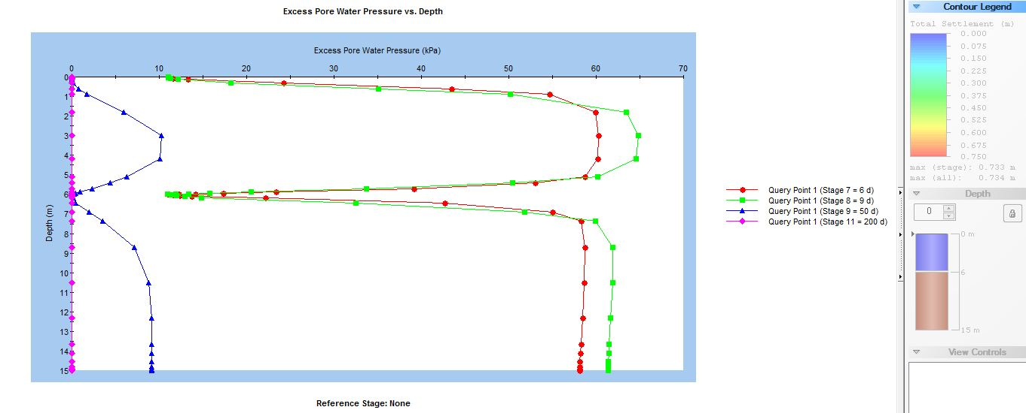

**CITATION**

(n.d.). Retrieved November 12, 2016, from https://www.rocscience.com/help/settle3d/webhelp4/pdf_files/tutorials/Tutorial_04_Wick_Drains.pdf

(n.d.). Retrieved November 12, 2016, from <https://www.rocscience.com/help/settle3d/webhelp/Settle3D/Add_Embankment.htm>