

**CE468: GEOTECHNICAL DESIGN TERM PROJECT**

**DATE: 02.01.2017**

**GROUP MEMBERS:**

**TABLE OF CONTENTS**

1. Introduction 1
2. Soil Profile & Soil Parameters 1
3. Preliminary Design 2
4. Final Design 3
5. Stability Check 5
6. Settlement Calculations 6
7. Pile Design 7
8. Conclusion 9

Appendices 10

**1) INTRODUCTION**

A road embankment is to be placed at the site after eliminating the top organic soil layer. Due to an existing nearby hospital building that located on the southern side of the embankment, a retaining system is to be constructed. The planned layout of the existing structures, road alignment and the location of the site investigation tests are shown in Figure below.

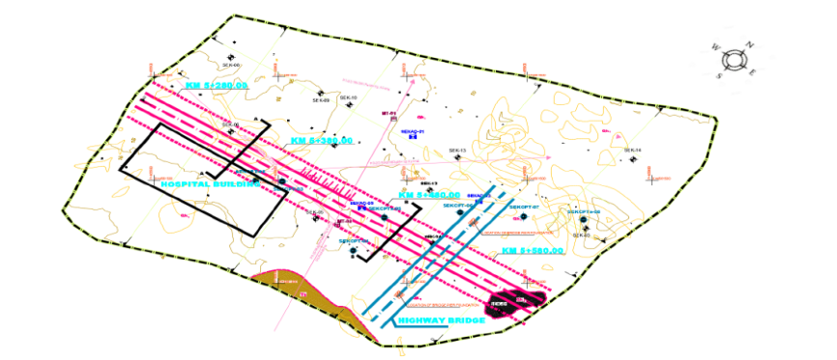

**Figure 1: Concstruction area and soil investigation layout plan**

**2) SOIL PROFILE&SOIL PARAMETERS**

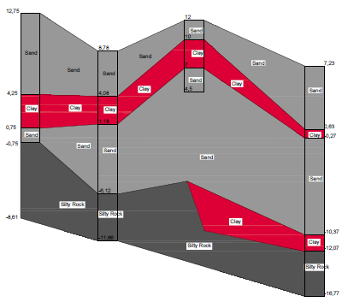

**Figure 2: Soil Profile**

*Soil Parameters:*

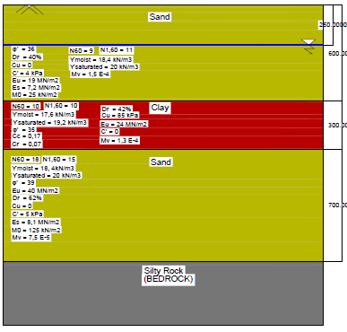

**Figure 3: Idealized Soil Profile and Soil Parameters**

|  |  |
| --- | --- |
| **Clayton (1993)** | |
| **SPT** | |
| ***Soil*** | **Soil Classification** |
| ***1- Sand*** | **Medium dense** |
| ***2- Clay*** | **Stiff** |
| ***3- Sand*** | **Medium dense** |

|  |  |
| --- | --- |
| **Briaud (1992)** | |
| **PMT** | |
| ***Soil*** | **Soil Type** |
| ***1- Sand*** | **Normally consolidated** |
| ***2- Clay*** | **Normally consolidated** |
| ***3- Sand*** | **Overconsolidated** |

**Table 1**

Our parameters chosen as followings;

For cu we use Fugra (2004) correlations which was an average and sufficient value. For unit weight of soil’s we use Çetin at all. (2016), since it correlation gave us direct unit weights. In order to find φ’, Schmertmann (1975) was chosen because it is both related with overburden pressure and CPT values. For Eu parameter Paulos & Small (2000) correlation is used. On the other hand, Es parameter we use mean value of FHWA (2002) and Kulhawy & Mayne (1990) is used. Coduta (2000) correlation is used for estimating relative density of soils. For mv value, Stroud (1974) is used. And finally, for M0, Lunne & Christopher is used.

**Values according to correlations of Cu,φ,Dr,Eu,Es,Mv, and Mo are given in appendix A.**

**3) PRELIMINARY DESIGN**

Selected dimensions are as following;

|  |  |
| --- | --- |
| **PREDESİGN 9**  **Figure 4: Preliminary Design** | **Width: 4500mm**  **Bottom Length: 700mm**  **Bottom Stem: 700mm**  **Top Stem: 300mm**  **Length: 6000mm**  **Toe: 1500mm**  **Bottom Stem : 700mm**  **Heel: 2300mm** |

|  |  |  |  |  |  |
| --- | --- | --- | --- | --- | --- |
| **Backfill Parameters** | | | **Surcharge** | **Active pressure (Triangular Dist. Load)** | |
| **ϒ (kN/m3)** | **φ ( ͦ)** | **Ka** | **q (kPa)** | **At 0 m depth** | **At 6,7 m depth** |
| **18** | **37** | **0.248292** | **15** | **3.724377147** | **33.66836941** |

**Table 2**

|  |  |  |  |  |  |  |  |  |  |
| --- | --- | --- | --- | --- | --- | --- | --- | --- | --- |
|  | **Soil Parameters** | | | | | | | | |
|  | **φ ( ͦ)** | **δ** | **N gama** | **Nq** | **Nc** | **ϒ (kN/m3)** | **c** | **qc** | **c\*** |
| **Sand** | **36** | **24** | **50** | **40** | **50** | **18.4** | **4** | **6** | **12.2** |
| **Clay** | **35** | **23.33333333** | **50** | **40** | **50** | **19.2** | **0** | **13** | **12.2** |

|  |  |  |
| --- | --- | --- |
| **OVERTURNING CHECK** | | |
| **Resisting moment** | **1244.535** |  |
| **Overturning moment** | **307.6246138** |  |
| **Factor of Safety** | **4.045628809** |  |
|  | **F.S.>2** | **It is ok.** |

|  |  |  |
| --- | --- | --- |
| **SLIDING CHECK** | | |
| **Resisting Forces** | **188.3576047** |  |
| **Sliding Forces** | **125.265701** |  |
| **Factor of Safety** | **1.503664636** |  |
|  | **F.S.>1.5** | **It is ok.** |

|  |  |
| --- | --- |
| **BEARING CHECK(SAND) BY TERZAGHI(1943)** | |
| **Bearing Capacity** | **2785.2** |
| **Net Bearing** | **410.42** |
| **Factor of Safety** | **6.786218995** |  |
|  | **F.S.>3** | **It is ok.** |

|  |  |  |
| --- | --- | --- |
| **BEARİNG CHECK(SAND) BY MEYERHOF (1974)** | | |
| **Bearing Capacity** | **2557.377049** |  |
| **Net Bearing** | **410.42** |  |
| **Factor of Safety** | **6.231121898** |  |
|  | **F.S.>3** | **It is ok.** |

|  |  |  |
| --- | --- | --- |
| **BEARİNG CHECK(CLAY) BY TERZAGHİ(1943)** | | |
| **Bearing Capacity** | **1572.6** |  |
| **Net Bearing** | **410.42** |  |
| **Factor of Safety** | **3.831684616** |  |
|  | **F.S.>3** | **It is ok.** |

|  |  |  |
| --- | --- | --- |
| **BEARİNG CHECK(CLAY) BY MEYERHOF (1974)** | | |
| **Bearing Capacity** | **5540.983607** |  |
| **Net Bearing** | **410.42** |  |
| **Factor of Safety** | **13.50076411** |  |
|  | **F.S.>3** | **It is ok.** |

**Table 3**

**Detailed calculations are given in appendix B**

**4) FINAL DESIGN**

Preliminary design was actually safe. However, it can be said that it is overdesigned. To reduce cost some changes were made on preliminary design. Selected dimensions are as following;

|  |  |
| --- | --- |
| **C:\Users\emre\Desktop\final des,gn.png**  **Figure 5: Final Design** | **Width: 4200mm**  **Bottom Length: 700mm**  **Bottom Stem: 700mm**  **Top Stem: 300mm**  **Length: 6000mm**  **Toe: 1000mm**  **Bottom Stem : 700mm**  **Heel: 2500mm** |

|  |  |
| --- | --- |
| **Overturning Check** | |
| **Resisting moment** | **1149.621** |
| **Overturning moment** | **307.6246138** |
| **Factor of Safety** | **3.737090429** |
|  | **F.S.>2** |
| **SLIDING CHECK** | | |
| **Resisting** | **197.0613012** |
| **Sliding** | **125.265701** |
| **Factor of Safety** | **1.573146517** |
|  | **F.S.>1.5** | **It is ok.** |
| **BEARİNG CHECK(SAND) BY TERZAGHİ(1943)** | | |
| **Bearing Capacity** | **2647.2** |  |
| **Net Bearing** | **429.98** |  |
| **Factor of Safety** | **6.156565422** |  |
|  | **F.S.>3** | **It is ok.** |

|  |  |  |
| --- | --- | --- |
| **Bearing Check(Sand) By Meyerhof(1974)** | | |
| **Bearing Capacity** | **2409.836066** |
| **Net Bearing** | **429.98** |
| **Factor of Safety** | **5.604530596** |
|  | **F.S.>3** | **It is ok.** |

|  |  |  |
| --- | --- | --- |
| **BEARING CHECK(CLAY) BY TERZAGHI(1943)** | | |
| **Bearing Capacity** | **1503.6** |
| **Net Bearing** | **429.98** |
| **Factor of Safety** | **3.496906833** |
|  | **F.S.>3** | **It is ok.** |

|  |  |  |
| --- | --- | --- |
| **BEARING CHECK(CLAY) BY MEYERHOF(1974)** | | |
| **Bearing capacity** | **5221.311475** |  |
| **Net bearing** | **429.98** |  |
| **Factor of safety** | **12.14314962** |  |
|  | **F.S.>3** | **IT IS OK.** |

**Table 4**

**Detailed calculations are given in appendix B**

**5) STABILITY CHECK**

*Global Stability:*

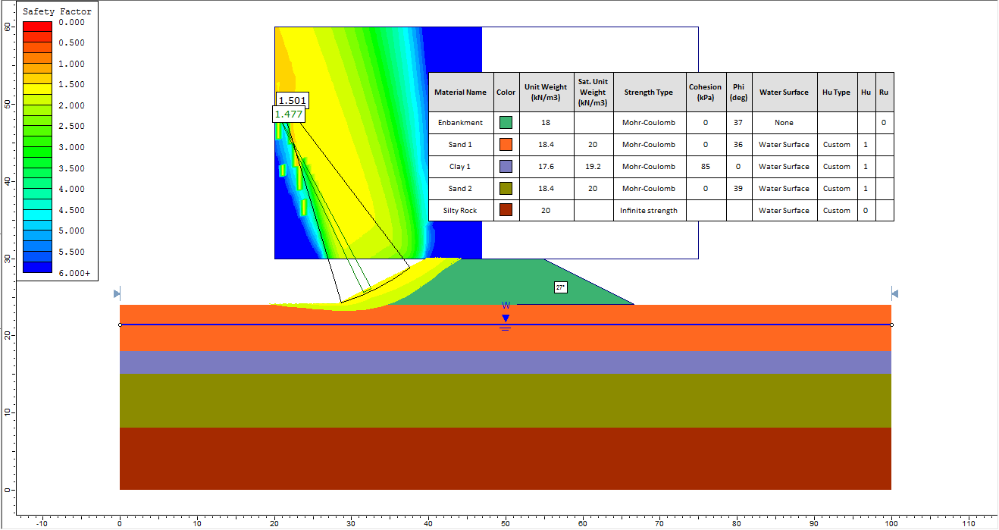Slope :27o

**Figure 6: Short term stability check**

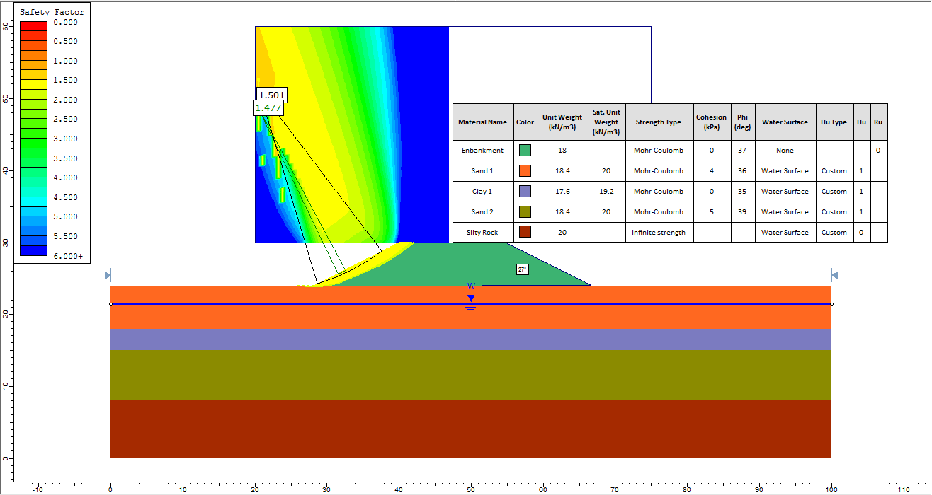

**Figure 7: Long term stability check**

*Internal Stability:*

*Slope :25o*

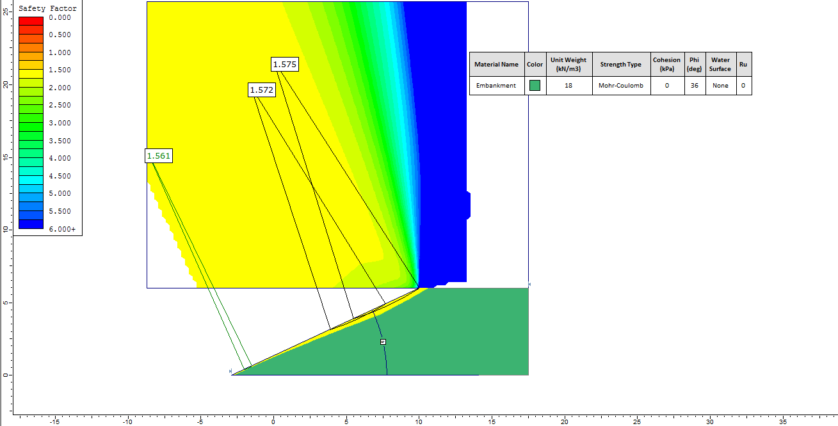

**Figure 8: Long term stability check**

**6) SETTLEMENT CALCULATIONS**

**Cr,Cc calculations**

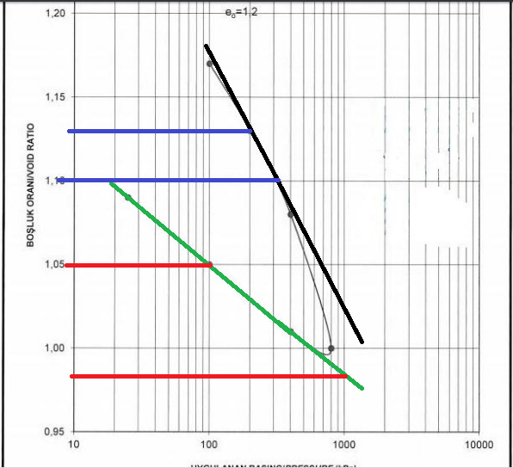

**Figure 9: Consolidation Test Result**

**Cr** = (1.05-0.98)/log (1000/100) =0.07

**Cc**= (1.13-1.10)/log (300/200) =0.17

**Load of Embankment**

qembakment = qbackfill + qsurcharge = 18*6+15 = 123 kPa

Consolidation Settlement;

In order to find stresses, 2V:1H approach is used.

σ’0= (18,4*2,5+10*3,5+9,2*1,5)*40,73/(48,23)

Δσ = 123*40,73/(48,23)

**Sc**= Cc/(1+e0)*H*log((σ’0+Δσ)/ σ’0)

0.17/(1+1,2)*3*log((80,06+103.87)/80,06)=8.37cm

Immediate Settlement;

From Burland and Burbidge:

Depth of influence, z1=17m

f1=6/17*(2-6/17)=0.581

Since L is infinite;

fs=1.56 (By taking the limit of equation)

For after 30 years calculation ft has been taken as 2.5 for the case of fluctuating loading.

Present: After 30 Years:

**Si**=q*B0,7*Ic*f1*fs  **Si**=q*B0,7*Ic*f1*fs*ft

123*150.7*1.71/121.4*0.581*1.56 123*150.7*1.71/121.4*0.581*1.56*2.5

3.92 cm 9.8 cm

**Total settlement**= 3.92+8.37=12.29 cm>10cm

To reduce settlement it can be applied a ground improvement method. This method can be deep mixing or stone columns. Generally for embankments deep mixing method is commonly used around the world.

**7) PILE DESIGN**

Pile design is done according to given parameters,

|  |  |  |
| --- | --- | --- |
| **Vertical** | **23914** | **kN** |
| **Horizontal** | **996** |  |
| **M** | **1196** |  |
| **Qapp,max** | **1211.647** | **kN per pile** |

|  |  |
| --- | --- |
| **As m2** | **Ap m2** |
| **37.68** | **0.5024** |

**Table 5**

Calculations are made for a 4x4 pile system with fixed head.

|  |  |  |
| --- | --- | --- |
| **m** | **n** | **s** |
| 4 | 4 | 3 |

**Table 6**

Pile resistance is calculated with the data obtained from idealized soil profile and piles are assumed to be driven from 8.78m elevation.

Results obtained from Biraud (1985) are used for design and pile group resistance is calculated from Converse-Labarre method since spacing is less than 6,4m.

|  |  |  |  |  |  |  |
| --- | --- | --- | --- | --- | --- | --- |
| **Converse-Labarre** | | | |  |  |  |
| **Qultdecided** |  | **tan teta** |  | **n** | **Qug (kN)** | **Qug,all (kN)** |
| 5179.369 |  | 0.273173 |  | 0.997724 | 82681.25 | 27560.41781 |

**Table 7**

Designed system carries the given vertical load successfully.

After this step, vertical resistance is calculated from Brom’s method;

|  |  |  |
| --- | --- | --- |
| **VERTICAL RESISTANCE** | | |
|  |  |  |
| **Ep (kPa)** | **20000000** |  |
| **Ip** | **0.321536** | **m4** |
| **R** | **4.764433** |  |
| **Kh** | **15600** | **kN/m3** |
| **2*R** | **9.528867** |  |
| **L>2R** | **Long pile** |  |
| **nh** | **6600** | **kN/m3** |
| **T** | **3.960437** |  |

|  |  |  |
| --- | --- | --- |
| **s/D** | 3.75 |  |
| **Ge** | 0.475 |  |
| **My** | 750 | kNm |
| **L/D** | 18.75 |  |

**Table 8**

Weighted averages are calculated since soil is not homogeneous.

|  |  |  |  |  |  |
| --- | --- | --- | --- | --- | --- |
| **Tavg** | 4.3905 | **Kavg** | 38772.92 | **Kpavg** | 4.027793 |

|  |  |  |  |  |  |  |
| --- | --- | --- | --- | --- | --- | --- |
|  | **Hu** | **485.412** | **kN** | **Hugr,all (kN)** | **3353.755636** | **OK!** |
|  |  |  |  |  |  |  |
| **From graph** |  | **My/Kpyd4** | 24.71 |  |  |  |
|  | **Hu** | 607.12 | kN | **Hu,gr,all (kN)** | **4194.647273** | **OK!** |

**Table 9**

Designed piles satisfy the requirements for lateral loads.

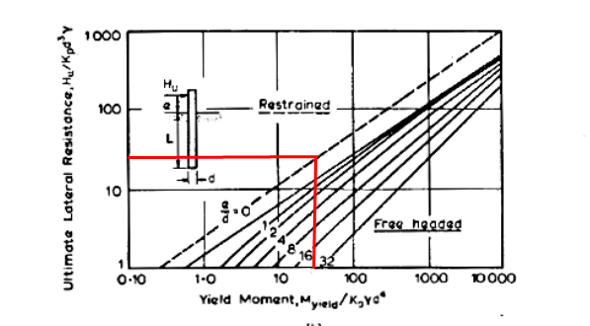

Deflection check is done according to Modulus of Subgrade Reduction method.

|  |  |  |  |  |  |
| --- | --- | --- | --- | --- | --- |
| **Deflection Check** | | |  |  |  |
| **Z** | 3.416467 |  | **xz** | -1.13303 | mm |
| **Cy** | -0.16 | **Mz** | 35.61498 | kNm |
| **Cm** | 0.01 |  | 20>1,133 | ***OK!*** |
| **Cp** | -0.415 |  | | |
|  | | | | | |

**Table 10**

Deflection check requirements are satisfied.

Decided pile parameters are as follows. (All units are in centimeters unless stated otherwise);

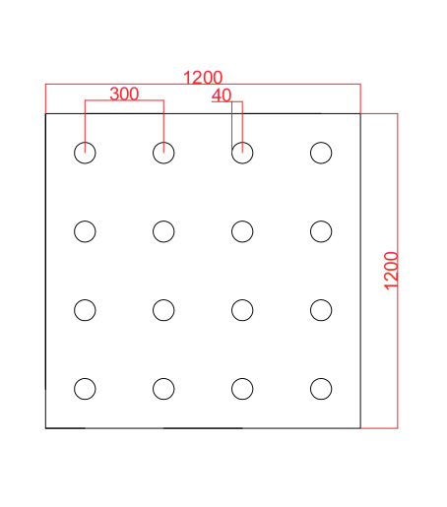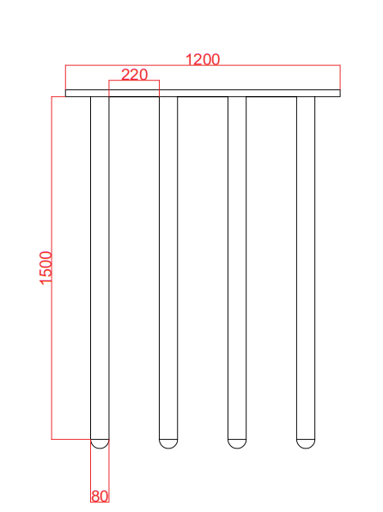

**Figure 10: Final Design of Piles**

Detailed calculations are given in Appendix C.

**8) CONCLUSION**

Firstly, using field tests and many kind of soil classification correlations general soil profile and idealized soil profile generated. Secondly, a preliminary cantilever wall design was made with suggested dimensions. Then, some changes were done on preliminary design to make it more economical design. Thirdly, with the help of slide software slopes and safety of embankment were checked. Finally, pile design was made according the retrieved data.

**APPENDIX A**

*Finding Cu;*

|  |  |  |  |  |  |  |  |  |  |
| --- | --- | --- | --- | --- | --- | --- | --- | --- | --- |
| **Kulhawy & Mayne (1990)** | | **Stroud (1974)** | | **Fugra (2004)** | | **Baguelin (1978)** | | **Skempton (1957)** | |
| **SPT** | | **SPT** | | **CPT** | | **PMT** | | **SPT** | |
| **Soil** | **Cu (kN/m2)** | **Soil** | **Cu (kN/m2)** | **Soil** | **Cu (kN/m2)** | **Soil** | **Cu (kN/m2)** | **Soil** | **Cu (kN/m2)** |
| **1- Sand** | **0** | **1- Sand** | **0** | **1- Sand** | **0** | **1- Sand** | **0** | **1- Sand** | **0** |
| **2- Clay** | **60** | **2- Clay** | **74.2** | **2- Clay** | **85** | **2- Clay** | **130** | **2- Clay** | **367** |
| **3- Sand** | **0** | **3- Sand** | **0** | **3- Sand** | **0** | **3- Sand** | **0** | **3- Sand** | **0** |

*Finding φ’:*

|  |  |  |  |  |  |
| --- | --- | --- | --- | --- | --- |
| **Bowles (1996)** | | | | **Schertmann (1975)** | |
| **SPT** | | | | **SPT** | |
| **Soil** | **φ ( ͦ)** | **Soil Classification** | **ϒ (kN/m3)** | **Soil** | **φ ( ͦ)** |
| **1- Sand** | **32-36** | **Medium dense** | **17-20** | **1- Sand** | **36** |
| **2- Clay** | **32-36** | **Medium dense** | **17-20** | **2- Clay** | **35** |
| **3- Sand** | **35-39** | **Dense** | **17-22** | **3- Sand** | **38** |
| **Robertson & Campanella (1983)** | | **Terzaghi, Peck and Mesri (1996)** | | **Gibson (1953)** | |
| **CPT** | | **Other Empirical Correlations** | | **Other Empirical Correlations** | |
| **Soil** | **φ ( ͦ)** | **Soil** | **φ ( ͦ)** | **Soil** | **φ ( ͦ)** |
| **1- Sand** | **38** | **1- Sand** | **33** | **1- Sand** | **31** |
| **2- Clay** | **43** | **2- Clay** | **34** | **2- Clay** | **32** |
| **3- Sand** | **41** | **3- Sand** | **33** | **3- Sand** | **32** |

*Finding Eu:*

|  |  |
| --- | --- |
| **Poulos & Small (2000)** | |
| **SPT** | |
| **Soil** | **Eu (MN/m2)** |
| **1- Sand** | **19** |
| **2- Clay** | **24** |
| **3- Sand** | **40** |

*Finding Dr:*

|  |  |  |  |  |
| --- | --- | --- | --- | --- |
| **Terzaghi & Peck (1996)** | | | **Coduto (2000)** | |
| **SPT** | | | **SPT** | |
| **Soil** | **Soil Classification** | **Dr (%)** | **Soil** | **Dr (%)** |
| **1- Sand** | **Loose** | **15-35** | **1- Sand** | **40** |
| **2- Clay** | **Medium** | **35-65** | **2- Clay** | **42** |
| **3- Sand** | **Medium** | **35-65** | **3- Sand** | **62** |

*Finding Es:*

|  |  |  |  |
| --- | --- | --- | --- |
| **Kulhawy & Mayne (1990)** | | **FHWA (2002)** | |
| **SPT** | | **SPT** | |
| **Soil** | **Es (MN/m2)** | **Soil** | **Es (MN/m2)** |
| **1- Sand** | **9** | **1- Sand** | **6.3** |
| **2- Clay** | **0** | **2- Clay** | **0** |
| **3- Sand** | **9** | **3- Sand** | **7.2** |

*Finding Mv &M0:*

|  |  |  |  |
| --- | --- | --- | --- |
| **Stroud (1974)** | | **Lunne & Christopher** | |
| **SPT** | | **SPT** | |
| **Soil** | **Mv (m2/kN)** | **Soil** | **M0 (kN/m2)** |
| **1- Sand** | **1.50E-04** | **1- Sand** | **25** |
| **2- Clay** | **1.30E-04** | **2- Clay** | **0** |
| **3- Sand** | **7.50E-05** | **3- Sand** | **125** |

**APPENDIX B**

Calculations for preliminary design;

|  |  |  |  |
| --- | --- | --- | --- |
|  |  | **Moment w.r.t left end point of wall** | |
| **Force** | **(kN/m)** | **Moment arm** | **Moment (kN.m/m)** |
| **VERTİCAL FORCES** |  |  |  |
| **Bottom part of wall** | **75.6** | **2.25** | **170.1** |
| **Top (rectangular) part of wall** | **43.2** | **2.05** | **88.56** |
| **Top (triangular) part of wall** | **21.6** | **1.766666667** | **38.16** |
| **Backfill** | **248.4** | **3.35** | **832.14** |
| **Surcharge** | **34.5** | **3.35** | **115.575** |
| **SUM** | **423.3** |  | **1244.535** |
| **HORİZONTAL FORCES** |  |  |  |
| **Active pressure 1** | **24.95332688** | **3.35** | **83.59364506** |
| **Active pressure 2** | **100.3123741** | **2.233333333** | **224.0309688** |
| **SUM** | **125.265701** |  | **307.6246138** |

Calculations for final design;

|  |  |  |  |
| --- | --- | --- | --- |
|  |  | **Moment w.r.t left end point of wall** | |
| **Force** | **(kN/m)** | **Moment arm** | **Moment (kN.m/m)** |
| **VERTİCAL FORCES** |  |  |  |
| **Bottom part of wall** | **70.56** | **2.1** | **148.176** |
| **Top (rectangular) part of wall** | **43.2** | **1.55** | **66.96** |
| **Top (triangular) part of wall** | **21.6** | **1.266666667** | **27.36** |
| **Backfill** | **270** | **2.95** | **796.5** |
| **Surcharge** | **37.5** | **2.95** | **110.625** |
| **SUM** | **442.86** |  | **1149.621** |
| **HORİZONTAL FORCES** |  |  |  |
| **Active pressure 1** | **24.95332688** | **3.35** | **83.59364506** |
| **Active pressure 2** | **100.3123741** | **2.233333333** | **224.0309688** |
| **SUM** | **125.265701** |  | **307.6246138** |

**APPENDIX C**

|  |  |  |  |  |  |  |  |
| --- | --- | --- | --- | --- | --- | --- | --- |
| **CONVENTINAL METHOD** | | | | | | | |
| **First Sand Layer** |  | **Fi** | **Sigma** | **Ks** | **sigmav'** | **Qs** |  |
| P | L | 36 | 24 | 1 | 0 | 25.72353252 | kN |
| 2.512 | 2.5 | 0.628319 | 0.418879 |  | 46 |  |  |
| **Second Sand Layer** |  |  |  |  |  |  |  |
| **P** | **L** | 36 | 24 | 1 | 46 | Qs |  |
| 2.512 | 3.5 |  | 0.418879 |  | 81 | 248.5676132 | kN |
| **Clay** | **alfa** | **cu** | **P** |  |  | **Qs** |  |
| L | 0.631 | 85 | 2.512 |  | 81 | 404.19336 | kN |
| 3 |  |  |  |  | 101 |  |  |
| **Third Sand Layer** |  | **Fi** | **Sigma** | **Ks** | **sigmav'** | **Qs** |  |
| P | L | 38 | 25.33333 | 2 | 101 |  |  |
| 2.512 | 6 | 0.663225 | 0.44215 |  | 161 | 1869.430919 | kN |
|  |  |  |  |  |  | **Qs total** |  |
|  |  |  |  |  |  | 2547.915425 | kN |
| **Bearing** | **Nq** | **f** |  | **F.S** |  | **Qult** |  |
|  | 100 | 8088.64 |  | 3 |  | 10562.62727 | kN |
|  |  |  |  |  |  | **Qult,all** |  |
|  |  | **Vpile** |  |  |  | 3520.875755 | kN |
| **Uplift force** |  | 7.536 | 73.92816 |  |  |  |  |

|  |  |  |  |  |  |
| --- | --- | --- | --- | --- | --- |
| **EMPIRICAL METHODS** | | | | | |
| **Meyerhof (1976)** | | | |  |  |
| **Weighted avg. N60 bw 0<z<15** | | | 12.8 |  |  |
| **Weighted avg. N60 bw 7<z<18,2** | | | 31.10714 |  |  |
| **qs** | **Qs** | **qp** | **Qp** | **Qult** | **Qult,all** |
| 25.6 | 964.608 | 9332.142857 | 4688.469 | 5653.076571 | 1884.358857 |

|  |  |  |  |
| --- | --- | --- | --- |
| **Schmertmann (1975)** | | | |
| **Layer** | **SM** | **CL** | **SC** |
| **L** | 9 | 1 | 5 |
| **qs** | 26.0832 | 54.912 | 54.784 |
| **qp** | - | - | 5337.986 |
| **Qs** | 589.6889856 | 137.938944 | 688.087 |
| **Qp** |  |  | 2681.804 |
| **Qult** | 4097.518992 |  |  |
| **Qult,all** | 1365.839664 |  |  |

|  |  |  |
| --- | --- | --- |
| **Biraud (1985)** | |  |
| **qs** | 46.91793719 | kPa |
| **qp** | 6790.408018 | kPa |
| **Qp** | 3411.500988 |  |
| **Qs** | 1767.867873 |  |
| **Qult** | 5179.368861 |  |
| **Qall** | 1726.456287 |  |

|  |  |  |  |  |  |
| --- | --- | --- | --- | --- | --- |
| **PMT** |  |  |  |  |  |
| |  | | --- | |  | |  |  |  |  |  |
|  |  |  |  |  |  |
|  |  |  |  |  |  |
|  |  |  |  |  |  |
|  |  |  |  |  |  |
|  |  |  |  |  |  |
|  |  |  |  |  |  |
|  |  |  |  |  |  |
|  |  |  |  |  |  |
|  |  |  |  |  |  |
|  |  |  |  |  |  |
|  |  |  |  |  |  |
| From PMT | qp=Kg*PLN (kPa) | Qp (kN) | fs (kPa) | Qs (kN) | Qult (kN) |
| Average PLN | 6116.535 | 3072.947 | 77 | 2901.36 | 5974.307 |
| **1054.575** |  |  |  |  |  |

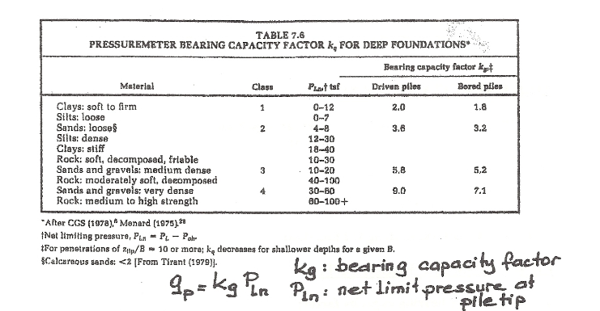

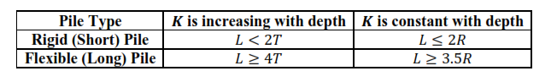

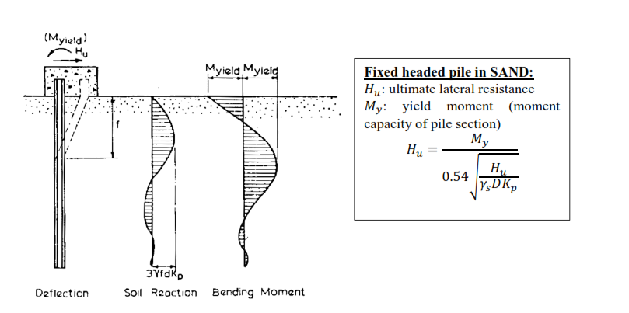

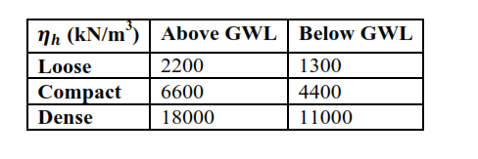

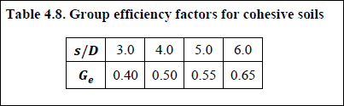

|  |  |  |  |  |  |
| --- | --- | --- | --- | --- | --- |
| Layer | nh | L | T | K | Kp |
| **Sand** | 2200 | 2.5 | 4.933639 | 6875 | 3.85184 |
| **Sand** | 1300 | 3.5 | 5.481044 | 5687.5 | 3.85184 |
| **Clay** | 4400 | 3 | 4.294982 | 16500 |  |
| **Sand** | 11000 | 6 | 3.575801 | 82500 | 4.203746 |

