

CE 482 - Design of Steel Structures

Term Project

Design of Industrial Building

Prepared by

Submission Date

21.01.2016

1. **Overview of Structure**

Design of Industrial Building is to be constructed. The structure has 12 m spacing in both directions having total of 48 m by 36 m. Used structural members are columns, beams, purlins, and braces. Fixed ends and pinned ends are provided whenever it is thought to be suitable

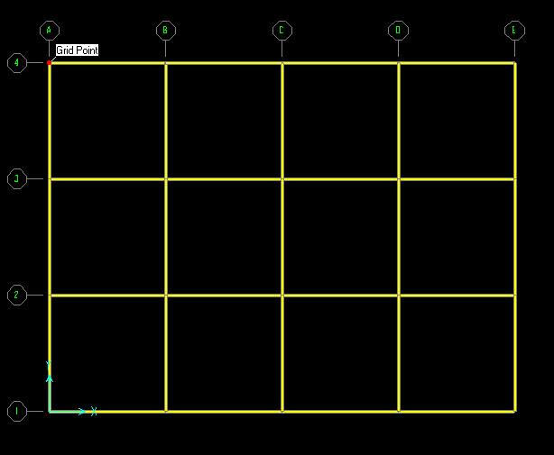

Figure 1: Layout (grids) of the system

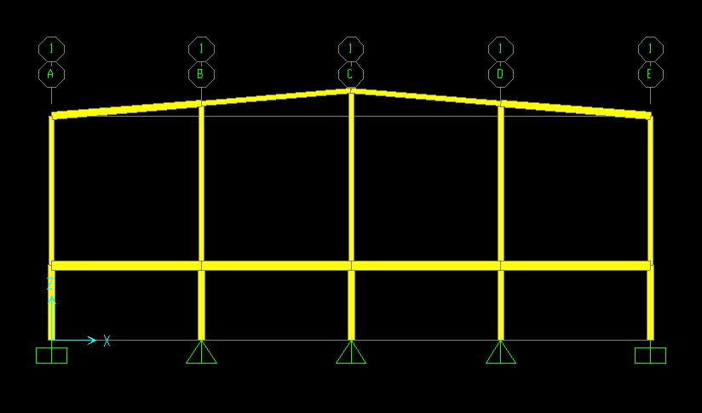

Figure 2: An overview from X-Z plane

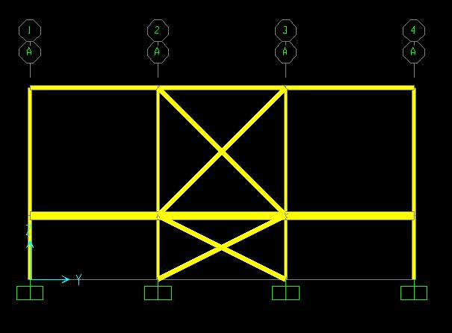

Figure 3: An overview from Y-Z plane

**2. Load Cases and Combinations**

**2.1. Load Cases**

DL (Dead_load+Self_Weight): The summation of dead load and self-weight cases

Live_Load: Live load

Snow_Load: Undrifted snow case

Snow_Load_Left: Drifted snow on the left part of the roof

Snow_Load_Right: Drifted snow on the right part of the roof

Seismic_Load_X+: Seismic load in +x direction

Seismic_Load_X-: Seismic load in -x direction

Seismic_Load_Y+: Seismic load in +y direction

Seismic_Load_Y-: Seismic load in -y direction

Wind_Load_X+(- -): Wind in +x direction, loading on I part of the roof is suction

Wind_load_X+(- +): Wind in +x direction, loading on I part of the roof is compression

Wind_Load_X-(- -): Wind in -x direction, loading on I part of the roof is suction

Wind_Load_X-(- +): Wind in -x direction, loading on I part of the roof is compression

Wind_Load_Y +(-): Wind in +y direction, loading on roof is suction

Wind_Load_Y -(-): Wind in -y direction, loading on roof is suction

In Y direction we have assumed that the roof behaves as H part and there will be just suction throughout the roof.

**2.2. Load Combinations**

Load Combinations are shown in Appendix A.

**2.3. Load Calculations**

**2.3.1. DL (Dead_load+Self_Weight):**

Dead loads and 1.15*self weight of the members are summed. 1.15 factor is used to account for the connection weights. A capture of dead weights exerted on the system is provided below. Note that 0.6 kN/m of cover load is barely seen on the roof despite the fact that it exists.

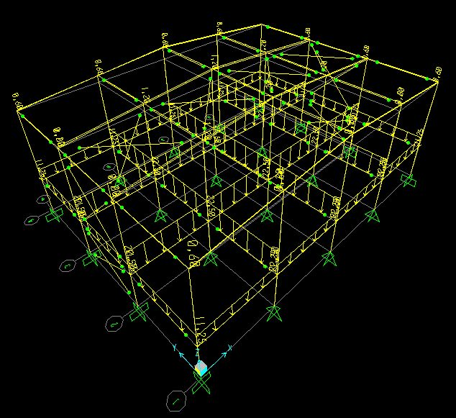

Figure 4: Dead loads exerted on the system

**2.3.2. Live Load**

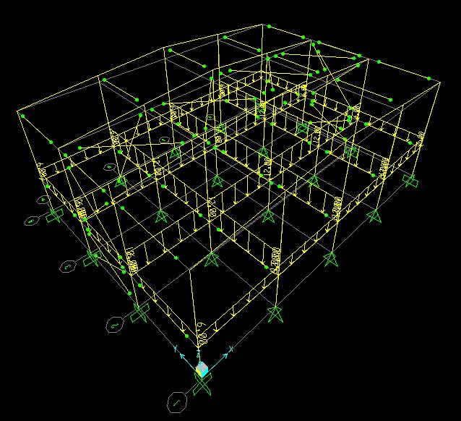

Figure 5: Live loads exerted on the system

**2.3.3. Snow load Calculations:**

In snow load calculations, 3 cases are considered: Undrifted case, Drifted (left) case, Drifted (right) case. Snow load calculations and its screenshots are provided below.

a) S1,2 = Ce * Ct * Sk * μ = 1 * 1 * 1.05 * 0.8 = 0.84 kPa

q=0.84*12=10.08 kN/m

b) S1 = Ce * Ct * Sk * μ = 1 * 1 * 1.05 * 0.8/2= 0.42 kPa , 5.04 kN/m

S2 = Ce * Ct * Sk * μ = 1 * 1 * 1.05 * 0.8 = 0.84 kPa , 10.08 kN/m

c) S1 = Ce * Ct * Sk * μ = 1 * 1 * 1.05 * 0.8 = 0.84 kPa , 10.08 kN/m

S2 = Ce * Ct * Sk * μ = 1 * 1 * 1.05 * 0.8/2 = 0.42 kPa , 5.04 kN/m

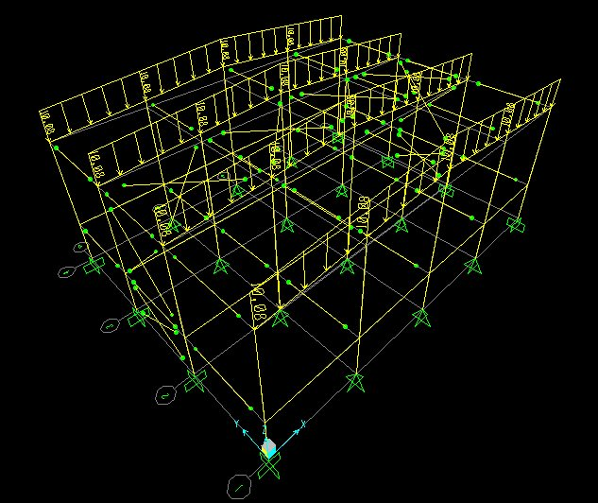

Figure 6: Undrifted Snow loads exerted on the system

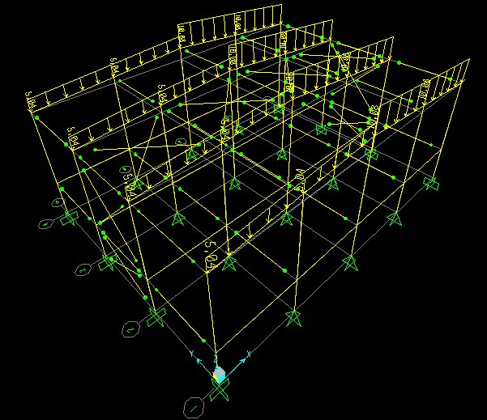

Figure 7: Drifted (Right) snow loads exerted on the system

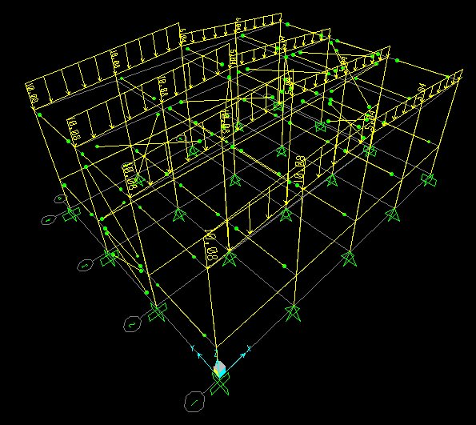

Figure 8: Drifted (Left) snow loads exerted on the system

**2.3.4. Wind load Calculations:**

Vb = 28 m/s qb = 282 * 1.25 * 0.5 = 490 N/m2

Cr (z) ;

Kr = 0.19*(0.3/0.05)0.07= 0.215

z=20 m

Cr (z) = 0.215 * ln(20/0.3) = 0.58

Vm (z) = 28*0.9*1 = 25.33 m/s

Iv = 1/(ln(20/0.3)) = 0.238

qp(z) = [1+7*0.238]*1.25*0.5*25.332 = 1069.4 Pa =1.07 kPa

qp,e = 1.07 kPa and Cpe,10 table is shown below

* θ values are taken as 0, calculations are made for flat roof since pitch angle is lower than 5 degrees according to prEN 1991-1-4.

In X direction we have h/d=0.42, D and E values are found interpolating between given values from Table 7.1 prEN 1991-1-4 on page 37.

|  |  |  |  |  |  |  |  |  |  |
| --- | --- | --- | --- | --- | --- | --- | --- | --- | --- |
| X Direction | | | | | | | | | |
|  | A | B | C | D | E | F | G | H | I |
| Cpe,10 | -1.2 | -0.8 | -0.5 | 0.723 | -0.345 | -1.8 | -1.2 | -0.7 | -0.2 |
| Cpe,10 | -1.2 | -0.8 | -0.5 | 0.723 | -0.345 | -1.8 | -1.2 | -0.7 | +0.2 |
| W (kN/m) | -15.4 | -10.3 | -6.4 | 9.3 | -4.43 | -23.1 | -15.4 | -9 | -2.6 |
| W (kN/m) | -15.4 | -10.3 | -6.4 | 9.3 | -4.43 | -23.1 | -15.4 | -9 | +2.6 |

In Y direction we have h/d=0.56, D and E values are found interpolating between given values from Table 7.1 prEN 1991-1-4 on page 37.

|  |  |  |  |  |  |  |  |  |  |
| --- | --- | --- | --- | --- | --- | --- | --- | --- | --- |
| Y Direction | | | | | | | | | |
|  | A | B | C | D | E | F | G | H | I |
| Cpe,10 | -1.2 | -0.8 | -0.5 | 0.741 | -0.38 | -1.8 | -1.2 | -0.7 | -0.2 |
| Cpe,10 | -1.2 | -0.8 | -0.5 | 0.741 | -0.38 | -1.8 | -1.2 | -0.7 | +0.2 |
| W (kN/m) | -15.4 | -10.3 | -6.4 | 9.5 | -4.9 | -23.1 | -15.4 | -9 | -2.6 |
| W (kN/m) | -15.4 | -10.3 | -6.4 | 9.5 | -4.9 | -23.1 | -15.4 | -9 | +2.6 |

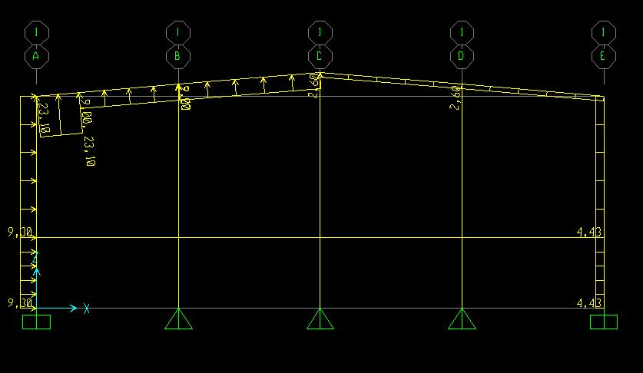

Figure 9: Wind in +x direction, loading on I part of the roof is suction

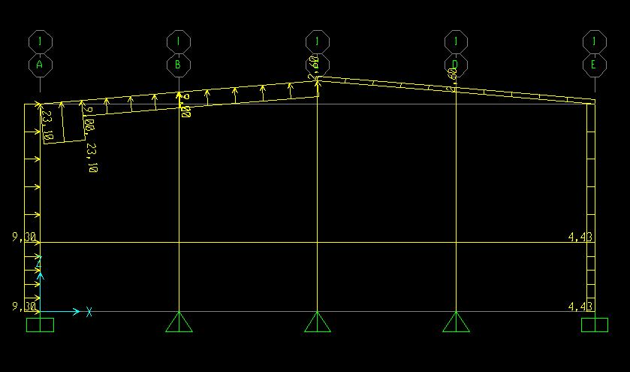

Figure 10: Wind in +x direction, loading on I part of the roof is compression

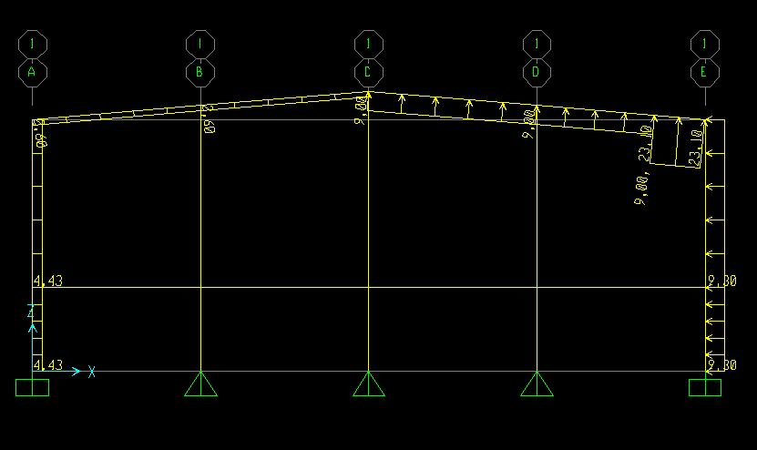

Figure 11: Wind in -x direction, loading on I part of the roof is suction

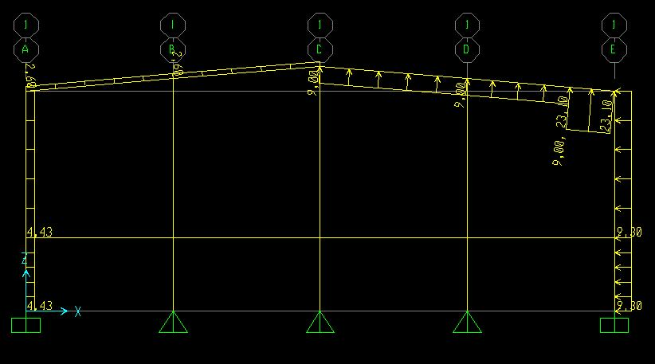

Figure 12: Wind in -x direction, loading on I part of the roof is compression

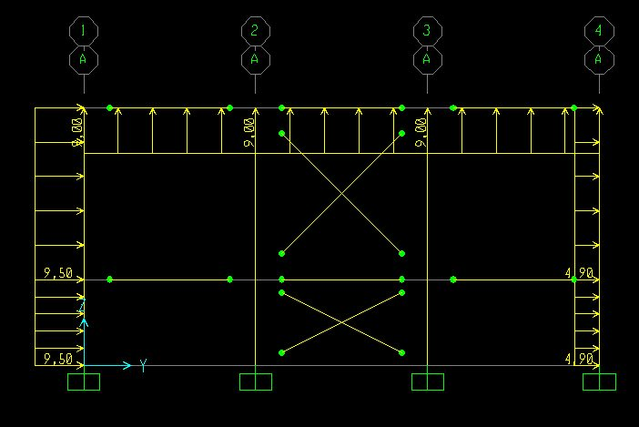

Figure 13: Wind in +y direction, loading on the roof is suction

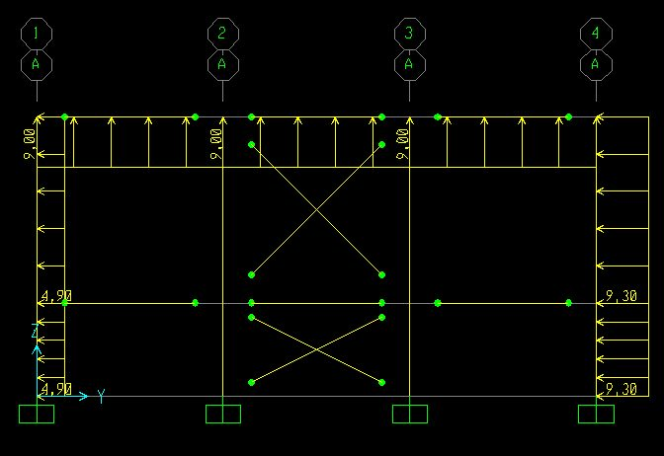

Figure 14: Wind in -y direction, loading on the roof is suction

**2.3.5. Seismic Load**

Seismic loads are calculated in 4 different directions as +X, -X, +Y, -Y. Calculations are done according to prEN 1998-1:2003 (E). Evaluating the mass participating ratios table periods in the directions of x and y are taken as: Tx=0.62 sec, Ty=0.238 sec. And base shear forces are calculated as Fbx=409 kN & Fby=508 kN. These loads are distributed using spacing and placed as point loads on the nodes of the structure proportional to story heights. The applications of this procedure are provided below.

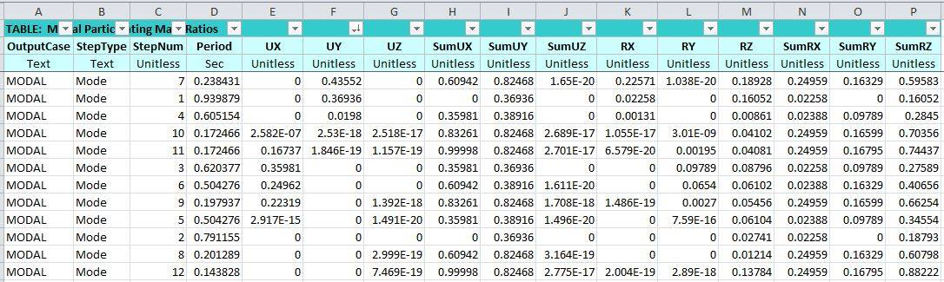

Figure 15: Modal Participating Mass Ratios Table

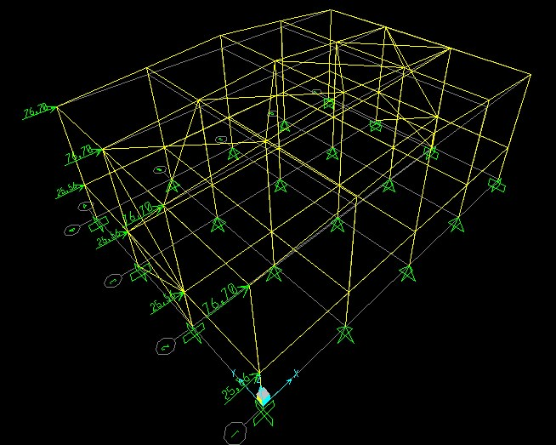

Figure 16: Seismic load in +X direction

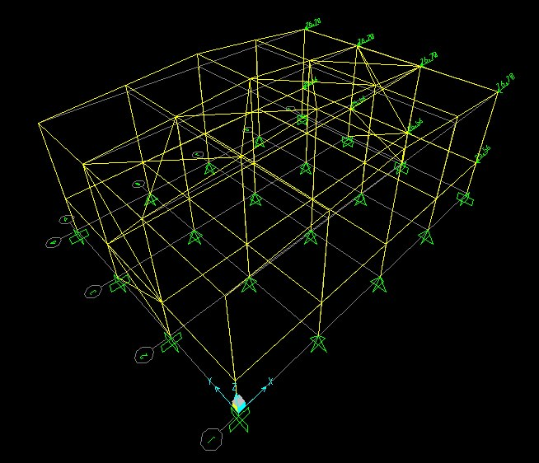

Figure 17: Seismic load in -X direction

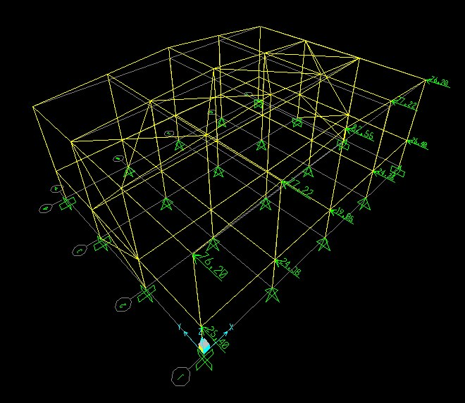

Figure 18: Seismic load in +Y direction

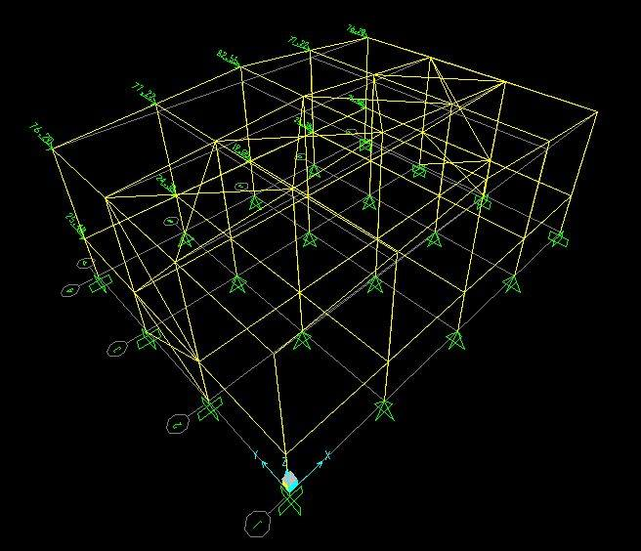

Figure 19: Seismic load in -Y direction

**3. Computer Model**

Loadings models and member sections are provided above and below respectively**.**

**4. Design Calculations**

**4.1. Column Calculations**

The column carrying the maximum axial load is analysed.

**Global Buckling**

* **Strong axis**

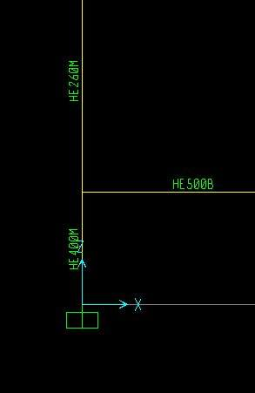

Figure 20: An overview of column HE400M

K=2.2 is found from alignment chart

* OKAY!
* **K=1 in weak direction(braced)**
* OKAY!

**Shear Check**

Cv=1 (rolled section)

Beam Column Check

This ratio is taken from SAP2000 as 0.436 which is less than 1

* OKAY!

**4.2. Beam Calculations**

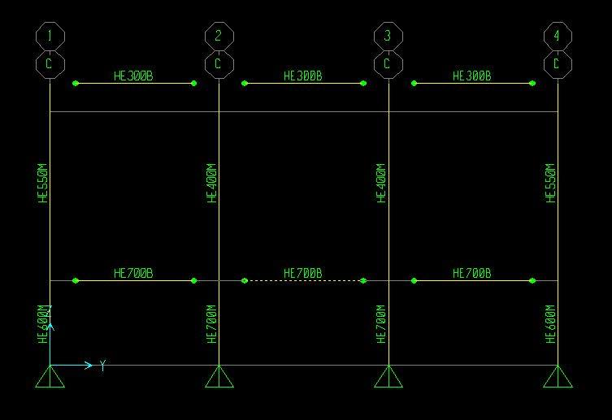

Figure 21: An overview of beam HE700B

**Yielding**

**Lateral Torsional Buckling**

1.136 taken from SAP2000

=12000 mm

8208.5 mm

* LTB governs and the beam HEB700 is OKAY.

**Shear Check**

Cv=1 (rolled section)

* OKAY!

**4.3. Bracing Calculations**

**Buckling**

TUBO-D-368x6.3 is used as bracing.

L=16.97 m

r=0.1279 m= 127.9 mm & Ag=7159 mm2 (taken from SAP2000)

k=1 (pin ends)

* OKAY!

**4.4. Purlin Calculations**

Try UPN240

* 2 m spacing is selected from BorusanPro Catalog.

Cover load =0.2*36*48=345.6 kN

For 12 m purlin, distributed cover load of 0.4 kN/m is calculated.

For self-weight of the channel section 33.2*9.81/103 is distributed as 0.326 kN/m.

* DL=0.4+0.326=0.726 kN/m

Snow load of 1.68 kN/m is determined.

* SL=1.68 kN/m

COMB=1.2DL+1.6SL

=1.2*0.726+1.6*1.68=3.56 kN/m is determined.

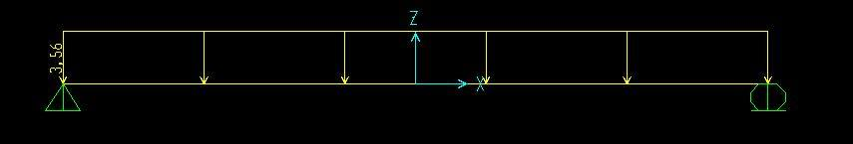

Figure 22: Purlin loading

Mmax=ϕMy=0.9*Fy*Sx

Using UPN240 is OKAY since it has Sx= 300 cm2 >

* The resistance of UPN240 :

64 kN.m (OKAY!)

* Therefore, select UPN240 section for purlins.

**5. Connection Details**

**5.1. Beam-to-Column Connection**

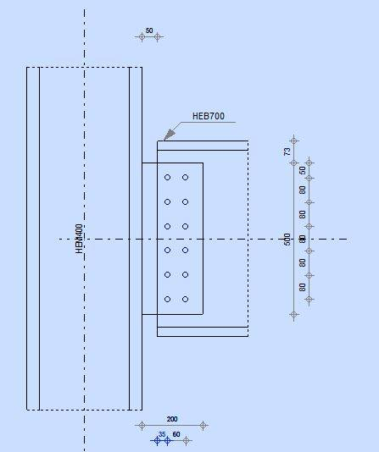

Figure 23: Beam to column connection

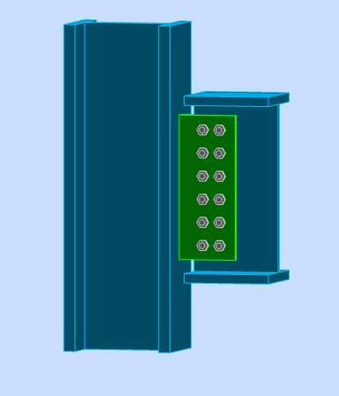 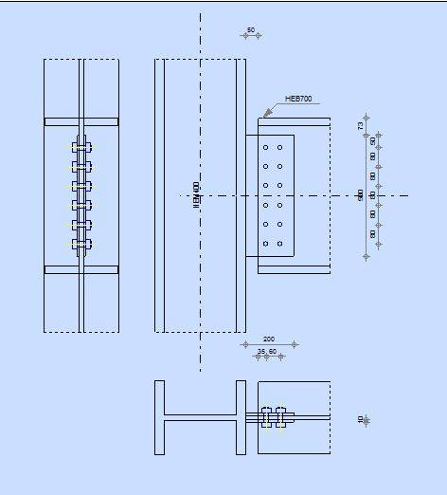

Figure 24: Beam to column connection Figure 25: Beam to column connection

Use M20 bolts, Grade 10.9, s275

V= 701 kN Taken from SAP2000

M=701*200 =140.2*103 kN.mm

Vi=701/12=58.4 kN

Bolt capacity

V= 58.4 kN

Frv=

Fnt=0.75*900=675 MPa (tensile capacity without shear)

Fnv=0.45*1000=450MPa

F’nt=

Rn= F’nt*Ab= ,

Ni=79.66<128.8 OKAY!

**5.2. Bracing-to-Column Connection**

Since bracing-to-column connection

=

Since the braces work under only tension or compression because they are pinned to the connection resulting equation is =

=1.3*0.75*900=877 MPa

Bolt Area=(pi*20^2)/4=314 mm^2

R=877*314=275.4 kN/bolt

5 bolts are used 1376.9 kN>25 kN OKAY!

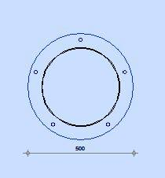

Figure 1= TUBO-D-368x6.3 brace connection, note that brace diameter is 368 mm while the plate diameter is 500 mm.

**5.3Purlin-to-Beam Connection**

UPN240 section is decided in previous calculations, and M20 bolt is used.

In this connection, it is assumed that the bolts work under shear force since the purlin works under flexure. Thus, only the shear resistance of M20 bolt is considered.

=

Since there is no tensile force on the bolts connecting the purlins and the shear legs, above formulation cannot be used. It is assumed to use 45 percent reduction in shear strength of bolts and the folllwing calculations are done.

Fnv=0.45.1000=450 MPa

Bolt Area=(pi*20^2)/4=314 mm^2

R=450*314/1000=141.3 kN/bolt

**6. Conclusion**

During load calculations, Eurocode (EN1990, EN1991-1-1, EN1991-1-3, EN1991-1-4, EN1998) is used, whereas AISC2010 (American) is used in steel design calculations. Bracing is added in the direction of Y axis of frames and moment releases are implemented in that direction. Bracing is added on the roof in order to have continuous load distributing throughout the structure. Moment frames are allowed in the other direction(X).

Total weight of the structure is 7958.184 kN, and 540.8 kg/m2 of steel is used.