

**CE 482**

**DESIGN OF STEEL STRUCTURES**

**TERM PROJECT**

DESIGN OF A STRUCTUREL STEEL BUILDING

**Written By**

**10/06/2016**

1) INTRODUCTION OF A STRUCTURE: 3

1.1) Cost: 4

1.2) Strength/Wight Ratio: 4

1.3) Sustainability: 4

1.4) Fire Resistance: 4

1.5) Corrosion: 4

1.6) Overview of The Structure: 5

2) Load Cases and Combinations 7

2.1)Load Cases 7

2.2)Load Calculations: 7

2.2.1)DL0 7

2.2.2)DL1 7

2.2.3)Snow load Calculations: 8

2.2.4)Wind load Calculations: 10

3) CALCULATIONS: 14

3.1) Column Calculations: 14

3.1.1) Strong Axies: 14

3.1.2) Weak Axies: 15

3.2) Shear Check: 15

3.3) Beam-Column Design: 16

3.3.1) Flexural Buckling: 16

3.3.2) Beam-Column Check: 20

3.4)Discussion..........................................................................................................................21

3.5) Bracing Calculations 21

3.6) Purlin Calculations 22

3.7) Connections: 22

4) Conclusion: 25

1) INTRODUCTION OF A STRUCTURE:

Structural steel is a category of [steel](https://en.wikipedia.org/wiki/Steel) used as a construction material for making structural steel shapes. A structural steel [shape](https://en.wikipedia.org/wiki/Shape) is a [profile](https://en.wikipedia.org/wiki/Profile_(engineering)), formed with a specific [cross section](https://en.wikipedia.org/wiki/Cross_section_(geometry)) and following certain standards for [chemical composition](https://en.wikipedia.org/wiki/Chemistry) and mechanical properties. Structural steel shapes, sizes, composition, strengths, storage practices are regulated by [standards](https://en.wikipedia.org/wiki/Technical_standard) in most industrialized countries.

Structural steel members, such as [I-beams](https://en.wikipedia.org/wiki/I-beam), have high [second moments of area](https://en.wikipedia.org/wiki/Second_moment_of_area), which allow them to be very stiff in respect to their cross-sectional area.

Most construction projects require the use of hundreds of different materials. These range from concrete of all different specifications, structural steel of different specifications, clay, mortar, ceramics, wood, etc. In terms of a load bearing structural frame, they will generally consist of structural steel, [concrete](https://en.wikipedia.org/wiki/Concrete), [masonry](https://en.wikipedia.org/wiki/Masonry), and/or wood, using a suitable combination of each to produce an efficient structure. Most commercial and industrial structures are primarily constructed using either structural steel or [reinforced concrete](https://en.wikipedia.org/wiki/Reinforced_concrete). When designing a structure, an engineer must decide which, if not both, material is most suitable for the design.

There are many factors considered when choosing a construction material. Cost is commonly the controlling element; however, other considerations such as weight, strength, constructability, availability, sustainability, and fire resistance will be taken into account before a final decision is made.

## 1.1) Cost:

The cost of these construction materials will depend entirely on the geographical location of the project and the availability of the materials. Just as the price of gasoline fluctuates, so do the prices of cement, aggregate, steel, etc. Due to the fact that steel is sold by the pound it is the responsibility of the structural designer to specify the lightest members possible while still maintaining a safe structural design. An additional method of reducing expenditures in design is to use many of the same size steel members as opposed to many unique members.

## 1.2) Strength/Wight Ratio:

Construction materials are commonly categorized by their strength to weight ratio, or [specific strength](https://en.wikipedia.org/wiki/Specific_strength). This is defined as the strength of a material over its density. This gives an engineer an indication as to how useful the material is in comparison to its weight, with the weight being a direct indication of its cost and ease of construction.

## 1.3) Sustainability:

Many construction companies and material vendors are making changes to be a more environmentally friendly company. [Sustainability](https://en.wikipedia.org/wiki/Sustainability) has become an entirely new consideration for materials that are to be placed into the environment for generations of time. A sustainable material will be one that has minimal effect on the environment, both at the time of installation as well as throughout the life cycle of the material. Reinforced concrete and structural steel both have the ability to be a sustainable construction option, if used properly. Over 80% of structural steel members fabricated today come from recycled metals, called A992 steel. This member material is cheaper, as well as having a higher strength to weight ratio, than previously used steel members (A36 grade).

## 1.4) Fire Resistance:

One of the most dangerous hazards to a building is a fire hazard. This is especially true in dry, windy climates and for structures constructed using wood. Special considerations must be taken into account with structural steel to ensure it is not under a dangerous fire hazard condition. Reinforced concrete characteristically does not pose a threat in the event of fire and even resists the spreading of fire, as well as temperature changes. This makes concrete an excellent insulation, improving the sustainability of the building it surrounds by reducing the required energy to maintain climate.

## 1.5) Corrosion:

When choosing a structural material, it is important to consider the life cycle of the building. Some materials are susceptible to corrosion from their surrounding elements, such as water, heat, humidity, or salt. Special considerations must be taken into account during the installation of a structural material to prevent any potential corrosion hazards. This must also be made clear to the occupants of the building because there may or may not be a necessary maintenance requirement to prevent corrosion. For example, structural steel cannot be exposed to the environment because any moisture, or other contact with water, will cause it to rust. When the steel rusts it compromises the structural integrity of the building and poses a potential danger to the residual or surrounding occupants.

## 1.6) Overview of The Structure:

A structural steel building will be constructed in Konya. The structure has a height of 25 meters and has a width and length of 40 meters. As seen in figure 1, it has a spacing 8 meters in x-direction and a spacing of 10 meters in y-direction. The roof has a height of 3.5 m in the middle and 0.5 m at the ends from top of the columns, so the roof angle is equal to 8.53 ̊.

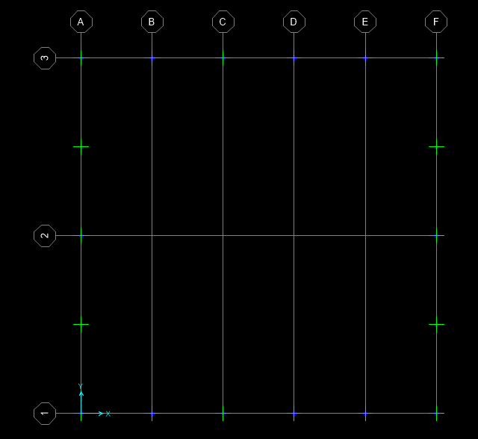

**Figure 1:** Layout of the Structure

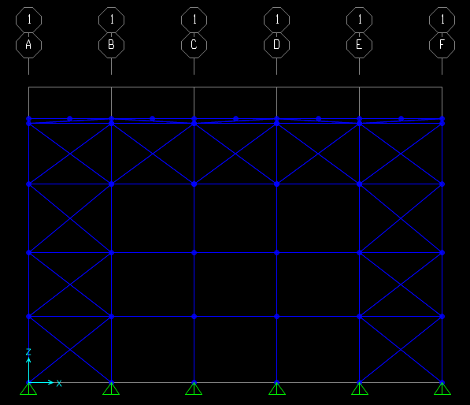

**Figure 2:** An overview from X-Z plane

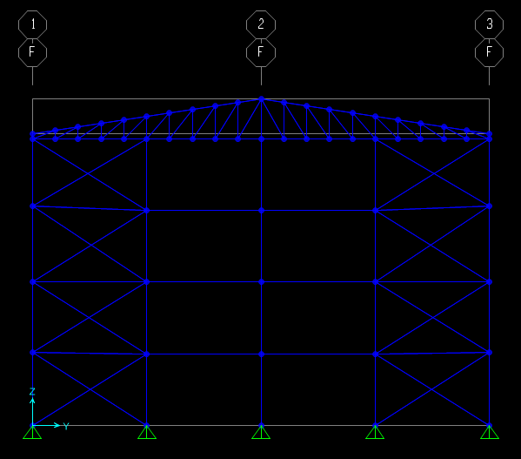

**Figure 3:** An overview from Y-Z plane

# 2) Load Cases and Combinations

## 2.1)Load Cases

**Table 1 :** The loads used in program and their definitions

|  |  |
| --- | --- |
| **LOADS** | **Definitions** |
| DL0 | Dead Load of the Structure |
| DL1 | Cover Load |
| SL | Snow Load Not Drifted |
| SL1 | Snow Load Drifted Right |
| SL2 | Snow Load Drifted Left |
| WX+ | Wind Load From x(+)-direction |
| WX- | Wind Load From x(-)-direction |
| WY | Wind Load From y(+)-direction |
| WY- | Wind Load From y(-)-direction |
| EQX | Earthquake load from x-direction |
| EQY | Earthquake load from y-direction |

## 2.2)Load Calculations:

### 2.2.1)DL0

Dead load is the self weight of the structure. This load is multiplied by 1.15 factor to consider connections. Normally, connections cannot be defined in SAP2000 so, the load is factored by 1.15.

### 2.2.2)DL1

DL1, is the load coming from the cover which is sandwich panel on the top of the roof. The cover has a weight of 0.2 kPa. For example; 0,2*8 = 1,6 kN/m distributed load is exerted on the roof beam.

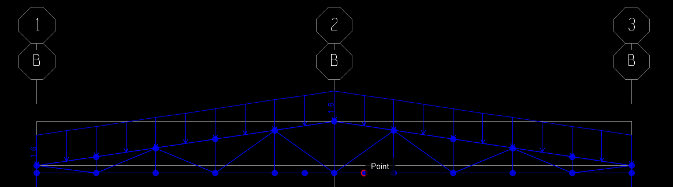

**Figure 4:** Cover load applied on the beam

### 2.2.3)Snow load Calculations:

In snow load calculations, three types of load are considered, these are Undrifted case, Drifted left case, Drifted right case. Snow load calculations are below.

#### 2.2.3.1)Undrifted Case

S= Ce * Ct * Sk * μ = 1 * 1 * 1.3 * 0.8 = 1,04 kPa

1,04*4 = 4,16 kN/m (for end beams) (8,32 kN/m for internal beams)

#### 2.2.3.2)Drifted Right Case

S= Ce * Ct * Sk * μ = 1 * 1 * 1.3 * 0.8 = 1,04 kPa

1.04*4 = 4.16 kN/m (for end beams) (2.08 kN/m for left part-4.16 kN/m for right part)

1.04*8 = 8.32 kN/m (for internal beams) (4.16 kN/m for left part-8.32 kN/m for right part)

#### 2.2.3.3)Drifted Left Case

S= Ce * Ct * Sk * μ = 1 * 1 * 1.3 * 0.8 = 1,04 kPa

1,04*4 = 4,16 kN/m (for end beams) (4.16 kN/m for left part-2.08 kN/m for right part)

1,04*8 = 8,32 kN/m (for internal beams) (8.32 kN/m for left part-4.16 kN/m for right part)

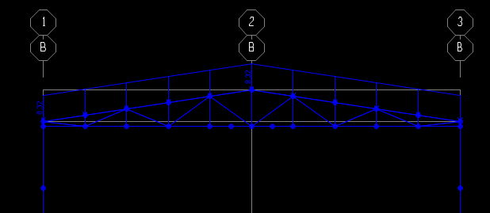

**Figure 5:** Undrifted Snow loads exerted on the beams

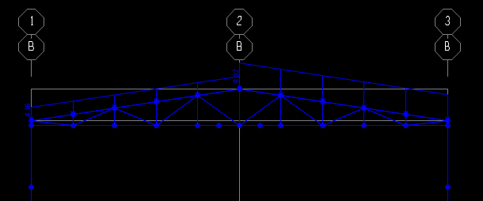

**Figure 6:** Drifted Right snow loads exerted on the beam

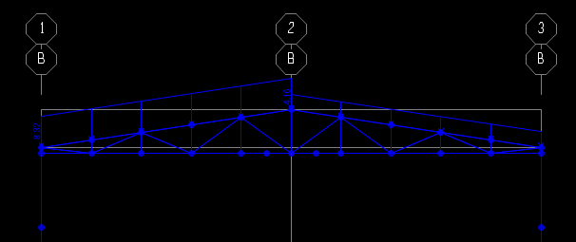

**Figure 7:** Drifted Left snow loads exerted on the beams

### 2.2.4)Wind load Calculations:

Vb = 42 m/s

Cr (z);

Kr = 0.19*(0.3/0.05)0.07= 0.215

z=25 m

Cr (z) = 0.215 * ln (25/0.3) = 0.957

Vm (z) = 42*0.9*1 = 40.19 m/s

Iv = 1/ (ln (25/0.3)) = 0.226

qp (z) = [1+7*0.226]*1.25*0.5*40.192 = 2607 Pa = 2.607 kPa

For pressures, Figure 7.5 and Figure 7.8 (in prEN 1991-1-4:2004) are used. The structure has duopicth roof and the calculations are done according to this. The design roof angle is 8.53 ̊. To find some Cpe,10 values interpolation is required and calculated according to that interpolations. In both directions, Cpe,10’s maximum and minimum values are found and showed in the following figures. (-) means suction and (+) means compression in the related member.

For side pressures, e is calculated as 40 m, and d is also found as 40 m. “Elevation for e ≥ d” is used to calculate Cpe,10 values. For roofs, wind direction is considered in two directions.

**Table 2:** Cpe,10 values found in x-direction from related tables in prEN 1991-1-4:2004

|  |  |  |  |  |  |  |  |  |  |  |
| --- | --- | --- | --- | --- | --- | --- | --- | --- | --- | --- |
| x - direction | | | | | | | | | | |
|  | A | B | C | D | E | F | G | H | I | J |
| Cpe,10 | -1.2 | -0.8 | -0.5 | 0.76 | -0.42 | -1.42 | -1.06 | -0.49 | -0.53 | -0.74 |
| Cpe,10 | -1.2 | -0.8 | -0.5 | 0.76 | -0.42 | -1.42 | -1.06 | -0.49 | -0.53 | -0.74 |
| W(kN/m) | -3.13 | -2.09 | -1.31 | 1.98 | -1.1 | -3.71 | -2.77 | -1.28 | -1.38 | -1.93 |
| W(kN/m) | -3.13 | -2.09 | -1.31 | 1.98 | -1.1 | 0.18 | 0.18 | 0.18 | -1.02 | 0.34 |

In y direction, Cpe,10 values are found as in Table 3.

**Table 3** : Cpe,10 values found in y-direction from in prEN 1991-1-4:2004

|  |  |  |  |  |  |  |  |  |  |
| --- | --- | --- | --- | --- | --- | --- | --- | --- | --- |
| y - direction | | | | | | | | | |
|  | A | B | C | D | E | F | G | H | I |
| Cpe,10 | -1.2 | -0.8 | -0.5 | 0.76 | -0.42 | -1.49 | -1.3 | -0.66 | -0.56 |
| Cpe,10 | -1.2 | -0.8 | -0.5 | 0.76 | -0.42 | -0.6 | -0.53 | -0.27 | -0.23 |
| W(kN/m) | -3.13 | -2.09 | -1.31 | 1.98 | -1.1 | -3.71 | -2.77 | -1.28 | -1.38 |
| W(kN/m) | -1.28 | -0.86 | -1.31 | 0.81 | -0.45 | -1.59 | -1.39 | -0.71 | -0.6 |

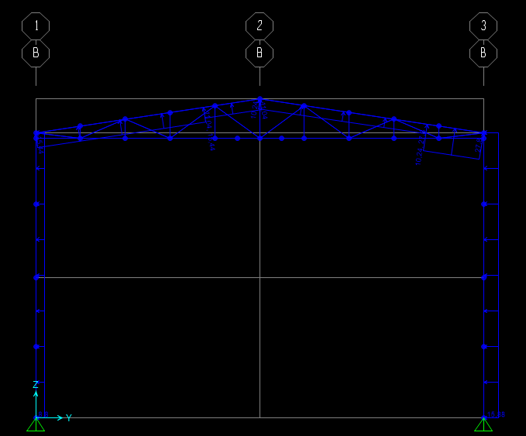

**Figure 8:** Wind in x(+) direction

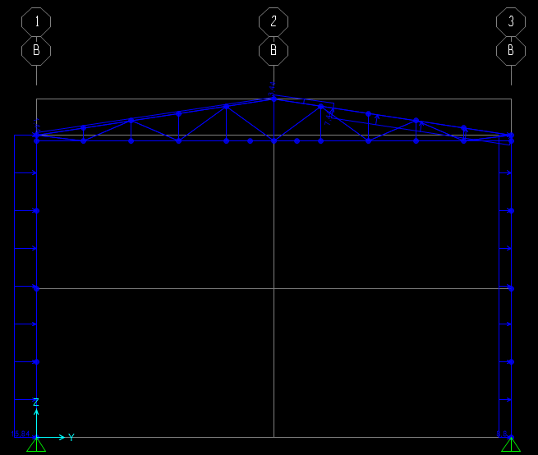

**Figure 9:** Wind in x(-) direction

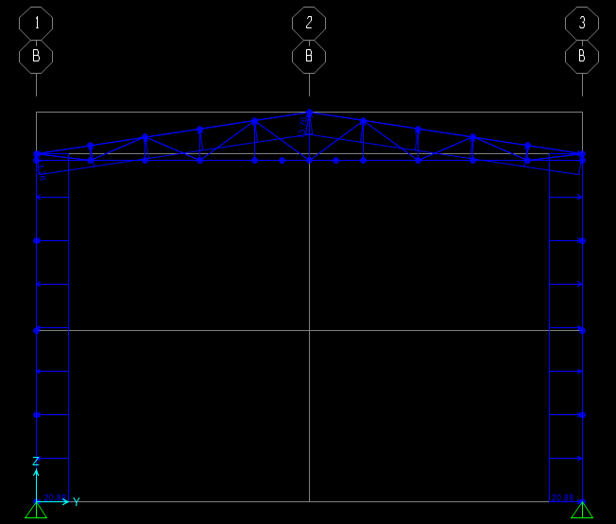

**Figure 10:** Wind in y(+) direction

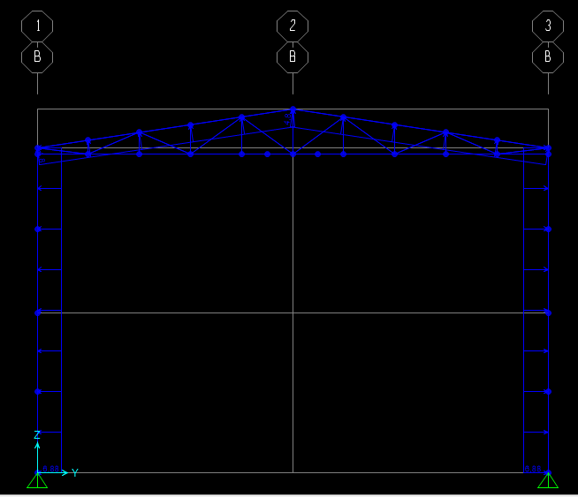

**Figure 11:** Wind in y(-) direction

# 3) CALCULATIONS:

## 3.1) Column Calculations:

According to AISC provision, following equations can be applied.

### 3.1.1) Strong Axies:



**Figure 12 = Column-Beam Overviews**

$$Ga=\frac{\left(\frac{86970}{2500}\right)+\left(\frac{86970}{50}\right)}{\frac{570400}{1000}}=3.11$$

$Gb=10 (recommended value)$

Therefore, by using chart K value is equal to 0.93

$$λ=\frac{kL}{r}=\frac{0.93*2500}{20.98}=110.82<4.71*\sqrt{\left(\frac{{2*10}^{5}}{275}\right)}=127$$

(*In Elastic Buckling)

$$Fe=\frac{π^{2}*E}{λ^{2}}=\frac{π^{2}*2*{10}^{5}}{{110.82}^{2}}=160.73 MPa$$

$$Fcr={(0.658}^{\frac{275}{160.73}})*275=134.38 MPa$$

$$ϕPn=0.9*Fcr*Ag=0.9*134.38*\frac{19750}{{10}^{3}}=2388.60 kN>710.932 kN$$

* OKAY!

### 3.1.2) Weak Axies:

* **K=1 in Weak Direction (braced)**

$$λ=\frac{kL}{r}=\frac{1*2500}{7.24}=345.30>4.71*\sqrt{\left(\frac{{2*10}^{5}}{275}\right)}=127$$

* Elastic Buckling

$$Fe=\frac{π^{2}*E}{λ^{2}}=\frac{π^{2}*2*{10}^{5}}{{345.30}^{2}}=16.55 MPa$$

$$Fcr=0.877*16.55=14.52 MPa$$

$$ϕPn=0.9*Fcr*Ag=0.9*14.52*\frac{19750}{{10}^{3}}=258.07 kN>203.87 kN \left(applied force\right)$$

* OKAY!

## 3.2) Shear Check:

Cv=1 (For Hot Rolled Sections)

$$ϕVn=0.9*0.6*Fy*Aw*Cv=0.9*0.6*275*\left(12*490\right)*\frac{1}{{10}^{3}}=873.18 kN>44.08 kN\left(applied shear\right)$$

## 3.3) Beam-Column Design:

### 3.3.1) Flexural Buckling:

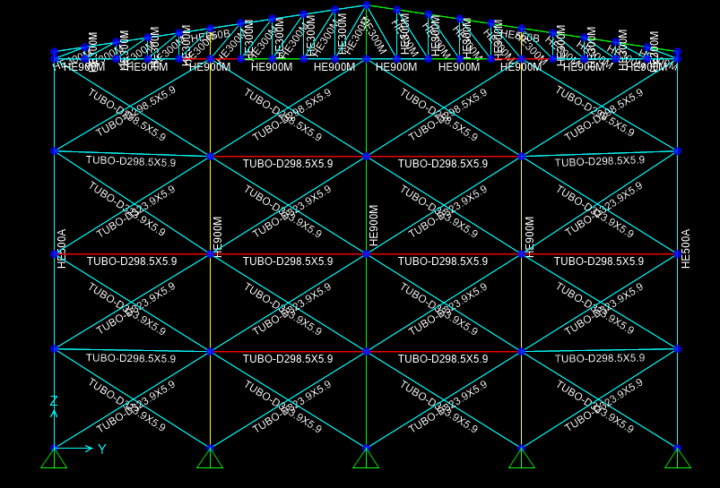

**Figure 13 = Overview of Beam and Columns**

#### 3.3.1.1) Yielding:

${∅*M}_{n}=M_{p}=F_{y}*Z_{x}=0.9*275*14440*\frac{{10}^{3}}{{10}^{6}}=3573.9 kN.m>13.91 kN.m$

#### 3.3.1.2) Lateral Torsional Buckling:

**3.3.1.2.1) Strong Axies:**

$C_{b}=$ 1.753

*It was taken from SAP2000 Software

$L_{b}$ =1000 cm

$L_{p}=1.76*r_{y}*\sqrt{\frac{E}{{F }_{y}}}=1.76*6.60*\sqrt{\frac{200000}{275}}=313.26 cm$

${r_{ts}}^{2}=\frac{\sqrt{I_{y}*C_{w}}}{S_{x}}=\frac{\sqrt{18450*{10}^{3}*34750}}{12540}=63.85 {cm}^{2}$

$$r_{ts}=8 cm$$

$L_{r}=1.95*r_{ts}*\frac{E}{0.7*F_{y}}*\sqrt{\frac{J*c}{S_{x}*h_{0}}+\sqrt{{\left(\frac{J*c}{S_{x}*h_{0}}\right)}^{2}+6.76*{\left(\frac{0.7*F_{y}}{E}\right)}^{2}}}$

$L_{r}=1.95*8*\frac{200000}{0.7*275}*\sqrt{\frac{1671*10}{12540*(910-40)}+\sqrt{{\left(\frac{1671*10}{12540*870}\right)}^{2}+6.76*{\left(\frac{0.7*275}{200000}\right)}^{2}}}$

$L_{r}=$ 1083.09 cm

Lp = 3.13m < Lb = 10 m < Lr = 10.83 m

$M_{n}=F_{cr}*S_{x}$

$F_{cr}=\frac{C_{b}*π^{2}*E}{{\left(\frac{L_{p}}{r_{ts}}\right)}^{2}}*\sqrt{1+0.078*\frac{J*c}{S_{x}*h_{0}}*{\left(\frac{L_{p}}{r_{ts}}\right)}^{2}}$

$F_{cr}=\frac{1.753 *π^{2}*200000}{{\left(\frac{313.26}{8}\right)}^{2}}*\sqrt{1+0.078*\frac{1671*10}{12540*870}*{\left(\frac{313.26}{8}\right)}^{2}}$

$F_{cr}=2454.75 MPa$

$${∅*M}_{n}=0.9*C_{b}*[\left(M_{p}-\left(M_{p}-0.7*Fy*Sx\right)*\left(\frac{L_{b}-L_{p}}{L_{r}-L_{p}}\right)\right]<M_{p}$$

$${∅*M}_{n}=0.9*1.753*\left(3574-\left(3574-0.7*275*12540\right)*\left(\frac{1000-313.26}{1083.9-313.26}\right)\right]<M_{p}$$

$${∅*M}_{n}=4007 knM<M_{p}=3574 kNM$$

Therefore, Mn capacity should be equal as 3574 knM

In Sap2000 analysis, the moment that carried by beam is 13.91 kNM

It is smaller than the capacity.

* According to strong axes of LTB design, the beam HE900M is OKAY

**3.3.1.2.2) Weak Axies:**

There should not be LTB in weak axles direction. According to AISC provision, the following formula can be applied.

$${∅*M}_{n}=0.9*Z_{y}*F_{y}=0.9*275*1929=477.43 kNm$$

According to calculation and Sap2000, the moment which is carried by beam in the weak axes is 24.851 kN m. It is smaller than the capacity. Then,

* According to weak axes of LTB design, the beam HE900M is OKAY

All of calculations can be checked by using following figure.

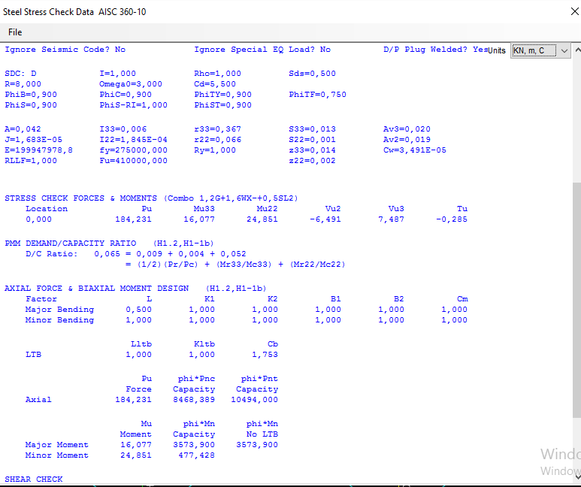

**Figure 14 = Proof of The Calculations**

**3.3.1.2.3) Shear Check:**

Cv=1 (For Hot Rolled Sections) and $ϕ$ can be taken as 1.0 according AISC 360 provisions.

$$ϕVn=1.0*0.6*Fy*Aw*Cv=1.0*0.6*275*\left(21*910\right)*\frac{1}{10^{3}}=3153.15kN> 6.491 kN \left(applied shear\right)$$

* That’s OK!

Again results can be compared with SAP2000 data in following figure.

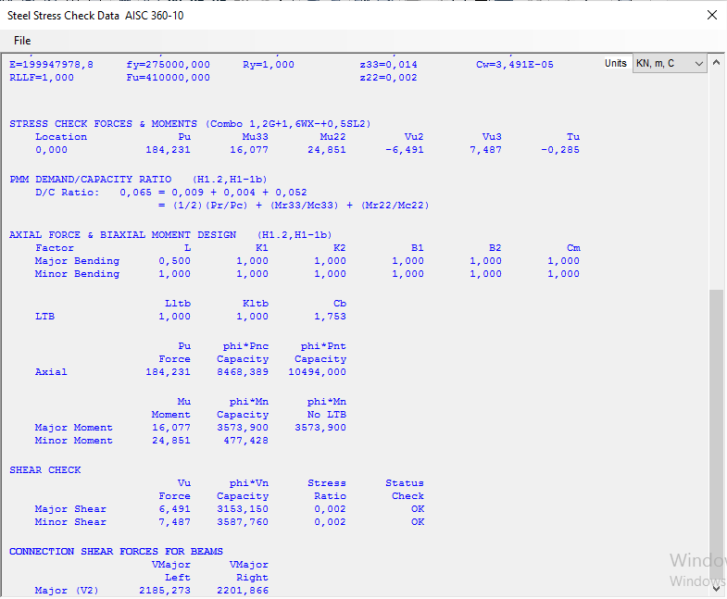

**Figure 15 = Shear Design Results**

### 3.3.2) Beam-Column Check:

In this section, same beam was analyzed according to Beam-Column Design Criteria based on AISC provision.

The important values can be seen below.

P= 184.231 kN (From Sap2000 Software)

P capacity should be calculated.

$$λ=\frac{kL}{ry}=\frac{1*1000}{6.60}=151.54>4.71*\sqrt{\left(\frac{{2*10}^{5}}{275}\right)}=127$$

(*Elastic Buckling)

$$Fe=\frac{π^{2}*E}{λ^{2}}=\frac{π^{2}*2*{10}^{5}}{{151.54}^{2}}=85.98 MPa$$

$$Fcr=0.877*85.98=75.407 MPa$$

$$ϕPc=0.9*Fcr*Ag=0.9*75.407*\frac{42360}{{10}^{3}}=2874 kN$$

Mrx = 16.077 kN m

Mrc = 3574 kNm

Mry= 24.851

Mcy= 477.43 kNm

$$\frac{P}{Pc}=\frac{184.231}{2874}=0.06 <0.2$$

$$\frac{P}{2Pc}+\left(\frac{Mrx}{Mcx}+\frac{Mry}{Mcy}\right)≤1$$

$$\frac{184.231}{2*2874}+\left(\frac{16.077}{3574}+\frac{24.851}{477.43}\right)=0.1≤1$$

The Beam-Column is SAFE

## 3.4) Discussion:

In this part, capacities are much larger than the section whose loads are quite smaller comparing the capacity. Therefore, a designer can be thought that there is a over design. However, this design is only available for that part. For the rest of structure, the loads are huge and there should be big sections such as HEM and HEA. That's why these big sections were used. The other loads and design criterias can be seen in the attached SAP2000 software program file.

## 3.5 ) Bracing Calculations

**3.5.1) Buckling**

TUBO-D-3239x5.9 is used as bracing.

L=11.7925 m

r=0.1019 m= 101.9 mm & Ag=(0.0302-SAPTA) = 30200 mm2 (taken from SAP2000)

k=1 (pin ends)

$$λ=\frac{kL}{r}=\frac{1*11792.5}{101.9}=115.73<4.71*\sqrt{\left(\frac{{2*10}^{5}}{275}\right)}=127$$

$$Fe=\frac{π^{2}*E}{λ^{2}}=\frac{π^{2}*2*{10}^{5}}{115.73x115.73}=147.38 MPa$$

$$Fcr=0.658^(\frac{275}{147.38})*275=125.9375 MPa$$

$$ϕPn=0.9*Fcr*Ag=0.9*125.9375*\frac{30200}{{10}^{3}}$$

$$=3420.98 kN>1113 kN \left(maximum occured force\right)$$

-That’s OK !

**3.6) Purlin Calculations**

Let we assume UPN240

* 4 m spacing is selected for purlin member. Length of purlin will be 8 meters.

-Cover load =0.2*4=0.8 kN

-For self-weight of the channel section 33.2*9.81/103 is distributed as 0.326 kN/m.

DL=0.8+0.326 = 1.126 kN/m

-Snow load of 1.04x4 = 4.16 kN/m is determined.

SL=4.16 kN/m

Wind load of 4x3.89 = 15.56 kN/m (3.89 is the maximum suction pressure acting on the purlin) is determined.

WL= 15.56 kN/m

COMB=1.2DL+1.6SL+0.8WL

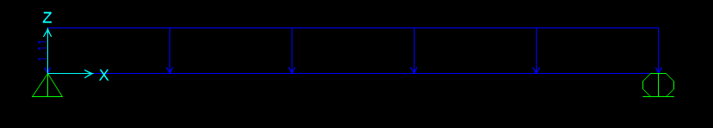

**Figure 22:** Dead load applied on the member

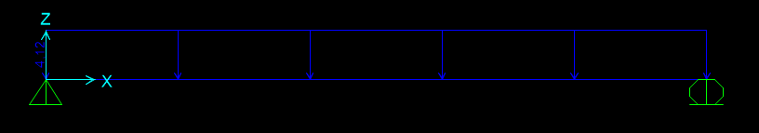

**Figure 23:** Snow load applied on the member

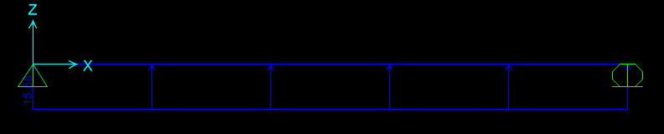

**Figure 23:** Wind load applied on the member

At the end of the analysis UPN240 cannot carry the found load, the section is increased to UPN 350 and it did carry the given load.

# 3.7) Connections

## 3.7.1) Beam-to-Column Connection

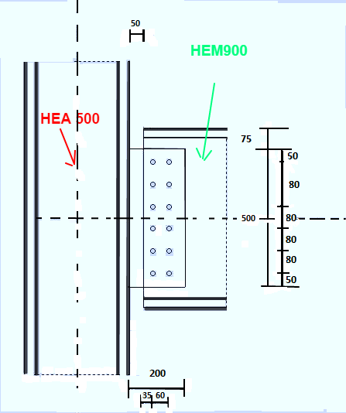

**Figure 23: The connection between beam and column**

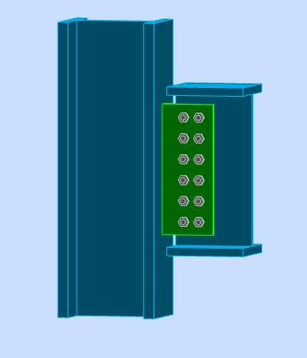 **Figure 24: Connection of beam to column**

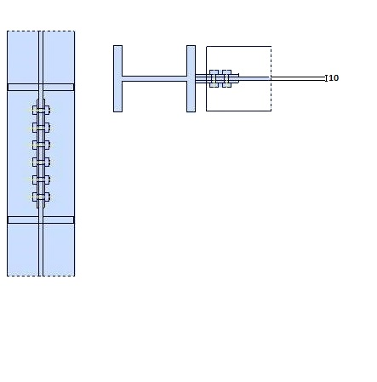 **Figure 25:** Another representation

1. Take Grade 10.9,M20 bolts, , S275

V= 702 kN Obtained via SAP2000

M=702*200 =140.4*103 kN.mm

Vi=702/12=58.5 kN

$$\sum_{k=0}^{n}{Yi^{2}}=2*\left({80}^{2}+{160}^{2}+{240}^{2}+{320}^{2}+{400}^{2}\right)=704000 mm^{2}$$

$$Ni=\frac{200*702*400}{704000}=79.77 kN$$

1. Bolt capacity Determination

V= 58. 5 kN

Frv=

Fnt=0.75*900=675 MPa (Tensile Capacity )

Fnv=0.45*1000=450MPa

F’nt=

Rn= F’nt*Ab=

Ni=79.77<128.798 That’s OK!

## 3.7.2) Bracing Calculation for Column Connection

Because bracing-to-column connection

${F_{nt}}^{'}$ = $1.3*F_{nt}-\frac{F_{nt}}{ϕ*F_{nv}}*f_{rv}≤F_{nt}$

We use this equation is ${F_{nt}}^{'}$ = $F_{nt}$, because the braces are active under only tension or compression due to pinned to the connection $f_{rv}=0$

${F_{nt}}^{'}$ =0.75*900=675 MPa

Bolt Area=(π*202)/4=314.159 mm2

R=675*314.159=211.95 kN/bolt

6 bolts are used 1271.7 kN>1113 kN(maximum occurred force in bracing) kN *That’s OK!

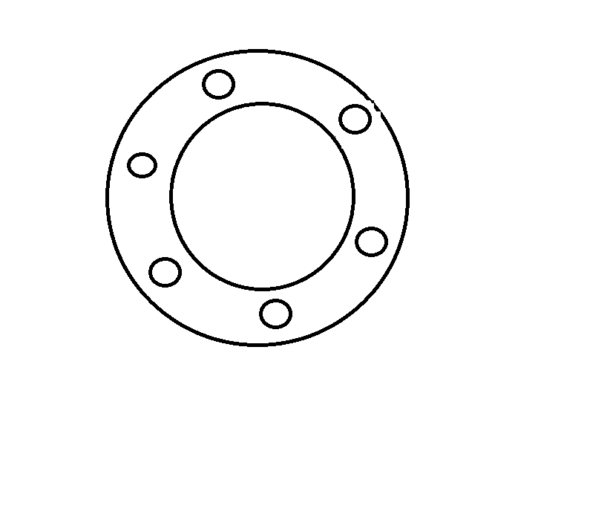

Figure : TUBO-D-3239x5.9 brace connection; note that brace diameter is 3239 mm while the plate diameter is 500 mm.

## 3.7.3) Purlin Calculation for Beam Connection

UPN350 section is used in previous calculations, and

The bolt is M20.

The bolts work under shear force because the purlin effect exists under flexure in this connection,.Therefore, we consider only the shear resistance of M20 bolt.

${F_{nt}}^{'}$ = $1.3*F_{nt}-\frac{F_{nt}}{ϕ*F_{nv}}*f_{rv}≤F_{nt}$

Formulation shown in above cannot be used as we do not have any tensile force on the bolts connecting the purlins and the shear legs. Therefore,we use 45 percent reduction in shear strength of bolts..So,there are calculations in the following;

Fnv=0.45.1000=450 MPa

Bolt Area= (π*20^2)/4=314.159 mm2

R=450*314.159/1000=141.37 kN/bolt

**4)Conclusion:**

In this project, firstly the angle of the roof was determined. Then , according to provisions; snow loads, wind loads, earthquake loads and dead or live loads were calculated respectively. After finding those values, in order to check stabilization of the structure, SAP2000 software program was used. The calculated values were also entered to the software after the shape of the structure was drawn to the program. Then, by making hand calculations and using some iterations, the lightest steel section was tried to select for the structure.

For the structure, a column , a beam and a beam-column design was also checked by hand calculations. Initially, the compression strength of a column was calculated. Then, its shear capacity was also determined. After finding those values, it was seen that the loads that were determined by using provisions are less than section capacities. Same procedure, was also applied for calculation of the flexural strength and the structure that having both beam and column type. As a result, it was observed that all members in the structure is safe according to calculated values. To be more sure of the result, the analyze was also done in the SAP2000 software program and the results were affirmed.

Lastly, connection members were analyzed. The results were above show that the structure also safe for bolts connections.

At the end, the weight of the structure was calculated and it can be seen in the following charts.

**Table .... = The Weight of The Structure**



The weight of the structure is nearly **545** tons.