Homework 1

* Information related to Earthquake (given in the homework)

Earthquake: LOMA PRIETA 10/18/89

Station: GILROY HISTORIC BLDG

Component: 180

Dt: 0.005 sec

# of Data: 7991

Source: PEER Strong Motion Database

Site Class: Z1

* Information related to the earthquake (obtained from internet)

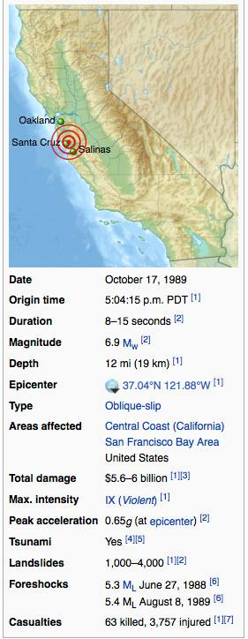

Figure 1. Infoırmation related to earthquake (references listed below)

* Part 1) Plot 𝑢̈𝑔, 𝑢̇𝑔, 𝑢𝑔 vs. time

The following code is used to obtain the plots below:

clear

close all

clc

tic;

% Original acceleration history data

time = 0:0.005:39.95; %delta=0.005 as specified in the hw

accel_read = dlmread('GOF180.txt'); %reading the ground acceleration data from the file

ga = accel_read*(9.80665); %multipying the values by g=9.80665

gv = cumtrapz(time, ga); % Finding ground velocity using cumulative trapezoidal numerical integration

gd = cumtrapz(time, gv); % Finding ground displacement

figure(1)

plot(time,ga) %ploting ground acceleration vs time

title('ground acceleration vs time')

xlabel('time (sec)')

ylabel('acceleration (m/s^2)');

figure(2)

plot(time,gv) %ploting ground velocity vs time

title('ground velocity vs time')

xlabel('time (sec)')

ylabel('ground velocity (m/s)');

figure(3)

plot(time,gd) %ploting ground displacement vs time

title('ground displacement vs time')

xlabel('time (sec)')

ylabel('ground displacement (m)');

Duration = toc;

display(Duration);

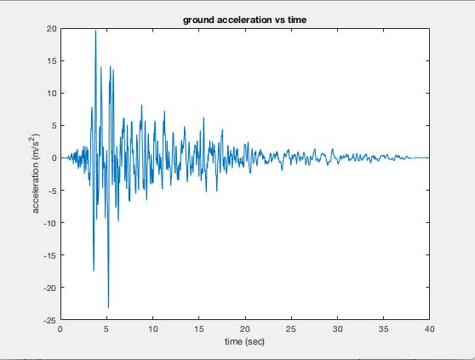

Figure 2. 𝑢̈𝑔 vs time graph

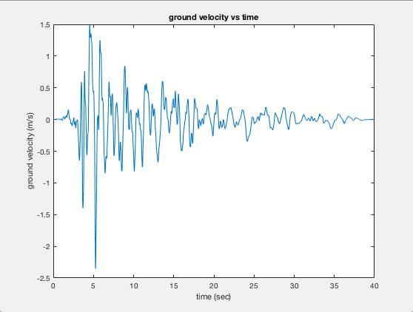

Figure 3. 𝑢̇𝑔 vs time graph

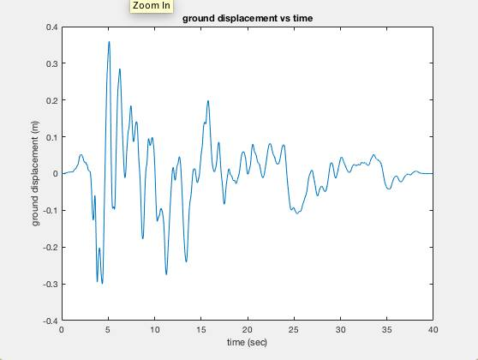

Figure 3. 𝑢𝑔 vs time graph

Part 2) Calculate and plot the following spectra for 2, 5, 10 % damping respectively.

The following code is used to obtain the plots below:

The code given is for damping ratio=2%. The same procedure is used for caping ratio =5% and 10%.

clear

close all

clc

tic;

% Original acceleration history data (ksi=0.02)

time = 0:0.005:39.95; %delta=0.005 as specified in the hw

accel_read = dlmread('GOF180.txt'); %reading the ground acceleration data from the file

p = transpose(accel_read*(9.80665)); %multipying the values by g=9.80665

deltat=0.005

sz_time = size(time,2);

%Code written based on the step-by-steo direct integration procedure described in the book

%Basic Earthquake Engineering (H.Sucuoglu, S. Akkar)

m=1;

ksi=0.02;

T=0.01:0.01:5; %Perid value starts from 0.01 instead of 0. T=0 would give undefined value starting from wn. For T=0, Sa=PGA)

sz_T = size(T,2);

w=zeros(1,sz_T);

c = zeros(1,sz_T);

k = zeros(1,sz_T);

kbar = zeros(1,sz_T);

deltap = zeros(1,sz_time);

deltapbar = zeros(1,sz_time);

deltadisp = zeros(1,sz_time);

deltavel = zeros(1,sz_time);

deltaaccel = zeros(1,sz_time);

disp = zeros(1,sz_time);

vel = zeros(1,sz_time);

accel = zeros(1,sz_time);

%calculations for each time step

for j=1:sz_T %period loop

w(j)=(2*pi())/T(j);

c(j)=2*ksi*w(j)*m;

k(j)=((w(j))^2)*m;

kbar(j)=k(j)+(2*c(j))/(deltat)+(4*m/(deltat^2));

accel(1)=(-p(1)-c(j)*vel(1)-k(j)*disp(1))/m;

totalaccel(1) = accel(1) + p(1);

for i=1:sz_time - 1

deltap(i)=-(p(i+1)-p(i));

deltapbar(i)=deltap(i)+((4*m/deltat)+(2*c(j)))*vel(i)+2*m*accel(i);

deltadisp(i)=deltapbar(i)/kbar(j);

deltavel(i)=((2*deltadisp(i))/(deltat)) - (2*vel(i)) ;

deltaaccel(i)=((4*deltadisp(i))/(deltat^2)) - ((4*vel(i))/(deltat)) - (2*accel(i));

disp(i+1)=disp(i)+deltadisp(i);

vel(i+1)=vel(i)+deltavel(i);

accel(i+1)=accel(i)+deltaaccel(i); %relative acceleration time history for each period

totalaccel(i+1) = accel(i+1) + p(i+1); %total acceleration time history for each period

end

Sa(j) = max(abs(accel+p));

Sd(j)=max(abs(disp));

% pseudoaccel(j)=((2*pi()/T(j))^2)*realdisp(j);

end

figure(1)

plot(T,Sa,'color','b'); hold on;

title('Acceleration Response Spectrum')

xlabel('Period (sec)')

ylabel('Sa (m/s2)');

figure(2)

plot(T,Sd,'color','b'); hold on;

title('Displacement Response Spectrum')

xlabel('Period (sec)')

ylabel('Sd (m)');

Duration = toc;

display(Duration)

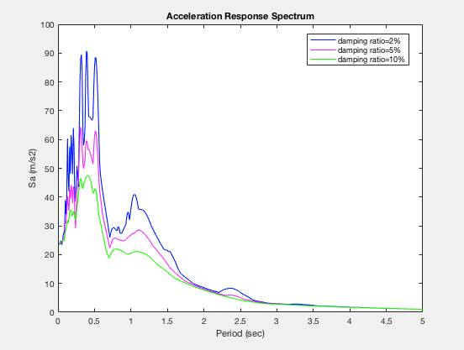

Figure 4. Acceleration Response Spectrum

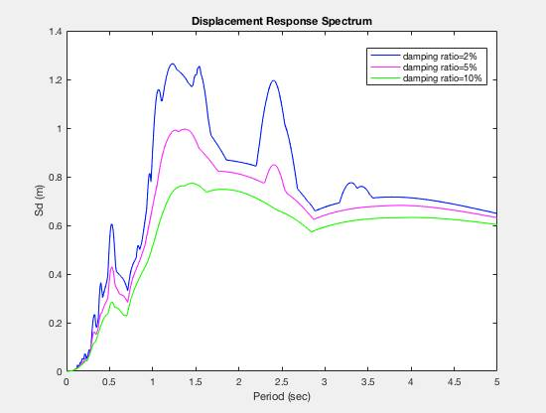

Figure 4. Displacement Response Spectrum

Part 3) Compare the 5% damped Sa with the code Spectrum (TEC2007)

The following plot shows the code Spectrum (TEC2007)

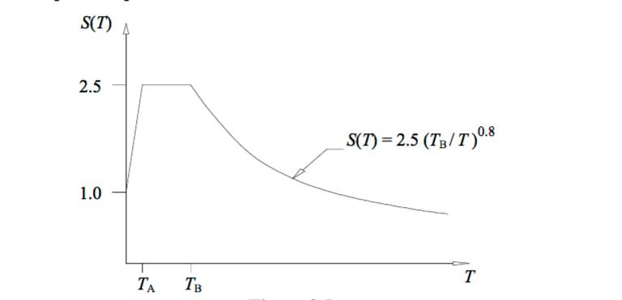

Figure 5. Code Spectrum

Table 1. TA and TB values

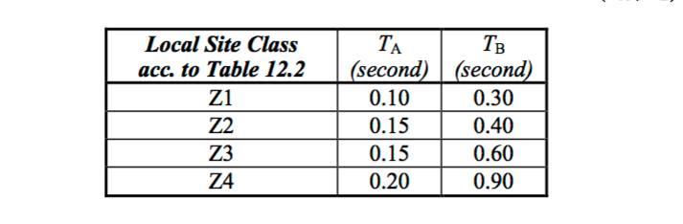

According to my homework data, the site zone I should use is Z1. As shown in the table above for zone 1 TA=0.10 sec and TB=0.30 sec .

Using the code bolow the plot is obtained.

accel_read = dlmread('GOF180.txt'); %reading the ground acceleration data from the file

p = transpose(accel_read*(9.80665)); %multipying the values by g=9.80665

pga=max(abs(p)) %peak ground acceleration

deltat=0.005

sz_time = size(time,2);

%Code written based on the step-by-steo direct integration procedure described in the book

%Basic Earthquake Engineering (H.Sucuoglu, S. Akkar)

m=1;

ksi=0.05;

T=0.01:0.01:5;

sz_T = size(T,2);

w=zeros(1,sz_T);

c = zeros(1,sz_T);

k = zeros(1,sz_T);

kbar = zeros(1,sz_T);

deltap = zeros(1,sz_time);

deltapbar = zeros(1,sz_time);

deltadisp = zeros(1,sz_time);

deltavel = zeros(1,sz_time);

deltaaccel = zeros(1,sz_time);

disp = zeros(1,sz_time);

vel = zeros(1,sz_time);

accel = zeros(1,sz_time);

%calculations for each time step

for j=1:sz_T %period loop

w(j)=(2*pi())/T(j);

c(j)=2*ksi*w(j)*m;

k(j)=((w(j))^2)*m;

kbar(j)=k(j)+(2*c(j))/(deltat)+(4*m/(deltat^2));

accel(1)=(-p(1)-c(j)*vel(1)-k(j)*disp(1))/m;

totalaccel(1) = accel(1) + p(1);

for i=1:sz_time - 1

deltap(i)=-(p(i+1)-p(i));

deltapbar(i)=deltap(i)+((4*m/deltat)+(2*c(j)))*vel(i)+2*m*accel(i);

deltadisp(i)=deltapbar(i)/kbar(j);

deltavel(i)=((2*deltadisp(i))/(deltat)) - (2*vel(i)) ;

deltaaccel(i)=((4*deltadisp(i))/(deltat^2)) - ((4*vel(i))/(deltat)) - (2*accel(i));

disp(i+1)=disp(i)+deltadisp(i);

vel(i+1)=vel(i)+deltavel(i);

accel(i+1)=accel(i)+deltaaccel(i); %relative acceleration time history for each period

totalaccel(i+1) = accel(i+1) + p(i+1); %total acceleration time history for each period

end

Sa(j) = max(abs(accel+p));

Sd(j)=max(abs(disp));

% pseudoaccel(j)=((2*pi()/T(j))^2)*realdisp(j);

end

%Turkish Seismic Desing Code

%Site Class: Z1 (i.e. TA=0.1, TB=0.3)

x=0:0.01:0.1 % T<TA=0.1

y=((1.5*x)/0.1 + 1.0)*pga % where 23.2403 is the value of Sa at T=0.01

x2=0.1:0.01:0.3 %TA<T<TB

y2=2.5*pga

x3=0.3:0.01:5 %T>TB

y3=(2.5*((0.3)*(x3).^(-1)).^0.8)*pga

figure(1)

plot(T,Sa,'color','m'); hold on;

plot(x,y,'color','k'); hold on;

plot(x2,ones(size(x2)) * y2,'color','k'); hold on;

plot(x3,y3,'color','k')

title('Acceleration Response Spectrum')

xlabel('Period (sec)')

ylabel('Sa (m/s^2)');

Duration = toc;

display(Duration);

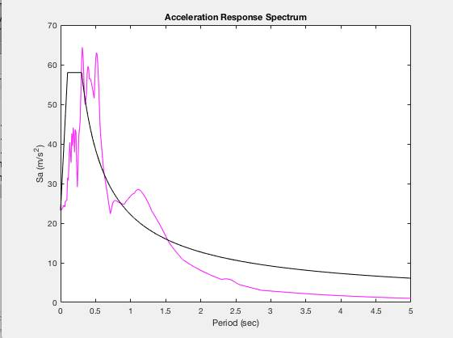

Figure 6. Code Spectrum and Earthqauake ARS

Part 4) Discuss the results obtained in parts 2, 3 and 4.

In the part 1 of the homework, using the given ground acceleration data, and multiplying each of them by g, the necessary plots were obtained.

In part 2, acceleration response spectra and displacement response spectra were obtained for different values of damping ratio. As it can be seen from the graphs, a higher value of damping ratio gives lower values of displacement and acceleration. This is logical because damping ratio describes the decay in oscillations. A higher damping ratio means that the decay will be bigger, yielding smaller displacement and acceleration values.

In part 3, Tukish Code Response Spectra is plotted. Design response spectrum is normally obtained by taking and smoothing the mean of a set of response spectra for a desired seismic zone. Since the design spectrum is a mean of a large number of spectra, the values of acceleration corresponding to TA and TB are not the same as the ones of our Acceleration Response Spectra. However, as it can be seen at figure 6, the values are reasonable.

For TA= 0.10 sec and TB= 0.30 sec, according to design spectrum, Sa=PGA*2.5=58.01 m/s2. According to our graph for TA= 0.10 sec, Sa=31.47 m/s2 and for Tb= 0.30 sec Sa=60.67 m/s2

*Note that acceleratin values are multilied by g

References

(1) Stover, C. W.; Coffman, J. L. (1993), Seismicity of the United States, 1568–1989 (Revised), U.S. Geological Survey Professional Paper 1527, United States Government Printing Office, pp. 98, 99, 180–186

(2) Clough, G. W.; Martin, II, J. R.; Chameau, J. L. (1994), "The geotechnical aspects", Practical lessons from the Loma Prieta earthquake, National Academies Press, pp. 29–46, ISBN 978-0309050302

(3) Housner 1990, pp. 19–23

(4) Ma, K.; Satake, K.; Kanamori, H. (1991), "The origin of the tsunami excited by the 1989 Loma Prieta Earthquake –Faulting or slumping–" (PDF), Geophysical Research Letters, American Geophysical Union, 18 (4): 637–640, Bibcode:1991GeoRL..18..637M, doi:10.1029/91gl00818

(5) Breaker, L. C.; Murty, T. S.; Norton, J. G.; Carrol, D. (2009), "Comparing sea level response at Monterey, California from the 1989 Loma Prieta earthquake and the 1964 Great Alaskan earthquake" (PDF), Science of Tsunami Hazards, Tsunami Society,pp. 255–271

(6) Perfettini, H.; Stein, R. S.; Simpson, R.; Cocco, M. (1999), "Stress transfer by the 1988–1989 M = 5.3 and 5.4 Lake Elsman foreshocks to the Loma Prieta fault: Unclamping at the site of peak mainshock slip" (PDF), Journal of Geophysical Research: Solid Earth, Wiley, 104 (B9): 20,169, 20,173, 20,174, Bibcode:1999JGR...10420169P, doi:10.1029/1999JB900092

(7) Bolt, B. (2005), Earthquakes: 2006 Centennial Update – The 1906 Big One (Fifth ed.), W. H. Freeman and Company, pp. 10–14, 293–297, ISBN 978-0716775485