***MIDDLE EAST TECHNICAL UNIVERSITY***



***CE -490-***

***Homework 1***

***20.03.2017***

***Prepared by***

1. Introduction

In this homework, acceleration data is given and with the data some of the earthquake related properties are calculated using Matlab software. Site related information are given below.

Earthquake: Loma Prieta 10/18/89

Station: Gilroy Array #2

Component: 090

Dt: 0.005 sec

# of Data: 7990

Source: PEER Strong Motion Database

Site Class: Z3

1. Answers
2. 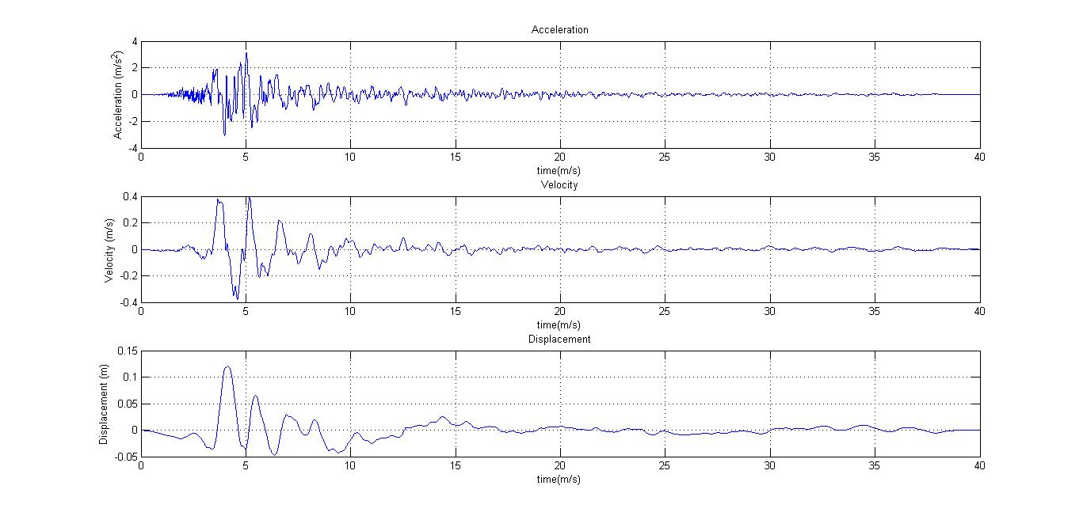

In this figure acceleration, velocity and displacement of this earthquake can be seen in the above three plot.

In this question, spectral accelerations and displacements are plotted in the below graphs. For the upper graph, one can see displacement response spectra for 2, 5 and 10 % damping. At the uppermost line, there is 2% damping and at the middle section 5 % and below there is 10 % damping. For the second graph, also same line is satisfied. For the uppermost, there is 2% and continues as same as the first graph.

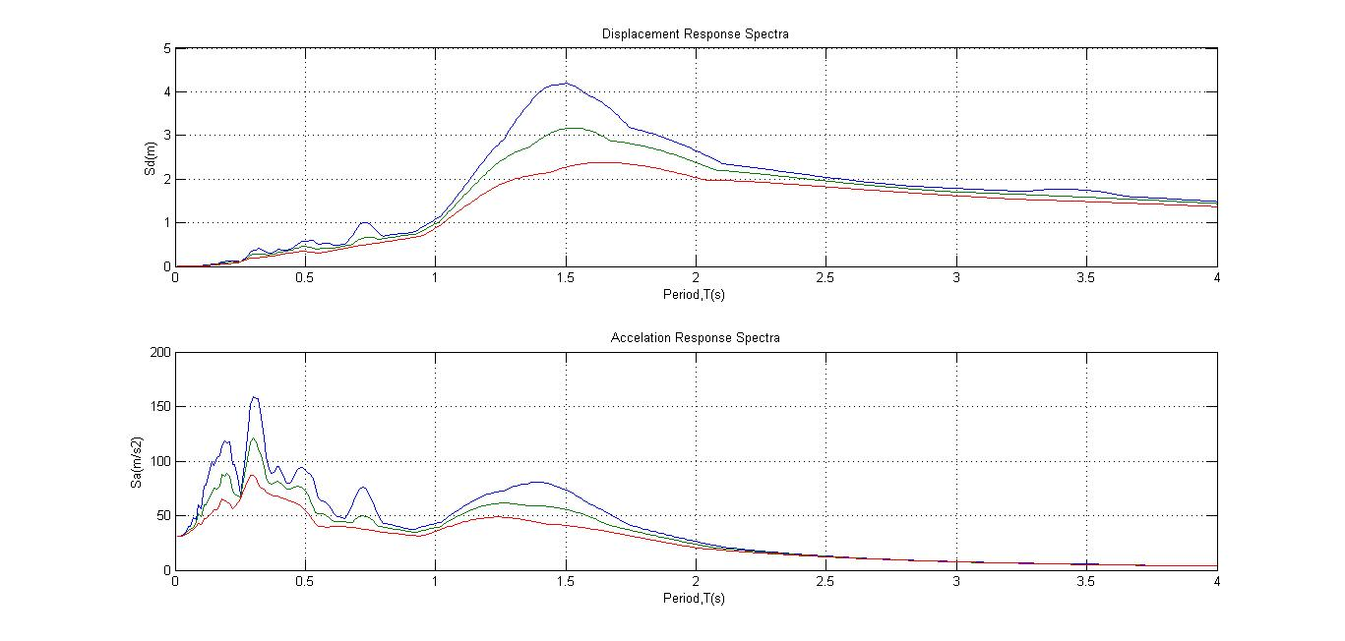



For the third question, a comparison with TEC2007 for the 5 % damping is done. And in the below graph it can be found.

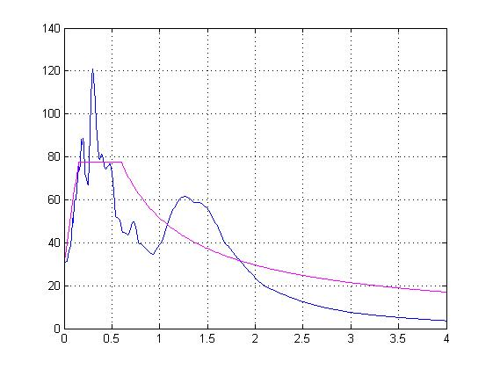

For the second question it can be said that, as damping increases, displacement and acceleration will be decrease due to equation of motion. Another thing is that PSa is not given in the figure since below 20 % damping PSa and Sa are almost equal.

For the third question, as can be seen that, a linearization is made for the simplicity. In the code, a much simpler equation is given and for the real life purposes, it is convenient.