***MIDDLE EAST TECHNICAL UNIVERSITY***



***CE -490-***

***Homework 2***

***02.04.2017***

***Prepared by***

1. For the first question of the homework, it is requested to find horizontal design

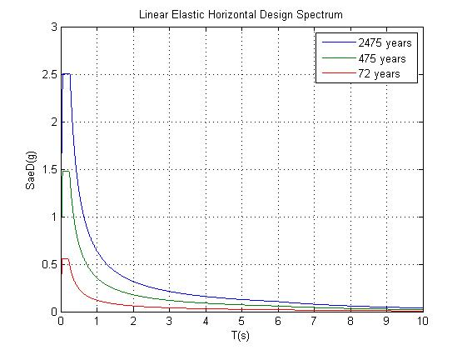spectra from afad internet site. Assigned place is for me Kocaeli, Derince. With the found values from the internet site, 72, 475 and 2475 years of return period spectra are plotted below.

Legend is given in the figure. However, for a better understanding, highest spectrum is belongs to 2475 years which is DD-1, middle spectrum is 475 years which is DD-2 and lowest spectrum is 72 years which is DD-3.

1. For the second question, a comparison is requested for the two sites. A plot is given

for comparison.

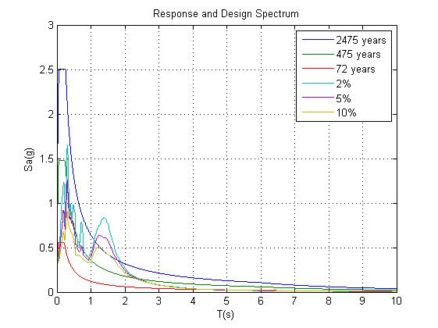

It can be seen that spectrum which belongs to Kocaeli,Derince is much higher intensity than those in Loma Prieta in 1989. There might be some reasons behind it such as ground condition, soil type or maybe Kocaeli is closer to the fault which might be ended with such results. 2475 years spectrum is almost twice of that with 2 % damping spectrum. On the other hand for 475 years return period and 2 % damping are close to each other. Nevertheless, a correlation between those spectra is not expected since they are not in the same region nor they are close to each other. Yet, they are not too different than each other.