

MIDDLE EAST TECHNICAL UNIVERSITY

DEPARTMENT OF CIVIL ENGINEERING

CE490- Introduction to Earthquake Engineering

Homework II

Instructor

Prof. Dr. Uğurhan AKYÜZ

Prepared by

02.04.2018

* Information related to earthquake *(taken from homework)*:

Earthquake: Morgan Hill 04/24/84

Station: Gilroy Array #4

Component: 360

Dt: 0.005 sec

# of Data: 7996

Source: PEER Strong Motion Database

Site Class: Z3

* Information related to earthquake *(taken from the Internet)*:

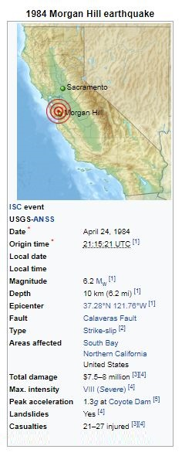

**Figure 1.** General information about 1984 Morgan Hill earthquake

1.) The code given below is used to obtain necessary plots:

clear

close all

clc

tic;

% Original acceleration history data

time = 0:0.005:39.975; %delta=0.005 as specified in the hw

accel_read = dlmread('G04360.txt'); %reading the ground acceleration data from the file

ga = accel_read*(9.80665); %multipying the values by g=9.80665

gv = cumtrapz(time, ga); % Finding ground velocity using cumulative trapezoidal numerical integration

gd = cumtrapz(time, gv); % Finding ground displacement

figure(1)

plot(time,ga) %ploting ground acceleration vs time

title('ground acceleration vs time')

xlabel('time (sec)')

ylabel('acceleration (m/s^2)');

figure(2)

plot(time,gv) %ploting ground velocity vs time

title('ground velocity vs time')

xlabel('time (sec)')

ylabel('ground velocity (m/s)');

figure(3)

plot(time,gd) %ploting ground displacement vs time

title('ground displacement vs time')

xlabel('time (sec)')

ylabel('ground displacement (m)');

Duration = toc;

display(Duration);

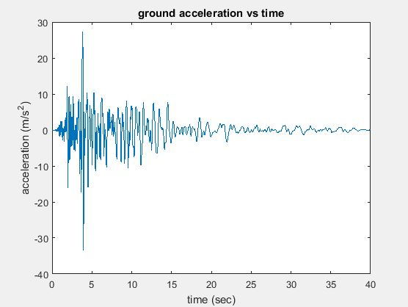

**Figure 2.** 𝑢̈𝑔 vs time graph

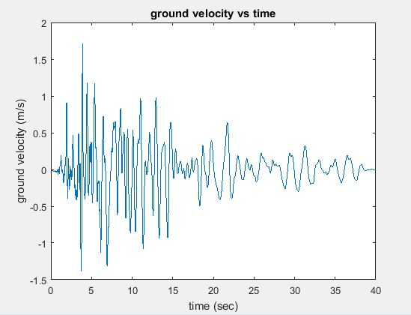

**Figure 3.** 𝑢̇𝑔 vs time graph

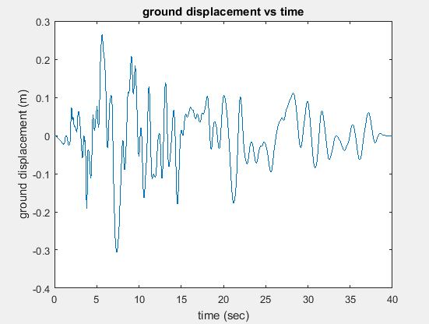

**Figure 4.** 𝑢𝑔 vs time graph

2.) The code given below is used to obtain necessary plots:

clear

close all

clc

tic;

% Original acceleration history data (ksi=0.02)

time = 0:0.005:39.975; %delta=0.005 as specified in the hw

accel_read = dlmread('G04360.txt'); %reading the ground acceleration data from the file

p = transpose(accel_read*(9.80665)); %multipying the values by g=9.80665

deltat=0.005

sz_time = size(time,2);

%Code written based on the step-by-steo direct integration procedure described in the book

%Basic Earthquake Engineering (H.Sucuoglu, S. Akkar)

m=1;

ksi=0.02;

T=0.01:0.01:5;

sz_T = size(T,2);

w=zeros(1,sz_T);

c = zeros(1,sz_T);

k = zeros(1,sz_T);

kbar = zeros(1,sz_T);

deltap = zeros(1,sz_time);

deltapbar = zeros(1,sz_time);

deltadisp = zeros(1,sz_time);

deltavel = zeros(1,sz_time);

deltaaccel = zeros(1,sz_time);

disp = zeros(1,sz_time);

vel = zeros(1,sz_time);

accel = zeros(1,sz_time);

%calculations for each time step

for j=1:sz_T %period loop

w(j)=(2*pi())/T(j);

c(j)=2*ksi*w(j)*m;

k(j)=((w(j))^2)*m;

kbar(j)=k(j)+(2*c(j))/(deltat)+(4*m/(deltat^2));

accel(1)=(-p(1)-c(j)*vel(1)-k(j)*disp(1))/m;

totalaccel(1) = accel(1) + p(1);

for i=1:sz_time - 1

deltap(i)=-(p(i+1)-p(i));

deltapbar(i)=deltap(i)+((4*m/deltat)+(2*c(j)))*vel(i)+2*m*accel(i);

deltadisp(i)=deltapbar(i)/kbar(j);

deltavel(i)=((2*deltadisp(i))/(deltat)) - (2*vel(i)) ;

deltaaccel(i)=((4*deltadisp(i))/(deltat^2)) - ((4*vel(i))/(deltat)) - (2*accel(i));

disp(i+1)=disp(i)+deltadisp(i);

vel(i+1)=vel(i)+deltavel(i);

accel(i+1)=accel(i)+deltaaccel(i); %relative acceleration time history for each period

totalaccel(i+1) = accel(i+1) + p(i+1); %total acceleration time history for each period

end

Sa(j) = max(abs(accel+p));

Sd(j)=max(abs(disp));

% pseudoaccel(j)=((2*pi()/T(j))^2)*realdisp(j);

end

% Original acceleration history data (ksi=0.05)

time1 = 0:0.005:39.975;

accel_read1 = dlmread('G04360.txt');

p1 = transpose(accel_read1*(9.80665));

deltat1=0.005

sz_time1 = size(time1,2);

m1=1;

ksi1=0.05;

T1=0.01:0.01:5;

sz_T1 = size(T1,2);

w1=zeros(1,sz_T1);

c1 = zeros(1,sz_T1);

k1 = zeros(1,sz_T1);

kbar1 = zeros(1,sz_T1);

deltap1 = zeros(1,sz_time1);

deltapbar1 = zeros(1,sz_time1);

deltadisp1 = zeros(1,sz_time1);

deltavel1 = zeros(1,sz_time1);

deltaaccel1 = zeros(1,sz_time1);

disp1 = zeros(1,sz_time1);

vel1 = zeros(1,sz_time1);

accel1 = zeros(1,sz_time1);

%calculations for each time step

for j1=1:sz_T1 %period loop

w1(j1)=(2*pi())/T1(j1);

c1(j1)=2*ksi1*w1(j1)*m1;

k1(j1)=((w1(j1))^2)*m1;

kbar1(j1)=k1(j1)+(2*c1(j1))/(deltat1)+(4*m1/(deltat1^2));

accel1(1)=(-p1(1)-c1(j1)*vel1(1)-k1(j1)*disp1(1))/m1;

totalaccel1(1) = accel1(1) + p1(1);

for i1=1:sz_time1 - 1

deltap1(i1)=-(p1(i1+1)-p1(i1));

deltapbar1(i1)=deltap1(i1)+((4*m1/deltat1)+(2*c1(j1)))*vel1(i1)+2*m1*accel1(i1);

deltadisp1(i1)=deltapbar1(i1)/kbar1(j1);

deltavel1(i1)=((2*deltadisp1(i1))/(deltat1)) - (2*vel1(i1)) ;

deltaaccel1(i1)=((4*deltadisp1(i1))/(deltat1^2)) - ((4*vel1(i1))/(deltat1)) - (2*accel1(i1));

disp1(i1+1)=disp1(i1)+deltadisp1(i1);

vel1(i1+1)=vel1(i1)+deltavel1(i1);

accel1(i1+1)=accel1(i1)+deltaaccel1(i1); %relative acceleration time history for each period

totalaccel1(i1+1) = accel1(i1+1) + p1(i1+1); %total acceleration time history for each period

end

Sa1(j1) = max(abs(accel1+p1));

Sd1(j1)=max(abs(disp1));

% pseudoaccel(j)=((2*pi()/T(j))^2)*realdisp(j);

end

% Original acceleration history data (ksi=0.1)

time2 = 0:0.005:39.975;

accel_read2 = dlmread('G04360.txt');

p2 = transpose(accel_read2*(9.80665));

deltat2=0.005

sz_time2 = size(time2,2);

m2=1;

ksi2=0.10;

T2=0.01:0.01:5;

sz_T2 = size(T2,2);

w2=zeros(1,sz_T2);

c2 = zeros(1,sz_T2);

k2 = zeros(1,sz_T2);

kbar2 = zeros(1,sz_T2);

deltap2 = zeros(1,sz_time2);

deltapbar2 = zeros(1,sz_time2);

deltadisp2 = zeros(1,sz_time2);

deltavel2 = zeros(1,sz_time2);

deltaaccel2 = zeros(1,sz_time2);

disp2 = zeros(1,sz_time2);

vel2 = zeros(1,sz_time2);

accel2 = zeros(1,sz_time2);

%calculations for each time step

for j2=1:sz_T2 %period loop

w2(j2)=(2*pi())/T(j2);

c2(j2)=2*ksi2*w(j2)*m2;

k2(j2)=((w2(j2))^2)*m2;

kbar2(j2)=k2(j2)+(2*c2(j2))/(deltat2)+(4*m2/(deltat2^2));

accel2(1)=(-p2(1)-c2(j2)*vel2(1)-k2(j2)*disp2(1))/m2;

totalaccel2(1) = accel2(1) + p2(1);

for i2=1:sz_time2 - 1

deltap2(i2)=-(p2(i2+1)-p2(i2));

deltapbar2(i2)=deltap2(i2)+((4*m2/deltat2)+(2*c2(j2)))*vel2(i2)+2*m2*accel2(i2);

deltadisp2(i2)=deltapbar2(i2)/kbar2(j2);

deltavel2(i2)=((2*deltadisp2(i2))/(deltat2)) - (2*vel2(i2)) ;

deltaaccel2(i2)=((4*deltadisp2(i2))/(deltat2^2)) - ((4*vel2(i2))/(deltat2)) - (2*accel2(i2));

disp2(i2+1)=disp2(i2)+deltadisp2(i2);

vel2(i2+1)=vel2(i2)+deltavel2(i2);

accel2(i2+1)=accel2(i2)+deltaaccel2(i2); %relative acceleration time history for each period

totalaccel2(i2+1) = accel2(i2+1) + p2(i2+1); %total acceleration time history for each period

end

Sa2(j2) = max(abs(accel2+p2));

Sd2(j2)=max(abs(disp2));

% pseudoaccel(j)=((2*pi()/T(j))^2)*realdisp(j);

end

figure(1)

plot(T,Sa,'color','b'); hold on;

plot(T1,Sa1,'color','m');hold on;

plot(T2,Sa2,'color','g')

title('Acceleration Response Spectrum')

xlabel('Period (sec)')

ylabel('Sa (m/s2)');

legend('damping ratio: 2%','damping ratio: 5%','damping ratio: 10%')

figure(2)

plot(T,Sd,'color','b'); hold on;

plot(T1,Sd1,'color','m'); hold on;

plot(T2,Sd2,'color','g')

title('Displacement Response Spectrum')

xlabel('Period (sec)')

ylabel('Sd (m)');

legend('damping ratio: 2%','damping ratio: 5%','damping ratio: 10%','Location','southeast')

Duration = toc;

display(Duration);

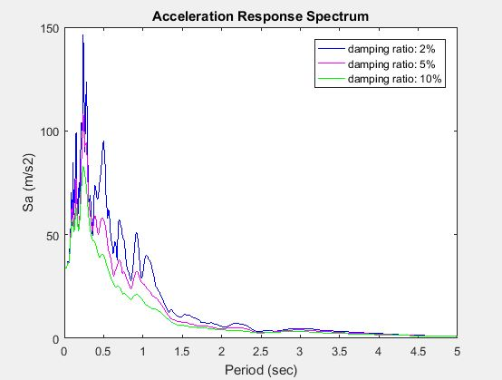

**Figure 5.** Acceleration Response Spectrum

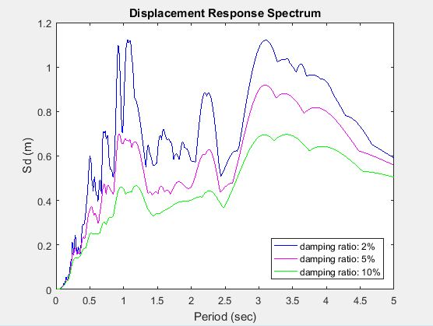

**Figure 6.** Displacement Response Spectrum

3.) According to given data to me, my location is Yalova – Center (coordinates with latitude is 40.6549° and longitude is 29.2842°) and the local soil class is ZD. Using data obtained from the Turkish Seismic Hazard Map, the graph of the linear elastic horizontal design spectrum for 72, 475 and 2475 years return periods was plotted. *(Excel was used for this process because the Turkish Seismic Hazard Map did not give spectra on same plot.)*

**Figure 7.** Linear elastic horizontal design spectrum from the Turkish Seismic Hazard

Map for 72, 475 and 2475 years return periods

4.) The code given below is used to obtain necessary plot:

clear

close all

clc

tic;

% Original acceleration history data (ksi=0.02)

time = 0:0.005:39.975;

accel_read = dlmread('G04360.txt'); %reading the ground acceleration data from the file

p = transpose(accel_read*(9.80665)); %multipying the values by g=9.80665

pga=max(abs(p))

deltat=0.005

sz_time = size(time,2);

%Code written based on the step-by-steo direct integration procedure described in the book

%Basic Earthquake Engineering (H.Sucuoglu, S. Akkar)

m=1;

ksi=0.05;

T=0.01:0.01:5;

sz_T = size(T,2);

w=zeros(1,sz_T);

c = zeros(1,sz_T);

k = zeros(1,sz_T);

kbar = zeros(1,sz_T);

deltap = zeros(1,sz_time);

deltapbar = zeros(1,sz_time);

deltadisp = zeros(1,sz_time);

deltavel = zeros(1,sz_time);

deltaaccel = zeros(1,sz_time);

disp = zeros(1,sz_time);

vel = zeros(1,sz_time);

accel = zeros(1,sz_time);

%calculations for each time step

for j=1:sz_T %period loop

w(j)=(2*pi())/T(j);

c(j)=2*ksi*w(j)*m;

k(j)=((w(j))^2)*m;

kbar(j)=k(j)+(2*c(j))/(deltat)+(4*m/(deltat^2));

accel(1)=(-p(1)-c(j)*vel(1)-k(j)*disp(1))/m;

totalaccel(1) = accel(1) + p(1);

for i=1:sz_time -1

deltap(i)=-(p(i+1)-p(i));

deltapbar(i)=deltap(i)+((4*m/deltat)+(2*c(j)))*vel(i)+2*m*accel(i);

deltadisp(i)=deltapbar(i)/kbar(j);

deltavel(i)=((2*deltadisp(i))/(deltat)) - (2*vel(i)) ;

deltaaccel(i)=((4*deltadisp(i))/(deltat^2)) - ((4*vel(i))/(deltat)) - (2*accel(i));

disp(i+1)=disp(i)+deltadisp(i);

vel(i+1)=vel(i)+deltavel(i);

accel(i+1)=accel(i)+deltaaccel(i); %relative acceleration time history for each period

totalaccel(i+1) = accel(i+1) + p(i+1); %total acceleration time history for each period

end

Sa(j) = max(abs(accel+p));

Sd(j)=max(abs(disp));

% pseudoaccel(j)=((2*pi()/T(j))^2)*realdisp(j);

end

figure(1)

plot(T,Sa,'color','m'); hold on;

title('Acceleration Response Spectrum')

xlabel('Period (sec)')

ylabel('Sa (m/s^2)');

legend('damping ratio: 5%')

Duration = toc;

display(Duration);

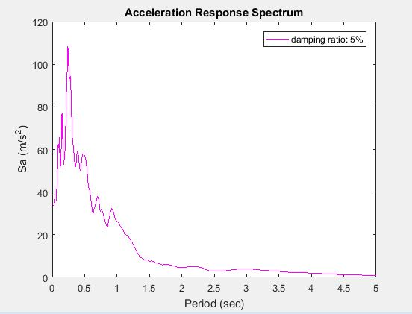

**Figure 8.** Acceleration Response Spectrum for 5% damping *(graph is from Matlab)*

**Figure 9.** Linear elastic horizontal design spectrum for years return period *(graph is from Excel)*

5.) In the first part of the homework, to obtain necessary plots (𝑢̈𝑔, 𝑢̇𝑔, 𝑢𝑔 vs. time), the given ground acceleration data is used and multiplied each of them by g.

In the second part of the homework, for 2, 5 and 10 % damping ratios acceleration displacement response spectra and displacement response spectra were calculated. According to the graphs, when damping ratio increases, acceleration and displacement values decreases. This makes sense because it describes how oscillations in a system decay after a disturbance. So, having higher damping ratio means that bigger decay and smaller displacement and acceleration values will be obtained.

In the third part of the homework, the linear elastic horizontal design spectrum from the Turkish Seismic Hazard Map for 72, 475 and 2475 years return periods were obtained and plotted. When we look at the related plot, we can say that design spectrum will increase with larger return periods.

In the fourth part of the homework, 5% damped Sa spectrum obtained in Part 2 and 475-year design spectrum from Part 3 were compared. The design response spectrum is ordinarily obtained by considering and ordering the mean of s set of response spectra for a seismic zone. Because of that, values of acceleration are not same as the acceleration response spectra. This can be seen in Figure 8 and Figure 9.

References

1. Sucuoğlu, H. Akkar, S., 2014. Basic Earthquake Engineering: From Seismology to Analysis and Design, 1st edition. Springer International Publishing, 288 pages.
2. Stover, C. W., Coffman, J. L., 1993. Seismicity of the United States, 1568–1989 (Revised), U.S. Geological Survey Professional Paper 1527, United States Government Printing Office
3. Bolt, B., 2005. Earthquakes: 2006 Centennial Update – The 1906 Big One, 5th edition. W. H. Freeman and Company, ISBN 978-0716775485
4. Fahjan Y., 2017. Türk Bina Deprem Yönetmeliği (TBDY, 2017) Tabanlı Tasarım Spektrumları, TMMOB İnşaat Mühendisleri Odası İzmir Şubesi
5. (n.d.). Retrieved from https://tdth.afad.gov.tr/