

MIDDLE EAST TECHNICAL UNIVERSITY

DEPARTMENT OF CIVIL ENGINEERING

CE 490 - INTRODUCTION TO EARTHQUAKE ENGINEERING

Take Home Exam

Instructor

Prof. Dr. Uğurhan AKYÜZ

Prepared by

29.05.2018

**TABLE OF CONTENT**

Hand Calculation……………………………………………………………………….…..…….………...2

Computer Programming Calculation……………………………………………………...................….....6

References………………………………………………………………………………………………....20

1.) Design spectrum

My location is Yalova- Center and the local site class for this place is ZD. In the light of these information, related data was taken from the web tool of the Turkish Seismic Hazard Map. And design response spectrum curve for DD-2 (recurrence interval of 475 years) and reduced one can be seen below:

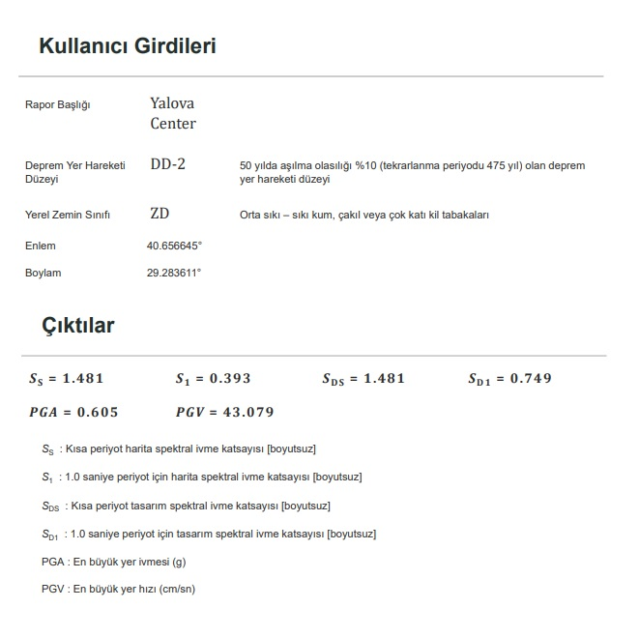

**Figure 1.** The data is taken from *https://tdth.afad.gov.tr/*

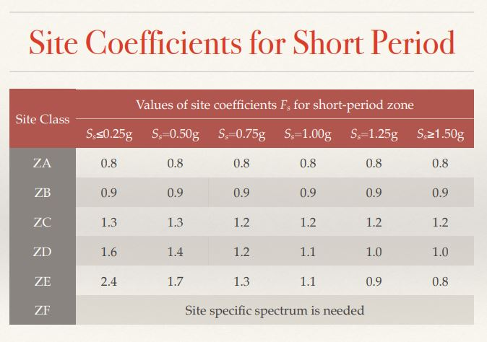

**Figure 2.** Site coefficients for short period

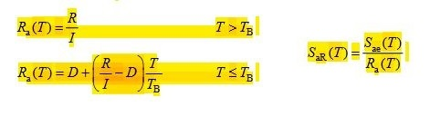

**Figure 3.** Formulas of earthquake response reduction factor and reduced (inelastic) acceleration response spectrum from TSC2018

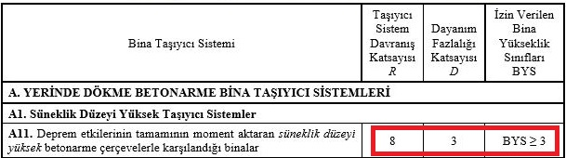

**Figure 4.** Structural system behavior factor, R and a coefficient, D for buildings have more than three stories TSC2018

|  |  |  |  |  |
| --- | --- | --- | --- | --- |
| **T(s)** | **Sₐₑ(g)** | **S*g(m/s^2)** | **R** | **S/R** |
| 0.000 | 0.591 | 5.79771 | 3 | 1.93257 |
| 0.050 | 1.028 | 10.08468 | 3.494071 | 2.886226 |
| 0.100 | 1.466 | 14.38146 | 3.988142 | 3.606055 |
| 0.101 | 1.477 | 14.48937 | 3.998024 | 3.624133 |
| 0.150 | 1.477 | 14.48937 | 4.482213 | 3.232637 |
| 0.200 | 1.477 | 14.48937 | 4.976285 | 2.911684 |
| 0.250 | 1.477 | 14.48937 | 5.470356 | 2.648707 |
| 0.300 | 1.477 | 14.48937 | 5.964427 | 2.429298 |
| 0.350 | 1.477 | 14.48937 | 6.458498 | 2.243458 |
| 0.400 | 1.477 | 14.48937 | 6.952569 | 2.084031 |
| 0.450 | 1.477 | 14.48937 | 7.44664 | 1.945759 |
| 0.500 | 1.477 | 14.48937 | 7.940711 | 1.824694 |
| 0.506 | 1.477 | 14.48937 | 8 | 1.811171 |
| 0.550 | 1.360 | 13.3416 | 8 | 1.6677 |
| 0.600 | 1.247 | 12.23307 | 8 | 1.529134 |
| 0.650 | 1.151 | 11.29131 | 8 | 1.411414 |
| 0.700 | 1.068 | 10.47708 | 8 | 1.309635 |
| 0.750 | 0.997 | 9.78057 | 8 | 1.222571 |
| 0.800 | 0.935 | 9.17235 | 8 | 1.146544 |
| 0.850 | 0.880 | 8.6328 | 8 | 1.0791 |
| … | … | … | … | … |

**Table 1.** Design response spectrum values

**Figure 5.** The graph of linear elastic and reduced (inelastic) design spectrum

To input data to the SAP2000 program, I used ones that I already calculated in hand calculations.

2.) Equivalent Lateral Load Analysis

|  |  |  |  |  |  |  |
| --- | --- | --- | --- | --- | --- | --- |
| **TABLE: Modal Participating Mass Ratios** | | | |  |  |  |
| **OutputCase** | **StepType** | **StepNum** | **Period** | **UX** | **UY** | **UZ** |
| Text | Text | Unitless | Sec | Unitless | Unitless | Unitless |
| MODAL | Mode | 1 | 0.820782 | 0.85709 | 0 | 0 |
| MODAL | Mode | 2 | 0.205198 | 0.12317 | 0 | 0 |
| MODAL | Mode | 3 | 0.08692 | 0.01974 | 0 | 0 |
| MODAL | Mode | 4 | 0.032355 | 0 | 0 | 0.94137 |
| MODAL | Mode | 5 | 0.032312 | 1.009E-07 | 0 | 4.538E-18 |
| MODAL | Mode | 6 | 0.017642 | 0 | 0 | 0 |
| MODAL | Mode | 7 | 0.017595 | 0 | 0 | 0 |
| MODAL | Mode | 8 | 0.017314 | 0 | 0 | 0 |
| MODAL | Mode | 9 | 0.011122 | 0 | 0 | 0.05319 |
| MODAL | Mode | 10 | 0.011121 | 5.816E-09 | 0 | 5.986E-14 |
| MODAL | Mode | 11 | 0.007436 | 1.203E-19 | 0 | 0.00544 |
| MODAL | Mode | 12 | 0.007435 | 1.718E-09 | 0 | 3.81E-13 |

**Table 2.** Modal participating mass ratios

|  |  |  |  |  |  |
| --- | --- | --- | --- | --- | --- |
| **N** | **Hj (m)** | **mi (ton)** | **mj*Hj (ton-m)** | **FiE(X) (kN)** | **Mo(X) (kN-m)** |
| 1 | 4 | 11.82 | 47.3 | 7.39 | 29.57 |
| 2 | 7 | 11.82 | 82.7 | 12.94 | 90.55 |
| 3 | 10 | 11.82 | 118.2 | 18.48 | 184.79 |
|  |  | Σ = | 248.2 | 39.70 | 304.91 |

**Table 3.** Total weight of the building

|  |  |  |  |  |  |
| --- | --- | --- | --- | --- | --- |
| **Equivalent Earthquake Lateral Load in x - direction** | | | | | |
| Tp(X) = | 0.82 | s | Period |  |  |
| SaR(Tp(X)) = | 1.119566 | m/s2 | From response spectrum of DD2 | | |
| mt = | 35.46 | tons | Total mass |  |  |
| I = | 1 |  | Importance factor | |  |
| SDS = | 1.481 |  | From response spectrum of DD2 | | |
| N = | 3 |  | The number of story | |  |
|  |  |  |  |  |  |
| VtE(X)  = mt*SaR(Tp(X)) ≥ 0.04*mt*I*SDS*g | | |  | |  |
| VtE(X) = | 39.7 | kN ≥ | 20.6 | kN | OK ! |
|  |  |  |  |  |  |
| FiE(X) = (VtE(X) - ΔFNE(X))*mi*Hi/(Σmj*Hj) | | |  | |  |
| ΔFNE(X) = 0.0075*N*VtE(X) | | |  |  |  |
| ΔFNE(X) = | 0.893246 | kN |  |  |  |
| Mo(X) = ΣFiE(X)*Hi | |  |  |  |  |
|  |  |  |  |  |  |

**Table 4.** Equivalent Earthquake Lateral Load results according to TSC2018

|  |  |  |  |  |  |  |  |  |
| --- | --- | --- | --- | --- | --- | --- | --- | --- |
| **TABLE: Joint Displacements** | | |  |  |  |  |  |  |
| **Joint** | **OutputCase** | **CaseType** | **U1** | **U2** | **U3** | **R1** | **R2** | **R3** |
| Text | Text | Text | m | m | m | Radians | Radians | Radians |
| 13 | lateral | LinStatic | 0 | 0 | 0 | 0 | 0 | 0 |
| 14 | lateral | LinStatic | 0.008937 | 0 | -0.000021 | 0 | 0.003056 | 0 |
| 15 | lateral | LinStatic | 0.018859 | 0 | -0.000031 | 0 | 0.002905 | 0 |
| 16 | lateral | LinStatic | 0.027071 | 0 | -0.000036 | 0 | 0.002186 | 0 |
| 17 | lateral | LinStatic | 0 | 0 | 0 | 0 | 0 | 0 |
| 18 | lateral | LinStatic | 0.008947 | 0 | 0.000021 | 0 | 0.003059 | 0 |
| 19 | lateral | LinStatic | 0.018876 | 0 | 0.000031 | 0 | 0.002907 | 0 |
| 20 | lateral | LinStatic | 0.027096 | 0 | 0.000036 | 0 | 0.002188 | 0 |

**Table 5.** Storey displacements after analysing of Equivalent Earthquake Lateral Load



**Figure 6.** Base reactions after analysing of Equivalent Earthquake Lateral Load

3.) Response Spectrum Analysis

To obtain Response Spectrum Analysis, I imported the text file of reduced acceleration spectrum vs. period data of my location.

|  |  |  |  |  |  |  |  |  |  |
| --- | --- | --- | --- | --- | --- | --- | --- | --- | --- |
| **TABLE: Joint Displacements** | | |  |  |  |  |  |  |  |
| **Joint** | **OutputCase** | **CaseType** | **StepType** | **U1** | **U2** | **U3** | **R1** | **R2** | **R3** |
| Text | Text | Text | Text | m | m | m | Radians | Radians | Radians |
| 13 | response spectrum | LinRespSpec | Max | 0 | 0 | 0 | 0 | 0 | 0 |
| 14 | response spectrum | LinRespSpec | Max | 0.00805 | 0 | 0.000019 | 0 | 0.002738 | 0 |
| 15 | response spectrum | LinRespSpec | Max | 0.016884 | 0 | 0.000028 | 0 | 0.002654 | 0 |
| 16 | response spectrum | LinRespSpec | Max | 0.024298 | 0 | 0.000033 | 0 | 0.002067 | 0 |
| 17 | response spectrum | LinRespSpec | Max | 0 | 0 | 0 | 0 | 0 | 0 |
| 18 | response spectrum | LinRespSpec | Max | 0.00805 | 0 | 0.000019 | 0 | 0.002738 | 0 |
| 19 | response spectrum | LinRespSpec | Max | 0.016884 | 0 | 0.000028 | 0 | 0.002654 | 0 |
| 20 | response spectrum | LinRespSpec | Max | 0.024298 | 0 | 0.000033 | 0 | 0.002067 | 0 |

**Table 6.** Storey displacements after analysing of Response Spectrum Analysis



**Figure 7.** Base reactions after analysing of Response Spectrum Analysis

4.) Comparison of values from Equivalent Earthquake Lateral Load and Response Spectrum Analysis

|  |  |  |
| --- | --- | --- |
|  | **Equivalent Earthquake Lateral Load** | **Response Spectrum Analysis** |
| u1 (m) | 0.008937 | 0.00805 |
| u2 (m) | 0.018859 | 0.016884 |
| u3 (m) | 0.027071 | 0.024298 |
| Vb (kN) | 38.81 | 36.413 |
| Mb(Kn.m) | 304.94 | 272.6172 |
| C | 1.094473 | 1.026875 |

**Table 7.** All values obtained from Earthquake Lateral Load and Response Spectrum Analysis

C is the base shear coefficient and it was obtained by this formula:

C= Vb/ΣW

Results that was obtained from Earthquake Lateral Load are mostly close to others, in proportion to the results of the hand calculation. Then, choosing computer programming calculation is more reliable and preferable source for a designer.

5.) Design of beams and columns

Load combinations are used in this part are below:

- 1.4G+1.6Q - 0.9G+E

- G+Q+E - 0.9G-E

- G+Q-E - Envelope (a combination that are contained all other combinations)

*Column design*

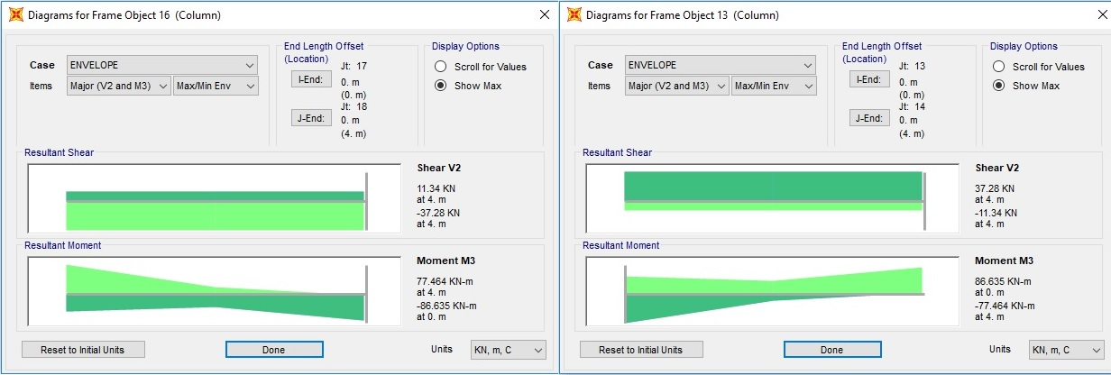

**Figure 8.** Shear force and moment values of the left column (left) and right one (right) at the first story

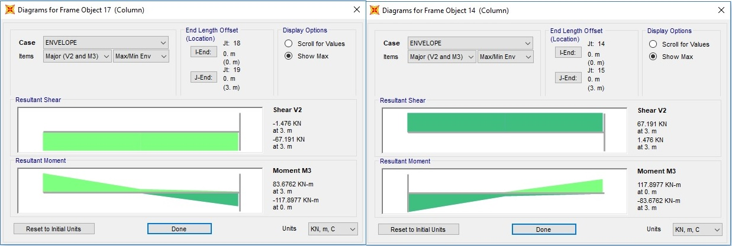

**Figure 9.** Shear force and moment values of the left column (left) and right one (right) at the second story

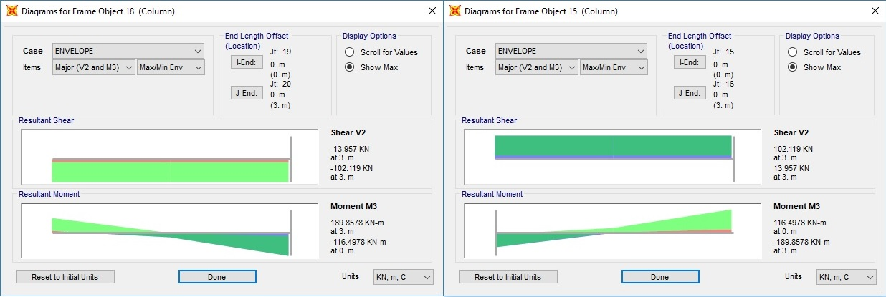

**Figure 10.** Shear force and moment values of the left column (left) and right one (right) at the third story

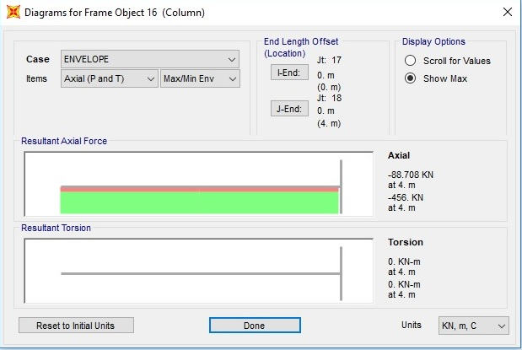

**Figure 11.** Axial force value of columns at the first story

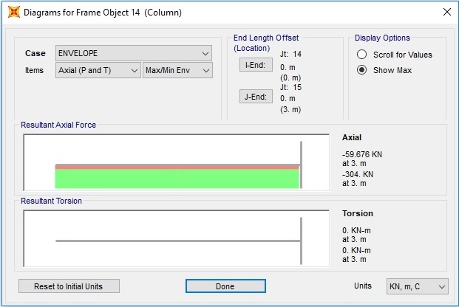

**Figure 12.** Axial force value of columns at the second story

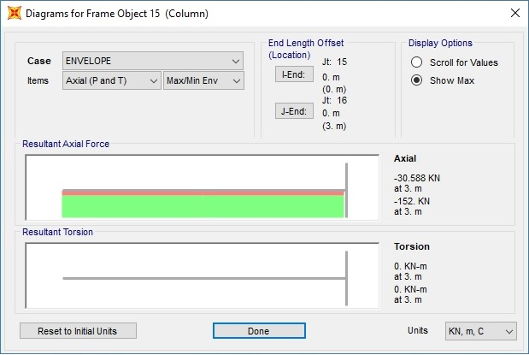

**Figure 13.** Axial force value of columns at the third story

- Sway check

Ψ= 1.5*Δi*(∑Ndi/li)/Vfi

Ψ= 1.5*0.00805*(456/4)/37.28 Ψ= 1.5*0.008937*(456/4)/37.28

Ψ= 0.03692<0.05 it is non-sway Ψ= 0.04099<0.05 it is non-sway

Therefore, second order effect is negligible.

After finding all axial forces, shear forces and moments for columns (and also beams), we need to consider just critical beam(s) and column(s). Design phase was done in this way and I assumed all beams are same, and columns are also identically.

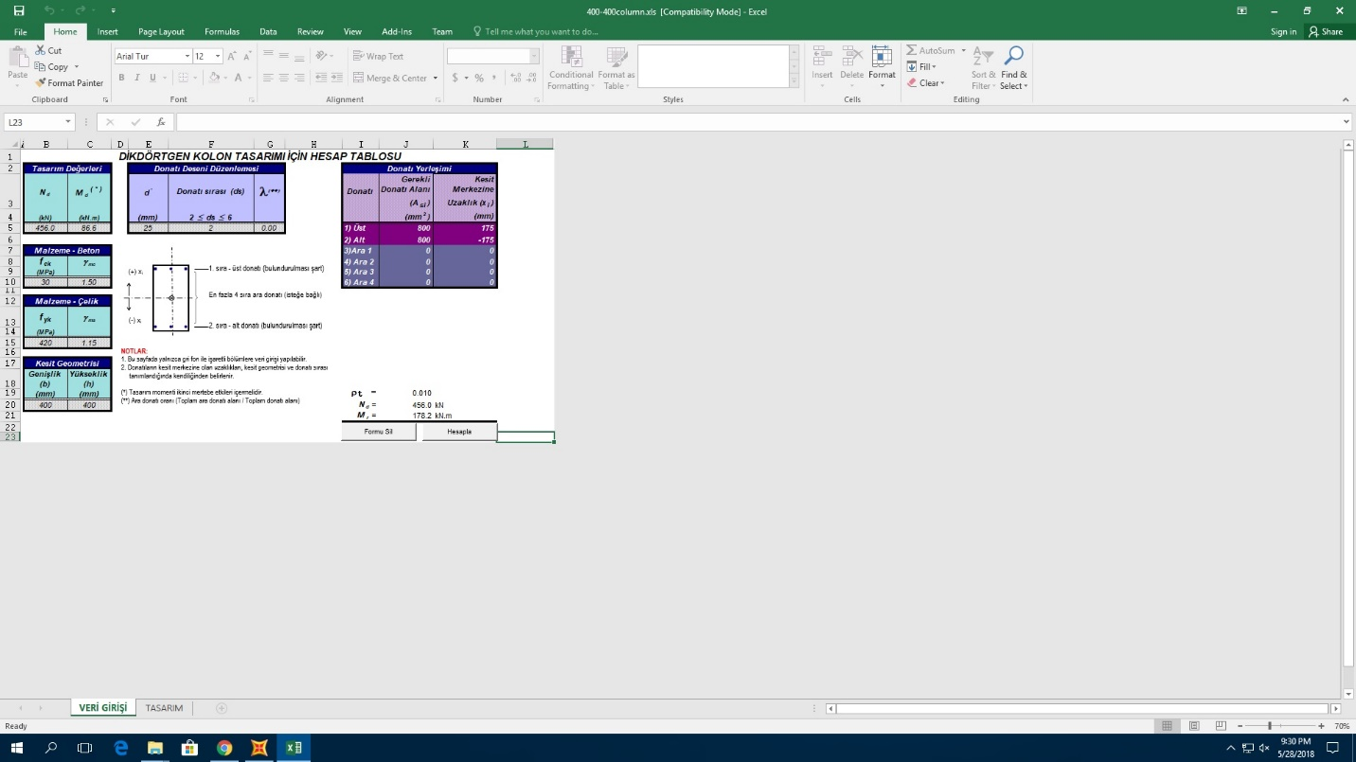

**Figure 14.** Reinforcement areas are obtained by using an Excel macro

Ast= 800+800= 1600 mm2



Ac= 800*800= 160000 mm2

Ndm= 456000 N

fck= 30 MPa

160000 ≥ 456000/ (0.4*30) = 38000 OK.



Ast= 800+800= 1600 mm2

Use 8∅18= 2036 mm2 > Ast OK.

ρt= As/ Ac= 1600/160000= 0.01

0.01 ≤ ρt = 0.01 ≤ 0.04 OK.

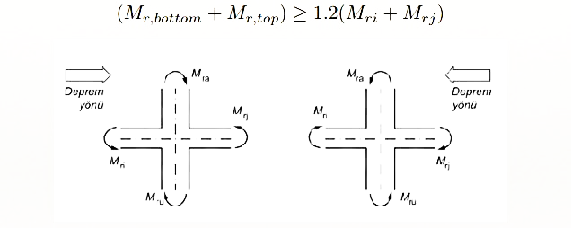

For right column on the first story;

Mrbottom= 86.635 kN.m

Mrtop= 117.8977 kN.m

Mri= 108.6383 kN.m

Mrj= 0 kN.m

(86.635+ 117.8977) ≥ 1.2*(108.6383+0) OK.



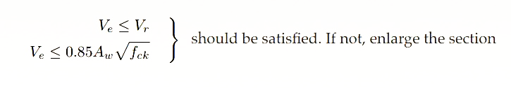

Ve= (86.635+ 117.8977)/ (4-0.4) = 56.8146 kN

Vcr= [0.65*(0.35*301/2/1.5) *400*400]/1000 = 132.914 kN

Vc= 0.8* Vcr= 106.331 kN

Vr= Vc+Vw> 106.331 kN so Ve< Vr OK.

By using ∅8, Aw= 100.531 mm2

Ve≤ 0.85*100.531*301/2= 468. 036 kN OK.

Asw/s= [(Vd-Vc) *1000]/ (365*400) = 2.39499

s= 41.97550 mm

min Asw/s= 0.3*fctd*bw/fyd

min Asw/s= 0.3*1.28*400/365= 0.42082

min s= 238.892 mm

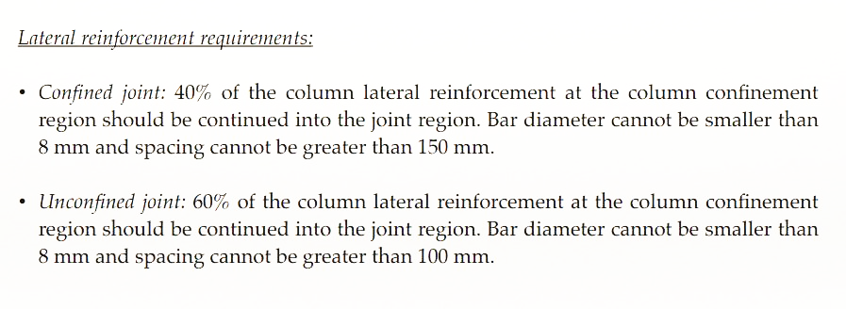

And also s should be less than or equal to d/2 for mid-span and d/4 for support.

So, lateral reinforcement will be ∅8/200 mm for mid-span and ∅8/100 mm for support.

*Beam design*

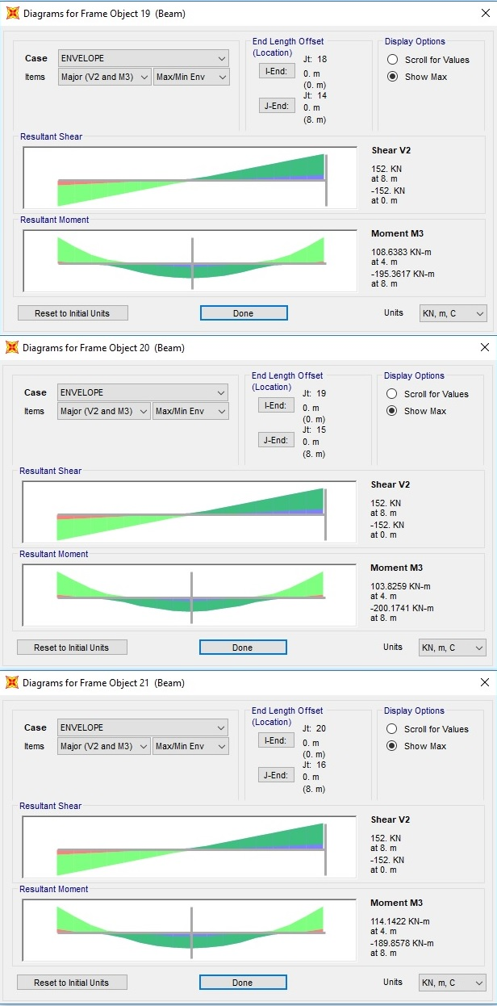

**Figure 15.** Shear force and moment values of beam at the first story



**Figure 16.** Shear force and moment values of beam at the second story



**Figure 17.** Shear force and moment values of beam at the third story

According to these values;

- Flexural design

For mid-span

Md= + 108.6383 kN.m

Kl= 247 mm2/kN

K= bw*d2/ Md= 300*4002/108.6383= 442 mm2/kN

K>Kl not use compression steel

Asmin= 0.8*(fctd /fyd) *bw*d= 342.0 mm2

As= Md/(0.86*fyd *d)= (108.6383*106)/(0.86*365*400)= 865.23 mm2

As> Asmin

Use 4∅18= 1018 mm2 > As OK.

For support

Md= - 200.1741 kN.m

K= bw*d2/ Md= 300*4002/200.1741= 240 mm2/kN

K<Kl use compression steel

M1= bw*d2/ Kl= 300*4002/(247*103)= 194.3320 kN.m

M2= Md- M1= 200.1741-194.3320= 5.8421 kN.m

As1= M1/ (0.86*fyd *d) = (194.3320*106)/ (0.86*365*400) = 1547.72 mm2

As1> Asmin

Available 2∅18= 509 mm2 (bent bars)

Use 2∅16= 403 mm2 (hanger bars)

Use 4∅18= 1018 mm2

ΣAs= 1930 mm2> As1 OK.

As2= M2/fyd*(d- d´) = 5.8421*106/365*(400-40) = 44.46 mm2

As2< Asmin, As2= 342.0 mm2

Available 2∅16= 403 mm2 (hanger bars) > As2 OK.

- Shear design

Vd =152 kN

Vd´ = 136.8 kN (shear force at point d away from the column face)

Vd> Vcr

Vcr = 0.65*fctd*bw*d =99.8 kn

Vc = 0.8*(0.65*1.28*300*400*1)/1000 = 79.872 kN

Vw =136.8-79.872=56.93 kN

Asw/s= (Ve-Vc)/ (fyd*d)

Asw/s=(136800-79872)/ (365*400)= 0.3899 mm

For ∅8, Asw= 100.531 mm2

s= 255 mm

min Asw/s= 0.3*fctd*b/fywd= 0.37 mm

min s= 265 mm

So lateral reinforcement will be ∅8/255 mm

**REFERENCES**

1. H. Sucuoğlu and Sinan Akkar, Basic Earthquake Engineering, Springer, 2014
2. Turkish Building Earthquake Code 2018: Specification for Structures to Be Built in Disaster Areas
3. “Türkiye Deprem Tehlike Haritaları İnteraktif Web Uygulaması” from https://tdth.afad.gov.tr/
4. Ersoy, U., Özcebe, G., & Tankut, T. (2010). Reinforced Concrete (Eighth edition). Odtü Yayınları.