MIDDLE EAST TECHNICAL UNIVERSITY
DEPARTMENT OF CIVIL ENGINEERING

CE 410 - CIVIL ENGINEERING DESIGN
TAŞUCU TOWN WASTE WATER COLLECTION PROJECT

Name of the Group: Mesopotamia D&C
Group Members:

CONTENT
1. Wastewater/Stormwater Collection Systems 1
2. Population Planning 4
2.1. Introduction 4
2.2. Location 4
2.3. Scope and Goal 5
2.4. Population Estimation 5
2.4.1. Population Estimation Methods 5
2.4.1.1. Graphical Methods 6
2.4.1.2. Arithmetic Increasing Method 7
2.4.1.3. Geometric Increasing Method 8
2.4.1.4. Bank of Provinces Method 8
2.4.2. Comparison of Methods 9
2.4.3. Summary,Conclusion and Comments 10
3. Wastewater Calculation and Diameter Selection 11
4. Discharges and Pump Selection 15
4.1. Motor Power Calculation 16
4.2. Pump Station 18
4.2.1. Valve House 18
4.2.2. Grille 18
4.2.3. Pump Station Dimensions 18
4.3. Stormwater Calculations 19
5. Sewage Network System 19
5.1 Introduction 18
5.2 Location 18
5.3 Design Criteria's 18
5.3.1.1. Topography 6
5.3.1.2. Elevation 6
5.3.1.3. Fullness Ratio 6
5.3.1.4. Desing Criteria 6
5.4 Example Solution for a Network 18
5.4.1. Slope 6
5.4.2. Fullness 6
5.4.3. Deciding 6
6. Storm Water Pipe Dimension and Elevation 6
7) Cost Estimation 6
7.1. Importance of Cost Estimate 6
7.2. Definition 6
7.3. Types 6
7.3.1 Preliminary Cost Estimate 6
7.3.2 Final Cost Estimate 6
7.4.Preliminary Cost Estimate of Kum Neighborhood 6
7.4.1.Cost Estimate for the Pipes 6
7.4.2. Cost Estimates for the Inspection Manholes 6
8. Summary 6

1. WASTEWATER / STORMWATER COLLECTİON SYSTEMS
We will design wastewater collection system in this course for Taşucu town, Silifke in Mersin. We determined place of wastewater treatment plant and pumping stations; line of sewers and force mains according to our several calculations and investigations which will be mentioned in detail below.
Wastewater collection systems are used to collect and transmit liquid wastes to a central treatment plant. Wastewater from individual homes, businesses and industries enters the collection system through a service line.
The ancient Romans were one of the first civilizations to employ wastewater collection through clay pipes and covered cannel sewers. Modern wastewater collection systems are a combination of components that include; sewers, force mains, manholes, and pump stations.
Sewer: Component of system which conveys the sewage.
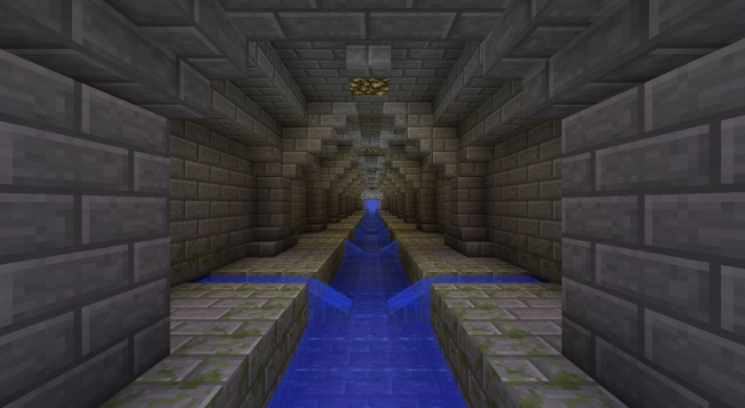
Figure 1
Force mains: is a pressurized main pipe that can carry water, sewage, and other materials.
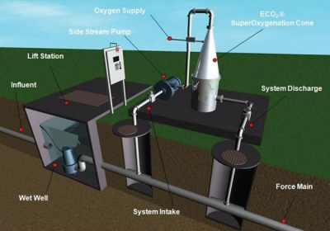
Figure 2
Manhole: is the top opening to an underground utility vault used to house an access point for making connections, inspection, valve adjustments or performing maintenance on underground and buried public utility and sewers.
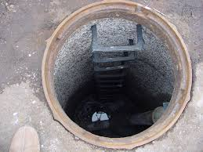
Figure 3
Pump stations: are facilities including pumps and equipment for pumping fluids from one place to another.
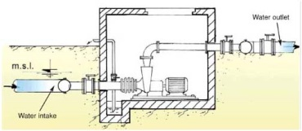
Figure 4

INTRODUCTION OF TAŞUCU
Taşucu is a town of Silifke, Mersin. Taşucu has a coast on Mediterranean, and is surrounded with Akdere town in west, center of SilifkeCounty in northeast and Göksu delta. There is forest area in north of town.
Taşucu takes 10,533 hectare space. Taşucu which located in Mediterranean region has typical meditrraean climate. Therefore, summer is hot and dry; winter is soft and rainy there. The average temperature of this town is 19.5 Celsius degree. Due to this good weather condition, Taşucu is the important touristic place of Turkey, so economy of town depends on tourism. In addition to tourism, commerce, fishing and agriculture are means of existence in this town.
Town is on a rolling terrain, between 0.0 elevation in coast and 100.0 elevation in north. Since, most part of living site is on bottom land, slope of site is almost 5%.

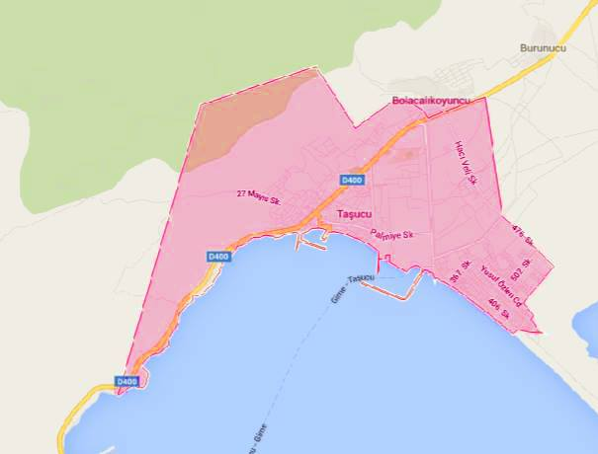
Figure 5

2. POPULATION PLANNING
2.1. Introduction:
Population project is the helpful or useful tool to reflect and to digitize a region in terms of social and economical point of view. The population project is defined as making the estimation of changing of the population in the future based on assumptions of future trend for birth, deaths and migration acts. The population project can be done with different scale for different purposes such as the settlements or administrative agency having different population greatness or administrative agency besides the whole around the country, region and province.
The population projection is being done in order to prepare development plan scene since the beginning of the planning and design process. It aims to submit for one's review to present applications of scientific and demographic models, which are essential parts of preparing development plan, as much as possible in population planning; including the more common and simple methods for planning studies as well. Although the prediction methods which will be elaborated in this report are guide for users, users should take into account that the methods should be updated or new methods should be developed in case the condition have changed and the accuracy of population prediction could be high by unique approaching of themselves.
In the first step of this study, the estimation of population methods will be covered. In the second step, the different methods will be compared and the best method will be selected and the result will be used for waste water project. In the third step, a short summary will be done and the comment for the project will be shared.
2.2. Location:
The place which the project will be done is Taşucu Neighborhood, Mersin. The view of Google Map can be seen in the 'Figure 6' .
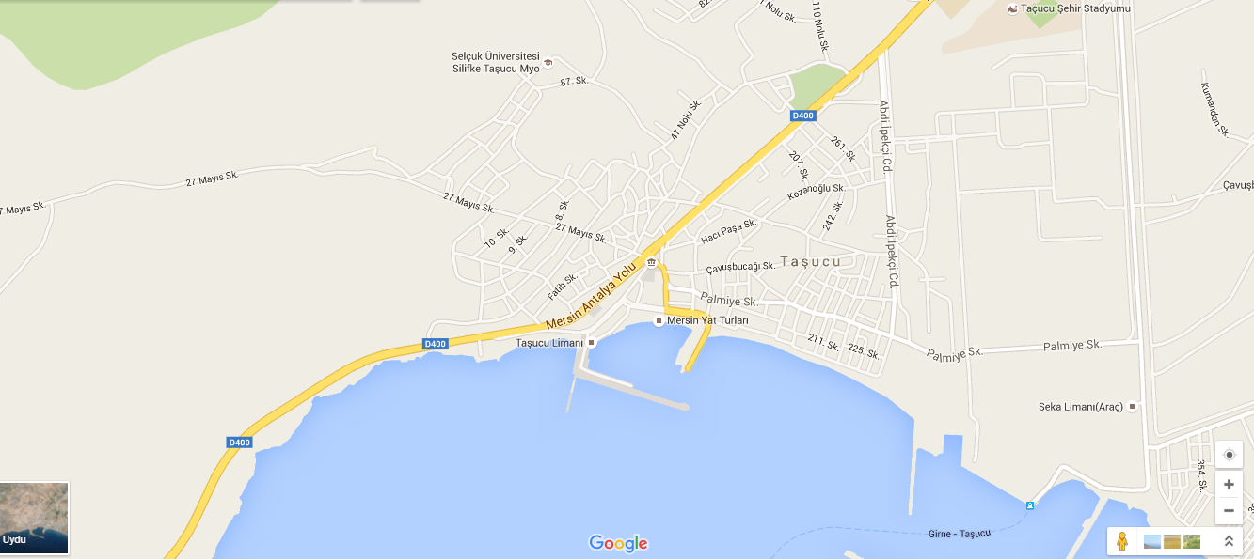
Figure 6: The Google Map View of Taşucu Region

2.3. Scope and Goal:
The scope of population planning is only Taşucu in Mersin. To estimate the population of Mersin, the recent data of population census which belongs to Taşucu, Mersin was used.
The main goal to find population of Taşucu is making the project properly. Because the finding population is very important issue. The average life of a project is generally 35 years. Therefore, any project should be designed and done by considering future. If the capacity of the project does not supply the demand of the region, that would be a dead invest and would be money waste. For this reason, the population of Taşucu region should be found out correctly.
Therefore, the main purpose in this report is finding Taşucu population in the year of 2050.
2.4. Population Estimation:
The population increases by births, decreases by deaths. The migrations affect the population with either increasing or decreasing. These components are under the impression of social and economical factors. The shape of changing the population in years is 'S' most of all. (Figure ...) The initial speed of increasing population is low and this level increases in time and reach its maximum point.
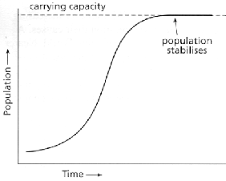
Figure 7: The shape of population growth

2.4.1 The Population Estimation Methods:
The population estimation methods to find a region basically are listed below.
- Graphical Method
- Arithmetic Increasing Method
- Geometric Increasing Method
- Bank of Provinces Method
2.4.1.1. Graphical Method:
In this method, the population versus time graph should be plotted. The axis of graph should be time and the ordinate of the graph should be population. The graphs whose ordinate population help designers to see trend of the population in the future. Then, the population trend of a region can be drawn simply. The equation of a trend line can be observed easily and the future estimation can be made.
The available data of Taşucu population is listed in the 'Figure 8' .
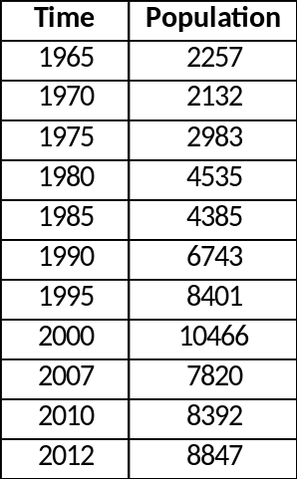
Figure 8: The available data of Taşucu Region
The time versus population graph and the trend line of the population can be seen below.
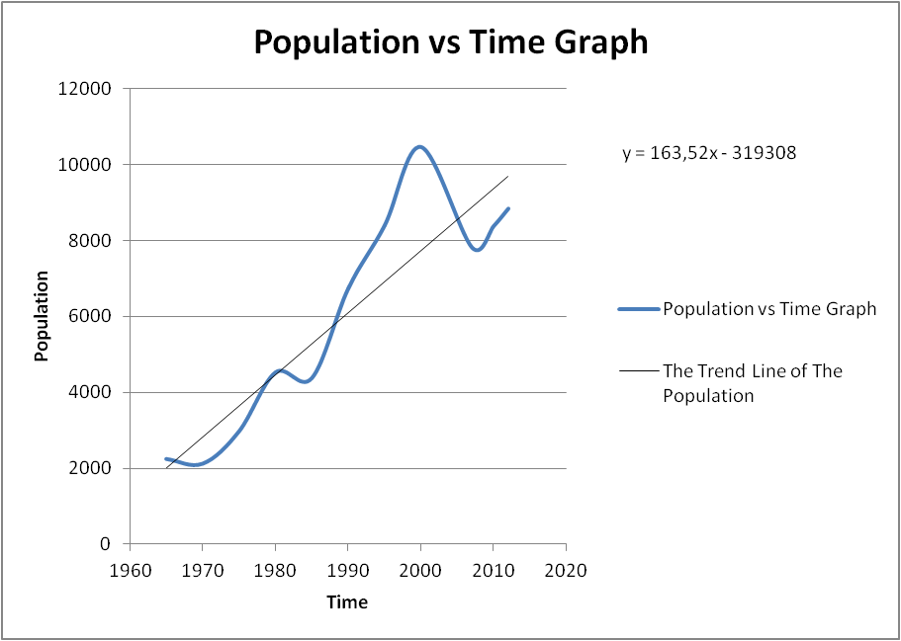
Figure 9: The population graph and trend line
The equation of trend line is:
Then, in 2050 ;
y = 163,52 * 2050 - 319308 = 16000 person ( Approximately )
2.4.1.2. Arithmetic Increasing Method:
This method is a mathematical method that both two axis of a graph points in a graphical paper having arithmetic scale as if previous population values became a straight line situation. In this situation, the increasing rate of population is constant, in other words, the tangent of the curve is also constant.
There are equations for calculation.
k_{a}= The arithmetic increasing speed constant (d_{y}/d_{t} = k_{a} )
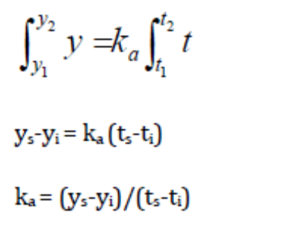
y_{s}= Last Population
y_{i}= Initial Population
t_{s}= Last time
t_{i}= Initial time
The population versus time graph for 1965 and 2012 years and the equation of trend line based on 1965 and 2012 years can be seen in the 'Figure 10 '.
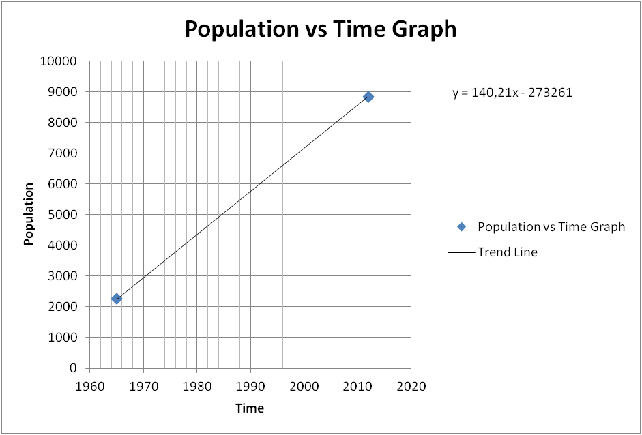
Figure 10: Population versus Time Graph for arithmetic method
Then, in 2050;
The Population= 140,21*2050- 273261 = 14200 people (Approximately)
2.4.1.3. Geometric Increasing Method:
In this method, the increasing rate of the population per unit time is accepted as related with the present population. According to this, the population change rate can be written as dy/dt=kg .k_{g} represents geometric increase rate constant.
The useful equations can be seen below.
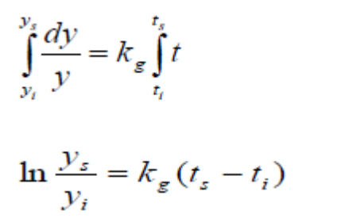
Then Equation Becomes

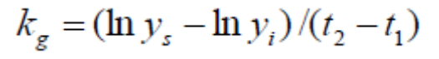

kg = (In(Ny)-In(Ne))/(ty-te) = (In(8847)-In(2257))/(2012-1965) = 0.0291
Population Projection :
In (Ng) = In (Ny) + kg * ( tg - ty ) = In (8847) + 0.0291 * (2050-2012)
Ng = 34000 person ( Approximately )
2.4.1.4. Bank of Provinces Method:
According to drink water ordinance of directorate general of bank of provinces, it is forecasted as below expressions for drink water and canalization projects preparation which is sustained by bank of provinces method.
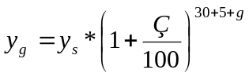
y_{g}= Future Population Ç= reproduction coefficient
y_{s} = Present Population g = The time from last population counting to planning
30= Project Service Time (year) 5: The time for planning, design, bidding, construction
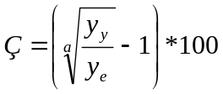
y_{e} = First population data a= the time difference y_{y} and y_{e}
Also, there are limitations for Ç values
If
- Ç<1 ; Ç= 1
- Ç>3 ; Ç=3
- 1<Ç<3 ; Ç= Calculated Value
y_{y} = 8847 ; y_{e} = 2257 ; a= 2012-1965 = 47 years
Then;
Ç = 100 * ((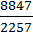)^{1/(2012-1965)} - 1) = 2.949
Then, the first equation can be applied as below.
y₂₀₅₀ = y₂₀₁₂ * ( 1 + 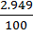 )⁽³⁵⁺²⁰⁵⁰⁻²⁰¹²⁾ ; y₂₀₁₂ = 8847
y₂₀₅₀ = 27000 person ( approximately )
2.4.2. Comparison of Methods:
The comparison result can be seen in 'Table 1'
Table 1: The Comparison of all methods
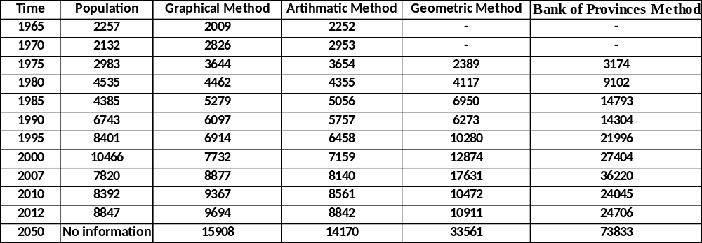

The comparison graphs can be seen in 'Figure 11'
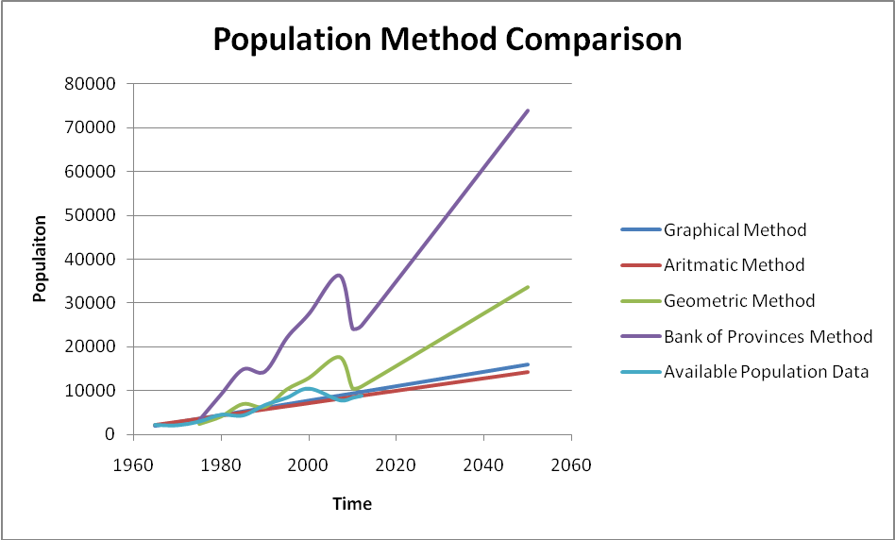
Figure 11: All graphs in together for estimation of population methods

2.4.3. Summary, Conclusion and Comments:
The results for Graphical, Arithmetic, Geometric and Bank of Provinces Methods are approximately 16000,14200,34000 and 74000 respectively.
The population of waste water project was selected as 60000 people. There were two considerations. The first one is whether the project would supply the demand of people in the region or not. Therefore, the methods which give around 16000, 15000 and 34000 was not selected. The more population was selected, as a result of this the capacity of pipe line would be enough for Taşucu. The second consideration is that the population should not be exaggerated.
Also, according to ministry of environment and urbanization data, the estimated population of Taşucu in 2025 is 50000 people.
In the light of all numerical population data and design concerns, the population was selected as 60000 people instead of 74000 people in bank of provinces method. The main reason is reducing the cost of the project. If population of 74000 was selected, the cost of the project of Taşucu waste water would be extremely high, therefore the population of 60000 was considered as future of Taşucu in 2015, the population estimation is also a reasonable estimation for ministry of environment and urbanization data.

3. WASTE WATER CALCULATION AND DIAMETER SELECTION
In the design of sewage water amount, potable water is taken as reference point.
Table 2: Potable water demand according to population (illerbankası)
population | Potable water demand(l/p/d)
3000 | 60
3000-5000 | 60-80
5000-10000 | 70-80
10000-30000 | 80-100
30000-50000 | 100-120
50000-100000 | 120-170

Table 3 : Total water demand
Type of consumption | Consumption per person daily  (l/p/d) | Project year consumption per person* (l/p/d) | Project target year consumption per person** (l/p/d)
Household (q_{home}) | 80-140 | 76 | 97
Commerce, construction, service, industry (%5-10*q_{net}) | (q_{net})*0.05-0.10 | 0.10*89 = 9 | 0.10*108 = 11
Net Consumption (q_{net}) | (q_{home})/0.90-0.95 | 80 / 0.90 = 89 | 97 / 0.90=108
Losses (q_{loss}) (%10-20*q_{gross})*** | (q_{gross})*0.10-0.20 | 0.10*99 = 10 | 0.10*120 = 12
Total (q_{gross}) | (q_{net}) + (q_{loss}) | 89/0.90=99 | 108/0.90 =120

Table 4: Water demand for Kum neighborhood
facility | water demand(l) | present unit | predicted unit | unit per facility | Water(lt/day)
pension(per person) | 190 | 1 | 7 | 50 | 66500
hotel(per bed) | 300 | 4 | 15 | 100 | 450000
swimming pool | 500l/m^2 | 3 | 10 | - | 500000*
***the area of the pool is assumed to be 100 m²

total demand | 3032500(lt/day)
demand per person(l/p/d) | 180,5

Table 5: Total sewage values obtained from the parts of the map
parts of the map | sewage(l/s/p) | areas(ha) | p/ha | total sewage(l/s)
1 | 120 | 340 | 50 | 23,61
2 | 120 | 430 | 60 | 35,83
3 | 180 | 210 | 80 | 35

Kutter’s equation
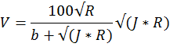
Q=V*F
F : Area of the pipe while the pipe is full (m²)
R : F/r: hydraulic diameter
J : mean velocity of the sewage (m/s)
Q : discharge of the sewage (m³/s)
b : coefficient of roughness
r : wetted perimeter

Table 6: Minimum and Maximum Velocities in Sewer Pipes
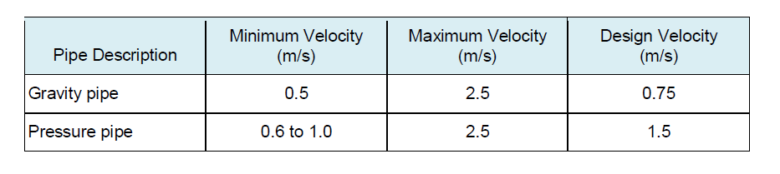
Table 7: Grade standards for sewage works
diameter(mm) | minimum grade | maximum grade | fullness ratio | manhole distance(m)
φ200 | 300 | 7 | 40 | 50
φ300 | 500 | 7 | 50 | 60
φ400 | 600 | 25 | 60 | 70
φ500 | 800 | 25 | 60 | 70
φ600 | 1000 | 25 | 60 | 70
φ800 | 1200 | 50 | 60 | 80
φ1000 | 2000 | 75 | 70 | 100
φ1200 | 2050 | 75 | 70 | 125
φ1400 | 2100 | 75 | 80 | 150
φ1600 | 2150 | 75 | 80 | 150
φ2000 | 2250 | 75 | 80 | 150
φ3000 | 2500 | 75 | 80 | 150

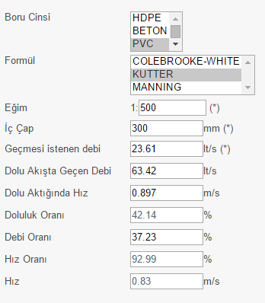
Figure 12: Diameter selection and the calculation of the pipe fullness for part 1(Dizayn group)

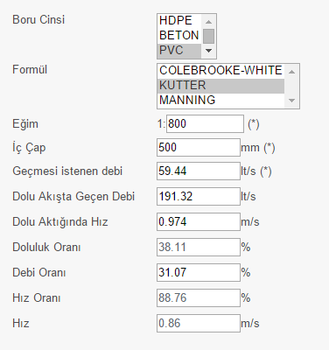
Figure 13: Diameter selection and the calculation of the pipe fullness for part 2 (Dizayn group)

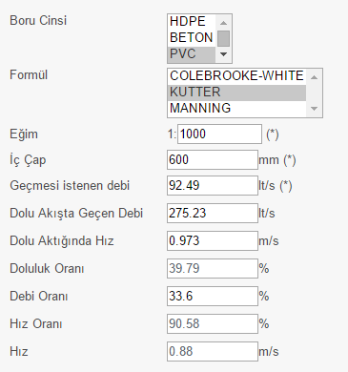
Figure 14: Diameter selection and the calculation of the pipe fullness for part 3 (Dizayn group)
4. DİSCHARGES & PUMP SELECTİON :
Pump station 2 (Kum Mahallesi)
For 35 years :
Q12 = 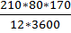 = 66 lt/s Q18 = 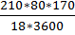 = 44 lt/s Q37 = 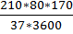 = 21 lt/s
 | Q37 (lt/s) | Q18 (lt/s) | Q12 (lt/s)
25 YEARS | 18.00 | 37.00 | 55.00
35 YEARS | 21.00 | 44.00 | 66.00

 | Q (lt/s) | PUMP TYPE
25 YEARS | 3*33 | PLUNGER TYPE
35 YEARS | 3*33 | PLUNGER TYPE

Differences of water consumption at certain times in a day are important for the hydraulic calculations. Change in water consumption create different discharges for hourly, daily and even weekly. To make the calculations in the safe side, discharge for 12 hours in a day is used in the calculations.
3 pumps are used in the pumping station since discharges show differences according to the seasons. Since Taşucu is tourism province, the population has been increasing sharply in the summer. The differences discharges in the summer and winter have been increasing. To provide energy effienciency, the pumps which can work for different discharges properly are used.
Plunger pumps are used as a pump type. They are feasible for small discharges ( less than 100 - 150 lt/s ). The important advantage of plunger pumps is low cost maintenance and no need extra place to install pumps therefore it makes plunger pumps cheaper compared to other type of pumps. Another advantage is that plunger pumps do not cause vibrations and noise since they run in the fluid.
Circular caisons are used since Kum Neighborhood has weak soil. Also, installation of the caissons is easy. Diameter of the caissons should not exceed 7 meters.
As a material type of the pipeline, polyethylene( HDPE ) pipes are chosen. Because, it has high flexibility which allows the pipe not to break and being uneffected from underground movements. Also, it has high impact strength and high resistance to crack.

4.1.Motor Power Calculation :
Calculations of motor power are done according to the pump discharges for 25 years since economic life of pumps and air chambers is 25 years.
H_{g} = final elevation of pump line - pump axis elevation
H_{g} = (2.50) - (-9.10) = 11.60 m
Q_{p} = 55 lt/s (for 25 year)
J = f_{s} * 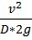
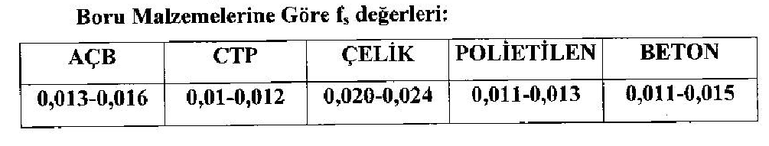
For polyethylene, f = 0.012
Q = v * A
55*10⁻³ = v * (π * (0.15)²) where D = 300 mm → v = 0.78 m/s
J = 0.012 * 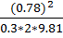 → J = 0.00123 m/m
L = 712 m → JL = 0.00123*712 = 0.88 m
H_{m} = H_{g} + JL + minor losses = 11.60 + 0.88 + 2.00 → H_{m} = 15 m
N_{e} = 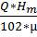 = 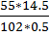 → N_{e} = 15.6 kW
N_{e} = 15.6 kW → E.K. = 1.25
N_{m} = N_{e} * E.K. = 15.6*1.25 → N_{m} = 19.5 kW
N_{m} = 19.5 kW → n=8
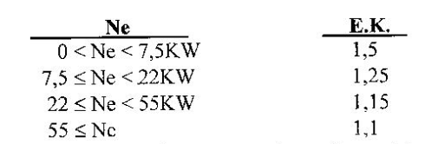
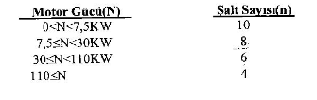

Calculation of the Volume of Collecting Chamber :
T_{min} = 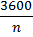 For n=8, T_{min} = 450 s
V₁ = 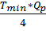 = 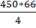 → V₁ = 7425 lt
V₂ = 0.392 * V₁ = 0.392*7425 → V₂ = 2911 lt
V₃ = 0.264 * V₁ = 0.264*7425 → V₃ = 1960 lt
V_{R} = 1704 lt is taken.
V_{T} = V₁ + V₂ + V₃ + V_{R} = 7425 + 2911 + 1960 + 1704 → V_{T} = 14000 lt = 14 m³

Base Area of Collecting Chamber :
F = π * r² = 3.14 * (2.50)² → F = 19.63 m² where diameter of caisson is taken as 4.00 m.
When concrete of bottom slope is considered, F_{net} = A = 15 m²
h₁ = = 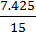 → h₁ = 0.50 m
h₂ = = 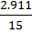 → h₁ = 0.19 m
h₃ = = 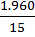 → h₁ = 0.13 m
h_{R} = = 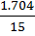 → h₁ = 0.11 m
h_{ö} is taken as 0.80 m.
H_{T} = h₁ + h₂ + h₃ + h_{R} + h_{ö} → H_{T} = 1.73 m
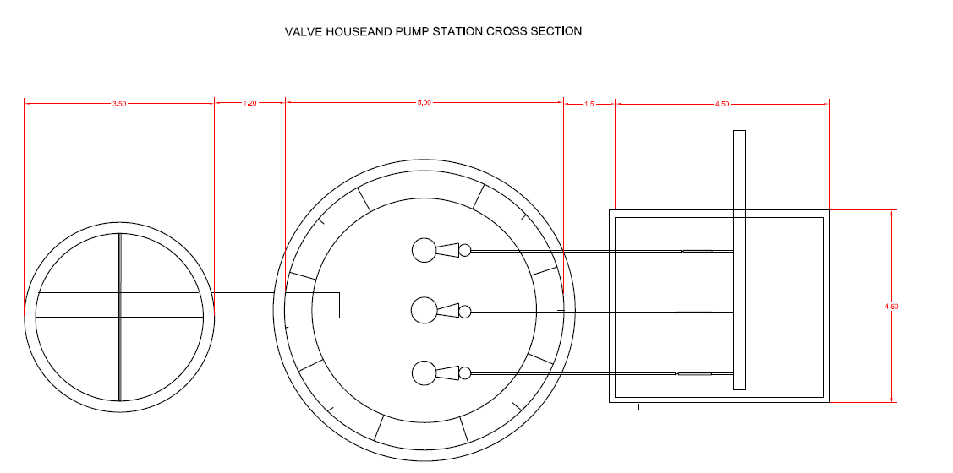
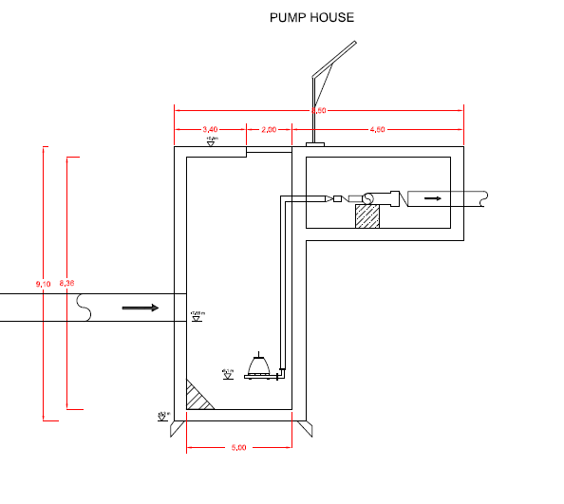
4.2.Pump Station
4.2.1.Valve House
When pump station is shut down, valve house is used for making sewage stop to flow. Valve house will build just before the grille and will include butterfly valve which will be according to DIN 3216.
4.2.2.Grille
It will need to separate bulk meterials from row sewage. It will be appropriate for Iller Bankasi standarts.
4.2.3. Pipe Station Dimensions
Valve house enter pipe base elevation : -7.57 m
Basket grille enter pipe base elevation :-7.58 m
Basket grille exit pipe base elevation : -8.09 m
Pipe station enter pipe base elevation : -8.1 m
Pump station base elevation :0,5 m
Pump axis elevation: -8.3 m
Pump room base elevation : -9.1 m
Final elevation of pipeline :2.5 m
Pressure pipeline : Φ 300mm L = 712 m (HDPE PIPE)
4.3. Storm Water Calculatıons
Storm Water Discharges :
In the calculations, rational method is used. Rational method is the method that gives the best result. It is assumed that the rain falls the whole area uniformly.
Q = C * I * A
where ;
Q = storm water discharge ( lt/s )
C = runoff coefficient depending on drainage area and type of rainfall
I = Rainfall intensity ( lt/s/ha )
A = Area ( ha )
Collecting time, T = T_{g} + T_{a}( minutes )
T_{g} = Entrance time ; It is the time that raindrops that drop the remotest point of the water collecting area come to the beginning of the canal.
Slope Entrance Time (min.)
J > 1/20 5
1/20 > J > 1/50 10
1/50 > J 15
T_{a} = Runoff time ; It is the elapsed time between two points in the section where storm water passes.
T_{a} = 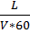 (min) V = conduit runoff velocity (m/s)
Average runoff coefficients are shown below considering reconstruction densities.
TYPE OF DRAINAGE AREASRUNOFF COEFFICIENTS (C)
COMMERCIAL ZONES
Central Zones 0.70 - 0.95
Outskirt 0.50 - 0.70
REZIDENTIAL ZONES
Isolated houses with garden 0.30 - 0.50
Multi-storey isolated blocks 0.40 - 0.60
Multi-storey adjacent blocks 0.60 - 0.75
Residential Areas 0.25 - 0.40
INDUSTRIAL ZONES
Light Industrial Zones 0.50 - 0.80
Heavy Industrial Zones 0.60 - 0.90
ROADS
Asphalt Pavement 0.70 - 0.95
Concrete Pavement 0.80 - 0.95
Durax-cube Pavement 0.70 - 0.85
Green Areas, Parks & Graveyards 0.10 - 0.25
Sports Arena 0.20 - 0.35

General Criteria :
In the storm water conduits, concrete pipes whose section is circular or B.A. pipes and reinforced concrete pipes whose section is rectangular are usually used.Selection of conduits whose section is rectangular is more appropriate where the slope is very few. When concrete pipe is used, minimum diameter of conduit will be Φ300 mm. Kutter Equation is used in the concrete pipes as the sewerage conduits and Manning Equation is used in the conduits whose section is rectangular.
Manning Equation :
Q = V * A
V = * R^{2/3} * S^{1/2}

Q = discharge that can pass through the selected section ( m³/s )
V = velocity ( m/s )
n = Manning roughness coefficient ( 0.015 )
R = Hydraulic Radius ( m )
S = Slope
Wastewater treatment plants which are available and will be installed and intersections will be controlled, necessary distances between conduits will be provided.
Storm water grille places will be shown on the project. Absolute grille installation will be specified with control organization in the stage of practice according to the last situation of pavements and roads.
When rectangular sections are planned, canals have freeboard to flow the water regularly. Since duration of storm water runoff is less than the duration of waste water runoff, maximum velociy can be taken as 5 m/s and Manning equation is used to specify the section discharge.
Inlets are used to take the storm water to the conduits.
When the storm water drainage system is planned, discharging of the storm water to the nearest places is taken into account.
Minimum diameter of conduits that has circular section will be Φ300 mm and it allows the conduits to flow 100 % fully and Kutter equation is used to specify the conduit section discharge.
In places where totally 80-100 lt/s storm water discharge is formed in 2 borders, conduit planning will be done.
In circular section conduits, minimum ground cover will be h = 1.20 m.
In rectangular section conduits, minimum ground cover will be taken as h = 1.20 m but it decreases to 0.20 m in unavoidable situations.
Manholes will be installed as in the sewerage system and water that is collected in inlets will be connected with Φ300 mm concrete pipe to the main conduit. To connect the inlets to the manholes is more appropriate in terms of maintenance and management.
In inlet grilles, grilles whose dimensions are 60-40 cm will be used and placed parallel to the road to increase the capacity.

5) SEWAGE NETWORK SYSTEM:
5.1) Introduction:
The purpose of a sewage collection system is to remove wastewater from points of origin to a treatment facility or place of disposal. The collection system consists of the sewers and plumbing necessary to convey sewage from the points of origin to the treatment system or place of disposal. It is necessary that the collection system be designed so that the sewage will reach the treatment system as soon as possible after entering the sewer. If the length of time in the sewers is too long, the sewage will be anaerobic when it reaches the treatment facilities. Sanitary sewage collection systems should be designed to remove domestic sewage only. Surface drainage is excluded to avoid constructing large sewers and treating large volumes of sewage diluted by rainwater during storms. Sewers which exclude surface drainage are called sanitary sewers, and those which collect surface drainage in combination with sanitary sewage are called combined sewers. Except for force mains, sewers are laid to permit gravity flow of their contents. Unlike water in a water distribution system, the contents of a sewer do not flow under pressure. Usually the slope is such that a flow rate of 0.03 meter per second or more is maintained when the line is flowing half full to full. This is a self-cleansing velocity and prevents solids from settling in the sewer pipes. To the maximum extent practical, sewers are laid in straight lines. Corners and sharp bends slow the flow rate, permit clogging, and make line cleaning difficult. Pumping is necessary where the slope of the sewer does not produce the required minimum velocity of 0.03 m or where sewage must be lifted to a higher elevation. Sewage can be pumped from pumping stations through pressure lines regardless of their slope, or it can be raised to a higher elevation at pumping stations (lift stations), so that gravity flow will again produce the required velocity. For gravity flow lines, sewer pipes of vitrified clay tile, concrete, cement-asbestos, or bituminous-impregnated fibre may be used. For force mains and stream crossings, cast iron or cement-asbestos pipes are used. Removing grease from sewage is essential to the proper functioning of sewage systems. At fixed installations, grease is collected by ceramic or cast iron grease interceptors installed at kitchens and other facilities that generate grease and by concrete or brick grease traps outside the building. Approximately 90 per cent of the grease will be removed from greasy wastes by properly maintained grease interceptors and traps. Petrol and oil separators are installed in sewer lines from garages and shops where petrol and oil might be accidentally spilled. Separators are also installed under washing facilities to contain the oil in water. In areas where large amounts of volatile material are produced as waste, some other method must be provided. Volatile liquids accumulating in sewers can cause explosions and destroy sewer lines or the treatment plant.
5.2) Location:
The region of the treatment plant that would like to construct was already mentioned in previous part. Therefore, any further detailed information will not be mentioned in this part again.
Since Taşucu, Mersin is not a small region, the numbers of pipe that should be solved are thousands. That's why the number was limited by Mr. Oktay Baş. The limited area can be seen in the following figure.
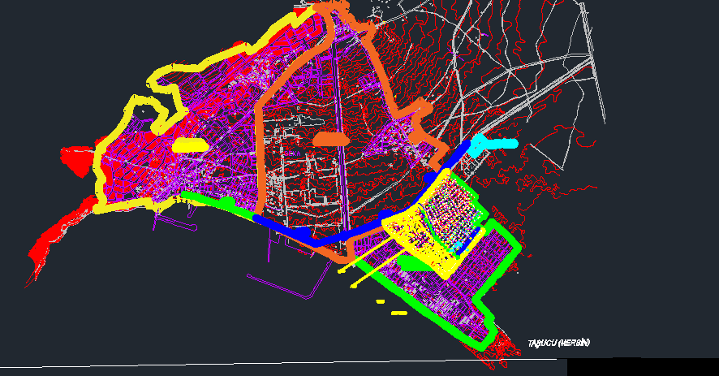
Limited Area of Taşucu, Mersin

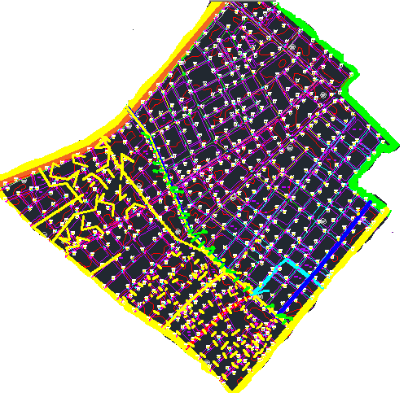
Figure .... : The Region whose NetWork System Solved
This limited area was only used for this report preparation and for scope of CE410 Civil Engineering Design course. In real life, designers cannot make such limitations. They have to solve whole system properly.
Since limited region has connections with other parts of Taşucu, an engineering judgment was made in order to decide the discharge of limited regions. Initially, total discharge of Kum Neighborhood was found as 66 m³/s and it has almost 210 hectare region. After finding approximate surface area of the region; the main area that solved, left part of main area, left-bottom part and finally down part of main area was found as 78, 53.6 , 39.5 and 38.9 hectares respectively. Then, discharge was calculated by using linear interpolations. The discharge of main region that was solved was found as follows.
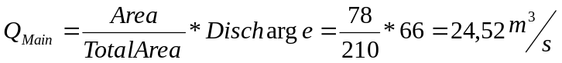
As mentioned above, the rest discharge which is approximately 41.5 m³/s was distributed uniformly. However, it is important to give higher discharge to main pipes. From this point of view, main pipe has taken big share of left 41.5 m³/s waste water. The main reason for giving to main pipe is that waste water is wanted to sent as soon as possible and it is possible to use main big pipes.
5.3) Design Criteria's:
5.3.1) Slope:
Slope is actually the main issue for sewage network system. Since sewage is based on gravitational flow, there should not be any flow which is based on energy. No energy is using for sewage system. Therefore, the orientation of waste water should be from high to low. In this point, slope is getting important.
As designers, deeper excavation is not wanted. That's why the slope should be minimum as much as it can be. Because, the smallest slope means less excavation and less cost.
5.3.1.1) Topography:
There are different kind of topographies. The first one is inclined one. Normally, the pipe lines are located from high elevation to less elevation. For such cases, the slope is not a problem. Because, the pipe can be located along the surface, that's why there would no further excavation needed. It is almost enough to keep pipes parallel to ground. The second one is flat surfaces. For flat surfaces, slope issue governs. Depending on diameter of the pipe, minimum slopes should be selected in order to prevent high excavation. The third one is again inclined one, but this time against gravity. Normally, designers never apply such case. However, it can be applied rarely due to some circumstances. This case is the hardest one for designer, since excavation is too much. Because, waste water is going higher location and deeper part of ground simultaneously.

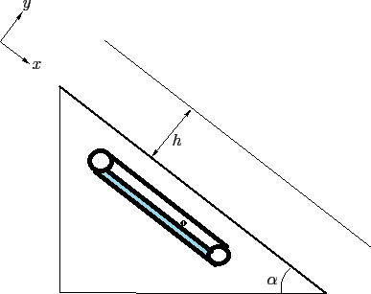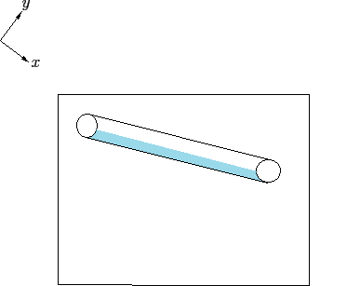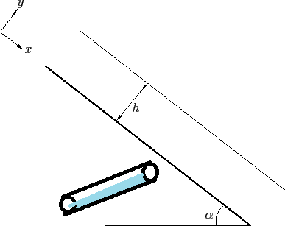
For Gravity For Flat Surface Against Gravity Movement
Figure .... : Different Topographies
5.3.1.2) Elevation:
In design process, there many connections and links. Generally, pipes have two connections. However, this number can be up to four or five. That's why elevation of connected pipes should be always equal. It can be seen on next simplified figure.
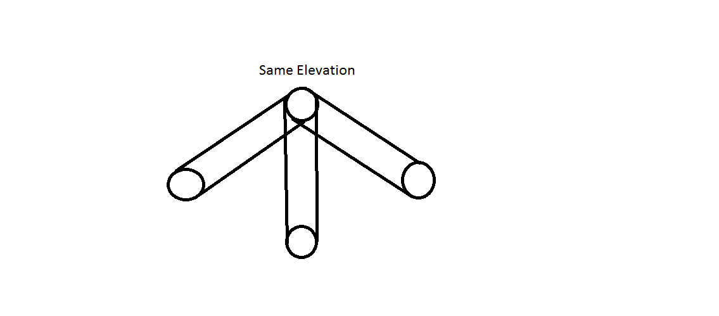 Figure ... : Elevation of Connected Pipes
5.3.2) Fullness Ratio:
Fullness is really big issue to prevent obstruction. There are different limits for each different pipes. This limitation should be obeyed by designers. In realty, pumps are deadlocking in time and attendants are connects to pipes and pumps water. Then, obstruction can be prevented. However, if the fullness ratio was not calculated correctly, these unfortunate and unwanted situations could be occurred continuously.
Fullness can be calculated by using following formula.
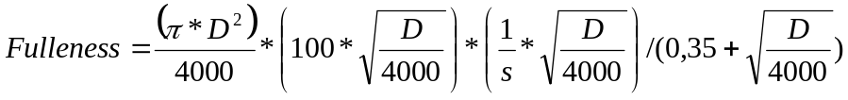
where ; D= Diameter of Pipe and s= Slope of Pipe
5.3.3) Design Criteria:
There are some limited values for slope and fullness ratio. These values can be listed in 'Table ....' .
Table .... : Grade Standards for Sewage Works
diameter(mm) | minimum grade | maximum grade | fullness ratio | manhole distance(m)
φ200 | 300 | 7 | 40 | 50
φ300 | 500 | 7 | 50 | 60
φ400 | 600 | 25 | 60 | 70
φ500 | 800 | 25 | 60 | 70
φ600 | 1000 | 25 | 60 | 70
φ800 | 1200 | 50 | 60 | 80
φ1000 | 2000 | 75 | 70 | 100
φ1200 | 2050 | 75 | 70 | 125
φ1400 | 2100 | 75 | 80 | 150
φ1600 | 2150 | 75 | 80 | 150
φ2000 | 2250 | 75 | 80 | 150
φ3000 | 2500 | 75 | 80 | 150

Since the region was limited by professor, all of types of pipes were not used. Using φ200, φ300 were sufficient. However, φ400 needed when calculation the main big pipe. Much more detail can be seen in the attached excel sheet.
5.4) Example Solution for a Network:
Initially, all pipes should be labeled with numbers to prevent confusion. Then an excel sheet or any useful program page should be prepared. Then, pipe numbers should be entered to the page. Length and elevation of pipes should be entered separately. After entering necessary variations following procedure should be followed.
5.4.1) Slope:
According to diameter size, slope should be found as much as minumum. The slope can be revised by changing pipe elevations. It should not forget that value of ground elevation and top invert depths should not be changed. Only application for changing should belongs to bottom invert of pipe elevations.
5.4.2) Fullness:
Now, calculating fullness ratio is straight forward. It can be found by applying given equations.
5.4.3) Deciding:
If there is problem for slope or fullness ratio limited, some revisions should be done. In this point there are two concept that followed by designers. The first one is increasing slope of pipe. Increasing slope is a logical application if the discharge of pipe is quite low. After the increasing slope of pipe, it can be seen that the fullness ratio drops and it would be problem anymore. However, for the one having high discharge, the most suitable and logical application is increasing the diameter of pipes. If still fullness ratio is a matter, then again increasing slope procedure can be applied.
6.) Calculations of Storm Water Pipe Dimension and Elevation
Before start the calculations, pipe type is identified by considering the general soil type and surface slope of our region. In Kum Mahallesi (Tasucu) soil type is generally loose sand up to depth 6 m. Slope of the surface nearly zero. Beginning elevation of storm water pipe is 0.5 m and it will be lay on 250 m long surface which has 1.5 m elevation at the end. Because of these two characteristic of our region , rectangular concrete pipe has chosen for transmission of storm water. For the dimension of concrete rectangular pipe, discharge of storm water should be calculated.
Storm Water Discharges :
In the calculations, rational method is used. Rational method is the method that gives the best result. It is assumed that the rain falls the whole area uniformly.
Q = C * I * A
where ;
Q = storm water discharge ( lt/s )
C = runoff coefficient depending on drainage area and type of rainfall
I = Rainfall intensity ( lt/s/ha )
A = Area ( ha )

Storm water area determinations:
In table 2.1 green line shows the storm water pipe line. For each pipe, collecting areas are determined. This areas belongs to each pipe and refers to all the rain which drop this area, will be collected related storm water pipe. (Table 2.2)
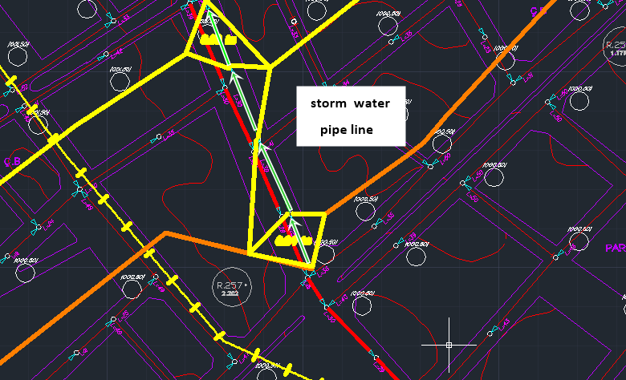
Table 2.1: storm water pipe line
During drawing the areas , possible flow directions are considered. Sewage pipe lines give basic idea for flow direction. Areas are calculated on autocad and for each pipe areas is tabulated on excell file (Table 3.1)
Runoff (C) coefficient determination :
Our region is in rezidential zone, most of area has two storied buildings , roads and park areas.(fugure 3.2) Buildings are not so close each other.Because of that our our C coefficient is between 0.4 and 0.6(table 2.2). to be stay safe side 0.6 has chosen as runoff drainage coefficient(C).

REZIDENTIAL ZONES
Isolated houses with garden 0.30 - 0.50
Multi-storey isolated blocks 0.40 - 0.60
Multi-storey adjacent blocks 0.60 - 0.75
Residential Areas 0.25 - 0.40
Table 2.2: C coefficient table.

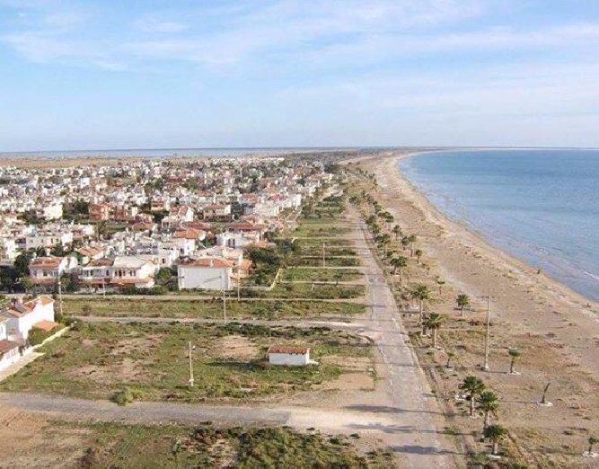
Figure 3.2: Kum Mahallesi (Tasucu)
After area and cooefficient ( c) are identified equivalent areas are calculeted.(table 4.1)
Equivalant area = Area * C
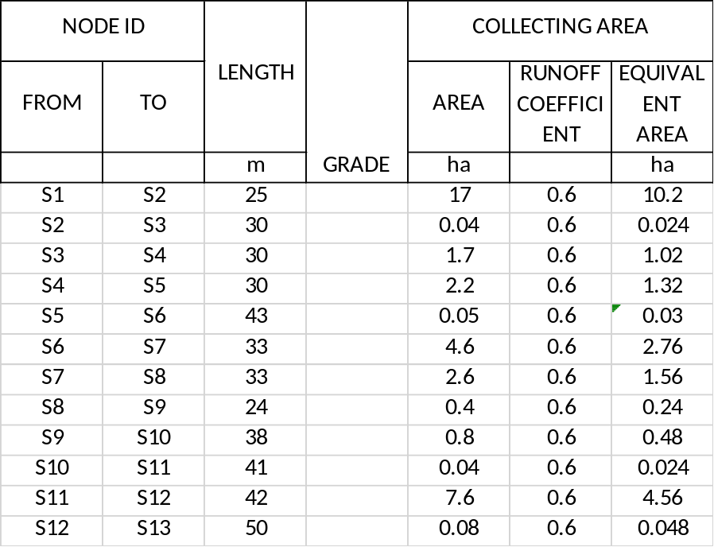
Table 4.1: Areas and nodes.

Discharge Determinations:
Collecting time, T = T_{g} + T_{a} ( minutes )
T_{g} = Entrance time ; It is the time that raindrops that drop the remotest point of the water collecting area come to the beginning of the canal.
Slope Entrance Time (min.)
J > 1/20 5
1/20 > J > 1/50 10
1/50 > J 15
Our slope is greater than 1/50 because of that entrance time is 15 m
At the begining we assume our dimension of rectangular pipe 1.5 m x 1.5 m. Manning Equation is used in the conduits whose section is rectangular.
Q = V * A
V = * R^{2/3} * S^{1/2}

Q = discharge that can pass through the selected section ( m³/s )
V = conduit runoff velocity (m/s)
n = Manning roughness coefficient ( 0.015 )
R = Hydraulic Radius ( m )
S = Slope
By using Manning equation V (m/s) is determined for each pipe. After calculating the conduit velocity Ta runoff time is calculated. (table 4.2)

T_{a} = Runoff time ; It is the elapsed time between two points in the section where storm water passes.
T_{a} = (min) V = conduit runoff velocity (m/s)

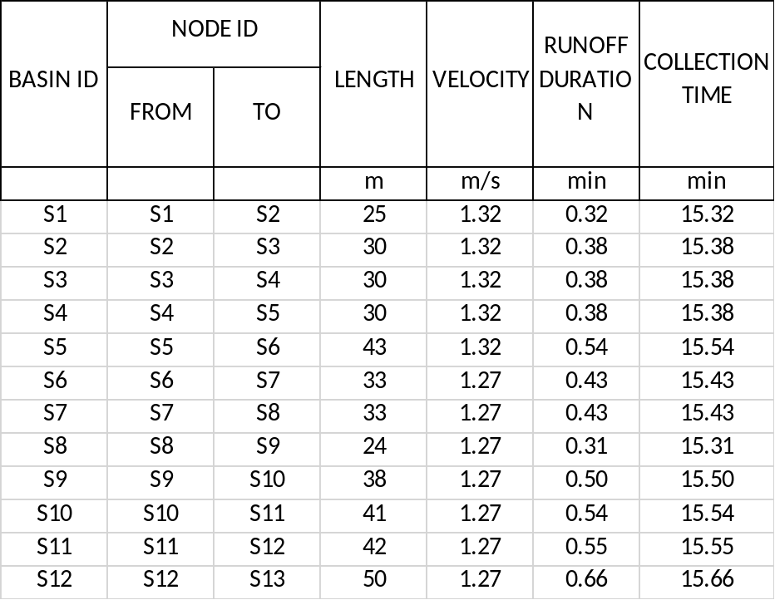
Table 4.2: collection time and velocity results
With collection time datas ,rainfall intensity (I) are identified by using chart 1.
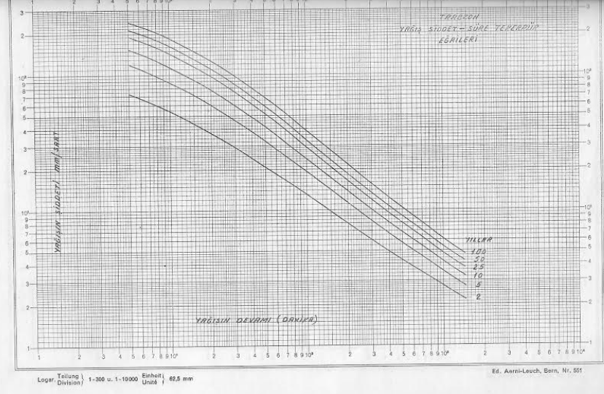
Chart 1: collecting time vs rain intensity
To avoid overdesign, 5 year rainfall regime is used. After find the rainfall intensity, discharges are calculated by using Rational method.(table 4.3)
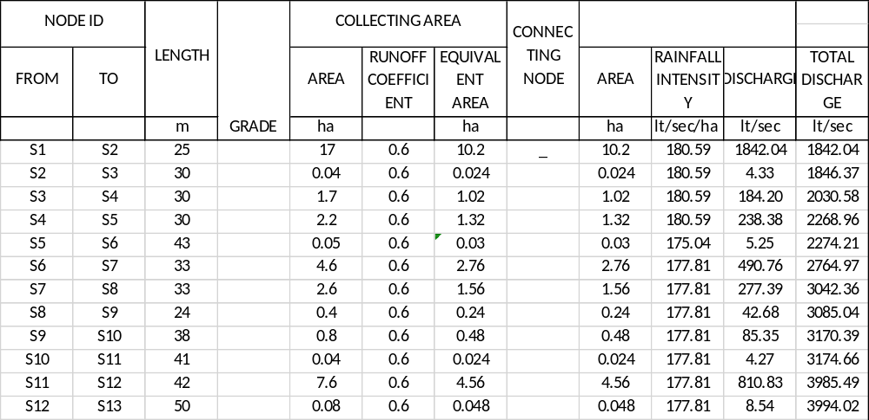
Table 4.3: rainfall intensity and discharges

At the begining we assume dimension of pipe as 1.5m x 1.5 m inner heights. after calculete the fullness ratio , we see that our assumtion is okay for begining. Fullness ratio should be less than 80 % percent for safe flow of water.
Fullness ratio is 100*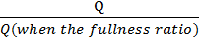 for first pipe (S1 –S2) fullnes ratio is:
100*(1842.04/2970) = 62 % it is OK.(table 4.4)
Up to node number S6, fullness ratio is okay for 1.5 x 1.5 dimensions. After that pipe (S5 – S6) we increase the witdh of the pipe as 2.5 m and all storm water line pipe has fullness ratio less than 85% percent.
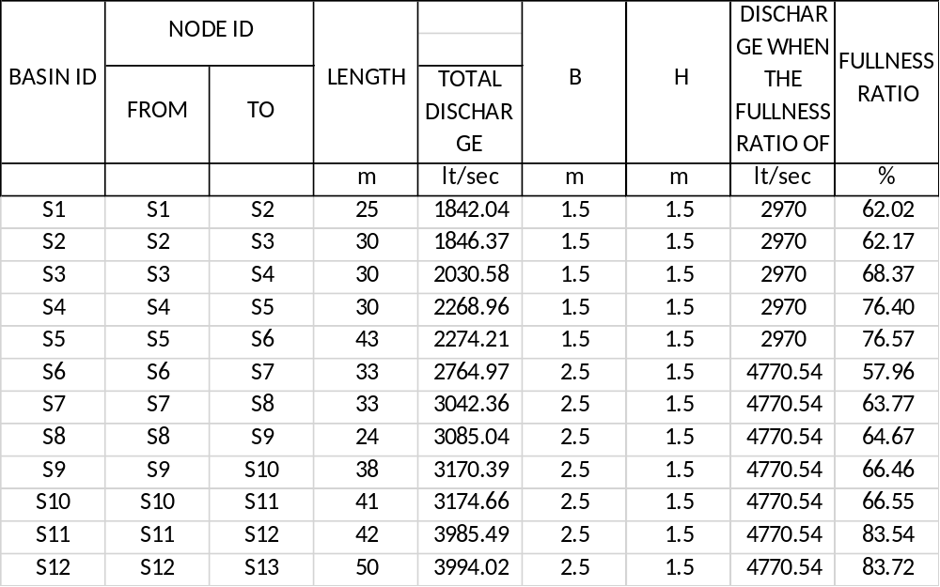
Table 4.4: pipe dimensions and fulness ratios
Elevations of storm water pipe:
Our storm water line will open the river which is in south of Kum mahallesi.(figure 3.3)
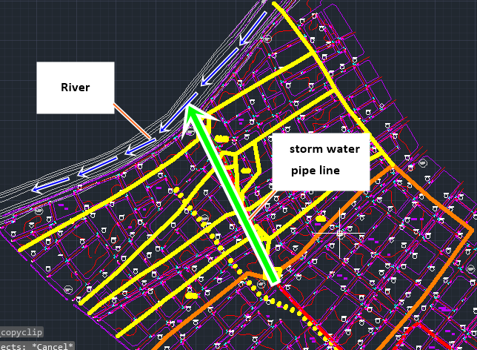
Figure 3.3: Kum Mahallesi (Tasucu)
River water elevation is 0.1 m high from sea level. End of the pipe line should be higer than river water level because of proper flow of the storm water. In first case , to make end elevation of pipe greater than river water level (0.1m) we starts at minumum depth 0.5 m layind the pipe.(figure 4.1)
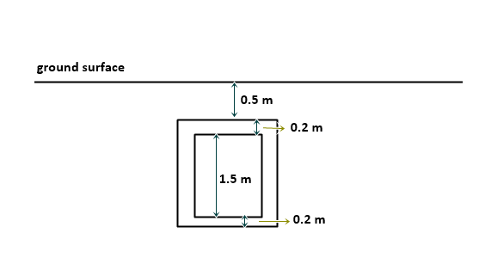
Figure 4.1: pipe laying under ground
With minumum slope 1/1000, elevation of pipes are calculated ( table 5.1)
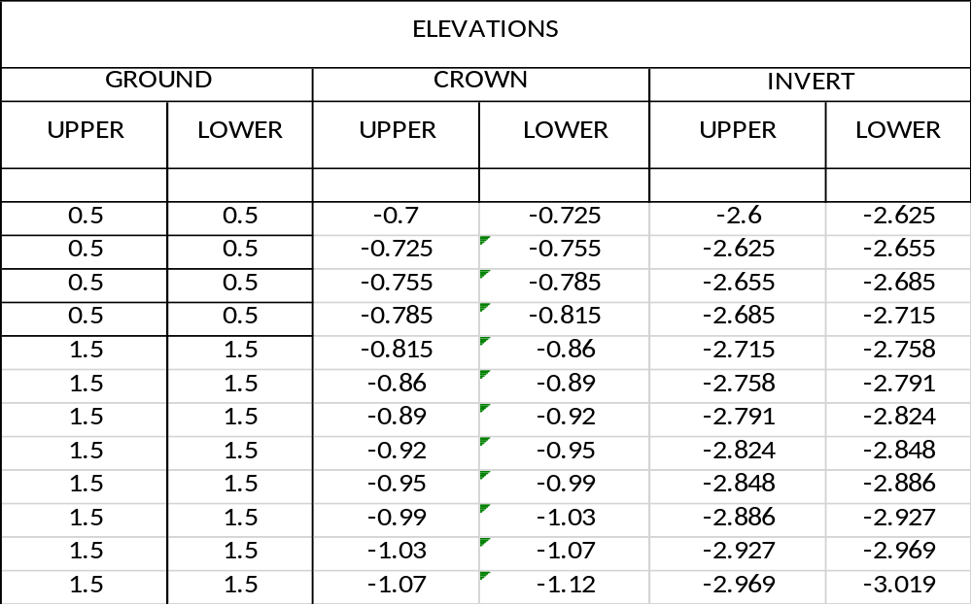
Table 5.1: elevations of storm water pipe line
After calculate elevations we see that end of pipe line is -3.019 m which is under the river water level. We deside to built a pump station near the river which will work only on rainy days and will pump the storm water into the river in safety way.
Crossing of storm water and sewage pipe lines
In some points sewage pipe and storm water pipe crossing.(figure 4.2) We should consider this issue. We calculate bottom elevation of sewage pipe lines in 5 crossing point and make the storm water pipe line laying more deeper.
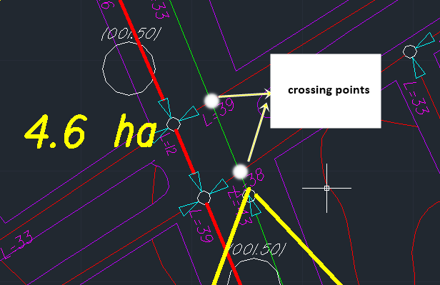
Figure 4.2: crossing ponts

To avoid from crossing, storm water first pipe line upper elevation is deeper 3.05 m than ground level. In figure 4.3 we can see the one crossing point which is (479-182 ) sewage pipe line and (S2 –S3) storm water pipe. Sewega pipe has – 2.55 m bottom elevation on the other hand storm water pipe line upper elevation is -2.575 m. They have 20 cm distance between them.(figure 4.3)

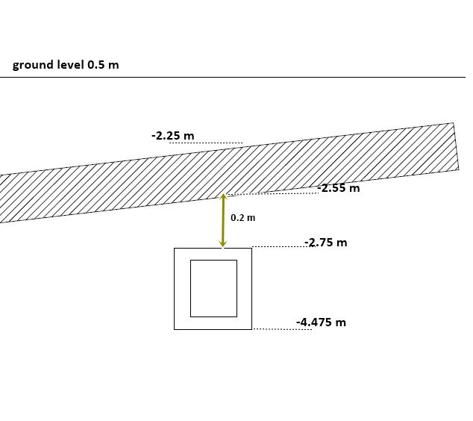
Figure 4.3: distance between two pipw line (crossing ponts)
After all crossing points are checked elevations of storm water pipe lines are recalculated.
(table 5.2)
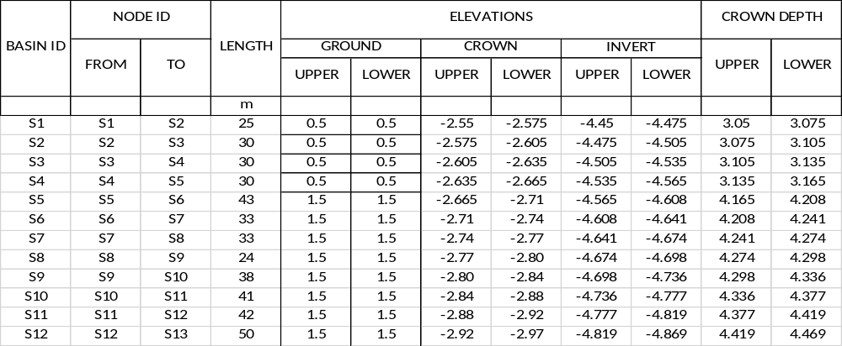

Wastewater treatment plants which are available and will be installed and intersections will be controlled, necessary distances between conduits will be provided.
Storm water grille places will be shown on the project. Absolute grille installation will be specified with control organization in the stage of practice according to the last situation of pavements and roads.

7) Cost Estimation

  - Importance of Cost Estimate
The cost of a structure should be known before construction. The owner of the project should prepare an adequate financial structure. Otherwise, unexpected problems can occur. The completion date of the project delays and some economical loss can appear. A project can be completed by different alternatives. The cost estimation minimizes the project completion time. For these reasons, to know the cost of a building is important and necessary. If the contractor is a public institution, the tendering is done according to the cost of the project the financial resources is also gathered according to cost.

  - Definition
All calculations that are used to find the cost of a structure is called cost estimate. The main bodies of the estimate are quantities and unit price. Amounts of materials are multiplied with their unit prices and at the end of the multiplication they are summed up, the cost estimate is completed.

  - Types
Today, there are two types of cost estimations, and these are;

    - Preliminary Cost Estimate
Estimation which is done before construction is called preliminary or conceptual cost estimation. The conceptual estimate is also defined as approximate estimate and used to know the budget for a project. Considerable experience and judgment are required to obtain a dependable approximate estimate for the cost.

    - Final Cost Estimate
It is the final estimate which is done by using completed fabrication. It increases with completed parts. At the end of the project, the cost of a project is determined by using final cost estimate.

  - ) Preliminary Cost Estimate of Kum Neighborhood
As mentioned before, the selected area (Kum Neighborhood) divided into four parts, and north-east one’s design is completed. The elevations of pipes are calculated for both waste water and rain water in previous steps. Now, the amount of the excavation, pipe lengths, soil to fill etc. will be calculated and the cost of the project will be determined.

Table 1: Class ratios of the soil types
TYPE OF EXCAVATION | CLASS RATIO | Ratio Related to Excavation Type |  | Excavation Ratios for Trenching
TYPE OF EXCAVATION | CLASS RATIO | Manually | By Machine | Narrow Deep | Wide Deep
Soil | 0.60 | 0.20 | 0.80 | 0.68 | 0.32
Hardpan | 0.20
Soft Rock | 0.00
Hard Rock | 0.20 | Trench and Found. Fill with Fixed Price
Very Hard Rock | 0.00 | Manually |  | By Machine
Sticky Mud-Bog | 0.00 | 0.20 |  | 0.80

Boring studies show that Kum neighborhood has 60% soil, 20% hardpan and 20% hard rock. In the excavation, soil from the route of pipes is excavated manually in the ratio of 20% and by machine in the ratio of 80%. In the calculations these ratios are considered.

7.4.1 Cost Estimate for the Pipes
Cost estimation of pipes consists of excavation (machine and manual), trenching, bedding layer, granular layer and material costs. As a material type of the pipe, polyethylene (PVC) pipes are used because it has high flexibility which allows the pipe not to break and being unaffected from underground movements. Also, it has high impact strength and high resistance to crack.
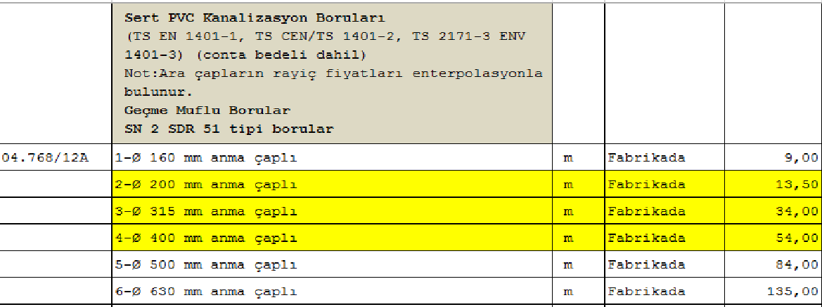
Figure 1: Unit prices of PVC sewage pipes
In the calculation of excavation of pipes, firstly average depth is found and depth of bedding layer is added. This gives the total excavation depth. When the total excavation depth is multiplied by the width of trench and lengths of the pipes, this gives the volume of the excavation. Then, unit prices of the excavation which is deeper than 2 meters are used according to the unit prices 2015 of the Ministry of Environment and Urban Planning.
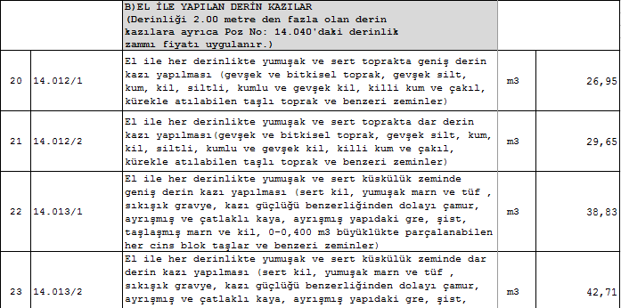
Figure2: Unit prices of the manual deep (>2m) excavation

As a trench type, whole covered wooden trenches are used in the sides of the excavation since all the excavation depths are less than 4,5 meters. Therefore, steel trenches are not used in the sides of the excavation.

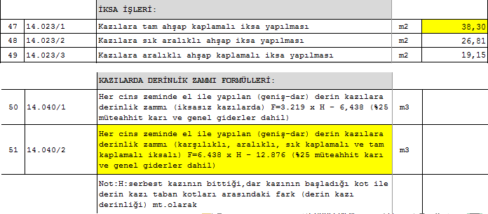
Figure 3: Unit prices of trenching
As a bedding type, A type bedding is used as a result of site investigation. This type of bedding is applied in a given section, using filling material and forming 120 degree bedding angle, when base of trench is soft, rock, very hard or too full with stones to clean. But, in excavation trench which done A type of bedding, base of trench is sand – gravel because ground improvement or drainage is done.
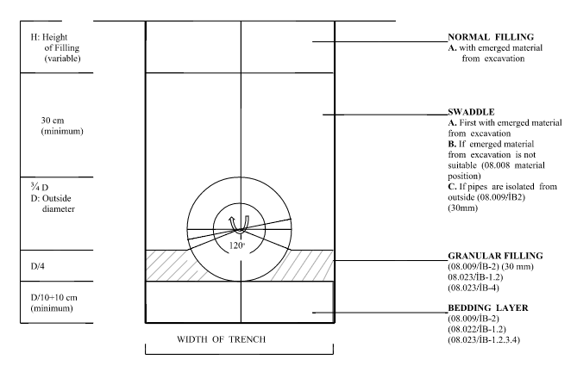
Figure 3: A type bedding section

    - Cost Estimates for the Inspection Manholes
Manholes are constructed in the purpose of controlling, interference, connections, ventilation in the storm water and waste water pipeline systems. Inner diameter of the manholes is usually 1000 mm and 1200mm.

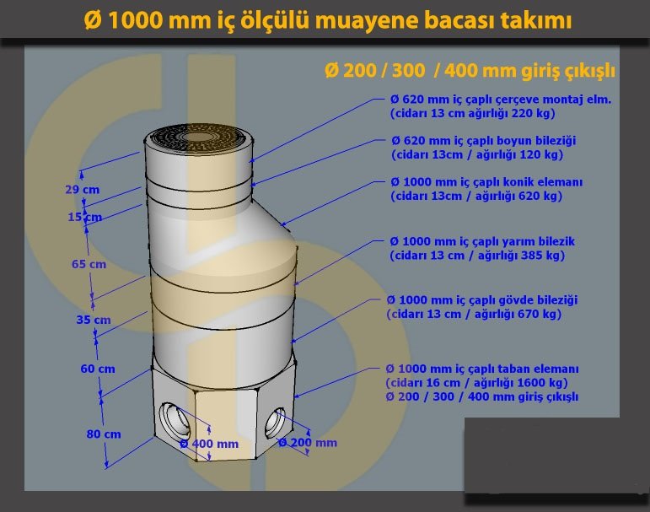
Figure 4: An example of manhole
Table 2: Cost estimate for inspection manholes
COST ESTIMATE FOR INSPECTION MANHOLES (Ø1200 mm)
POZ NO | NAME OF WORK | QUANTITY | UNIT | UNIT PRICE (TL/m3) | COST (TL)
14,16004 | Foundation Excavation (0-2 m) | 25,92 | m3 | 9,266 | 240,17
14,160041 | Foundation Excavation (2-3 m) | 12,96 | m3 | 9,266 | 120,09
14,160042 | Foundation Excavation (3-4 m) | 12,08 | m3 | 9,266 | 111,93
14,160043 | Foundation Excavation (4-5 m) | 3,76 | m3 | 9,266 | 34,84
14,170000 | Trench and Foundation Fill with Fixed Price | 39,44 | m3 | 4,965 | 195,82
15,140/İB-8 | Laying Bank Sand and Gravel | 7,28 | m3 | 11,57 | 84,23
20,011/İB-3 | Supporting with Steel Lines Strike | 30,28 | m2 | 30,4 | 920,51
20,012/İB-3 | Supporting with Steel Lines Pulling Out | 30,28 | m2 | 18,694 | 566,05
23,245/İB-1 | Supporting with Profile Steel at Steel Lines | 0,14 | ton | 479,72 | 67,16
12,2191/1 | Steam-cured Body Clamp (H=0.6 m) | 1 | unit | 134,04 | 134,04
12,2191/2 | Steam-cured Body Clamp (H=0.35 m) | 1 | unit | 96,28 | 96,28
12,2191/5 | Steam-cured Body Height Adjusting Clamp | 0,15 | m | 210,15 | 31,52
12,2191/1 | Steam-cured Conical Element (D=1.00 m) | 1 | unit | 128,24 | 128,24
12,2193 | Steam-cured Body Clamp | 1 | unit | 34,7 | 34,70
12,2194 | Steam-cured Frame Assemblage Element | 1 | unit | 40,3 | 40,30
23,255/İB-1 | Production of Cast-Iron Manhole Cover | 90,5 | kg | 3,2 | 289,60
04,92713/a | Ø1000 mm Body Adjusting Element Gasket | 1 | unit | 15,5 | 15,50
 | One Inspection Manhole Cost |  |  |  | 3110,99
 | Unit Inspection Manhole
 | Unit Temporary Discharge Line Inspection Manhole
590 | Unit Inspection Manhole Cost | 3110,99*590 = |  |  | 1,835,486.66 TL

As seen in table 2, one inspection manhole cost is calculated as 3110,99 TL. There are 590 manholes in selected region of Kum neighborhood. Total cost is calculated as 1,835,486.66 TL.
While calculating unit prices of manholes according to 2015, some prices are found and for the prices which are not found are obtained by using ratio between 2001 and 2015 prices.

In the construction of the waste water connection pipelines, lot manholes are mounted to the exit of the buildings in the purpose of controlling and interference. Calculations of cost estimates for lot connections and lot manholes are illustrated in tables 3 and 4 below.

Table 3: Cost estimate for lot connections
COST ESTIMATE FOR LOT CONNECTIONS
POZ NO | NAME OF WORK | QUANTITY | UNIT | UNIT PRICE (TL/m3) | COST (TL)
14,160030 | Trenching (0-2 m) | 18928 | m3 | 9,266 | 175386,85
14,1600300 | Trenching with support (0-2 m) | 10192 | m3 | 28,92 | 294752,64
14,1700 | Trench and Foundation fill with fixed price | 39325 | m3 | 4,61 | 181288,25
15,140/İB-8 | Laying bank sand and gravel | 1613 | m3 | 5,65 | 9113,45
12,218201 | Laying of Ø150 mm. Steam cured concrete pipes | 1680 | m | 13,68 | 22982,40
12,218601 | Laying of Ø150 mm. Steam cured joint | 2800 | units | 7,14 | 19992,00
18,189 | Taking out pitching and blockage | 852 | m2 | 2,84 | 2419,68
18,190 | Taking out crushed stone, roadway and asphalt | 365 | m3 | 15,64 | 5708,60
TOTAL |  |  |  |  | 711,643.86 TL

Table 4: cost estimate for lot manholes

COST ESTIMATE FOR LOT MANHOLES
POZ NO | NAME OF WORK | QUANTITY | UNIT | UNIT PRICE (TL/m3) | COST (TL)
14,160040 | Foundation Excavation (0-2 m) | 7 | m3 | 9,266 | 64,86
14,1700 | Trench and Foundation fill with fixed price | 7,218 | m3 | 4,61 | 33,27
14,023/3 | Forming spaced wooden support | 10 | m2 | 9,48 | 94,80
15,140/İB-8 | Laying bank sand and gravel | 0,5 | m3 | 5,65 | 2,83
12,2190/1 | Steam cured lot manhole prefabricated bottom element | 1 | unit | 143,4 | 143,40
12,2190/2 | Steam cured lot manhole body element (0,50 m) | 1 | unit | 104,44 | 104,44
12,2190/3 | Steam cured lot manhole body element (0,25 m) | 1 | unit | 74,4 | 74,40
12,2190/4 | Steam cured lot manhole body height adjusting element | 0,15 | m | 232,25 | 34,84
12,2190/5 | Unframed RC lot manhole cover | 1 | unit | 22,73 | 22,73
12,2190/6 | Framed RC lot manhole cover | 1 | unit | 38,32 | 38,32
 | One lot manhole cost |  |  |  | 613,89
54000 | units lot manhole cost | 2843*613,89 = |  |  | 1,745,287.79 TL

Length of the waste water pipeline is 28426 m. lot manholes and connections are mounted in every 10 meters. Therefore, the amount of lot manholes and connections is 2843.

8) Summary

TAŞUCU (MERSİN)
SEWERAGE SYSTEM PROJECT INFORMATION FORM
- PROGRAM SITUATION OF PLANT
Name of the Project and Location : Taşucu (Mersin) Sewerage System Project
Characteristics of the Project : Network and Collector
- INFORMATION ABOUT BIDDING OF THE PROJECT
Cost Estimation of the Project and Year :7,184,260.74 TL 2016/1
Contractor of the Project :Mesapotamia D&C
Date of the Contract :14/10/2015
- FUNDAMENTAL INFORMATION RELATED TO CONSTRUCTION
Target Population :N₂₀₅₀=60,000 people
Daily Water Demand :170 l/p/d
Project Calculation Discharge :66 l/s
The Area of Development Plan :210 ha

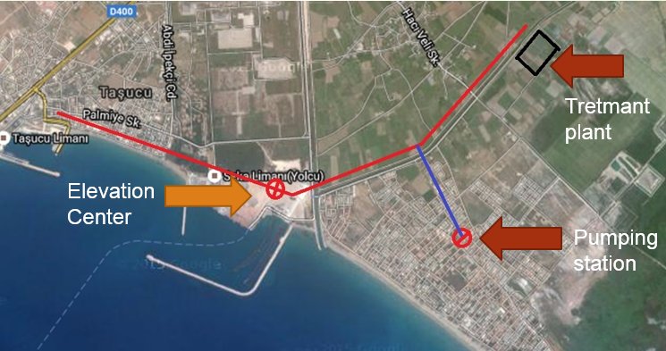

- INFORMATION RELATED TO PROJECT CONTENT
Sum of 1st Grade Networks : 28,426 m
Sum of the Storm Water Pipeline : 419 m
Sum of Cost Estimates of 1st Grade Networks : 7,184,260.74 TL

CHARACTERISTICS OF PUMPING STATION
Pumping Station | PS
Grade | 1
Elevation of Entrance Pipe(m) | -8,1
Discharge(l/s) | 66
Force Main Diameter and Type | Ø400 HDPE
Hm (m) | 14,5
Nm (kW) | 19,5
Qp (lt/s) | 33
Type of Pump | Plunger
Number of Pump | 3
Length of Force Main | 712
Exit Elevation of Force Main | 2,5
Ground Elevation of the Entrance of Force Main | 0,5
Air Chamber | -
Grit Arrester | -
Vacuum Lifter & Extraction | -
Generator Capacity | -

- INFORMATION ABOUT WASTEWATER TREATMENT PLANT
Area and Location of the Plant : 2 ha, north-east of the development
Drainage Location after treatment : Canal near Kum Neighborhood
- QUANTITY TAKEOFF OF THE PROJECT
DIAMETER (mm) | 1st Grade (m) | Available (m) | Total (m)
Waste Water Network
Ø200 | 27388 | - | 27388
Ø300 | 678 | - | 678
Ø400 | 360 | - | 360
TOTAL | 28426 | - | 28426
Storm Water
1500x1500 | 158 | - | 158
1500x2500 | 261 | - | 261
TOTAL | 419 | - | 419

