MIDDLE EAST TECHNICAL UNIVERSITY
DEPARTMENT OF CIVIL ENGINEERING

CE 410 - CIVIL ENGINEERING DESIGN
TAŞUCU TOWN WASTE WATER COLLECTION PROJECT

Name of the Group : Mesapotamia D&C
Group Members :

CONTENT
1. Wastewater/Stormwater Collection Systems 1
2. Population Planning 4
2.1. Introduction 4
2.2. Location 4
2.3. Scope and Goal 5
2.4. Population Estimation 5
2.4.1. Population Estimation Methods 5
2.4.1.1. Graphical Methods 6
2.4.1.2. Arithmetic Increasing Method 7
2.4.1.3. Geometric Increasing Method 8
2.4.1.4. Bank of Provinces Method 8
2.4.2. Comparison of Methods 9
2.4.3. Summary,Conclusion and Comments 10
3. Wastewater Calculation and Diameter Selection 11
4. Discharges and Pump Selection 15
4.1. Motor Power Calculation 16
4.2. Pump Station 18
4.2.1. Valve House 18
4.2.2. Grille 18
4.2.3. Pump Station Dimensions 18
4.3. Stormwater Calculations 19

1. WASTEWATER / STORMWATER COLLECTİON SYSTEMS
We will design wastewater collection system in this course for Taşucu town, Silifke in Mersin. We determined place of wastewater treatment plant and pumping stations; line of sewers and force mains according to our several calculations and investigations which will be mentioned in detail below.
Wastewater collection systems are used to collect and transmit liquid wastes to a central treatment plant.Wastewater from individual homes, businesses and industries enters the collection system through a service line.
The ancient Romans were one of the first civilizations to employ wastewater collection through clay pipes and covered cannel sewers.Modern wastewater collection systems are a combination of components that include; sewers, force mains, manholes, and pump stations.
Sewer: Component of system which conveys the sewage.
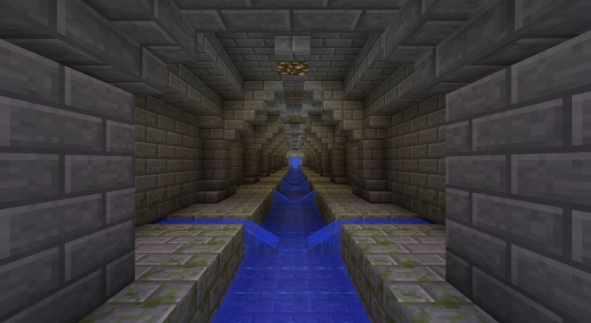
Figure 1
Force mains: is a pressurized main pipe that can carry water, sewage, and other materials.
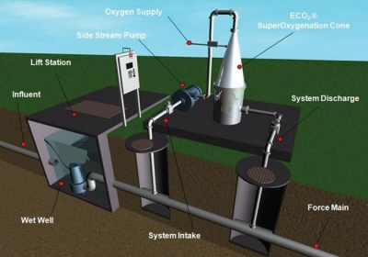
Figure 2
Manhole: is the top opening to an underground utility vault used to house an access point for making connections, inspection, valve adjustments or performing maintenance on underground and buried public utility and sewers.
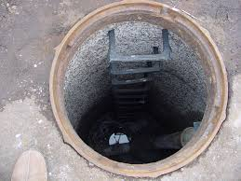
Figure 3
Pump stations: are facilities including pumps and equipment for pumping fluids from one place to another.
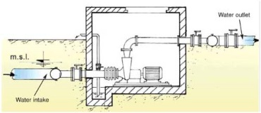
Figure 4

INTRODUCTION OF TAŞUCU
Taşucu is a town of Silifke, Mersin. Taşucu has a coast on Mediterranean, and is surrounded with Akdere town in west, center of SilifkeCounty in northeast and Göksu delta. There is forest area in north of town.
Taşucu takes 10,533 hectare space. Taşucu which located in Mediterranean region has typical meditrraean climate. Therefore, summer is hot and dry; winter is soft and rainy there. The average temperature of this town is 19.5 Celsius degree. Due to this good weather condition, Taşucu is the important touristic place of Turkey, so economy of town depends on tourism. In addition to tourism, commerce, fishing and agriculture are means of existence in this town.
Town is on a rolling terrain, between 0.0 elevation in coast and 100.0 elevation in north. Since, most part of living site is on bottom land, slope of site is almost 5%.

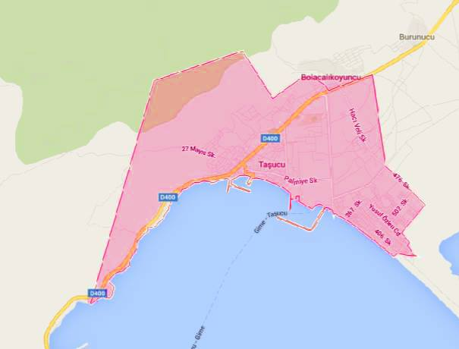
Figure 5

2. POPULATION PLANNING
2.1. Introduction:
Population project is the helpful or useful tool to reflect and to digitize a region in terms of social and economical point of view. The population project is defined as making the estimation of changing of the population in the future based on assumptions of future trend for birth, deaths and migration acts. The population project can be done with different scale for different purposes such as the settlements or administrative agency having different population greatness or administrative agency besides the whole around the country, region and province.
The population projection is being done in order to prepare development plan scene since the beginning of the planning and design process. It aims to submit for one's review to present applications of scientific and demographic models, which are essential parts of preparing development plan, as much as possible in population planning; including the more common and simple methods for planning studies as well. Although the prediction methods which will be elaborated in this report are guide for users, users should take into account that the methods should be updated or new methods should be developed in case the condition have changed and the accuracy of population prediction could be high by unique approaching of themselves.
In the first step of this study, the estimation of population methods will be covered. In the second step, the different methods will be compared and the best method will be selected and the result will be used for waste water project. In the third step, a short summary will be done and the comment for the project will be shared.
2.2. Location:
The place which the project will be done is Taşucu Neighborhood, Mersin. The view of Google Map can be seen in the 'Figure 6' .
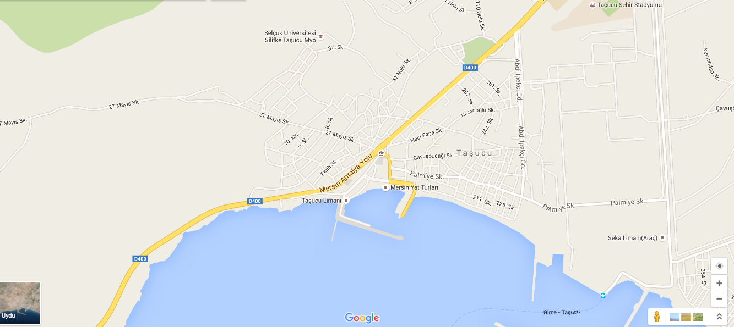
Figure 6: The Google Map View of Taşucu Region

2.3. Scope and Goal:
The scope of population planning is only Taşucu in Mersin. To estimate the population of Mersin, the recent data of population census which belongs to Taşucu, Mersin was used.
The main goal to find population of Taşucu is making the project properly. Because the finding population is very important issue. The average life of a project is generally 50 years. Therefore, any project should be designed and done by considering future. If the capacity of the project does not supply the demand of the region, that would be a dead invest and would be money waste. For this reason, the population of Taşucu region should be found out correctly.
Therefore, the main purpose in this report is finding Taşucu population in the year of 2050.
2.4. Population Estimation:
The population increases by births, decreases by deaths. The migrations affect the population with either increasing or decreasing. These components are under the impression of social and economical factors. The shape of changing the population in years is 'S' most of all. (Figure ...) The initial speed of increasing population is low and this level increases in time and reach its maximum point.
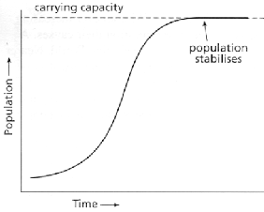
Figure 7: The shape of population growth

2.4.1 The Population Estimation Methods:
The population estimation methods to find a region basically are listed below.
- Graphical Method
- Arithmetic Increasing Method
- Geometric Increasing Method
- Bank of Provinces Method
2.4.1.1. Graphical Method:
In this method, the population versus time graph should be plotted. The axis of graph should be time and the ordinate of the graph should be population. The graphs whose ordinate population help designers to see trend of the population in the future. Then, the population trend of a region can be drawn simply. The equation of a trend line can be observed easily and the future estimation can be made.
The available data of Taşucu population is listed in the 'Figure 8' .
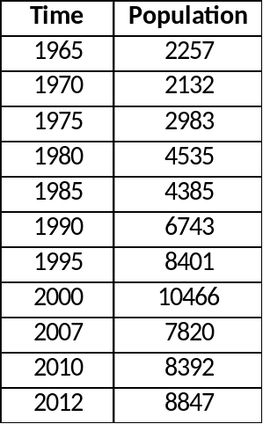
Figure 8: The available data of Taşucu Region
The time versus population graph and the trend line of the population can be seen below.
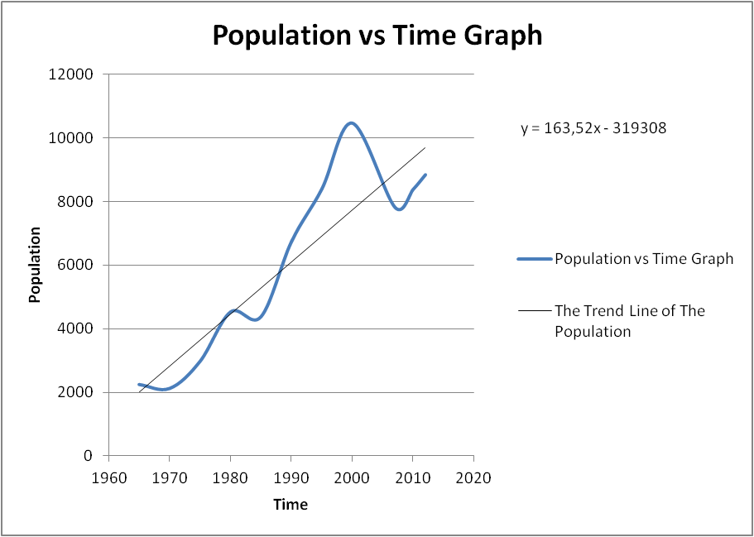
Figure 9: The population graph and trend line
The equation of trend line is:
Then, in 2050 ;
y = 163,52 * 2050 - 319308 = 16000 person ( Approximately )
2.4.1.2. Arithmetic Increasing Method:
This method is a mathematical method that both two axis of a graph points in a graphical paper having arithmetic scale as if previous population values became a straight line situation. In this situation, the increasing rate of population is constant, in other words, the tangent of the curve is also constant.
There are equations for calculation.
k_{a}= The arithmetic increasing speed constant (d_{y}/d_{t} = k_{a} )
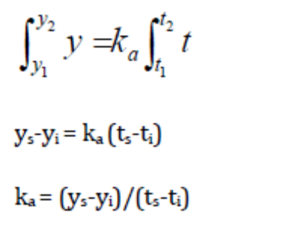
y_{s}= Last Population
y_{i}= Initial Population
t_{s}= Last time
t_{i}= Initial time
The population versus time graph for 1965 and 2012 years and the equation of trend line based on 1965 and 2012 years can be seen in the 'Figure 10 '.
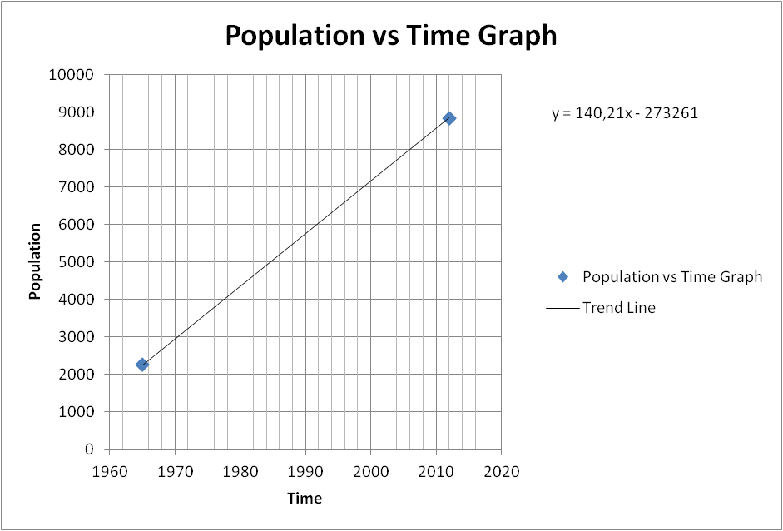
Figure 10: Population versus Time Graph for arithmetic method
Then, in 2050;
The Population= 140,21*2050- 273261 = 14200 people (Approximately)
2.4.1.3. Geometric Increasing Method:
In this method, the increasing rate of the population per unit time is accepted as related with the present population. According to this, the population change rate can be written as dy/dt=kg .k_{g} represents geometric increase rate constant.
The useful equations can be seen below.
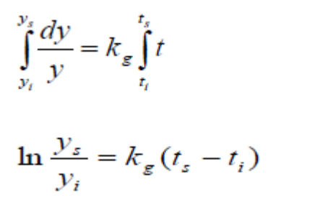
Then Equation Becomes

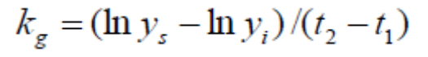

kg = (In(Ny)-In(Ne))/(ty-te) = (In(8847)-In(2257))/(2012-1965) = 0.0291
Population Projection :
In (Ng) = In (Ny) + kg * ( tg - ty ) = In (8847) + 0.0291 * (2050-2012)
Ng = 34000 person ( Approximately )
2.4.1.4. Bank of Provinces Method:
According to drink water ordinance of directorate general of bank of provinces, it is forecasted as below expressions for drink water and canalization projects preparation which is sustained by bank of provinces method.
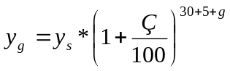
y_{g}= Future Population Ç= reproduction coefficient
y_{s} = Present Population g = The time from last population counting to planning
30= Project Service Time (year) 5: The time for planning, design, bidding, construction
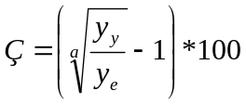
y_{e} = First population data a= the time difference y_{y} and y_{e}
Also, there are limitations for Ç values
If
- Ç<1 ; Ç= 1
- Ç>3 ; Ç=3
- 1<Ç<3 ; Ç= Calculated Value
y_{y} = 8847 ; y_{e} = 2257 ; a= 2012-1965 = 47 years
Then;
Ç = 100 * ((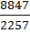)^{1/(2012-1965)} - 1) = 2.949
Then, the first equation can be applied as below.
y₂₀₅₀ = y₂₀₁₂ * ( 1 + 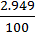 )⁽³⁵⁺²⁰⁵⁰⁻²⁰¹²⁾ ; y₂₀₁₂ = 8847
y₂₀₅₀ = 27000 person ( approximately )
2.4.2. Comparison of Methods:
The comparison result can be seen in 'Table 1'

Table 1: The Comparison of all methods
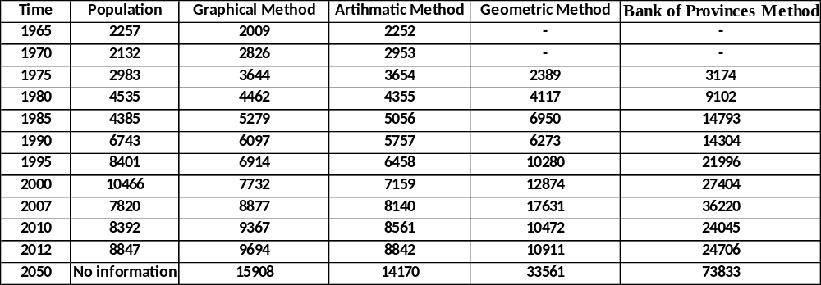
The comparison graphs can be seen in 'Figure 11'
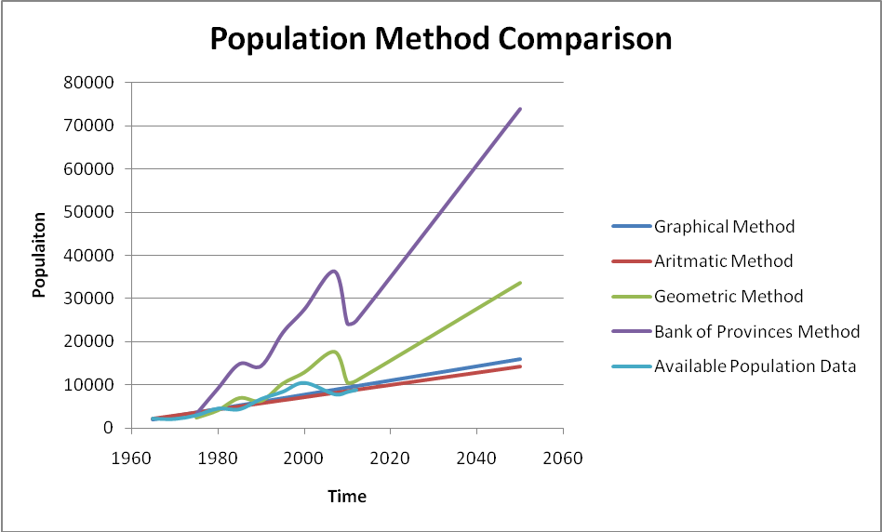
Figure 11: All graphs in together for estimation of population methods
2.4.3. Summary, Conclusion and Comments:
The results for Graphical, Arithmetic, Geometric and Bank of Provinces Methods are approximately 16000,14200,34000 and 74000 respectively.
The population of waste water project was selected as 60000 people. There were two considerations. The first one is whether the project would supply the demand of people in the region or not. Therefore, the methods which give around 16000, 15000 and 34000 was not selected. The more population was selected, as a result of this the capacity of pipe line would be enough for Taşucu. The second consideration is that the population should not be exaggerated.
Also, according to ministry of environment and urbanization data, the estimated population of Taşucu in 2025 is 50000 people.
In the light of all numerical population data and design concerns, the population was selected as 60000 people instead of 74000 people in bank of provinces method. The main reason is reducing the cost of the project. If population of 74000 was selected, the cost of the project of Taşucu waste water would be extremely high, therefore the population of 60000 was considered as future of Taşucu in 2015, the population estimation is also a reasonable estimation for ministry of environment and urbanization data.

3. WASTE WATER CALCULATION AND DIAMETER SELECTION
In the design of sewage water amount, potable water is taken as reference point.
Table 2: Potable water demand according to population (illerbankası)
population | Potable water demand(l/p/d)
3000 | 60
3000-5000 | 60-80
5000-10000 | 70-80
10000-30000 | 80-100
30000-50000 | 100-120
50000-100000 | 120-170

Table 3 : Total water demand
Type of consumption | Consumption per person daily  (l/p/d) | Project year consumption per person* (l/p/d) | Project target year consumption per person** (l/p/d)
Household (q_{home}) | 80-140 | 76 | 97
Commerce, construction, service, industry (%5-10*q_{net}) | (q_{net})*0.05-0.10 | 0.10*89 = 9 | 0.10*108 = 11
Net Consumption (q_{net}) | (q_{home})/0.90-0.95 | 80 / 0.90 = 89 | 97 / 0.90=108
Losses (q_{loss}) (%10-20*q_{gross})*** | (q_{gross})*0.10-0.20 | 0.10*99 = 10 | 0.10*120 = 12
Total (q_{gross}) | (q_{net}) + (q_{loss}) | 89/0.90=99 | 108/0.90 =120

Table 4: Water demand for Kum neighborhood
facility | water demand(l) | present unit | predicted unit | unit per facility | water
pension(per person) | 190 | 1 | 7 | 50 | 66500
hotel(per bed) | 300 | 4 | 15 | 100 | 450000
swimming pool | 500l/m^2 | 3 | 10 | - | 500000*
***the area of the pool is assumed to be 100 m²

total demand | 3032500
demand per person(l/p/d) | 180,5

Table 5: Total sewage values obtained from the parts of the map
parts of the map | sewage(l/s/p) | areas(ha) | p/ha | total sewage(l/s)
1 | 120 | 340 | 50 | 23,61
2 | 120 | 430 | 60 | 35,83
3 | 180 | 210 | 80 | 35

Kutter’s equation
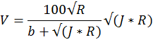
Q=V*F
F : Area of the pipe while the pipe is full (m²)
R : F/r: hydraulic diameter
J : mean velocity of the sewage (m/s)
Q : discharge of the sewage (m³/s)
b : coefficient of roughness
r : wetted perimeter

Table 6: Minimum and Maximum Velocities in Sewer Pipes
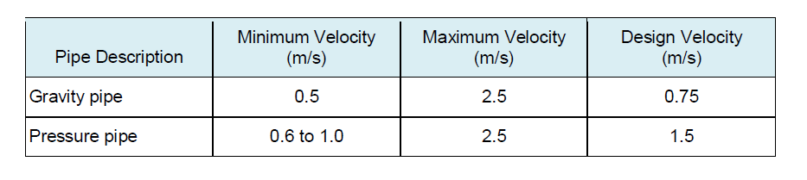
Table 7: Grade standards for sewage works
diameter(mm) | minimum grade | maximum grade | fullness ratio | manhole distance(m)
φ200 | 300 | 7 | 40 | 50
φ300 | 500 | 7 | 50 | 60
φ400 | 600 | 25 | 60 | 70
φ500 | 800 | 25 | 60 | 70
φ600 | 1000 | 25 | 60 | 70
φ800 | 1200 | 50 | 60 | 80
φ1000 | 2000 | 75 | 70 | 100
φ1200 | 2050 | 75 | 70 | 125
φ1400 | 2100 | 75 | 80 | 150
φ1600 | 2150 | 75 | 80 | 150
φ2000 | 2250 | 75 | 80 | 150
φ3000 | 2500 | 75 | 80 | 150

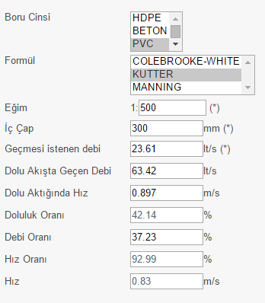
Figure 12: Diameter selection and the calculation of the pipe fullness for part 1(Dizayn group)

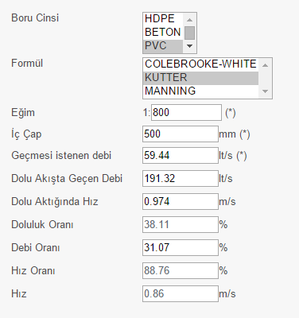
Figure 13: Diameter selection and the calculation of the pipe fullness for part 2 (Dizayn group)

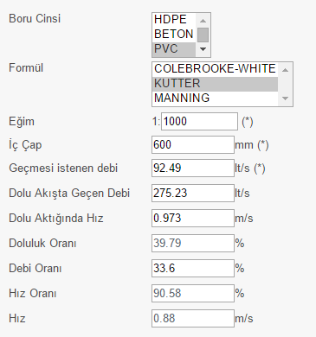
Figure 14: Diameter selection and the calculation of the pipe fullness for part 3 (Dizayn group)
4. DİSCHARGES & PUMP SELECTİON :
For 35 years :
Q12 = 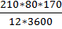 = 66 lt/s Q18 = 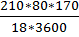 = 44 lt/s Q37 = 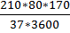 = 21 lt/s
 | Q37 (lt/s) | Q18 (lt/s) | Q12 (lt/s)
25 YEARS | 18.00 | 37.00 | 55.00
35 YEARS | 21.00 | 44.00 | 66.00

 | Q (lt/s) | PUMP TYPE
25 YEARS | 3*33 | PLUNGER TYPE
35 YEARS | 3*33 | PLUNGER TYPE

Differences of water consumption at certain times in a day are important for the hydraulic calculations. Change in water consumption create different discharges for hourly, daily and even weekly. To make the calculations in the safe side, discharge for 12 hours in a day is used in the calculations.
3 pumps are used in the pumping station since discharges show differences according to the seasons. Since Taşucu is tourism province, the population has been increasing sharply in the summer. The differences discharges in the summer and winter have been increasing. To provide energy effienciency, the pumps which can work for different discharges properly are used.
Plunger pumps are used as a pump type. They are feasible for small discharges ( less than 100 - 150 lt/s ). The important advantage of plunger pumps is low cost maintenance and no need extra place to install pumps therefore it makes plunger pumps cheaper compared to other type of pumps. Another advantage is that plunger pumps do not cause vibrations and noise since they run in the fluid.
Circular caisons are used since Kum Neighborhood has weak soil. Also, installation of the caissons is easy. Diameter of the caissons should not exceed 7 meters.
As a material type of the pipeline, polyethylene( HDPE ) pipes are chosen. Because, it has high flexibility which allows the pipe not to break and being uneffected from underground movements. Also, it has high impact strength and high resistance to crack.
4.1.Motor Power Calculation :
Calculations of motor power are done according to the pump discharges for 25 years since economic life of pumps and air chambers is 25 years.
H_{g} = final elevation of pump line - pump axis elevation
H_{g} = (2.50) - (-9.10) = 11.60 m
Q_{p} = 55 lt/s
J = f_{s} * 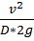
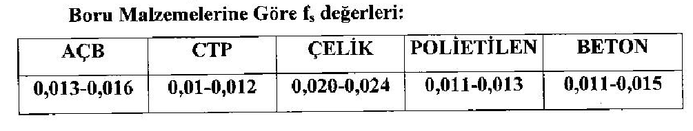
For polyethylene, f = 0.012
Q = v * A
55*10⁻³ = v * (π * (0.15)²) where D = 300 mm → v = 0.78 m/s
J = 0.012 * 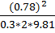 → J = 0.00123 m/m
L = 712 m → JL = 0.00123*712 = 0.88 m
H_{m} = H_{g} + JL + minor losses = 11.60 + 0.88 + 2.00 → H_{m} = 14.5 m
N_{e} = 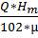 = 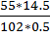 → N_{e} = 15.6 kW
N_{e} = 15.6 kW → E.K. = 1.25
N_{m} = N_{e} * E.K. = 15.6*1.25 → N_{m} = 19.5 kW
N_{m} = 19.5 kW → n=8
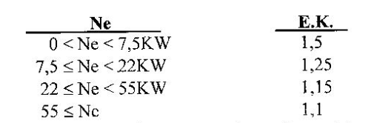
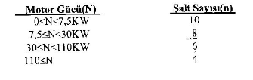

Calculation of the Volume of Collecting Chamber :
T_{min} = 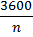 For n=8, T_{min} = 450 s
V₁ = 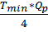 = 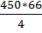 → V₁ = 7425 lt
V₂ = 0.392 * V₁ = 0.392*7425 → V₂ = 2911 lt
V₃ = 0.264 * V₁ = 0.264*7425 → V₃ = 1960 lt
V_{R} = 1704 lt is taken.
V_{T} = V₁ + V₂ + V₃ + V_{R} = 7425 + 2911 + 1960 + 1704 → V_{T} = 14000 lt = 14 m³

Base Area of Collecting Chamber :
F = π * r² = 3.14 * (2.50)² → F = 19.63 m² where diameter of caisson is taken as 5.00 m.
When concrete of bottom slope is considered, F_{net} = A = 15 m²
h₁ = = 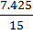 → h₁ = 0.50 m
h₂ = = 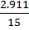 → h₁ = 0.19 m
h₃ = = 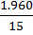 → h₁ = 0.13 m
h_{R} = = 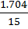 → h₁ = 0.11 m
h_{ö} is taken as 0.80 m.
H_{T} = h₁ + h₂ + h₃ + h_{R} + h_{ö} → H_{T} = 1.73 m
4.2.Pump Station
4.2.1.Valve House
When pump station is shut down, valve house is used for making sewage stop to flow. Valve house will build just before the grille and will include butterfly valve which will be according to DIN 3216.
4.2.2.Grille
It will need to separate bulk meterials from row sewage. It will be appropriate for Iller Bankasi standarts.
4.2.3. Pipe Station Dimensions
Valve house enter pipe base elevation : -7.57 m
Basket grille enter pipe base elevation :-7.58 m
Basket grille exit pipe base elevation : -8.09 m
Pipe station enter pipe base elevation : -8.1 m
Pump station base elevation :0,5 m
Pump axis elevation: -9.1 m
Pump room base elevation : -8.3 m
Final elevation of pipeline :2.5 m
Pressure pipeline : Φ 300mm L = 712 m
4.3. Storm Water Calculatıons
Storm Water Discharges :
In the calculations, rational method is used. Rational method is the method that gives the best result. It is assumed that the rain falls the whole area uniformly.
Q = C * I * A
where ;
Q = storm water discharge ( lt/s )
C = runoff coefficient depending on drainage area and type of rainfall
I = Rainfall intensity ( lt/s/ha )
A = Area ( ha )
Collecting time, T = T_{g} + T_{a}( minutes )
T_{g} = Entrance time ; It is the time that raindrops that drop the remotest point of the water collecting area come to the beginning of the canal.
Slope Entrance Time (min.)
J > 1/20 5
1/20 > J > 1/50 10
1/50 > J 15
T_{a} = Runoff time ; It is the elapsed time between two points in the section where storm water passes.
T_{a} = 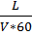 (min) V = conduit runoff velocity (m/s)
Average runoff coefficients are shown below considering reconstruction densities.
TYPE OF DRAINAGE AREASRUNOFF COEFFICIENTS (C)
COMMERCIAL ZONES
Central Zones 0.70 - 0.95
Outskirt 0.50 - 0.70
REZIDENTIAL ZONES
Isolated houses with garden 0.30 - 0.50
Multi-storey isolated blocks 0.40 - 0.60
Multi-storey adjacent blocks 0.60 - 0.75
Residential Areas 0.25 - 0.40
INDUSTRIAL ZONES
Light Industrial Zones 0.50 - 0.80
Heavy Industrial Zones 0.60 - 0.90
ROADS
Asphalt Pavement 0.70 - 0.95
Concrete Pavement 0.80 - 0.95
Durax-cube Pavement 0.70 - 0.85
Green Areas, Parks & Graveyards 0.10 - 0.25
Sports Arena 0.20 - 0.35

General Criteria :
In the storm water conduits, concrete pipes whose section is circular or B.A. pipes and reinforced concrete pipes whose section is rectangular are usually used.Selection of conduits whose section is rectangular is more appropriate where the slope is very few. When concrete pipe is used, minimum diameter of conduit will be Φ300 mm. Kutter Equation is used in the concrete pipes as the sewerage conduits and Manning Equation is used in the conduits whose section is rectangular.
Manning Equation :
Q = V * A
V = * R^{2/3} * S^{1/2}

Q = discharge that can pass through the selected section ( m³/s )
V = velocity ( m/s )
n = Manning roughness coefficient ( 0.015 )
R = Hydraulic Radius ( m )
S = Slope
Wastewater treatment plants which are available and will be installed and intersections will be controlled, necessary distances between conduits will be provided.
Storm water grille places will be shown on the project. Absolute grille installation will be specified with control organization in the stage of practice according to the last situation of pavements and roads.
When rectangular sections are planned, canals have freeboard to flow the water regularly. Since duration of storm water runoff is less than the duration of waste water runoff, maximum velociy can be taken as 5 m/s and Manning equation is used to specify the section discharge.
Inlets are used to take the storm water to the conduits.
When the storm water drainage system is planned, discharging of the storm water to the nearest places is taken into account.
Minimum diameter of conduits that has circular section will be Φ300 mm and it allows the conduits to flow 100 % fully and Kutter equation is used to specify the conduit section discharge.
In places where totally 80-100 lt/s storm water discharge is formed in 2 borders, conduit planning will be done.
In circular section conduits, minimum ground cover will be h = 1.20 m.
In rectangular section conduits, minimum ground cover will be taken as h = 1.20 m but it decreases to 0.20 m in unavoidable situations.
Manholes will be installed as in the sewerage system and water that is collected in inlets will be connected with Φ300 mm concrete pipe to the main conduit. To connect the inlets to the manholes is more appropriate in terms of maintenance and management.
In inlet grilles, grilles whose dimensions are 60-40 cm will be used and placed parallel to the road to increase the capacity.

