

REPORT ON CE 300 SUMMER PRACTİCE BETWEEN 15.6.2009- 10.7.2009

8.10.2009

Submitted by :
Group :6
Surveying :Group 5 Members:

TABLE OF CONTENTS

Introduction …

INTRODUCTİON

As an undergraduate student, studying under the deparment of Civil Engineering, I am required to participate in a summer training course to enlarge my skills in engineering in the extent of both experience and knowledge. CE300 was a compulsary summer practice program which is organised by the department. It was like a package program that includes activities related to different civil engineering subjects. These activities can be grouped as surveying, technical trips, documentaries and computer programs. Here is a brief summary of works that had done during this summer pracitce;

Surveying sessions enabled both the theoritical knowledge in the classrooms and gaining experience in the field following it. We had five surveying activities; angle and distance measurements, levelling,curve and building layout, traversing and tophograghic survey as a final project.

Under the title of “Technical trips” here are the list of our visits:
  - 2. Kurtboğazı and Eğrekkaya Dams
  - ASKİ İvedik Treatment Plant
  - Metro constructions at National Library and Kizilay
  - Polarkon -prefabricated steel structures
  - Ilgaz- prestressed beam prefabric elements and ready mixed concrete production plant
  - Mesa Imalat- Formwork and Scaffolding Systems

Documentaries were the most fascinating part of the summer practice. We watched some episodes of the “Extreme Engineering” program by Discovery Channel which involve hard core civil engineering pracitce. The structures covered are namely The Millau Viaduct, Venice Flood Gates,Iceland tunnels…

Also in Computer programs part, we practised MS Word and MS Excel basics and attend MatLAB courses learned about the basics of MatLAB.

4.THE WORK DONE

4.1. SURVEYİNG

Surveying was one of the purposes of this summer practice. It required a considerable amount of time and energy. Surveying was the most challenging part of this summer practice because of the hot weather. Surveying lessons composed of lectures in classrooms about the topic and practicing it in the field following it. We have given information about the total station, its setup and how to use it. It really surprised met that the total station is such a multifuntional instrument. The subjects we covered was angle and diastance measurments, leveling, curve and building layout, traversing and tophograghic survey as a final project.
Firstly, we learned the basic things such as setting the total station, adjusting the pond and plate bubble, horizontal and vertical distance, angle measuremnts. In the field,which was the METU Stadium, every group member personally set the total station and measured the distance and angle between the picked buildings.(you can find the report on appendice …)

In the second surveying, we started to consider elevations of points in addition to their distances and angles between.We used the benchmark to attain the elevetions of points. We also did the two-peg test which helps us to identify and determine the collimation errors of a level. We determined elevations of points taken at the stadium and also learned to determine the elevation of a point by using Back sight and foresight readings.(report on appendice 1.23…)

At the fourth subject of surveying, curve and building layout, we learned the meaning of layout and how to generate curve layout. On the field by using reflector and pins we form a curve according to given data. Then by using reflector and pins we entered the given data to total station setup menu and pinned four data point of a building layout.

At the third subject of surveying, traversing, we learned the open and closed traverse, traverse angle, traverse calculations and azimuth calculations. Then we worked on the American Football Field. Every group set their total stations according the station points and then we make measurements

Last week, we are given a project about curve layout and we tried to calculate some points. We made a big project with our group members. We also prepare topographic map of the American football field. Then we drew the contour lines according the height of data points. We also drew the traverse at the final project.

Here is the list of ten relevant terms that I heard during Surveying

- Elevation
- Leveling
- Layout
- Traverse
- Azimuth
- Contour line
- Benchmark
- Total Station
- Collimation error
- Resection

I have researched in detail two of them ;

Total Station :

4.2 TECHNICAL TRIPS

Technical trips were I think the most important part since it gived me the chance to get familiar some with civil engineering aspects and observe things by naked eye at the site. Below, I listed our visits in chronological order.

Kurtbogazı Dam:
This dam of Ankara was constructed on the Kurtbogazı River between the years 1963-1967 in response to the rising city population demands. It is an earthfill type dam wtih a clay core. Kurtbogazı Dam is one of the main drinking water source for Ankara (67 hm³ per year). It supplies water to the city with two pipes with a diameter of 2200mm. These pipes directly passes through ASKI Ivedik Treatment Plants.

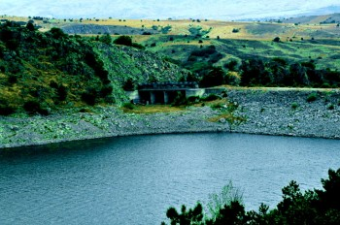
Figure 2A- Kurtbogazi Dam

Egrekkaya Dam:

Egrekkaya Dam was constructed on the Sey River between the years 1985-1992 near Kızılcahamam. The purpose of this dam is to provide water for Kurtbogazı Dam.The dam body is composed of sand and gravel. The water levels are decreasing in recent years.

. 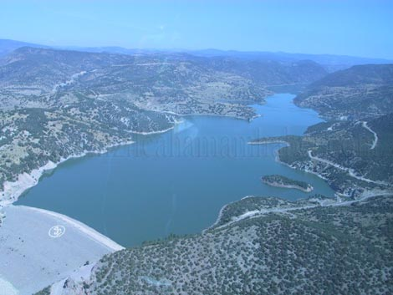
Figure 2B- Egrekkaya Dam

ASKI Ivedik Water Treatment Plants:

It is the biggest water treatment plant in Turkey. It provides Ankara’ s all industrial, drinking and tap water needs. The water is provided to the plant by Kurtbogazı and Camlidere Dams. The Purification of water includes these steps briefly;
- The ventilation of water
- Adjusting pH by using Sulphiric acid
- Adding Aluminium Sulfate as a coagulator
- Filtration
- Chlorination to disinfect water
- Using lime to again adjust pH of water

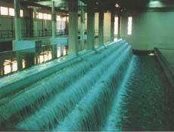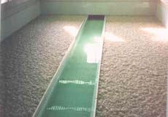
Figure 3A-Ventilation process 1 Figure 3B -Filtration process

Mesa Imalat: Formwork & Scaffolding Systems:

MESA group of Companies is one of the mos prestigous companies in construction sector and MESA Imalat founded in 1978 to design and manufacture formwork and Scaffolding Systems.They have one of the biggest formwork manufacture plant in the europe The famous product of them is the tunnel formwork systems as they are the initiative of it. It is a very benefitial system in many ways, such as ;
- Allows casting of walls and slabs together in one operation
- Considerably reduces the required time for construction
- Minimize the workmanship costs
- Does not need plastering since it provides smooth concrete surfaces
- Forms can be reused

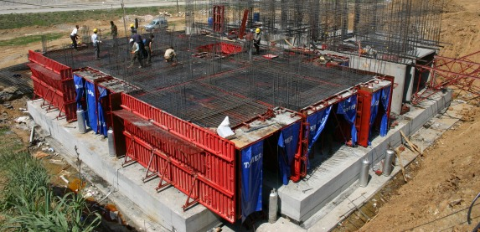
Figure 3C-A building construction using tunnel formworks

Polarkon -prefabricated steel structures :

Polarkon company was started in 1995 and specifed on designing and manifacturing of prefabricated steel structures space frames.

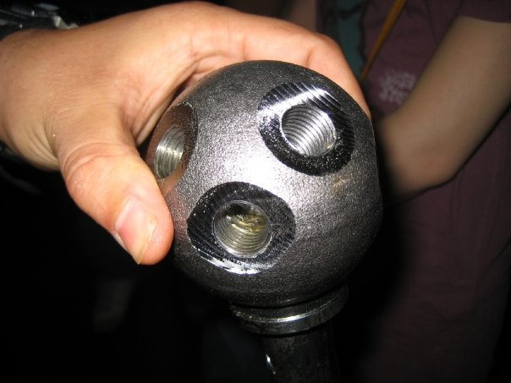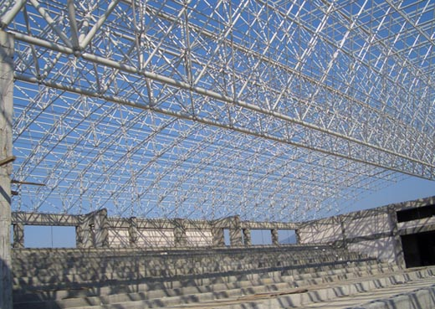
Figure 4B- A Sample Space Frame
Figure 4A- Joint of the truss

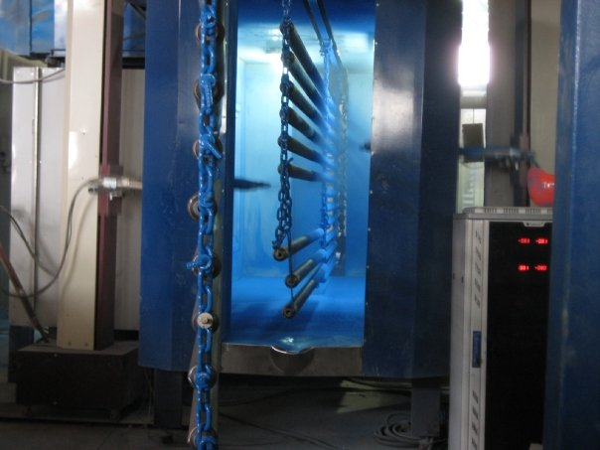
Figure 4C-Painting the Prefabric Steel Elements

ILGAZ prestressed beams, prefabric elements and ready mixed concrete production plant:

We visitied the Polatlı plant of the Ilgaz Company. The plant was built in order to supply prestressed beams and other prefabric concrete elements to the Ankara- İstanbul high-speed train railway construction.Here is some steps of the process;

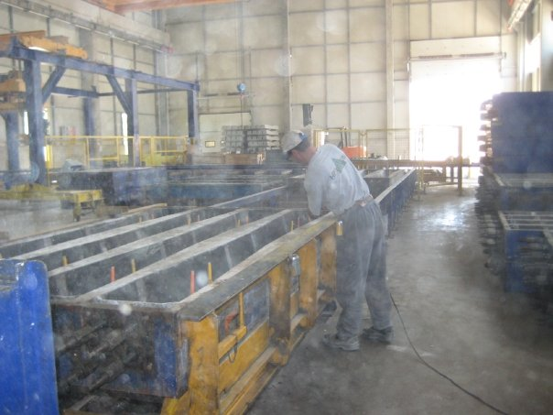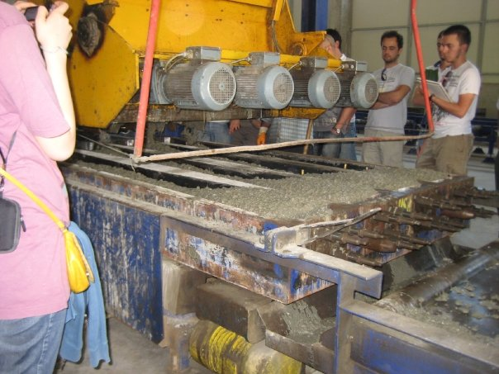
Figure 5A-Oiling the forms Figure 5B- Pouring the Mix

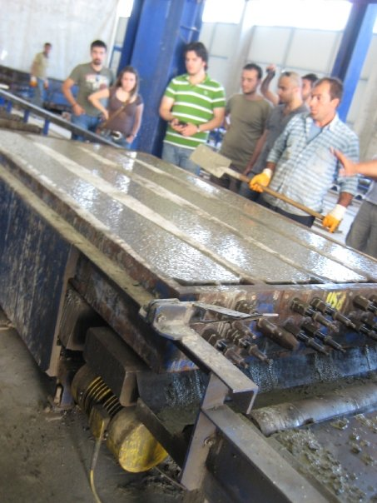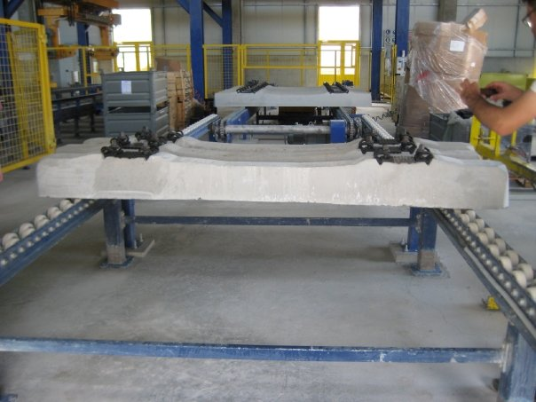
Figure 5C- Vibrating the Forms to Compact The Mix Figure 5D-The final product

Metro Constructions at Kiziliay and National Library:

We also visited the METRO constructions at Bahcelievler in front of National Library. This station is a part of Kizilay – Cayyolu line.
Actually the constructions began at 2002 and it should have been completed today.However, they are far behind the Schedule and the site coordinator said that it will not be shorter than 3 years to complete the line, The station also includes a big parking garage. The constructions in Kızılıay was much more interesting because they have done something new. In the beggining they had a big problem because the state limited their site area because of the monuments around. They had only a field on the land with around 8 meters width. The area they need under the land is much more bigger. So they used inclined piles.They started to excavate and widen their excavation as they go deeper. In this trip,

I have also had the chance to see a TBM(tunnel boring machine) that made me feel lucky.

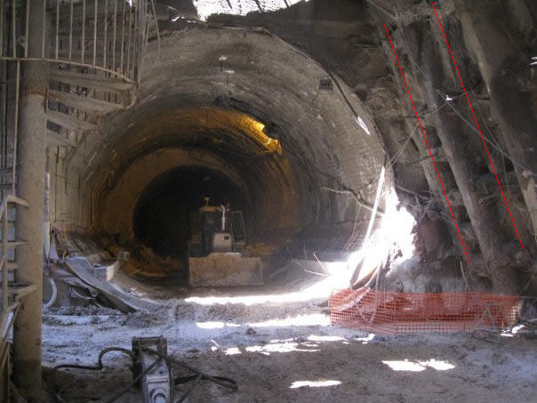
Figure6A-You can see the inclined piles

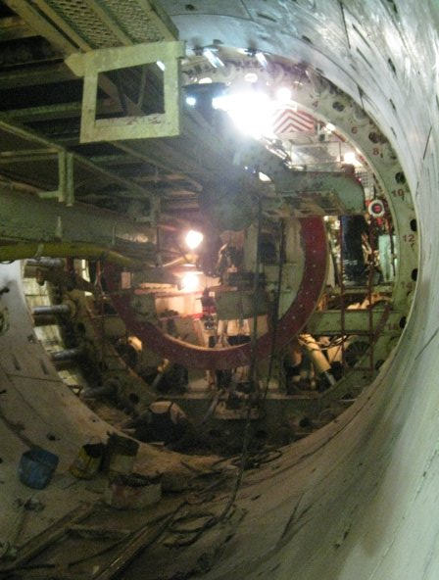
Figure 6B- TBM in the Kizilay Metro Tunnel

10 terms I have heard during technical trips:

- Lower coffer dam
- Upper coffer dam
- Derivation channel
- Shear wall
- Flat slab
- Space frame
- Scaffolding
- Prestrressed beam
- Formwork
- Spillway

4.3 DOCUMENTARIES

As a part of this summer practice, every weer we watched technical documentaries. Specifically, it was the program “Extreme Engineering” by Discovery Channel. The videos are generally related to tunnels ,bridges, hydraulics. However, the common point was the high problem solving ağabeylities and hard engineering practice. These documentaries really impressed and enlightened me. Here are some of the structures in the videos;

Millau Viaduct:
This civil engineering wonder is built at 2004 and it is typically an extreme engineering sample.It was designed by Norman Foster and Michel Virlogeux. With a height of 343 meters, it is the talles vehicular bridge ever(even taler than Eiffel Tower). It connects the motorway between Paris and Barcelona.

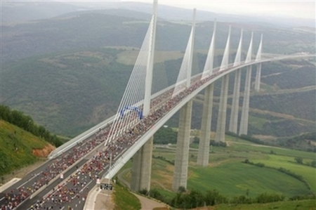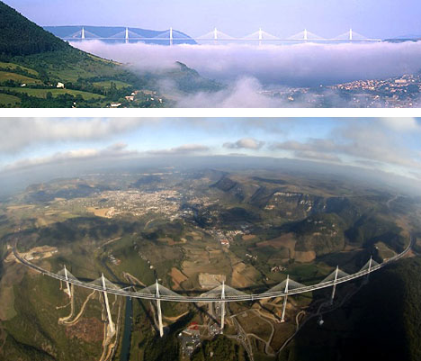
Figur 7A-Views of Millau Viaduct

Flood Gates of Venice:
Global warming cause water levels to increase all over the world and it may cause venice sink into the water like Atlantis. In September 2003, work began to prevent the city’s 45km of canals from cannibalising its ancient architecture.
Phase one saw dredging machines begin to remove 3.8 million cubic metres of clay from the lagoon bed at the mouth of its three inlets.
This is being replaced with 9m tons of rock and concrete to provide a sturdy foundation to fix the 79 steel floodgates. Each is bigger than a football field and weighs over 300 tons.
When not in use, the gates will lie flat against the lagoon floor. At the threat of a high tide, hydraulic valves can be opened at the flick of a switch allowing the gates to pivot into position.
At a cost of $3 billion, the project isn’t exactly cheap. But then, it’s less than the estimated losses during Venice’s worst ever flood in 1966.

Oakland bay bridge
Roller coaster
İceland dam
Flood Gates of Venice
World’s Biggest Arch Bridge Hoover Dam Bypass

Computer Programs:
First week of the CE300 Summer Practice, we introduced to Microsoft Office Excel program and we have learned some basic features of this program. We were shown that how to draw graphs and diagrams in Excel, how to write formulas and use them to solve some problems. We applied what we learned in lab hours.
In second week, we have attended Microsoft Word and PowerPoint courses. We have learned how to add graphs to word files, how we can draw figures in word, how to prepare table of contents in PowerPoint. We also see what can be done in basic Office programs and we make exercises in lab hours by the help of assistant and we strengthen our knowledge with these applications.

We also leaned mathematical calculation program, MatLab, and some basic commands of MatLab computing program. We learned some functions such as adding, multiplying, subtracting two matrices and plotting graphics and functions.
We have computer lab hours every week. We study in lab computers what we have learned in lessons. Useful subjects were covered in these computer lectures. Many different specifications of Office programs and MATLAB were thought and provided with homework. We do this homework at home or at computer labs to improve our ability in these programs.

Conclusion,

According to my subjective evaluation of the structure of education in the engineering faculty, there are two main components included. One of those two bases is the theoretical education that is completely based on technical information and scientific examination of the specific field of engineering, such as civil engineering. To give an example, almost seventy-five percent (%75) of the undergraduate education is based on the theoretical structure of electrical engineering, focusing on the physical and mathematical nature of the specific field of engineering education. The remaining main base of the education is the laboratory experimentations. Throughout the four semesters, 1st and 2nd year of education, we are introduced by many theoretical knowledge on the wide spectrum of civil engineering. However, this excessive loading of information is strengthened and balanced by laboratory experimentations that allow the student literally observe the knowledge that has already been gathered. So in this manner, this summer practice was very benefitial. The whole summer practice was like warming up to civil engineeringand it really gave ideas about my future plans.However, I think a summer practice should also give a clue about the business life, human relationships at the site and how things work in real life civil engineering, together with technical knowledge and practical experience. Lastly, I think the biggest problem was the population of groups. I think it was very high and it made difficult to observe things at the site.

REFERENCES

- http://www.dsi.gov.tr/tricold/kurtboga.htm
- http://www.dsi.gov.tr/tricold/egrekkay.htm
- http://www.aski.gov.tr/m.asp?tid=11&pn=1&tpn=1
- http://www.mesaimalat.com.tr/
- http://www.ilgazinsaat.com/tesisler.htm
- http://viaductconstruction.blogspot.com/2009/04/millau-viaduct-world-tallest-bridge.html

