INTRODUCTION:
In Summer Practice Program(CE 300),we did some beneficial trips to ATAK Engineering,KAM Concrete Industry,ParkOran Housings,Sogutozu Convention and Commercial Center,Metro Stations(Kizilay,National Library and Necatibey) and Dams of Ankara(Egrekkaya,Kurtbogazi, Kavsakkaya).These trips helped us to know how to prepare some important engineering products and how construct these buildings.
Another part of this program is technical videos. We learned some important informations from these videos. They helped us to know how the engineers could succeed to finish great projects all over the world.These projects are the Turning Torso, Cooper River Bridge, Iceland Tunnels, Venice Floodgates, Millau Viaduct, Marmaray Construction and Izmir Metro Construction.
We learned some important computer and Microsoft Office Programs such as PowerPoint, Word, Excel and MatLAB. In lab hours we applied on some exercises what we have learned so far. Assistant also helped us to do this exercises.
By the way we attend surveying applications every week. First we were given theoric information about surveying then we apply this knowledge to real performance in stadium and American football field by making some exercises
At the end of CE300 Summer Practice we have learned many things about civil engineering and its place in daily life. We see what civil engineers construct and how they do this job.
I am going to give more detailed information about summer practice in the second part of my report.
TECHNICAL TRIPS:
We also had some technical trips in the Summer Practice Program. These trips was arranged to give us job opportunities.In my opinion, they are the most beneficial parts of the Summer Practice Program. We had trips to ATAK Engineering, Kam Concrete Industry CO., Sogutozu Convention and Commercial Center construction site, Parkoran Housings, some dams of Ankara which are Kurtbogazi, Egrekkaya, Kavsakkaya and also some important metro construction sites near National Library, Necatibey and Kizilay.Now I want to give some brief informations about these trips.
ATAK ENGINEERING:
Atak Engineering Company was founded in 1988. They provide works including design, construction, reconstruction, restoration, renovation, rehalitation of facilities, decoration, recreation and electrical-mechanical installation of buildings and various consultancy services. Having a vast international experience with different type of buildings, ATAK is familiar with different building standards. (DIN, EUROCODE, SNIP, GOST, BS, AISC, ACI, STAS, etc.).
Atak's design and construction activities :
--Heavy and light (steel, composite and/or reinforced concrete) industrial buildings (cement and brick, cotton fiber, fabric, distillation factories, refineries)
--Agricultural buildings; grain storing utilities (vertical & horizontal grain silos), grain transporting equipment (elevators, conveyors), greenhouses, etc.
--Power plants, dams, water and sewage treatment facilities.
--Food industrial structures (Meat factories, bread and bakery factories, brewery factories, fruit juice (nectar) factories, etc.
--Seaports and airports (and its facilities).
--Hangar buildings (multipurpose warehouses, airplane hangars)

The production capacity of the company is approximately 5.000 tons per year. Their works include construction, reconstruction, restoration, renovation, decoration and electric-mechanical installation of buildings. They are mainly deal with steel works and steel, composite and/or reinforced concrete, cement and brick and water related works. After this session they give us a tour of the factory..While touring they give us some informations about the sections of the factory. This units are; cold forming unit, automatic sheet and profile sand blasting unit, guillotine shear, cnc cutting machine, sheet bending machine.
Until now they made very important projects in Turkey.They were part of the construction of Sukru Saracoglu Stadium,Adnan Menderes Airport,Antalya International Terminal and the AnkaMall Shopping Center.their abroad projects are Erbil Hawler Airport,Erbil Culture and Congress Center and Prefabricated Aviation Control Tower and Communication Building.
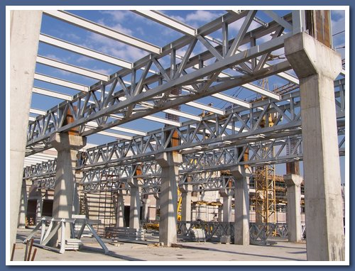
Photo from Ankamall Shopping Center
http://www.atakltd.com.tr/site_eng.htm

KAM CONCRETE INDUSTRY:
KAM Concrete industry started its productions at 1980. In 1992 the have established a factory in Ankara. It takes place on 28 km of Istanbul road from Ankara. They are mainly deal with prefabricated concrete and its productions.
Their works are planning, project and consultancy services, prefabricated buildings; concrete, steel, prefabricated, temporary and transportable structures, foundation structures and structure-carrying units, foundations, infrastructure facility units, pipes and water related structures and environmental arangement units.
When we arrived there the manager of the company met us and gave some information about the company’s techniques.He gave us some important information about prestressed concrete and showed how they do it.We saw some diffferent profiles of beams called “I beams” and “T beams”.
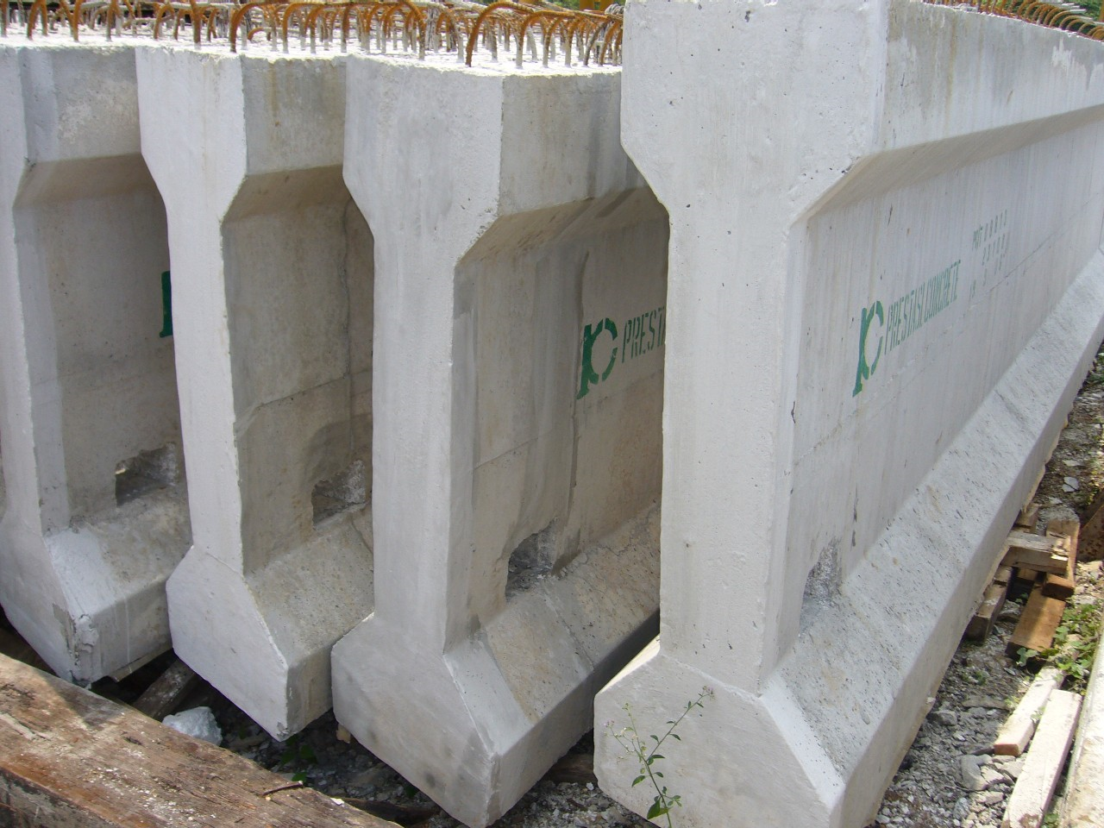
Prestressed Concrete “I” Profile

SOGUTOZU CONVENTION AND COMMERCIAL CENTER:
Our another trip is to Sogutozu Convention and Commercial Center. Total construction side lies on 140.000 m2 land. This complex will include three big conference hall. First of them has a capacity of 4500 people and other two have 575 and 700 people. 9 meeting hall with total capacity of 1855 people and 32 seminar hall with a capacity of 1280 people will also take place in this complex. 10 cinema salon, 248 shops and 38 fast-food restaurant will also be constructed on 35040m2 lands.
Half of main coloumns of this structure is made by steel and the other half is made by concrete. At combining point there exist “earthquake isolators” which are imported from Germany. Earthuaqe isolators are made by two parts which are looks like plates. This two plates can be slide on each other. When earthquake occurs this plates give the building a durability to the tensile stresses and seismic isolation. Bottom parts of building slides whereas upper parts can remains stable.
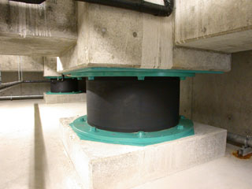

An earthquake Isolator
http://www.kawaroku.co.jp/images/isolator.jpg
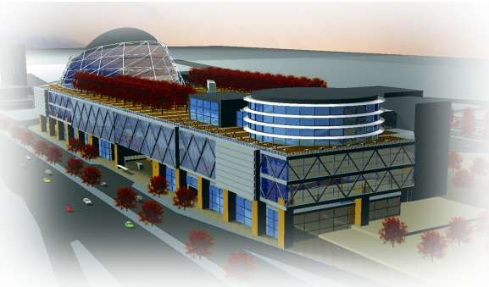
Future view of the Sogutozu Convention and Commercial Center
http://www.karcelsan.com.tr/sogutozu.htm

METRO CONSTRUCTIONS :
(KIZILAY,NATIONAL LIBRARY,NECATIBEY STATIONS)
This metro constructions are the part of the general metro line of Ankara. The construction of Asti-Cayyolu part of metro has started at 2002. The big amount of that construction has completed. Predicted date for finish is 2009. We had a trip to Kizilay, National Library and Necatibey metro constructions. Normally, we are always almost 25 meters down of the land. At that trip we had a chance to see how this kind of constructions is. We saw metro tunnels, places that are going to be the metro stations, the foundations and tunnels’ structural design. There are lots of term we are really concerned about such as embedment, strain gage, inclinometer, foundation piles, inclined foundation piles and TBMs. I briefly introduce you about them.
Embedment: Mainly, it is the act of binding weak or indurable soil parts to the strong and durable soil parts with steel strings. You make this weak soil parts stable and strong with holding these parts with strong and durable soil part.
Strain Gage: Device for measuring the changes in distances between points in solid bodies that occur when the body is deformed. Strain gauges are used either to obtain information from which stresses in bodies can be calculated or to act as indicating elements on devices for measuring such quantities as force, pressure, and acceleration.
Inclinometer: With this we measure the angles of slope (or tilt), elevation or inclination with respect to gravity. Clinometers measure both inclines (positive slopes, as seen by an observer looking upwards) and declines (negative slopes, as seen by an observer looking downwards).
TBM (Tunnel Boaring Machine): Tunnel Boaring Machine is a device that we can excavate tunnels with its circular crossectional head. It is used for almost 19 meters-diameter tunnels, fot the tunnels that has diameter less than 1 meter, we can not use TBMs. They are also used for drilling and blasting (D&B) methods in rock and conventional 'hand mining' in soil.

PARKORAN HOUSINGS:
Our other trip was to the Parkoran Housings. The project is made by Mesa. When we arrive there they gave us some basic informations about this construction. And give us a tour of this construction site. After this project is completed there will be 1832 house. “Tunnel Formwork” is used in that constructions.
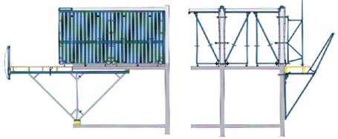
Tunnel Formwork
www.turanlargroup.com/PELIT/EN/PRODUCTS/

At this system there exist some molds which look like a tunnel and there is no coloumns. They are prepared specially for the designation styles. Concrete is spilled and we obtain cells according to the sizes of this tunnel formworks. It is more cheaper and fast method than the other ordinary systems.
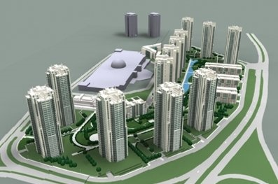http://konutdergisi.com/resim/Park%Oran.jpg

KURTBOGAZI,EGREKKAYA,KAVSAKKAYA DAMS:
Kurtbogazi Dam: It lies on the Kurtbogazi river and it is builded for irrigation and drinking water. Its construction was between 1963 and 1967. Soil body filling type is used and its body volume is 834000 meters cube. The height from the river bed is 54 m. Normally dam lake volume is 101.5 hm cube and lake area is 5.5 km square.
Egrekkaya Dam: It is 3 kms far from Kizilcahamam and it is on the Sey River. Its construction was between the years 1985 and 1992. This dam provides water to the Kurtbogazi Dam with Akyar Dam. We can accept this water basin as the cleanest and purest of Turkey but the water level decreased because of both unconscious use of water and drought.
Kavsakkaya Dam: It is the other dam that provides 58 million meters cube water to the Kurtbogazi Dam. It is 23 kms far from Kurtbogazi Dam. And a hydroelectric power plant is planned to be build on the line of that Dam.

TECHNICAL VIDEOS:
We have watched several technical videos about the important constructions all over the world.There are Turning Torso, Cooper River Bridge, Iceland Tunnels, Venice Floodgates, Millau Viaduct, Marmaray Construction and Izmir Metro Construction.
THE TURNING TORSO:
Turning Torso is a high-rise building in Malmö, consisting of nine cubes twisting towards the waterfront. Turning Torso houses top-quality apartments, offices and conference rooms and, at the time of completion (27 August 2005), is the second tallest residential tower in Europe after the 264m-high Triumph-Palace in Moscow andthe tallest building in Scandinavia.

The 86 metre high Kronprinsen was the tallest building in Malmö before Turning Torso.
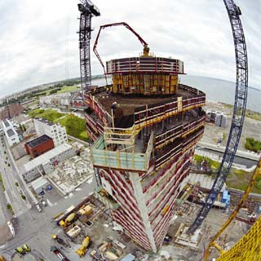 Photo by Pierre Mens, Klas Andersson
When it’s completed in 2005, the 54-story Turning Torso will be packed with sustainable features, including a recycling system that turns organic waste into biogas to fuel city buses.

The design is based on a sculpture by Santiago Calatrava called Twisting Torso. It uses nine segments of five-story pentagons that twist as it rises; the topmost segment is twisted ninety degrees clockwise with respect to the ground floor. Each floor consists of an irregular pentagonal shape rotating around the vertical core, which is supported by an exterior steel framework. The two bottom segments are intended as office space. Segments three to nine house 149 luxury apartments.
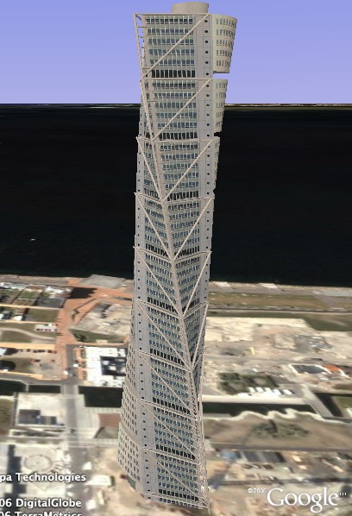

When built: Began 2001 and completed 2005 Torso's 26,000m² ground plan includes 4,200m² of office space on floors 2–12, the first two cubes. The commercial area has its own pair of lifts, as well as separate heating, cooling and IT systems. The development's top two floors have been reserved for meeting rooms, which can be rented by any organisation via HSB (these were officially ready for hire at the end of March 2006). A separate parking block for residents and business tenants can be accessed via a private tunnel.
Sweden has perhaps the most far-reaching environmental legislation in Europe, along with a comprehensive welfare system, so it is no surprise that central services are a high priority. Indeed, Western Harbour is being promoted as a global leader in urban sustainability. For heating, Torso connects to power utility Sydkraft's system, which uses 100% locally renewable energy. This is obtained from a variety of sources, including solar power, wind, bedrock and water.
Height: 190m
Workforce: 175
Timescale: 4 years
Number of elevators: 5
Capacity: 25,000 cubic meters of concrete
THE COOPER RIVER BRIDGE:
Connecting the bustling port city of Charleston and Mount Pleasant in South Carolina, the Cooper River Bridge will be the longest cable-stay bridge in America. Although nature is the biggest threat for its construction, it has to be built immediatelly because it is on the busy shipping lane. There was a threat of 300kmph hurricanes and engineers faced with very tall order and they had low amount of budget which is $531million. The road deck itself is suspended 54m above sea level by 128 individual cables, strung in parallel from the diamond-shaped support towers.
The signature design for this single cable-stay bridge evolved from public input, engineering requirements, and the expertise of the world’s leading bridge and lighting designers.
The bridge footprint was determined to create minimal impacts to existing neighborhoods within the city of Charleston and to be sensitive to the enhancement of the public realm.
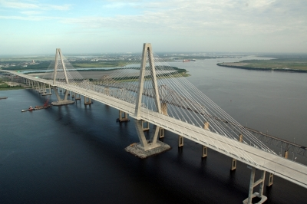 Through several public hearings, the local public chose the diamond tower design from other options.
Letters, testimony, and even a local bumper sticker campaign worked to add a pedestrian/bicycle component into the bridge design.
Local officials offered their insight to enhance interchange options with additional ramps to Morrison Drive in Charleston and Wingo Way in Mount Pleasant.
Local architects, city and town officials were enlisted to aid the bridge designers in refining the final design to reflect a local aesthetic, while staying within the available budget.
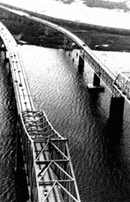
The need for a crossing of the Cooper River and Town Creek had been longstanding. The issue was how it should be done, and who would finance it. The solution came in 1928 when the dream of Charlestonian John P. Grace and others of building a Cooper River Bridge materialized, with financial backing from H.M. Byllesby and Company of Chicago and its allied financial group.
The 2.71-mile bridge, later to be named the Grace Memorial Bridge, was built in just 17 months, at a total cost of approximately $6 million. It was opened with a three-day celebration on Aug. 8, 1929.
Rock barrier islands have been built up around the support towers to prevent ships from careering into the bridge. Plastic hinge zones are being built into towers to allow flexibility during an 8.0 magnitude earthquake. In addition, a damping system has been developed to ensure the structure can withstand hurricane-force wind. The Cooper River Bridge is designed to remain in operation for the next 100 years.

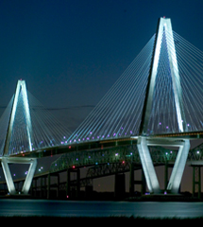
When built: 2005
Height: 175m
Length: 490m
Timescale: Four years
Workforce: 500
Construction material: Concrete and steel
Number of suspension cables: 128
Capacity: 18.2m people per year

MILLAU VIADUCT:
The Millau Viaduct (French: le Viaduc de Millau) is a large cable-stayed road-bridge that spans the valley of the River Tarn near Millau in southern France. It was designed by the structural engineer Michel Virlogeux and British architect Norman Foster, it is the tallest vehicular bridge in the world, with one mast's summit at 343 metres (1,125 ft) — slightly taller than the Eiffel Tower and only 38 m (125 ft) shorter than the Empire State Building. The viaduct is part of the A75-A71 autoroute axis from Paris to Béziers. It was formally dedicated on 14 December 2004, inaugurated the day after and opened to traffic two days later. The bridge won the 2006 IABSE Outstanding Structure Award.
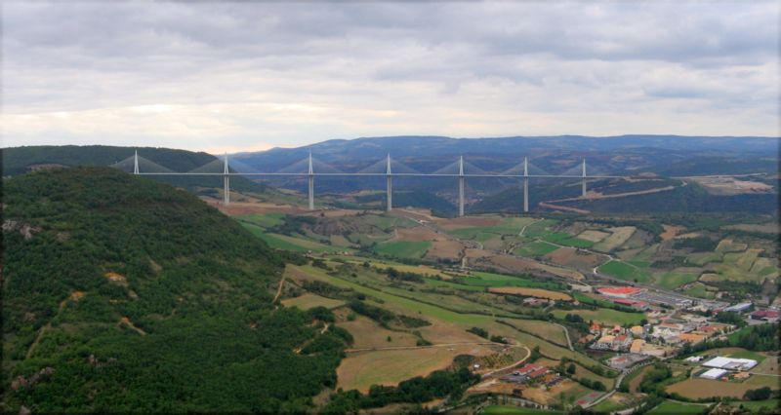
Panaromic view of Millau Viaduct from south- east side

The bridge’s construction broke three world records:
- The highest pylons in the world: pylons P2 and P3, 244.96 metres (803 ft 8 in) and 221.05 metres (725 ft 3 in) in height respectively, broke the French record previously held by the Tulle and Verrières Viaducts (141 m/460 ft), and the world record previously held by the Kochertal Viaduct (Germany), which is 181 metres (590 ft) at its highest;
- The highest mast in the world: the mast atop pylon P2 peaks at 343 metres (1,130 ft).
- The highest road bridge deck in the world, 270 m (890 ft) above the Tarn River at its highest point. It is nearly twice as tall as the previous tallest vehicular bridge in Europe, the Europabrücke in Austria. It is slightly higher than the New River Gorge Bridge in West Virginia in the United States, which is 267 m (880 ft) above the New River.
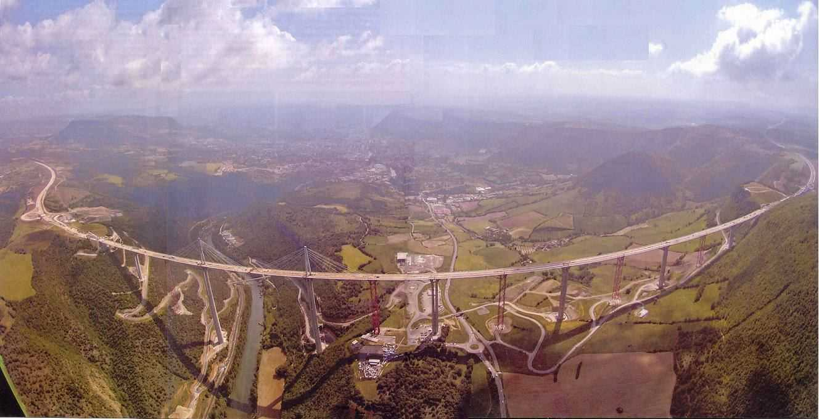
Located in southern France, the bridge will connect the motorway from Paris to Barcelona at the point where it is interrupted by the River Tarn, which runs through a wide gorge between two plateaus. A reading of the topography suggested two possible approaches: to cross the river, the geological generator of the landscape; or there was the challenge of spanning the 2.5 kilometers from one plateau to the other in the most economical manner.
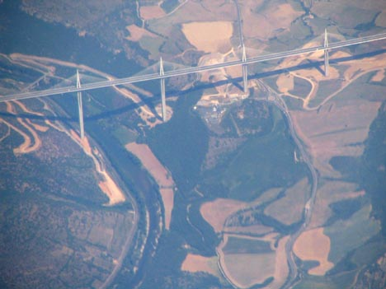
When built: 2004
Height: 343m
Width: 2 460 m
Workforce: 500
Timescale: Three years
Construction material: Steel and concrete
Number of piers: 7
Capacity of concrete used: 85,000 cubic meters
ICELAND TUNNELS:
Fifty years after the idea of harnessing the frightening force of Iceland’s glacial rivers was first conceived, the vision is about to be realised. Around 200 miles northeast of the capital, Reykjavik, engineers are hard at work drilling 72km of tunnels deep in the mountains.
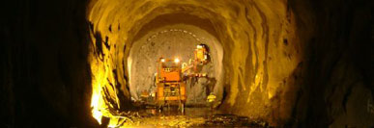
There are eight tunnels in the Icelandic road system (as of September 2005). Tunnels in Iceland are usually built under mountains to prevent winter isolation of remote communities which would otherwise have to depend on high roads that often closed due to snow, to shorten distance between communities, and to increase road-safety by bypassing dangerous stretches of road. A tunnel under a fjord, the Hvalfjörður Tunnel (Hvalfjarðargöng), is among the longest underwater road tunnels in the world.
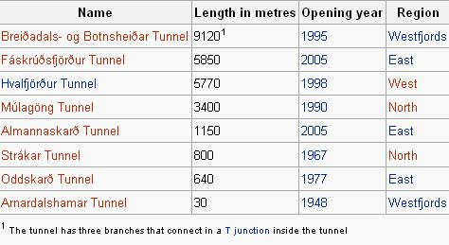

When built: Started 2003, completion due 2009
Length: 72km
Depth: 100-200m
Diameter: 7m
Timescale: Five years
Construction material: Concrete and steel
Capacity: Will provide enough hydro-power to generate enough electricity for a city the size of Manchester

VENICE FLOOD GATES:
Global warming cause water levels to increase all over the world and it may cause venice sink into the water like Atlantis. In September 2003, work began to prevent the city’s 45km of canals from cannibalising its ancient architecture.
Phase one saw dredging machines begin to remove 3.8 million cubic metres of clay from the lagoon bed at the mouth of its three inlets.
This is being replaced with 9m tons of rock and concrete to provide a sturdy foundation to fix the 79 steel floodgates. Each is bigger than a football field and weighs over 300 tons.
When not in use, the gates will lie flat against the lagoon floor. At the threat of a high tide, hydraulic valves can be opened at the flick of a switch allowing the gates to pivot into position.
At a cost of $3 billion, the project isn’t exactly cheap. But then, it’s less than the estimated losses during Venice’s worst ever flood in 1966.
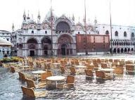
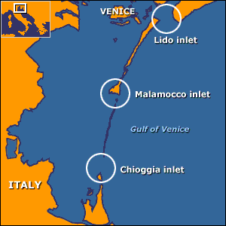
When built: Started 2003, completion due 2010
Height: 30m
Weight: 300 tons each
Timescale: Seven years
Construction material: Steel
Number of barriers: 79
Capacity: Stop tides of up to 2m

MARMARAY PROJECT:
The Project provides an upgrading of the commuter rail system in Istanbul, connecting Halkalı on the European side with Gebze on the Asian side with an uninterrupted, modern, high-capacity commuter rail system.
Railway tracks in both sides of Istanbul Strait will be connected to each other through a railway tunnel connection under the Istanbul Strait. The line goes underground at Yedikule, continues through the Yenikapı and Sirkeci new underground stations, passes under the Istanbul Strait, connects to the Üsküdar new underground station and emerges at Sögütlüçesme.
This Project is one of the major transportation infrastructure projects in the world at present. The entire upgraded and new railway system will be approximately 76 km long. The main structures and systems; include the immersed tube tunnel, bored tunnels, cut-and-cover tunnels, at - grade structures, three new underground stations, 37 surface stations (renovation and upgrading), operations control centre, yards, workshops, maintenance facilities, upgrading of existing tracks including a new third track on ground, completely new electrical and mechanical systems and procurement of modern railway vehicles.
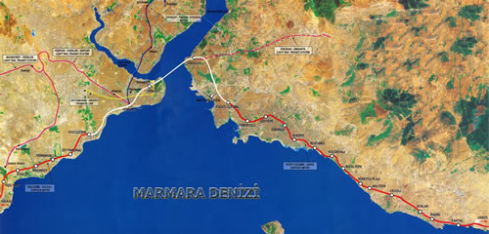

Total Line Length: 76.3 kms
Station Length: 225 meters (at least)
Passengers In One Way: 75.000
Maximum Inclination: %18
Maximum Speed: 100 kmph
Commercial Speed: 45kmph
Train Run Time: 2-10 minutes
Vehicle Number: 440 (predicted number for 2015)

Metro Line in Land: 63 kms
Stations in Land: 37
Tube Tunnel Length: 13.6 kms
Drilling Tunnel Length: 9.8 kms
Submersion Tube Tunnel Length: 1.4 kms
Open-Close Tube Tunel Length: 2.4 kms
Subterraneous Stations: 3
IZMIR METRO PROJECT:
The project started in 1984 and the German Company Heusch und Bosefeldt had made investigations on the main traffic artels of the city and prepared Transportation Master Plan. According to this plan there is two metro lines which reach Bornova, Buca, Narlidere, Cigli for the year 2010.
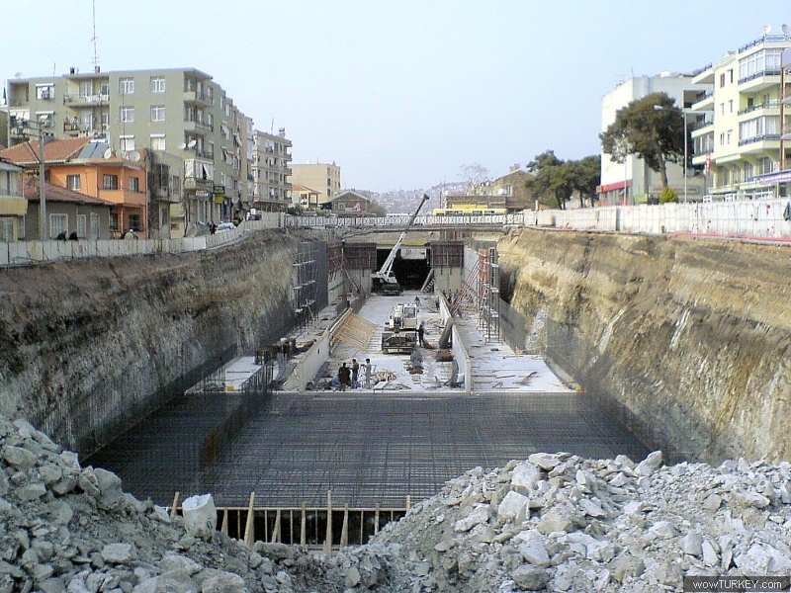

İzmir Metro A.Ş. has been established to meet the requirements and expectations of passengers for a fast, reliable, safe and comfortable travel at high efficiency levels, without sacrificing the
quality of service.
In order to increase the numbers and satisfaction of passengers on a continuous basis, İzmir Metro A.Ş. adopts the following as its targets:

- timely transit service without delays,
- high service quality,
- high performance level of staff,
- effective, continuous and on-time communication with passengers,
- efficient cost and investment management.

MICROSOFT OFFICE PROGRAMS & MATLAB:
First week of the CE300 Summer Practice, we introduced to Microsoft Office Excel program and we have learned some basic features of this program. We were shown that how to draw graphs and diagrams in Excel, how to write formulas and use them to solve some problems. We applied what we learned in lab hours.
In second week, we have attended Microsoft Word and PowerPoint courses. We have learned how to add graphs to word files, how we can draw figures in word, how to prepare table of contents in PowerPoint. We also see what can be done in basic Office programs and we make exercises in lab hours by the help of assistant and we strengthen our knowledge with these applications.
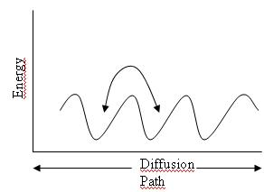
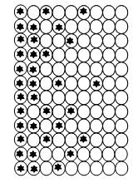
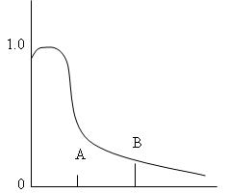

We also leaned mathematical calculation program, MatLab, and some basic commands of MatLab computing program. We learned some functions such as adding, multiplying, subtracting two matrices and plotting graphics and functions.
We have computer lab hours every week. We study in lab computers what we have learned in lessons. Useful subjects were covered in these computer lectures. Many different specifications of Office programs and MATLAB were thought and provided with homework. We do this homework at home or at computer labs to improve our ability in these programs.

Surveying
During CE300 Summer Practice we have attended Surveying lessons and practices. We learned some basic technuqies of surveying. Each week, firstly we took theoric lessons then we apply what we learned in lessons in practice. We were shown how to use Total Station to measure distances angles and level differences between points.
We have learned 5 main subjects in surveying lessons.Those are,

- Angle and distance measurement
- Levelling
- Traversing
- Curve and building layout
- Topographic survey
At the first subject of surveying,we did angle and distance measurement. Our lecturer helped us to know the total station setup, horizontal angle, horizontal distance, vertical angle, vertical distance, zenith angle, bearing, azimuth, direct and reverse reading. After the lecture we worked on the field with our group members. Firstly each group member tried to setup the total station. Then we choose two fixed points and measured the angle between those points. After this measurement, we read the angle between two point and we tried to reach 400 grad. Finally, each of us read the angle between two points directly and reversely.
At the second subject of surveying, leveling, we learned some term such as level, elevation of point, benchmark, back sight reading, foresight reading, turning point and learned how to calculate elevation difference and calculate the collimation error of level. Then we worked on the stadium. We started our measurements from the top of stadium and went 60 m horizontally by reading back sight and foresight. We recorded our data and after the field work, we calculated elevation difference and draw the graph of leveling. We also made two peg test at the top of stadium.
At the third subject of surveying, traversing, we learned the open and closed traverse, traverse angle, traverse calculations and azimuth calculations. Then we worked on the American Football Field. Every group setup their total stations according the station points and then we make measurements.
At the fourth subject of surveying, curve and building layout, we learned the meaning of layout and how to generate curve layout. On the field by using reflector and pins we form a curve according to given data. Then by using reflector and pins we entered the given data to total station setup menu and pinned four data point of a building layout.
Last week, we are given a project about curve layout and we tried to calculate some points. We made a big project with our group members. We also prepare topographic map of the American football field. Then we drew the contour lines according the height of data points. We also drew the traverse at the final project.

TEN CIVIL ENGINEERING RELATED TECHNICAL TERMS:
- TBM
- Spillway
- Seismic isolator
- Total station
- Strain gage
- Shotcrete
- Precast concrete
- Surveying
- Inclinometer
- Tunnel formwork

Surveying:Surveying is the technique and science of accurately determining the terrestrial or three-dimensional space position of points and the distances and angles between them. These points are usually, but not exclusively, associated with positions on the surface of the Earth, and are often used to establish land maps and boundaries for ownership or governmental purposes. In order to accomplish their objective, surveyors use elements of geometry, engineering, trigonometry, mathematics, physics, and law.
An alternative definition, per the American Congress on Surveying and Mapping (ACSM), is the science and art of making all essential measurements to determine the relative position of points and/or physical and cultural details above, on, or beneath the surface of the Earth, and to depict them in a usable form, or to establish the position of points and/or details.
Precast Concrete: A form of construction, where concrete is cast in a reusable mold or "form" which is then cured in a controlled environment transported to the construction site and lifted into place. In contrast, standard concrete is poured into site specific forms and cured on site. Precast stone is distinguished from precast concrete by using a fine aggregate in the mixture so the final product approaches the appearance of naturally occurring rock or stone.
There are many different types of precast concrete forming systems for architectural applications, differing in size, function and cost.These are:
- Pre Tensioned Concrete
-Bonded Post-Tensioned Concrete
-Unbonded Post-Tensioned Concrete

CONCLUSION:
In conclusion, generally Summer Practice Program was beneficial.We have learned some important informations about our occupation.Lecturers were very helpful.However,in my opinion, it has some negative parts.The trips to the dams were very tiring.They are very far away each other and we finished them in one day.Other trips were really impressive. These trips covered different areas of civil engineering from dams to steel structures, from subway constructions to a steel factory. These trips were good opportunities to turn theoretical knowledge into effect.The videos were also very beneficial for civil engineering.We have seen how the engineers construct the mega buildinhs.
The surveying part was also very tiring because of the hot weather.But,we have learned a lot of things from that practice. Surveying practice was something the students faced the first time in their life. Surveying is very common in all construction areas so it was important to teach the students this to enable them to understand the surveying process when they start their professional life.
To conclude, the summer practice was satisfactory considering that was the first time. It was obvious that the department organised it as well as they could possibly do. With the improvement a couple of points i believe the summer practice will be more satisfactory in the next semesters.

