Example1) The moisture content of a sample of saturated soil is 32.3 %. Find the void ratio, bulk and dry density and unit weights. Assume the specific gravity of the soil particle to be 2.70.

Solution:

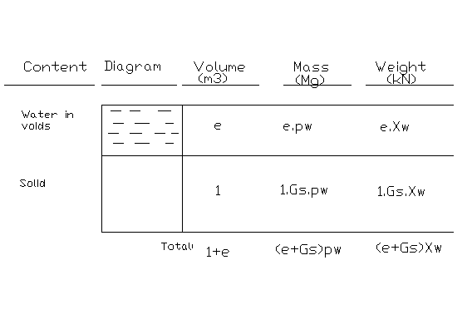
Moisture content; w=mass of water / mass of solid = e.ρ_{w} / G_{s}. ρ_{w} =e / G_{s}

=> 0.323 = e / 2.70 => e = 0.872 = 87.2 %

Dry density; ρ_{d} = mass of dry soil / total wet volume of soil
ρ_{d} = G_{s}. ρ_{w} / (1+e) = 2.7*1/ 1.872 = 1.442 Mg/m³ (take ρ_{w} as 1.0Mg/m³)

Dry unit weight; γ_{d} = G_{s}. γ_{w} / (1+e) = 1.442*9.807 = 14.14kN/m³ (take γ_{w} as 9.807kN/m³)

OR
γ_{d} = ρ_{d}. γ_{w} / ρ_{w} = 1.442* (9.807/1.000) = 14.14 kN/m³

Bulk density; ρ = (e+G_{s}).ρ_{w}/(1+e) = (0.872+2.70).1.000/1.872 = 1.908Mg/m³

Bulk unit weight; γ = ρ. γ_{w} / ρ_{w} =1.908.(9.807/1.000) = 18.71 kN/m³

CHECK: γ = (1+e).γ_{d} = (1+0.323).(14.14) =18.71 kN/m³ O.K.

Note that: 1 Mega gram(Mg) = 1000kg = 1 ton

Example2) The bulk unit weight of the soil has been measured as 19.17 kN/m³, the moisture content as 25.3% and the Gs of the solid particles as 2.70. Calculate the degree of saturation, Sr.

Solution:
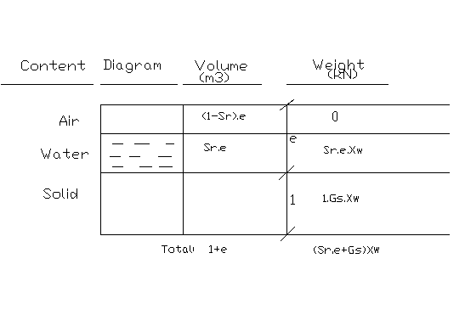

Bulk unit weight; γ=(G_{s}+S_{r}.e) / (1+e)* γ_{w}

19.17 = (2.7 + S_{r.}e) / (1+e)*9.807
=> 1.955.(1+e) = (2.7+S_{r}.e) .........................1

Moisture content; w =weight of water / weight of solids = S_{r}.e. γ_{w} / G_{s}. γ_{w} = S_{r}.e / G_{s}
=> 0.253 = S_{r}.e / 2.7 => S_{r}.e = 0.683 .......................2

substitute 2 in 1;

1.955.(1+e) = (2.7+0.683)
=> (1+e) = 3.383/1.955=1.731
=> e = 0.731 ............................3

substitute 3 in 2;

S_{r} = 0.683/0.731 * 100 %
=> S_{r} = 93.4%

Example3) A 8m depth of fine sand overlies a 10m layer of clay, the water table is 6m below the ground level but the 2m of the sand layer is under artesian pressure. The saturated and dry unit weight of the sand is 20kN/m³ and 18kN/m³, respectively. The saturated unit weight of clay is 15kN/m³. A 20kN/m² distributed force is applied on the surface. Calculate the effective vertical stress at the bottom of the clay layer after the distributed force has been applied. Draw the total stress, effective stress, and pore water pressure diagrams.

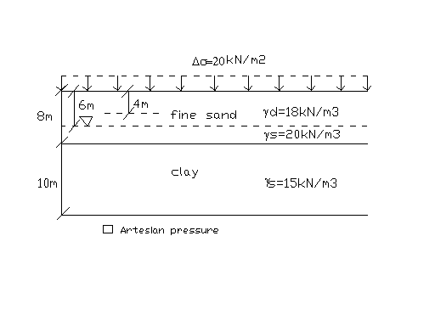

Solution:

At d=18m; σ=(18*4)+(20*2)+(20*2)+(15*10) = 302kPa
u = 12*10=120kPa
σ’= σ − u = 182kPa
OR
σ’= (18*4)+(20*2)+(20-10)*2+(15-10)*10 = 182kPa 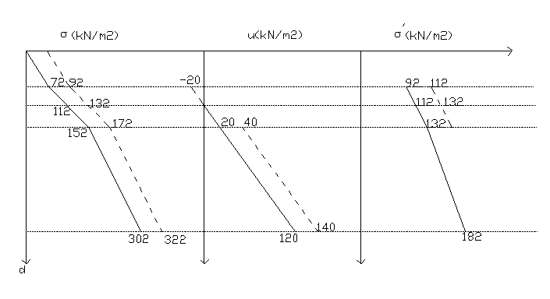

Example4) A sand layer of 5m lies in between two clay layer of 5 meter thick each, the water table is at 2m depth below the ground level. The saturated and dry unit weight of the upper clay layer is 17kN/m³ and 16kN/m³, respectively. The saturated unit weight of bottom clay is 17kN/m³. The saturated unit weight of sand is 19kN/m³. During rainy season, the artesian pressure in sand layer increases as shown in the figure below. Draw the total stress, effective stress, and pore water pressure diagrams for the cases a) before the rain b) immediately after the rain c) long time after the rain. Also find the factor of safety against heaving after 2m excavation at rainy season.
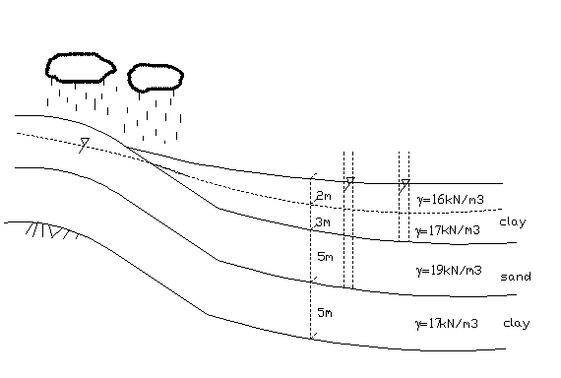

Solution:
a)
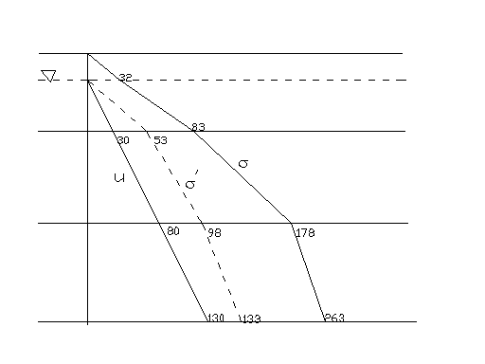

b)
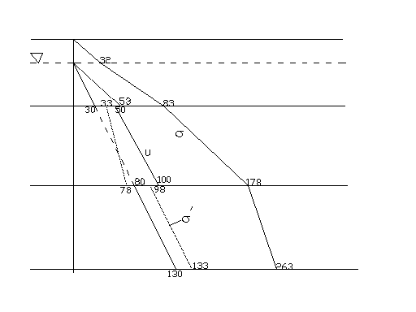

c)
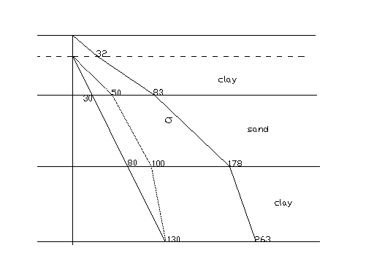

d) FSagainst heaving after 2m excavation=3*17/50=51/50=1
=> about to heave

