Example5) The section through a dam is shown in the below figure. Plot the equipotential lines on the base of the dam. Find the total stress and the water pressure at point p.
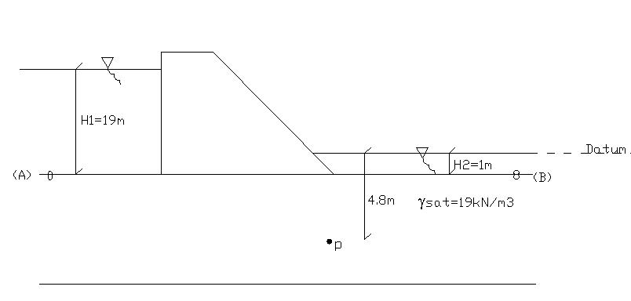

Solution:

σ=(3.8*19) + (1.0*10) = 82.2kPa

N=#of equal drops = 8
ΔH=drop in head between A&B
= (Pres. head + Pos. head)_{A} – (Pres. head + Pos. head)_{B}
= [H₁+(-H₂)] – [H₂+(-H₂)] = H₁ – H₂

i) (Pres. head + Pos. head)_{A} – (Pres. head + Pos. head)_{P} = (6.4 – 0)/8*ΔH
[H1 + (-H2)] – [(u_{p}/γ_{w}) + (-4.8)] = (6.4 – 0)/8*ΔH
(19-1) – u_{p}/ γ_{w} + 4.8 = 6.4/8*18
u_{p}/ γ_{w} = 8.4m => u_{p}=84kPa (assume γ_{w}=10kN/m³)
OR
ii) (Pres. head + Pos. head)_{P} – (Pres. head + Pos. head)_{B} = (8 – 6.4)/8*ΔH
[u_{p}/ γ_{w} + (-4.8)] – [1 + (-1)] = (8 – 6.4)/8*18
u_{p}/ γ_{w} = 4.8 + (8-6.4)/8*18 = 8.4m =>u_{p}=84kPa
OR
iii)
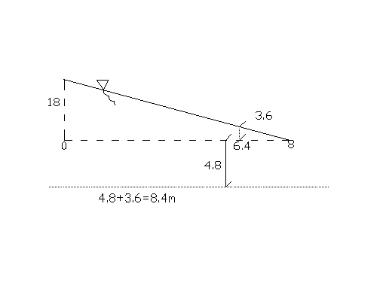
Example6) The section through a sheet pile wall along a tidal estuary is shown below. The saturated unit weight of the soil being 20kN/m³. Plot the net disribution of water pressure on the piling. Evaluate the boiling condition at the surface AB. Find the water pressure at point p.

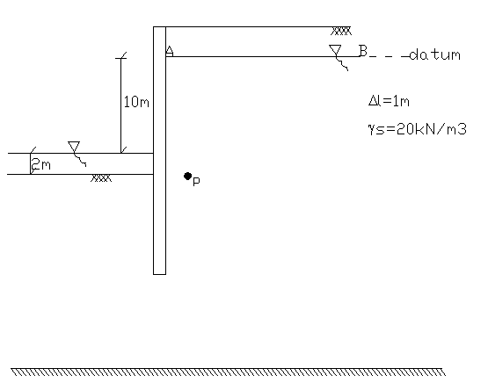

i=Δh /l = Δh/(N_{d}* Δl)=10/(20*1) =0.5 < 1(no boiling)

h_{p}= 0 – (i*N_{p} + (-6.5))
h_{p}=6.5 – 0.5*6.4 = 3.3m
=> u_{p}=3.3*10kN/m³=33kPa

Example7) The results shown in table were obtained at failure in a series of tests, with pore water pressure measurement. Determine the values of a) total stress parameters a, α, c, φ b)effective stress parameters a’, α’, c’, φ’. Also calculate shear stress on a horizontal plane at point P assuming principal direction remain horizontal where A=0.6, B=1(fully saturated) and γ_{clay}=15kN/m³ for the cases i) before the construction ii) just after the construction iii) long term after the construction . Note that upon construction of the structure the vertical stress increases by 60kPa and the horizantal stress by 40kPa.
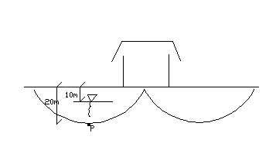

Solution:
Test No: | 1 | 2
Pore Pressure(kPa) | 10 | 15
Cell Presure(kPa) | 81 | 113
σ1−σ3(kPa) | 158 | 204
Part1)
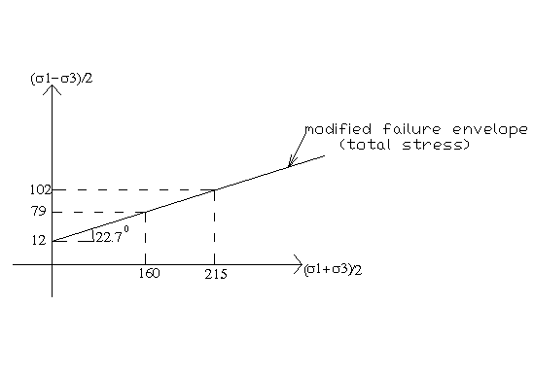

α = 22.7⁰ a = 12kPa
φ = sin⁻¹(tanα) = 24.7⁰
c = a/cosφ = 13.2kPa

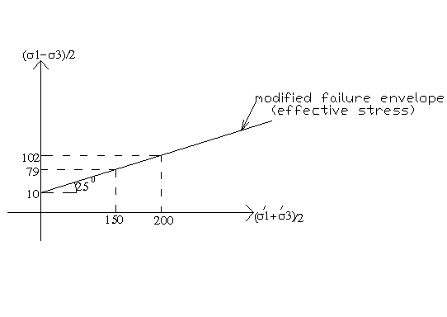

α’ = 25⁰ a’ = 10kPa
φ’ = sin⁻¹(tanα’) = 28⁰
c’ = a’/cosφ’ = 11.3kPa
Part2)
A=Δu/Δ(σ₁−σ₃) ; Β=Δu/Δσ₃

Before building:
σ_{v}=20*15kPa=300kPa
u₀=10*10=100kPa
σ_{v}’=300-100=200kPa
Effective Stress: Total Stress:
τff=c’ + σ_{v}’*tanφ’ τff=c + σ_{v}*tanφ
=11.3+200*tan28=117.64kPa =13.2+300*tan24.7=151.19kPa

After building:
σ_{v}=20*15 + 60=360kPa
u₀=u₀ + 40*B + (60-40)*A = 100+40*1+20*0.6=152kPa
σ_{v}’=360-152=208kPa
Effective Stress: Total Stress:
τff=c’ + σ_{v}’*tanφ’ τff=c + σ_{v}*tanφ
=11.3+208*tan28=121.90kPa =13.2+360*tan24.7=178.78kPa

Long term:
σ_{v}=360kPa
u₀=100kPa
σ_{v}’=360-100=260kPa
Effective Stress: Total Stress:
τff=c’ + σ_{v}’*tanφ’ τff=c + σ_{v}*tanφ
=11.3+260*tan28=149.55kPa =13.2+360*tan24.7=178.78kPa

