Example8) A 4m depth of sand overlies a 8m layer of clay; the water table is 1m below the surface of the sand. A 4m depth of fill (unit weight 21kN/m³) is to be dumped on the surface over an extensive area. The unit weight of the sand and clay is 19kN/m³. For the clay, the initial void ratio is 0.85 and the values of C_{c} and C_{r} are 0.15 and 0.04, respectively. Calculate the final settlement of the area due to consolidation of the clay a) without subdividing the clay layer b) with dividing the clay layer into two sublayers. c) If the fill were to be removed after consolidation; how much heave would eventually take place due to swelling of the clay?
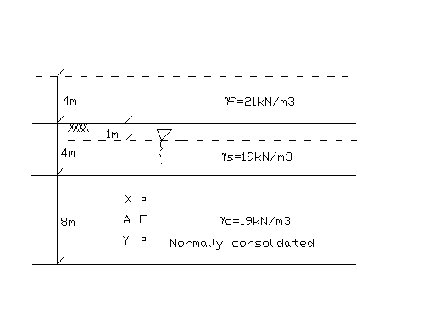
Solution:
a) σ_{A}’=19+9*3+9*4=82kPa
Δσ=21*4=84kPa
Sc=C_{c}*H₀/(1+e₀)*log[(σ’_{v0}+Δσ)/σ’_{p}] = 0.15*8/(1+0.85)*log(166/82)=0.199m

b) σ_{X}’=19+9*5=64kPa
σ_{Y}’=19+9*9=100kPa
Sc=0.15*4/1.85*log[(64+84)/64] + 0.15*4/1.85*log[(100+84)/100]=0.204m

c) σ_{A}’_{after end of consol.}=82+84=166kPa
ef=e₀ – log(166/82)*C_{c}=0.804
Sc=C_{R}*H₀/(1+ef)*log(82/166)=0.05m

Example9) In an oedometer a test specimen of saturated clay, 19mm thick reaches 50% consolidation in 20min. How long would it take a layer of this clay, 5m thick to reach to the same degree of consolidation under the same stress & drainage condition?

Solution:

Tv_{50%}=C_{v}*t_{lab}/d²_{lab}=Cv*20min/(19/2)²=Cv*t/(5*1000/2)²
- t=1,385,041min≈32months

Example10) A clay layer of 20m lies in between two sand layer of 1 meter thick each, the water table is at 1m depth below the ground level. The unit weight of the sand and clay layer is 19kN/m³ and 18kN/m³, respectively. A 40kN/m² distributed force is applied on the surface. Calculate the final settlement of the area due to consolidation of the clay for a) σ_{p}’=200kPa (over consolidation pressure) b) σ_{p}’=120kPa c) σ_{p}’=99kPa.(figures are given below). Also find d) how much excess pore water pressure dissipate in 10 year e) excess pore water pressure and effective stress at 6m depth if Cv=0.45 m²/year.

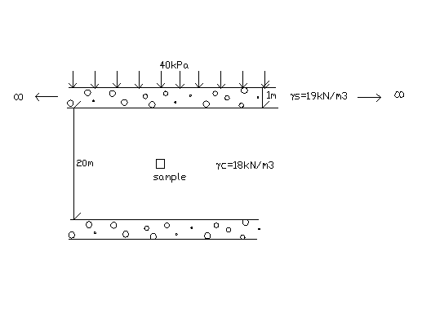
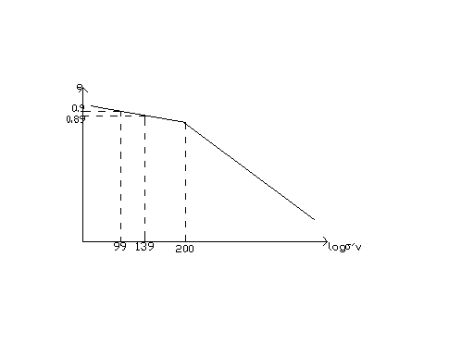
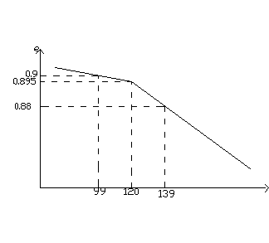
a) σ_{p}’=200kPa b) σ_{p}’=120kPa c

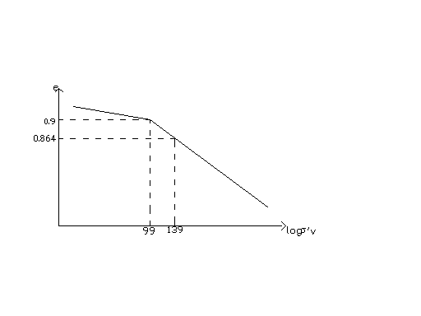

c) σ_{p}’=99kPa

Solution:
a)
ΔH/H₀ = Δe/(1+e₀)
ΔH/20 = (0.9-0.89)/(1+0.9)
ΔH = 0.1m

OR

C_{R}=Δe/log(139/99)=0.07
Sc=C_{R}*H₀/(1+e₀)*log[(σ’_{v0}+Δσ)/σ’_{v}]
=0.07*20/1.9*log(139/99)=0.1m

b)
ΔH/H₀ = Δe/(1+e₀)
ΔH/20 = (0.9-0.88)/(1+0.9)
ΔH = 0.21m

OR

Cc=Δe/[log139 – log120]=(0.895-0.88)/log(139/120)=0.24
Sc=C_{R}*H₀/(1+e₀)*log[(σ’_{v0}+Δσ_{v})/σ’_{v0}] + C_{C}*H₀/(1+e₀)*log[(σ’_{p}+(σ’_{v0}+Δσ_{v}-σ’_{p})/σ’_{p}]
=0.07*20*1.9*log(120/99)+0.24*20/1.9*log(139/120)=0.22m

c)
ΔΗ/Η0 = Δe/(1+e₀)
ΔH/20 = (0.9-0.864)/(1+0.9)
ΔH = 0.38m

OR

Sc=0.24*20/1.9*log(139/99)=0.37m

d) Tv=c_{v}*t/d²=0.45*10/10²
Tv=0.05

u Tv
0 0
5 0.002
10 0.008
15 0.018
20 0.031
25 0.049
30 0.071

50 0.196

90 0.848

100 ∞

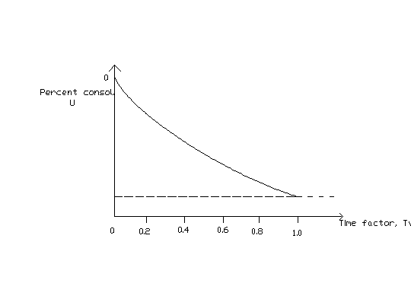

u=25%
t=10years
Sc=0.25*(∑Sc)

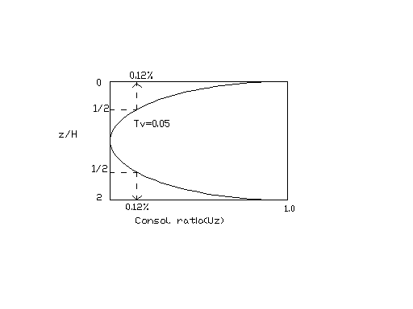

U_{z=11m}≈0
U_{z=6&16m}=12%
Excess pore pressure => U₀*( 1-0.12)=35.2kPa
σv’_{at6m}=1*19+5*8+0.12*40=99+4.8=103.8kPa

